The Shoulder Strength Testing Out of Pain (SSTOP) Study: Reliability of fixed portable dynamometry for measuring pain-free shoulder strength in people with rotator cuff-related shoulder pain (RCRSP).

Tim Cook, MSc¹˒²*
Iker J. Bautista, PhD²
Luke Emmett, BSc (Hons)¹
Jeremy Lewis, PhD, FCSP³˒⁴^{, 5}
¹ Physiotherapy Department, Sussex MSK Health NHS, Chichester, West Sussex, United Kingdom
² School of Nursing and Allied Health, University of Chichester, Chichester, United Kingdom
³ Health Sciences University, United Kingdom.
⁴ Therapy Department, Central London Community Healthcare National Health Service Trust, United Kingdom.
⁵ School of Life and Health Sciences, University of Nicosia, Nicosia, Cyprus

*Corresponding Author
Tim Cook, MSc
Physiotherapy Department, Sussex MSK Health NHS
Madgwick Lane
Chichester
West Sussex
PO18 0FB
United Kingdom
Email: tim.cook1@nhs.net
ORCID: 0009-0001-6344-1538

This work was supported by the National Institute of Health Research (NIHR) Applied Research Collaboration (ARC), Kent, Surrey and Sussex (KSS) Individual development award (IDA) (grant number: ARC KSS IDA 25).
The authors report no financial affiliation (including research funding) or involvement with any commercial organisation that has a direct financial interest in any matter included in this manuscript.
Ethical approval for this study was obtained from Health Research Authority (HRA) (South West – Frenchay) Research Ethics Committee on the 18th January 2024, reference number 23/SW/0139.

Data sharing
All data relevant to the study are included in the article or are available as supplementary files, starting three months and ending five years following publication. No patient-identifiable data are available.
Protocol and statistical analysis plan
The full trial protocol and statistical analysis plan are held electronically within the secure institutional site file at Sussex MSK Health. These documents are available from the corresponding author upon reasonable request, subject to institutional data governance approval.
Author Contributions
TC conceived and designed the study as Chief Investigator and drafted the manuscript; LE performed data acquisition and assisted in manuscript revision; IJB and JL critically revised the manuscript for intellectual content; and all authors approved the final version and agree to be accountable for the work.
Use of artificial intelligence (AI)
The authors declare that an artificial intelligence tool (Claude, Anthropic, 2026) was used during manuscript preparation to assist with language editing and grammatical refinement, particularly during final word-count reduction. The tool was not used for data analysis, interpretation, or generation of scientific content. All outputs were reviewed and edited by the authors, who take full responsibility for the accuracy, integrity, and final content of the manuscript.
Patient and public involvement
Patients and members of the public contributed to the co-design of this study through a focus group held at a local community hospital, where feedback on the research rationale and proposed methods informed refinement of the study design.

Abstract
Objective: To investigate the intra-rater and inter-rater reliability of pain-free shoulder force testing in people with rotator cuff-related shoulder pain (RCRSP), and to explore its associations with patient-reported clinical and psychosocial measures.

Design: Reliability study of fixed portable dynamometry. Assessment order was randomised.

Methods: Two investigators tested mean and maximal pain-free abduction and external rotation force for both shoulders in 31 people with unilateral RCRSP, using a fixed, portable hand-held dynamometer (HHD). The order in which the investigators assessed each participant was randomised. Participants were blinded to their test scores, and each investigator was blinded to the other investigator’s measurements. Secondary analyses examined the relationship between the relative pain-free force index (as well as three psychosocial outcome measures) and the Shoulder Pain and Disability Index (SPADI).
Results: Absolute measurement error was substantial: the inter-rater limits of agreement (LoA) were wide, the standard error of measurement (SEM) ranged from 8.9 to 19.5 N (minimal detectable change at the 95% confidence level [MDC95] 24.7–53.9 N) and the intra-rater repeatability coefficient reached 34.5 N, indicating the need for caution when interpreting small changes in isometric shoulder force; relative reliability was nonetheless good to excellent (intraclass correlation coefficient [ICC] 0.89–0.97 intra-rater and 0.83–0.89 inter-rater). In secondary exploratory analyses, pain-free force deficits showed weak-to-moderate associations with SPADI scores (|r| = 0.01 to 0.43). Psychosocial measures demonstrated stronger correlations (|r| = 0.44 to 0.71; moderate-to-strong associations), with the Pain Self-Efficacy Questionnaire (PSEQ) showing the strongest association.

Conclusion: Pain-free HHD shoulder force testing in RCRSP showed substantial absolute measurement error, with wide LoA despite good relative reliability. Exploratory associations with patient-reported pain and disability were numerically stronger for psychosocial measures than for the relative pain-free force index. These findings suggest limitations in detecting small differences in force and support assessment beyond force testing alone.

Key words: Reproducibility of results; observer variation; psychometrics; agreement; clinimetrics

- Introduction
Shoulder pain is the third most frequent musculoskeletal complaint for which people seek medical care, with rotator cuff-related shoulder pain (RCRSP) considered the most prevalent subtype ^{10,39}. In managing musculoskeletal conditions like RCRSP, clinicians use objective and performance-based impairment tests ⁴. Measuring certain constructs (e.g., pain, disability, movement, muscle performance) may inform those seeking care, researchers, and clinicians regarding diagnosis and prognosis²⁸. A key construct in RCRSP is reduced shoulder muscle force production, particularly in abduction and external rotation ^{12,15,53}. It has been argued that accurately measuring shoulder force is important as it may offer a quantified representation of the patient’s problem, which may help guide treatment planning, adherence, and progression ^{4,38}.
Currently there is no widely adopted and practical observer-rated measure of shoulder force in the clinical setting. Manual muscle testing provides only ordinal, examiner-dependent grading and is insensitive to subtle strength deficits ^{4,53}, while isokinetic dynamometry, although valid and reliable, is largely inaccessible in routine clinical practice. A more accessible tool for measuring force is a hand-held dynamometer (HHD). Although the available evidence is conflicting ^{9,49}, several research groups have reported that HHD testing is reliable, although reliability is device-dependent and varies with the degree of external stabilisation and the testing protocol ^{9,29,49}, with moderate to strong correlations with gold-standard isokinetic testing ^{24,26}.
HHD testing protocols vary in positioning, degree of stabilisation, and the selection of “make” (isometric against fixed resistance) versus “break” methods (examiner-applied force that overcomes the isometric contraction). Break tests, by design, introduce joint motion and eccentric loading, producing consistently higher peak values than make tests and introducing tester-strength dependency, limiting both comparability and reliability ^{44,57}. A further source of measurement bias is pain itself. An individual’s ability to express maximal force in the presence of pain may be impaired by a variety of inhibitory factors such as their level of perceived pain ^{2,20,55}, fear ^{19,35}, and even the degree of movement- related fear of the tester ³⁴. These effects are thought to be greater with movement evoked (intermittent) pain compared with tonic (constant) pain ⁶. A “maximal” contraction performed into pain therefore reflects a person’s strength despite their pain related inhibition; it is not a pure measure of strength ^{2,17}. This may explain conflicting results in studies investigating the association between maximal shoulder force and degree of pain and disability in those with RCRSP ^{1,15,36}. Accordingly, this study used a pain-onset make test; participants build force gradually against fixed resistance and stop at the onset of pain. The aim is to investigate an interpretable measure of tolerance distinct from maximal strength, while minimising unnecessary symptom provocation. This type of testing has established reproducibility and reliability in similar upper limb tendinopathy studies ^{22,50}.
To date, no study has examined the reliability of an externally fixed HHD pain-onset make test for shoulder force measurement in people with RCRSP. The aims of this study were to 1) investigate the reliability of pain-free shoulder force testing in people with RCRSP, and 2) examine the relationship between the relative pain-free force index and psychosocial measures with patient-reported shoulder pain and disability.

- Methods
2.1 Study design
This was a within-session reliability study in which two investigators assessed isometric shoulder force using a HHD on the same day in randomised order, using an online random number generator (random.org). Participants were blinded to their performance, and investigators were blinded to each other’s measurements. The data analysed in this reliability study were collected within the first of the two trials of the prospectively registered STOP–START parent study (NCT06107127); this reliability report is not itself a registered clinical trial. This study was reported in accordance with the Strengthening the Reporting of Observational Studies in Epidemiology (STROBE) Statement, the COnsensus-based Standards for the selection of health status Measurement INstruments (COSMIN) reporting guideline for studies on reliability and measurement error, and the Guidelines for Reporting Reliability and Agreement Studies (GRRAS) ^{14,18,32}
2.2 Setting
The study was carried out in the National Health Service Outpatient Physiotherapy Department at Bognor Regis War Memorial Hospital, UK.
2.3 Participants
Participants were screened by a physiotherapist to confirm eligibility. Inclusion criteria were: age ≥18 years; unilateral shoulder pain for ≥3 months; no shoulder pain at rest or during periods of inactivity; and positive findings on at least three of the following: pain on resisted abduction and/or external rotation, near-normal passive range of motion, painful arc during abduction, and pain on passive impingement testing (Hawkins–Kennedy and/or Neer’s sign) ³⁷.
Patients were excluded from participation if they presented with bilateral shoulder pain, had previously had surgery on the affected shoulder, or had received a corticosteroid injection for their shoulder pain in the previous 6 weeks. Additionally, patients with confirmed or suspected frozen shoulder, massive rotator cuff tears, calcific tendinopathy, a history of shoulder dislocation, symptomatic glenohumeral or symptomatic acromioclavicular osteoarthritis or referred pain from the cervical spine were excluded.
Prior to enrolment, potential participants were provided with an information sheet by their treating physiotherapist outlining the study's purpose and assessment procedures. Interested individuals gave informed consent to be contacted by the research team to schedule a one-off, 60-minute assessment session. At the commencement of the assessment session, the testing protocol was explained verbally, and participants were provided an opportunity to ask questions. The investigators rescreened all potential participants to verify that all inclusion criteria were strictly met. Once eligibility was confirmed, participants provided written informed consent to participate prior to commencing the remainder of the testing protocol. The rights of all participants were protected at all times. At baseline, participants rated their average shoulder pain over the previous week on a 0–10 pain rating scale (0 = no pain; 10 = worst pain imaginable).
2.4 Procedure
    - Participant characteristics.
Participant demographics, including age, sex, and duration of symptoms, were recorded at the commencement of each assessment session. These data were securely stored in a confidential manner within an encrypted electronic database. Following baseline data collection, the lead investigator randomly assigned the sequence of examiners using an online random number generator (www.random.org) to determine which investigator would conduct the primary assessment.
    - Force testing
Two qualified musculoskeletal physiotherapists with 18 years (T.C) and 10 years (L.E) experience separately carried out the testing procedure. Both investigators completed a minimum of two hours of training using the EasyForce™ digital dynamometer before data collection (FIGURE 1). The testing protocol incorporated standardisation of participant positioning, stabilisation and resistance placement, consistent with published recommendations for muscle strength measurement ⁴. Each participant was tested with the same device. Participants attended one assessment session lasting approximately one hour.
Each subject sat on a chair with a back support with their hips and knees at 90° and their feet flat on the floor. They were asked to adopt a natural relaxed sitting position of the upper torso.
Isometric External rotation force: Participants were asked to sit with the testing arm relaxed by their side and their elbow flexed to 90 degrees. The HHD cuff was placed around their wrist (FIGURE 2). Participants completed one or two practice trials to familiarise themselves with the required movement. The asymptomatic side was tested first. Participants were asked to gradually increase isometric force over a 5-second period, stopping at the onset of pain, and repeat this three times with a 5 second break between repetitions. Maximal scores were recorded as well as an average of the three measurements as this has been shown to be more reliable than a single test ⁴.
Standardised instructions were given to each participant during each contraction: “on my go, push outwards against the cuff as hard as you can, stopping if you feel any pain” (5 seconds). The investigator prompted the participants to stop each repetition by saying the words “and now relax”. The same procedure was then performed on the symptomatic side.
Isometric Abduction force: Participants were asked to initially place their hand on their ipsilateral hip to allow a consistent degree of shoulder abduction for each test. The examiner then placed the cuff at the level of the distal humerus. The length of the strap was adjusted to fix the distance between the cuff and the fixed platform (FIGURE 3a). Finally, the shoulder was externally rotated to a neutral position, and the participant was instructed to keep their palm facing the floor to help them replicate the position between tests (FIGURE 3b). Testing at approximately 30–50° of abduction optimises leverage for rotator cuff recruitment while avoiding the painful arc position (60–120°), theoretically reducing the risk of pain being experienced before taking a force measurement ^{16,23}. As with external rotation testing the asymptomatic side was tested first.
Force was measured in Newtons (N). A relative pain-free force index (%) was calculated for each participant for each movement by dividing the average pain-free force of the symptomatic shoulder by the average force of the asymptomatic side and multiplying by 100. Higher values therefore indicate that the symptomatic shoulder produced more force relative to the asymptomatic side, that is, less impairment. Calculating this relative pain-free force index allowed for statistical correlation with the Shoulder Pain and Disability Index (SPADI) score.
    - Psychosocial measurements
Following the primary round of physical force testing, participants were allocated a standardised rest period of approximately 15 minutes to minimise any cumulative neuromuscular fatigue or symptom irritability ⁸. To maximise protocol efficiency, participants completed the following self-reported psychosocial and functional outcome measures during this rest interval:
- Shoulder Pain and Disability Index (SPADI) ⁴⁷.
- Pain Self-Efficacy Questionnaire (PSEQ) ⁴².
- Tampa Scale for Kinesiophobia-11 (TSK-11) ²¹.
- Pain Catastrophising Scale (PCS) ⁵¹.
Higher scores on the SPADI (0–100) indicate greater pain and disability. The PSEQ (0–60) assesses confidence in performing activities despite pain, with higher scores indicating greater pain self-efficacy. The TSK-11 (11–44) assesses fear of movement or re-injury, and the PCS (0–52) assesses catastrophic thinking about pain, with higher scores indicating greater kinesiophobia and catastrophising, respectively.
Upon completion of these questionnaires, the participant immediately crossed over to the secondary testing block, replicating the identical force-testing protocol with the alternate, blinded investigator.
2.5 Statistical methods
Reliability and Limits of Agreement
Reliability was quantified using both absolute and relative indices. Because the study was sized for the precision of the absolute-agreement estimates, these are reported before relative reliability throughout. Absolute reliability and measurement error were assessed using Bland–Altman limits of agreement (LoA), the standard error of measurement (SEM) and the minimal detectable change at the 95% confidence level (MDC95 = 1.96 × √2 × SEM), expressed in Newtons. For within-session (intra-rater) reliability the SEM was derived from the within-subject standard deviation (Sw) across the three repetitions, and the repeatability coefficient (2.77 × Sw) is reported as the smallest within-session change distinguishable from measurement error²⁵. For inter-rater analyses, the mean and maximum values from the three repetitions obtained by each investigator were compared separately. Bland–Altman plots displayed the mean difference and the 95% LoA (mean difference ± 1.96 × SDdiff, where SDdiff is the standard deviation of the paired differences). This range represents the interval within which 95% of the differences between the two raters are expected to lie. Narrow LoAs indicate greater agreement between raters, whereas wider LoAs indicate greater measurement variability. The distribution of the paired differences was examined for normality (Shapiro–Wilk), for proportional bias (regression of the differences on their mean) and for heteroscedasticity (Kendall's tau of the absolute differences against the mean); where the spread of differences increased with magnitude, proportional (regression-based) LoA are reported alongside the fixed limits. To determine whether the LoA were acceptable, the limits were expressed as a percentage of the grand mean of all data points. Expressing the LoA as a percentage standardises the interpretation. An a priori threshold of ±15% of the grand mean was specified as the criterion for acceptable agreement, consistent with thresholds previously applied to absolute measurement error in shoulder HHD reliability research⁹; the protocol was defined as acceptable only if neither the upper nor the lower relative LoA exceeded that threshold. This threshold was used as a study-specific criterion for interpreting the magnitude of measurement error and should not be interpreted as a minimal clinically important difference (MCID), for which an established value for shoulder strength in RCRSP is currently lacking. Relative reliability was assessed using the intraclass correlation coefficient (ICC), estimated with a two-way, single-measures, absolute-agreement model (ICC(A,1)). The effects model followed the design of each analysis: a two-way random-effects model for inter-rater reliability, the two investigators being treated as representative of a wider population of raters, and a two-way mixed-effects model for within-session (intra-rater) reliability, where the repetitions of a single fixed investigator are not a random sample of raters. Following current guidance on reporting the ICC model, type and definition, ICC was interpreted as poor (<0.50), moderate (0.50–0.75), good (0.75–0.90) or excellent (>0.90).³¹
Secondary analysis utilised Pearson’s correlation coefficient (r) to investigate the linear relationships between the calculated relative pain-free force index, the three independent psychosocial measures (PSEQ, TSK-11, and PCS), and the primary functional outcome score on the SPADI. Pearson's correlation coefficients are reported with 95% CI, with Spearman's rank correlation (bootstrap 95% CI) reported as a sensitivity analysis given the ratio-based nature of the relative pain-free force index. Data normality and linearity were verified via visual inspection of residual scatter plots. All statistical analyses were conducted with significance set a priori at p < 0.05. All analyses were performed in R (version 4.4.1; R Core Team, Vienna, Austria) using the 'irr' package (intraclass correlation coefficients) and 'ggplot2' (figures). The LoA, SEM, MDC95, repeatability coefficients, correlations and the heteroscedasticity assessment (Kendall's tau of the absolute differences against their mean) were computed in base R; the 'lmtest' package was used only for a supporting Breusch–Pagan test.
Sample size and precision
Because this was an agreement and reliability study, the sample size was determined using a precision-based approach rather than a hypothesis-testing power calculation. The precision of a 95% limit of agreement depends on its standard error, which for n paired observations is approximately √(3/n) × SDdiff; the 95% CI of each limit is therefore approximately ±1.96 × √(3/n) × SDdiff, equal to ±0.62 × SDdiff for n = 30³. A standard deviation of paired differences of 15 N was assumed for planning, a magnitude consistent with typical error previously reported for shoulder testing with the same dynamometer in asymptomatic participants⁵²; on that assumption the 95% CI of each limit is approximately ±9 N. Calculations were performed in R (version 4.4.1). A target of 30 participants was therefore judged sufficient to provide reasonable precision for the study's absolute reliability estimates, including both within-session (intra-rater) and inter-rater agreement measures, across the two movement conditions.
In the analysed sample the observed standard deviation of the paired differences ranged from 12.7 to 23.2 N across the eight inter-rater measures, corresponding to an achieved 95% CI half-width around each limit of approximately 7.8 to 14.2 N. The observed variability therefore exceeded the a priori assumption of 15 N in five of the eight measures. The sample provided reasonable precision for absolute reliability estimates (LoA, SEM, MDC95), although higher-than-anticipated variability in five of eight measures resulted in wider-than-planned confidence intervals. In contrast, ICC estimates were associated with relatively wide confidence intervals, reflecting the larger sample sizes typically required for precise estimation of relative reliability; the ICCs should therefore be interpreted together with their associated confidence intervals⁵.

- Results
A total of 31 participants (42% male, 58% female; mean age 57.8 years (standard deviation 13.9), range 29–83) with unilateral RCRSP were recruited. All referred participants met the inclusion criteria (FIGURE 4).
Data collection was conducted between January and June 2024. Full demographic and clinical characteristics are reported in TABLE 1.

3.1 Within-session (Intra-rater) reliability
Within-session (intra-rater) measurement error was substantial: the SEM ranged from 5.1 to 10.9 N (Investigator A) and 7.4 to 12.5 N (Investigator B), and the repeatability coefficient reached up to 34.5 N — approximately 55% of the grand mean for that movement. Relative reliability is a statistical measure that shows how well individuals maintain their position within a group across repeated measurements. The relative reliability was good to excellent across both investigators and all movement conditions (FIGURE 5). For Investigator A, ICC ranged from 0.93 to 0.97 and for Investigator B from 0.89 to 0.95. Full SEM, repeatability-coefficient and ICC values with 95% CI are reported in TABLE 2.
3.2 Inter-rater reliability
Inter-rater measurement error exceeded the prespecified acceptable threshold for all measures (FIGURE 6). Expressed as a percentage of the grand cohort mean, the 95% LoA ranged from −34% to +33% for the narrowest measure (asymptomatic external rotation, maximal) to −57% to +73% for the widest (symptomatic abduction, mean); measures were ranked by the total span of their percentage limits.
The associated measurement error was substantial (SEM 8.9–19.5 N; MDC95 24.7–53.9 N). Relative reliability was nonetheless good (ICC 0.83–0.89). Full values are reported in TABLE 3.
The paired differences were normally distributed with no proportional bias; the spread of differences increased with magnitude in four of the eight measures (Kendall's tau, p < 0.05: symptomatic external rotation [maximal], symptomatic abduction [mean], asymptomatic external rotation [mean] and asymptomatic abduction [maximal]; Supplementary Figure S1), for which proportional (regression-based) LoA are reported in the Supplementary material (Supplementary Figure S2). Full inter-rater LoA, SEM, MDC95 and ICC with 95% CI are reported in TABLE 3.
3.3 Correlation between relative pain-free force index and SPADI
For investigator A, moderate negative correlations were observed for the external rotation relative pain-free force index (INDEXERMEAN (r = −0.43, 95% CI −0.68 to −0.09) and INDEXERMAX (r = −0.41, 95% CI −0.67 to −0.06)), while correlations for pain-free abduction measures were weak (r ≈ -0.01 to -0.03). For investigator B, correlations were generally weaker across all measures (r ≈ -0.08 to 0.10) (FIGURE 7).
By contrast, psychosocial measures demonstrated stronger associations with SPADI scores: PSEQ (r = −0.71; strong negative), PCS (r = 0.61; strong positive), and TSK-11 (r = 0.44; moderate positive). Spearman's rank correlations, computed as a sensitivity analysis with bootstrap 95% CI, agreed in direction and magnitude with the Pearson estimates for every comparison and did not materially alter the interpretation.
- Discussion
To our knowledge, this is the first study to examine pain-free isometric shoulder force testing using an externally fixed HHD in people with RCRSP. Absolute measurement error was substantial: the intra-rater repeatability coefficient and the inter-rater SEM and MDC95 were large, and the LoA exceeded the pre-specified 15% acceptability threshold in every case, despite good to excellent relative reliability. Notably, substantial measurement variability was observed even in asymptomatic shoulders under controlled conditions with experienced clinicians, echoing previous findings that absolute error for shoulder HHD testing frequently exceeds prespecified acceptability thresholds ^{9,49}.
These findings contrast with previously reported ICC values for HHD shoulder testing, which have been described as high to excellent ^{9,48}. However, ICC reflects relative reliability and is sensitive to sample heterogeneity; it can mask absolute measurement error that exceeds prespecified acceptability thresholds. Neither Romero-Franco et al. nor the systematic review by Chamorro et al. reported LoA, which are necessary to determine whether repeated measures fall within acceptable margins. In the present study, ICC values were good to excellent (intra-rater 0.89–0.97; inter-rater 0.83–0.89), yet the corresponding SEM and MDC95 were substantial (inter-rater MDC95 approximately 25–54 N) and the LoA were wide, illustrating how high relative reliability can coexist with substantial absolute measurement error. Importantly, the sample size was determined using a precision-based approach targeting the LoA; estimates of absolute measurement error are therefore likely to be more precise than the ICC estimates, for which larger samples are generally recommended. ICC values should accordingly be interpreted alongside their 95% CI and in the context of the study's agreement findings. These findings reinforce the importance of reporting absolute agreement metrics and relevant error margins alongside ICC values to support decision-making in both research and clinical settings.
Our findings are consistent with previous evidence that externally stabilised portable dynamometry can deliver good relative reliability while still carrying appreciable absolute measurement error. Trajković et al reported good to high inter- and intra-rater reliability for shoulder testing with the same dynamometer in healthy adults, yet absolute reliability that fell outside their 10% coefficient-of-variation criterion for every shoulder test.⁵² Cadogan et al, testing resisted shoulder abduction and external rotation in 40 people with shoulder pain, reported high intra-rater reliability (ICC 0.91 to 0.99) alongside LoA as wide as ±7.0 kg (approximately 69 N), and inter-rater ICC of 0.68 to 0.84 with LoA of 3.2 to 8.5 kg.⁷ More recently, belt-stabilised HHD in people with chronic subacromial pain syndrome produced excellent relative reliability for glenohumeral movements (ICC 0.93 to 0.98) but an MDC95 of 19% to 38% of mean force, which those authors judged insufficient against a measurement-error criterion of the same 15% magnitude applied here.¹³
Several factors may have contributed to the observed measurement error. Pain, strength, and disability share a complex, non-linear relationship; pain can inhibit muscle activation through protective neuromuscular mechanisms ^{2,20,45}, yet individuals often adapt functionally through compensatory strategies, meaning strength deficits may not translate directly into perceived disability ^{11,36}. Additionally, the pain-onset criterion is inherently subjective and potentially influenced by fear-avoidance and pain anticipation, introducing variability even under standardised conditions ^{19,43}. Exercise-induced hypoalgesia, whereby brief isometric contractions acutely elevate pain thresholds for 30–45 minutes, may have raised the perceived pain-onset threshold across repeated trials, inflating later pain-free loads and widening LoA ^{30,41,46}. Responses to exercise-induced hypoalgesia are heterogeneous and frequently blunted in musculoskeletal pain populations ^{54,56}. Collectively, these factors may have contributed to fluctuations in perceived pain-free force between trials, thereby increasing measurement variability and widening the LoA.
Secondary analyses found at best a moderate correlation between the relative pain-free force index and SPADI for one investigator (external rotation, r ≈ −0.43), with negligible correlations for abduction and across all measures for the second investigator. By contrast, psychosocial measures — pain self-efficacy (PSEQ, r = −0.71), catastrophising (PCS, r = 0.61), and kinesiophobia (TSK-11, r = 0.44) — demonstrated stronger and more consistent associations with patient-reported disability, mirroring previous findings that self-efficacy and positive recovery expectations independently predict SPADI outcomes at six months ¹¹. These results suggest that isolated force measurement captures only a narrow dimension of the patient's experience. As the study was sized for the reliability outcome, the correlation analyses should be treated as exploratory, with Type II error a possibility.
Several limitations should be considered. First, reliability was assessed within a single session on the same day; between-session (test–retest) reliability, which is needed to support longitudinal clinical monitoring, was not examined. Second, recruitment was from a single centre, and the sample was selected to estimate the LoA with prespecified precision, although observed variability exceeded the planning assumption; the secondary correlation analyses were exploratory and susceptible to Type II error. Third, the pain-onset criterion used to define pain-free force is inherently subjective and may be influenced by fear-avoidance, pain anticipation and exercise-induced hypoalgesia. Fourth, repeated force efforts within a session may introduce order effects: familiarisation could raise later measurements while fatigue could lower them and either could systematically alter later values and contribute to within-session or between-investigator disagreement; the order in which investigators tested participants was randomised to mitigate this. Finally, the eligibility criterion of no shoulder pain at rest or during periods of inactivity was assessed clinically at screening and was not operationalised using a numerical threshold, which may reduce the reproducibility of the eligibility assessment across settings.
Despite strong recommendations for the use of HHD in assessing shoulder force in RCRSP ^{33,38}, several gaps exist in the evidence base. Future research should prioritise between-session reliability of pain-free HHD testing across a multi-week plan of care, as same-day metrics cannot confirm the longitudinal stability needed for clinical monitoring. Anchor-based MCID values are available for patient-reported shoulder outcome measures; establishing equivalent anchor-based thresholds for shoulder force testing in RCRSP, rather than distribution-based thresholds, remains an important next step for determining whether observed changes in shoulder force are clinically meaningful ^{27,40}.
- Conclusion
Pain-free isometric shoulder force testing using an externally fixed HHD showed substantial absolute measurement error in people with RCRSP, with LoA exceeding acceptable thresholds across all movement conditions and both investigators, despite good relative reliability. The relative pain-free force index showed at best a moderate association with patient-reported pain and disability, while psychosocial measures demonstrated stronger and more consistent relationships. These findings question the utility of pain-free HHD force testing as a standalone outcome measure in RCRSP and highlight the importance of multidimensional assessment incorporating psychosocial factors.
- Key points:
Findings
• Pain-free shoulder force testing using a fixed hand-held dynamometer showed substantial absolute measurement error (wide LoA), despite good relative reliability, in individuals with rotator cuff–related shoulder pain.
• Pain-free shoulder force showed at best a moderate association with patient-reported pain and disability, while psychosocial measures demonstrated stronger and more consistent relationships.
Implications
• These findings suggest that pain-free shoulder force testing may have limited utility for reliably quantifying impairment or monitoring change in people with RCRSP.
• Multidimensional assessment, including psychosocial factors such as pain self-efficacy and catastrophising, may better reflect patient-reported pain and disability in clinical practice.
Caution
• The study was limited by a relatively small sample size, same-day testing, and single-centre recruitment, which may restrict generalisability and limit conclusions about longitudinal clinical use.

References:
1. Bandholm T, Rasmussen L, Aagaard P, Jensen BR, Diederichsen L. Force steadiness, activity, and maximal muscle strength in subjects with subacromial impingement syndrome. Muscle Nerve. 2006;34(5):631-639. doi:10.1002/mus.20636
2. Ben-Yishay A, Zuckerman JD, Gallagher M, Cuomo F. Pain inhibition of shoulder strength in patients with impingement syndrome. Orthopedics. 1994;17(8):685-688. https://www.ncbi.nlm.nih.gov/pubmed/7971520
3. Bland JM, Altman DG. Measuring agreement in method comparison studies. Stat Methods Med Res. 1999;8(2). doi:10.1177/096228029900800204
4. Bohannon RW. Considerations and Practical Options for Measuring Muscle Strength: A Narrative Review. Biomed Res Int. 2019;2019:8194537. doi:10.1155/2019/8194537
5. Bonett DG. Sample size requirements for estimating intraclass correlations with desired precision. Stat Med. 2002;21(9):1331-1335. doi:10.1002/sim.1108
6. Cabral H V., Devecchi V, Oxendale C, Jenkinson N, Falla D, Gallina A. Effect of movement-evoked and tonic experimental pain on muscle force production. Scand J Med Sci Sports. 2024;34(1). doi:10.1111/sms.14509
7. Cadogan A, Laslett M, Hing W, McNair P, Williams M. Reliability of a new hand-held dynamometer in measuring shoulder range of motion and strength. Man Ther. 2011;16(1):97-101. doi:10.1016/j.math.2010.05.005
8. Carroll TJ, Taylor JL, Gandevia SC. Recovery of central and peripheral neuromuscular fatigue after exercise. J Appl Physiol. 2017;122(5). doi:10.1152/japplphysiol.00775.2016
9. Chamorro C, Arancibia M, Trigo B, Arias-Poblete L, Jerez-Mayorga D. Absolute reliability and concurrent validity of hand-held dynamometry in shoulder rotator strength assessment: Systematic review and meta-analysis. Int J Environ Res Public Health. 2021;18(17). doi:10.3390/ijerph18179293
10. Chard MD, Hazleman R, Hazleman BL, King RH, Reiss BB. Shoulder disorders in the elderly: A community survey. Arthritis Rheum. 1991;34(6). doi:10.1002/art.1780340619
11. Chester R, Jerosch-Herold C, Lewis J, Shepstone L. Psychological factors are associated with the outcome of physiotherapy for people with shoulder pain: A multicentre longitudinal cohort study. Br J Sports Med. 2018;52(4):269-275. doi:10.1136/bjsports-2016-096084
12. Clausen MB, Witten A, Holm K, et al. Glenohumeral and scapulothoracic strength impairments exists in patients with subacromial impingement, but these are not reflected in the shoulder pain and disability index. BMC Musculoskelet Disord. 2017;18(1):302. doi:10.1186/s12891-017-1667-1
13. Custódio GAP, Gobatto CF, Martins J, Terroni ÉC, de Oliveira AS. Intrarater and interrater reliability of scapulothoracic and glenohumeral strength measurements by the belt-stabilized handheld dynamometer in individuals with subacromial pain syndrome. J Manipulative Physiol Ther. 2025;48:357-364. doi:10.1016/j.jmpt.2025.10.004
14. von Elm E, Altman DG, Egger M, Pocock SJ, Gøtzsche PC, Vandenbroucke JP. The Strengthening the Reporting of Observational Studies in Epidemiology (STROBE) statement: guidelines for reporting observational studies. Lancet. 2007;370(9596):1453-1457. doi:10.1016/S0140-6736(07)61602-X
15. Erol O, Ozçakar L, Celiker R. Shoulder rotator strength in patients with stage I-II subacromial impingement: relationship to pain, disability, and quality of life. J Shoulder Elbow Surg. 2008;17(6):893-897. doi:10.1016/j.jse.2008.05.043
16. Escamilla RF, Yamashiro K, Paulos L, Andrews JR. Shoulder muscle activity and function in common shoulder rehabilitation exercises. Sports Med. 2009;39(8):663-685. doi:10.2165/00007256-200939080-00004
17. Farshad M, Jundt-Ecker M, Sutter R, Schubert M, Gerber C. Does subacromial injection of a local anesthetic influence strength in healthy shoulders?: a double-blinded, placebo-controlled study. J Bone Joint Surg Am. 2012;94(19):1751-1755. doi:10.2106/JBJS.K.00855
18. Gagnier JJ, Lai J, Mokkink LB, Terwee CB. COSMIN reporting guideline for studies on measurement properties of patient-reported outcome measures. Quality of Life Research. 2021;30:2197–2218. doi:10.1007/s11136-021-02822-4
19. Gatchel RJ, Neblett R, Kishino N, Ray CT. Fear-avoidance beliefs and chronic pain. Journal of Orthopaedic and Sports Physical Therapy. 2016;46(2). doi:10.2519/jospt.2016.0601
20. Graven-Nielsen T, Arendt-Nielsen L. Impact of clinical and experimental pain on muscle strength and activity. Curr Rheumatol Rep. 2008;10(6). doi:10.1007/s11926-008-0078-6
21. Hapidou EG, O’Brien MA, Pierrynowski MR, de las Heras E, Patel M, Patla T. Fear and avoidance of movement in people with chronic pain: Psychometric properties of the 11-item Tampa scale for Kinesiophobia (TSK-11). Physiotherapy Canada. 2012;64(3). doi:10.3138/ptc.2011-10
22. Heales L, Hill C, Kean C, Stanton R. Within- and between-session test-retest reliability of pain-free grip strength in individuals with lateral elbow tendinopathy. J Sci Med Sport. 2021;24. doi:10.1016/j.jsams.2021.09.196
23. Hik F, Ackland DC. The moment arms of the muscles spanning the glenohumeral joint: a systematic review. J Anat. 2019;234(1). doi:10.1111/joa.12903
24. Holt KL, Raper DP, Boettcher CE, Waddington GS, Drew MK. Hand-held dynamometry strength measures for internal and external rotation demonstrate superior reliability, lower minimal detectable change and higher correlation to isokinetic dynamometry than externally-fixed dynamometry of the shoulder. Phys Ther Sport. 2016;21:75-81. doi:10.1016/j.ptsp.2016.07.001
25. Hopkins WG. Measures of Reliability in Sports Medicine and Science. Sports Medicine. 2000;30(1):1-15. doi:10.2165/00007256-200030010-00001
26. Johansson FR, Skillgate E, Lapauw ML, et al. Measuring Eccentric Strength of the Shoulder External Rotators Using a Handheld Dynamometer: Reliability and Validity. J Athl Train. 2015;50(7):719-725. doi:10.4085/1062-6050-49.3.72
27. Jones IA, Togashi R, Heckmann N, Vangsness CT. Minimal clinically important difference (MCID) for patient-reported shoulder outcomes. J Shoulder Elbow Surg. 2020;29(7). doi:10.1016/j.jse.2019.12.033
28. Kamper SJ. Reliability and validity: Linking evidence to practice. Journal of Orthopaedic and Sports Physical Therapy. 2019;49(4). doi:10.2519/jospt.2019.0702
29. Katoh M. Test-retest reliability of isometric shoulder muscle strength measurement with a handheld dynamometer and belt. J Phys Ther Sci. 2015;27(6). doi:10.1589/jpts.27.1719
30. Koltyn KF, Brellenthin AG, Cook DB, Sehgal N, Hillard C. Mechanisms of exercise-induced hypoalgesia. Journal of Pain. 2014;15(12). doi:10.1016/j.jpain.2014.09.006
31. Koo TK, Li MY. A guideline of selecting and reporting intraclass correlation coefficients for reliability research. J Chiropr Med. 2016;15(2):155-163. doi:10.1016/j.jcm.2016.02.012
32. Kottner J, Audigé L, Brorson S, et al. Guidelines for Reporting Reliability and Agreement Studies (GRRAS) were proposed. J Clin Epidemiol. 2011;64(1):96-106. doi:10.1016/j.jclinepi.2010.03.002
33. Lafrance S, Charron M, Roy JS, et al. Diagnosing, Managing, and Supporting Return to Work of Adults With Rotator Cuff Disorders: A Clinical Practice Guideline. Journal of Orthopaedic and Sports Physical Therapy. 2022;52(10). doi:10.2519/jospt.2022.11306
34. Lakke SE, Soer R, Krijnen WP, van der Schans CP, Reneman MF, Geertzen JH. Influence of Physical Therapists’ Kinesiophobic Beliefs on Lifting Capacity in Healthy Adults. Phys Ther. 2015;95(9):1224-1233. doi:10.2522/ptj.20130194
35. Lentz TA, Barabas JA, Day T, Bishop MD, George SZ. The relationship of pain intensity, physical impairment, and pain-related fear to function in patients with shoulder pathology. J Orthop Sports Phys Ther. 2009;39(4):270-277. doi:10.2519/jospt.2009.2879
36. MacDermid JC, Ramos J, Drosdowech D, Faber K, Patterson S. The impact of rotator cuff pathology on isometric and isokinetic strength, function, and quality of life. J Shoulder Elbow Surg. 2004;13(6):593-598. doi:10.1016/j.jse.2004.03.009
37. Michener LA, Walsworth MK, Doukas WC, Murphy KP. Reliability and Diagnostic Accuracy of 5 Physical Examination Tests and Combination of Tests for Subacromial Impingement. Arch Phys Med Rehabil. 2009;90(11). doi:10.1016/j.apmr.2009.05.015
38. Minshull C. Mastering the use of hand-held dynamometry in clinical practice. Arch Physiother. Published online 2025. doi:10.33393/aop.2025.3722
39. Mitchell C, Adebajo A, Hay E, Carr A. Shoulder pain: diagnosis and management in primary care. BMJ. 2005;331(7525):1124-1128. doi:10.1136/bmj.331.7525.1124
40. Mukadam AA, Nayak S, Willems J, Pandey V. Estimating the minimal clinically important difference of shoulder functional scores after arthroscopic rotator cuff repair: a prospective study. Arch Orthop Trauma Surg. 2024;144(4). doi:10.1007/s00402-024-05222-8
41. Naugle KM, Fillingim RB, Riley JL. A meta-analytic review of the hypoalgesic effects of exercise. Journal of Pain. 2012;13(12). doi:10.1016/j.jpain.2012.09.006
42. Nicholas MK. The pain self-efficacy questionnaire: Taking pain into account. European Journal of Pain. 2007;11(2). doi:10.1016/j.ejpain.2005.12.008
43. Pfingsten M, Leibing E, Harter W, et al. Fear-avoidance behavior and anticipation of pain in patients with chronic low back pain: A randomized controlled study. Pain Medicine. 2001;2(4). doi:10.1046/j.1526-4637.2001.01044.x
44. Van Der Ploeg RJO, Oosterhuis HJGH. The “make/break test” as a diagnostic tool in functional weakness. J Neurol Neurosurg Psychiatry. 1991;54(3). doi:10.1136/jnnp.54.3.248
45. Rice DA, McNair PJ. Quadriceps Arthrogenic Muscle Inhibition: Neural Mechanisms and Treatment Perspectives. Semin Arthritis Rheum. 2010;40(3). doi:10.1016/j.semarthrit.2009.10.001
46. Rio E, Kidgell D, Purdam C, et al. Isometric exercise induces analgesia and reduces inhibition in patellar tendinopathy. Br J Sports Med. 2015;49(19). doi:10.1136/bjsports-2014-094386
47. Roach KE, Budiman‐Mak E, Songsiridej N, Lertratanakul Y. Development of a Shoulder Pain and Disability Index. Arthritis Rheum. 1991;4(4). doi:10.1002/art.1790040403
48. Romero-Franco N, Fernández-Domínguez JC, Montaño-Munuera JA, Romero-Franco J, Jiménez-Reyes P. Validity and reliability of a low-cost dynamometer to assess maximal isometric strength of upper limb. J Sports Sci. 2019;37(15):1787-1793. doi:10.1080/02640414.2019.1594570
49. Schrama PP, Stenneberg MS, Lucas C, van Trijffel E. Intraexaminer reliability of hand-held dynamometry in the upper extremity: a systematic review. Arch Phys Med Rehabil. 2014;95(12):2444-2469. doi:10.1016/j.apmr.2014.05.019
50. Smidt N, van der Windt DA, Assendelft WJ, et al. Interobserver reproducibility of the assessment of severity of complaints, grip strength, and pressure pain threshold in patients with lateral epicondylitis. Arch Phys Med Rehabil. 2002;83(8):1145-1150. doi:10.1053/apmr.2002.33728
51. Sullivan MJL, Bishop SR, Pivik J. The Pain Catastrophizing Scale: Development and Validation. Psychol Assess. 1995;7(4). doi:10.1037/1040-3590.7.4.524
52. Trajković N, Kozinc Ž, Smajla D, Šarabon N. Interrater and intrarater reliability of the EasyForce dynamometer for assessment of maximal shoulder, knee and hip strength. Diagnostics (Basel). 2022;12(2):442. doi:10.3390/diagnostics12020442
53. Tyler TF, Nahow RC, Nicholas SJ, McHugh MP. Quantifying shoulder rotation weakness in patients with shoulder impingement. J Shoulder Elbow Surg. 2005;14(6):570-574. doi:10.1016/j.jse.2005.03.003
54. Vaegter HB, Handberg G, Graven-Nielsen T. Hypoalgesia after Exercise and the Cold Pressor Test is Reduced in Chronic Musculoskeletal Pain Patients with High Pain Sensitivity. Clinical Journal of Pain. 2016;32(1). doi:10.1097/AJP.0000000000000223
55. Wassinger CA, Sole G, Osborne H. The role of experimentally-induced subacromial pain on shoulder strength and throwing accuracy. Man Ther. 2012;17(5):411-415. doi:10.1016/j.math.2012.03.008
56. Wewege MA, Jones MD. Exercise-Induced Hypoalgesia in Healthy Individuals and People With Chronic Musculoskeletal Pain: A Systematic Review and Meta-Analysis. Journal of Pain. 2021;22(1). doi:10.1016/j.jpain.2020.04.003
57. Wikholm JB, Bohannon RW. Hand-held dynamometer measurements: Tester strength makes a difference. Journal of Orthopaedic and Sports Physical Therapy. 1991;13(4). doi:10.2519/jospt.1991.13.4.191

Tables:
TABLE 1. Participant characteristics. SD = standard deviation.
Subject characteristics (n=31) | Number | Percentage
Male | 13 | 42%
Female | 18 | 58%
Dominant hand affected | 18 | 58%
Remaining at Work | 21 | 68%
Off work due to shoulder pain | 1 | 3%
Not currently in work/retired | 9 | 29%
Engaging in resistance training | 12 | 39%
Engaging in Physiotherapy exercises/treatment | 23 | 74%
Taking pain medication | 11 | 35%
 | Mean (SD) | Range
Age (years) | 57.8 (13.9) | 29 – 83
Duration of Pain (months) | 14.4 (8.9) | 3-36
Pain rating (0–10 pain rating scale) | 4.4 (2.6) | 1-10

TABLE 2. Intra-rater (within-session) reliability: standard error of measurement (SEM), repeatability coefficient (2.77 × Sw) and intraclass correlation coefficient (ICC(A,1), two-way absolute agreement, single measures) with 95% CI. Abbreviations: ASER/ASABD = asymptomatic-side external rotation / abduction; SER/SABD = symptomatic-side external rotation / abduction.

Measure | Investigator | SEM (N) | Repeatability coefficient (N) | ICC (95% CI)
ASER | A | 5.1 | 14.2 | 0.97 (0.94–0.98)
ASABD | A | 10.3 | 28.5 | 0.95 (0.92–0.98)
SER | A | 5.9 | 16.3 | 0.95 (0.91–0.97)
SABD | A | 10.9 | 30.1 | 0.93 (0.88–0.96)
ASER | B | 7.4 | 20.5 | 0.93 (0.88–0.96)
ASABD | B | 10.8 | 30.1 | 0.95 (0.91–0.97)
SER | B | 9.0 | 24.9 | 0.89 (0.82–0.94)
SABD | B | 12.5 | 34.5 | 0.91 (0.84–0.95)
Abbreviations: ASER = Asymptomatic-side External Rotation, ASABD = Asymptomatic-side Abduction, SER = Symptomatic-side External Rotation, SABD = Symptomatic-side Abduction, LoA = Limits of Agreement; CI = Confidence Interval, N = Newtons.

TABLE 3. Inter-rater agreement: Bland–Altman mean bias and 95% limits of agreement (LoA) in Newtons and as a percentage of the grand mean, with relative reliability (ICC(A,1), 95% CI), SEM and minimal detectable change at the 95% confidence level (MDC95). * spread of differences increased with magnitude (heteroscedastic), for which proportional limits of agreement are also reported. MEAN/MAX = mean / maximal of three repetitions.

Measure | Mean bias (N) | 95% LoA (N) | 95% LoA (%) | ICC (95% CI) | SEM (N) | MDC95 (N)
SERMEAN | –0.8 | –26.3 to 24.7 | –45 to 43 | 0.88 (0.77–0.94) | 9.0 | 25.0
SERMAX* | –2.5 | –33.1 to 28.1 | –52 to 44 | 0.85 (0.72–0.93) | 10.9 | 30.3
SABDMEAN* | 5.0 | –37.7 to 47.7 | –57 to 73 | 0.85 (0.72–0.93) | 15.4 | 42.8
SABDMAX | 4.2 | –37.6 to 46.1 | –50 to 62 | 0.88 (0.77–0.94) | 15.0 | 41.7
ASERMEAN* | 2.1 | –22.9 to 27.0 | –31 to 36 | 0.89 (0.79–0.95) | 8.9 | 24.7
ASERMAX | –0.4 | –26.8 to 26.1 | –34 to 33 | 0.89 (0.78–0.94) | 9.3 | 25.8
ASABDMEAN | 16.3 | –29.2 to 61.9 | –28 to 60 | 0.83 (0.52–0.93) | 19.5 | 53.9
ASABDMAX* | 15.7 | –27.9 to 59.4 | –25 to 53 | 0.85 (0.57–0.94) | 18.7 | 51.9
Abbreviations: SERMEAN = Symptomatic-side External Rotation (Mean), SERMAX = Symptomatic-side External Rotation (Max), SABDMEAN = Symptomatic-side Abduction (Mean), SABDMAX = Symptomatic-side Abduction (Max), ASERMEAN = Asymptomatic-side External Rotation (Mean), ASERMAX = Asymptomatic-side External Rotation (Max), ASABDMEAN = Asymptomatic-side Abduction (Mean), ASABDMAX = Asymptomatic-side Abduction (Max), LoA = Limits of Agreement, CI = Confidence Interval

Figures:
FIGURE 1. EasyForce™ portable hand-held dynamometer (Gait and Motion Technology Ltd, Suffolk, UK)

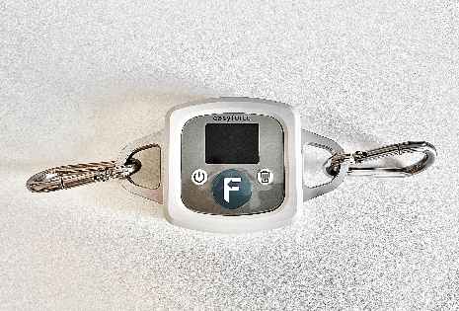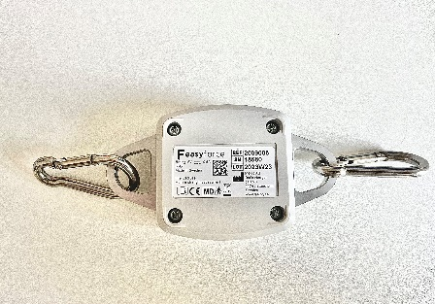

FIGURE 2 - Isometric shoulder external rotation force testing.

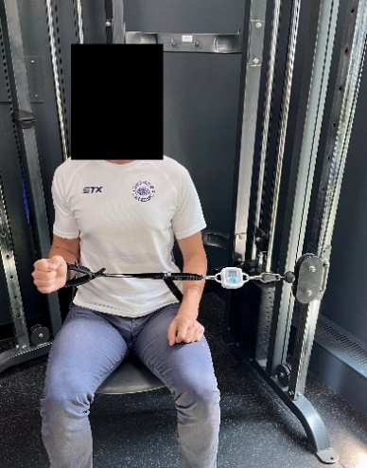

FIGURE 3a and 3b – Isometric shoulder abduction force testing.
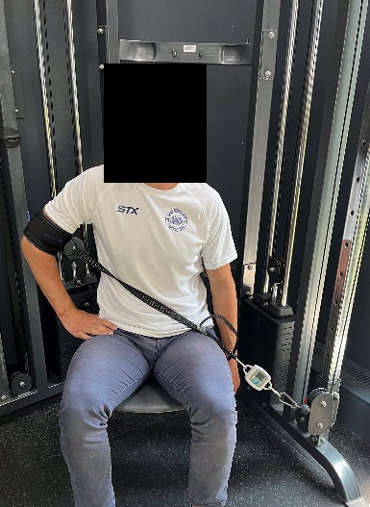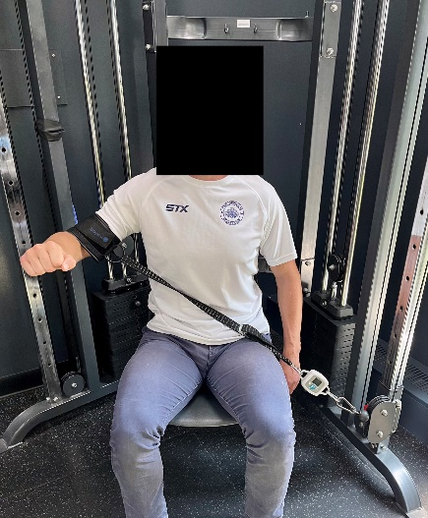

FIGURE 4. Study design. All 31 eligible participants (none excluded) were assessed by both investigators on the same day in randomised order (crossover: Investigator A first, n = 17; Investigator B first, n = 14). Each session comprised external rotation and abduction of the asymptomatic and symptomatic sides, with three maximal pain-free repetitions per condition. The three within-session repetitions provided the intra-rater reliability, and the comparison between investigators provided the inter-rater reliability.

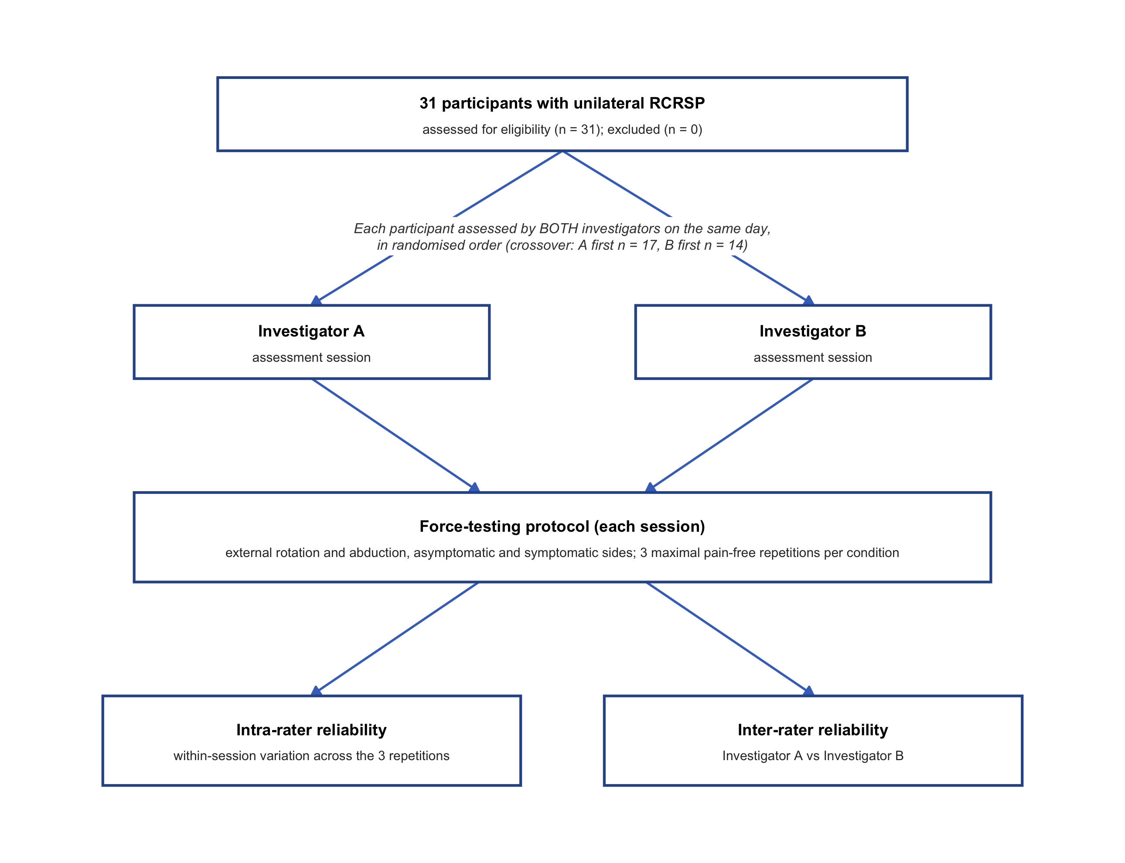

FIGURE 5. Forest plot of intraclass correlation coefficients (ICC(A,1), two-way absolute agreement, single measures) with 95% confidence intervals for intra-rater (Investigators A and B) and inter-rater reliability. Dashed lines mark the good (0.75) and excellent (0.90) thresholds; shaded bands separate the three reliability groups.
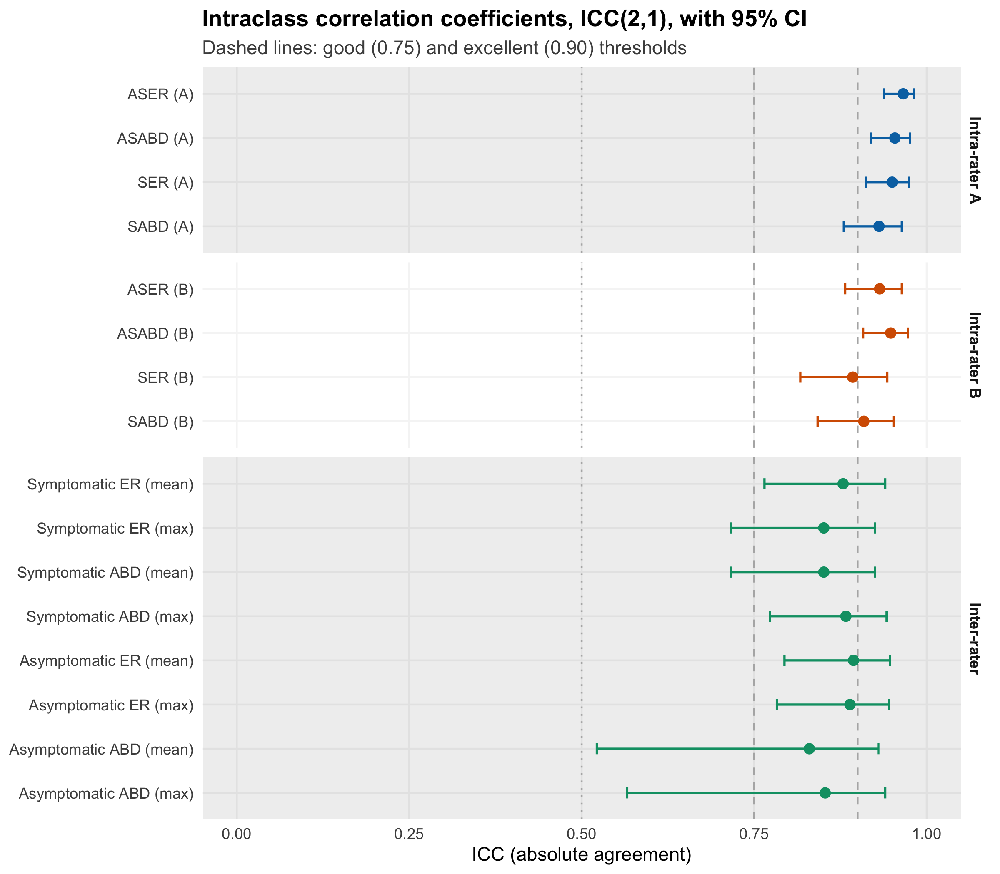
Abbreviations: ASER = Asymptomatic-side External Rotation, ASABD = Asymptomatic-side Abduction, SER = Symptomatic-side External Rotation, SABD = Symptomatic-side Abduction, A = Investigator A, B = Investigator B, LoA = Limits of Agreement, N = Newtons of force, ICC = intraclass correlation coefficient; CI = confidence interval; the dashed lines mark the good (0.75) and excellent (0.90) reliability thresholds.

FIGURE 6.
Bland–Altman plots of absolute agreement at three reliability levels (intra-rater A, intra-rater B and inter-rater), with one row per movement. In the intra-rater panels each point is a repetition minus the participant's mean (within-session variation); in the inter-rater panels each point is the difference between Investigators A and B. Orange dashed lines mark the 95% limits of the differences plotted (mean ± 1.96 SD): Bland–Altman LoA in the inter-rater panels, and limits of within-session dispersion about each participant's own mean in the intra-rater panels, which are not agreement between two measurements. The y-axis is shared within each movement so the width of the limits can be compared across levels.
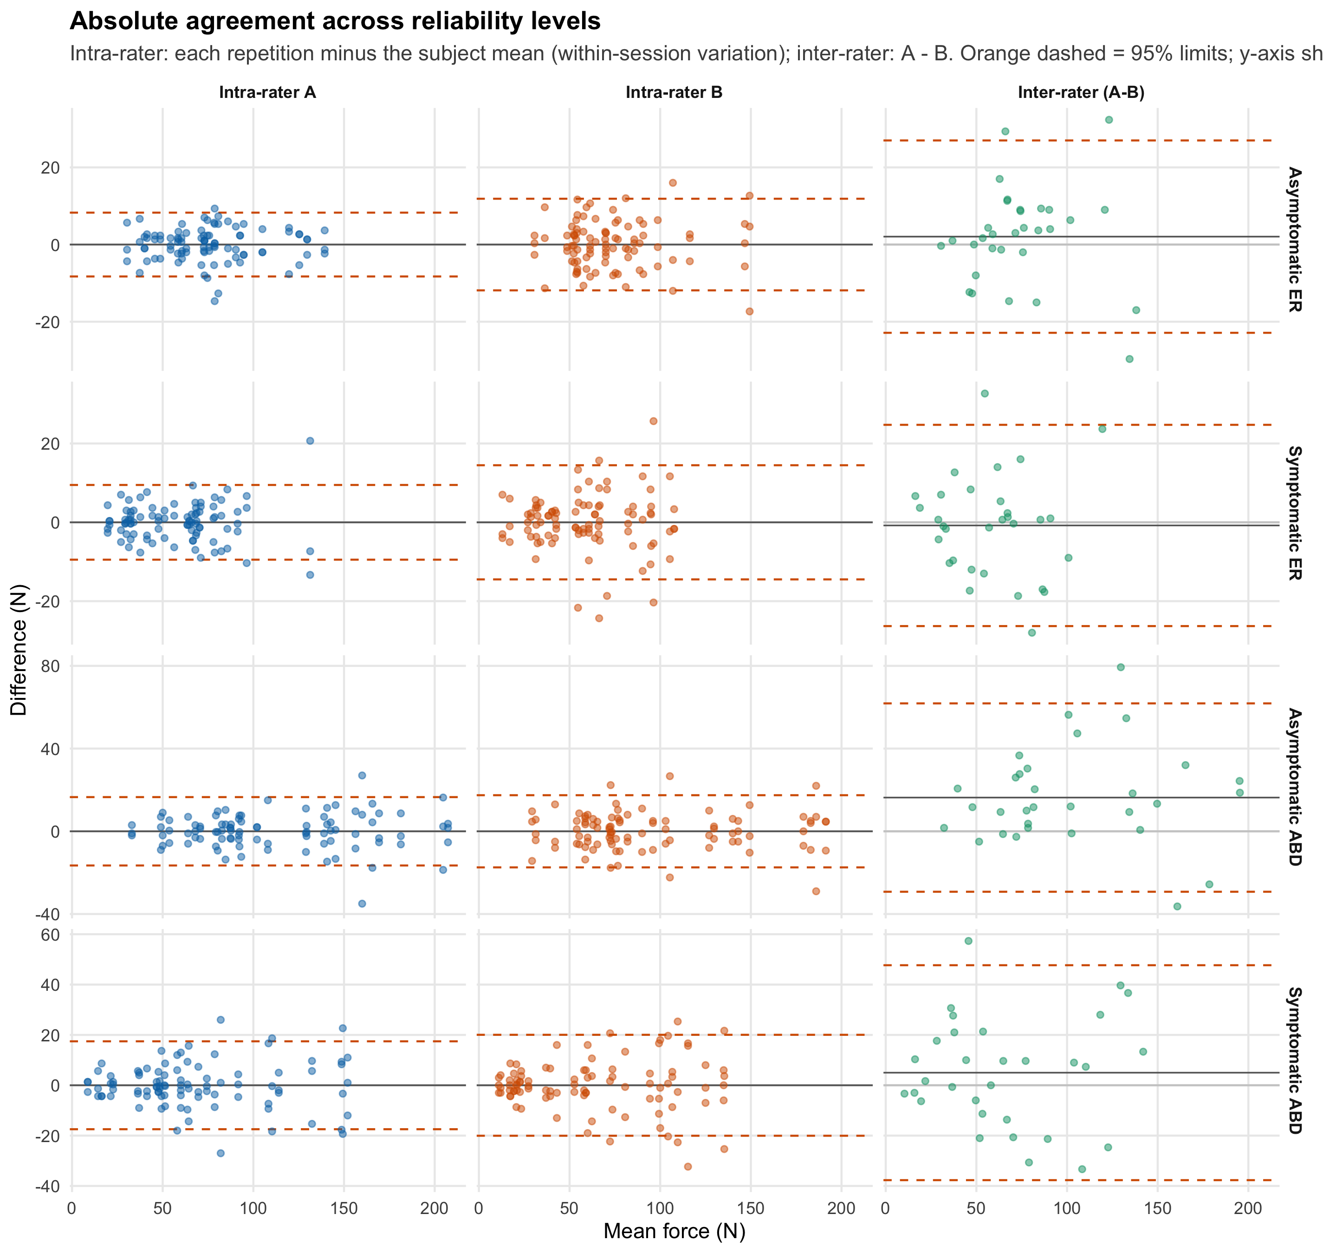
Abbreviations: ER = external rotation; ABD = abduction; the asymptomatic and symptomatic sides are the unaffected and affected shoulders, respectively; A = Investigator A; B = Investigator B; LoA = limits of agreement; N = Newtons.

FIGURE 7. Pearson correlations with SPADI (95% confidence intervals) for the relative pain-free force indices (Investigators A and B) and the psychosocial measures. Most force-index confidence intervals included zero; the Investigator A external-rotation mean and maximal indices did not, and neither did any of the psychosocial measures. n = 31 for every comparison.
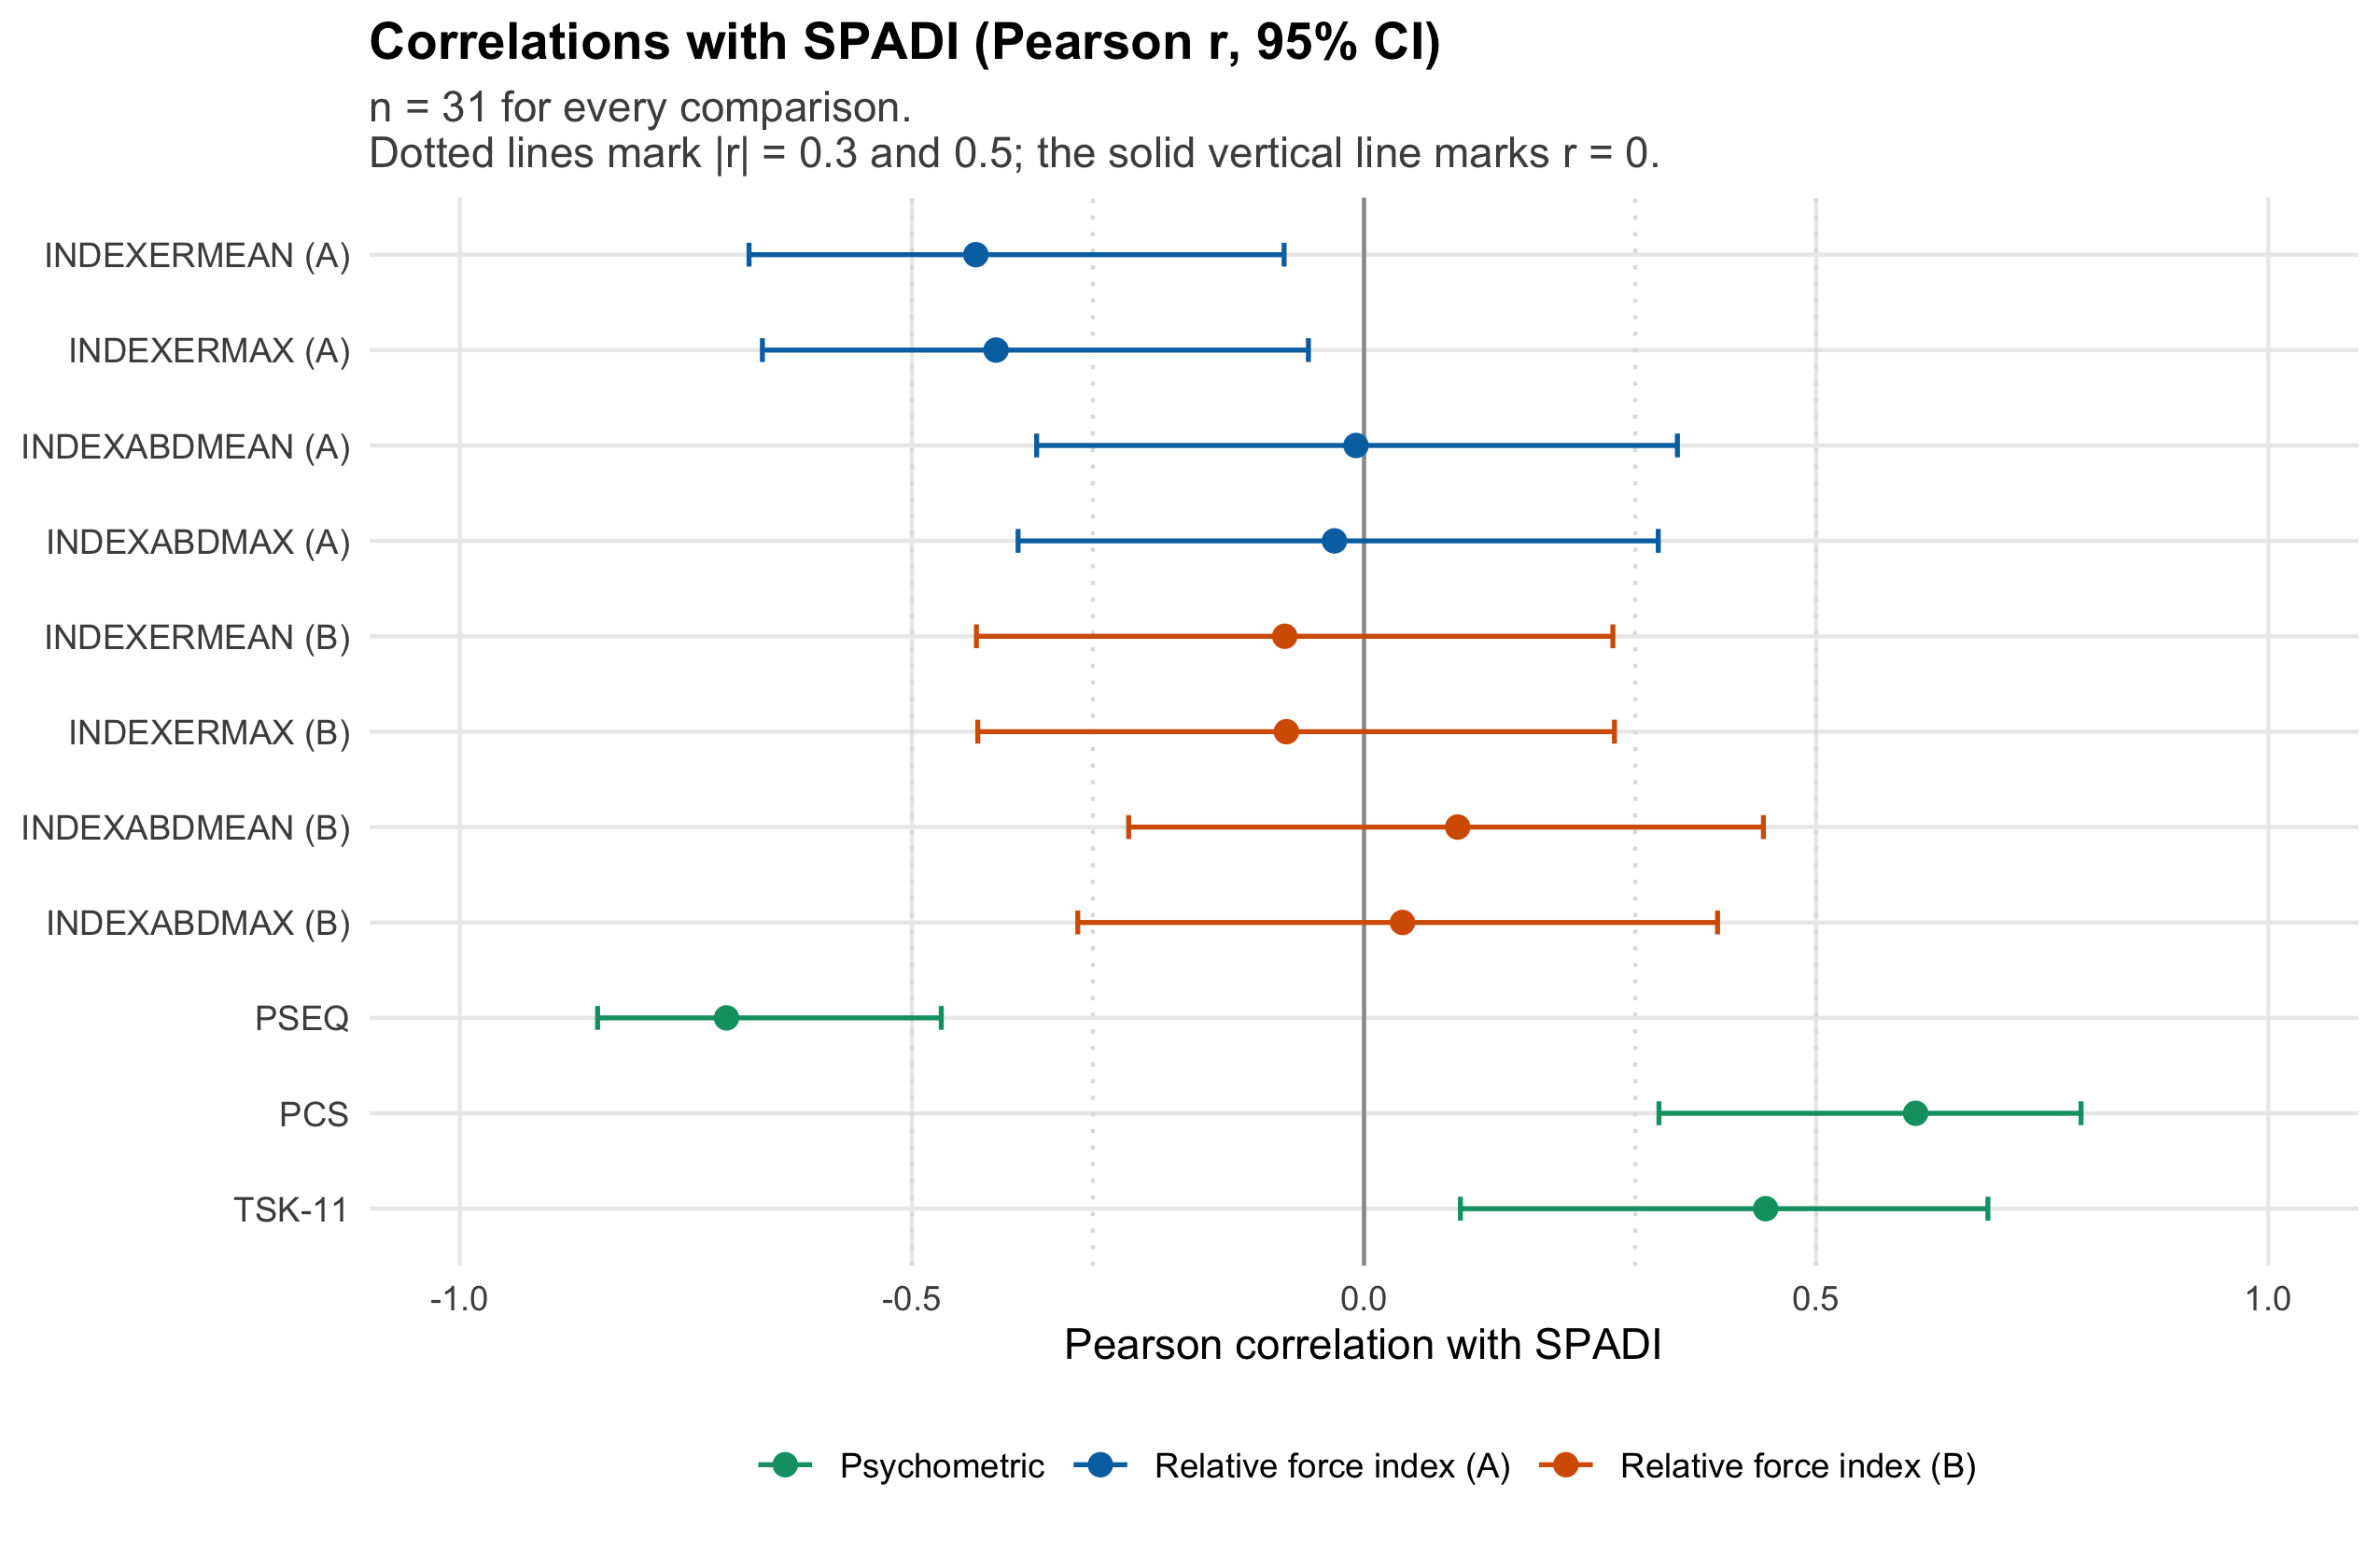
Abbreviations: INDEXERMEAN A/B = relative pain-free external rotation force index (mean) for Investigator A/B, INDEXERMAX A/B = relative pain-free external rotation force index (maximal) for Investigator A/B, INDEXABDMEAN A/B = relative pain-free abduction force index (mean) for Investigator A/B, INDEXABDMAX A/B = relative pain-free abduction force index (maximal) for Investigator A/B; higher values indicate more force on the symptomatic side relative to the asymptomatic side. PSEQ = Pain Self-Efficacy Questionnaire, PCS = Pain Catastrophising Scale, TSK-11 = Tampa Scale for Kinesiophobia (11-item); the dotted lines mark correlations of |r| = 0.30 and |r| = 0.50.

Supplementary material
The Shoulder Strength Testing Out of Pain (SSTOP) Study
Supplementary Figure S1
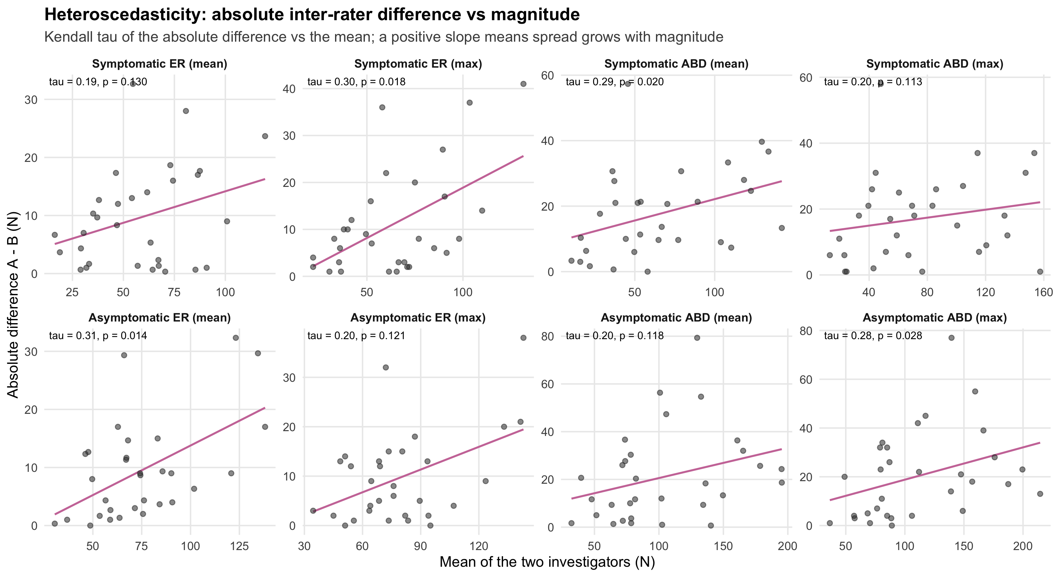
Supplementary Figure S1. Heteroscedasticity of the inter-rater differences. For each measure, the absolute inter-rater difference (|A − B|) is plotted against the mean of the two investigators; each panel is annotated with Kendall's tau and its p-value. A positive slope indicates that the spread of differences increases with magnitude. Heteroscedasticity was statistically significant (p < 0.05) in four of the eight measures: symptomatic external rotation (maximal), symptomatic abduction (mean), asymptomatic external rotation (mean) and asymptomatic abduction (maximal).

Supplementary Figure S2
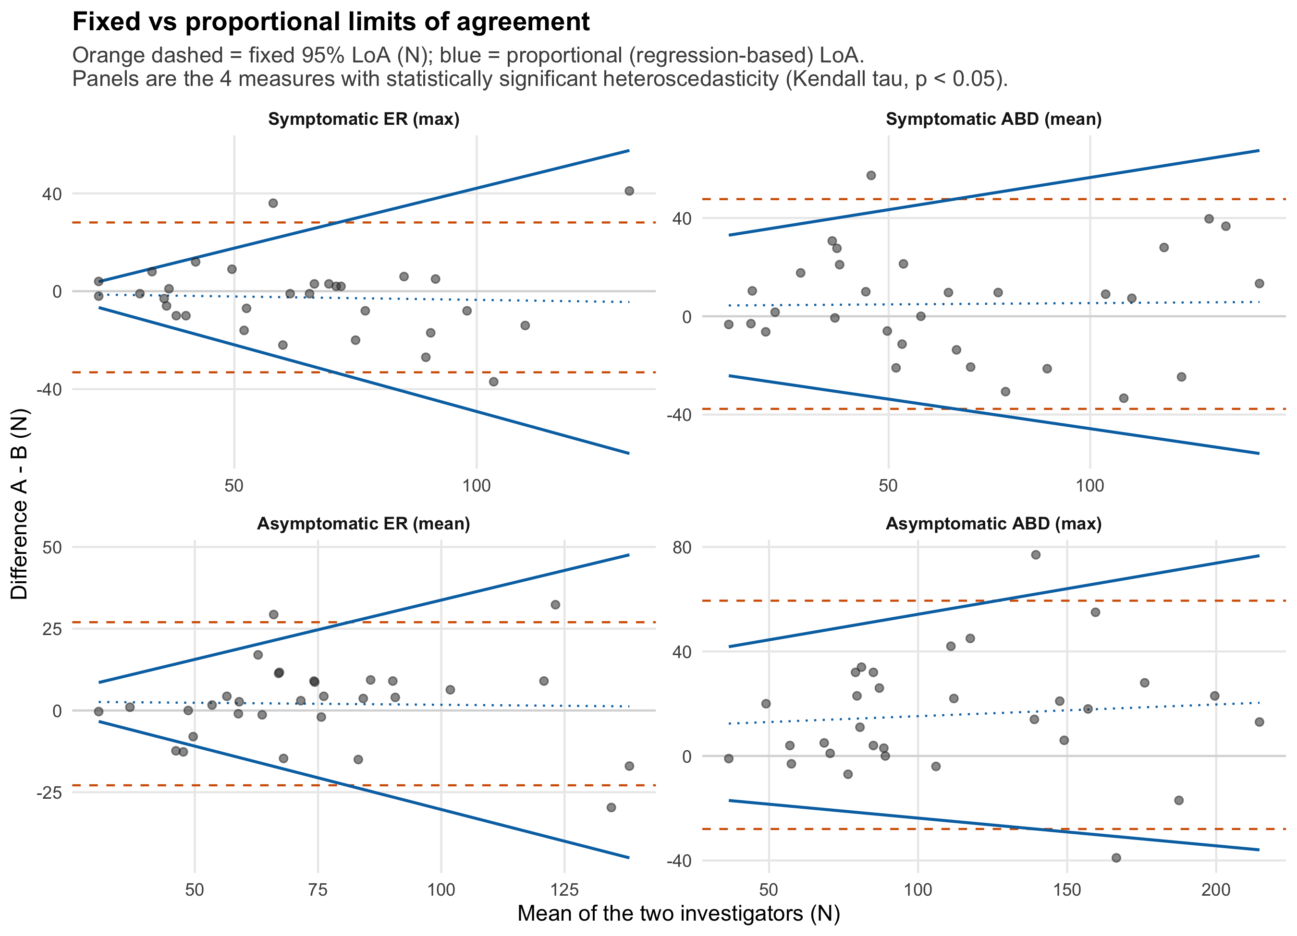
Supplementary Figure S2. Fixed versus proportional limits of agreement for the four measures with statistically significant heteroscedasticity (Kendall's tau, p < 0.05; Supplementary Figure S1): symptomatic external rotation (maximal), symptomatic abduction (mean), asymptomatic external rotation (mean) and asymptomatic abduction (maximal). Orange dashed lines are the fixed (constant) 95% limits of agreement reported in the main manuscript; the blue lines are the proportional (regression-based) limits of agreement, which widen with magnitude.

