UNIVERSITY OF CHICHESTER
5th COACHING SYMPOSIUM
THURSDAY 28th MAY 2026, CLOISTERS, BISHOP OTTER CAMPUS, UNIVERSITY OF CHICHESTER

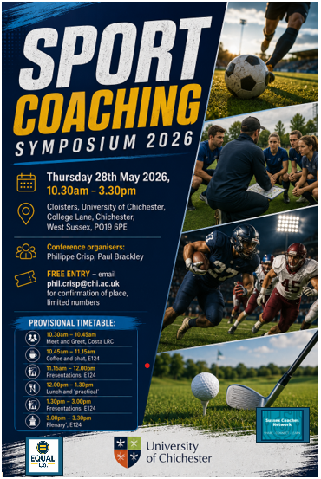

[Date]
Editor: PhilIPPE Crisp
University of Chichester
Institute of Sport
conference proceedings

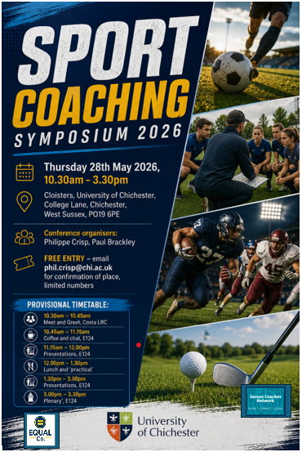

Sports coaching is increasingly understood as a multifaceted and interdisciplinary area of practice, shaped by insights from a variety of academic and professional disciplines. This breadth is evident across numerous coaching settings, including elite performance sport, grassroots and community programmes, and educational environments.
This publication contains the proceedings from the fourth Coaching Symposium, following earlier symposiums hosted in 2019, 2023,, 2024, and 2025. The proceedings from the first symposium, held in 2019, can be accessed through the University of Chichester repository at https://eprints.chi.ac.uk/id/eprint/4840/. Collectively, the symposium series is designed to foster debate, critical reflection, and research-informed discussion within the field of sports coaching, while also strengthening collaboration between coaching practitioners and academic researchers.

University of Chichester Coaching Hub FIFTH Coaching Symposium
Thursday 28th May, 2026, Cloisters, Bishop Otter Campus, University of Chichester

Title: Welcome, ‘headspace’, challenges…
Abstract: This presentation, explores emerging and reflective themes within coaching research and practice, centred “headspace,” “challenges,” and “guidelines.” It introduces a series of practitioner and research-led discussions focused on contemporary issues in sport coaching, and emphasises the importance of supportive, collegiate environments that encourage clarity, reflection, shared learning, and the navigation of practical coaching challenges.

Title: Map of interconnected ideas/concepts - VALORISATION AND COACH EDUCATION?
Abstract: - This presentation outlines a PhD by Publication exploring community sport coaching through a series of qualitative studies. The research argues that coaching is a deeply human, purpose-driven practice shaped by relationships, empathy, meaning, and social contribution, while highlighting implications for coach education and community sport practice.

Key references:
Crisp, P. (2018). Sports coach mentoring – Impacts on the mentors, not the ‘mentees’: A case study of the Active Sussex Coach Support Officers Scheme. The Sport Journal. http://thesportjournal.org/article/sports-coach-mentoring/
Crisp, P. (2018). Coaching placements and incidental learning – How reflection and experiential learning can help bridge the industry skills gap. Journal of Learning Development in Higher Education, 13, 1–28. http://journal.aldinhe.ac.uk/index.php/jldhe/article/view/442
Crisp, P. (2019). Sports coaching and youth sports: A case study on how good practice in Sport England funded projects can be monitored. Journal of Sports and Games, 1(1), 15–24. https://doi.org/10.22259/2642-8466.0101003
Crisp, P. (2019). Developing expertise in sport coaching through engagement with disability programmes. Acta Facultatis Educationis Physicae Universitatis Comenianae, 59(1), 21–32. https://doi.org/10.2478/afepuc-2019-0003
Crisp, P. (2019). Deep learning and self-sufficiency – Rediscovering the joy of learning through doing: A case study of an HE disability-sport programme. Choregia: Sport Management International Journal, 15(1), 1–15. https://eprints.chi.ac.uk/id/eprint/4829/
Crisp, P. (2019). Youth sport coaching and the importance of maintaining participation: Why evidence must underpin notions of performance, talent, and development. Archives of Sports Medicine, 3(2), 162–165. https://doi.org/10.36959/987/244
Crisp, P. (2019). Inclusion and SEN coaching: How accelerated learning and ‘workplace’ immersion can help develop core sport coaching skills. Support for Learning, 34(3), 326–329. https://doi.org/10.1111/1467-9604.12260
Crisp, P. (2019). Sidestepping talent ID models: Avoiding early specialisation, maintaining participation, and focusing on the participant as an athlete. Journal of Sports and Games, 1(4), 16–21. https://doi.org/10.22259/2642-8466.0104004
Crisp, P. (2020). Leadership, empowerment and coaching: How community sport coaches in the UK can effect behavioural change in disadvantaged youth through incrementally given roles of responsibility. International Journal of Sport Policy and Politics, 12(2), 221–236. https://doi.org/10.1080/19406940.2020.1725095
Crisp, P. (2020). Leadership, bridging, and group-game engineering: Guidelines for community sport coaches. International Sport Coaching Journal, 7(2), 229–238. https://doi.org/10.1123/iscj.2020-0005
Crisp, P. (2020). Real-world coaching: Student reflections on work-based placements and being in the ‘flow’. Research in Post-Compulsory Education, 25(3), 1–18. https://doi.org/10.1080/13596748.2020.1802943
Crisp, P. (2020). Building capacity of community sport coaches: An emotional intelligence approach to practice and delivery. Journal of Sport and Games, 2(3), 14–18. https://doi.org/10.22259/2642-8466.0203003
Crisp, P. (2020). Toward a multidimensional framework of expertise and professionalism in sport coaching: The case for adding reflexivity to reflective practice. Journal of Sport and Games, 2(3), 28–33. https://doi.org/10.22259/2642-8466.0203005
Crisp, P. (2021). Experience, competence, and developing practitioner skills – A personal reflection on how an on-site community engagement programme benefits HE sport coaching students. Innovative Practice in Higher Education, 4(2), 283–296. https://eprints.chi.ac.uk/id/eprint/5595/1/213-873-1-PB.pdf
Crisp, P. (2021). The effectiveness of sport within social intervention projects: A UK case study. Physical Culture and Sport. Studies and Research, 89, 55–65. https://doi.org/10.2478/pcssr-2021-0006.
Crisp, P. (2021). Autonomy, pro-social behaviour, and working to the future: How coaches in the community can model “next” practice for their participants. Managing Sport and Leisure, 26(5), 362–376. https://doi.org/10.1080/23750472.2020.1829988
Crisp, P. (2021). Community engagement, extending higher education student learning and raising aspirations of primary school children: Initial reflections. Widening Participation and Lifelong Learning, 23(1), 168–177. https://doi.org/10.5456/WPLL.23.1.169
Crisp, P., & Sims, J. (2021). Public health concerns and increased risk of severe COVID-19 disease through androgen use. Current Opinion in Endocrinology, Diabetes and Obesity. Advance online publication. https://doi.org/10.1097/MED.0000000000000674
Hamblin, M., & Crisp, P. (2022). Negative focus, self-doubt, and issues of ‘tool proficiency’: Beginner-coaches’ reflections on reflective practice. Physical Culture and Sport. Studies and Research, 95, 1–13. https://doi.org/10.2478/pcssr-2022-0007
Crisp, P., & Statham, A. (2022). Participation and youth sport coaching good practice – An overview and reflection of the Active Sussex Coach Support Officers Scheme. Acta Facultatis Educationis Physicae Universitatis Comenianae, 62(2), 213–233. https://doi.org/10.2478/afepuc-2022-0019
Crisp, P., & Brackley, P. (2023). A Premier League Football in the Community Program’s “New” Coaches and Support Systems: Practitioner Reflections. International Sport Coaching Journal, 10(1), 126-136. https://doi.org/10.1123/iscj.2021-0067
Crisp, P. (2023). Industry experience and supporting part-time academic professionals: professional sport and academic development parallels. International Journal for Academic Development. https://doi.org/10.1080/1360144X.2022.2
Crisp, P. & Hamblin, M. (2023). Beginner-Coaches and Connectivity of Knowledge: Real-World Coaching and Self-Reported Importance of Prior Playing Experience. Physical Culture and Sport. Studies and Research, 95: 1–15, https://doi.org/10.2478/pcssr-2023-0020
Huddleston, A., Crisp, P., and Bright, D. (2024). Burn out, coaching philosophy, and why the end does not justify unethical means – here’s why sport coaches should follow a deontological ethical approach. Journal of Emerging Sport Studies, 10. Available at: https://journals.library.brocku.ca/index.php/jess/article/view/4545/3281
Huddleston, A., Crisp, P., and Bright, D. (2024). Burn out, coaching philosophy, and why the end does not justify unethical means – here’s why sport coaches should follow a deontological ethical approach. Journal of Emerging Sport Studies, 10. Available at: https://journals.library.brocku.ca/index.php/jess/article/view/4545/3281
Crisp, P. (2024). Relationships, stability, and authenticity: How being yourself is ‘the’ key to community sport coaching and youth work. Journal of Community & Applied Social Psychology, 34(3), e2805. https://doi.org/10.1002/casp.2805
Crisp, P. (2024). Performance Environment Parallels: How Community Sport Coaches and Youth Workers Can Model Practice to Improve Young Peoples’ Life Skills and Prosocial Behaviours. Child & Youth Services, 1–30. https://doi.org/10.1080/0145935X.2024.2417652
Crisp, P. (2025). Emotional intelligence, helping others and generativity: perspectives of community sport coaches. Leisure/Loisir, 1–29. https://doi.org/10.1080/14927713.2025.2503186
Crisp, P., & Brackley, P. (2025). Activity, Communication, Environment, Skill (ACES): A Coaching Framework for Great Youth-Sport Sessions. Strategies, 38(4), 53–56. https://doi.org/10.1080/08924562.2025.2499426
Crisp, P. (2025). Community sport coaching and youth work: relatability and effective practice in the context of austerity. World Leisure Journal, 1–27. https://doi.org/10.1080/16078055.2025.2587632
Crisp, P. (2026). The Ethos, Practice, Parallels, and Intersubjectivity of Elite and Community Sport Coaching: How Coaches Define Personal Meaning, Motivation, and Validation. Quest, 1–24. https://doi.org/10.1080/00336297.2026.2641132

