UNIVERSITY OF CHICHESTER
3rd COACHING SYMPOSIUM
THURSDAY 23RD MAY 2024, CLOISTERS, BISHOP OTTER CAMPUS, UNIVERSITY OF CHICHESTER

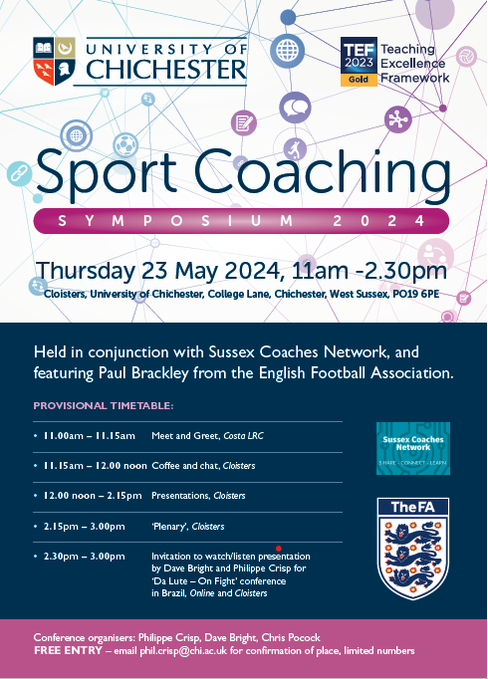

[Date]
Editor: PhilIPPE Crisp
University of Chichester
Institute of Sport
conference proceedings

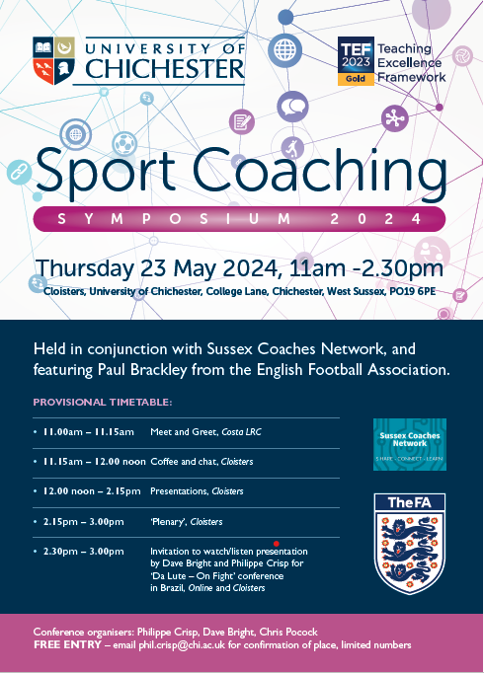

Sports coaching is increasingly acknowledged as a complex and interdisciplinary process that requires the integration of knowledge from a variety of fields. This complexity is evident across all sporting contexts, including performance, community, and school sport.
These proceedings are from the third Coaching Symposium, following previous events held in 2019 (https://eprints.chi.ac.uk/id/eprint/4840/ ) and 2023. The symposium series aims to encourage critical debate and scholarly inquiry within sports coaching, foster stronger relationships between academics and practitioners, and provide a platform for sharing applied coaching practice and research.
These proceedings contain the symposium schedule (see poster) and the keynote speaker abstract.

University of Chichester Coaching Hub second Coaching Symposium
Thursday 23rd May, 2024, Cloisters, Bishop Otter Campus, University of Chichester

Title: Coachademics’, feel, flow, authoritativeness and authenticity: why ‘fieldwork’ matters for HE coach educators…
Abstract:
This presentation explores my concept of the “coachademic” and critically reflects on the value of higher education coach educators maintaining active engagement in practical coaching environments alongside their academic roles. Framed as emerging and reflective research, the discussion considers how ongoing coaching practice may contribute to greater authenticity, credibility, and relevance within coach education programmes.
Drawing upon themes of “feel”, “flow”, authoritativeness, and authenticity, the presentation examines the potential benefits of “fieldwork” for coach educators and questions how applied coaching experiences can enhance teaching, learning, and student engagement within higher education settings. Particular attention is given to the relationship between lived coaching experience and the ability to effectively support the development of emerging coaches through meaningful and contextually relevant pedagogy.
The session is intended as a platform for discussion and critical reflection, inviting attendees to consider the role of practitioner identity within coach education and to share thoughts on the opportunities and challenges associated with balancing academic and applied coaching practice.

Key references:

Crisp, P. (2018). Sports coach mentoring – Impacts on the mentors, not the ‘mentees’: A case study of the Active Sussex Coach Support Officers Scheme. The Sport Journal. http://thesportjournal.org/article/sports-coach-mentoring/
Crisp, P. (2018). Coaching placements and incidental learning – How reflection and experiential learning can help bridge the industry skills gap. Journal of Learning Development in Higher Education, 13, 1–28. http://journal.aldinhe.ac.uk/index.php/jldhe/article/view/442
Crisp, P. (2019). Sports coaching and youth sports: A case study on how good practice in Sport England funded projects can be monitored. Journal of Sports and Games, 1(1), 15–24. https://doi.org/10.22259/2642-8466.0101003
Crisp, P. (2019). Developing expertise in sport coaching through engagement with disability programmes. Acta Facultatis Educationis Physicae Universitatis Comenianae, 59(1), 21–32. https://doi.org/10.2478/afepuc-2019-0003
Crisp, P. (2019). Deep learning and self-sufficiency – Rediscovering the joy of learning through doing: A case study of an HE disability-sport programme. Choregia: Sport Management International Journal, 15(1), 1–15. https://eprints.chi.ac.uk/id/eprint/4829/
Crisp, P. (2019). Youth sport coaching and the importance of maintaining participation: Why evidence must underpin notions of performance, talent, and development. Archives of Sports Medicine, 3(2), 162–165. https://doi.org/10.36959/987/244
Crisp, P. (2019). Inclusion and SEN coaching: How accelerated learning and ‘workplace’ immersion can help develop core sport coaching skills. Support for Learning, 34(3), 326–329. https://doi.org/10.1111/1467-9604.12260
Crisp, P. (2019). Sidestepping talent ID models: Avoiding early specialisation, maintaining participation, and focusing on the participant as an athlete. Journal of Sports and Games, 1(4), 16–21. https://doi.org/10.22259/2642-8466.0104004
Crisp, P. (2020). Leadership, empowerment and coaching: How community sport coaches in the UK can effect behavioural change in disadvantaged youth through incrementally given roles of responsibility. International Journal of Sport Policy and Politics, 12(2), 221–236. https://doi.org/10.1080/19406940.2020.1725095
Crisp, P. (2020). Leadership, bridging, and group-game engineering: Guidelines for community sport coaches. International Sport Coaching Journal, 7(2), 229–238. https://doi.org/10.1123/iscj.2020-0005
Crisp, P. (2020). Real-world coaching: Student reflections on work-based placements and being in the ‘flow’. Research in Post-Compulsory Education, 25(3), 1–18. https://doi.org/10.1080/13596748.2020.1802943
Crisp, P. (2020). Building capacity of community sport coaches: An emotional intelligence approach to practice and delivery. Journal of Sport and Games, 2(3), 14–18. https://doi.org/10.22259/2642-8466.0203003
Crisp, P. (2020). Toward a multidimensional framework of expertise and professionalism in sport coaching: The case for adding reflexivity to reflective practice. Journal of Sport and Games, 2(3), 28–33. https://doi.org/10.22259/2642-8466.0203005
Crisp, P. (2021). Experience, competence, and developing practitioner skills – A personal reflection on how an on-site community engagement programme benefits HE sport coaching students. Innovative Practice in Higher Education, 4(2), 283–296. https://eprints.chi.ac.uk/id/eprint/5595/1/213-873-1-PB.pdf
Crisp, P. (2021). The effectiveness of sport within social intervention projects: A UK case study. Physical Culture and Sport. Studies and Research, 89, 55–65. https://doi.org/10.2478/pcssr-2021-0006.
Crisp, P. (2021). Autonomy, pro-social behaviour, and working to the future: How coaches in the community can model “next” practice for their participants. Managing Sport and Leisure, 26(5), 362–376. https://doi.org/10.1080/23750472.2020.1829988
Crisp, P. (2021). Community engagement, extending higher education student learning and raising aspirations of primary school children: Initial reflections. Widening Participation and Lifelong Learning, 23(1), 168–177. https://doi.org/10.5456/WPLL.23.1.169
Crisp, P., & Sims, J. (2021). Public health concerns and increased risk of severe COVID-19 disease through androgen use. Current Opinion in Endocrinology, Diabetes and Obesity. Advance online publication. https://doi.org/10.1097/MED.0000000000000674
Hamblin, M., & Crisp, P. (2022). Negative focus, self-doubt, and issues of ‘tool proficiency’: Beginner-coaches’ reflections on reflective practice. Physical Culture and Sport. Studies and Research, 95, 1–13. https://doi.org/10.2478/pcssr-2022-0007
Crisp, P., & Statham, A. (2022). Participation and youth sport coaching good practice – An overview and reflection of the Active Sussex Coach Support Officers Scheme. Acta Facultatis Educationis Physicae Universitatis Comenianae, 62(2), 213–233. https://doi.org/10.2478/afepuc-2022-0019
Crisp, P., & Brackley, P. (2023). A Premier League Football in the Community Program’s “New” Coaches and Support Systems: Practitioner Reflections. International Sport Coaching Journal, 10(1), 126-136. https://doi.org/10.1123/iscj.2021-0067
Crisp, P. (2023). Industry experience and supporting part-time academic professionals: professional sport and academic development parallels. International Journal for Academic Development. https://doi.org/10.1080/1360144X.2022.2
Crisp, P. & Hamblin, M. (2023). Beginner-Coaches and Connectivity of Knowledge: Real-World Coaching and Self-Reported Importance of Prior Playing Experience. Physical Culture and Sport. Studies and Research, 95: 1–15, https://doi.org/10.2478/pcssr-2023-0020
Huddleston, A., Crisp, P., and Bright, D. (2024). Burn out, coaching philosophy, and why the end does not justify unethical means – here’s why sport coaches should follow a deontological ethical approach. Journal of Emerging Sport Studies, 10. Available at: https://journals.library.brocku.ca/index.php/jess/article/view/4545/3281

