UNIVERSITY OF CHICHESTER
2ND COACHING SYMPOSIUM
THURSDAY 8TH JUNE 2023, CLOISTERS, BISHOP OTTER CAMPUS, UNIVERSITY OF CHICHESTER

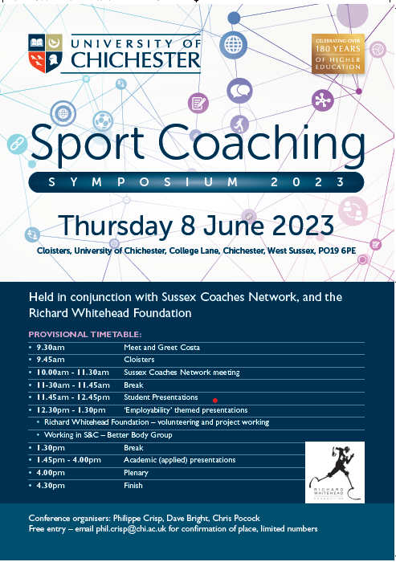

[Date]
Editor: PhilIPPE Crisp
University of Chichester
Institute of Sport
conference proceedings

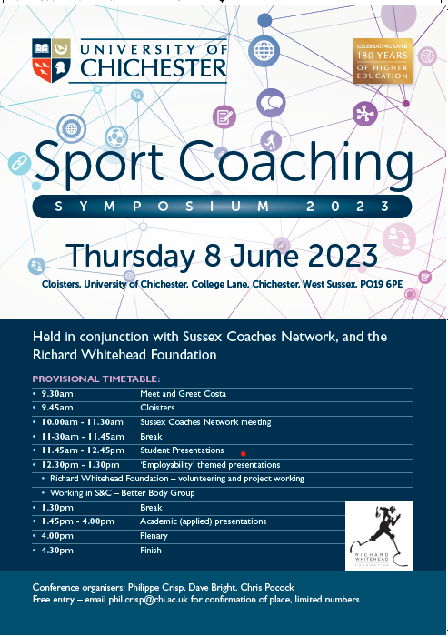

Sport coaching is widely recognised as a multifaceted process that draws upon the integration of numerous disciplines. This complexity exists across all areas of sport, including performance, community, and school-based settings.
The inaugural UCCA Coaching Hub Symposium (https://eprints.chi.ac.uk/id/eprint/4840/ ) was held on 19 June 2019 at the University of Chichester, and this second symposium was held on 8th June 2023. The event sought to continue to promote critical discussion and inquiry within the field of sports coaching, strengthen connections between practitioners and academics, and provide a platform for the dissemination of applied coaching practice and research. In particular, this event sought to highlight employability matters for emerging sport coaches through showcasing a range of case studies and opportunities.
These proceedings include the symposium schedule, and the key speaker abstract.

Schedule
- 9.30 meet and greet Costa
- 9.45 – Cloisters
- 10.00 - 10.30 keynote speech, Philippe Crisp
- 10.30 - 11.30 Sussex Coaches Network meeting
- 11-30 - 11.45 break
- 11.45 –12.45 student presentations
- 12.30 – 1.30 ‘employability’ themed presentations
- Richard Whitehead Foundation – volunteering and project working
- Working in S&C – Better Body Group
- 1.30 Break
- 1.45 – 4.00 academic (applied) presentations
- 4.00 plenary
- 4.30 finish

University of Chichester Coaching Hub second Coaching Symposium
Thursday 8th June 2023, Cloisters, Bishop Otter Campus, University of Chichester

Title: EMERGING (and ruminating/reflecting) RESEARCH - as coach educators, how can we get our beginner-coaches to (really) learn?”

Abstract:
This presentation explores emerging reflections and research into how coach educators can better support beginner coaches in developing meaningful and lasting learning. Drawing upon over 20 years of experience across coaching, youth work, coach education, and higher education, the presentation critically reflects on the challenges of bridging theory, teaching, and applied coaching practice.
Focusing on the University of Chichester coaching pathway, the discussion considers how beginner coaches engage with experiential learning across Levels 4–7 and examines the frustrations often experienced by coach educators when students fail to connect theoretical concepts with real-world coaching situations. Particular attention is given to the search for impactful learning mediators, including reflective practice, experiential opportunities, analogies, frameworks, acronyms, and other pedagogical “tricks” designed to create memorable “lightbulb moments” for novice coaches.
The presentation also introduces emerging ideas and applied research projects, including the ACES Coaching framework (Activity, Communication, Environment, Skill) and the concept of the “Golden Thread” as a means of helping student-coaches maintain clarity and focus on session aims and objectives. Overall, the session encourages critical discussion around coach learning, coach education pedagogy, and the practical strategies that may better support the development of reflective and adaptable beginner coaches

Key references:

Crisp, P. (2018). Sports coach mentoring – Impacts on the mentors, not the ‘mentees’: A case study of the Active Sussex Coach Support Officers Scheme. The Sport Journal. http://thesportjournal.org/article/sports-coach-mentoring/
Crisp, P. (2018). Coaching placements and incidental learning – How reflection and experiential learning can help bridge the industry skills gap. Journal of Learning Development in Higher Education, 13, 1–28. http://journal.aldinhe.ac.uk/index.php/jldhe/article/view/442
Crisp, P. (2019). Sports coaching and youth sports: A case study on how good practice in Sport England funded projects can be monitored. Journal of Sports and Games, 1(1), 15–24. https://doi.org/10.22259/2642-8466.0101003
Crisp, P. (2019). Developing expertise in sport coaching through engagement with disability programmes. Acta Facultatis Educationis Physicae Universitatis Comenianae, 59(1), 21–32. https://doi.org/10.2478/afepuc-2019-0003
Crisp, P. (2019). Deep learning and self-sufficiency – Rediscovering the joy of learning through doing: A case study of an HE disability-sport programme. Choregia: Sport Management International Journal, 15(1), 1–15. https://eprints.chi.ac.uk/id/eprint/4829/
Crisp, P. (2019). Youth sport coaching and the importance of maintaining participation: Why evidence must underpin notions of performance, talent, and development. Archives of Sports Medicine, 3(2), 162–165. https://doi.org/10.36959/987/244
Crisp, P. (2019). Inclusion and SEN coaching: How accelerated learning and ‘workplace’ immersion can help develop core sport coaching skills. Support for Learning, 34(3), 326–329. https://doi.org/10.1111/1467-9604.12260
Crisp, P. (2019). Sidestepping talent ID models: Avoiding early specialisation, maintaining participation, and focusing on the participant as an athlete. Journal of Sports and Games, 1(4), 16–21. https://doi.org/10.22259/2642-8466.0104004
Crisp, P. (2020). Leadership, empowerment and coaching: How community sport coaches in the UK can effect behavioural change in disadvantaged youth through incrementally given roles of responsibility. International Journal of Sport Policy and Politics, 12(2), 221–236. https://doi.org/10.1080/19406940.2020.1725095
Crisp, P. (2020). Leadership, bridging, and group-game engineering: Guidelines for community sport coaches. International Sport Coaching Journal, 7(2), 229–238. https://doi.org/10.1123/iscj.2020-0005
Crisp, P. (2020). Real-world coaching: Student reflections on work-based placements and being in the ‘flow’. Research in Post-Compulsory Education, 25(3), 1–18. https://doi.org/10.1080/13596748.2020.1802943
Crisp, P. (2020). Building capacity of community sport coaches: An emotional intelligence approach to practice and delivery. Journal of Sport and Games, 2(3), 14–18. https://doi.org/10.22259/2642-8466.0203003
Crisp, P. (2020). Toward a multidimensional framework of expertise and professionalism in sport coaching: The case for adding reflexivity to reflective practice. Journal of Sport and Games, 2(3), 28–33. https://doi.org/10.22259/2642-8466.0203005
Crisp, P. (2021). Experience, competence, and developing practitioner skills – A personal reflection on how an on-site community engagement programme benefits HE sport coaching students. Innovative Practice in Higher Education, 4(2), 283–296. https://eprints.chi.ac.uk/id/eprint/5595/1/213-873-1-PB.pdf
Crisp, P. (2021). The effectiveness of sport within social intervention projects: A UK case study. Physical Culture and Sport. Studies and Research, 89, 55–65. https://doi.org/10.2478/pcssr-2021-0006.
Crisp, P. (2021). Autonomy, pro-social behaviour, and working to the future: How coaches in the community can model “next” practice for their participants. Managing Sport and Leisure, 26(5), 362–376. https://doi.org/10.1080/23750472.2020.1829988
Crisp, P. (2021). Community engagement, extending higher education student learning and raising aspirations of primary school children: Initial reflections. Widening Participation and Lifelong Learning, 23(1), 168–177. https://doi.org/10.5456/WPLL.23.1.169
Crisp, P., & Sims, J. (2021). Public health concerns and increased risk of severe COVID-19 disease through androgen use. Current Opinion in Endocrinology, Diabetes and Obesity. Advance online publication. https://doi.org/10.1097/MED.0000000000000674
Hamblin, M., & Crisp, P. (2022). Negative focus, self-doubt, and issues of ‘tool proficiency’: Beginner-coaches’ reflections on reflective practice. Physical Culture and Sport. Studies and Research, 95, 1–13. https://doi.org/10.2478/pcssr-2022-0007
Crisp, P., & Statham, A. (2022). Participation and youth sport coaching good practice – An overview and reflection of the Active Sussex Coach Support Officers Scheme. Acta Facultatis Educationis Physicae Universitatis Comenianae, 62(2), 213–233. https://doi.org/10.2478/afepuc-2022-0019

