Main Manuscript for
Chants across seven traditions share acoustic traits that enhance subjective relaxation

Valentina Canessa-Pollard^{1,3}*, Andrey Anikin^{2,3}, David Reby^{3,4}

1 Institute of Psychology, Business and Human Sciences, University of Chichester, UK
2 Division of Cognitive Science, Lund University, Lund, Sweden
3 ENES Bioacoustics Research Laboratory, ENES/CRNL, University of Saint-Etienne, CNRS, Inserm, Saint-Etienne, France
4 Institut universitaire de France

*Email: v.canessapollard@chi.ac.uk

Author Contributions: V.C.P., A.A., and D.R. conceived and designed the studies. V.C.P. collected the acoustic data and drafted the paper. A.A. created the resynthesized and synthesised stimuli, programmed the experiments and collected the playback data. V.C.P. and A.A. conducted the acoustic and statistical analyses. V.C.P., A.A., and D.R. wrote the final manuscript, and all authors approved the final version. All authors gave final approval for publication and agreed to be held accountable for the work performed therein.

Competing Interest Statement: The authors declare no competing interests.

Classification: Psychological and Cognitive Sciences.

Keywords: chants, acoustic traits, subjective relaxation, vocal communication, experimental psychology

This PDF file includes:
Main Text
Figures 1 to 5, Figure S1, S2, S3
Tables 1

Abstract
For over 5,000 years, chanting has been practiced across many Western and Eastern traditions. However, there is hardly any empirical research on 1) whether chants from across the globe share common acoustic properties, 2) whether these acoustic features make them distinct from other human vocalizations, and 3) the extent to which they may positively impact listeners’ well-being. Here we collected 242 chants belonging to seven distinct traditions and associated with a wide range of language families, and compared them acoustically to a large corpus of song (n=126) and speech (n=616) samples from across 14 linguistic and 12 geographical regions. We show that, irrespective of language and geographical origin, chants share distinctive acoustic traits, namely relatively flat and slow-changing intonation and steady, unbroken voicing in a comfortable, rather low pitch range with a prevalence of mid-central vowels. Thus, chants are produced in a relaxed vocal tract configuration with minimal articulation. Additionally, playback experiments involving original chants (with a participant pool of 61 listeners), resynthesized chants (with 114 listeners), and fully synthetic chants (with 80 listeners) demonstrate that these acoustic characteristics enhance listeners' perceived sensations of relaxation. Specifically, relatively flat and slow-changing intonation, combined with vowel production in a relatively relaxed vocal tract configuration, resulted in higher overall relaxation ratings. Together these results hint at a specific function of chants’ acoustic commonalities: the enhancement of well-being through relaxation.

Significance statement
This research presents the first evidence that chants possess distinct acoustic characteristics compared to speech and other genres of singing. Across different cultures, chants share common characteristics such as predominantly flat and slow--changing intonation, consistent and uninterrupted voicing in a comfortably low pitch range, minimal vibrato-like inflections, and a high proportion of mid-central vowels. Furthermore, this study demonstrates the impact of these acoustic features on subjective well-being, particularly in terms of promoting relaxation, implying that the acoustic form of chants has evolved culturally to optimize listener relaxation.

Main Text
Introduction
The acoustic form of vocal signals in the animal world, including various forms of human vocal signals, tends to be aligned with the function of these signals (1, 2). As part of the human vocal repertoire, singing noticeably exhibits universal form-function relationships that transcend cultural boundaries (3). For instance, lullabies, with their slow tempos and soft dynamics, soothe infants and reinforce caregiver bonds (4) while dance songs, driven by rhythmic regularity and strong beats, promote movement and social coordination (5). Chanting is another deeply rooted vocal practice found across cultures and religions, including Tibetan Buddhism (ngak), Hinduism (mantras), Paganism (Wiccan chants), and Sufism (Dhikr) (6-9). Characterised by the rhythmic repetition of words, sounds, or phrases (10), chanting is defined as a meditative vocal practice aimed at soothing, healing, and inducing altered states of consciousness (10-12). Despite being so widespread, chanting has received surprisingly little scientific scrutiny. Crucially, it remains unknown whether chants from different traditions share specific acoustic properties, or how these might contribute to their reported effects on emotional regulation and well-being. Here, to fill this gap and identify the acoustic signature of chanting, we first compared the acoustics of chants from seven major traditions with that of speech modes and singing genres. Then, to investigate the function of these acoustic features, we conducted three perceptual experiments to test their effect on subjective well-being.
One of the prominent social functions of chanting is to promote self-healing. Correspondingly, clinical research indicates that chanting reduces stress and enhances positive affect for various populations, including HIV patients (e.g., “Om Mani Padme Hum” from Buddhism, “Rama, Rama” from Hinduism, Lord have mercy from Christianity, “Shalom” from Judaism, “Allah” from Islam, and “O Wakan Tanka” from Native American spiritual traditions (4)), elderly individuals with hypertension (“OM” chant (13)), and those suffering from depression and anxiety (“OM” chant (13,14)). Non-clinical populations, including practitioners of Transcendental Meditation (15) and “OM” chanting (16), have also reported enhanced well-being through chanting practices. Physiological studies further support these findings. Chanting has been associated with improved respiratory function (e.g., “OM” chanting (17), “Ave Maria” rosary repetitions (18)), while neuroimaging research suggests that specific chants (e.g., “OM” and “Amitabha” mantras (19-21)) can induce mental calmness, enhance emotional balance, deactivate stress-related brain regions (e.g., amygdala), and increase activity in areas associated with emotion regulation (e.g., dorsal medial frontal cortex) and attentional control (e.g., dorsal attentional network).
While these findings indicate that chanting has measurable psychological and physiological effects, it remains unclear whether these effects are driven by shared acoustic properties. Music psychology research has traditionally focused on how melody, harmony, and rhythm shape cognition, including enhancements in memory, attention, and neuroplasticity (22). Additionally, engaging with music has been associated with improved well-being, reduced depression and anxiety symptoms, and enhanced quality of life (23). Studies link music listening to emotional well-being through mechanisms such as rhythmic entrainment, evaluative conditioning, changes in physiological arousal, and contagion (23, 24). Additionally, neuroimaging research suggests that music processing involves multiple brain areas, including the limbic system and prefrontal cortex, underscoring its role in emotion regulation and cognitive enhancement (22). Preliminary acoustic studies (25,26) indicate that chanting may exhibit systematic structural characteristics, such as slow tempo, across diverse traditions, including Eastern (OM chanting) and Western (Gregorian chanting) practices. Low-pitched, slow, and steady vocalizations are typically associated with relaxation and parasympathetic nervous system activation, while vocalizations with high and variable pitch signal urgency or arousal due to their connection with heightened autonomic activity (24). If chanting aligns with these established acoustic-arousal mappings, it may have evolved as a vocal behaviour that facilitates stress reduction and emotional stability. Despite these insights, research on chanting remains sparse, primarily focusing on a narrow range of chants and a limited set of acoustic characteristics (e.g., see 25-27) overlooking a more comprehensive analysis of how multiple parameters contribute to its effects on listeners. Beyond its psychological effects, chanting’s acoustic structure may explain its enduring role in collective rituals, meditation, and transcendental experiences across cultures (10).
This gap calls for a systematic investigation into chanting as a regulatory vocal behavior. By examining its acoustic and psychological mechanisms, this research contributes to understanding its cross-cultural persistence, psychological impact, and broader theoretical significance within evolutionary psychology, music psychology, and cultural studies. Moreover, chanting holds practical value as a simple, cost-effective tool for emotional regulation. Unlike pharmacological or technology-based interventions, it requires no specialized equipment or training, making it accessible across diverse populations and settings.
Research Objectives. The present study integrates comprehensive acoustic analyses of chants with playback studies of re-synthesized and synthesized chants from a diverse range of traditions. The term “tradition” here encompasses both structured and loosely defined systems, serving as a broad classification for different chant categories rather than a strictly religious or institutional definition. Specifically, this study aims to: (1) test the hypothesis that chants from different cultural and religious traditions across the globe share acoustic characteristics, distinguishing chanting from other forms of human verbal vocalizations, such as speech and singing (Study 1); (2) assess the influence that chanting has on listeners’ self-reported well-being, compared to listening to songs or speech (Study 2); (3) explore the acoustic features by which chants may impact listeners’ affective well-being (Studies 3 and 4).

Results
Is chanting acoustically different from other human verbal vocalizations, such as speech and singing?
In Study 1, we conducted acoustic analyses of chants from seven traditions across the world (Fig. 1) obtained from our own recordings of individuals with chanting experience or from published recordings, focusing on pitch-related, formant-related and temporal features. We compared these acoustic features with values from our acoustic analyses of a large corpus of song and speech samples from across 14 linguistic and 12 geographical regions (28) (Details of recordings are in Table S1,dataset: https://osf.io/ajqvr).
Differences in pitch-related features. We tested whether chants (N = 242) across seven traditions share pitch-related characteristics that differentiate them from singing (N = 153) and speech (N = 615). A Random Forest classifier using 15 pitch descriptives (see Materials and Methods) correctly distinguished chanting from speech and singing 91% of the time (chance level = 33%). Notably, classification accuracy was highest for speech (96%) and chanting (88%), whereas singing was less distinct (78% correct). To reduce our set of 15 correlated acoustic variables to a smaller number of uncorrelated dimensions, we performed a principal component analysis (PCA) by speaker sex with varimax rotation on all aforementioned acoustic variables (see Fig. S1). Components with Eigenvalues greater than 1 were retained. The PCA identified two latent dimensions which accounted for the majority of the total variance. The first dimension (Dim1) contributed to 30.9% (for males) and 28.9% (for females) of the variance, and was characterized primarily by overall pitch (max, mean, start and end). The second dimension (Dim2) contributed in additional 22.4% (for males) and 23% (for females) to the overall variance and was characterised primarily by pitch modulation (mean absolute slope, SD, range and maximum absolute slope). Chants exhibited lower values in the first dimension (overall pitch measures). Additionally, they generally displayed lower values in the second dimension, except in males for the mean absolute slope, which was higher for singing compared to chanting. The PCA results confirm that chants possess a distinct intonation profile when compared to singing and speech.
To further nuance this finding, we ran a multivariate mixed model (see Materials and Methods) to identify the key acoustic differences in all 15 pitch-related features among the three categories (Fig. 2a), while controlling for the language of origin, geographical location, and sex. The model revealed that the absolute slope – or rate of pitch change regardless of its direction – was dramatically lower in chanting (0.38 oct/s averaging across males and females, 95% CI [0.13, 0.61]) compared to singing (0.85 oct/s [0.61, 1.09]) and especially to speech (1.55 oct/s [1.29, 1.81]). Rapid, vibrato-like pitch inflections were also less common in chants (3.5 per second, 95% CI [2.7, 4.3]) compared to singing (5.3 [4.5, 6.1]) and speech (4.4 [3.5, 5.3]). Chanting was also slightly lower than speech and singing on most of the overall pitch measures, particularly on mean pitch (0.55 [0.04, 1.03]) octaves lower than singing and 0.39 [-0.08, 0.87] octaves lower than speech). We also specifically compared chanting to lullabies (N = 40 recordings). Even though this is a very special and potentially “chant-like” singing genre, chants had noticeably flatter intonation, with a lower absolute slope (-0.45 [-0.71, -0.19] oct/s), narrower pitch range (-0.42 [-0.64, -0.22] oct), less pronounced vibrato (-0.91 [-1.79, -0.01] rapid inflections/s), and fewer slow pitch inflections (-0.12 [-0.24, -0.01]; see Fig. S2).
Whereas chanting was found to be acoustically distinct from singing and speech, different chanting traditions were not so easy to distinguish. A supervised Random Forest model classified chanting into seven traditions with an overall out-of-sample accuracy of ~39% using 14 pitch descriptive variables. This is far below the accuracy of recognizing chanting as a single category (88%), but still better than chance level with seven response categories (100/7 = 14%). In sum, while chants from different cultural traditions do have their distinct “flavors”, chanting as a category remains highly distinct vis-a-vis both speech and singing thanks to its universal acoustic signatures such as low voice pitch and flat intonation.

Differences in F1-F2 vowel space. In order to describe the typical range of vowels found in chants, normalized formant frequencies were extracted from individual frames (N = 113,306) in the chant recordings and normalized by the speaker’s estimated vocal tract length (see Materials and Methods). The overall density of vowels and their distribution are shown in Fig. 2b. The results show that mid-central and mid-back vowels are most common in chants, clustering around “schwa” and [ʌ]. Previous research comparing the acoustic vowel spaces of speech and songs (ballads) has shown that the acoustic vowel space used in singing deviates from that which occurs in speech, resulting in a singing vowel space which is shifted towards high and back vowels due to a lowering of the first and second formants, respectively; further, the variance of formant frequencies has been reported to be lower in singing than in speech (29). We note that, overall, the effect of chanting is a general compression of the acoustic vowel space and a shift towards mid-central and mid-back vowels. These vowels are produced with a slightly open mouth, the tongue at a low position in the mouth, and generally relaxed articulators (as illustrated in Fig. 2c). Emphasis is placed on cultivating a sensation of vibration in the oral cavity, on the lips, and in the facial region, while eliminating perceived constriction or sense of “work” from the throat region.

How does listening to chants affect short-term well-being?
Results from Study 1 suggest that chants occupy a unique niche in the human vocal repertoire. As mentioned in the introduction, previous research has revealed how at least some chants appear to improve the well-being of the chanter. Little is known, however, about the effects that chants may have on listeners, or about what acoustic parameters may drive these effects. We performed three playback experiments on independent samples of a total of 255 participants who spoke English as their first language and had no self-reported hearing problems. In a first playback experiment (Study 2), we tested whether listening to chants can have short-term effects on listeners’ well-being by comparing listeners’ ratings of chants, songs and speech samples (chosen pseudo-randomly from our original corpus) on 10 affective dimensions encompassing arousal (i.e., relaxation, alertness, excitement, restlessness), pleasantness and mood states (i.e., anger, confidence, carefreeness, emotionality). Then, in two subsequent playback experiments, we explored which key acoustic cues drive chants’ ratings by modifying a subset of acoustic features in original chants (Study 3), and by varying these in synthetic chants (Study 4).

Well-being ratings of original chants versus speech and songs. In Study 2, sixty-one participants (30 females, mean age = 28, 18-40, SD = 6.9) listened to 84 excerpts of chants, songs, and speech across different musical styles and languages (28 songs, 28 speech samples, and 28 chants from Study 1), with each participant evaluating 42 excerpts (14 songs, 14 speech samples, 14 chants) and providing ratings on 10 relaxation and mood scales for each excerpt (Materials and Methods for details).
The key results of this study are summarized in Fig. 3. Listeners assigned the highest relaxation ratings when listening to chants, surpassing the ratings for both songs and speech (chants vs songs: 0.60 [0.24, 0.94], chants vs speech: 0.97 [0.58, 1.35]). In contrast, chants were rated lowest in alertness (chants vs songs: -0.70 [-0.93, -0.48]; chants vs speech: -0.62 [-0.90, -0.36]). Listeners also felt more emotional when exposed to chants compared to speech (with no significant difference observed between chants and songs) (chants vs songs: 0.18 [-0.11, 0.50]; chants vs speech: 1.26 [0.89, 1.61]). However, they reported lower levels of excitement when listening to chants in comparison to songs (with no significant contrast between chants and speech) (chants vs songs: -0.76 [-1.04, -0.48]; chants vs speech: 0.10 [-0.19, 0.38]). Songs, chants and speech samples were also rated as similarly low in anxiety, anger and restlessness. No other significant differences between speech, songs and chants were found. Overall, the results show that listening to brief excerpts of chants is sufficient to elicit feelings related to relaxation in listeners.

Relaxation and mood ratings of original chants and their manipulated versions. To explore the specific acoustic attributes contributing to the relaxing effect of chants, we undertook an additional study (Study 3) manipulating chants’ key acoustic features, as identified in Study 1. Specifically, we resynthesized 14 chants (2 per tradition, selected at random) across three values for pitch, tempo, and pitch excursion (the amount by which voice pitch varied, from flat to more strongly modulated), resulting in a total of 1,050 vocal stimuli. Subsequently, 114 participants (57 females, mean age = 36, SD = 10.4, range 18-61) individually rated 14 pseudo-randomized stimuli on 5 relaxation and mood scales used in Study 2. The results are reported in Fig. 4. The original tempo elicited the highest ratings of relaxation, emotionality, and pleasantness: chants maximally slowed down or sped up were rated as less relaxed (by 0.9 [0.5, 1.2] and by 0.9 [0.5, 1.3], respectively), less emotional (by 0.4 [0.2, 0.7] and by 0.5 [0.3, 0.8]), and less pleasant (by 1.0 [0.7, 1.3] and by 0.4 [0.1, 0.7]). Making the chants faster monotonically increased the ratings of alertness (+0.7 [0.4, 1.0] units on a scale of 1 to 5 as the tempo increased from the slowest to the fastest) and excitement (+0.3 [0.1, 0.6] from the slowest to the fastest), with the original chants being intermediate in terms of alertness and excitement ratings.
While tempo manipulations had clear perceptual effects, ratings for the pitch-manipulated versions barely differed in ratings compared to the original chants. For example, the highest pitch (+4 semitones) was perceived as marginally (0.3 points, 95% CI [0.0, 0.5]) more emotional than the lowest one (-4 semitones). Finally, manipulating pitch excursion from the original level to either flat (excursion = 0) or emphasized intonation contour (excursion = original * 1.4) made the chants sound slightly less emotional (by 0.3 [0.1, 0.6] and by 0.2 [0.0, 0.4], respectively), less pleasant (by 0.5 [0.2, 0.7] and by 0.3 [0.1, 0.5]) and less relaxed (by 0.5 [0.3, 0.8] and by 0.2 [0.0, 0.4]), but they had no detectable effect on the ratings of alertness (0.1 [-0.1, 0.2] and 0.1 [-0.1, 0.3]) and excitement (0.0 [-0.2, 0.2] and 0.1 [-0.1, 0.2]). In summary, the manipulation of tempo influenced the perceived relaxation, emotionality, and pleasantness of chants, with the original (slow) tempo yielding the highest ratings, while pitch and pitch excursion manipulations had minimal effects on the ratings.

Relaxation and mood ratings of synthesized chants. To eliminate potential language-related influences on ratings and test a broader range of acoustic parameters, we conducted a further playback experiment (Study 4) with chants that were created “de novo”, each consisting of one of 5 synthesized vowels ([a], [e], [i], [o], [u]). The synthesis included additional parameters i.e., pitch change direction and vibrato, as well as pitch excursion, average pitch, and tempo, resulting in 195 fully synthetic vocal stimuli (13 manipulations x 15 prototypes), which were then rated by 80 listeners (55 females, mean age = 25, SD = 11.4, range 18-63) on the same scales used in Study 3.
As shown in Fig. 5, synthesizing chants with either no vibrato at all or with exaggerated vibrato (0.5 semitones) decreased perceived pleasantness (-0.3 [-0.4, -0.1] and -0.2 [-0.3, 0.0], respectively) and relaxation (-0.3 [-0.5, -0.1] and -0.3 [-0.5, -0.1], respectively) compared to the baseline vibrato level of 0.15 semitones. Chants with no vibrato were also rated as more alert and excited (both by +0.3 [0.1, 0.5] points compared to baseline). Hence, the presence of slight, relaxed vibrato in chants further enhances their soothing effect.
Comparing our 5 vowels, [u] and [o] were rated as more pleasant (by 0.5 [0.4, 0.6] and 0.3 [0.2, 0.5] points, respectively) and relaxed (0.6 [0.4, 0.8] and 0.4 [0.2, 0.6]), compared to the average across the other three vowels ([aei]).
For tempo and pitch, results from the synthetic chants largely confirmed the results from the previous playback experiment with natural chants and their resynthesized versions. Once again, a relaxed tempo of 60 bpm (perceptually close to the typical tempo of many original chants) was the “sweet spot” producing the highest ratings of pleasantness and relaxation, while chants synthesized at either slow (bpm = 27) or fast (bpm = 135) tempi were rated as less pleasant (by 0.4 [0.3, 0.6] and 0.1 [0.0, 0.2], respectively) and less relaxed (by 0.5 [0.3, 0.7] and 0.5 [0.3, 0.7]). Interestingly, while the ratings of alertness and excitement increased monotonically with tempo in manipulated natural chants (Study 2 above), in synthetic chants the ratings of alertness and excitement were lowest at 60 bpm and increased both at faster (135 bpm: alert +0.7 [0.5, 0.9], excited +0.3 [0.2, 0.5] compared to 60 bpm) and, somewhat unexpectedly, at slower tempi (27 bpm: +0.2 [0.0, 0.4] and +0.4 [0.2, 0.6] compared to 60 bpm, respectively). Emotionality ratings decreased steadily with tempo (by 0.3 [0.1, 0.5] from 27 to 135 bpm).
Again, in line with the previous experiment on manipulated natural chants, the average pitch of synthetic chants had monotonic and relatively minor effects of the ratings. Comparing the highest (235 Hz) vs. lowest (93 Hz) average pitch, more high-pitched synthetic chants were rated as more alert (+0.4 [0.2, 0.6]), excited (+0.4 [0.2, 0.5]), and slightly less relaxed (-0.2 [-0.4, 0]), with little or no change in the ratings of emotionality (0.1 [-0.1, 0.3]) and pleasantness (-0.1 [-0.3, 0.1]).
Finally, chants with an upward direction of pitch change (a rising intonation) were perceived as more pleasant (0.4 [0.3, 0.6]) and relaxed (0.4 [0.3, 0.6]) compared to chants with a flat pitch contour, but we did not observe any clear effect of changing pitch excursion regardless of the direction of pitch change. It is important to emphasize that all synthetic chants had relatively flat intonation contours (low absolute pitch slope) as they were designed to mimic natural chants. In future work, a greater degree of variation in the direction and amount of pitch change would need to be created in order to test the effects of intonation on the perceptual properties of chants.

Discussion
In this study, we demonstrate that chants across geographical and linguistic boundaries share specific and potentially universal acoustic features – namely, a flat intonation and steady, unbroken voicing in a comfortable, rather low range, as well as a reduced acoustic vowel space around mid-central and mid-back vowels. These shared acoustic characteristics set chanting clearly apart from other common human verbal vocalizations, such as singing and speech, and determine their impact on listeners, especially in relation to self-reported relaxation. In the following sections, we first discuss how the acoustic “form” of chants (in terms of tempo, pitch variation, average pitch, and vowel space) may reflect their putative “function” of promoting relaxation, and then we consider the likely cultural phylogeny of these form and function commonalities.

Potential adaptive value of key shared acoustic characteristics in chanting. One of the most robust findings in our study is that chants are characterized by simple phrases with noticeably flatter and slower intonation than other types of singing, Study 3 further supports this pattern, showing that chants at their original tempo, which was typically rather slow, elicited the highest ratings of relaxation, emotionality, and pleasantness. In contrast, chants that were either excessively slowed down or sped up were rated as significantly less relaxing. Although the altered versions may have sounded unnatural, potentially affecting perceived authenticity or musicality, Study 4, which used synthetic chants, largely confirmed these findings. In this study, a moderately slow tempo of 60 bpm emerged as the "sweet spot," producing the highest ratings of pleasantness and relaxation. These results align with research on instrumental music, which has shown that tempo plays a crucial role in inducing relaxation (30). Specifically, music with a steady but unhurried pace has been linked to reductions in physiological stress markers, including intraocular pressure, diastolic blood pressure, heart rate, and respiration rate (31,32), as well as psychological indicators such as self-reported anxiety and pain (33).
One explanation for these relaxation benefits is that the temporal structure of chants may have evolved to slow down respiration and promote synchronized breathing and heart rate, leading to heightened relaxation. Bernardi and colleagues (18) found that reciting the rosary “Ave Maria” and the mantra “om-mani-padme-om” slows heart rate to nearly 60 bpm and enhances heart rate variability and baroflex sensitivity, which are indicators of cardiac autonomic regulation. In contrast, irregular breathing during free talking does not yield these positive effects. The authors suggested that the rhythm of simple chant phrases naturally teaches slower respiration. Exposure to chants might induce similar physiological responses, with both perception and vocal production systems acting as biofeedback mechanisms to reduce breathing rate and synchronize cardiovascular rhythms. Future studies could measure listeners’ synchronization of cardiac and respiratory patterns while listening to chants, similar to protocols used in choir singing studies (34).
Whilst less salient than temporal features, chants were also characterized by unique pitch-related parameters that contributed to listeners’ ratings of relaxation. First, chants were slightly lower in average pitch than speech and singing. Contraction of the intrinsic muscles of the larynx is primarily responsible for raising the pitch, while at the low end of a person's pitch range, the extrinsic muscles are the primary mechanism of pitch control, and contracting these muscles lowers the pitch (35). This suggests that chants were recited within the speaker’s comfortable pitch range close to their baseline pitch—the point at which both the intrinsic and extrinsic muscles are relaxed. Second, chants were uniquely characterized by a relatively flat, slow-changing intonation, with few rapid, vibrato-like pitch inflections. From a vocal production perspective, reduced tension in the vocal folds both lowers the pitch (35) and limits the extent of pitch variation (36). Thus, the relatively flat and low melodic contour of chants is consistent with complete relaxation of laryngeal muscles. Perceptually, sudden changes in intonation, particularly moving to a pitch that is a large interval away from the preceding pitch, are perceived as segregated (37), and induce higher arousal in listeners (38). Moreover, larger pitch excursions, both in music and in speech, generally correspond to more outgoing and expressive affective tone (39). Thus, chanting’s slow and relatively small pitch variations may exploit general characteristics of our auditory system, avoiding startling, jarring changes that may increase listeners’ arousal levels. Compared to the chants’ intonation, average pitch manipulations had remarkably little impact on listeners’ ratings, though more high-pitched synthetic chants (235 Hz) were rated as marginally more alert, excited, and slightly less relaxed than the lower-pitched variants. Whilst our results only partly support a positive relationship between higher pitch and arousal, previous studies have shown that high-pitched instrumental music is related to increased subjective tension arousal (i.e., tense-relaxed) (40,41). Moreover, high-pitched singing is associated with increased arousal (42), and low-pitch lullabies have been found to be more soothing for infants than high-pitch ones (43). It is possible that pitch values beyond those adopted here would have impacted relaxation ratings to a greater extent. Future studies could explore ceiling and floor effects using greater pitch manipulations in either direction than those adopted here (i.e., greater than 4 semitones). For instance, pitch may affect arousal and valence together or perhaps only one (or none) at a time, depending on the musical context. This could explain why some studies report low pitch to be related with both pleasantness and boredom (44).
Compared to speech and singing, chants were also characterized by a narrower vowel space and a predominance of mid-central vowels. The specific configuration of the vocal tract in the production of these vowels is likely to be responsible for their prevalence in chants and for their possible relaxation effects. Tense vowels (i.e., [i], [e]) require greater muscular tension as, jaw, lips and tongue move away from their neutral configuration, resulting in formant frequencies further from a neutral vocal tract configuration (45). On the other hand, in mid-central vowels (i.e., ʊ, ə, ʌ) the tongue positions are more central and both throat and jaw are relaxed. Taken together, these findings suggest that chants tend to be produced with a vocal tract that is relaxed, without effort/tightening or “constriction”, which may increase speakers’ feeling of relaxation. We also found that, in line with our acoustic analyses, listeners rated our “de novo” synthetic chants consisting of the mid-central vowels as more pleasant and more relaxing than those consisting of more fully articulated vowels. Neuroscience investigations with humans (see (46) for a review) and other primates (47) have demonstrated that observing another’s action recruits part of the neural circuits involved in preparing to execute the same action. Therefore, relaxation in listeners may occur through the internal simulation of vocal tract relaxation in premotor areas of the brain (i.e., responsible for action planning). Another possible mechanism is vibration. Although not yet rigorously tested in scientific studies, vowel sounds may offer therapeutic benefits, potentially by generating vibrations that resonate through the body. Research in vibroacoustic therapy suggests that such vibrations could have significant effects on the brain and body, promoting relaxation and healing by stimulating tissue and neural responses (48) and this capacity for the body to heal through self-generated vibrational frequencies has also been suggested in other species (e.g., cat purring) (49).
While our findings show that chants promote relaxation, particularly through tempo and intonation, this effect may reflect only the initial phase of a broader experiential trajectory. For novice listeners, relaxation likely stems from attentional stabilisation, whereby chanting reduces mind-wandering and anchors focus, as described in focused attention meditation research (50). Neuroimaging studies support this mechanism, showing that mantra recitation activates motor and language areas involved in internally sustaining focus (51) and decreases activity in the Default Mode Network (DMN) (19). As practice deepens, chanting can lead to more immersive states. A large-scale survey found that 60% of regular chanters reported mystical experiences characterised by peace, unity, and altered self-perception (10), with these outcomes linked to absorption, religiosity, and emotional engagement. A follow-up survey (52) showed that intentional chanting—emphasising sound quality, symbolic meaning, or spiritual connection—was associated with more frequent mystical and flow states, as well as cognitive benefits like enhanced mindfulness. These deeper experiences may engage distinct neural networks; for instance, Gao et al. (20) found that regular chanters exhibited increased activation in the left amygdala, a region associated with improved emotional regulation. Similarly, Hove et al. (53) found that rhythmic practices—such as those used in shamanic trance—enhanced connectivity between the posterior cingulate cortex, dorsal anterior cingulate cortex, and left insula. This co-activation of networks linked to both internal awareness and focused attention may underlie the altered self-processing and mystical states reported by experienced practitioners. Together, these findings support a developmental view of chanting practice: from early relaxation and focus, to deeper absorption and altered consciousness, potentially supported by a dynamic interplay of cognitive, emotional, and neural mechanisms.
Potential cultural phylogeny. Overall, our findings suggest the presence of a "sweet spot" for several key acoustic characteristics, suggesting that humans with similar problems to solve (i.e., finding cost-effective ways to relax) may have developed similar acoustic adaptations for chants regardless of phylogenetic relatedness (namely, mostly flat, slow-changing intonation, moderately low pitch and mid-central vowels). Convergent cultural evolution can still be influenced by the specific social context in which the chants were created, which might explain the (limited) presence of cultural variability. For instance, Gregorian chants’ extended durations may have evolved to mimic the relaxed human heart beat, but may have also been influenced by the need for greater intelligibility, considering the specific acoustic conditions within cathedrals where these chants were traditionally performed (high reverberation times exceeding 5 seconds, especially at low frequencies) (26). While rather unlikely given the rapid pace of cultural evolution, where even languages can undergo significant transformations in less than 100 years (54), we cannot fully discount a shared origin and the subsequent divergence and adaptation of chants across different cultural contexts. Under this rather unlikely scenario, chants may have evolved from a common “ancestral” chant and alterations in a chant have been acquired from neighboring cultures and disseminated across various societies and through time, via humans’ refined vocal imitation abilities (55). Methods developed within evolutionary biology have been successfully applied to cultural data, mainly in the field of linguistics (56-57), and they may also provide a basis for testing hypotheses related to the potential cultural evolution of chants.

Limitations and conclusions. While this is the largest study on chanting to date, it has a number of important limitations. In order to minimize the bias of evaluating each excerpt within a different cultural framework, our listeners were all English speakers, raising the question of whether their perceptions generalize to all listeners worldwide. One obvious trait is language: would listening to chants in one’s mother tongue affect listeners’ well-being to a greater extent than listening to chants in other languages, as they are able to access chants’ linguistic content as well as super-linguistic features? Furthermore, our sample of listeners was predominantly drawn from WEIRD (Western, Educated, Industrialized, Rich, and Democratic) and Anglophone countries, with most participants coming from the UK, US, Canada, and South Africa. This demographic skew may further limit the generalizability of our findings to non-WEIRD populations and those from non-Anglophone cultural backgrounds. In addition, we did not collect detailed information about participants’ musical background or preferences, which may have influenced their perceptual judgments (58). However, our within-subjects design and randomised stimulus presentation help mitigate this concern, and our general population sample reduces the likelihood of bias from specialised musical expertise. Future studies could include measures of musical training and listening habits to explore their moderating effects on responses to chants. In addition, using pre-rated, perceptually balanced stimuli, particularly in terms of variation in tempo, rhythm, and emotional tone, could help isolate the specific acoustic features that influence listener responses.
Another limitation concerns the artificial and decontextualized listening context. Participants rated short chant excerpts presented online, divorced from the social, ritualistic, and spiritual contexts in which chants are typically performed. While this controlled design allowed us to isolate specific acoustic features, it does not reflect the full experiential, symbolic, or communal dimensions of chanting traditions. As such, findings related to relaxation should be interpreted within the limits of this secular, experimental framework.Future studies should also incorporate objective measures to assess the extent to which listeners share any kind of impact from chanting. Borrowing from similar investigations in “OM” chanting (21) and music (32,34), future studies could complement subjective measures of relaxation similar to those employed in this study with physiological indexes of relaxation such as heart-rate variability, breathing rate, and pre-frontal cortex activation patterns. Additionally, researchers should explore the longer-term impact and reversibility of these observations, specifically: Is relaxation maintained after the practice has ceased? Can the extent of this maintenance be increased or decreased (reversed) by other means? What is the optimal schedule for the practice? What is the optimal schedule of practice to maximize gains? To date, these questions remain untested and unanswered. Additionally, expanding on the present line of inquiry, follow-up studies may also consider a broader range of functions that chanting may serve. Indeed, a recent psychometric study with 456 English speaking participants who regularly chant across 32 countries and various chanting traditions found that participants reported increases in concentration and healing (52). Finally, future investigations could compare chanting with other vocalizations like infant-directed speech and lullabies, which also regulate arousal but incorporate distinct acoustic features such as pitch variation for socio-communicative purposes (59). Exploring tempo and accentuation differences may clarify how these sounds are optimized for varying levels of arousal, offering a more nuanced understanding beyond general descriptions of 'low arousal' (60).
Despite these limitations, the present study makes three key contributions. Firstly, we have provided the first comprehensive characterization of the acoustic traits shared by all chants: mostly flat intonation, steady and unbroken voicing in a comfortable, rather low pitch range, few vibrato-like inflections, and greater proportion of mid-central vowels. Secondly, we have demonstrated that, regardless of their origin, chants occupy a unique acoustic niche in the human vocal repertoire, clearly distinct from both speech and singing. Thirdly, we have provided the first evidence that chants are indeed perceived as relaxing, and that this is due to their mostly flat, slow-changing intonation and minimal articulation with a predominance of schwa-like vowels. Taken together, our findings point at a culturally evolved form-function mapping between the acoustic structure of chants and their ability to promote relaxation.

Materials and Methods
Ethical approval for all studies was obtained from the University of St Etienne (IRBN692019/CHUSTE) and the University of Chichester (2122_09). Informed consent was obtained from all participants.

Study 1.
Chant selection. We define chanting functionally, as vocal expressions used in meditative or religious contexts to achieve a trance-like or meditative state. This aligns with definitions on other musical forms found in ethnographic studies (61-62). A total of 341 recordings were initially identified across sources as meeting the criteria. After screening for audio quality and duplication, 99 recordings were excluded. The final dataset included 242 unique chants (female-led = 129, male-led = 113) were selected for analysis. A flowchart summarising the selection process is provided in Figure S3 and also below.
Inclusion criteria. Chants were included if they met the following conditions:
- Practitioner-led: Chants had to be performed by experienced (1 year or more) practitioners rather than laypersons or commercial artists.
- A cappella performance: No background music or instrumental accompaniment was allowed.
- Solo chanting: Only chants performed by a single voice were considered to ensure clarity in acoustic analysis.
- Adult chanters: To maintain consistency in vocal characteristics, chants by children were excluded.
Chants were drawn from seven traditions, ensuring a broad geographical, cultural, and linguistic representation: Buddhism (India and Tibet), Hinduism (India), Early Christianity (Europe and Eastern Europe), Modern Christianity (Canada, US, UK, Africa), Paganism (UK), Islam (Middle East), Indigenous Shamanic and Other Practices (North & South Americas), belonging to a wide range of language families (Afro-asiatic, Algic, Athabaskan-Eyak-Tlingit, Coachuilteco, Indo-European, Sino-Tibetan, Quechuan, Irouoian, Siouan, Zuni). We use the label "Indigenous Shamanic and Other Practices" to reflect the fact that this category encompasses diverse traditions that do not stem from a single, continuous cultural lineage in the way the other six traditions do. Rather than representing a unified tradition, these recordings share certain ritualistic and spiritual features commonly associated with shamanic practice but are drawn from distinct and unrelated cultural contexts. We did not find sufficient numbers of good quality recordings from aboriginal chants (e.g. Africa, Australia and New Zealand), so these were excluded from the final dataset. All extracts were clipped at ~30 sec. on average (~ 3 repetitions).

The final dataset included Field recordings (n = 57) from practitioners recruited through personal networks, as well as contemplative prayer groups, Christian communities, Kirtan groups, Buddhist and Sufi circles, yoga gatherings, Shamanic/Other traditions, and Pagan groups. To ensure high-quality recordings in a controlled environment, the first author visited these groups and arranged for participants to chant in a quiet room, replicating their usual practice. In cases where a group setting was not feasible or where practitioners preferred a more private setting, individuals were invited to chant as they would normally in their practice during one-on-one sessions. This approach ensured that the recordings were both authentic and acoustically clear, capturing the natural dynamics of each chanting tradition while minimising background noise and external interruptions. All field recordings were explicitly identified as chants by the practitioners themselves, ensuring cultural and contextual authenticity. Online platforms, (n=111) including contemplativewisdom.net, soundcloud.com, , wildmind.org, freebuddhistaudio.com, sacredmountainsangha.org, Earthspirit.com, and Weaveandspin.com, were used to obtain chants. (https://osf.io/ajqvr) These recordings were explicitly labelled as chants by the platforms, content descriptions, or practitioner-uploaders. One published research dataset (n = 19; from Anikin and colleagues, (28)) was included, containing recordings explicitly categorized as chants in the original dataset’s documentation. Commercial recordings from CDs (n = 55) including D’Angelo, Bossinger and Neubronner, Tamura, Mahasukha, Meier, AnamCaraMusic, and Houston (63-73). All recordings were identified as chants or as terms representing chanting practices within their respective traditions (e.g., mantra, dhikr) based on album descriptions, liner notes, or accompanying materials.
Speech recordings (n = 615, mean duration 5.9 s, range 0.8-33.5) were obtained from Anikin and colleagues (57). They represented 23 languages belonging to a wide range of language families (Indo-European, Sino-Tibetan, Afro-asiatic, Niger-congo, Austronesian, Dravidian, Japanonic, Arawakan, Oto-Manguean, Papuan, and Kra-Dai). Five of these languages are tonal: Burmese, Matlatzinca, Thai, Yoruba, and Zulu. Non-neutral speech (n = 199, mean duration 2.6 s, range 0.6-32.5) consisted of four categories: emotional speech (speech conveying a specific emotion: 66 samples); oratory (speech aimed at persuasive public speaking: 13 samples from publicly available speeches delivered by internationally renowned orators such as A. Hitler, M. L. King, M. Thatcher, and M. Yousafzai); gender imitation (96 recordings of 15 female and 17 male adults in their normal voice and while sounding as masculine and feminine as possible (45 and 51 samples, respectively)); and pet-directed speech (24 samples from 13 female and 11 male adults speaking to images of dog). Pet-directed speech is similar to infant-directed speech, usually characterized by higher pitch and slower tempo than adult-directed speech.
Song recordings (n = 153, from females = 88, males = 65) were taken from research datasets (50) of acapella recordings (excluding chants). The song corpus consisted of six music genres: classical (19 samples); folk (18 samples), lullabies (40 samples), pop (31 samples), rock (25 samples), unconventional (e.g., traditional throat singing, 20 samples) belonging to a wide range of language families (Indo-European, Koreanic, Mongolic-Khitan, Samoan, Sino-Tibetan, Tuplan). Beyond music genre and language diversity, the main inclusion criterion was the feasibility of manually controlled pitch tracking.

Acoustic Analyses. Pitch tracking was performed in Praat v. 6.1.50 (74), and then a number of summary features were calculated for each recording using R package soundgen (75). Fundamental frequency parameters were measured with a search range of 60–2000 Hz, 0.05 s window length and 0.01 s time step using a validated custom script, and extracted F0 contours were systematically verified and corrected. We obtained 15 measures, which included: fundamental frequency (F0) parameters linked to the perception of voice pitch and its variability: overall pitch levels were characterized by F0 mean, minimum, maximum, starting and ending values, time of F0 minimum and time of F0 maximum, pitch variability by F0 range, standard deviation, rate of relative and absolute F0 change (i.e., mean slope, mean absolute slope (MAS), max absolute slope), proportion of voiced frames, and, finally, pitch modulation wherein smoothing algorithms were applied to the pitch contour or measure major for modulations (inflex10) and minor vibrato-like inflections (inflex1). Formants F1-F4 were automatically extracted from each 50 ms frame in 242 chants (n = 113,306 frames) with linear predictive coding, vocal tract length was estimated using the regression method (76) and formant frequencies were speaker normalized by calculating the difference (in units of formant spacing) between the observed frequencies and those predicted for a cylindrical vocal tract of the same length (81). Because automatic formant tracking is noisy, implausible formant frequencies were excluded (F1 > 1500 Hz, F2 < 300 Hz or >4000 Hz), and the vowel space was further pruned by cropping its outlying, sparsely populated regions (kernel density under the 10th percentile. We also extracted formant features from every 25 ms voiced frame in all chants (N = 86,631 measurements) with the function soundgen::analyze. Following median smoothing of each formant frequency for reducing noise, we excluded F1 values below 1500 Hz, as well as F2 values greater than 300 and below 4000 Hz, to exclude measurement errors. Next, we performed a 2D kernel density estimation to see where most frames are in speaker-normalized F1-F2 space, and 10% (threshold selected via visual inspection) of the points that fell in the sparsest regions were discarded.

Statistical Analyses of the audio recordings. All statistical analyses were performed using R (see scripts as markdown notebooks at https://osf.io/6bevs/). We used open-source implementation of Random Forest (77) for classification. Random Forest is a supervised machine learning algorithm that fits a number of decision tree classifiers using different combinations of predictors on various sub-samples of the dataset and uses averaging to improve the predictive accuracy and control over-fitting. To identify the most important potential acoustic predictors underlying the classification, we fit a multivariate mixed model predicting each of 14 pitch-related variables as a function of category (chanting, singing, or speech), separately for men and women and accounting for nestedness within traditions, language families, and geographical regions. All mixed model analyses were conducted in R using the brms package (78) with mildly informative conservative priors. We report the results as medians of posterior distributions and 95% credible intervals. We also performed a principal component analysis in R, including all our 15 pitch descriptives, separately for men and women. Principal components were estimated using Varimax Rotation, missing values were excluded listwise and components with eigenvalues >1 were kept for further processing.

Study 2.
Stimuli. We selected 42 extracts (~30 sec. average duration per excerpt) from the original dataset, encompassing 14 songs (including calm classical and lullabies), 14 speech samples,and 14 chants, evenly divided between male and female voices. These extracts represented diverse musical styles, traditions, and languages.
Participants and Procedure. 61 participants (30 females, mean age ± SD = 28 ± 6.9) recruited through the research participation scheme at a UK university (eligibility criteria included the absence of hearing impairments and English being their first language) were exposed to all excerpts through an online platform (https://www.labvanced.com/) in counter-balanced blocks (one block included all male speakers, while the other included all female speakers, or vice-versa). The order of the excerpts was randomized within each block, with a break every 10 excerpts (~30 s average duration per excerpt, ~20 min in total). To avoid familiarity bias, each rater was also asked whether they were familiar with the music excerpt being presented, and no-one reported familiarity. The background factors (i.e. age, gender, native language) were collected after listening experiment. Listeners rated each excerpt on 10 well-being scales specifying their level of agreement to the statement Does this excerpt make you feel Alert / Angry / Anxious? on a scale of 1 (strongly agree) to 5 (strongly disagree). Stimuli could be replayed twice through listeners’ headphones (checked via an intensity-discrimination task (79)), and there was no time limit for responding.
Data Analysis. Because ratings were given on a Likert scale, they were analyzed with ordinal logistic regression (the “cumulative” family in brms). A single multilevel, multivariate model predicted the ratings on all 10 scales as a function of category (chant, singing, or speech); the effect of category was assumed to vary across listeners, and each unique recording was assigned a group-level intercept.

Study 3.
Stimuli. Fourteen chants (seven by one female and seven by one male speaker, each 30 seconds in length) were resynthesized to independently manipulate key acoustic features of chanting from Study 1. Mean pitch was adjusted (unaltered or shifted by ±2 and ±4 semitones) using Praat 6.1.50 (74)’s Pitch-Synchronous Overlap and Add (PSOLA) algorithm, which enables the manipulation of pitch and duration independently from the formant frequencies, ensuring that the vocal timbre would not change. Pitch excursion was manipulated in three conditions: completely flat at the original median pitch (excursion = 0), unaltered (original variation), and strongly modulated (+140%). Tempo was modified across five levels (1–2–3–4–5), where 3 represented the original tempo (estimated at approximately 60 bpm), and was adjusted up or down to values close to 27, 40, 60, 90, and 135 bpm. These manipulations resulted in a total of 1,050 vocal stimuli (14 original chants × 75 manipulations). modulated (+140%). This resulted in a total of 1,050 vocal stimuli (14 original chants x 75 manipulations).
Participants and procedure. We recruited 114 participants (57 females, mean age ± SD = 36 ± 10.4, 64% from the UK, 16% Europe, 14% from US and Canada, 6% South Africa) on the online platform Prolific (https://prolific.co/), with the same eligibility criteria as in Study 2. None reported familiarity with the chants they were exposed to when asked after the experiment. Listeners rated all 14 chants, but for each chant, one of the manipulated versions was drawn at random, ensuring that each participant heard only one version of each chant (which took 10 min on average). We used a reduced version of the scale from Study 1, including only those five affective dimensions for which chants elicited significantly different ratings from speech and/or songs: Alert, Emotional, Excited, Pleasant, and Relaxed. We also added a description for each of the emotions to help listeners distinguish them.
Data Analysis. As in Study 2 we used a multi-level, multivariate ordinal logistic regression model. Manipulations of tempo, average pitch, and pitch excursion, being orthogonal by study design, were simply entered simultaneously as predictors. Because the effects of tempo and pitch manipulations were strongly nonlinear (U-shaped), they were fit as smooth terms. Each prototype (manipulated recording) and each listener were assigned a group-level intercept, and the effects of all manipulations were allowed to vary across prototypes.

Study 4.
Stimuli. We used soundgen (75) to create five synthetic chants, each comprised of one of five synthesized vowels ([a], [e], [i], [ɑ], [u]) repeated three times. Original vowel recorded from an adult female speaker were used as templates for synthesis (chant average duration: 20 s). We created each of the five synthetic chants with two additional acoustic parameters identified in Study 1, namely direction of pitch change (downward, no slope, upward) and vibrato (-0.5, 0, +0.5 semitones), as well as three parameters tested in Study 2, namely pitch excursion (baseline 5 semitones, exaggerated 7 semitones, relatively flat 3 semitones), average pitch (93, 117, 148, 235 Hz), and bpm (27, 60, 135). This resulted in a total of 195 fully synthetic vocal stimuli (5 vowels * 3 direction of pitch change * 13 manipulations). Synthesis was performed with
Participants and Procedure. Listeners (N = 80, 55 females, mean age ± SD = 25 ± 11.4, 56% UK, 8% Europe, 24% USA & Canada, 12% South Africa) recruited via Prolific fit the same eligibility criteria as for Studies 2 and 3 and had not participated to our other studies Listeners were tasked with rating a random sample of 30 chants from the 195 synthetic vocal stimuli.
Data Analysis. The results were analyzed with a single multivariate mixed model, as in Studies 2 and 3, but with a different set of predictors. Main effects of pitch and bpm were modeled as nonlinear with smooth terms; vibrato and vowel entered as linear main terms; and pitch excursion and intonation modeled with an interaction.

Data, Materials, and Software Availability. Data and R scripts have been deposited at https://osf.io/6bevs/

Acknowledgements: We thank chanters whose expertise made these audio recordings possible. A. A. was supported by grant 2023-00850 from the Swedish Research Council (Vetenskapsrådet). D.R. was supported by the Institut universitaire de France (IUF), LabEx CeLyA, CNRS, Inserm, the University of Saint-Etienne, IDEXLYON (ANR-16-IDEX-0005) and by a SCREAM” ANR-21-CE28000701 ANR grants.

References

1. P. Marler, Animal Communication Signals: We are beginning to understand how the structure of animal signals relates to the function they serve. Science 157, (3790), 769-774 (1967).
2. K. Pisanski, K., G. A. Bryant., C. Cornec, A. Anikin, D. Reby, Form follows function in human nonverbal vocalisations. Ethology Ecology & Evolution 34, 3, 303-321 (2022).
3. S. A Mehr et al., Universality and diversity in human song. Science, 366 (6468), eaax0868 (2019).
4 C. M. Bainbridge et al., Infants relax in response to unfamiliar foreign lullabies. Nature Human Behaviour, 5, 2, 256-264, (2021).
5. L. Yurdum, et al., Universal interpretations of vocal music. Proceedings of the National Academy of Sciences, 120(37), e2218593120, (2023).
6. G.L. Beck, Sacred Sound: Experiencing Music in World Religions (Wilfrid Laurier University Press, 2006).
7. P.E. Burchett, The ‘Magical’ Language of Mantra. J. Am. Acad. Relig. 76, 807–843 (2008).
8. S. Magliocco, & H. Tannen, The Real Old-Time Religion: Towards an Aesthetics of Neo-Pagan Song. Ethnologies, 20, 1, 175-201, (1998).
9.J. Elias, Sufi dhikr between meditation and prayer. Meditation in Judaism, Christianity and Islam: Cultural Histories, 189-200, (2013).
10. G. Perry, V. Polito, W. F. Thompson, Rhythmic chanting and mystical states across traditions. Brain Sciences, 11(1), 101, (2021).
11. G. Perry, Y. Sun, V. Polito, W. F. Thompson, Altered states of consciousness induced by online chanting meditation. Current Psychology, 1-16, (2025).
12. J. D’Angelo, Healing with the Voice (Harper Thorsons, 2000).
13. A. Amin et al., Beneficial effects of OM chanting on depression, anxiety, stress and cognition in elderly women with hypertension. Indian J Clin Anat Physiol 3, 253 (2016).
14. M. Kenny, R. Bernier, C. DeMartini, Chant and be happy: The effects of chanting on respiratory function and general well-being in individuals diagnosed with depression. Int. J. of Yoga Therapy, 15, 61-64, (2005).
15. J. Lynch et al., Mantra meditation for mental health in the general population: A systematic review. European J. Integrative Medicine 23, 101–108 (2018).
16. F. M. Simpson, G. Perry, W. F. Thompson, Assessing Vocal Chanting as an Online Psychosocial Intervention. Frontiers in Psychology 12 (2021).
17. A. Mooventhan, V. Khode, Effect of Bhramari pranayama and OM chanting on pulmonary function in healthy individuals: A prospective randomized control trial. Int. J. of Yoga 7, 104 (2014).
18. L. Bernardi et al., Effect of rosary prayer and yoga mantras on autonomic cardiovascular rhythms: comparative study. BMJ 323, 1446–1449 (2001).
19. J. Gao, H. K. Leung, B. W. Y. Wu, S. Skouras, H. H. Sik, The neurophysiological correlates of religious chanting. Scientific Reports 9 (2019).
20. J. Gao et al., Repetitive Religious Chanting Invokes Positive Emotional Schema to Counterbalance Fear: A Multi-Modal Functional and Structural MRI Study. Frontiers in Behavioral Neuroscience 14 (2020).
21, M. Saini et al., Global Effect on Cortical Activity in Young Indian Males in Response to “OM” Chanting: A High-Density Quantitative Electro-Encephalography Study. Annals of Neurosciences (2023).
22. C. Toader et al., Cognitive crescendo: how music shapes the brain’s structure and function. Brain sciences, 13,10, 1390 (2023).
23. G. A. Dingle et al., How do music activities affect health and well-being? A scoping review of studies examining psychosocial mechanisms. Frontiers in psychology 12, 713818 (2021).
24. P. N. Juslin, D. Västfjäll Emotional responses to music: The need to consider underlying mechanisms. Behavioral and brain sciences, 31, 5, 559-575, (2008).
25. A. A. Gurjar, S. A. Ladhake, A. P. Thakare, Analysis Of Acoustic of “OM” Chant To Study It’s Effect on Nervous System. Int J Comput Sci Netw Secur, 9, 363-367 (2009).
26. R. Vitale, R. Pisani, P. Onali, A. Astolfi, Why does the acoustic space of churches exalt Gregorian Chant” in Proceedings of the 31th International Computer Music Conference (ICMC, 2005).
27. C. Pereira, Frequencies of the Buddhist Meditative Chant–Om Mani Padme Hum. International Journal of Science and Research (IJSR), (2016).
28. A. Anikin, V. Canessa-Pollard, K. Pisanski, M. Massenet, D. Reby, Beyond speech: Exploring diversity in the human voice. iScience 26, 108204 (2023). Available at https://osf.io/a6bw5/. Deposited 29 April 2023.
29. E. D. Bradley, comparison of the acoustic vowel spaces of speech and song. Linguistic Research 35, 2, (2018).
30.Y. Ooishi, H. Mukai, K. Watanabe, S. Kawato, M. Kashino, Increase in salivary oxytocin and decrease in salivary cortisol after listening to relaxing slow-tempo and exciting fast-tempo music. PloS One 12, e0189075 (2017).
31. T. Bertelmann, I. Strempel, Short-term effects of relaxation music on patients suffering from primary open-angle glaucoma. Clinical Ophthalmology, 1981-1988 (2015).
32. Y. Z. Tan, S. Ozdemir, A. Temiz, F. Celik, The effect of relaxing music on heart rate and heart rate variability during ECG GATED-myocardial perfusion scintigraphy. Complementary Therapies in Clinical Practice 21, 137–140 (2015).
33. S. Park, S. Lee, S. Howard, S., J. Yi, Technology-Based Music Interventions to Reduce Anxiety and Pain Among Patients Undergoing Surgery or Procedures: Systematic Review of the Literature. JMIR mHealth and uHealth, 12, 1, e48802 (2024).
34. B. Vickhoff et al., Music structure determines heart rate variability of singers. Frontiers in Psychology 4 (2013).
35. I. R. Titze, Principles of Voice Production (Prentice Hall, 2000).
36. C. Dromey, P. Warrick, J. Irish, The Influence of Pitch and Loudness Changes on the Acoustics of Vocal Tremor. Journal of Speech, Language, and Hearing Research 45, 879–890 (2002).
37. A. S. Bregman, Auditory Scene Analysis (The MIT Press, 1990).
38. G. Ilie, W. F. Thompson, A Comparison of Acoustic Cues in Music and Speech for Three Dimensions of Affect. Music Perception 23, 319–330 (2006).
39. R. Jackendoff, F. Lerdahl, The capacity for music: What is it, and what’s special about it? Cognition 100, 33–72 (2006).
40. E. Coutinho, A. Cangelosi, The Use of Spatio-Temporal Connectionist Models in Psychological Studies of Musical Emotions. Music Perception 27, 1–15 (2009).
41. Z. Eitan, R. Timmers, Beethoven’s last piano sonata and those who follow crocodiles: Cross-domain mappings of auditory pitch in a musical context. Cognition 114, 405–422 (2010).
42. P. N. Juslin, Perceived Emotional Expression in Synthesized Performances of a Short Melody: Capturing the Listener’s Judgment Policy. Musicae Scientiae 1, 225–256 (1997).
43. L. K. Cirelli, Z. B. Jurewicz, S. E. Trehub, Effects of Maternal Singing Style on Mother–Infant Arousal and Behavior. Journal of Cognitive Neuroscience 32, 1213–1220 (2020)..
44. A. Gabrielsson, E. Lindström, “The Role of Structure in the Musical Expression of Emotions” in Oxford University Press eBooks, 367–400 (1993).
45. P. J. Alfonso, T. Baer, Dynamics of Vowel Articulation. Language and Speech 25, 151–173 (1982).
46. M. Iacoboni, Imitation, Empathy, and Mirror Neurons. Annual Review of Psychology 60, 653–670 (2009).
47. V. Gallese, L. Fadiga, L. Fogassi, G. Rizzolatti, Action recognition in the premotor cortex. Brain 119, 593–609 (1996).
48. O. Skille, T. Wigram, “The effect of music, vocalisation, and vibration on brain and muscle tissue: Studies in vibroacoustic therapy” In Art & Science of Music Therapy (Routledge, 2013, pp. 23-57).
49. E. Von Muggenthaler, The felid purr: A healing mechanism? The Journal of the Acoustical Society of America 110, 2666 (2001).
50. A. Lutz, H. A. Slagter, J. D. Dunne, R. J. Davidson, Attention regulation and monitoring in meditation. Trends in Cognitive Sciences, 12(4), 163–169, (2008).
51. K. C. R. Fox, M. L. Dixon, S. Nijeboer, M. Girn, J. L. Floman, M. Lifshitz, M. Ellamil, P. Sedlmeier,K. Christoff, Functional neuroanatomy of meditation: A review and meta-analysis of 78 functional neuroimaging investigations. Neuroscience & Biobehavioral Reviews, 65, 208–228, (2016).
50. S. J. Greenhill, R. D. Gray, Testing population dispersal hypotheses : Pacific settlement, phylogenetic trees, and Austronesian languages, The evolution of cultural diversity: A phylogenetic approach,31–52 (2005).
51. M. Pagel, Q. D. Atkinson, A. Meade, Frequency of word-use predicts rates of lexical evolution throughout Indo-European history. Nature 449, 717–720 (2007).
52. G. Perry, V. Polito, N. Sankaran, W. F. Thompson, How Chanting Relates to Cognitive Function, Altered States and Quality of Life. Brain Sciences 12, 1456 (2022).
53 M. J., Hove, J. Stelzer, T. Nierhaus, S. Thiel, C. Gundlach, D. S. Margulies, B. Merker, Brain network reconfiguration and perceptual decoupling during an absorptive state of consciousness. Cerebral Cortex, 26,7, 3116-3124, (2015).
54. J. E., Joseph, G. Rutten, & R. Vosters, Dialect, language, nation: 50 years on. Language policy 19, 161-182, (2020).
55. K. Pisanski, V. Cartei, C. McGettigan, J. Raine, & D. Reby, Voice modulation: a window into the origins of human vocal control? Trends in cognitive sciences 20, 304-318, (2016).
56. S. J. Greenhill, R. D. Gray, Testing population dispersal hypotheses : Pacific settlement, phylogenetic trees, and Austronesian languages, The evolution of cultural diversity: A phylogenetic approach,31–52 (2005).
57. M. Pagel, Q. D. Atkinson, A. Meade, Frequency of word-use predicts rates of lexical evolution throughout Indo-European history. Nature 449, 717–720 (2007).
58. A.C. Lehmann, J. A. Sloboda, R. H. Woody, Psychology for musicians: Understanding and Acquiring the Skills. (Oxford University Press, 2007).
59. C.B. Hilton, C.J. Moser, M. Bertolo, H. Lee-Rubin, D. Amir, C.M. Bainbridge, J. Simson, et al., Acoustic regularities in infant-directed speech and song across cultures. Nat Hum Behav, 6, 1545–1556 (2022).
60. C.B. Hilton, L. Crowley-de Thierry, R. Yan, A. Martin, S.A. Mehr, Children infer the behavioral contexts of unfamiliar foreign songs. Journal of Experimental Psychology: General 152, 839–850 (2023).
61. S. A. Mehr, M. Singh, H. York, L. Glowacki, M. M. Krasnow, Form and Function in Human Song. CB 28, 356-368.e5 (2018).
62. S. Aubinet, Lullabies and Universality: An Ethnographic Review. Cross-Cultural Research 58, 5, 411-446, (2024).
63. Various. Sacred Spirit: Chants and Dances of the Native Americans [Audio CD]. Virgin Records; 2008.
64. J. D’ Angelo, The Healing Power of the Human Voice: Mantras, Chants, and Seed Sounds for Health and Harmony [Audio CD]. Healing Arts Press; 2005.
65. W. Bossinger, K. Neubronner, Healing Songs of the World [Audio CD]. Traumzeit Verlag (2012).
66. A. Tamura, Kirtan! [Digital Album]. 2016.
67. A. Tamura, Kirtan and Spirit Songs [Digital Album]. 2019.
68. H. Houston. Sisters of the Moon [Audio CD]. 2020.
69. Mahasukha, Longing [Digital Album]. 2011
70. Mahasukha, Soulful Spirit – Parts! [Digital Album]. 2014
71. P. Meier, Wellsprings of Life: Quaker Wisdom in Chant [Digital Album]. 2020.
72. AnamCaraMusic, Chant Magic [Digital Album], 2018.
73. L. Lila, Return of the Goddess [Digital Album], 2008.
74. P. Boersma, D. Weenink, Praat: Doing phonetics by computer (Version 6.1.50, 2021). https://www.praat.org.
75. A. Anikin, Soundgen: An open-source tool for synthesizing nonverbal vocalizations. Behav. Res. Methods 51, 778–792 (2019).
76. A. Anikin, S. Barreda, D.Reby, A practical guide to calculating vocal tract length and scale-invariant formant patterns. Behavior Research Methods 56, 5588–5604 (2024)
77. L. Breiman, Random Forests. Machine Learning, 45, 5-32 (2001).
78. P.-C. Bürkner, brms: An R Package for Bayesian Multilevel Models Using Stan. Journal of Statistical Software 80 (2017).
79. K. J. P. Woods, M. H. Siegel, J. Traer, J. H. McDermott, Headphone screening to facilitate web-based auditory experiments. Attention, Perception & Psychophysics 79, 2064–2072 (2017).
80.J. Hillenbrand, R. A. Cleveland, R. A., R. L. Erickson, Acoustic correlates of breathy vocal quality. Journal of Speech, Language, and Hearing Research 37, 4, 769-778 (1994).
81. D. Reby, et al., Red deer stags use formants as assessment cues during intrasexual agonistic interactions, Proceedings - Royal Society. Biological Sciences/Proceedings - Royal Society. Biological Sciences 272, 941–947 (2005).

Figures and Tables
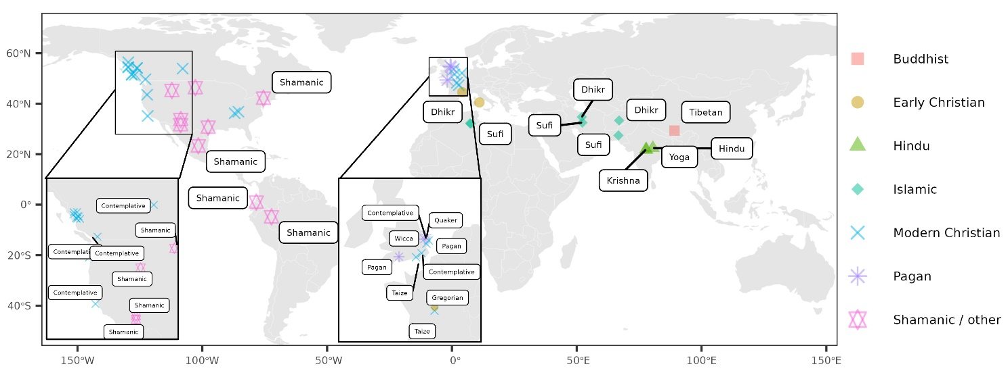
Figure 1. Geographical Distribution of the Chanting Traditions included in this Study. The color of each dot represents the religious origins of the chants. N = 242 chants, ~30 seconds each, equivalent to 1.25 hours of recordings, deriving from seven traditions: Buddhism (India and Tibet), Hinduism (India), Early Christianity (Europe and Eastern Europe), Modern Christianity (Canada, US, UK, Africa), Paganism (UK), Islam (Middle East), Shamanism/Other (North & South Americas). Further details are in Supplementary Materials (Table 1).

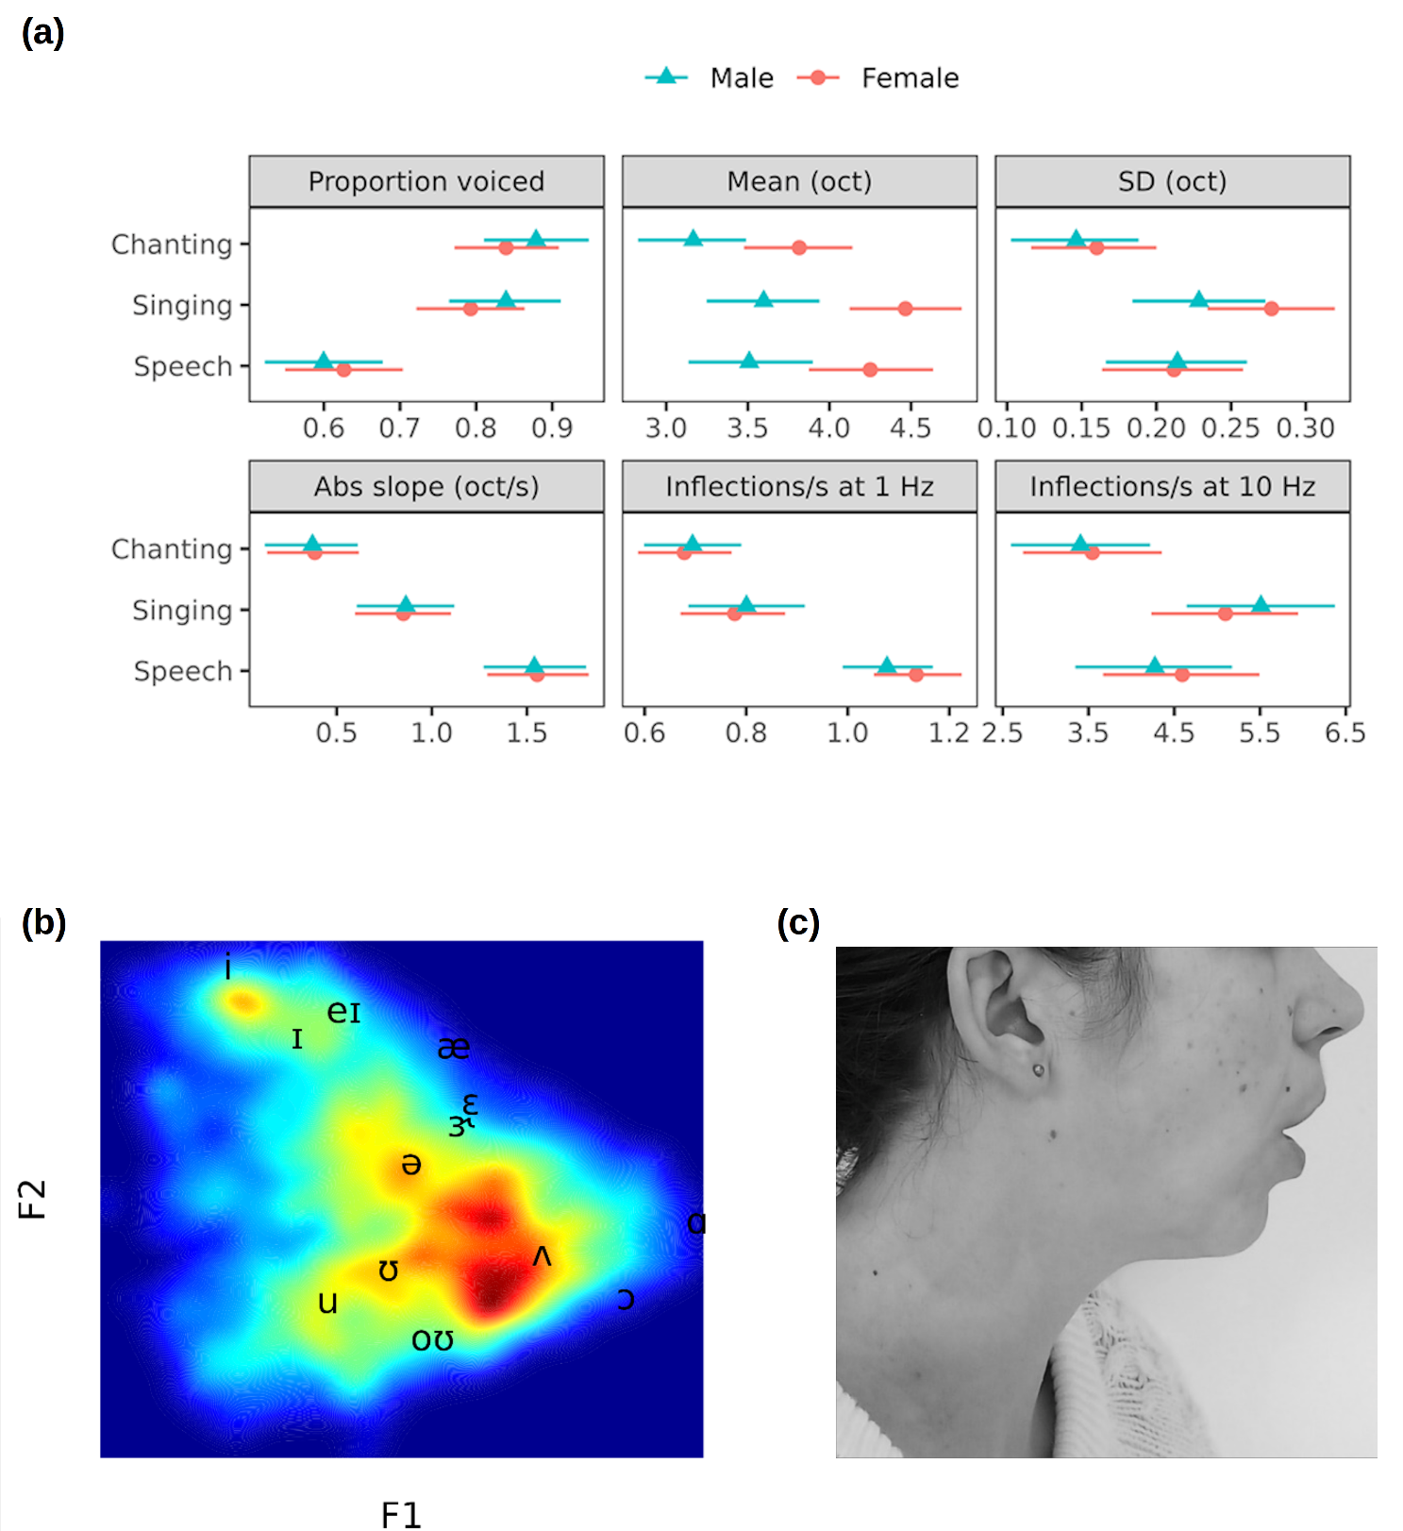

Figure 2. Characteristics of the intonation and vowel distribution in chants compared to singing and speech. (A) Chants are performed at a low pitch and with a relatively flat and slow-changing intonation (medians of posterior distribution and 95% Cis, fitted values from a multivariate mixed model). (B) The predominance of central vowels in chants suggests limited articulation. Density distribution of normalized F1-F2 values from vowel extracts of chants, plotted against Hillenbrand’s (80) set of vowels. The color shows the density of observations within different regions of the speaker-normalized vowel space. (C) First author chanting “OM”, showing the relaxed-open-mouth (ROM) configuration.

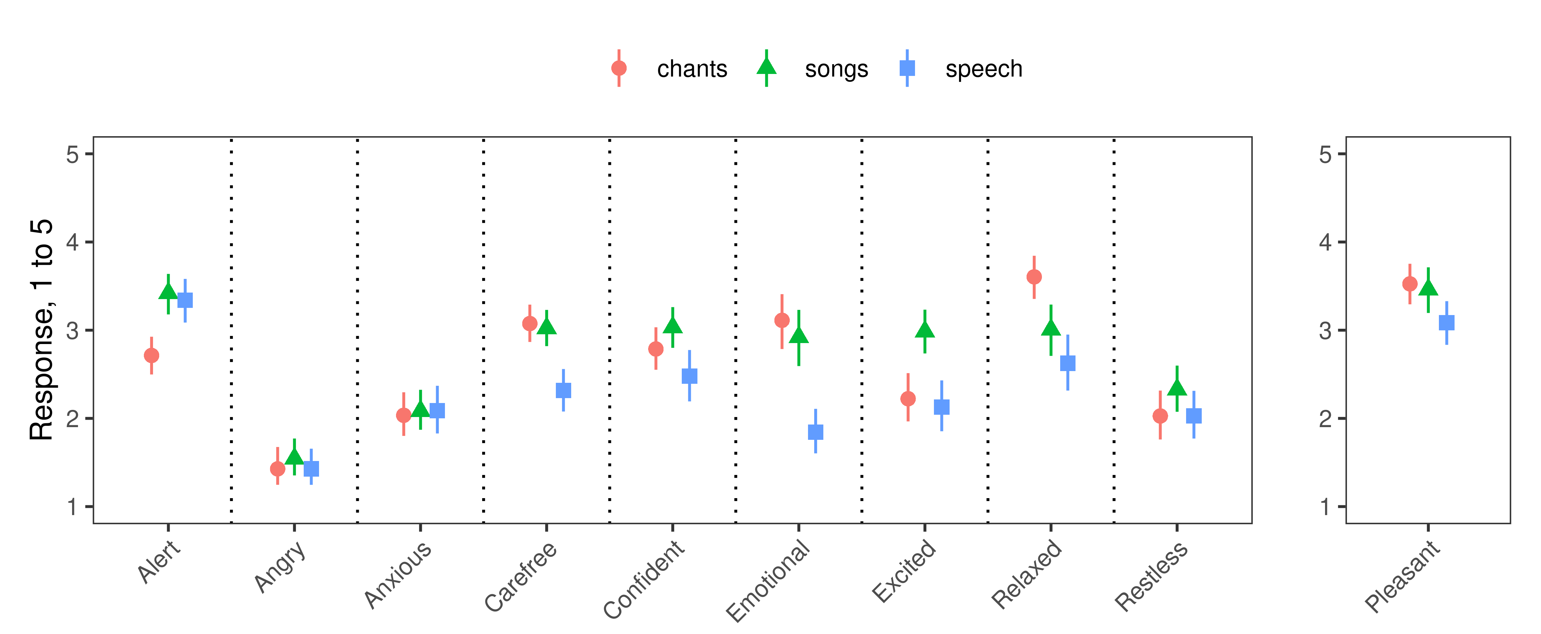
Figure 3. Results of study 2: listeners’ subjective ratings (Means and CIs) for 28 chants, 28 songs and 28 speech samples across different musical styles and languages (taken from Study 1) on 10 Likert scales, 1 = totally disagree to 5 = totally agree.

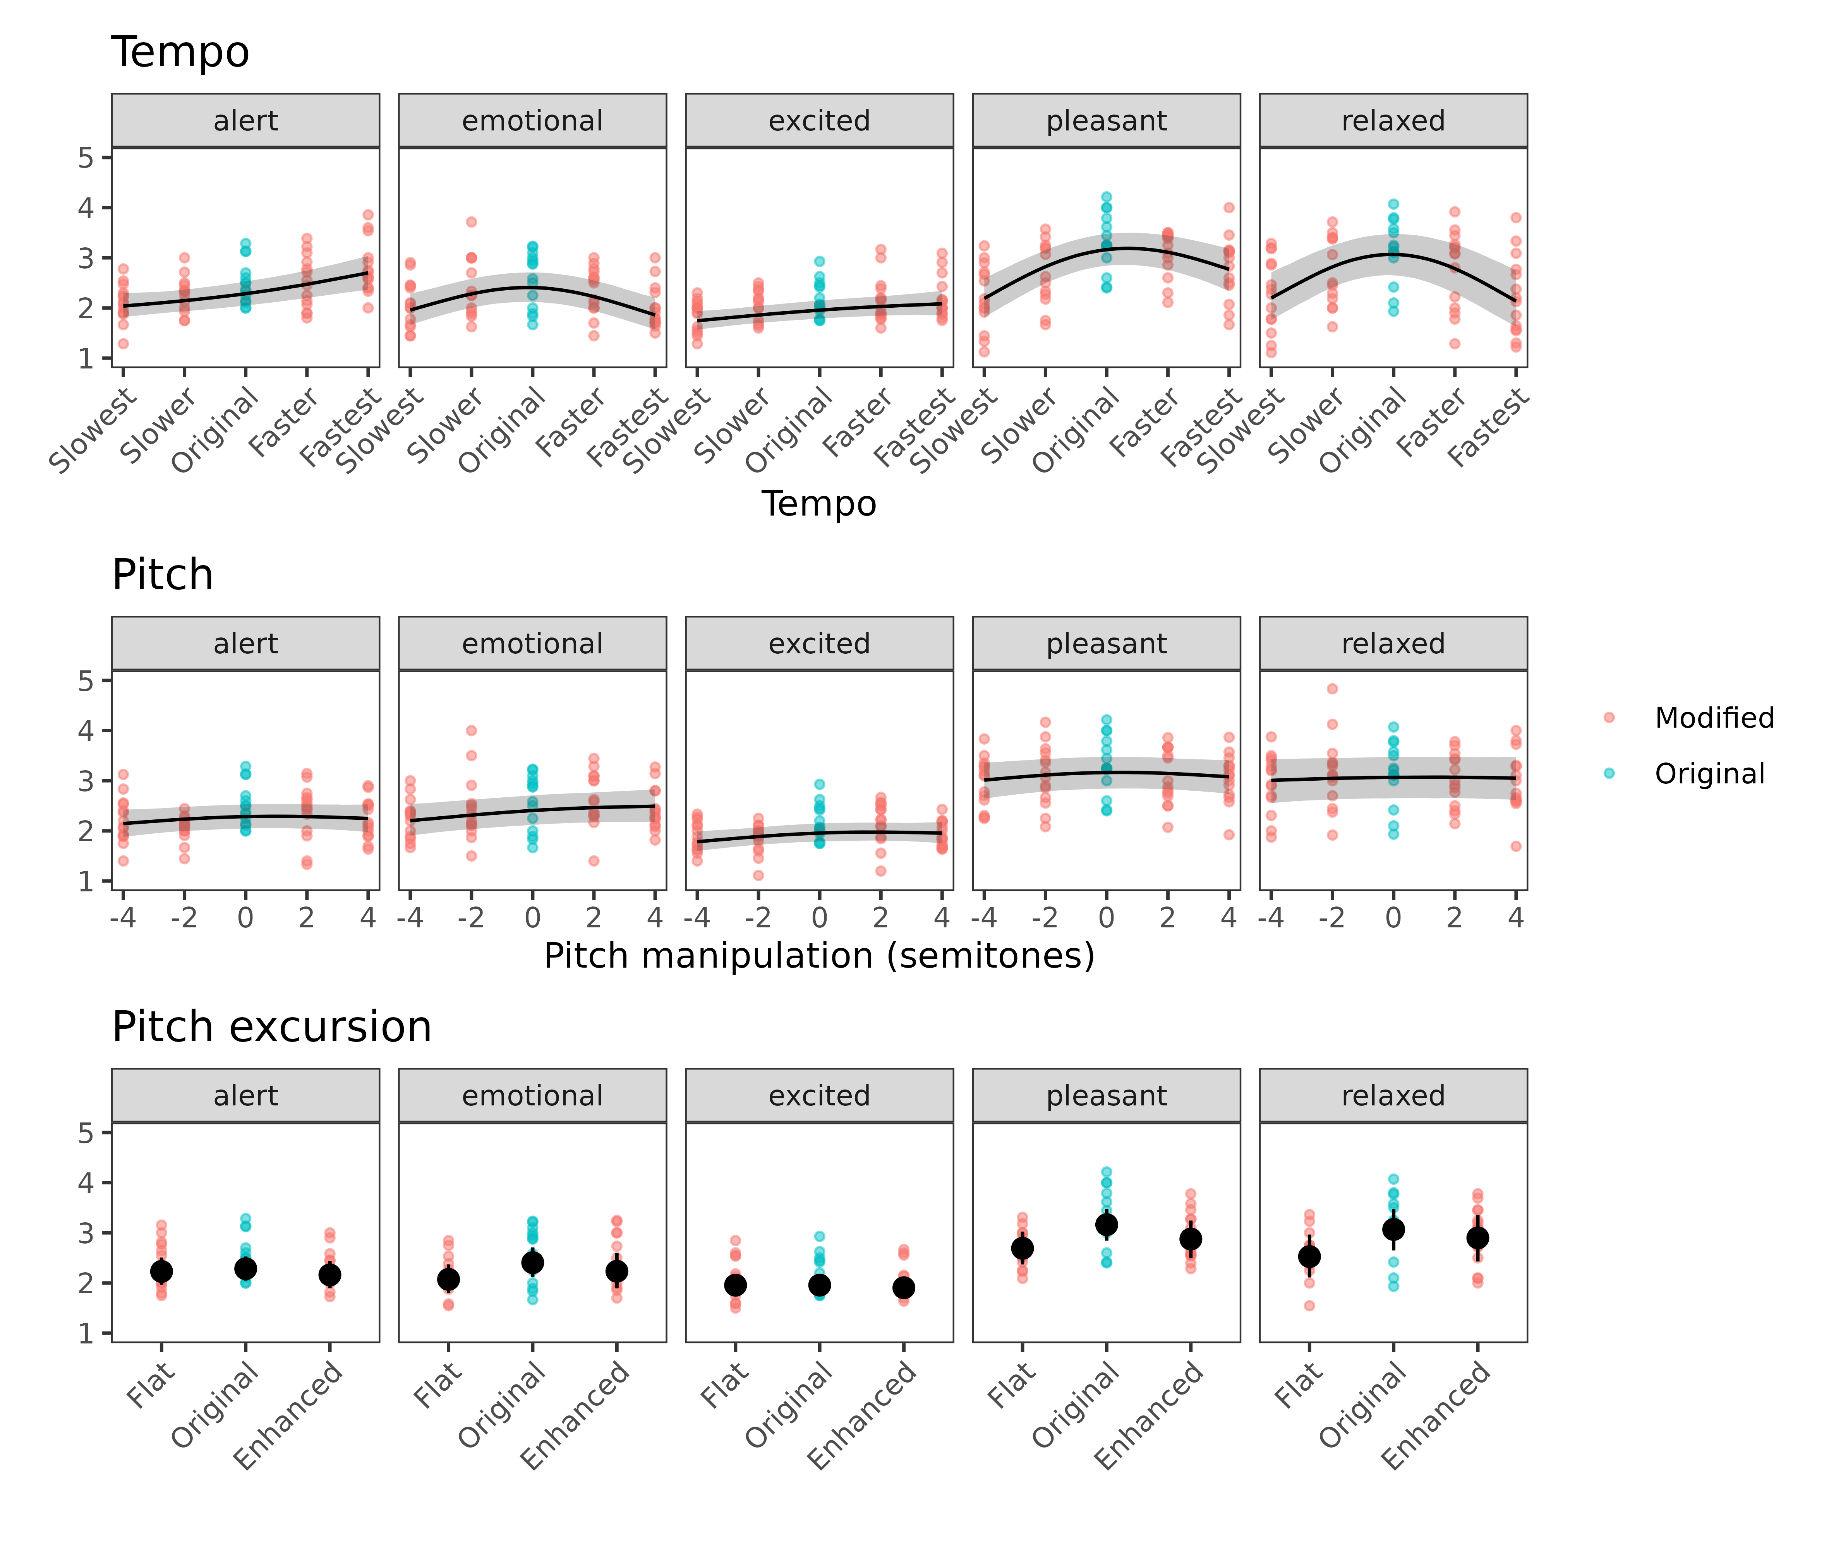
Figure 4. Results of Study 3: Effect of manipulating tempo, average pitch and its excursion on the perceptual relaxation and mood ratings of chant recordings. Lines in the first two panels and solid black points in the lowest panel show fitted values and 95% CIs from mixed models, while small light points show observed data averaged per prototype chant. Likert scales: 1 = Totally disagree to 5 = Totally agree.

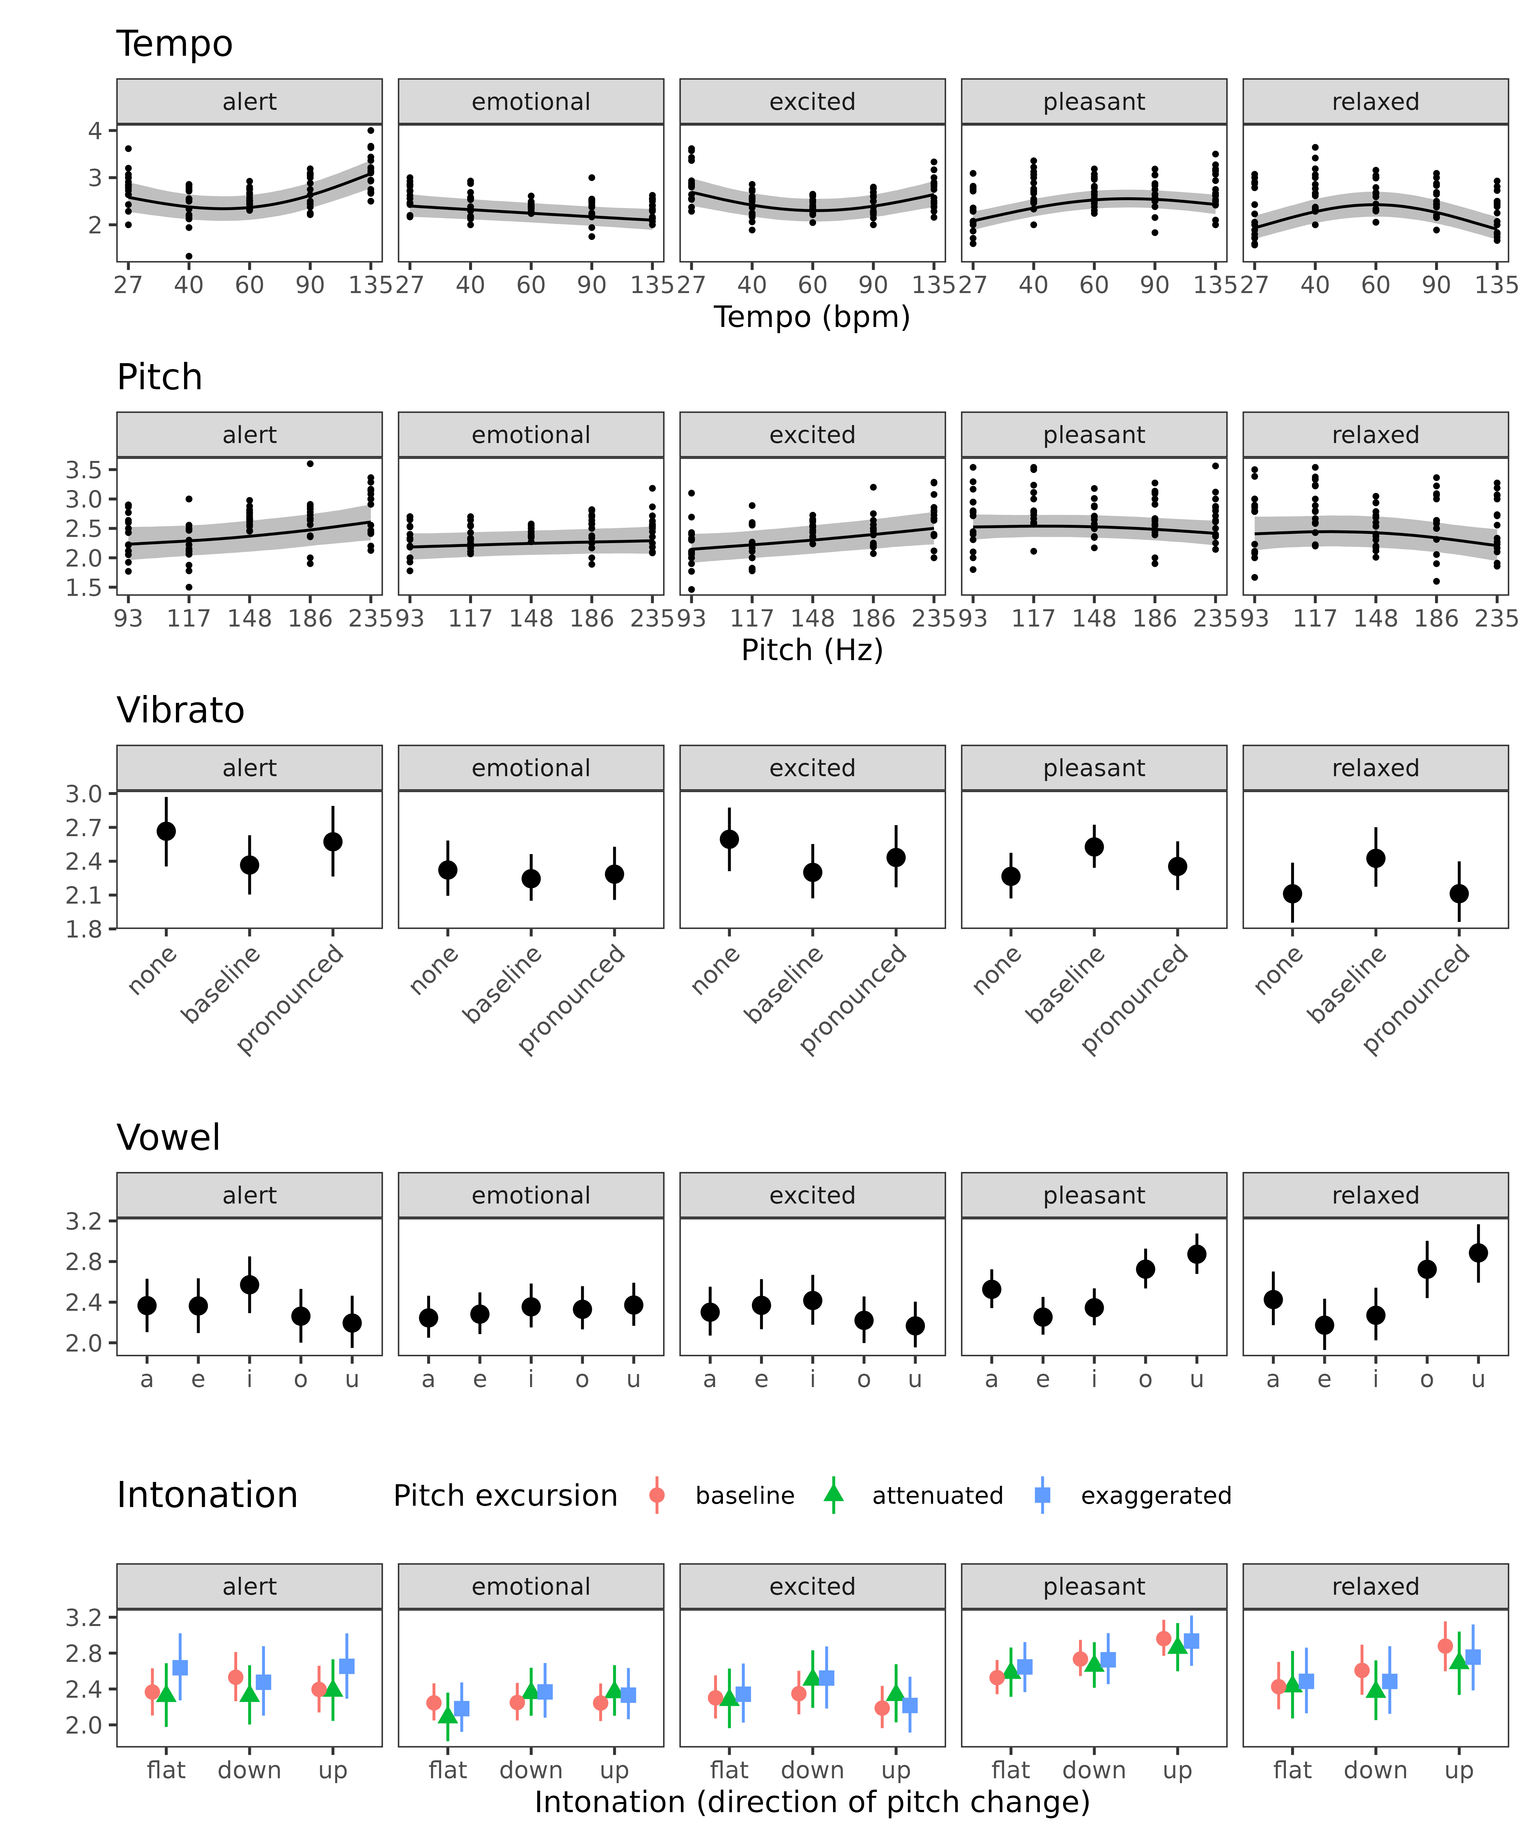
Figure 5. Results of study 4: Effect of acoustic manipulations of synthetic chants on their perceptual ratings. Fitted values and 95% credible intervals. Because this is ordinal logistic regression rather than linear regression, marginal effects of a predictor depend on the values of other predictors even if there are no interaction effects. When calculating the marginal effect of a predictor, we set all other predictors to the baseline level, intonation to “flat”, and vowel to “o”. Using other baselines for comparisons would not substantively change the results.

