RUNNING HEAD: Aphantasia, Autism, and Mental Imagery

Aphantasia and Autism: An Investigation of Mental Imagery Vividness

Rachel King, Harry Buxton, & Ian Tyndall

Department of Psychology, University of Chichester, UK

Corresponding Author:

Dr. Ian Tyndall

Department of Psychology

University of Chichester

Chichester, West Sussex, PO196PE, UK

Email: I.Tyndall@chi.ac.uk

**Abstract**

**Objective**: The present study investigated whether autistic adults report different levels of mental imagery vividness than non-autistic adults, and, moreover, if autism is associated with aphantasia which is defined as a condition of reduced or absent voluntary imagery. **Design and Methods:** Clinically diagnosed and self-identifying autistic participants were compared with non-autistic participants in their mental imagery vividness (vision, sound, smell, taste, touch, bodily sensation and emotional feeling) and autistic traits using an online survey (*N* = 121). **Results:** The autistic group scored significantly lower than the non-autistic group on imagery vividness (d = -0.44), in addition to having a higher proportion of participants scoring at cut-off for aphantasia. Moreover, a similar difference was observed for the emotional feel (η2 = .11). **Conclusion:** The vividness of visual and emotional mental imagery was on average lower for autistic individuals, with a higher proportion presenting at cut-off to be considered an aphantasic.

*Keywords:* Autism, Aphantasia, Mental Imagery Vividness, Visual Imagery, Emotional Imagery, Sensory Modalities.

**Introduction**

Autism is characterised as a neurodevelopmental condition, presenting with difficulties in reciprocal social interactions and communication, in addition to repetitive movements and behaviours, and often hyper/hyposensitivity or unusual interest to sensory aspects of the environment (Murphy et al., 2016). While possible cognitive differences in autistic compared to non-autistic (see Monk et al., 2022) populations continue to be a source of scientific debate (e.g., Baron-Cohen & Wheelwright, 2003; Demetriou et al., 2018; Jassim et al., 2021; Maw et al., 2024; Nader et al., 2015; Oliveras et al., 2012; Van der Hallen et al., 2015), current literature leaves open many questions. One specific question that is both pertinent and currently debated, is whether or not autistic individuals present with differences in the ability to generate mental imagery.

Previous work has described autistic individual’s mental representations as more detailed and suggests that they may use mental imagery more frequently and, on some components, outperform their non-autistic counterparts (Bled et al., 2021; Bled et al., 2024). Conversely, other researchers have demonstrated a negative relationship between autistic traits and visualisation scores, and that specific differences (e.g., in imagination) are related to reduced mental imagery vividness (Hatakeyama, 2024). It is also noted that aphantasic individuals, who have greatly diminished or entirely absent visual mental imagery, score higher on autistic traits (Dance et al., 2021a; Milton et al., 2021). Therefore, it is evident that autistic individuals may present with differences in mental imagery; however, exactly how these cognitive differences manifest is still not clear and requires further investigation. This is especially pertinent with regard to the vividness of mental imagery, given the potential connection to aphantasia and the important role that imagery plays in many day-to-day cognitive activities such as memory, emotion and imagination (e.g., Nanay, 2023; Wicken et al., 2021; Zeman et al., 2020).

**Mental Imagery and Mental Imagery Vividness**

Mental imagery is the experience of sensory information that has been generated internally, in the absence of external stimulus (Pearson et al., 2015). This cognitive process can be experienced across modalities and shares mechanisms with perception (Dance et al., 2021b, Nanay, 2018; Pearson et al., 2015; Pearson et al., 2019). For example, during visual imagery tasks, it has been observed that, amongst other areas such as the prefrontal cortex, the visual cortices are recruited in a similar manner to when perceiving visual information (Dijkstra et al., 2017; Lee at al., 2012; Naselaris et al., 2015). Although the mechanisms driving this activity may be distinct (e.g., inhibitory rather than excitatory; Pace et al., 2023), there is evidence to suggest that both subjective ratings of visual imagery vividness and performance on visual imagery experimental tasks are correlated with occipital activity (Cui et al., 2007; Amedi et al., 2005). When we consider the composition of visual mental imagery, the weight of evidence now generally indicates that mental imagery can be represented in a depictive (pictorial) format (Pearson & Kosslyn, 2015) and that the vividness of this imagery can vary substantially from person to person (Floridou et al., 2022; Pearson, 2019; Zeman et al., 2020).

Although the concept of mental imagery can be abstract, it has a profound influence on many daily tasks, such as planning, navigating, remembering and decision making (Pearson et al., 2015). Perhaps this influence can be considered of particular pertinence in the context of autism given the suggestion that autistic individuals use visual strategies and recruit visual brain regions even on language comprehension and verbal reasoning tasks (Kana, 2006; Sahyoun et al., 2010). Measuring mental imagery can be complex given its internal nature, with measurement taking the form of experimental paradigms (e.g., Pearson et al., 2008; Pearson et al., 2011) and self-report methods. The most common method of self-report currently is the Vividness of Visual Imagery Questionnaire (VVIQ; Marks, 1973), a questionnaire that was designed to measure vividness of mental imagery. Within this method individuals are asked to generate a series of images and rate the vividness of each image on a scale ranging from no image to perfectly clear and as vivid as normal vision. Although the different approaches have their own strengths and limitations the self-report measures such as the VVIQ have been associated with neural correlates of visual mental imagery (Fulford et al., 2018; Runge et al., 2017). In comparison to the more experimental approaches, VVIQ provides a more global approach to measuring mental imagery vividness (Runge et al., 2017) and provides a good starting point to examine differences between cohorts.

**Differences in Mental Imagery in Autism**

The literature on whether capacity for mental imagery represents a cognitive strength or deficit for autistic people presents quite a mixed picture (e.g., Bled et al., 2021; Bled et al., 2024; Crane et al., 2012; Erdődi et al., 2013; Hughes et al., 2018; Kana et al., 2006). Early research was influenced by the speculation that being autistic was akin to being a *visual* thinker (Grandin, 1995; 2009), referring to the preference of thinking with depictive images rather than verbal propositions. This view aligns with Bled et al.’s (2021) work in which a group of autistic individuals reported more frequent use of visual mental representations and defined these representations as more detailed than controls. When describing their inner experience, they also utilised more perceptive visual themes in comparison to controls that utilized more verbal description of events and memories. Furthermore, autistic individuals have been seen to have greater activation of the visual cortex compared across a range of tasks (e.g., Koshino et al., 2005; Manjaly et al., 2007). This observation has extended to tasks that are not necessarily designed to tap into visual imagery processes. For example, Kana et al. (2006) found that autistic participants showed an increase of activity in the parietal and occipital regions of the brain associated with mental imagery when asked to comprehend low imagery sentences, implying that autistic participants tend to engage with more mental imagery than controls even on tasks where use of imagery is not particularly necessary (also see Sahyoun et al., 2010). These findings suggest that within the autistic population the use of mental imagery is of importance, however, whether there are differences in mental imagery ability and vividness is a separate consideration to frequency or preference.

Recently, Bled et al. (2024) examined mental imagery in 44 autistic and 42 non-autistic adults across a range of tasks including image generation, visual pattern test (maintenance), image scanning (inspecting mental images) and mental rotation (manipulating mental images). They found that on the image generation task and the mental rotation task autistic and non-autistic groups performed equivalently (accuracy and reaction time). However, autistic individuals demonstrated a higher visual span and no impact of distance during the scanning task. This is suggestive that the autistic group had better maintenance and scanning of mental imagery and aligns with an atypical perceptual processing style in autism (suggested to reflect an increased weight of perception-based information relative to a top-down effect of knowledge and language). It is worth noting that in correspondence to Bled et al.’s (2024) study, a recent meta-analysis found a nonsignificant effect of mental rotation (Muth et al., 2014), an effect also noted in the aphantasic population that present with reduced mental imagery vividness but intact mental rotation performance (Kay et al., 2024).

One particular visual task where autistic individuals have been found to perform better than non-autistic controls is on block design tests (Shah & Frith, 1993; Muth et al., 2014). In the block design task, the participant is instructed to mentally rearrange coloured blocks to fit a certain pattern, and therefore, it is utilised as a measure of spatial visualization ability. One explanation of the observed advantage is that autistic individuals have a greater capacity to form, access, and manipulate visual mental representations (e.g., veridical mapping; Soulieres et al. 2011). However, the possibility remains that this advantage may not be underpinned by a superior ability to form vivid mental images, but instead could exclusively relate to differences in perceptual processing with a focus on local rather than global details (Maw et al., 2024; Muth et al., 2014; Van der Hallen et al., 2015). Therefore, it is unclear whether this advantage is indeed related to mental imagery ability and to further this it has been noted that block design performance has a component of spatial imagery, rather than solely relying on image generation. Once again, it is of particular note that visuo-spatial performance has been found to remain intact in individuals with aphantasia (see Zeman et al., 2010; Zeman et al., 2015).

Although our understanding of mental imagery in autism is developing, as far as we are aware there is no study to date that has explicitly examined mental imagery vividness in an autistic sample. Bled et al. (2024) have examined image generation and did not find any evidence to suggest differences between autistic and non-autistic groups, however, they did not focus on the vividness of the images created. They did, however, demonstrate differences in the maintenance and scanning of mental imagery. Although, previous work has demonstrated a link between superior mental imagery vividness and visual short-term memory (Keogh & Pearson, 2011; 2014) there is also work that has suggested that the number of details remembered is not necessarily correlated to the perceived vividness of memoranda (Cooper et al., 2019) or found no evidence of a relationship between mental imagery vividness (as reported on the VVIQ) and visual short-term memory (across spatial and non-spatial features of recall; Tabi et al, 2022). Therefore, whether this observed advantage may be related to mental imagery vividness is at present, unclear.

**Vividness of Mental Imagery and Aphantasia**

Galton (1880) is typically credited with the original discussion of the idea that vividness of images that appear in our minds could be an important individual difference amongst people, with some people reporting vivid, powerful mental imagery whilst others report experiencing weaker and less clear images. Zeman et al. (2015, p. 4) defined aphantasia as “a condition of reduced or absent voluntary imagery”. The term comes from the Greek word for imagination, ‘phantasia’ with the prefix ‘a’ added to denote absence (Monzel et al., 2022). The prevalence of aphantasia in the general population varies considerably between studies, but across two studies Dance et al. (2022) estimated the prevalence at approximately 3.9%, and pretty evenly split across males and females. Part of the reason for the considerable variation in prevalence estimates is due to an ongoing debate over the definition of aphantasia and whether it should include both reduced or absent voluntary imagery as Zeman et al. (2015) defined it or whether it should refer only to absent imagery (e.g., Blomkvist & Marks, 2023; Monzel et al., 2022). Using a stricter cut-off point on the VVIQ to determine aphantasia, Zeman et al. (2020) reported a prevalence rate of only 0.7%, demonstrating the rarity of the more extreme cases.

**Link between Autism and Aphantasia?**

Of particular relevance to the present study, Dance et al. (2021a) investigated if aphantasia is associated with autism. Dance et al. matched 118 aphantasics with controls and examined differences in their score on the Autism Spectrum Quotient (AQ; Baron-Cohen et al., 2001) test, which measures autistic traits. In their study, aphantasics scored significantly lower on imagination and social skills demonstrating a link to autistic traits. These findings are similar to Hatakeyama (2024) who demonstrated a link between the AQ imagination subscale and mental imagery vividness, with the high scoring unimaginative group demonstrating lower imagery vividness in a sample of 250 college students. They also found that the group that scored high on the AQ total score also presented with lower visualization scores. Although mental imagery is distinct from the concept of imagination, it is interconnected and important as it is utilized within the process of imagination (Nanay, 2023). Imagination is a skill that has been suggested to be difficult for autistic individuals, either more generally (e.g., Low et al., 2009) or more specifically with regard to social contexts (Ten Eycke & Müller, 2015). Therefore, this observed connection between mental imagery vividness and autistic traits warrants further study and present study aims to look at the vividness of mental imagery in a sample of autistic individuals and compare them to a non-autistic comparator group.

**Vividness of Other Sensory Modalities**

Although literature has generally focused on visual imagery, mental imagery is a multimodal process that involves an interaction of multiple senses (Nanay, 2018). For example, Bacon et al. (2020) explored the cross-modal sensory issue and administered the Bucknell Auditory Imagery Scale (BAIS) which assesses the vividness of audio imagery across musical, verbal, and environmental sounds. Bacon et al. found that autistic people scored significantly lower than non-autistics on the vividness of voice and environmental sounds but less so for music. This indicates that there could be some level of impact in vividness for audio stimuli in autistic individuals. Further research is needed to examine if these findings can be replicated across other scales than the BAIS, and if differences in audio imagery also extend to other modalities such as visual imagery.

An interesting observation by Dance et al. (2021a) is that participants with aphantasia were likely to also demonstrate reduced imagery across other sensory domains (e.g., olfactory, tactile, gustatory, bodily sensation). Of their sample, 62% of aphantasics demonstrated diminished imagery across all domains tested and 97% had reduced imagery in at least one another domain. This observation has led Dance and colleagues to propose the term *dysikonesia*, rather than the term aphantasia which is visual imagery specific. Another observation of note is that Dance et al. (2021b) also reported that individuals with aphantasia also presented with perceptual hyposensivity across all domains, demonstrating a connection between perception and mental imagery vividness. Both hyper- and hypo-perceptual sensitivities have been found to be prevalent in autistic individuals, with a study by Billstedt et al. (2007) demonstrating that within their adult autistic sample 93% reported a sensory difference (across domains), with 45% reporting sensitivity to visual stimuli specifically. Considering the similarities between imagery and perception and the observation that autistic individuals often present with sensory differences across domains (e.g., Balasco et al., 2020; Bennetto et al., 2007; Rotschafer, 2021), another important consideration would be to see whether autistic individuals also present with multi-domain mental imagery differences.

**Present Study**

The research reviewed above highlights substantive discrepancies in our understanding regarding the visual imagery abilities of autistic individuals. To begin to address these discrepancies the present study will firstly aim to compare autistic participants’ visual mental imagery vividness scores to a control sample of non-autistic participants using the VVIQ (Marks, 1973) and the visual sub-scale of the Psi-Q (Plymouth Sensory Imagery Questionnaire; Andrade et al., 2014). It is predicted that (*H*1) the group of autistic participants will score differently on the visual mental imagery vividness scales as compared to the non-autistic group. To further investigate the link between autism and mental imagery the research by Dance et al. (2021a) was extended to examine whether aphantasia (indicated by a score < 32 or < 16 on the VVIQ) is more prevalent in autistic participants as compared to the non-autistic participants. Based on Dance et al.’s (2021a) findings it is hypothesized that (*H*2) there will be a higher proportion of individuals with aphantasia in the autistic group as compared to the non-autistic group.

There are relatively few studies examining imagery across the different sensory modalities in an autistic sample. Therefore, a further exploratory analysis will be run to understand whether differences in mental imagery might also extend to other sensory modalities. To achieve this purpose, the autistic group will be compared to the non-autistic group on the other subscales of the Psi-Q (audition, smell, taste, touch, bodily sensation and emotional feel). In consideration that the results from Bacon et al. (2020) suggest differences in audition it is tentatively predicted that (*H*3) the group of autistic participants will score differently on mental imagery vividness across a range of sensory modalities as compared to the group of non-autistic participants.

**Method**

**Participants**

There was a total of 121 participants. Participants naturally fell into three groups, clinically diagnosed autistic (*N* = 55, mean age = 36.85, *SD* = 14.03), self-identifying autistic (*N* = 19, mean age = 42.16, *SD* = 12.66) and non-autistic (*N* = 46, mean age = 40.96, *SD* = 14.58). The overall mean age of participants was 39.27 (*SD* = 14.11). No participants were removed from the analysis. Participants were recruited online, through posting an advertisement of the study containing a link for people to click on, and through word of mouth. The advertisement was posted to multiple Facebook groups/pages and emailed through the National Autistic Society XXXX (*withheld for blind peer-review*) Branch newsletter, where it was encouraged to be shared amongst people interested in autism. Although we referred to aphantasia in the study debrief process, we did not attempt to target people with aphantasia or extreme mental imagery in the advertisement/recruiting process. However, we did target Facebook pages about autism to recruit autistic participants. Although males are more likely to be diagnosed as autistic (Loomes et al., 2017), participants were predominantly female (71% female, 26% male and 3% non-binary/prefer not to say), likely because they are more likely to participate in online surveys. Ethical approval was granted by the Research Ethics procedures at the University of X (*withheld for blind review*). Participants were not offered reimbursement.

**Measures**

***Categorizing Diagnosis***

Participants were asked the question “Have you had an official diagnosis of autism or Asperger’s Syndrome?”. We categorized them based on three responses: 1) “Yes”, which was entered into the autistic (diagnosed) group; 2) "I believe I'm autistic but have not had an official diagnosis", which was entered into the autistic (self-identifying) group or 3) “No,” which was entered into the non-autistic group. As there is a large portion of the population undiagnosed with autism (Baron Cohen et al., 2009) due to barriers towards getting a diagnosis (Lewis, 2017) we felt it was valuable to include people who strongly suspected they were on the autistic spectrum but had not yet been officially diagnosed. To ensure the combination of the groups is reasonable a comparison of AQ-50 scores will be reported.

Studies in the autism literature often term the control group of non-autistic participants as ‘neurotypical’ but this is often done without any reason or evidence of the absence of other forms of neurodivergence. As we did not have a screening test for a range of neurodivergent differences or conditions, we have chosen the label ‘non-autistic’ which is a term used to describe people who are not affected by autism (Monk et al., 2022). Although it is recognised that the preference for person-first (people with autism) and identity-first (autistic people) can vary, based on recommendations from Monk et al. (2022) we also have chosen to use identity-first language.

***The Autistic Quotient (AQ-50; Baron-Cohen et al., 2001).***

The goal of the AQ-50 is to measure autistic traits. The AQ has 50 questions, where participants rate how much they agree with the statements from “definitely agree” to “definitely disagree”, on a scale of 1 - 4. Answers are scored as either 1 or 0, where 1 is scored for responses that are “definitely or slightly”, with approximately half the items being reverse scored. The 5 traits measured are communication (e.g. “Other people frequently tell me that what I’ve said is impolite, even though I think it is polite”), social skills (e.g. “I prefer to do things with others rather than on my own”), imagination (e.g. “when I’m reading a story, I find it easy to imagine what the characters look like”), attention to detail (e.g. “I often notice small sounds when others do not”) and attention switching (e.g. “I prefer to do things the same way over and over again”). A total score of between 0 and 50 is calculated, with higher scores indicating the presence of more autistic traits.  The internal consistency of the scale was excellent (α = 0.94).

***The Vividness of Visual Imagery Questionnaire (VVIQ; Marks, 1973; Pearson, 1995).***

The goal of the VVIQ is to measure the vividness of visual imagery. The VVIQ consists of 16 questions, where participants are asked to imagine a certain visual scenario, and then rate the vividness of the subscale on a scale of 1 - 5, with 1 being “No image at all, you only “know” that you are thinking of an object” and 5 being “Perfectly clear and as vivid as normal vision”. Therefore, scores range from 16-80 with higher scores indicating clearer visual imagery. A sample item includes: “Visualize a rising sun. Consider carefully the picture that comes before your mind’s eye… The sun is rising above the horizon into a hazy sky”. The VVIQ is usually done first with eyes closed and then with eyes open, with a separate score calculated for each condition; however, we only used the eyes open segment of the VVIQ. This decision was made due to concerns about participant recruitment, the potential burden of the length of the survey. The eyes open condition was selected for comparability with the visual subsection of the Psi-Q which is performed with eyes open (Andrade et al., 2014). The internal consistency of the scale was excellent (α = 0.96).

The VVIQ will also be used to categorised participants based on the presence of aphantasia. Aphantasic was defined by scoring 32 points or lower on the VVIQ. There is currently no standard definition for categorising aphantasia, but our study is using a cut-off consistent with previous literature such as Dance et al. (2021a)’s categorisation of 32 or below (minimum score = 16) on the VVIQ. To score 32 or lower on the VVIQ you would score as “vague and dim” to “No image at all, you only ‘know’ that you are thinking of an object” on most questions. Moreover, given the recent discussions around whether aphantasia should be considered only if there is an absence of visual imagery (Blomkvist & Marks, 2023; Monzel et al., 2022; Zeman et al., 2015) the stricter cut-off of 16 will also be examined.

***The Plymouth Sensory Imagery Questionnaire (Psi-Q; Andrade et al., 2014).***

The Psi-Q is a 35-item questionnaire that aims to measure mental imagery across 7 sensory modalities (Vision, Sound, Smell, Taste, Touch, Bodily Sensation and Emotional Feeling), with 5 questions for each sensory experience. Participants are asked to rate each question on a scale of 0 - 10, with 0 being the equivalent to “no image at all” and 10 being “as clear and as vivid as real life”. Examples of the questions are “imagine the appearance of… a friend you know well” for visual, “imagine the sound of… an ambulance siren” for sound, “Imagine the smell of… a stuffy room” for smell, “imagine the taste of… mustard” for taste, “imagine touching… warm sand” for touch, “imagine the bodily sensation of… relaxing in a warm bath” for bodily feel, and “imagine feeling… excited” for emotions. Scores were calculated by finding the mean response in each subscale (Andrade et al., 2014). The internal consistency of each subscale in our sample was as follows: Vision (α = 0.932); Sound (α = 0.96); Smell (α = 0.95), Taste (α = 0.93), Touch (α = 0.96), Bodily Feel (α = 0.94); and Emotion (α = 0.90).

**Procedure**

Participants were directed to the study through a link to the Qualtrics online survey platform. Participants were informed the objective of the study was to investigate mental imagery vividness, Autism and Aphantasia, and those who gave consent proceeded to complete the survey. Participants were asked their age and gender at the start of the study. They then completed the VVIQ, followed by the Psi-Q, and then the AQ-50. The Qualtrics forced-choice response function was employed, meaning every participant that finished the study answered every question, with the exception of one participant who did not enter their age. The study protocol took approximately 1 hour to complete.

**Design & Analysis**

The study was an independent measures design comparing an autistic group to an non-autistic comparator group on mental imagery vividness. Firstly, visual mental imagery (as measured by the VVIQ) and the proportion of individuals meeting the cut off for aphantasia will be compared across groups. These comparisons will be made using independent *t*-tests and Fisher’s exact test. Secondly an exploratory analysis across the 7 subscales of the Psi-Q (Vision, Sound, Smell, Taste, Touch, Bodily Sensation and Emotional Feeling) will be conducted. Given the potential for cross domain differences a MANOVA was used for this purpose. The analysis was run in R version 4.3.1 (R Core Team, 2023) and utilized packages such as tidyverse (2.0.0, Wickham et al., 2019) and effect size (0.8.6, Ben-Shachar et al., 2020). Outliers were identified as scores over 2.58 standard deviations from the mean and the impact on the analysis critically discussed if removed.

**Results**

**AQ-50 Comparison**

To understand the comparability of the two autistic sub-groups the AQ-50 scores were compared between the clinically diagnosed autistic (*N* = 55), self-diagnosed autistic (*N* = 19) and non-autistic (*N* = 47) groups. There was negative skew noted in the clinically diagnosed autistic group due to an outlier which was 2.76 standard deviations below the group mean. It was observed that removal of the outlier did not impact the statistical conclusions and, therefore, the data point was retained within the analysis. The assumption of homogeneity of error variances had been met, *F*(2, 118) = 1.17, *p* = .314. Despite the slight negative skew, a One-Way Between Subjects ANOVA was deemed appropriate to conduct the group analysis (Blanca et al., 2017).

A significant main effect of autism group on AQ-50 scores was observed, *F*(2, 118) = 97.27, *p* < .001, ω2 = .61 (see Figure 1). Bonferroni corrected post-hoc tests revealed that on average the non-autistic group scored significantly lower on the AQ-50 as compared to both the clinically diagnosed (*M* difference = 19.80, 95% CI [16.11, 23.49], *p* < .001) and self-diagnosed (*M* difference = 20.20, 95% CI [15.15, 25.25], *p* < .001) autistic groups. However, the difference between the self-diagnosed and clinically diagnosed groups was negligible (*M* difference = 0.40, 95% CI [-4.55, 5.34], *p* > .999).

To further examine whether the autism groups can be combined the AQ-50 cut off scores presented by Baron-Cohen et al. (2001) were examined (≥ 26 indicating the screening cut off and ≥ 32 indicating the clinical cut off for Autism Spectrum Condition). Of the 19 participants in that group only three were below the clinical threshold and one of those participants still met the screening threshold. Given that 14 individuals from the clinically diagnosed group also did not meet the clinical threshold we deemed it appropriate to combine the clinically and self-diagnosed groups in further analyses.

**Visual Vividness IQ Comparison**

To examine whether vividness of visual imagery differed between the combined autistic group (*N* = 74) and the non-autistic groups (*N* = 47), total scores for the eyes open section of the VVIQ were compared across groups. Visual inspection of the histograms and skew and kurtosis z-scores indicated that the assumption of normality had been met for both groups. There were two outliers that scored over 2.58 standard deviations below the group mean in the non-autistic group. It was observed that removal of the outlier did not impact the statistical conclusions and, therefore, the data point was retained within the analysis. Levene’s test for equality of error variances indicated the assumption of homogeneity had been met, *F*(1, 119) = 0.66, *p* = .420.

An independent samples *t*-test demonstrated that the autistic group had on average a significantly lower VVIQ total score (*M* = 49.80, *SD* = 16.63) as compared to the non-autistic group (*M* = 56.83, *SD* = 15.00, *t*(119) = - 2.35, *p* = .020, *d* = -0.44 (see Figure 2A). The mean difference is 7.03, indicating that on average the non-autistic group demonstrated stronger mental imagery scoring on average 7 points higher on the VVIQ total score (range: 16-80). After removal of the two negative outliers within the non-autistic group the average difference increased to 8.78 points (*d* = -0.57, 95% CI [.20, .95]). Similar results were obtained when running an ANOVA with the three groups (non-autistic, autistic [diagnosed] and autistic [self-identifying]), however, the analysis was less robust against the influence of outliers in the non-autistic group (see supplementary materials for details).

Given the overlap between groups in terms of the AQ-50 score the linear relationship between AQ-50 and VVIQ total score was also examined using a Pearson’s correlation. As can be seen in Figure 2B, a significant negative medium strength relationship was found, *r* (119) = - .34, 95% CI [-0.48, -0.17], *p* < .001, which demonstrated that higher instances of autistics traits were associated with lower visual imagery vividness. Question 3 of the AQ-50 directly relates to mental imagery (“If I try to imagine something, I find it very easy to create a picture in my mind.”), therefore the analysis was run again after removing this question. The negative relationship remained, with higher autistic traits being associated with lower visual vividness ratings, *r* (119) = - .31, 95% CI [-0.47, -0.14], *p* < .001.

**Aphantasia Prevalence**

In order to examine whether the prevalence of aphantasia was different in the combined autistic group as compared to the non-autistic group the participants were categorized based on whether they met the cut off for aphantasia on their VVIQ performance (VVIQ ≤ 32; Dawes et al., 2020; Wickens et al., 2021). In the non-autistic group 6.38% (3 out of 47) of participants reached the threshold for aphantasia, whereas in the combined autistic group 20.27% (15 out of 74) reached the threshold. In order to understand whether the difference was statistically significant a chi-square analysis was run. Fisher’s exact test is reported due to one of the cells having a frequency of less than five (Blalock, 1972). The analysis indicated that there was a statistically significant association between the presence of autism and aphantasia, *p* = .040, Odds Ratio = 3.69, 95% CI [0.96, 21.12]. Given the current discussions regarding implementing stricter cut off scores, we also examined a cut-off of 16 or below (Zeman et al., 2015; see Blomkvist & Marks, 2023), observing no instances of aphantasia in the non-autistic group and 4 cases (5%) in the autistic group.

**Psi-Q Exploratory Analysis**

In order to examine whether differences in mental imagery were present across different sensory modalities an exploratory analysis was conducted using MANOVA to examine multivariate differences in mental imagery vividness using the Psi-Q measure. The assumption of normality had been violated with significant negative skew present for one or both groups across variables. Given the data is moderately negatively skewed the reflect and square root transformation was applied. After transformation all variables (apart from the tactile modality in the autistic group which had become positively skewed) met the assumption of normality and had no outliers more than 2.58 standard deviations from the group mean. There was homogeneity of variance, as assessed by Levene’s test (*p* >.05) and covariance, as assessed by Box’s test of equality of covariance matrices (*p* > .001). All variables demonstrated a linear relationship and were moderately correlated, suggesting that MANOVA is an appropriate analysis. However, examination of mahalanobis distances indicated that the assumption of multivariate outliers had been violated for 3 participants. The analysis was run both with and without the outliers.

There was a significant main effect of autism on the combined mental imagery dependent variables, Pillai Trace = .22, *F*(7, 113) = 4.48, *p* < .001, partial η2 = .22. To understand which modalities differed between groups Bonferroni corrected univariate one-way ANOVAs were examined. It was observed that mental imagery vividness on the visual sub score was significantly higher in the non-autistic group as compared to the autistic group, *F*(1, 119) = 5.46, *p* = .021, partial η2 = .04 (see Figure 3). The difference in raw mean scores was 1.02, indicating that on average non-autistic individuals were rating their visual imagery vividness one point higher on the 0 -10 scale.

As demonstrated in Figure 4, a similar pattern was observed in emotional feel, with the non-autistic group scoring higher as compared to the autistic group, *F*(1, 119) = 14.18, *p* < .001, partial η2 = .11. The mean difference was 1.63, indicating that the non-autistic group were scoring emotional feel mental imagery between one and two points higher on the 0-10 scale compared to the autistic group. The comparison for all other modalities was non-significant (*p* > .23). When the analysis was re-run without the three multivariate outliers, there was no impact on the statistical conclusions drawn.

**Discussion**

Overall, the current study builds on the work of Dance et al. (2021a) and Bled et al (2024) by providing evidence in favor of the hypothesis that autistic individuals score, on average, lower on self-report measures of visual mental imagery as compared to an non-autistic comparison group. In the present study this observation was noted on two separate measures of visual imagery, the VVIQ and visual subsection of the Psi-Q. In addition to observing these differences between participant groups it was also noted that there was a significant negative correlation between autistics traits as measured by the AQ-50 and VVIQ scores, providing further support for the relationship between autistic traits and visual mental imagery. There was also support for the hypothesis that there is a relationship between the autistic traits and aphantasia, insofar as a larger proportion of individuals in the autistic group presented with VVIQ scores below a commonly used cut off to identify aphantasia. The exploratory analysis of the other sensory modalities went against our tentative expectations, with no reliable evidence for differences in almost all modalities. However, we did observe an interesting and novel difference in emotional imagery vividness, which if replicated, could provide an interesting direction for further research into the relationship between visual and emotional imagery. We will address these key findings in turn.

**Visual Mental Imagery**

The present study extends and provides further nuance to previous work that has demonstrated differences in visual imagery within the autistic population (e.g., Bled et al., 2021; Bled et al., 2024) by demonstrating reduced mental imagery vividness in the present autistic sample as compared to an non-autistic comparator group. This perhaps suggests that although both groups do have the ability to generate internal visual imagery, autistic individuals may do so with less vividness, an observation that does not correspond with Soulieres et al.’s (2011) suggestion that autistic individuals may form mental images more effectively as compared to their non-autistic counterparts. However, we should consider that accuracy and vividness (as measured by the VVIQ) may be seen as distinct and the interplay between them requires further investigation. It is also noted that diminished visual imagery vividness observed in the autistic group in the present study is not in conflict with the assertion that autistic individuals may use mental imagery more frequently or experience it as more detailed as suggested by Bled et al. (2021). Once again, these aspects can be considered distinct from the concept of vividness itself. An interesting future direction could be to explore both vividness and level of detail explicitly within the same paradigm, as it could be considered that if the resource used for mental imagery is limited, the level of detail and vividness may be interconnected. Thus, it is plausible that there could beless vividness/clarity as the resource is spread to incorporate further detail.

This interplay may also be particularly important when considering the link between mental imagery vividness and visual short-term memory. Given that there is some disparity in the literature body regarding the link between vividness and short-term visual memory (Cooper et al., 2019; Keogh & Pearson, 2011; 2014; Tabi et al., 2022) and the observation that VVIQ scores are positively related to hippocampal volume in an elderly sample (Tabi et al., 2022), this is a relationship that will require further more nuanced investigation with experimental approaches that afford a more controlled and detailed analysis. Bled et al.’s (2024) observation that autistic individuals perform better on the maintenance (The Visual Pattern Test; Della Sala et al., 1999) and scanning of internally represented imageries (The Image Scanning Test; Borst & Kosslyn, 2010), also highlights the importance of disentangling the relationship between detail, vividness and its impact on memory processes that utilize internally generated visual images. In the instance of memory maintenance, for example, could a trade of vividness for detail be an advantage? It would most likely depend on the type of recall being requested, such as the requirement to recall more global or local features and could be an interesting manipulation for further experimental work to consider.

The present study also compliments previous work that has demonstrated that aphantasic individuals score higher on autistic traits (Dance et al., 2021a; Milton et al., 2021) and those studies that have demonstrated differences in visualization and mental imagery vividness based on autistic traits in non-clinical populations (e.g., Hatakeyama, 2024). However, the current study extends these findings by studying mental imagery vividness directly within a sample of autistic individuals, by incorporating more than one self-report measure of visual mental imagery and by comparing the occurrence of aphantasia (as denoted by several proposed cut-off points 32 and 16). In our sample, a higher proportion of individuals in the autistic group (20.27%; 15/74) met the less stringent cut-off score of 32 for aphantasia as compared to the non-autistic comparison group (6.38%; 3/47). Using the more stringent cut-off demonstrated that 5% of the autistic group (4 cases, 3 female and 1 male) were found to reach the cut-off, whereas there were no cases identified in the non-autistic comparator group (Zeman et al., 2015; Blomkvist & Marks, 2023). Important contextual information to consider is that previous work has reported the prevalence of aphantasia to be around 3.9% using the less stringent cut-off (Dance et al., 2022) and 0.7% using the more stringent cut-off (Zeman et al., 2020). These finding are certainly noteworthy and require further investigation, although it must also be considered that the higher prevalence in the present study could be biased by the inclusion of the term aphantasia within the study information for participants.

**Mental Imagery Vividness Across Modalities**

The exploratory analysis of other sensory modalities did not support previous work by Bacon et al. (2020) that suggested autistic individuals may have weaker auditory mental imagery but did produce a novel result suggesting differences on emotional imagery vividness. Although we made no specific prediction, we found that the autistic group scored significantly lower on the “emotional feeling” category on the Psi-Q. This finding suggests that there might be a difference in the ability for autistic people to imagine feeling emotions and aligns with research that considers how autism might be associated with alexithymia and impaired interoception (e.g., Shah et al., 2016), albeit the association between autism and alexithymia is complex and far from clear (Poquérusse et al., 2018).

It also seems to fit with research that has associated dysfunction in the default mode network with autism. For example, Padmanabhan et al. (2017) found the default mode network activates when asked to imagine emotional scenarios, and that although autistic participants readings were close to non-autistic participants when imagining visual scenarios, when prompted to imagine feeling emotions they had significantly weaker responses in this region, which is consistent with our results. Padmanabhan et al. emphasised that emotions should be studied in context as opposed to as temporally constrained frameworks that strip away context. It should be noted here that in the present study, the Psi-Q asks respondents to imagine feeling emotions without any context. For example, the Psi-Q plainly asks the question ‘imagine feeling excited’ and requires respondents to rate the vividness of the feeling, without giving a prompt of a scenario that might make them excited, giving instructions or even setting a scene before questioning participants on the vividness of their emotion. Instead, it simply leaves the participant to imagine whatever scenario that might prompt the feeling of excitement.

That our autistic sample scored lower on emotional imagery ability becomes particularly relevant when you consider that aphantasic people also score significantly lower on emotional imagery. As aphantasia appears to be linked to autism and weaker social skills (Dance et al., 2021a), it is possible that the association between aphantasia and autism is mediated by low vividness in emotional imagery. Our present findings could also be considered in light of Wicken et al.’s (2021) study that suggested that aphantasics lack of visual imagery in a fearful context results in a dampened emotional response that is not observed in non-aphantasics. Given the complex and multiple module nature of imagery, it may also be considered that in the context of the Psi-Q, the imagery of the emotional feeling may be accompanied by an internally generated emotionally valanced image, such as a facial expression. Further research could benefit from incorporating a qualitative component to understand subjectively how participants undertake the task to provide greater insights into differences in approach and potential interplay between these aspects of imagery. This is perhaps an interesting direction in both aphantasic and autistic populations.

**Combining the Diagnosed and Self-Identifying Groups**

Although the AQ-50 is not a diagnostic tool *per se* (Baron-Cohen et al., 2001), it served as an effective instrument in the present study to enable the incorporation of a self-identifying group, demonstrating that they scored similarly to the clinically diagnosed group and scored significantly higher than the control group. This is of pertinence given the long waiting times and barriers currently being faced for a diagnostic assessment (Lewis, 2017), and enabled a more inclusive sampling approach with greater reach. The main analysis in the VVIQ was also run with the groups split and confirmed the analysis with the combined groups with both the clinically diagnosed and self-identifying groups demonstrating lower vividness as compared to the non-autistic group. However, it is worth noting here that this analysis was less resistant to the presence of two extreme outliers (≥ 3 SD below the group mean) within the non-autistic group (see the supplementary materials) which impacted the comparison between the clinically diagnosed and non-autistic groups before removal. Overall, given the barriers still being faced regarding diagnosis it is proposed that this approach can help promote supportive inclusive research participation practices.

**Limitations and Future Research**

A limitation of our study is that we only used the eyes open version of the VVIQ, out of concern for participant burden and recruitment. However, as the Psi-Q does not use an eyes closed procedure, the present study was focused on an investigation of mental imagery vividness with eyes open, which could create inconsistencies when comparing this study to other studies on mental imagery. In addition to this we did not have any way to clinically verify that participants were autistic other than their own self-reported clinical diagnosis. Furthermore, due to the disconnected nature of online surveys we had no way of verifying whether participants had an autism diagnosis, outside of comparing AQ scores with their self-reported diagnostic status. Moving forward a more controlled investigation that seeks to verify autism diagnosis and considers the neurodivergent profile of the comparator group would be of benefit.

A notable limitation of research on aphantasia, is an inconsistent use of the cut-off point on the VVIQ to be classified as aphantasic (Blomkvist & Marks, 2023). As noted above, a strength of our study is that it followed both (i) the method of Dance et al. (2021), Dawes et al. (2020), Keogh et al. (2021), and Wicken et al. (2021) in employing a criterion cut-off on the VVIQ of ≤ 32, as we were guided by Zeman et al.’s (2015) definition of aphantasia as reduced or absent visual imagery, and (ii) also Blomkvist and Marks’s (2023) recommendation of a cut-off score of 16 on the VVIQ for the definition of aphantasia to be revised to reflect no voluntary visual imagery rather than reduced or dim or vague imagery. Blomkvist and Marks (2023) observed that, for example, Zeman (2020) and Milton (2021) categorised aphantastics by a score of ≤23, while Bainbridge et al. (2021) used ≤25 as their cut off point for aphantasia. Thus, future researchers could overcome inconsistencies in the use of the VVIQ and the cut-off score for classification of aphantasia by agreeing on a fixed diagnostic or classification figure.

The present study relied, as have a number of previous studies in the area (e.g., Dance et al., 2021a), on self-report measures of mental imagery and aphantasia. The self-report of global imagery vividness has some important limitations to consider (Runge et al., 2017). Trial by trial self-report measures of vividness within experimental paradigms may be of interest to enable distinct comparisons across conditions within future research (e.g., where participants are requested to bring an image to mind with more or less detail). Moreover, future research could benefit from the inclusion of a greater range of behavioral measures of mental imagery (Pearson et al., 2015), and, for example, pupillary light response as a physiological index of aphantasia (see Kay et al., 2022), alongside self-report measures such as the VVIQ. It would be interesting to research if similar pupillary light responses would be observed in autistic as well as aphantasic samples as indices of phenomenological imagery strength.

**Future Directions**

Autistic people scoring lower on emotional imagery ability becomes particularly relevant when you consider that aphantasic individuals also score significantly lower on emotional imagery (e.g., Speed at al., 2024). As aphantasia appears to be linked to autism and weaker social skills (Dance et al., 2021a), it is possible that the association between aphantasia and autism is mediated by low vividness in emotional imagery or that visual mental imagery vividness may contribute to the ability to generate emotional imagery. Currently, as there is little research on aphantasia we do not know the extent of differences in emotional skills in aphantasic populations, but we encourage future studies that include variables such as emotional imagery, alexithymia and emotional intelligence, as this could help account for the tentative initial evidence that our present study and Dance et al. (2021a) have provided towards an overlap between aphantasia and autism.

It seems plausible that some autistic people simply have less vivid emotional imagery than non-autistics, and this could be measured by adding prompts to provide Psi-Q questions with specific context as the VVIQ does (see also The Guy Emotive Imaging Scale; Guy & McCarter, 1978). As Wilson-Mendenhall et al. (2013) acknowledged, when studies measure emotion using imagery they typically take two approaches: firstly, by prompting personal experiences by cueing personal vivid memories, and secondly, by giving participants a scripted prompt of an imagined scenario unrelated to the participant. Therefore, a follow-up study should carefully administer these approaches. If we find that autistic people have more equal vividness after giving clear prompts, it may be that there are differences in the ability to infer and summon context, or perhaps an unwillingness to do so as opposed to strong differences in the vividness of emotional imagery.

Given the observation that aphantasic individuals also present with both reduced sensory sensitivity and mental imagery across multiple domains (Dance et al., 2021b) and to presence of sensory sensitivity in autism (e.g., Balasco et al., 2020; Bennetto et al., 2007; Rotschafer, 2021; Billstedt et al., 2007) it would be of importance for future research to understand whether this connection also presents within an autistic population. Given, within this sample the imagery vividness differences were only observed within the visual and emotional domains understanding the connection is of particular interest. Visual sensitivity is the most commonly reported type of sensitivity (Billstedt et al., 2007) within the autistic population, which could perhaps underlie the differences found if indeed there is a connection between perceptual and imagery vividness within this sample. It would be prudent to study the relationship between sensory sensitivity and imagery vividness explicitly and then compare the strength of this relationship between populations (e.g., non-autistic, autistic and aphantasic) to consider cohort-based differences.

**Conclusion**

The present study extends the current literature by providing evidence that suggests that vividness of visual mental imagery, as measured by the VVIQ and Psi-Q, is weaker in an autistic population. Moreover, in the current sample there were higher instances of aphantasia in the autistic group as denoted by two commonly used cut-offs on the VVIQ (32, 16). With regards to extending this comparison into other sensory domains only differences in emotional imagery vividness were observed, with none of the comparisons across the other 5 sensory modalities (sound, smell, taste, touch & bodily sensation) reaching the threshold to be considered statistically significant. This study extends past research by utilizing a sample of autistic individuals, by providing an investigation that focuses explicitly on the vividness of mental imagery and by extending the investigation to incorporate imagery across other sensory modalities to provide a more targeted and nuanced understanding of proposed differences in mental imagery in autism.

**References**

Amedi, A., Malach, R., & Pascual-Leone, A. (2005). Negative BOLD differentiates visual imagery and perception. *Neuron*, *48*(5), 859–872. <https://doi.org/10.1016/j.neuron.2005.10.032>

Andrade, J., May, J., Deeprose, C., Baugh, S. J., & Ganis, G. (2014). Assessing vividness of mental imagery: The Plymouth Sensory Imagery Questionnaire. *British Journal of Psychology*, 105(4), 547-563. <https://doi.org/10.1111/bjop.12050>

Bacon, A., Beaman, C. P., & Liu, F. (2020). An exploratory study of imagining sounds and “hearing” music in autism. *Journal of Autism and Developmental Disorders*, *50*, 1123-1132. <https://doi.org/10.1007/s10803-019-04346-w>

Bainbridge, W. A., Pounder, Z., Eardley, A. F., & Baker, C. I. (2021). Quantifying aphantasia through drawing: Those without visual imagery show deficits in object but not spatial memory. *Cortex*, *135*, 159-172. doi:10.1016/j.cortex.2020.11.014.

Balasco, L., Provenzano, G., & Bozzi, Y. (2020). Sensory abnormalities in autism spectrum disorders: A focus on the tactile domain, from genetic mouse models to the clinic. *Frontiers in Psychiatry, 28*, 10:1016. <https://doi.org/10.3389/fpsyt.2019.01016>

Bargiela, S., Steward, R., & Mandy, W. (2016). The experiences of late-diagnosed women with autism spectrum conditions: An investigation of the female autism phenotype. *Journal of Autism and Developmental Disorders*, *46*(10), 3281-3294. <https://doi.org/10.1007/s10803-016-2872-8>

Baron-Cohen, S., Scott, F. J., Allison, C., Williams, J., Bolton, P., Matthews, F. E., & Brayne, C. (2009). Prevalence of autism-spectrum conditions: UK school-based population study. *The British Journal of Psychiatry*, *194*(6), 500-509. <https://doi.org/10.1192/bjp.bp.108.059345>

Baron-Cohen, S., Wheelwright, S., Skinner, R., Martin, J., & Clubley, E. (2001). The autism-spectrum quotient (AQ): Evidence from Asperger syndrome/high-functioning autism, males and females, scientists and mathematicians. *Journal of Autism and Developmental Disorders*, *31*(1), 5-17. <https://doi.org/10.1023/A:1005653411471>

Bennetto, L., Kuschner, E. S., & Hyman, S. L. (2007). Olfaction and taste processing in autism. *Biological Psychiatry*, *62*(9), 1015–1021. <https://doi.org/10.1016/j.biopsych.2007.04.019>

Ben-Shachar, M., Lüdecke, D., & Makowski, D. (2020). effectsize: Estimation of effect size indices and standardized parameters. *Journal of Open Source Software, 5*(56), 2815. <https://doi.org/10.21105/joss.02815>

Blanca, M. J., Alarcon, R., Arnau, J., Bono, R., & Bendayau, R. (2017). Non-normal data: Is ANOVA still a valid option. *Psicothema, 29*(4), 552-557.

Bled, C., Guillon, Q., Mottron, L., Soulières, I., & Bouvet, L. (2024). *Assessment of visual mental imagery abilities in autism*. <https://hal.science/hal-04405396v2>

Bled, C., Guillon, Q., Soulières, I., & Bouvet, L. (2021). Thinking in pictures in everyday life situations among autistic adults. *PLoS ONE*, *16*(7 July). <https://doi.org/10.1371/journal.pone.0255039>

Bölte, S., Hubl, D., Dierks, T., Holtmann, M., & Poustka, F. (2008). An fMRI-study of locally oriented perception in autism: altered early visual processing of the block design test. *Journal of Neural Transmission*, *115*(3), 545-552.

Borst, G., & Kosslyn, S. M. (2010). Individual differences in spatial mental imagery. *Quarterly Journal of Experimental Psychology*, *63*(10), 2031–2050. <https://doi.org/10.1080/17470211003802459>

Cooper, R. A., Kensinger, E. A., & Ritchey, M. (2019). Memories fade: The relationship between memory vividness and remembered visual salience. *Psychological Science*, *30*(5), 657–668. <https://doi.org/10.1177/0956797619836093>

Craig, J., & Baron-Cohen, S. (2000). Story-telling ability in children with autism or Asperger syndrome: A window into the imagination. *The Israel Journal of Psychiatry and Related Sciences*, 37(1), 64. <https://doi.org/10.1007/s00702-007-0850-1>

Crane, L., Pring, L., Jukes, K., & Goddard, L. (2012). Patterns of autobiographical memory in adults with autism spectrum disorder. *Journal of Autism and Developmental Disorders*, 42(10), 2100-2112. <https://doi.org/10.1007/s10803-012-1459-2>

Cui, X., Jeter, C. B., Yang, D., Montague, P. R., & Eagleman, D. M. (2007). Vividness of mental imagery: Individual variability can be measured objectively. *Vision Research*, *47*(4), 474–478. <https://doi.org/10.1016/j.visres.2006.11.013>

Dance, C. J., Ipser, A., & Simner, J. (2022). The prevalence of aphantasia (imagery weakness) in the general population. *Consciousness and Cognition*, *97*(April 2021), 103243. <https://doi.org/10.1016/j.concog.2021.103243>

Dance, C. J., Jaquiery, M., Eagleman, D. M., Porteous, D., Zeman, A., & Simner, J. (2021a). What is the relationship between Aphantasia, Synaesthesia and Autism?. *Consciousness and Cognition*, 89, 103087. <https://doi.org/10.1016/j.concog.2021.103087>

Dance, C. J., Ward, J., & Simner, J. (2021b). What is the link between mental imagery and sensory sensitivity? Insights from Aphantasia. *Perception*, *50*(9), 757–782. <https://doi.org/10.1177/03010066211042186>

Dawes, A. J., Keogh, R., Andrillon, T., & Pearson, J. (2020). A cognitive profile of multi-sensory imagery, memory and dreaming in aphantasia. *Scientific Reports, 10*(1), 10022.

Della Sala, S., Gray, C., Baddeley, A., Allamano, N., & Wilson, L. (1999). Pattern span: A tool for unwelding visuo-spatial memory. *Neuropsychologia*, *37*(10), 1189–1199. <https://doi.org/10.1016/S0028-3932(98)00159-6>

Demetriou, E. A., Lampit, A., Quintana, D. S., Naismith, S. L., Song, Y. J. C., Pye, J. E., ... & Guastella, A. J. (2018). Autism spectrum disorders: a meta-analysis of executive function. *Molecular Psychiatry*, 23(5), 1198-1204.

Dijkstra, N., Zeidman, P., Ondobaka, S., van Gerven, M. A. J., & Friston, K. (2017). Distinct top-down and bottom-up brain connectivity during visual perception and imagery. *Scientific Reports, 7*(1), 577.

Erdődi, L., Lajiness-O’Neill, R., & Schmitt, T. A. (2013). Learning curve analyses in neurodevelopmental disorders: Are children with autism spectrum disorder truly visual learners?. *Journal of Autism and Developmental Disorders*, 43(4), 880-890.

Floridou, G. A., Peerdeman, K. J., & Schaefer, R. S. (2022). Individual differences in mental imagery in different modalities and levels of intentionality. *Memory & Cognition*, *50*, 29–44. <https://doi.org/10.3758/s13421-021-01209-7/Published>

Fulford, J., Milton, F., Salas, D., Smith, A., Simler, A., Winlove, C., & Zeman, A. (2018). The neural correlates of visual imagery vividness–An fMRI study and literature review. *Cortex*, *105*, 26-40.

Galton, F. (1880). Statistics of mental imagery. *Mind*, 5(19), 301-318.

Grandin, T. (1995). How people with autism think. In *Learning and Cognition in Autism* (pp. 137-156). *Springer, Boston*, MA.

Grandin, T. (2009). How does visual thinking work in the mind of a person with autism? A personal account. Philosophical Transactions of the Royal Society B: *Biological Sciences*, 364(1522), 1437-1442.

Guy, M. E., & McCarter, R. E. (1978). A scale to measure emotive imagery. *Perceptual and Motor Skills*, 46(3), 1267-1274.

Hatakeyama, T. (2024). Associations between Autistic-like traits and imagery ability. *Vision*, *8*(1). <https://doi.org/10.3390/vision8010013>

Hughes, J. E., Ward, J., Gruffydd, E., Baron-Cohen, S., Smith, P., Allison, C., & Simner, J. (2018). Savant syndrome has a distinct psychological profile in autism. *Molecular Autism*, *9*(1), 1-18.

Jassim, N., Baron-Cohen, S., & Suckling, J. (2021). Meta-analytical evidence of differential prefrontal and early sensory cortex activity during non-social sensory perception in autism. *Neuroscience and Biobehavioural Reviews*, *127*, 146-157.

Kana, R. K., Keller, T. A., Cherkassky, V. L., Minshew, N. J., & Just, M. A. (2006). Sentence comprehension in autism: Thinking in pictures with decreased functional connectivity. *Brain*, *129*(9), 2484–2493. <https://doi.org/10.1093/brain/awl164>

Kay, L., Keogh, R., & Pearson, J. (2024). Slower but more accurate mental rotation performance in aphantasia linked to differences in cognitive strategies. *Consciousness and Cognition*, *121*. <https://doi.org/10.1016/j.concog.2024.103694>

Kay, L., Keogh, R., Andrillon, T., & Pearson, J. (2022). The pupillary light response as a physiological index of aphantasia, sensory and phenomenological imagery strength. *eLife, 11*, e72484. <https://doi.org/10.7554/eLife.72484>

Keogh, R., & Pearson, J. (2011). Mental imagery and visual working memory. *PLoS ONE*, *6*(12). <https://doi.org/10.1371/journal.pone.0029221>

Keogh, R., & Pearson, J. (2014). The sensory strength of voluntary visual imagery predicts visual working memory capacity. *Journal of Vision*, *14*(7). <https://doi.org/10.1167/14.12.7>

Keogh, R., Wicken, M., & Pearson, J. (2021). Visual working memory in aphantasia: Retained accuracy and capacity with a different strategy. *Cortex*, *143*, 237-253.

Koshino, H., Carpenter, P. A., Minshew, N. J., Cherkassky, V. L., Keller, T. A., & Just, M. A. (2005). Functional connectivity in an fMRI working memory task in high-functioning autism. *NeuroImage*, *24*(3), 810–821. <https://doi.org/10.1016/j.neuroimage.2004.09.028>

Lee, S-H., Kravitz, D. W., & Baker, C. I. (2012). Disentangling visual imagery and perception of real-world objects. *Neuroimage, 59*(4), 4064-4073.

Lewis, L. F. (2017). A mixed methods study of barriers to formal diagnosis of autism spectrum disorder in adults. *Journal* *of Autism and Developmental Disorders*, 47(8), 2410-2424.

Loomes, R., Hull, L., & Mandy, W. P. L. (2017). What is the male-to-female ratio in autism spectrum disorder? A systematic review and meta-analysis. *Journal of the American Academy of Child & Adolescent Psychiatry*, 56(6), 466-474.

Low, J., Goddard, E., & Melser, J. (2009). Generativity and imagination in autism spectrum disorder: Evidence from individual differences in children's impossible entity drawings. *British Journal of Developmental Psychology*, 27(2), 425-444.

Manjaly, Z. M., Bruning, N., Neufang, S., Stephan, K. E., Brieber, S., Marshall, J. C., Kamp-Becker, I., Remschmidt, H., Herpertz-Dahlmann, B., Konrad, K., & Fink, G. R. (2007). Neurophysiological correlates of relatively enhanced local visual search in autistic adolescents. *NeuroImage*, *35*(1), 283–291. <https://doi.org/10.1016/j.neuroimage.2006.11.036>

Marks, D. F (2020, March 10). Vividness of Visual Imagery Questionnaire (VVIQ). <https://davidfmarks.com/2020/03/10/vividness-of-visual-imagery-questionnaire-vviq/>

Marks, D. F. (1973). Visual imagery differences in the recall of pictures. *British Journal of Psychology*, 64(1), 17-24.

Maw, K. J., Beattie, G., & Burns, E. J. (2024). Cognitive strengths in neurodevelopmental disorders, conditions and differences. *Neuropsychologia, 197*, 108850.

McKelvie, S. J. (1995). The VVIQ and beyond: Vividness and its measurement. *Journal of Mental Imagery, 19*(3-4), 197–252.

Mealor, A. D., Simner, J., Rothen, N., Carmichael, D. A., & Ward, J. (2016). Different dimensions of cognitive style in typical and atypical cognition: New evidence and a new measurement tool. *PloS one*, 11(5), e0155483.

Milton, F., Fulford, J., Dance, C., Gaddum, J., Heuerman-Williamson, B., Jones, K., Knight, K. F., MacKisack, M., Winlove, C., & Zeman, A. (2021). Behavioral and neural signatures of visual imagery vividness extremes: Aphantasia versus Hyperphantasia. *Cerebral Cortex Communications*, *2*(2), 1-15. <https://doi.org/10.1093/texcom/tgab035>

Monk, R., Whitehouse, A. J. O. & Waddington, H. (2022). The use of language in autism research. *Trends in Neurosciences, 45* (11). 791-793. <https://doi.org/10.1016/j.tins.2022.08.009>

Monzel, M., Mitchell, D., Macpherson, F., Person, J., & Zeman, A. (2022). Aphantasia, dysikonesia, anauralia: Call for a single term for the lack of mental imagery – Commentary on Dance et al. (2021) and Hinwar and Lambert (2021). *Cortex*, 150, 149-152.

Murphy, C. M., Wilson, C. E., Robertson, D. M., Ecker, C., Daly, E. M., Hammond, N., Galanopoulos, A., Dud, I., Murphy, D. G., & McAlonan, G. M. (2016). Autism spectrum disorder in adults: diagnosis, management, and health services development. *Neuropsychiatric Disease and Treatment*, **7**(12), 1669-1686.

Muth, A., Hönekopp, J., & Falter, C. M. (2014). Visuo-Spatial Performance in Autism: A Meta-analysis. *Journal of Autism and Developmental Disorders*, *44*(12), 3245–3263. <https://doi.org/10.1007/s10803-014-2188-5>

Nader, A. M., Jelenic, P., & Soulières, I. (2015). Discrepancy between WISC-III and WISC-IV cognitive profile in autism spectrum: what does it reveal about autistic cognition?. *PloS one*, *10*(12), e0144645.

Nanay, B. (2018). Multimodal mental imagery. *Cortex*, 105, 125-134.

Nanay, B. (2023). Mental Imagery versus Imagination, in Mental Imagery: Philosophy, Psychology, Neuroscience, pp.165-171. Oxford University Press. <https://doi.org/10.1093/oso/9780198809500.003.0022>.

Naselaris, T., Olman, C. A., Stansbury, D. E., Ugurbil, K., & Gallant, J. L. (2015). A voxel-wise encoding model for early visual areas decodes mental images of remembered scenes. *NeuroImage*, *105*, 215–228. <https://doi.org/10.1016/j.neuroimage.2014.10.018>

Pace, T., Koenig-Robert, R., & Pearson, J. (2023). Different mechanisms for supporting mental imagery and perceptual representations: Modulation versus excitation. *Psychological Science*, *34*(11), 1229–1243. <https://doi.org/10.1177/09567976231198435>

Padmanabhan, A., Lynch, C. J., Schaer, M., & Menon, V. (2017). The default mode network in autism. *Biological Psychiatry: Cognitive Neuroscience and Neuroimaging*, 2(6), 476-486.

Pearson, D. G. (1995). The VVIQ and cognitive models of imagery: Future directions for research. *Journal of Mental Imagery, 19*(3-4), 167–170.

Pearson, J. (2019). The human imagination: The cognitive neuroscience of visual mental contact imagery. *Nature Reviews Neuroscience, 20*(10), 624-634.

Pearson, J., & Kosslyn, S. M. (2015). The heterogeneity of mental representation: Ending the imagery debate. *Proceedings of the National Academy of Sciences*, 112(33), 10089-10092.

Pearson, J., Clifford, C. W. G., & Tong, F. (2008). The functional impact of mental imagery on conscious perception. *Current Biology*, *18*(13), 982–986. https://doi.org/10.1016/j.cub.2008.05.048

Pearson, J., Naselaris, T., Holmes, E. A., & Kosslyn, S. M. (2015). Mental imagery: functional mechanisms and clinical applications. *Trends in Cognitive Sciences*, *19*(10), 590-602.

Poquérusse, J., Pastore, L., Dellantonio, S., & Esposito, G. (2018). Alexithymia and autism spectrum disorder: a complex relationship. *Frontiers in Psychology*, 9, 1196.

R Core Team (2023). R: A language and environment for statistical computing_. *R Foundation for Statistical Computing,* Vienna, Austria. <https://www.R-project.org/>.

Rotschafer, S. E. (2021). Auditory discrimination in autism spectrum disorder. *Frontiers in Neuroscience, 15*, 651209.

Runge, M. S., Cheung, M. W., & D’Angiulli, A. (2017). Meta-analytic comparison of trial-versus questionnaire-based vividness reportability across behavioral, cognitive and neural measurements of imagery. *Neuroscience of Consciousness*, *1*, nix006.

Sahyoun, C. P., Belliveau, J. W., Soulières, I., Schwartz, S., & Mody, M. (2010). Neuroimaging of the functional and structural networks underlying visuospatial vs. linguistic reasoning in high-functioning autism. *Neuropsychologia*, *48*(1), 86–95. <https://doi.org/10.1016/j.neuropsychologia.2009.08.013>

Shah, A., & Frith, U. (1993). Why do autistic individuals show superior performance on the block design task?. *Journal of Child Psychology and Psychiatry*, *34*(8), 1351-1364.

Shah, P., Hall, R., Catmur, C., & Bird, G. (2016). Alexithymia, not autism, is associated with impaired interoception. *Cortex*, *81*, 215-220.

Soulieres, I., Zeffiro, T. A., Girard, M. L., & Mottron, L. (2011). Enhanced mental image mapping in autism. *Neuropsychologia*, *49*(5), 848-857.

Speed, L. J., Eekhof, L. A., & Mak, M. (2024). *The role of visual imagery in story reading: Evidence from aphantasia, 118*, 103645.

Ten Eycke, K. D., & Müller, U. (2015). Brief report: new evidence for a social-specific imagination deficit in children with autism spectrum disorder. *Journal of Autism and Developmental Disorders*, 45(1), 213-220.

Van der Hallen, R., Evers, K., Brewaeys, K., Van den Noortgare, W., & Wagemans, J. (2015). Global processing takes time: A meta-analysis of local-global visual processing in ASD. *Psychological Bulletin, 141*(3), 549-573.

Wheelwright, S., & Baron-Cohen, S. (2001). The link between autism and skills such as engineering, maths, physics and computing: A reply to Jarrold and Routh, *Autism*, 1998, 2 (3): 281-9. *Autism, 5*(2), 223-227.

Wicken, M., Keogh, R., & Pearson, J. (2021). The critical role of mental imagery in human emotion: Insights from fear-based imagery and aphantasia. *Proceedings of the Royal Society: B, 288* (1946). 20210267

Wickham, H., Averick, M., Bryan, J., Chang, W., McGowan, L., François, R., Grolemund, G., Hayes, A., Henry, L., Hester, J., Kuhn, M., Pedersen, T., Miller, E., Bache, S., Müller, K., Ooms, J., Robinson, D., Seidel, D., Spinu, V., … Yutani, H. (2019). Welcome to the tidyverse. *Journal of Open Source Software, 4*(43), 1686.

Wilson-Mendenhall, C. D., Barrett, L. F., & Barsalou, L. W. (2013). Situating emotional experience. *Frontiers in Human Neuroscience*, 7, 764.

Wood, E. T., Cumming, K. K., Jung, J., Patterson, G., Okada, N., Guo, J., O’Neill, J., Dapretto, M., Bookheimer, S. Y., & Green, S. A. (2021). Sensory over-responsivity is related to GABAergic inhibition in thalamocortical circuits. *Translational Psychiatry, 11*, 39.

Zeman, A., Dewar, M., & Della Sala, S. (2015). Lives without imagery – congenital aphantasia. *Cortex*, 73, 378-380.

Zeman, A., Milton, F., Della Sala, S., Dewar, M., Frayling, T., Gaddum, J., Hattersley, A., Heuerman-Williamson, B., Jones, K., MacKisack, M., & Winlove, C. (2020). Phantasia–The psychological significance of lifelong visual imagery vividness extremes. *Cortex*, *130*, 426–440. <https://doi.org/10.1016/j.cortex.2020.04.003>

Figure Captions

**Figure 1**

*Average AQ-50 scores split by diagnosis group (error bars = 95% CI). Violin plot with overlaid boxplot plot represents the median, interquartile range and data distribution.*

**Figure 2**

***(A)*** *Mean difference in VVIQ total scores between the autistic and non-autistic groups (error bars = 95% CI). Violin plot with overlaid boxplot plot represents the median, interquartile range and data distribution.* ***(B)*** *Scatter graph demonstrating the negative relationship between VVIQ total scores and AQ-50 scores.*

**Figure 3**

*Average performance on the Psi-Q Visual Imagery subscales split by autism group (error bars = 95% CI). Violin plot with overlaid boxplot plot represents the median, interquartile range and data distribution.*

**Figure 4**

*Average performance on the Psi-Q subscales split by autism group (error bars = 95% CI). Violin plot with overlaid boxplot plot represents the median, interquartile range and data distribution.*

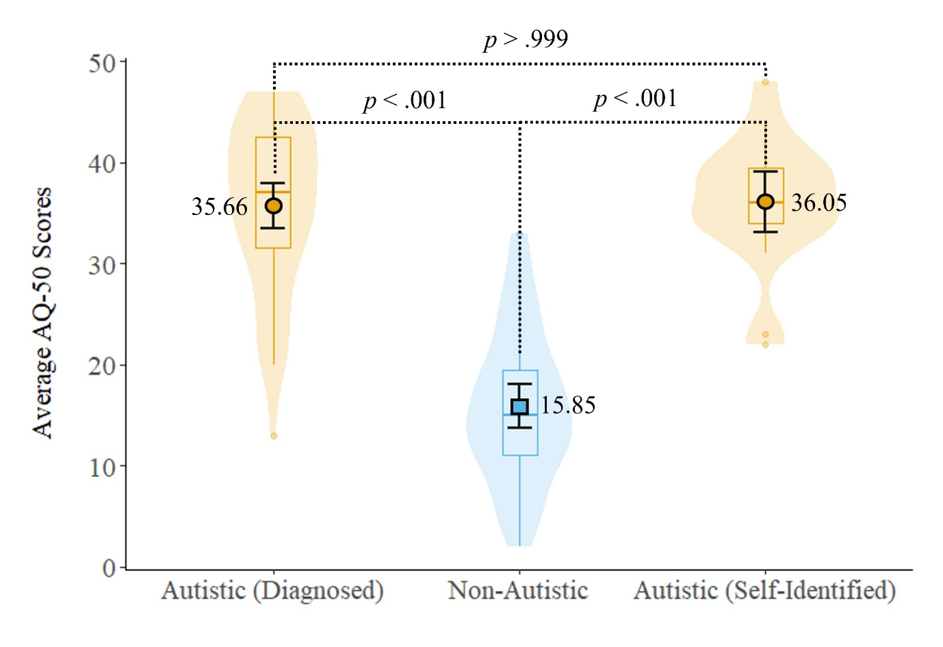

Figure 1

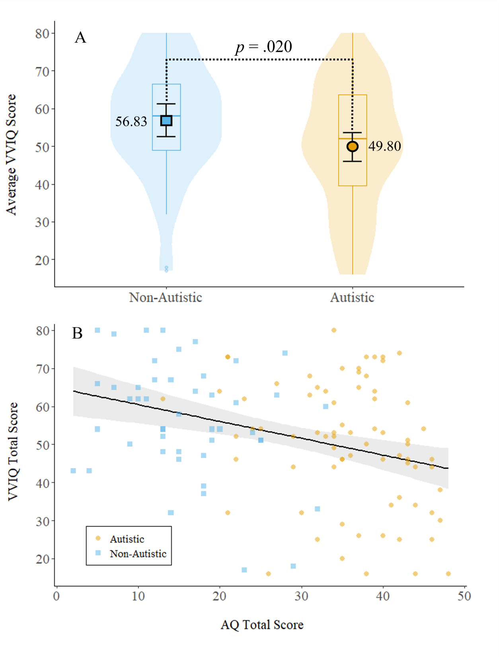

Figure 2

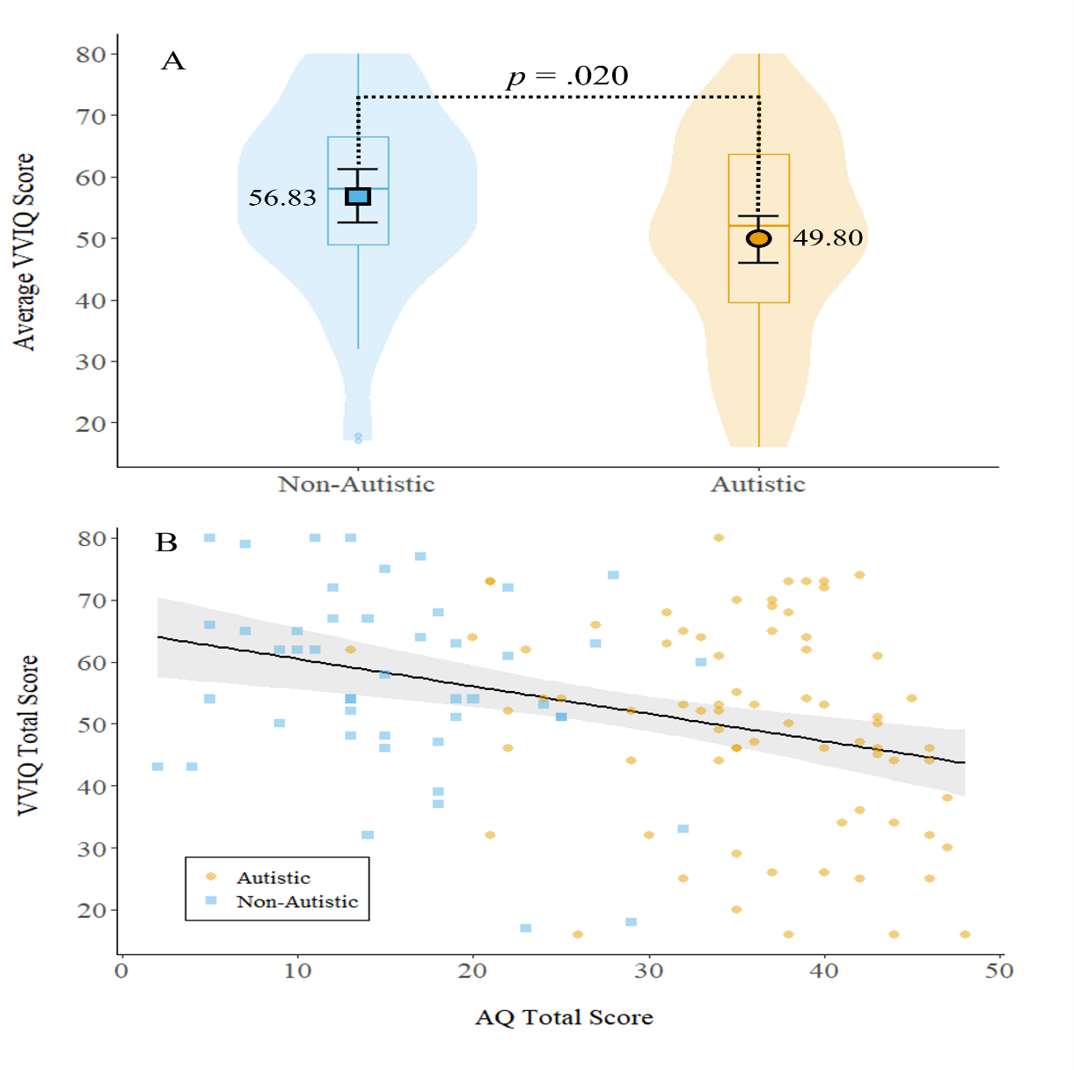

Figure 3

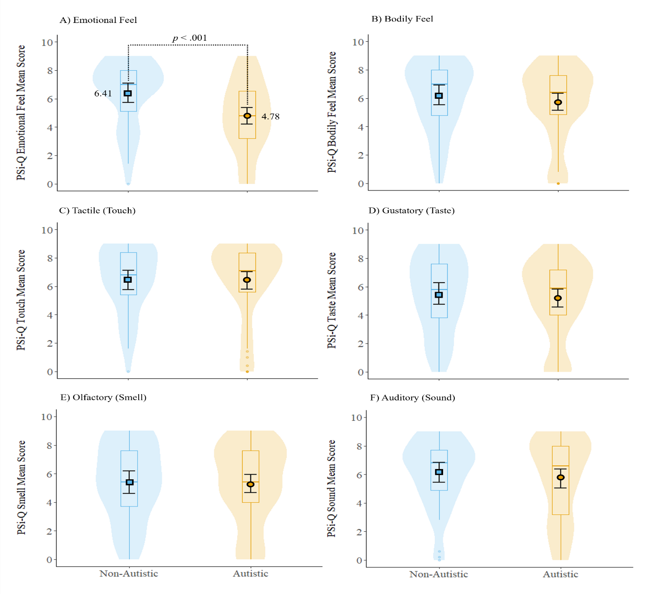

Figure 4