External workload intensity in cricket fast bowlers across maximal and submaximal intensities: Modifying PlayerLoad and IMU location
Corey Perrett ^{a,b,*}, Melanie Bussey ª and Peter Lamb ª
ª School of Physical Education, Sport and Exercise Sciences, University of Otago, Dunedin, New Zealand
^{b} Department of Sport and Exercise Sciences, University of Chichester, Chichester, UK

* Corresponding author: Tel 64 7936 678312, Email: @c.perrett@chi.ac.uk

Abstract
Workload is a commonly accepted risk factor for injury among fast bowlers, however many methods exist to characterise workload. Recently, automated intensity-sensitive measures like PlayerLoad have been used to improve the estimation of workload in fast bowlers. The purpose of this study was to determine whether similar variables could be extracted from a single inertial measurement unit (IMU) that highly correlate with intensity, according to release speed. Eight elite and pre-elite bowlers participated in the study, with each bowler bowling one over each at 60%, 80% and 100% intensity and repeating this across two sessions (36 balls per participant). IMUs were placed on the upper-back and non-bowling wrist and maximum PlayerLoad from each delivery (PL_{max}) was compared to the accumulated value across each delivery (PL_{acc}). The strongest correlation with release speed was with PL_{acc} from the non-bowling wrist (R = 0.74), followed by PL_{acc} from the upper-back (R = 0.65) and PL_{max} from the upper back (R = 0.60). Consequently, an improved estimation of the intensity at which bowlers are working at could be gained by examining accumulated PlayerLoad values from an IMU on the non-bowling wrist.

Key words
Workload, cricket, fast bowling,

INTRODUCTION
Injuries are common among cricket fast bowlers, often resulting in match-time loss, chronic health issues and premature retirement (Frost & Chalmers, 2012; Orchard et al., 2016). Although the aetiology and severity may differ between the type and location of injuries, the most commonly reported risk factor for all injuries is ‘workload’ (Alway et al., 2019; Dennis et al., 2003, 2005; Hulin et al., 2013; Orchard et al., 2009; Warren et al., 2018). A dual-risk threshold has been recognised for the relationship between workload and injury (Dennis et al., 2003), meaning that too high a workload can increase the risk of injury (e.g., overuse injury), while too low a workload may not sufficiently facilitate the positive adaptations as a result of training, therefore also increasing the risk of injury.
Workload, despite being a widely accepted risk factor, does not have an agreed upon definition (Udby et al., 2020) and its use as a proxy for describing the volume and intensity of exercise has even been disputed (Staunton et al., 2021). Commonly, workload in fast bowlers is only defined by the external load on the body, or total bowling volume (Hulin et al., 2013), measured as the number of balls bowled. Many methods of assessing external workload exist; common approaches include self-reporting the number deliveries (Dennis et al., 2005; Warren et al., 2018), retrospective scorecard examination (Dennis et al., 2003; Orchard et al., 2015; Orchard et al., 2016) and automatic detection of deliveries using inertial measurement units (IMUs) (Jowitt et al., 2020; McGrath et al., 2019; McNamara et al., 2015b). Assessment of workload may involve simply monitoring the number of overs bowled in a match (Orchard et al., 2009), the number of career overs (Orchard et al., 2015), or in other cases, workload variables such as the acute:chronic workload ratio (Ahmun, McCaig, Tallent, Williams, & Gabbett, 2019; Hulin et al., 2013; Warren et al., 2018) and ‘differential load’ (Tysoe et al., 2020) have been used.
Internal workload refers to the perceived effort or physiological demand of each ball, over, or spell of bowling, in terms of the amount of stress placed on the internal structures of the body. While variables such as rate of perceived exertion (RPE) or heart rate may provide estimates of internal workload (Feros et al., 2017; Hulin et al., 2013), neither measure closely approximates the mechanical ‘load’ placed on the body. Instead, internal workload measures indicate the intensity at which a bowler is working. So, while internal workload measures can indicate intensity, the bowling repetitions are unaccounted for, and while external workload tracks bowling volume, the intensity is left out. Since bowlers work across a range of intensities across warm-ups, trainings and matches (Petersen et al., 2011), an intensity-sensitive method of tracking workload would be helpful.
Microtechnology units such as IMUs have the potential for improving workload estimation and tracking in the field because they are simple to use, data extraction and reporting can be automated, and they are rapidly becoming more cost effective. Recent studies have shown some of the potential of IMUs in cricket applications, particularly when automatically detecting bowling events (Jowitt et al., 2020; McGrath et al., 2019; McNamara et al., 2015b). However, IMU data are recorded from multiple sensors with multiple channels recorded for each sensor, all of which vary temporally during the bowling movement, thus complicating the task of characterising the movement. Catapult Sports (Melbourne, Australia) developed a workload variable called PlayerLoad, which has been used as an intensity-sensitive estimate of external workload for fast bowling. PlayerLoad is calculated as the squared difference in acceleration in successive frames across each axis of the accelerometer fixed to the upper back. Often, the maximum PlayerLoad value from each delivery (PL_{max}) is extracted from the PlayerLoad time-series for examination (McNamara et al., 2015a, 2018). However, since PlayerLoad was originally developed for use in other sports such as rugby league, soccer, and Australian Rules Football, it is not clear whether PL_{max} provides a satisfactory estimate of external workload intensity for cricket fast bowlers. Additionally, different IMU mounting locations may lead to better estimations of external workload intensity – as can be found in other commercially available workload tracking technology, such as those offered by Motus (Motus Global, Seattle, WA) for other throwing activities, which use IMUs placed at a more distal end of the kinetic chain (e.g., elbow or wrist).
The aim of this study was to determine the concurrent validity of various external workload intensity measures using ball release speed as the intensity criterion, in a group of elite and pre-elite fast bowlers. The objectives of the study were to: 1) determine whether the integral of PlayerLoad across a delivery is a better proxy for intensity, according to release speed, than PL_{max}; 2) examine whether the location of the IMU affects the strength of association between PlayerLoad and release speed; and 3) determine whether the association between release speed and PlayerLoad persists when deliberately bowling at submaximal intensities.

MATERIALS AND METHODS
Participants
A sample of convenience comprised eight right-handed, male fast bowlers (age: 21 ± 3 years; height: 182 ± 6 cm; weight: 82 ± 9 kg) including first-class (n = 2), provincial A (n = 2) and provincial U19 players (n = 4). The sample size was smaller than anticipated (n = 15) due to the COVID-19 outbreak shortening the data collection period. All participants were free of lumbar stress fractures and disc herniations in the previous 12 months, provided written consent prior to data collection and considered themselves to be fully match-fit at both testing sessions. All procedures were approved by the University of XXXXX Ethics Committee (H19/138).
Study design
Two repeated testing sessions, one week apart, were used for this cross-sectional study. In each session, participants bowled three overs. Each over was bowled at a different prescribed intensity, two at submaximal intensities (60% and 80%) and one over at 100% intensity in a randomised order. At the beginning of each test session the bowlers were asked to warm-up as if they were bowling at 100% intensity first. During the warm-up, bowlers were equipped with the IMUs and asked to familiarise themselves with the run-ups (length and velocity) they would use at each intensity.
Equipment
To characterise the bowling delivery, Noraxon Ultium (Noraxon, Scottsdale, AZ, USA) multi-modal sensors were used and activated to measure IMU data only, sampling at 400 Hz. Each IMU contained a tri-axial accelerometer (±16 g), gyroscope (±2000°/s) and magnetometer (±4800 µT). One was placed in a GPS-unit harness attached to the athlete, located between the scapulae at the level of T6 and was orientated such that x and y axes aligned with vertical and mediolateral axes of the upper trunk, respectively. Another IMU was placed posteriorly on the non-bowling wrist aligned with the anatomical axis of the forearm, x vertical, y mediolateral.
Release speed was measured using a calibrated Stalker ATSII radar gun. The radar gun was held at arm’s-length, parallel to the ground by the experimenter who was standing 3 m behind the stumps at the bowler’s end. Due to space restrictions, this could not be held at the batter’s end, as recommended by Stalker.
A GoPro Hero 5 (GoPro, San Mateo, CA, USA) was set up on a tripod at a height of 1 m (frame rate 100 fps, ISO 800, and shutter speed 1/400). The camera was placed 3 m in front of the popping crease and angled so that the entire run-up, ball release and the first two steps of the follow through were visible for all participants.
Procedure
The IMU recording was started on the Noraxon software (MyoResearch MR3 3.13.38), followed by video. A light triggered by the software in the view of the camera was then used to allow synchronisation between the IMU data and video recording. At the start of the over, participants were informed of the prescribed intensity for the over and instructed to bowl to hit the top of off-stump for a right-handed batter from over the wicket. Release speed was recorded for every ball although, no feedback was provided to participants. At the conclusion of the sixth ball, both IMU and video recordings were stopped. This procedure was then repeated for the remaining two intensities. No balls or overs needed to be repeated, meaning there was complete IMU, video and ball speed data for 48 overs, or 288 balls.
Data reduction
Using Kinovea (version 0.8.15), the frame numbers of key events for each ball were identified. These were: the start of the run-up (heel strike of the first step); back-foot contact; front-foot contact; ball release and the end of the follow through (determined as the subsequent contact of the front-foot). These frame numbers were recorded, and along with release speed data were read into MATLAB (R2017b; The MathWorks Inc., Natick, MA) where all analyses were performed. Raw IMU data were filtered using a low-pass, double second-order Butterworth filter with a cut-off of 10 Hz (Winter, 2009) and each over was separated out into its six balls.
PlayerLoad was calculated from the filtered IMU outputs for each time point, f, in the delivery as (from Nicolella et al., 2018):
$$PL = \sqrt{\frac{{{(Ax}_{\left(f\right)}- {Ax}_{\left(f-1\right)})}^{2}+ {{(Ay}_{\left(f\right)}- {Ay}_{\left(f-1\right)})}^{2}+ {{(Az}_{\left(f\right)}- {Az}_{\left(f-1\right)})}^{2}}{100}}$$
Where A_{X}, is longitudinal acceleration, A_{Y} is mediolateral acceleration and A_{Z} is anterior-posterior acceleration.
The maximum value for PlayerLoad was determined for each ball, referred to as PL_{max}. Additionally, the integral of PlayerLoad was calculated across each delivery from the start of the run-up to the end of the follow-through, referred to as accumulated PlayerLoad (PL_{acc}). Release speed, PL_{max} and PL_{acc} from the upper-back and non-bowling wrist were normalised to each participant’s maximum values to reflect relative effort across the group.
Statistical analyses
Concurrent validity between PlayerLoad variables and release speed was determined using Pearson’s correlation. The Pearson correlation coefficients are reported along with corresponding 95% confidence intervals. To assess the fit of the linear regression models to release speed and PlayerLoad we examined the normalised root mean squared error (nRMSE) of the residuals relative to the mean value. Normalising RMSE allows models fit to different data to be compared, such as between maximum and accumulated PlayerLoad. Three potential PlayerLoad variables (upper-back PL_{acc}, non-bowling wrist PL_{max} and non-bowling wrist PL_{acc} were compared to the variable that has been the most commonly used in the literature, upper-back PL_{max}
To assess the inter-session reliability between measures, the intra-class correlation (ICC) type A-k: case 2 (McGraw & Wong, 1996) was used, which examines the degree of absolute agreement between sessions for measures that are an average of each intensity for every participant. Inter-session reliability was first examined in the performance variable, release speed, and then in the PlayerLoad variables.

RESULTS
The release speed of bowlers scaled with prescribed intensity when examined relative to participant maximums. There was a 5.2% difference between the 100% overs (96.8 ± 2.1%) and 80% overs (91.6 ± 3.4%), compared to a 4.9% difference between the 80% and 60 overs (86.7 ± 4.0%). A linear regression model fit to the data shows a 0.25% drop in release speed relative to participants’ maximums for every 1% decrease in prescribed intensity. There was a high degree of reliability in release speed between sessions (R = 0.82; 95% CI [0.62, 0.93]),
All intensities
Upper-back PL_{max} had a moderate association with release speed (R = 0.60, 95% CI [0.52, 0.67], while upper-back PL_{acc} had a slightly stronger association (R = 0.65; 95% CI [0.58, 0.71]). Seven of the eight participants also had a higher correlation between release speed and upper-back PL_{acc} (average R = 0.74) compared to upper-back PL_{max} (average R = 0.60). The normalised root mean squared error for upper-back PL_{acc} was 0.09 and 0.15 for upper-back PL_{max}, suggesting a slightly better fit for PL_{acc} from upper-back IMU. The inter-session reliability according to the intra-class correlation was slightly greater for upper-back PL_{acc} (R = 0.78) compared to upper-back PL_{max} (R = 0.76) (Table 1).
The strongest association with release speed was with PL_{acc} from the non-bowling wrist (R = 0.74; 95% CI [0.69, 0.79]). Non-bowling wrist PL_{acc} also had the highest average correlation coefficient for each participant (average R = 0.78), the equal lowest normalised root mean squared error (nRMSE = 0.09) and the highest inter-session reliability (R = 0.88).
[TABLE 1 NEAR HERE]
[FIGURE 1 NEAR HERE]

Maximal and submaximal intensities
The correlations between release speed and PlayerLoad variables were weaker when split by intensity (Table 2). PL_{max} from the upper-back had the strongest correlation in the 60% and 100% intensity overs, while PL_{acc} from the non-bowling wrist had the strongest correlation in the 80% intensity overs, which was also the strongest intensity-specific correlation overall.
The PlayerLoad variables varied considerably between participants across intensities, while release speed increased monotonically with prescribed intensity for all participants (Figure 2). PL_{acc} from the upper-back appeared to be the most similar to release speed for most participants. Of the PlayerLoad variable means, only PL_{acc} from the non-bowling wrist increased monotonically with prescribed intensity for all participants.
[TABLE 2 NEAR HERE]
[FIGURE 2 NEAR HERE]

DISCUSSION
The aim of this study was to determine the concurrent validity of various external workload intensity measures that could be used to better understand the stress placed on the internal structures of the body when bowlers work across a range of intensities. The objectives were to compare PL_{max} to PL_{acc} and examine whether the location of the IMU affected the strength of association between release speed and PlayerLoad variables. We also tried to determine whether the association between release speed and PlayerLoad was consistent when bowlers deliberately bowled at submaximal intensities.
Previous fast bowling studies have only examined PL_{max} (McNamara et al., 2015a, 2018); however, our results suggest that PL_{acc} calculated from an upper-back mounted IMU is a better estimate of intensity, according to release speed, compared to PL_{max} when calculated from the same IMU. Accumulated PlayerLoad likely provides a better estimate of the intensity at which a bowler is working, as it incorporates the entire delivery, from run-up to follow-through. For example, a faster run-up, which is an important factor in fast bowling performance (Glazier, Paradisis, & Cooper, 2000; Salter, Sinclair, & Portus, 2007; Worthington et al., 2013), can be accomplished either with higher acceleration or with a longer run-up and more gradual acceleration. Both instances will lead to higher accumulated values, meaning the intensity measure would be affected by run-up variables if the accumulated values were used. Conversely, PL_{max} is only sensitive to the peak change in acceleration over 0.005 seconds (when sampling at 400 Hz) and is unlikely to occur during the run-up, meaning PL_{max} is directly insensitive to workload associated with the run-up. Also, PL_{max} values are influenced by filtering and sample rate when calculated using the Cartesian equation (Nicolella et al., 2018). Filtering data more heavily will tend to reduce peak values in the data and, thus, PL_{max} values. Higher sample rates will also reduce PL_{max} values as the difference in acceleration between successive samples will be calculated over a shorter amount of time, resulting in a smaller change in acceleration. Consequently, it may be difficult to compare studies that have manually calculated PL_{max} to studies that have used PlayerLoad calculated with Catapult software. For example, in this study, there was an average PlayerLoad of 2.1 AU in the 100% deliveries. Comparatively, a “smoothed PlayerLoad” of 3.5 AU or greater is reported by Jowitt et al. (2020) as an important value for identifying fast bowling delivery instances. PL_{acc} values are less influenced by filtering and sample rate and should allow more valid comparisons across studies.
PL_{acc} calculated from the non-bowling wrist provided a slightly improved estimate of intensity, compared to PL_{acc} calculated from the upper-back (R = 0.74, R = 0.65, respectively). Additionally, an IMU on the non-bowling wrist could be used to distinguish between bowling events and throwing which both occur in games and training. It is recognised by McGrath et al. (2019) that trunk acceleration patterns are similar between bowling and throwing, which can result in throws being incorrectly classified as a bowl by the ball detection algorithms (Jowitt et al., 2020; McGrath et al., 2019; McNamara et al., 2015b). Although it is not yet known, it is plausible that having the IMU on the non-bowling wrist may help with ball detection, as the movement of the non-bowling wrist during bowling and throwing are likely more different than the upper-back. However, the upper-back location should not be completely disregarded either. Four participants had a stronger association with release speed for PL_{acc} calculated from the upper-back compared to the non-bowling wrist. Also, the consequence of determining a false positive ball (e.g., if throws are incorrectly classified as bowls) should also be considered as a throw still places a (albeit, reduced) load on the body.
In general, release speeds were consistent within each intensity, with the largest variance in release speed seen in the 80% overs for five of the eight participants. Therefore, it may be expected that within-intensity correlations between release speed and PlayerLoad may be weaker than correlations across intensities (particularly in the 60% and 100% overs where there was the least variance in release speed), as smaller differences require a more sensitive measure to detect the effect. However, the validity of potential workload variables at submaximal intensities is an important consideration and should be examined across different participants with differing movement patterns. To our knowledge, no studies have examined how bowlers change their technique to bowl at submaximal intensities – the way in which they do may affect the accuracy of workload estimates. For example, if a bowler keeps trunk movement fairly similar across all intensities, with a large change in arm speed, then PlayerLoad from the upper-back may not be a valid estimate of intensity nor workload. Potential variables should also be examined in both male and female bowlers, who generally employ different techniques to generate release speed (Felton et al., 2019).
Good inter-session reliability was found in this study for PL_{max} from the upper-back (R = 0.78), similar to that reported in other sports, such as AFL (Boyd et al., 2011), football (Barreira et al., 2017), handball (Luteberget et al., 2018), as well as in general laboratory conditions (Nicolella et al., 2018). However, none of these instances validate PlayerLoad that is calculated from the upper-back as a workload variable, particularly in fast bowlers, where sequential proximal to distal rotations of the pelvis, thorax and bowling arm contribute to ball speed (Zhang et al., 2011). It is recognised that PlayerLoad has been used in calculations for external workload (Jowitt et al., 2020; McNamara et al., 2015a), however, future studies should refer to PlayerLoad as an intensity measure rather than a workload measure.
The main limitation in this study is the use of release speed as the intensity measure. It is recognised that there may be some instances where release speed is not an accurate estimate of intensity and/or effort, such as when a bowler is fatigued or when bowling slower balls in an attempt to deceive batters (e.g., leg-cutters, off-cutters etc.) When bowling regular, seam-up deliveries at submaximal intensities, any number of variables relating to run-up speed, run-up length, effort at the crease etc. can be changed while keeping release speed constant. The changes to these aforementioned variables will alter the stresses experienced by the internal structures of the body (i.e., the workload) which may not be detected by intensity-sensitive external workload measures like release speed. However, in this study no deceptive slower balls were bowled, spell lengths were short, and the order of overs was randomised to reduce the effects of fatigue as a confounding factor, meaning that release speed was likely a good indication of intensity. Future studies may aim to identify intensity variables that are more sensitive to the internal loading experienced by the body in a range of situations, such as when fatigued.

CONCLUSION
IMUs can provide an estimate of external workload intensity in fast bowlers. While maximum PlayerLoad has been commonly adopted by elite cricket teams, a workload measure that more closely scales with ball release speed is accumulated PlayerLoad from the non-bowling wrist. Accumulated PlayerLoad calculated from the non-bowling wrist should be further investigated as a potential workload variable in larger samples encompassing wider skill levels, including females.

Acknowledgments
The authors would like to thank Nigel Barrett for technical support and assistance. The first author was financially supported by the University of Otago Doctoral Scholarship.

Declaration of interest statement
The authors have no conflicts of interest to declare

REFERENCES
Ahmun, R., McCaig, S., Tallent, J., Williams, S., & Gabbett, T. (2019). Association of daily workload, wellness, and injury and illness during tours in international cricketers. International Journal of Sports Physiology and Performance, 14(3), 369–377. https://doi.org/10.1123/ijspp.2018-0315
Alway, P., Brooke-Wavell, K., Langley, B., King, M., & Peirce, N. (2019). Incidence and prevalence of lumbar stress fracture in English County Cricket fast bowlers, association with bowling workload and seasonal variation. BMJ Open Sport & Exercise Medicine, 5(1), e000529. https://doi.org/10.1136/bmjsem-2019-000529
Barreira, P., Robinson, M. A., Drust, B., Nedergaard, N., Raja Azidin, R. M. F., & Vanrenterghem, J. (2017). Mechanical Player LoadTM using trunk-mounted accelerometry in football: Is it a reliable, task- and player-specific observation? Journal of Sports Sciences, 35(17), 1674–1681. https://doi.org/10.1080/02640414.2016.1229015
Boyd, L. J., Ball, K., & Aughey, R. J. (2011). The reliability of minimaxx accelerometers for measuring physical activity in australian football. International Journal of Sports Physiology and Performance, 6(3), 311–321. https://doi.org/10.1123/ijspp.6.3.311
Dennis, R. J., Farhart, R., Goumas, C., & Orchard, J. (2003). Bowling workload and the risk of injury in elite cricket fast bowlers. Journal of Science and Medicine in Sport, 6(3), 359–367. https://doi.org/10.1016/S1440-2440(03)80031-2
Dennis, R. J., Finch, C. F., Farhart, P. J., James, T., & Stretch, R. A. (2005). Is bowling workload a risk factor for injury to Australian junior cricket fast bowlers? British Journal of Sports Medicine, 39(11), 843–846. https://doi.org/10.1136/bjsm.2005.018515
Felton, P. J., Lister, S. L., Worthington, P. J., & King, M. A. (2019). Comparison of biomechanical characteristics between male and female elite fast bowlers. Journal of Sports Sciences, 37(6), 665–670. https://doi.org/10.1080/02640414.2018.1522700
Feros, S., Young, W., & O’Brien, B. (2017). Real-time prediction of internal load during cricket fast bowling. Journal of Science and Medicine in Sport, 20, 53. https://doi.org/10.1016/j.jsams.2017.09.299
Frost, W. L., & Chalmers, D. J. (2012). Injury in elite New Zealand cricketers 2002–2008: descriptive epidemiology. British Journal of Sports Medicine, 48(12), 1002–1007. https://doi.org/https://10.1136/bjsports-2012-091337
Glazier, P. S., Paradisis, G. P., & Cooper, S. M. (2000). Anthropometric and kinematic influences on release speed in men’s fast-medium bowling. Journal of Sports Sciences, 18(12), 1013–1021. https://doi.org/10.1080/026404100446810
Hulin, B. T., Gabbett, T. J., Blanch, P., Chapman, P., Bailey, D., & Orchard, J. W. (2013). Spikes in acute workload are associated with increased injury risk in elite cricket fast bowlers. Journal of Science and Medicine in Sport, 16(1), 95–96. https://doi.org/10.1016/j.jsams.2013.10.229
Jowitt, H. K., Durussel, J., Brandon, R., & King, M. (2020). Auto detecting deliveries in elite cricket fast bowlers using microsensors and machine learning. Journal of Sports Sciences, 38(7), 767–772. https://doi.org/10.1080/02640414.2020.1734308
Luteberget, L. S., Holme, B. R., & Spencer, M. (2018). Reliability of wearable inertial measurement units to measure physical activity in team handball. International Journal of Sports Physiology and Performance, 13(4), 467–473. https://doi.org/10.1123/ijspp.2017-0036
McGrath, J. W., Neville, J., Stewart, T., & Cronin, J. (2019). Cricket fast bowling detection in a training setting using an inertial measurement unit and machine learning. Journal of Sports Sciences, 37(11), 1220–1226. https://doi.org/10.1080/02640414.2018.1553270
McGraw, K. O., & Wong, S. P. (1996). Forming Inferences about Some Intraclass Correlation Coefficients. Psychological Methods, 1(1), 30–46. https://doi.org/10.1037/1082-989X.1.1.30
McNamara, D. J., Gabbett, T. J., Blanch, P., & Kelly, L. (2018). The relationship between variables in wearable microtechnology devices and cricket fast-bowling intensity. International Journal of Sports Physiology and Performance, 13(2), 135–139. https://doi.org/10.1123/ijspp.2016-0540
McNamara, D. J., Gabbett, T. J., Chapman, P., Naughton, G., & Farhart, P. (2015a). Variability of Player Load, Bowling Velocity, and Performance Execution in Fast Bowlers Across Repeated Bowling Spells. International Journal of Sports Physiology & Performance, 10(8), 1009. https://doi.org/https://doi.org/10.1123/ijspp.2014-0497
McNamara, D. J., Gabbett, T. J., Chapman, P., Naughton, G., & Farhart, P. (2015b). The validity of microsensors to automatically detect bowling events and counts in cricket fast bowlers. International Journal of Sports Physiology and Performance, 10(1), 71–75. https://doi.org/10.1123/ijspp.2014-0062
Nicolella, D. P., Torres-Ronda, L., Saylor, K. J., & Schelling, X. (2018). Validity and reliability of an accelerometer-based player tracking device. PLoS ONE, 13(2). https://doi.org/10.1371/journal.pone.0191823
Orchard, J. W., Blanch, P., Paoloni, J., Kountouris, A., Sims, K., Orchard, J. J., & Brukner, P. (2015). Cricket fast bowling workload patterns as risk factors for tendon, muscle, bone and joint injuries. British Journal of Sports Medicine, 49(16), 1064–1068. https://doi.org/10.1136/bjsports-2014-093683
Orchard, J. W., James, T., Portus, M. R., Kountouris, A., & Dennis, R. (2009). Fast bowlers in cricket demonstrate up to 3- to 4-week delay between high workloads and increased risk of injury.(Report). American Journal of Sports Medicine, 37(6), 1186–1192. https://doi.org/10.1177/0363546509332430
Orchard, J. W., Kountouris, A., & Sims, K. (2016). Incidence and prevalence of elite male cricket injuries using updated consensus definitions. Open Access Journal of Sports Medicine, 7, 187–194. https://doi.org/10.2147/OAJSM.S117497
Petersen, C., Pyne, D., Dawson, B., Kellett, A., & Portus, M. R. (2011). Comparison of Training and Game Demands of National Level Cricketers. J Strength Cond Res, 25(5), 1306–1311.
Salter, C. W., Sinclair, P. J., & Portus, M. R. (2007). The associations between fast bowling technique and ball release speed: A pilot study of the within-bowler and between-bowler approaches. Journal of Sports Sciences, 25(11), 1279–1285. https://doi.org/10.1080/02640410601096822
Staunton, C. A., Abt, G., Weaving, D., & Wundersitz, D. W. T. (2021). Misuse of the term ‘load’ in sport and exercise science. Journal of Science and Medicine in Sport. https://doi.org/10.1016/J.JSAMS.2021.08.013
Tysoe, A., Moore, I. S., Ranson, C., McCaig, S., & Williams, S. (2020). Bowling loads and injury risk in male first class county cricket: Is ‘differential load’ an alternative to the acute-to-chronic workload ratio? Journal of Science and Medicine in Sport, 23(6), 569–573. https://doi.org/10.1016/j.jsams.2020.01.004
Udby, C. L., Impellizzeri, F. M., Lind, M., & Nielsen, R. Ø. (2020). How Has Workload Been Defined and How Many Workload-Related Exposures to Injury Are Included in Published Sports Injury Articles? A Scoping Review. Journal of Orthopaedic & Sports Physical Therapy, 50(10), 538–548. https://doi.org/10.2519/JOSPT.2020.9766
Warren, A., Williams, S., McCaig, S., & Trewartha, G. (2018). High acute:chronic workloads are associated with injury in England &amp; Wales Cricket Board Development Programme fast bowlers. Journal of Science and Medicine in Sport, 21(1), 40–45. https://doi.org/10.1016/j.jsams.2017.07.009
Worthington, P. J., King, M. A., & Ranson, C. A. (2013). Relationships between fast bowling technique and ball release speed in cricket. Journal of Applied Biomechanics, 29(1), 78–84. https://doi.org/10.1123/jab.29.1.78
Zhang, Y., Unka, J., & Liu, G. (2011). Contributions of joint rotations to ball release speed during cricket bowling: A three-dimensional kinematic analysis. Journal of Sports Sciences, 29(12), 1293–1300. https://doi.org/10.1080/02640414.2011.591417

Table 1. Association between normalised release speed and both maximum PlayerLoad (PL_{max}) and accumulated PlayerLoad (PL_{acc}) calculated from the upper-back and non-bowling wrist. Pearson’s correlation coefficient (R), 95% confidence interval (CI), normalised root mean square error (nRMSE), average participant correlation coefficient (R) and inter-session reliability according to intra class correlation (ICC) are reported.
 |  | R [95% CI] | nRMSE | Average within-participant R | ICC  [95% CI]
Non-bowling wrist | PL_{max} | 0.44  [0.34, 0.53] | 0.31 | 0.54 | 0.85  [0.57, 0.94]
 | PL_{acc} | 0.74  [0.69, 0.79] | 0.09 | 0.78 | 0.88  [0.75, 0.95]
Upper back | PL_{max} | 0.60  [0.52, 0.67] | 0.15 | 0.60 | 0.78  [0.47, 0.90]
 | PL_{acc} | 0.65  [0.58, 0.71] | 0.09 | 0.74 | 0.76  [0.38, 0.90]

Table 2. Association between normalised release speed and normalised PlayerLoad variables at each intensity. Variable name, intensity, Pearson’s correlation coefficient and 95% confidence interval (CI) are shown in each column.
Variable | Intensity | R [95% CI]
NBW  PL_{acc} | 60% | 0.32 [0.12, 0.48]
 | 80% | 0.57 [0.42, 0.69]
 | 100% | 0.25 [0.05, 0.43]
UB  PL_{acc} | 60% | 0.22 [0.02, 0.40]
 | 80% | 0.40 [0.22, 0.56]
 | 100% | 0.20 [0.00, 0.39]
NBW  PL_{max} | 60% | 0.23 [0.03, 0.41]
 | 80% | 0.31 [0.12, 0.48]
 | 100% | 0.32 [0.13, 0.49]
UB  PL_{max} | 60% | 0.37 [0.18, 0.53]
 | 80% | 0.48 [0.31, 0.62]
 | 100% | 0.35 [0.16, 0.52]
NBW = non-bowling wrist; UB = upper-back; PL_{acc} = accumulated PlayerLoad; PL_{max} = maximum PlayerLoad

Figure 1
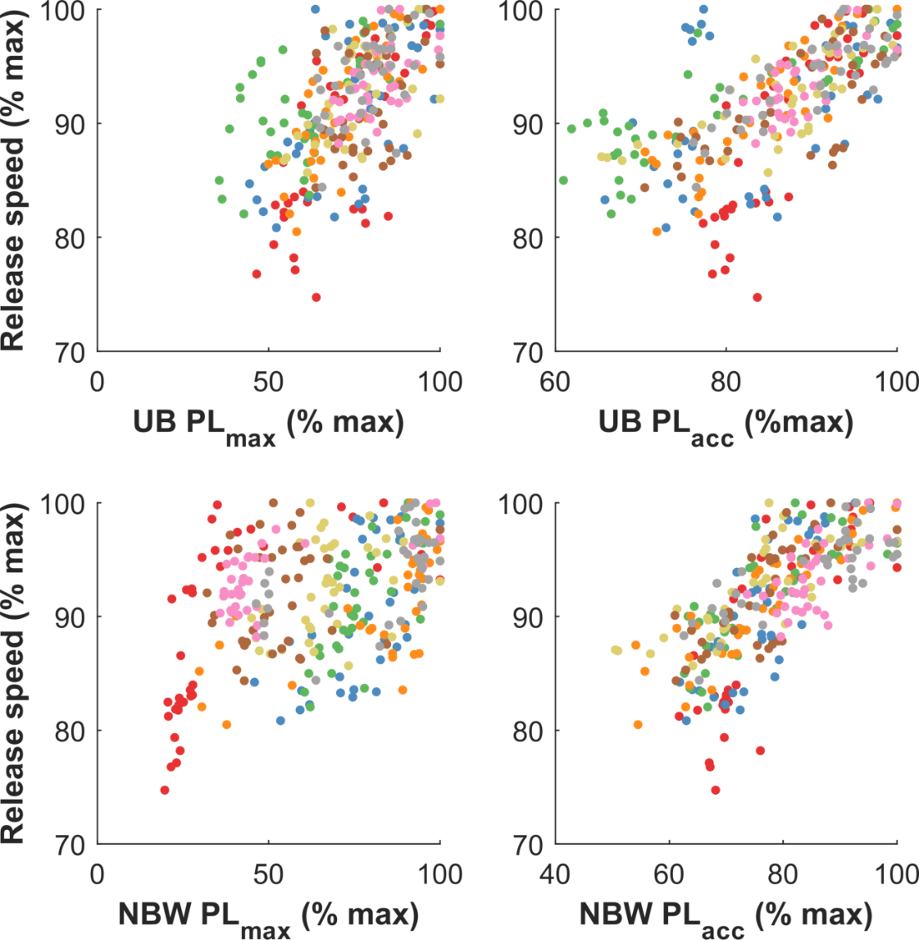

Figure 2
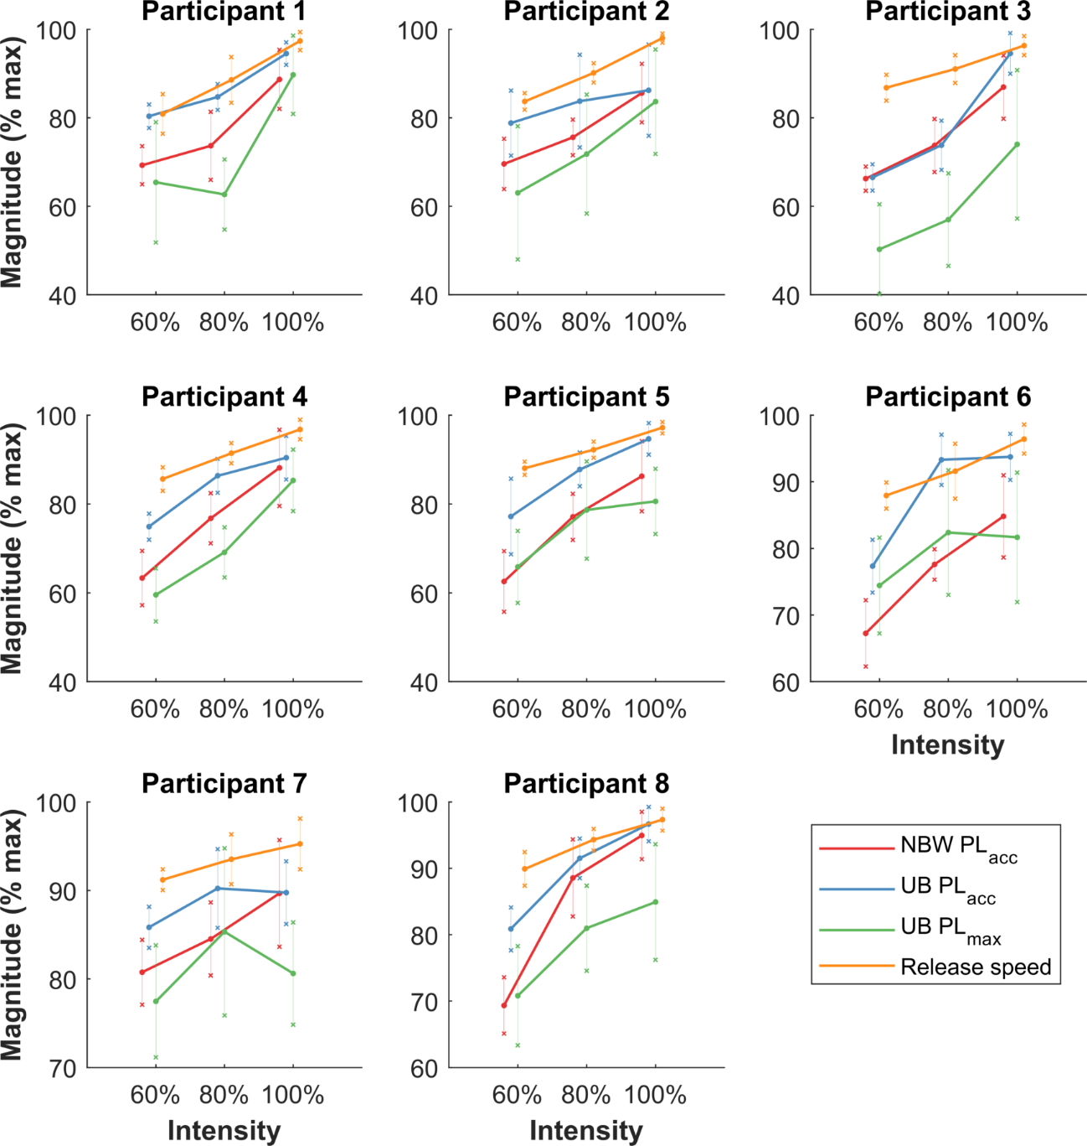
Figure captions

Figure 1. Scatterplot of release speed versus each PlayerLoad variable and IMU location for all balls bowled. Top two subplots show upper-back (UB) PL_{max} (left) and PL_{acc} (right) versus release speed. Bottom two subplots show non-bowling wrist (NBW) PL_{max} (left) and PL_{acc} (right) versus release speed. All data are normalised relative to participant maximum values.
Figure 2. Mean ± standard deviation for the three most valid PlayerLoad variables (PL_{acc} from the non-bowling wrist and upper-back, and PL_{max} from the upper-back) and release speed at each intensity. Data are normalised relative to participant maximum values. PL_{max} from the non-bowling wrist excluded for readability.

Peak longitudinal acceleration on a bowling wrist sensor exceeded the limits of the IMUs and was, therefore, excluded from the analysis.

