Keywords

imagery; creativity; measurement; dance; choreography; training; flexibility; fluency;
originality; novelty

Highlights

• development of workshops to develop dance students’ metacognitive imagery skills

• development and validation of a repeatable measure of flexible thinking

• training improved students’ scores on the flexible thinking test

• training improved students’ creativity on an objective choreographic assessment

• creativity can be enhanced through developing skills in the use of mental imagery

Supplemental materials

Training materials, assessment materials, data and analysis scripts are available from the project website [-------masked -------] and from the Open Science Framework at doi: [-----
---masked--------]

Enhancing creativity 1

Enhancing creativity by training metacognitive skills in mental imagery

Jon May1, Emma Redding2, Sarah Whatley3, Klara Lucznik1, Lucie Clements4, Rebecca Weber5, John Sikorski1, and Sara Reed3

1School of Psychology, Plymouth University, Drake Circus, Plymouth UK-PL4 8AA

2Trinity Laban Conservatoire of Music and Dance, Creekside, London UK-SE8 3DZ

3C-DARE, Coventry University, Priory Street, Coventry, UK-CV1 5FB

4Institute of Education, Health & Social Sciences, University of Chichester

5Dance Studies, University of Auckland, New Zealand.

Corresponding Author: Professor Jon May, School of Psychology University of Plymouth,
Drake Circus, Plymouth UK-PL4 8AA Jon.may@plymouth.ac.uk
ORCID: 0000-0001-7439-9200

Conflict of Interests: None.

5480 words excluding abstract, and references.

Enhancing creativity 1

Enhancing creativity by training metacognitive skills in mental imagery

Abstract

In a longitudinal study, 240 undergraduate dance students were recruited to assess the effectiveness of a series of workshops designed to develop metacognitive skills in use of mental imagery to support choreographic creativity. The workshops were based upon a theoretical model of mental representations and cognition. The students also completed a creativity test before the workshops, and a newly designed test of flexible thinking before and after the workshops, and a year later. Five forms of the flexible thinking test were created to allow for repeated administration over time, and the forms were shown to be equivalent and
to correlate with the creativity test. Students who had taken part in the imagery workshops showed a greater improvement in flexible thinking a year after the training, compared to the scores of students who had not received the training. Evaluations of choreographic assessments by the students’ teachers were rated for positive and negative mentions of imagery and creativity, and the control group scored higher than the imagery group on use of imagery immediately after the training, but lower than the imagery group on both creativity and use of imagery four months after the workshop. The findings provide some support for the idea that domain-specific creativity can be enhanced through developing skills in the use of mental imagery to produce novel ideas, and that this also improves domain-general flexible thinking.

227 words

Introduction

In popular culture, creativity is often viewed as a more or less fixed trait that some people possess in abundance while most of us do not. For example, Kaiser (2018) wrote
‘There’s no argument anymore. Neuroscience confirms that highly creative people think and act differently than the average person. Their brains are literally hardwired in a unique way.’ To answer ‘What makes highly creative people different from the rest of us?’ Gregoire (2016) concluded that two brain networks were involved, and that ‘the creative brain is particularly good at flexibly activating and deactivating these brain networks, which in most
people are at odds with each other.’ This popular view is not shared by creativity researchers, who accept that creativity is the result of many cognitive processes, which develop over time (Runco, 2016) and can thus potentially be trained to enhance creativity.

In this paper we develop and evaluate novel, theory-based training materials based upon metacognitive imagery skills, and create a brief test of creativity that can be used repeatedly in longitudinal studies. We show that five different forms of this test are
equivalent and correlate with a widely used test of creativity. We then use these materials in a longitudinal study to assess the effect of an imagery-based intervention upon flexible
thinking, and hence creativity. We also collect objective evaluations from domain specific creative tasks, and show that these are also improved by the intervention.

Measuring changes in creativity

There have been many attempts to train or improve creativity, and a review of 70 studies (Scott, Leritz & Mumford, 2004a, 2004b) concluded that training could indeed enhance creativity, with an average effect size d = 0.64. Paradoxically, a content analysis of the training courses indicated that the largest effects upon creativity came from courses that

emphasised analytic approaches to solving divergent problems: constraint identification, critical thinking, convergent thinking and metacognition. Training in expressive activities, imagery, metaphors, illumination and elaboration had a negative relationship with effect size. One interpretation of these findings is that the techniques that led to the best performance were those that helped people make the poorly-defined or ambiguous problems typical in divergent tasks more amenable to convergent solution: allowing non-creative thought to
work.

Scott et al. conclude that the most effective training included the generation of new ideas, specifically problem finding, conceptual combination, and idea generation, in line with the idea that creative problem solving involves the initial divergent production of novel ideas followed by the convergent selection and development of the useful ones. Koestler (1964) defined creativity as ‘the defeat of habit by originality’ (Koestler, 1964), and Campbell
(1960) described it as a result of the two processes of ‘blind variation and selective retention’. This long-established view of creativity recognises that creative products result from a great deal of effortful work, involving the generation, recognition, selection, evaluation, and elaboration of ideas related to a task or problem (Simonton, 2011). Without the initial generation of unusual ideas, habit cannot be defeated; but unless the useful ideas are recognised and selected from amongst the unusable ideas, no amount of elaboration will produce a truly original product.
Scott et al. also point out theoretical and methodological weaknesses in many creativity training studies. Based on their analysis, they advocate that training should have a firm theoretical basis for the cognitive activities underlying creative efforts; training should be lengthy and challenging, with principles being applied to relevant ‘real-world’ problems; and with exercises appropriate to the domain of interest. They also criticise studies where

post-tests of creativity were made immediately after training, and the testing used materials similar to the training materials, with little or no transfer problems.
Valgeirsdottir & Onarheim (2017) updated Scott et al’s review, finding another 22 studies, and similarly criticised them for methodological inconsistencies, especially variations in reporting results and measures of creativity. They argued that future studies of creativity training needed to meet three criteria: 1) pre- and post-training measures of creativity; 2) a control group; and 3) sufficient sample size (recommending at least 64 people over both intervention and control). Barbot (2019) reiterated these methodological criticisms, and made recommendations about the measurement of creativity, recommending inter alia measures with alternative forms that can be administered repeatedly in counterbalanced designs; measures of the constructs under investigation rather than ‘generic’ measures; and performance-based measures requiring creative action.
Given the emphasis in the creativity and problem solving literature upon problem representation, illumination and elaboration, it is puzzling that Scott et al. did not find that training in these specific skills improved creativity. It may be that these skills are particularly hard to train, that making people aware of their importance is not sufficient to support their application in practice when faced with an assessment. We argue that mental imagery is an essential component of problem representation and the generation of novel ideas, and that its use and application is subject to strategic skills that can be acquired, developed and practiced. Accordingly, we set out to develop a suite of training and assessment materials based upon a theoretical model of mental imagery, following the recommendations of Scott et al (2004), Valgeirsdottir & Onarheim (2017), and Barbot (2019) for the design and evaluation of a creativity intervention.

Creativity and Imagery in Choreography

We chose to work in the domain of choreographic creativity, because contemporary dance places a high value in novelty and creativity, and dance teachers have used mental imagery as part of their pedagogical repertoire for many years (Overby & Dunn, 2011). Todd (1975) described her anatomically-based imagery as a method of refining neuromuscular
co-ordination, and these ideas were further developed by Sweigard (1978), who popularised the term ideokinesis, meaning an idea of movement. Her aim was to help dancers develop greater control over their posture and spinal alignment, to unlearn bad movement habits and make new ways of moving automatic.

Franklin (1996) extended this idea, arguing that mental imagery supported changes in the mental representation of movement that were necessary precursors for physical changes in the musculature, enabling a wider movement repertoire. Similar ideas have become popular within sports psychology, where research has shown benefits for practitioners of imagining movement when combined with physical practice or when opportunities for actual movement are limited by for example, injury (Schuster, Hilfiker, Oliver et al., 2011). The development of the Dance Imagery Questionnaire (DIQ; Nordin & Cummings, 2006) was driven by a perceived need to link research into dance imagery with work in the sports domain, where Hall, Mack, Paivio & Hausenblas (1998) had identified imagery as supporting cognitive skill, cognitive strategies, goal-oriented motivation and mastery motivation.

Beyond the physical and motivational aspects, imagery has also been used to intervene with dancers’ cognitive representations of movement. Overby, Hall & Haslem (1988) identified different forms of sensory imagery (visual, auditory and kinaesthetic), perspectives (first or third person views), and referent (contextual, character or metaphor)

used by dance teachers and sport coaches to enrich their range and style of movement, and a review by Overby & Dunn (2011) concluded that kinaesthetic imagery helped with skill development, and metaphorical imagery with skill learning, both forms having beneficial effects upon performance.

This supports earlier work by Rosenberg and Trusheim (1989) reporting the ways that a variety of creative artists including dancers used mental imagery in their work, although other work in this area has produced ambiguous results. Morrison and Wallace (2001) emphasised the need to distinguish between participation and achievement in creative arts, finding that individual differences in visual imagery vividness were related to psychometric measures of divergent production and fluency, but not to ratings of creativity provided by judges or to a self-report creative behaviour inventory. Vivid imagery supported creativity but creativity was more than vividness; the original ideas had to be worked upon and selected, as argued by Campbell (1960).

In their recent review of motor imagery research, Moran, Guillot, MacIntyre & Collet (2012) conclude that meta-imagery processes, or people’s knowledge of and control over their own mental imagery skills and experiences, is a key new direction for imagery researchers, citing evidence that people have little insight into the role that imagery plays in behaviour on tasks such as mental scanning or rotation, or in its effects upon motor performance.

Our metacognitive, imagery-based creativity training applies a cognitive theory of mental representations called Interacting Cognitive Subsystems (ICS, Barnard, 1985). ICS distinguishes between three internal ‘cognitive loops’ that give rise to imagery about space and movement, sound and speech, and intuitive emotional schemas, respectively. These loops are linked together through a common sense of meaning. Working with the educational arm
of Wayne McGregor’s dance company Random Dance and its research director Scott

deLahunta, Barnard helped to develop a set of training materials for secondary school pupils studying dance (McGregor, 2013). These gave the pupils practical experience in working with their mental imagery to gain confidence in manipulating ideas in their minds, moving between visual imagery, sound imagery, and emotional imagery. The materials included a named set of twelve mental transformations that could be applied to a mental representation, and diagrams to provide a link between the core ideas and practical tasks (Figure 1).

Figure 1

We took the core conceptual ideas from Mind and Movement and worked with choreography teachers at two leading UK dance schools, [-material masked ---------------------
----------------------------------------------------------------------------------------------------------------

--------------], to produce a new suite of materials, with content suitable for students on undergraduate dance programmes. Our intention was to build on the model of imagery based creativity proposed by McGregor (2013) to give dance students the confidence to incorporate imaginal strategies when faced with creative tasks in their choreography.

Our final [---masked------] materials included 37 separate exercises which could be selectively combined in a modular fashion to support the delivery of six ‘targets’ (learning objectives). These targets were to introduce students to basic phenomena in mental imagery; to experience manipulating their visual imagery, their sound imagery, and their emotional schematic imagery; and then to move between these forms of imagery in a creative manner; before extending these exercises into the physical domain of movement creation. Some exercises were didactic, with video-based delivery by a member of the research team; others were movement based, so that students could experience the relationship between imagery and dance; some were discursive and reflective. These exercises were supported by posters, flash-cards and a revised set of ‘principles’ based upon the twelve mental transformations,

grouped into sets that helped students to modify a whole image, edit part of an image, or modify their mental image. The full set of materials is available online at the project website [---masked------]

As recommended by Scott et al. (2004a), Valgeirsdottir & Onarheim (2017) and

Barbot (2019) we evaluated these materials using a pre-post design, including a control

group. The training was embedded within the curriculum at two higher education institutions, which meant that we could not randomly allocate students within each institution to control and imagery training groups. Even if the teaching staff had been prepared to support this, and the timetable and teaching resources had been available to divide the students between two different courses, dance students necessarily work collaboratively throughout their course and the intervention group would share resources and materials with the control group, making comparisons impossible. The two institutions differed substantially in size, had different staff, and course design, so we could not treat one as the intervention and the other as the control; and if we had, then any differences might have been due to the institution rather than the intervention. Instead, students at both institutions beginning their course in the first year of
the study served as the ‘education as normal’ control group, and all students beginning their course in the subsequent year served as the intervention group, receiving the imagery training. A cohort-based design has obvious weaknesses, as any effects of the intervention will be confounded with other co-incidental changes in teaching provision or differences in recruitment, but as all of the students being taught together would form a cohort however we designed the study, we felt that comparing different years of students within an institution was the best way to compare an existing with a revised course designs.

Our post-test was scheduled for a year after the delivery of the training, to allow students time to practice using the imaginal strategies and to incorporate them into their normal choreographic practice. Although we also included a post-test soon after the training,

we did not expect students to have had the opportunity to become confident in the imaginal strategies at this point.

Method

Participants

We recruited 240 dance students in total, 111 to the control group in the 2015-16 academic session (76 females, 68%; 24 males, 22%; 11 did not state sex), and 129 to the imagery group in 2016-17 (103 females, 80%, 24 males, 19%; 2 did not state sex). 204 were recruited from [--------------------------masked-----------------------]; and 36 from a smaller programme at [------------masked------] Ages at recruitment overall ranged from 17.9 years to
28.2 years, with a median of 19.0, and did not differ between groups t(238) = 0.25, p = .800 or institution t(238) = 0.44, p = .662. There were 187 whose native language was English, and 53 (22%) who spoke English as a second language. All of the latter spoke English to IETL Level 6 (Competent User, with effective command of the language despite some inaccuracies).

Materials

Baseline Creativity

We used the Abbreviated Torrance Test for Adults (ATTA, Goff & Torrance, 2002) as a general baseline measure of creativity. The test consists of three activities, each lasting three minutes. In Activity 1, participants list problems that might result from an unfamiliar situation; in Activity 2, participants use two incomplete line drawings to make some unusual pictures that tell a story; in Activity 3, participants create pictures based on a 3x3 matrix of identical geometrical shapes. The test is scored using four norm referenced measures of

fluency, originality, elaboration, and flexibility, which are summed to provide the ATTA Creativity Index ranging from zero to 100, which is then binned into a 1 to 7 ordinal categorical measure, the ATTA Creativity Level.
An initial sample of 12 randomly selected booklets were scored by two researchers, to obtain a measure of inter-rater reliability, achieving an IRR of .87. (indicating a very good level of reliability between raters; McHugh, 2012). The remaining booklets were divided between the two researchers. Any queries which arose during scoring were discussed by the two researchers. Halfway through the scoring process, a further random 12 questionnaires were scored by both researchers, this time achieving an IRR of.82.

Longitudinal Flexible Thinking Tasks

As the ATTA can only be administered to an individual once, we also created five forms of a Flexible Thinking Test (FTT), intended to allow repeated measurement of creativity, as recommended by Barbot (2019). We based the FTT on three tests from the Comprehensive Ability Battery (Hakastian & Cattell, 1975): Ideational Fluency, Spontaneous Fluency, and Originality. These three tests had previously been found to cohere as a flexible thinking factor and to correlate with performance on lateral thinking problems (May, 1987). Spontaneous Fluency is measured by the number of different ways that participants can group subsets of seven everyday items, in three minutes, where each group shares a common
feature. Ideational Fluency is the number of adjectives that a participant can think of in 30 seconds to describe a given object. Originality is the number of new objects participants can create in six minutes from a list of fifteen pairs of items. The FTT score was obtained by summing the total obtained on each of the three tests. We created five different versions by using different sets of objects for Spontaneous Fluency, different given objects for Ideational Fluency, and by recombining the pairs of items to produce sixteen different pairs for

Originality. The booklets used are available from the project website [---------------masked----

----------]

Domain Creativity

As part of their undergraduate course, students from [---masked------] completed two assessment tasks for which their choreography teacher provided written feedback on pieces of dance they had created and either performed themselves (the performance task, completed in December of their first year, shortly after the imagery group’s training sessions) or directed another student to perform (the direction task, completed in March of their first year, fourth months after the imagery group’s training sessions). We were able to use this feedback to obtain objective, domain based measures of the teacher’s perceptions of their students’ creativity and evidence of imagery or imaginative ideas as guiding their work, although the two assessments were too different to allow a comparison of student evaluation over time.

Imagery Training

The workshops consisted of six 90-minute sessions delivered as part of the students’ timetabled curriculum by a member of their teaching staff. Each session used four or five exercises drawn from the complete set, and addressed a core learning target. The content of the sessions was chosen by the choreography teachers as a team at the start of the academic year, and the same programme was used with all of the students. At [---masked------] these sessions were scheduled at weekly intervals in October and November; at [---masked------] the sessions were scheduled between October and December.

Procedure

Ethical approval for the research was obtained from the three collaborating institutions’ ethical approval committees, and all procedures complied with the guidelines of

the APA and BPS. Students took part in three data collection sessions, one at the start of their first year, a second time half way through their first year, and then a third time, halfway through their second year. The imagery group additionally received the imagery workshops between the first and second data collection sessions.
In the first data collection session, the students completed the ATTA, the FTT, and then took part in a momentary assessment of imagery exercise, which is reported elsewhere. The second and third sessions included the FTT and the imagery exercises, but not the ATTA.

Results

Although 240 students took part in total, not all attended every testing session. Table

1 shows the attendance at each session, with 104 students (51 control, 53 imagery) attending all three, and 117 attending the first and final sessions (57 control, 60 imagery). The proportion of students in each condition completing both first and final sessions was equivalent χ2 (df=1, N=240) = 0.56, p=.454, and there was no difference in drop-out from those attending the first session χ2 (df=1, N=217) = 2.66, p=.10 (46% of control and 57% of imagery).

Table 1

Baseline Creativity

The ATTA was completed by 215 students, with a mean Index of 62.1 (SD=5.9) and mean Level of 4.4 (SD=1.5), and there was no difference in these scores between the control and imagery groups (Index: t(213) = 1.52, p = .130; Level: t(213) = 1.66, p = .098) or the institutions (Index: t(213) = 1.79, p = .074; Level: t(213) = 1.79, p = .075). The non-native

English speakers (Index M=58.8, SD=6.4; Level: M = 3.7, SD=1.5) did score lower than the native English speakers (Index M=63.1, SD=5.4, t(213) = 4.66, p < .001; Level: M = 4.6, SD=1.4, t(213) = 3.87, p < .001). According to the manual, an ATTA Level of 4 is ‘average’, and the distribution obtained from our sample was skewed to the more creative end compared to the normed distribution χ2(6, N=215) = 49.4, p < .001, with 96 scoring ‘above average’ and
72 ‘below average’.

Longitudinal Flexible Thinking task validity

Of the complete sample, 217 students completed the Flexible Thinking Tests (FTT) at the first testing session, 188 at the second session, and 126 at the final session. The five different versions of the FTT were each completed by between 99 and 109 different individuals over the course of the study, with people completing between one and three tests.
The FTT contained three subtests (ideational flexibility, spontaneous flexibility and originality), intended to be summed to produce a total score. In piloting the five versions of each subtest had produced equivalent scores for each form, and we confirmed this for ideational flexibility F(4, 526) = 1.78, p = .131, ηp2= .01 and Originality F(4, 526) = 0.539, p = .7071, ηp2< .01, but not for spontaneous flexibility F(4, 526) = 10.4, p <.001, ηp2= .07. For this subtest post hoc Tukey HSD showed that version 2 was scoring higher (M= 5.6, SD=1.6) and version 3 lower (M=4.13, SD=1.80) than the other three (M=4.84, SD=1.62). Despite these differences, the test totals showed no difference in means between the five versions F(4, 526) = 1.39, p = .237, ηp2= .01, and were normally distributed (skew = .35,
kurtosis = .07). Scores ranged from 3 to 40, with a mean of 19.6. The means of each version

of the three subtests and the totals are shown in Figure 2.

Figure 2 about here

As with the ATTA, the FTT scores were lower for non-native English speakers (first session: M=14.0, SD=4.9; second: M=18.0, SD=6.3; final: M=18.1, SD=6.0) than for native English speakers (first session: M=18.7, SD=5.8, t(215) = 5.10, p < .001; second: M=21.4, SD=5.7, t(186)=3.40, p = .001; final: M=22.4, SD=6.5, t(124) = 3.00, p = .003).
Individuals’ FTT scores from different sessions were positively correlated for both groups: control r = .55 to .64, all p < .001; imagery r = .54 to .73, all p < .001. FTT Scores also correlated positively with ATTA Index (first session r = .40; second r = .43, final r = .43, all p < .001) and ATTA Level (first session r = .39; second r = .48; final r = .53, all p < .001). The FTT thus appears to capture individual differences in creativity, and to be measuring a construct comparable to that measured by the ATTA.

Effect of intervention upon flexible thinking

We had not expected to detect any differential change in the two groups’ FTT scores by the second session, soon after the imagery training, and an ANOVA comparing the change from the first to second sessions showed just a main effect of time F(1,169) = 53.4, p < .001, ηp2 = .06, with no effect of group F<1, nor an interaction of time by group F<1. The control group and the imagery group did not differ in FTT scores at any of the testing sessions, when all those attending each session were compared directly (first: t(215) = 1.48, p = .141;
second: t(186)=0.38, p = .707; final: t(124)=1.03, p = .305), but these scores include some students who only attended that session, so are conservative.
However, we had predicted that FTT scores would differ by the time of the third session, halfway through their degree and a year after the imagery workshops. An ANOVA comparing the change from first to final session showed both an effect of session
F(1,115) = 21.5, p < .001, ηp2= .04, and an interaction with group F(1,115) = 4.49, p = .036,

ηp2= .01; again there was no main effect of group F<1 (Figure 3). While similar patterns were

shown by the Spontaneous Fluency and Originality tasks, this effect was driven largely by the Ideational Fluency subtest, where the control group showed no improvement over time. The interaction of session and group was statistically significant for only this subtest F(1,115)=8.54, p=.004, ηp2= .02.
Two-tailed t tests on the students who completed both the first and final sessions

showed that the change in the control group’s FTT total was not statistically significant t(56)

= 1.79, p = .079 but that the imagery group did improve t(59) = 4.76, p < .001.

Figure 3

The first and final FTTs were both completed by 117 of the students, 57 in the control and 60 in the imagery group (Table 1). Those who completed both sessions had scored higher on the first test (M=18.9, SD=6.0) than the 100 who did not return for the final session (M=16.3, SD=5.6), t(215) = 3.30, p = .001, and this was true for both groups (control
t(92) = 2.34, p = .021; imagery t(121) = 2.14, p = .034).

Effect of intervention upon Domain Creativity

Feedback from the performance task was available for 164 students (75 from the control and 72 from the imagery groups, and 17 other students), and from the direction task for 186 (75 control, 89 imagery, and 21 other students). We collated all 902 unique sentences from the performance feedback into a single file, sorted them alphabetically and then two of the authors ([---masked--]) independently classified each sentence as mentioning creativity or use of imagery/ideas. Mentions could be positive or negative, so sentences were scored as +1,
0 or -1 for each criterion. For example, a sentence with a positive mention of imagery/ideas was ‘An excellent piece of work with lovely spacing and a great opening image’; a negative mention of creativity was ‘Continue to challenge yourself to explore new material’. Of the

1804 classifications, the judges agreed on 1777 (98.5%), and agreement was reached for the remaining 27. As agreement was so high, only one judge classified the 787 unique sentences collected from the feedback for the direction task. Table 2 summarises the outcome of this classification process for the two tasks.

Table 2

Each students’ feedback was then compared against this classification to obtain a total

value for creativity and imagery/ideas, which ranged from -3 to +4 for Imagery/Ideas and -4 to +5 for Creativity. Within the two assessments, Creativity and Imagery/Ideas correlated (performance r(147) = .18, p = .03; direction r(164) = .32, p < .001), but neither measure correlated across assessments (Creativity r(136) =-.09, p =. 30; Imagery/Ideas r(136) = .02, p=.79). After correction for multiple comparisons, there were no statistically significant correlations between these scores and the ATTA or the FTT measures (-.16 < r < .18)
In the performance task, shortly after the training, the groups did not differ in Creativity t(145)=0.47, p=.637, but controls scored higher than the imagery group in use of Imagery/Ideas, t(145)=2.96, p=.004. Three months later, in the direction task, the imagery group scored better for both Creativity t(162)=2.34, p=.021 and use of Imagery/Ideas t(162)=2.83, p=.005 (Figure 4).

Figure 4

Discussion

In the months following the imagery training workshops, undergraduate dance students improved more on a pencil and paper test of domain-general flexible thinking, and

on their teachers’ ratings of domain-specific creativity in a choreographic task, compared to an equivalent group of students who had not received these workshops, although this improvement was most marked in only one of the subtests (Ideational Fluency). This gives some support to the idea that creativity can be enhanced through training, and specifically that using mental imagery can help people avoid routine ideas: they difference was not detected in Spontaneous Fluency or Originality. The workshops and training materials that we developed were motivated by a theoretical model of mental representations and so although the exercises and framing of the training was specific to the domain of choreography, the core principles are generic and the training should be adaptable for other domains, or for domain-general use.
The central role of imagery in our research is consistent with the long-standing idea that creative ideas arise from mentally reconfiguring problem representations in novel ways, and then inspecting, selecting and elaborating those ideas. Scott et al. (2004a, b) found that imagery based creativity training was ineffective despite being the most frequent form reported in the literature, reviewing 43 such studies. This reflects the nature of the imagery training used, as the courses Scott reviewed often focussed on expressive activities and imaginative exercises, and tended to be short, using unstructured exercises and instructor feedback to encourage exploratory thinking, while providing little support in the processes or strategies to apply to achieve those goals. Scott et al. (2004b) contrasted this with the more successful cognitive approaches which seek to develop various processes held to be involved in creative thought, and are typically lengthy, with substantial practice on realistic exercises, accompanied by discussion of problem-solving processes and their role in creative thought. Our imagery based training is clearly more like this in format, with training spaced over several workshops, realistic domain-specific exercises, and explanations and discussion of the

nature of imagery and its place in thought, experience and behaviour, giving the dance students practical guidance in the application of the strategies.
We were able to detect improvements in flexible thinking through our development of the five parallel forms of the FTT, which we showed to be reliable over time and also to correlate with an established measure of creativity, as recommended by Barbot (2019). The FTT is in itself a valuable contribution to the study of creativity, as it should allow within participant testing over time to evaluate the effectiveness or otherwise of creativity interventions. While we used the total of the three components in this research, and found the five forms equivalent, there is scope to further examine the three components to ensure that the forms of the test are truly balanced. As a short test, the FTT probably lacks individual sensitivity and so is of more use in assessing the distribution of creativity within groups of participants. We did not find differences between the two groups at any of the three assessments, and both groups improved over time on two of the subtests: our effect was due
to the imagery group improving in Ideational Fluency, while the control group did not.

As a pencil and paper test the FTT relies upon English, and our participants who had English as a second language scored lower on the test, as indeed they did on the ATTA, which is a more graphical test but with a strong linguistic component (especially in Part 1). It should be possible to develop translations of the FTT for use with other language groups, although comparisons across languages would remain problematic.
The students who received our imagery training did improve over time, but the effects of the training were not immediate, with the domain Performance task showing better performance for the control group. Four months after training though, the trained students scored better than the controls on the Direction task, and a year after training they showed a larger improvement in Ideational Fluency. It is not unreasonable to expect changes in
thinking strategies to take time to become ingrained enough to affect domain-general tests,

and future research into creativity training should take this into account. Scott et al (2004a) highlighted the weakness of immediate testing as it measures short-term effects that cannot be maintained, but it also underestimates longer-term effects that take time to develop.
The cohort design leads to a problem with interpreting the improved assessment performance as being due to the intervention, since we have no way of knowing if the intervention group were actually applying the imagery skills we had taught them. We could not compare the two groups in much they reported using the skills, as the control group would not know what we were asking them and would inevitably score lower. Conceivably, we could have asked the intervention group to self-report how much they had applied the imagery skills to their work, and then compared high and low sub-groups. This could be investigated in a follow-up study using the workshop materials we have developed.
The two domain specific assessments are not directly comparable, as they targeted different aspects of the students’ choreographic skills. The first assessment of the students’ own performance was commented upon more positively overall than the second assessment, in which the students’ direction of another dancer was evaluated. As these assessments were
made by the same staff who had been involved in the design and delivery of the workshops, it

is possible that they might have become more aware of students’ use of imagery and creativity over time and this might have influences the observed changes in from the first to second assessment; contrary to this, though, the total number of mentions of imagery and creativity actually decreased slightly in the second assessment.
We chose to work with dance as a domain because of its acceptance of creativity. Creativity is actually a criterion for entry onto both institutions’ courses, with applicants being assessed for creativity at an audition before being offered a place, and the profile of ATTA scores was more creative than that expected according to the manual. How this

interacts with the imagery training, which had both general and specific content, requires further investigation.

In conclusion, the role of imagery in creativity has been paradoxical, because theories of creativity give it a central role, yet reviews of creativity training have disputed the value of imagery training. Our research provides some initial evidence that when based upon a theoretical account of the function that imagery plays in creativity, imagery training can be successful, and creativity can be enhanced.

Acknowledgements

[---masked------]

References

Barbot, B. (2019) Measuring Creativity Change and Development. Psychology of Aesthetics, Creativity, and the Arts, 13, 203-210. 10.1037/aca0000232

Barnard, P. J. (1985). Interacting cognitive subsystems: A psycholinguistic approach to short-term memory. In A. Ellis (Ed.), Progress in the psychology of language (Vol. 2, pp. 197–258.). London: Lawrence Erlbaum Associates

Campbell, D. T. (1960). Blind variation and selective retention in creative thought as in other knowledge processes. Psychological Review, 67, 380 – 400.

Franklin E. (1996). Dance Imagery for Technique and Performance. Champaign, Illinois: Human Kinetics

Goff, K., & Torrance, E.P. (2002). Abbreviated Torrance Test for Adults manual.

Bensenville, IL: Scholastic Testing Service, Inc.

Gregoire, C. (2016) Creative people’s brains really do work differently. Quartz.

https://qz.com/584850/creative-peoples-brains-really-do-work-differently

Hakstian, A. R., & Cattell, R. B. (1976). Comprehensive ability battery. Champaign, IL: Institute for Personality and Ability Testing.

Hall, C., Mack, D., Paivio, A., & Hausenblas, H. (1998). Imagery use by athletes: Development of the Sport Imagery Questionnaire. International Journal of Sport Psychology, 29, 73–89

Kaiser, K. (2018). 20 Things only highly creative people would understand. Lifehack. https://www.lifehack.org/articles/communication/20-things-remember-you-love-highly- creative-person.html

Koestler, A. (1964). The act of creation. University of California Press.

May, J. (1987). The cognitive analysis of flexible thinking. Unpublished PhD thesis, University of Exeter.

McGregor,W. (2013) Mind and Movement – Choreographic Thinking Tools. London: Random Dance

McHugh, M.L. (2012) Interrater reliability: the kappa statistic. Biochemia Medica, 22,

276-282.

Moran, A., Guillot, A., MacIntyre T. & Collet, C. (2012) Re‐imagining motor imagery: Building bridges between cognitive neuroscience and sport psychology. British Journal of Psychology, 103, 224-247. 10.1111/j.2044-8295.2011.02068.x

Morrison, R.G. & Wallace, B. (2001) Imagery, vividness and the creative arts. Journal of mental imagery, 25, 135-152.

Nordin, S. M. & Cumming, J. (2006). Measuring the Content of Dancer’s

Images- Development of the Dance Imagery Questionnaire (DIQ). Journal of Dance

Medicine & Science, 10, 85-98.

Overby LY, Hall C, Haslem I. (1998) A comparison of imagery used by dance teachers, figure skating coaches, and soccer coaches. Imagination, Cognition and Personality.
17, 323-337. 10.2190/W56X-HNDF-7YHL-G0TB

Overby, L.Y., & Dunn, J. (2011). The History and Research of Dance Imagery- Implications for Teachers. IADMS Bulletin for Teachers, 3, 9-11

Rosenberg H.S., Trusheim W. (1989) Creative Transformations: How Visual Artists, Musicians, and Dancers Use Mental Imagery in Their Work. In: J.E. Shorr, P. Robin J.A. Connella and M. Wolpin M. (eds) Imagery. Springer, Boston, MA

Runco. M.A. (2016) Comentary: Developmental Perspectives on Creativity and the

Realization of Potential. New Directions for Child and Adolescent Development, 151,

97–109. http://dx.doi.org/10 .1002/cad.20145

Schuster, C. Hilfiker, R., Amft, O., Scheidhauer, A., Andrews, B. Butler, J. Kischka, U., & Ettlin, T. (2011). Best practice for motor imagery: a systematic literature review on motor imagery training elements in five different disciplines. BMC Medicine, 9, 75.
10.1186/1741-7015-9-75

Scott, G., Leritz, L.E. & Mumford, M.D. (2004a). The effectiveness of creativity training: A

quantitative review. Creativity Research Journal, 16, 361-388, DOI:

10.1080/10400410409534549

Scott, G., Leritz, L.E., & Mumford, M. D. (2004b). Types of creativity training- Approaches and their effectiveness. The Journal of Creative Behavior, 38, 149–179

Simonton, D. (2011) Creativity and discovery as blind variation- Campbell's (1960) BVSR

model after the half-century mark. Review of General Psychology, 15, 158-174.

10.1037/a0022912
Smith, S.M., Ward, T.B. & Finke, R.A. (1995) The creative cognition approach. MIT Press. Sweigard L. (1978) Human Movement Potential: Its Ideokinetic Facilitation. New York:

Dodd Mead

Todd, M.E. (1937) The Thinking Body. New York: Dance Horizons.

Valgeirsdottir, D. & Onarheim, B. (2017) Studying creativity training programs: A

methodological analysis. Creativity and Innovation Management, 26, 430–439.

10.1111/caim.12245

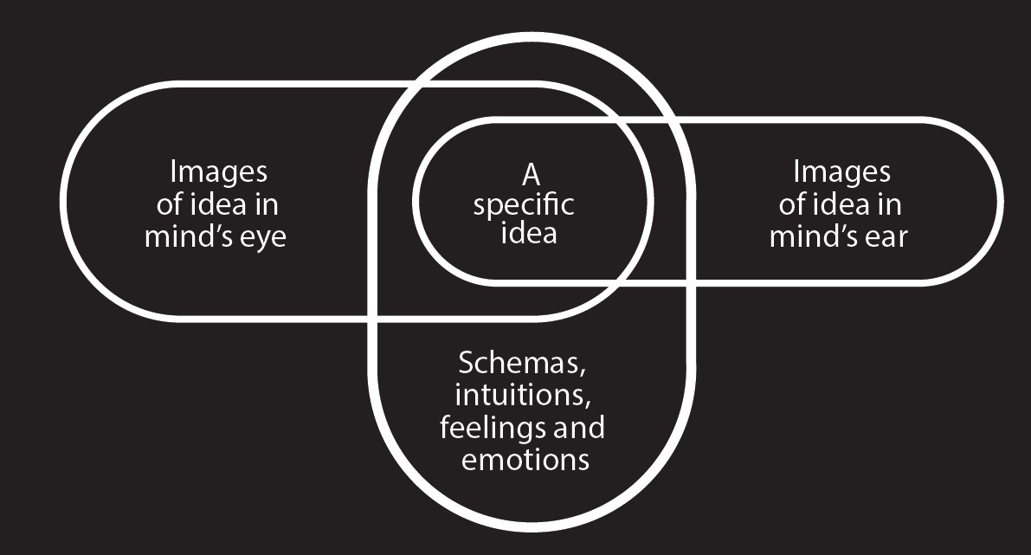

Figure 1: The ‘Loops diagram’ illustrating the concept of transformations between different forms of mental representation in the ICS theoretical model of cognition, in terms of mental imagery (McGregor, 2013, reproduced with permission).

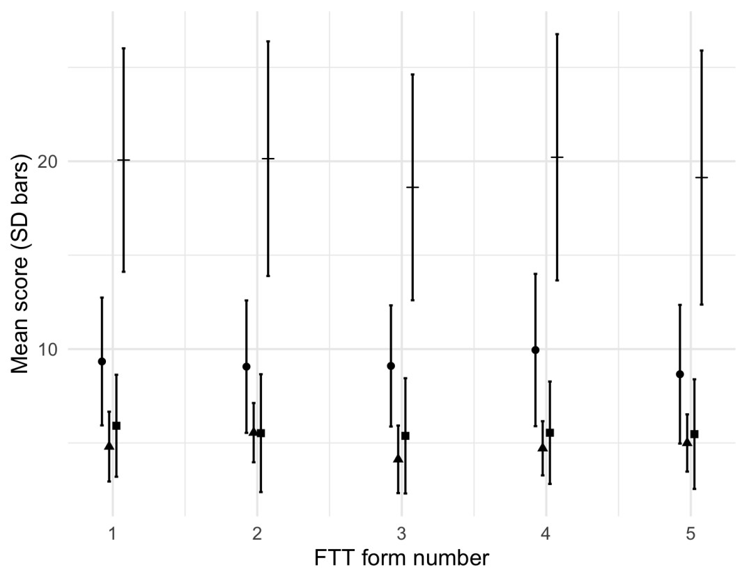

Figure 2: Across the five versions of the FTT, the Ideational flexibility (circles) and Originality (squares) subtests did not differ, but version 2 of the Spontaneous Flexibility (triangles) subtest was higher and version 3 was lower than the others. Overall, the summed total (bar) of the tests did not differ, and was normally distributed. Bars show one standard error.

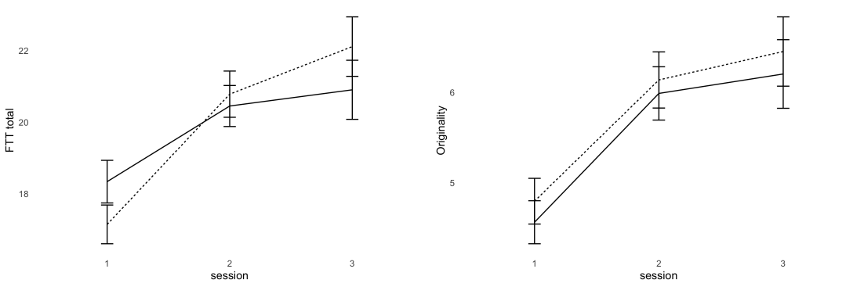

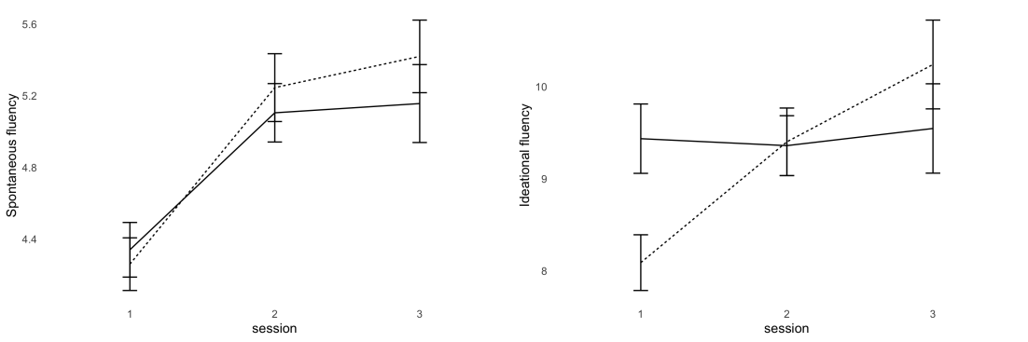

Figure 3: The improvement in Flexible Thinking Test totals (upper left panel) from session 1 to session 3 was statistically significant for the imagery group (dashed line) but not for the control group (solid line). While the imagery group improved on all subtests, the control group did not improve on the Ideational Fluency subtest (lower right panel). Bars show 1 SE.

Figure 4: In the performance task assessed midway through the students’ year, the groups did not differ in creativity but the imagery group (solid bar) were worse on imagery and ideas than the controls (white bar). By the end of the year, the imagery group were assessed as better than the control group on both criteria. (error bars show +1 SE).

Table 1: Number of participants attending each session, with those missing a session shown in parentheses. Thus in the control group, 57 of the students who
attended the third session had also attended the first session, but 16 had not.

Control
N=111
Session 1 94 (17)

Session 2 75 (19) 11 (6)

Session 3 51 (24) 6 (13) 10 (1) 6

Imagery
N=129
Session 1 123 (6)

Session 2 96 (27) 6 (0)

Session 3 53 (43) 7 (20) 2 (4) 0

Table 2: Of over two thousand sentences in students’ choreography feedback, around

a third referred to creativity or imagery/ideas (positively or negatively).

Task Sentences Imagery/Ideas Creativity classification

Performance 1080 26 2.4% 68 6.3% negative

156 14.4% 103 9.5% positive

353 32.7% total

Direction 995 48 4.8% 120 12.1% negative

93 9.3% 76 7.6% positive

337 33.9% total

Data Transparency Appendix

The data reported in this manuscript have not been previously published.

Other measures were collected at the three workshops and may form the basis of further publications. These include:
MS 1: Attitudes to Dreams – collected at the second workshop. Status: planned

MS 2: Imagery Vividness (collected at the first workshop) and Experiential Imagery Scales

(collected at all three workshops): Status - planned

