Developing Powerful Athletes
Part 1: Mechanical Underpinnings

Anthony N. Turner, Paul Comfort, John McMahon, Chris Bishop, Shyam Chavda, Paul Read, Peter Mundy, Jason Lake

Abstract
This review will revisit practitioner understanding of the development of power, before outlining some of the key mechanical parameters that contribute to power development. This understanding will help with planning and periodization of strength and power training, which is explored in part 2 of this two-part review. This review (part 1) discusses the force-time and force-velocity curve and addresses recent criticism in using terms such as power, rate of force development and explosiveness, over impulse. These terms are distinguished mechanically and conceptually for the benefit of the scientist and coach, and are essential for effective sharing of data and practice.

Key words: impulse; momentum; work; force; strength; speed

Introduction
The nature of sport is such that athletes are generally required to execute their motor skills, including jumping, kicking, lunging, and throwing, as quickly as possible over a given range of motion, underpinning these movements with high levels of force. Rapid acceleration is required to hit a ball long distances, out jump opponents, and physically outperform them when required. Consequently, developing powerful athletes is often a strength and conditioning (S&C) coach’s goal. Understanding the mechanical definition of power, and its relationship to the force-time characteristics of sporting movements and training drills, can assist the S&C coach in developing periodized training plans. Furthermore, analyzing the graphical representation of their data, from different assessment methods, can facilitate this understanding further. Here we refer to the 1) force-time curve and 2) force-velocity curve.
We will start with an explanation of mechanical terms, in the context of training for power, given the criticism that terms such as “power” and “explosiveness” have received when used by the S&C community (Knudson, 2009; Ruddock & Winter, 2015; Winter, et al., 2016; Winter & Fowler, 2009); this in turn is likely to have generated confusion amongst S&C coaches, and thus clarification is required. Equally, because the authors of these critical reviews do indeed make valid claims, their points must be elaborated on and considered when training and testing athletes. As they explain, this is essential if the sharing of data and practices among colleagues and across disciplines is to be effective.

Mechanical Definitions and Practical Applications
Firstly, we should note that while the term “power” is commonly accepted in the S&C community, the misuse of this mechanical variable has been criticized (Knudson, 2009; Ruddock & Winter, 2015; Winter, et al., 2016; Winter & Fowler, 2009). In brief, “power” is often expressed as a “generic neuromuscular or athlete performance characteristic” rather than as an application of the actual mechanical definition. Mechanically, power is the work performed per unit of time (the rate of doing work), which can also be calculated by multiplying force by velocity (see Table 1 for formulas). Equally, describing powerful movements as “explosive” has caused concern as nothing explodes (Winter, et al., 2016). However, it is an excellent coaching term that conveys key aspects of what the practitioner typically wants the athlete to achieve during power training, i.e., move the given load as fast as possible. Therefore, based on the context in which terms are used, as well as the desired outcome, coaches must clearly differentiate the use of such terms.
Secondly, it has been contested that given that the impulse–momentum relationship perfectly describes the requirements for “powerful” movements, strength and conditioning coaches should focus on examining net impulse and more importantly, its underpinning components: net force and time (duration of force application) (Knudson, 2009; Winter et al., 2016; Winter & Fowler, 2009). For example, we typically aim to calculate an athlete’s power profile from their jump data, when the impulse–momentum theorem (Newton’s second law of motion), which can be used to calculate jump height, is not often assessed or reported (the reader should note that take-off velocity is derived from net propulsion impulse divided by body mass, with jump height subsequently calculated from take-off velocity). Finally, as we note in our later analysis of Figures 1 and 2, the impulse over a given time period (usually up to 0.3 s), or the area under the force-time curve, is comparable to rate of force development (RFD). This is because when time is constrained by the use of a given epoch, only force output can influence the outcome of both metrics. However, while both net impulse and RFD include force and time, only net impulse is directly related to the change of velocity of the object of interest (McBride, Kirby, Haines, & Skinner, 2010).
It is interesting to consider why S&C coaches typically choose not to report impulse and instead concentrate on training and testing power and RFD, adopting terms such as “explosive” on route. Perhaps the answers lie in the communication of these terms with athletes and the impact that coaching cues have on athlete learning and retention (Winkleman, 2017). For example, rather than asking an athlete to ‘explode’, which is a very clear and conceptual term, asking them to be “highly impulsive” would likely generate confusion. Equally, referring to an athlete as “impulsive” in itself conveys a different message. Furthermore, asking athletes to pull or push against the bar as quickly as possible so we can assess their RFD seems to explicitly convey the focus and importance of the test. Telling them to do so because we want to analyze the area under the force-time curve or impulsivity, perhaps may not resonate so well. These terms, if not explicit in their meaning (such as be “powerful” and “explode”), provide a conceptual guide to describe the test and the relevance of its data (e.g., “RFD”). Clearly our intention is not to discourage the use of these terms (acknowledging that the authors routinely use them), but instead it is to highlight the fact that like many other words, they have different interpretations (here a theoretical or mechanical definition, and a practical, coaching orientated definition). This distinction is important to enable the unambiguous sharing of data and practice among colleagues; as S&C practitioners, we must regularly alternate between science and coaching. In summary, context determines if their use is correct. Telling an athlete, you want them to “explode” during a movement is acceptable, but such terminology should not be used within the scientific literature, unless describing the instructions given to athletes. When undertaking scientific analysis, it is important to forgo colloquial terms for mechanical ones. Table 1 summarizes key mechanical and practical terms covered throughout this paper and includes all associated formulas.
Table 1. Mechanical Definitions and Practical Applications
Term | Practical term | Mechanical definition | Mathematical formula
Power | Generic neuromuscular or athlete performance characteristic | Work performed per unit of time | Power = work/time or P = W/t  Where work = force x displacement or F * s  And because (F * s) / time is the same as force * velocity  P = Force * velocity or F * v
Explosive | “Push/pull hard and fast” | Referring to power if the athlete is “driving” forcefully over a set range of motion, or impulsive, if “driving” forcefully within a set time period | Power (as above)  Impulse = Force * time or J = F * t (Newton’s second law of motion)
Rate of force development (RFD) | “Explosive strength” or the ability to “push/pull hard and fast” | Change in force over given time period | RFD = ΔF / Δtime  Δ = change in
Epoch defined impulse | “Explosive strength” or the ability to “push/pull hard and fast” | Impulse (or rather area under the curve) over a given time period | Impulse = ΔF * Δtime  Δ = change in
Force | Strength | Ability to accelerate a mass (Newton’s 1st law of motion) | Force = mass * acceleration or F = m * a
Impulse–momentum theorem | Momentum is not often used as a practical term but may describe someone able to change the speed they are moving at. | Because mass typically remains constant in an S&C context, impulse is directly proportional to the change in velocity | p = F * t = m * Δv  Where p = momentum

Key: * = multiplied; P = power; W = work; t = time; F = force; s = displacement; v = velocity; J = Impulse; Δ = change; m = mass; a = acceleration; p = momentum

The Force-Time Curve
The first curve we will analyze is the force-time curve (Figure 1), which reveals that maximum isometric force is not instantaneously developed, taking ~ 0.6 - 0.8 s to develop in the leg-press (Siff, 2000), and ~ 2.5 s in the isometric mid-thigh pull (IMTP) (Haff, et al., 1997; Kawamori, et al., 2006). The vast majority of athletic movements however, occur within 0.3 s (Aagaard, 2003; Stone, Pierce, Sand, & Stone, 2006; Zatsiorsky, 2003) (Table 2) and therefore the opportunity to develop maximum force is not a time luxury afforded to most athletes; furthermore, some sporting actions are afforded more time to achieve this than others (illustrated in Figure 1). This suggests that during motor skills which are constrained by time and range of motion (ROM; or rather the distance over which they can apply force), the strongest athletes (as measured conventionally via one repetition maximum tests for example) are not necessarily at an advantage, but rather those who can produce the greatest force within these constraints (i.e., they have a greater RFD and thus impulse, leading to greater accelerative abilities). Using Figure 2 as an example, it is interesting to consider which athlete is best prepared for sporting competition, A or B? Athlete A would be at an advantage if maximum strength values were the objective within a non-time constrained movement task (e.g., bench pressing), whereas athlete B would be at an advantage if the sports movement required limited time to apply the requisite force (e.g., throwing a ball). Also, consider which athlete can punch the hardest? Considering a punch for example, involves contraction times of around 0.05 – 0.25 s (Aagaard, Simonsen, Andersen, Magnusson, & Dyre-Poulsen, 2002), athlete B would likely be able to hit hardest. While it is easy to think of sports, or rather the motor skills within them, that athlete B would be better at, it is more challenging for athlete A (rugby scrums and wrestling pins are suitable examples). In general, and across most sports, athlete B would possess the preferred capacity. By this logic, it is the first 0.3 s of the force-time curve that counts most, or rather, an athlete’s capacity to maximize force over a given time period. It should also be noted that given these different force-time profiles, the training focus for each athlete will be different and is covered in part 2 of this review.

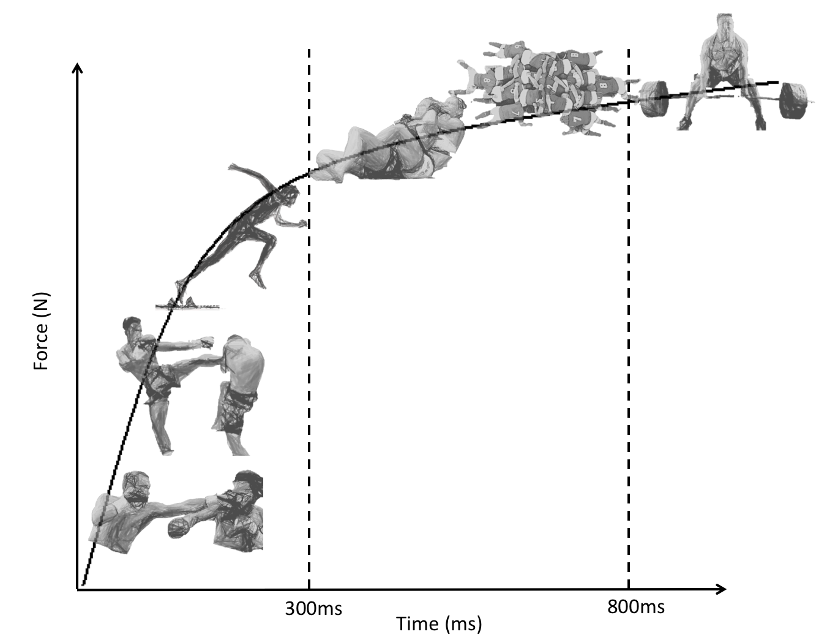
Figure 1. Force-time curve reveals that maximum force is not instantaneously developed, taking as much as 0.6 to 0.8 s to develop. The vast majority of athletic movements however, occur within < 0.3 s

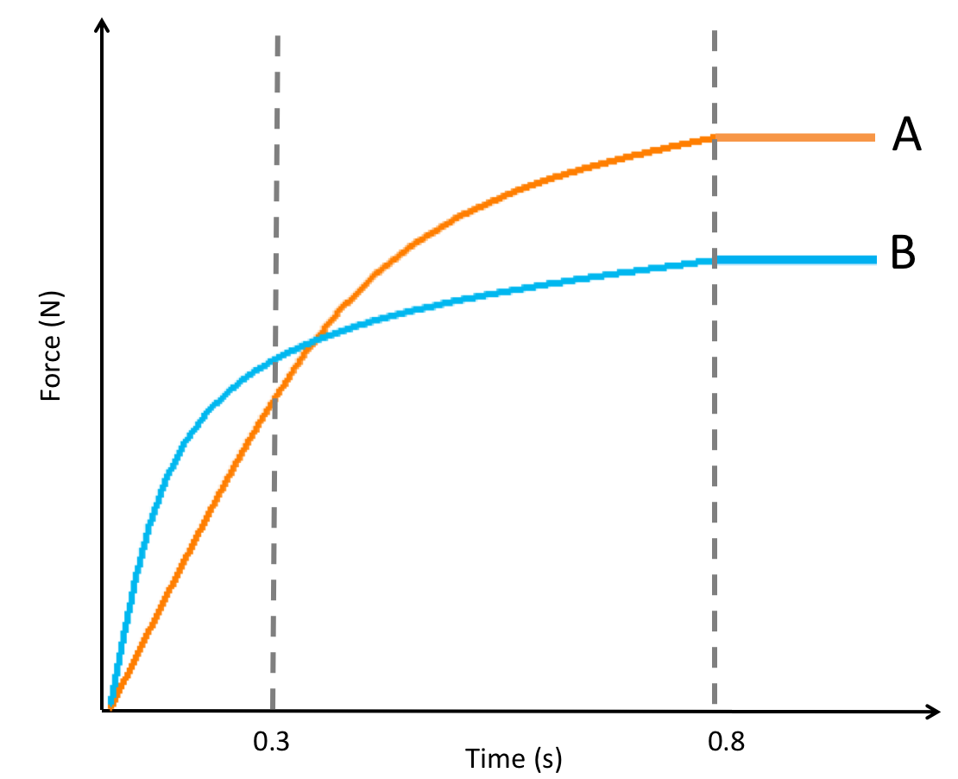

Figure 2. Which athlete is best prepared for competition, A or B? A is best if maximum strength can be expressed whereas B is best if the sports movement was time dependent (i.e., executed in < 0.3 s). These figures serve to conceptualize the significance of analyzing the force-time curve, noting that increases in impulse naturally accompany increases in strength. Equally, while having a high RFD is certainly a desirable characteristic, it is still essential that an athlete produce the required force to complete the task.

Table 2. Duration of ‘explosive’ force production in various athletic movements (adapted from (Zatsiorsky, 2003)
Sport and Motion | Time (s)
Take-off
Sprint running | Men: 0.101  Women: 0.108
Long jump | Men: 0.105 – 0.125
High Jump | Men: 0.150-0.230  Women: 0.140-0.180
Platform diving | Men: 1.330 (standing take-off)  Men: 0.150 (Running dives)
Ski jumping | 0.250-0.300
Delivery
Shot putting | Men: 0.220-0.270

Impulse and Rate of Force Development
Figures 1 and 2 describe the ability of an athlete to rapidly produce force (impulse capacity or RFD depending on your preference; or explosive strength if communicating with athletes). Given the significance of the initial portion of the force-time curve – i.e., up to a time point considered to correspond with a particular sporting movement (e.g., 0.25 or 0.30 s) – it is advisable to calculate net impulse and RFD across designated epochs. To calculate impulse during an IMTP for example, one would calculate the change in force applied to the force platform by the athlete up to the time point of interest, and then multiply that change in force by the time over which it occurred. Conversely, RFD is calculated as the change in force divided by the change in time. Again, using the example of the IMTP, this would mean recording the force generated up to the time point of interest then dividing it by time. Impulse will produce a value in Newton seconds (Ns), while RFD will produce a value in Newtons per second (N.s⁻¹). The subtle differences between them can also be seen in Figure 3, where it can be noted that their calculations (i.e., area under the curve vs. the linearly increasing force between designated time points) can result in slightly different, albeit highly correlated, results. It should also be pointed out that dividing net impulse by the athlete’s mass would provide a measure of their velocity capacity (potential for acceleration if performing a dynamic task). Of course, the athlete would be constrained by the task (isometric), but theoretically this indicates how fast one could move if they were able to let go of the bar at the time point of interest. This means that the greater the impulse one can apply during this sort of task, the greater their velocity capacity, and this could have important implications for sporting performance.

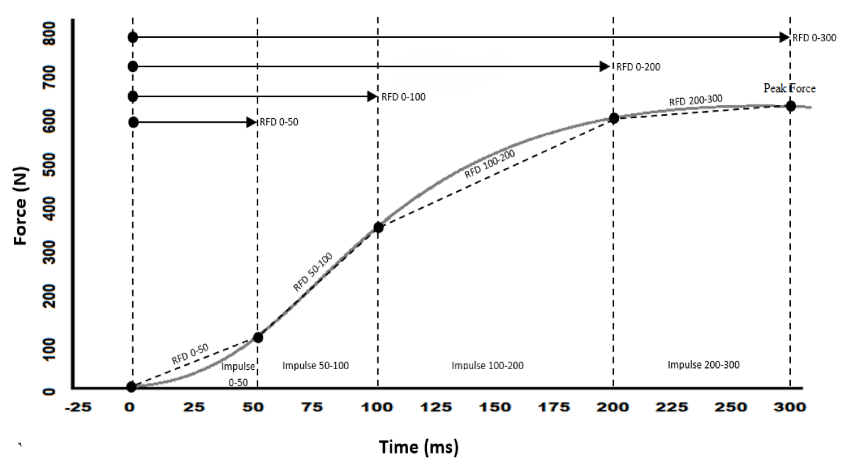
Figure 3. Determination of rate of force development and impulse across typical epochs

Theoretically, RFD and impulse at the corresponding epoch are quantifying similar characteristics, the ability to apply force during given time periods (again because time is constrained by a given epoch, both RFD and impulse are only influenced by force). However, because impulse is directly proportional to the change in momentum, and typically this refers to the change in velocity (i.e., acceleration) of a constant mass (athlete, implement, or athlete/implement system), it may provide a more complete picture of an athlete’s capacity to apply force during given time periods, in addition to providing an indication to accelerate from given start points because it provides a direct performance outcome.
It is also important to consider the error associated with different variables like RFD and impulse. Problems inherent to both include the determination of force onset (i.e., the threshold used) and factors associated with the sampling, filtering, and smoothing of the raw data; for more information on this within isometric assessments, see Comfort et al., (2018). Furthermore, the calculation of each metric also affects error, but potentially more so for RFD. For example, when calculating RFD, the force identified at the designated time point is divided by time (e.g., 0.25 s). Therefore, any error in the identification of this instantaneous time point is amplified. For example, if ΔF = 1000 N, then RFD = 4000 N.s⁻¹ (i.e., 1000 ÷ 0.25), thus any error contained within the determination of ΔF would, in this case, be multiplied by four. On the other hand, because impulse is calculated as the area under the curve, signal noise is suppressed. For example, if force was again applied over a duration of 0.25 s, then impulse would equal the integral of force multiplied by 0.25. Thus, the error contained with the calculation of force is in this example, now quartered. These calculations highlight the difference in signal noise (or error) generated when using differentiation (which examines the rate of change of a curve) vs. integration (which sums small discrete areas under the curve to calculate the total area) based on calculus; the former typically increases error, while the latter decreases it. All that said, more studies are showing the reliability of RFD and its association to performance, and readers should familiarize themselves with these when wanting to calculate RFD; refer to Haff et al. (2015).
As a final note, and considering the aforementioned error inherent with these calculations, simply identifying force at specific time points (e.g., 0.1 s or whatever epoch best corresponds to a fundamental sports motor skill such as those highlighted in Table 2) is another metric that may be reported (James, Roberts, Haff, Kelly, & Beckman, 2017; Wang, et al., 2016; Chavda, et al., In press) and compared to previous scores to determine if change has occurred. We would speculate that this metric will continue to grow in popularity and become far more used in research and practice. This is because if force at a specific time-point increases, then impulse and RFD across the same epoch must have also increased. Furthermore, as only force is being reported (and thus no calculations are required), no error is introduced via the respective calculations, and subject only to the identification of the onset of force production as detailed above. In support of this statement, this method of purely force identification at specific time points has shown good levels of reliability (intraclass correlation coefficients = 0.95-1.00 and 0.921-0.968), with low levels of variance (CV = 2.3%-2.7% and 6.2-8.0%) (Haff, Ruben, Lider, Twine, & Cormie, 2015).
Power, impulse, and the work-energy theorem
In the context of jumping, there is theoretically a direct cause and effect relationship between the work performed on the system centre of mass (CM) and the height jumped (work-energy theorem). Similarly, there is theoretically a direct cause and effect relationship between the impulse applied to the system CM and the height jumped (impulse-momentum theorem). Changes in the system’s CM momentum are due to the net impulse applied to the system CM, which depends on the time over which the net force is applied. Conversely, kinetic energy of the system CM changes when work is performed on the system CM, which depends on the displacement over which the net force is applied. An increase in the work performed and the impulse applied would result in an increase in jump height. Therefore, as the impulse-momentum relationship is well accepted within the literature, in this section we help to clarify the cause and effect relationships of the work-energy theorem.

Maintaining the context of jumping, the work-energy theorem states that the net work performed on an object is equal to the change in kinetic energy and is written as:
W = ΔKE or (assuming initial KE = 0) F * s = ½ * m * v².
It is important to note that this theorem can be expanded to include other forms of energy, but for the sake of brevity has been constrained to kinetic energy. When under the influence of a net force, the system CM accelerates as work is done on it. Given that the displacement over which the propulsion phase of jumping occurs is constrained by human anatomy (i.e., leg-length), greater work (which is now only influenced by the force applied) performed on the system CM results in a shorter propulsion phase duration (i.e., time), as the push-off phase is performed at a greater average velocity (i.e., velocity = displacement divided by time, with displacement in this example constrained). Therefore, average power output, which is the rate at which work is performed over the propulsion phase of jumping (remember that power equals (F * s) / t), increases in line with increases in work, assuming displacement is constrained and optimized. In essence then, the greater the work (or KE), the greater the power output, and the greater the jump height. In this scenario, power output possesses a cause and effect relationship with performance, in this case to jump height. For a worked example of the work-energy theorem and countermovement jump performance, readers are referred to Linthorne (2001).
So, for the CMJ, or a series of squat jumps in which propulsive displacement remains the same, increases in jump height would be matched by increases in power. However, let’s now consider the scenario whereby we are measuring an athlete’s CMJ height under progressive loads, for example progressing from bodyweight (BW) to BW + 30 kg, BW + 50 kg, and finally BW + 80 kg. In this example, the changes (reductions) in jump height will no longer perfectly align to the changes (also reductions) in power, with the reasons behind this going some way in explaining why jump height has recently fallen out of favor with the S&C community, who now instead see the process (i.e., the jump strategy) as a far better performance indicator than the output (i.e., jump height). Anecdotally, we would have all noted that as load increases during a CMJ, the athlete’s jump strategy will change to compensate. That is, under heavier loads, athletes may perform a greater dip or countermovement, in which they lower their CM further, thereby increasing the ROM (and thus work) and time over which they can apply force (in order to overcome a progressively heavier system mass). Under these conditions, where propulsive displacement increases with load and thus differs between conditions, the relationship between power and jump height weakens. Remember back to the fact that jump height is determined by velocity at take-off, so if distance increases along with time, and if velocity is distance divided by time, then velocity will continually decrease with increases in system mass. Thus, the disparity between jump height and power is a consequence of power being a product of force and velocity, with in this example, force potentially compensating for the decrease in velocity thus reducing the loss of power output. Finally, and just to reiterate our earlier point, if we now constrain displacement, i.e., the countermovement was controlled or they performed a squat jump from a set knee angle, across these various loaded conditions, then jump height and power would again be highly correlated. However, in doing so we must be mindful that this may reduce the ecological validity of the test and is thus a trade-off we must be aware of when constraining displacement so that we can define power from jump height.
Now we must turn to another pertinent area within this context, and one which centers on the question of whether S&C coaches should be reporting impulse (or work) when testing athletes (rather than power), and if we should, should they be using training loads that maximize net push-off impulse, rather than those that maximize power output? The answer to this is perhaps best demonstrated by Mundy et al. (2017) who profiled athletes across a series of progressively loaded jumps. Their study found that net impulse during the countermovement jump (CMJ) continually increased from an unloaded condition through to a 75% body mass (BM) loaded condition, at which point it started to decrease up until the athlete was only just able to jump (100% BM condition). These results can be explained by noting that as barbell load increases (and thus system mass), the change in velocity decreases (noting that velocity is zero at the beginning of the propulsion phase). However, across all loaded conditions, the decrease in average velocity was not proportional to the increase in system mass (13%, 25%, 34%, and 44% vs. 25%, 50%, 75%, and 100% respectively). Simply put, mass increases more than velocity decreases, therefore, momentum continues to increase. So, while it is tempting to hypothesize that jump training with barbell loads of 75% of BM should be advocated (acknowledging that this notion is yet to be tested), we must note that the maximal impulse achieved by this load is a consequence of increasing mass, which has come at the expense of movement velocity and time (in this example an extended push-off duration). Arguably the sporting arena requires that changes in range of motion (or displacement) are performed at high velocities, within time-constrained motor skills, and thus this training prescription may not optimally transfer to performance. Perhaps power has become such a popular variable to report as high values also depend on at least moderate velocities, thus conforming to the demands of sport; when only one value is captured, power can at least control for sport specificity given that force and velocity exhibit an inverse relationship (as discussed in the subsequent section).
In summary, it is important to note that net impulse may be maximized by either increasing the magnitude of the net force applied, or the duration for which the application occurs (with the latter causing a decrease in velocity if ROM is not increased). For example, Figure 4a illustrates two force-time and velocity-time traces for a CMJ, completed by the same athlete. Of note, jump height and thus net impulse is the same in both trials, but the strategy used to achieve each is different. In one trial (black line), the braking net impulse was characterized by a larger force and shorter time (and is thus representative of a desirable performance outcome in sport), while in trial two (grey line), the opposite occurred (McMahon, Suchomel, Lake, & Comfort, 2018). Conversely, work can be maximized by either increasing the net force or the displacement over which the application occurs, with power then maximized through the duration for which the application occurs. When referring to Figure 4b, the athlete (the same athlete who was discussed above) produced identical mechanical work but via a larger force and shorter propulsion displacement in trial 1 (black lines) versus trial 2 (grey lines). Given the time and ROM constraints of most sporting activities, choosing a strategy that increases impulse or work by virtue of an increase in time or displacement may not be most suitable (again we should note that this is an untested statement). Therefore, when assessing impulse, our focus would need to be on both how much force was produced and how long it took to apply it. Because we want to improve both variables in our athletes, reporting these in addition to impulse is far more informative. The same statement can be made for power, in that the underpinning force, displacement, and time components must be considered. Clearly an athlete who takes too long to complete a particular movement (whether that be a training exercise of sporting action) lacks one of, or a combination of, strength, RFD (explosive strength), or technical ability. The force-time curve should positively change as these components are improved; thus, analyzing the actual force trace is advocated.
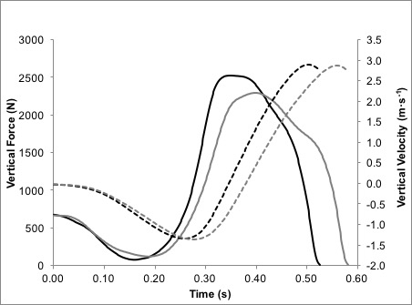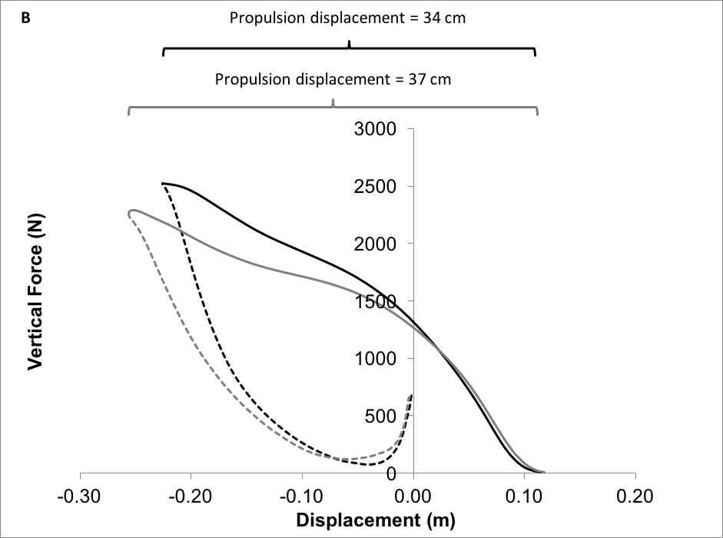
Figure 4a (top) and b (bottom). Graph 4a shows an example force-time record for a countermovement jump, between the onset of movement and take-off, performed by the same athlete (body mass 71.8 kg) who jumped identical heights (as determined by the same take-off velocity [dashed lines]). The athlete achieved an almost identical unweighting and braking phase net impulse 95–96 N.s but her braking phase net impulse was characterized by a larger force and shorter time in trial 1 (black lines) versus trial 2 (grey lines). In graph 4b, the athlete produced identical mechanical work but via a larger force and shorter propulsion displacement in trial 1 (black lines) versus trial 2 (grey lines). For clarity, the dashed part of the force-displacement curves represents the countermovement (combined unweighting and braking) phase of the countermovement jump. PF = peak force; PT = phase time. Adapted from McMahon et al., (13).

Power and the Force-Velocity Curve
The final curve to analyze is the force-velocity curve (Figure 5), which practitioners often use to identify training loads corresponding to maximal power output (and how this changes over time), as well determining adaptations to training centering on the ability to produce force at high and low velocities. The reader should note that for athlete testing and training purposes, the force and velocity relationships generally noted and reported within S&C (including herein) pertain to an analysis of the concentric (propulsive) portion of whole body movements (such as jumps, squats, and weightlifting derivatives), as oppose to those based on force and fascicle shortening as reported in the seminal research (Wickiewicz, Roy, Powell, Perrine, & Edgerton, 1984; Komi, 1973). Also, because we require our athletes to always be ‘explosive’ when lifting, movement velocity (of the body or barbell) is an outcome of resistive load, in that light loads will enable fast velocities, while heavy loads will generate slow velocities. These differences also explain why in S&C, we typical define a more linear relationship between force and velocity, rather than the parabolic curve illustrated in single muscle fibers.
In fully explaining and utilizing the force-velocity curve, we must first address the quantitative and perhaps more sport-focused definition of power (P), i.e., force multiplied by velocity (P = F * v); hence force-velocity curve. Logic dictates therefore, that an increase in either variable (i.e., F or v) will increase power if the other variable remains constant. Figure 5 illustrates that high forces are produced at low velocities, while high velocities generate low forces; thus, an inverse relationship exists between them. Theoretically, the highest values for power are produced when an optimal compromise between them is reached (but is exercise, athlete, and measurement method dependent). Such understanding deems that the placement of a sport motor skill on the force-velocity curve will depend on the mass of the object to be moved, given sporting actions call for the movement to be executed as quickly as possible within a given range of motion. For example, a rugby union tackle requires larger forces relative to those required to pitch a baseball and are hence at opposite ends of the curve. Because most sports require a variety of motor skills that span the entire force-velocity curve (Figure 6), it is considered prudent to ensure that training programs adequately cover all points. This is achieved through manipulation of exercise modality and/or training load and is discussed further in part 2 of this two-part review.
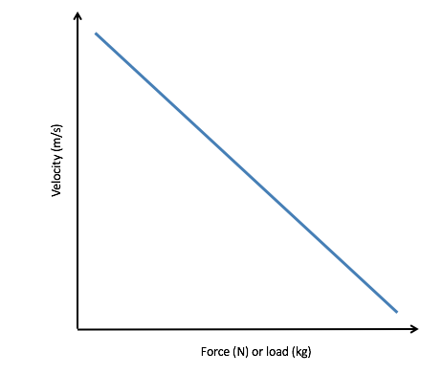
Figure 5. Theoretical illustration of the F-V relationship

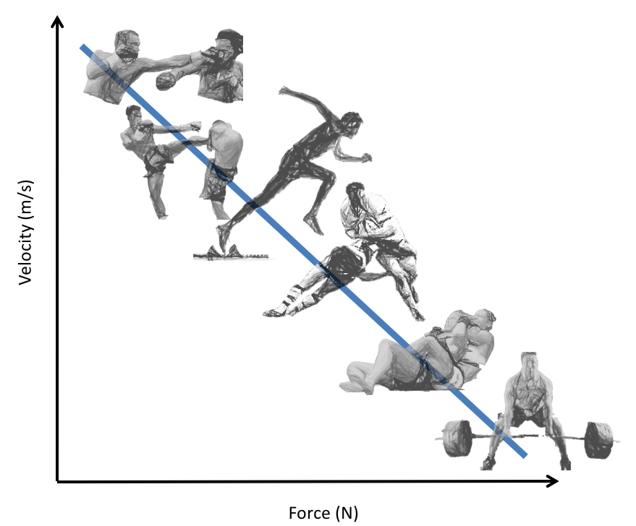
Figure 6. Theoretical placement of various sports motor skills upon the force-velocity curve. The placement of each motor skill is dependent on the mass of the object to be moved, as this will affect the force required to move it and inversely affect the velocity it moves at.

When it comes to identifying power, some researchers have sought to identify the peak instantaneous power, as opposed to average power (which has been the focus so far); this, however, may be seen as academically interesting rather than practically relevant. For example, Mundy et al. (2017) found that for the loaded CMJ, the majority of between-participant differences in peak power were either smaller than the CV, or the smallest worthwhile change. Also, of note, this variable only represents a ~ 1 ms period (if data collected at 1000 Hz), which only corresponds to ~ 1% of the propulsion phase. From a mechanistic perspective, average power may be a better proxy marker for performance. Unlike peak instantaneous power, average power is typically found at the same load for all athletes; in the CMJ, this is typically at body mass (Swinton, Stewart, Lloyd, Agouris, & Keogh, 2012). As intra-individual variation cannot explain the decreases observed in average power as load increases, Mundy et al. (2017) explained it at a system level using mechanical theory. As external load increases, the mechanical work (recall that work = force * displacement) required to jump the same height must then also increase. As countermovement displacement is limited by human anatomy (when aiming to optimally utilize the stretch-shortening cycle), more force must be applied. However, we are progressively unable to compensate for the decreases in average velocity caused by additional loads (or rather our inability to meet them given our capacity to generate force), which presents itself as an increase in propulsion phase duration. Therefore, the decreases observed in power (recall that power = work/time) may be explained by the increased time required to perform mechanical work, over an anatomically constrained propulsion phase.

Conclusion and Practical Applications
All metrics, power, RFD and impulse, can be used to effectively monitor athlete progress and define training windows. When impulse is used however, it is also important to capture changes in this metric with respect to changes in force and time, and in all cases, it is informative to include the force-time and force-velocity curves. From a sport performance perspective, however, it is worth remembering that the goal is generally to increase force (at high and low velocities), while simultaneously reducing the duration over which force is applied. When reporting and assessing the ability of an athlete to quickly produce force, we advise practitioners and researchers to consider simply identifying force at specific time points (e.g., 0.1-0.3 s). This is because if force at a specific time-point increases, then impulse and RFD across the same epoch must have also increased (if body weight remains constant); furthermore, this method limits error. Finally, when reporting scientific findings, it is important to forgo colloquial terms for mechanical ones. However, while coaching, telling an athlete you want them to “explode” during a movement is acceptable, as it appropriately infers the desired intent.

References
- Aagaard, P. (2003). Training –induced changes in neural function. Exerc. Sport Sci. Rev, 32, 61-67.
- Aagaard, P., Simonsen, E., Andersen, J., Magnusson, P., & Dyre-Poulsen, P. (2002). Increased rate of force development and neural drive of human skeletal muscle following resistance training. J. Appl. Physiol, 93, 1318-1326.
- Chavda, S., Turner, A., Comfort, P., Haff, G., Williams, S., Bishop, C., & Lake, J. (In press). A practical guide to analysing the force-time curve of isomeric tasks in Excel. Strength and Conditioning Journal.
- Comfort, P., Dos’Santos, T., Beckham, G., Stone, M., Guppy, S., & Haff, G. (2018). Standardization and methodological considerations for the Isometric Mid-Thigh Pull. Strength & Conditioning Journal.
- Haff, G., Ruben, R., Lider, J., Twine, C., & Cormie, P. (2015). A comparison of methods for determining the rate of force development during isometric midthigh clean pulls. The Journal of Strength & Conditioning Research, 29(2), 386-395.
- Haff, G., Stone, M., O’Bryant, H., Harman, E., Dinan, C., Johnson, R., & Han, K. (1997). Force-time dependent characteristics of dynamic and isometric muscle actions. J Strength Cond Res, 11, 269-272.
- James, L., Roberts, L., Haff, G., Kelly, V., & Beckman, E. (2017). Validity and reliability of a portable isometric mid-thigh clean pull. he Journal of Strength & Conditioning Research, 31(5), 1378-1386.
- Kawamori, N., Rossi, S., Justice, B., Haff, E., Pistilli, E., O’Bryant, . . . Haff, G. (2006). Peak force and rate of force development during isometric and dynamic mid-thigh clean pulls performed at various intensities. J Strength Cond Res, 20, 483-491.
- Knudson, D. (2009). Correcting the use of the term “power” in the strength and conditioning literature. The Journal of Strength & Conditioning Research, 23(6), 1902-1908., 23(9), 1902-1908.
- Komi, P. (1973). Measurement of the force-velocity relationship in human muscle under concentric and eccentric contractions. In Biomechanics III, 8, 224-229.
- Linthorne, N. (2001). Analysis of standing vertical jumps using a force platform. American Journal of Physics, 69(11), 1198-1204.
- McBride, J., Kirby, T., Haines, T., & Skinner, J. (2010). Relationship between relative net vertical impulse and jump height in jump squats performed to various squat depths and with various loads. International journal of sports physiology and performance, 5(4), 484-496.
- McMahon, J., Suchomel, T., Lake, J., & Comfort, P. (2018). Understanding the key phases of the countermovement jump force-time curve. Strength & Conditioning Journal., 40(4), 96-106.
- Mundy, P., Smith, N., Lauder, M., & Lake, J. (2017). The effects of barbell load on countermovement vertical jump power and net impulse. Journal of Sports Sciences, 35(18), 1781-1787.
- Ruddock, A., & Winter, E. (2015). Jumping depends on impulse not power. Journal of sports sciences, 34(6), 584-585., 34(6), 584-585.
- Siff, M. (2000). Biomechanical Foundations of Strength and Power Training. In V. Zatsiorsky, Biomechanics in sport: performance enhancement and injury prevention (Vol. 9, pp. 103 – 139). Blackwell Science.
- Stone, M., Pierce, K., Sand, W., & Stone, M. (2006). Weightlifting: a brief overview. Strength and Conditioning Journal, 28, 50-66.
- Swinton, P., Stewart, A., Lloyd, R., Agouris, I., & Keogh, J. (2012). Effect of load positioning on the kinematics and kinetics of weighted vertical jumps. The Journal of Strength & Conditioning Research, 26(4), 906-913.
- Wang, R., Hoffman, J., Tanigawa, S., Miramonti, A., La Monica, M., Beyer, K., & Stout, J. (2016). Isometric mid-thigh pull correlates with strength, sprint, and agility performance in collegiate rugby union players. Journal of strength and conditioning research, 30(11), 3051-3056.
- Wickiewicz, T., Roy, R., Powell, P., Perrine, J., & Edgerton, V. (1984). Muscle architecture and force-velocity relationships in humans. Journal of Applied Physiology, 57(2), 435-443.
- Winkleman, N. (2017). Applied coaching science. In A. Turner, & P. Comfort, Advanced strength and conditioning: An evidence-based aproach (pp. 327-346). Oxon: Routledge.
- Winter, E., & Fowler, N. (2009). Exercise defined and quantified according to the Systeme International d'Unites. Journal of sports sciences, 27(5), 447-460.
- Winter, E., Abt, G., Brookes, F., Challis, J., Fowler, N., Knudson, D., & Morton, R. (2016). Misuse of “power” and other mechanical terms in sport and exercise science research. The Journal of Strength & Conditioning Research, 31(1), 292-300.
- Zatsiorsky, V. (2003). Biomechanics of strength and strength training. In P. Komi, Strength and Power in Sport (Vol. 2, pp. 114-133). Oxford, UK: Blackwell Science:.

