Novel Flexible Enzyme Laminate-Based Sensor for Analysis of Lactate in Sweat
Eva L. Tur-García¹, Frank Davis^{1,5}, Stuart D. Collyer², Joanne L. Holmes³, Hugh Barr⁴ and Séamus P. J. Higson^{1,5}*
¹Cranfield Health, Vincent Building, Cranfield University, Bedfordshire, MK43 0AL, UK.
²Microarray Ltd, Colworth Science Park, Sharnbrook, Bedford, MK44 1LQ, UK.
³Metrohm UK Ltd, Runcorn, Cheshire, WA7 1LZ, UK.
⁴Gloucestershire Royal Hospital, Gloucester, GL1 3NN, UK.
⁵TheUniversity of Chichester, College Lane, Chichester, West Sussex, PO19 6PE, UK.
*Corresponding author. Tel: Email address: s.p.j.higson@cranfield.ac.uk
Running Head: FLEXIBLE LACTATE BIOSENSOR

Authors Contributions:
Eva L. Tur-García: was the PhD student who undertook the majority of the experimental work for this study.
Frank Davis: was co-supervisor for Eva Tur-Garcia – the PhD student for this project.
Stuart Collyer: helped develop the interrogation technique reported in this study.
Joanne Holmes helped develop the immobilisation procedure reported in this study.
High Barr: was a co-supervisor for the clinical aspects of this project.
Séamus Higson: was PI for this project and supervisor for Eva Tur-Garcia.

ABSTRACT
We present work towards a novel amperometric enzyme-based highly flexible biosensor for real-time and non-invasive monitoring of lactate in human sweat for the early detection of pressure ischemia onset. The core of the recognition system is a highly flexible laminate, comprising two highly porous polycarbonate membranes, which provide support for the lactate oxidase enzyme, immobilised via covalent cross-linking. A number of variables were assessed to attempt to optimise the sensors, such as membrane pore size, crosslinking time, crosslinking agent concentration and levels of incorporated enzyme. Oxidation of lactate produces H₂O₂, which is subsequently determined electrochemically. The transducer comprises a two-electrode system on a single highly flexible polycarbonate membrane, sputter-coated with gold and platinum to render it conductive. The sensor exhibits lactate selectivity with a working range of 0-70 mM, thus covering physiologically relevant concentrations for pressure ischemia and has been shown to be suitable for determination of lactate in PBS, synthetic sweat and diluted human sweat.
Keywords: lactate; pressure ischemia; sweat

NEW AND NOTEWORTHY ASPECTS:
This paper reports for the first time a flexible enzyme lactate oxidase based biosensor for lactate within undiluted human sweat comprising metallic sputter-coated polycarbonate membranes.
Laminates containing lactate oxidase were formulated for the optimisation of the working concentration range. The paper describes the measurement of lactate across the physiological range relevant to pressure ischemia. No significant interferences were observed in synthetic sweat solutions used for the validation of the sensors.

INTRODUCTION
Pressure ischemia is the condition in which skin and underlying tissue necrosis occurs due to malnutrition of the tissues in body areas exposed to continued pressure, or pressure in combination with shear and/or friction (1).
Pressure ischemia has significant health, quality of service and economical implications. It is estimated that, in general terms, approximately 9% of hospitalised patients develop pressure sores (2). People more susceptible to pressure ulcers include those with mobility problems such as bedridden, wheelchair-bound, debilitated or paralyzed patients. People suffering from cardiovascular and neurological diseases can in many cases also suffer from pressure ischemia, since these diseases lead to an impairment in circulation (1). Moreover, it is well understood that pressure ischemia is related to a notable increase in mortality rates (16). In acute care hospitals, the prevalence of pressure ulcers is approximately 10% (21). It is estimated that the treatment of pressure ulcers costs the UK National Health Service 4% of its budget, a cost of between £1.4 and £2.1 billion per year (3). It is for this reason that pressure ischemia has significant implications in cost and quality of service for the health sector. However, pressure ischemia is considered a preventable condition that arises mainly from poor clinical management and, more importantly, a lack of warning indicators (4).
When the skin undergoes prolonged pressure, the underlying blood vessels become occluded, either partially or totally. As a result of this, oxygen and other nutrients carried in the blood are not delivered in sufficient quantities to satisfy the metabolic demands of the affected tissue. Cells are then obliged to use their own stores of energy through an anaerobic metabolic pathway in order to survive. Consequently, breakdown products from anaerobic metabolism begin to accumulate within both the affected cells and the interstitial spaces. As the levels of energy stores diminish, cellular processes start to fail, the ionic flow across cellular membranes begins to fall and then cell necrosis occurs, with the subsequent formation of a pressure ulcer (pressure sore). Hence, pressure ulcers arise from prolonged tissue ischemia (22). Anaerobic metabolism of the cells’ glucose reserves leads to the production of more lactic acid, which begins accumulating (28). If lactate concentration exceeds a certain threshold level, lactic acidosis will occur, which leads to cell death (11, 28). For this reason, lactate levels are a useful alarm signal for the diagnosis of patient conditions in general clinical practice as well as in hospital intensive care units and operating rooms.
One of the most common clinical practices for the early detection of pressure ischemia was based on a periodical inspection of the skin colour of the patient. Later diagnosis methods were based on an alternative approach using tissues as the source of information. The first technique consisted of the monitoring of blood flow, which constituted a slight improvement from the observation of skin colour (10). It was known that even in early stages of pressure ulcer formation, the tissues responded with an accumulation of metabolites, a decrease in pH and oxygen partial pressure (PO₂, which is the amount of oxygen that will bind haemoglobin within the red blood cells) and an increase in partial pressure of carbon dioxide (PCO₂) (18). However, the techniques derived from this idea implied the use of invasive methods on areas of risk for the collection of samples. Pressure ischemia is considered a preventable condition that arises from poor clinical management, reduced nursing staff and a lack of warning indicators (4). However, in reality it is understood that it is not that easy to prevent because of the many factors that cause it.
Pressure ischemia causes a decrease in oxygen and glucose levels, forcing the cells within the vascularised tissues to change to anaerobic metabolism. Anaerobic metabolism of the cells’ glucose reserves leads to the production of more lactic acid, which starts accumulating (28). However, if lactate concentration exceeds or glucose levels fall below a certain threshold level, cell death will occur (11, 28).
Lactate levels constitute a useful warning indicator for the formation of pressure ulcers. In susceptible patients, pressure ulcers can develop in just one or two hours (8), even though in some cases the damage will only become evident a few days later. One approach would be to use biosensors to give direct, simple and highly specific lactate measurements, low response time, inexpensive and with minimal or no sample preparation. Commercially available biosensors for blood lactate have been developed but require an invasive method of sample collection or, in the case of implantable vascular sensors for in-situ monitoring impart a high risk of thrombosis (26). This issue and the current trend for non-invasive diagnostic and real-time monitoring methods have led researchers to search for other body fluids on which to perform lactate measurements and among these, sweat shows the most promise, since it is the most accessible specimen to collect, its collection is non-invasive and its real-time analysis offers valuable physiological information (6). Also, sweat analysis allows specific body areas to be studied (i.e. pressure points).
It was suggested that sweat lactate would be a good marker for evaluating the severity of peripheral occlusive arterial disease which implies a local occlusion of blood supply (9). Subsequent studies have suggested that sweat lactate, produced as a by-product of the anaerobic metabolism of glucose by the eccrine sweat glands, could be a sensitive indicator of damage in soft tissues (15, 22, 23).
Normal values of lactate in human perspiration are 20±7 mM, but under ischemic conditions these can rise up to 62±16.3 mM (23). In order to achieve continuous monitoring, wearable sensors have attracted increasing interest from the research community and the industry during the last decade (19). To date, most of these sensors have been developed for the monitoring of physiological parameters of the patient, such as breathing rate, heart rate or temperature (6). Wearable chemosensors, although at an early stage, have the potential to measure many more variables related to the wearer’s health. Moreover, the potential of these sensors to perform chemical and continuous measurements of body fluids (i.e. sweat) opens a new insight for medical science by providing valuable real-time feedback information about the patient’s health status, which is the key for preventative healthcare and early diagnosis of conditions such as pressure ischemia.
A review of lactate biosensors is beyond the scope of this paper, however previous workers (20) have analysed the different aspects within the preparation of amperometric lactate biosensors such as biorecognition elements, methods of immobilisation, mediators and cofactors, and fields in which these sensors can be applied. Most of the sensors utilise the technology developed for glucose monitoring, with lactate enzymes such as lactate oxidase forming the active biorecognition element. Our present work describes the development towards a novel flexible biosensor for real-time, continuous and non-invasive sensing of lactate in human sweat. This potentially will lead to development of an external sensor that will be directly applied to the skin of patients as a real-time, non-invasive test for the onset of pressure ischemia.

METHODS
Reagents and materials
Ferrocene carboxylic acid, lactate oxidase (from Pediococcussp, lyophilised powder, ≥20 units/mg solid), sodium L-lactate and bovine serum albumin (BSA, lyophilised powder) were purchased from Sigma-Aldrich (Dorset, U.K.). Sodium dihydrogen orthophosphate 1-hydrate (NaH₂PO₄•H₂O), disodium hydrogen orthophosphate 12-hydrate (Na₂HPO₄•12H₂O), sodium chloride, urea, ascorbic acid, glacial acetic acid, hydrochloric acid and ≈50% glutaraldehyde solution were purchased from VWR BDH (Poole, U.K.). All reagents were used as received unless otherwise stated.
Deionised water for preparation of all solutions was obtained using a Purelab® UHQ system from ELGA (Marlow, U.K) and had a resistivity >18 MΩ cm⁻¹. A phosphate buffered saline (PBS) solution was prepared at pH 7.4 containing 5.28 x 10⁻² M Na₂HPO₄•12H₂O, 1.3 x 10⁻² M NaH₂PO₄•H₂O and 5.1 x 10⁻³ M NaCl. BSA solutions were prepared at a concentration of 0.1 g mL⁻¹ in PBS. A lactate oxidase/BSA solution was prepared using LOD at the desired concentration dissolved in 0.1 g mL⁻¹ of BSA solution for use within an enzyme laminate. Enzyme/BSA solutions were stored in Eppendorf tubes at -20°C until use.
A suggested chemical formulation of artificial human sweat (14, 27) was made by dissolving 1.55 g L⁻¹ sodium chloride, 0.6 g L⁻¹ urea, 7.81 x 10⁻³ g L⁻¹ acetic acid, 9.92 x 10⁻³ g L⁻¹ uric acid and 1.76 x 10⁻³ g L⁻¹ ascorbic acid in PBS pH 7.4 and a range of lactate concentrations, from 0 to 70 mM, were prepared from this basic solution and analysed with the gold/platinum electrode system.
Human sweat was collected from a number of healthy volunteers, after running at speeds of 11-13 km h⁻¹ on a treadmill for up to one hour. Samples were collected from various parts of the body using sterile absorptive pads strapped to the body with surgical tape which were removed and then placed in centrifuge tubes and spun to extract the sweat from the pad. Samples were diluted 1:8 in PBS before measurement and tested as soon as possible after collection.
Polycarbonate membrane disks of pore sizes from 0.015 to 1.0 µm diameter with a thickness of 10 µm were purchased from both Whatman (Maidstone, U.K.) and Millipore (Consett, U.K.). Glass microscope slides (ground edges, twin frosted glass 76 mm x 26 mm, 0.8 mm to 1.0 mm thick) were purchased from Fisher Scientific (Loughborough, U.K.). Araldite® epoxy resin (rapid setting), multicore wires and silver conductive paint were purchased from RS Components (Corby, UK).

Equipment
A Uniscan (Buxton, Derbyshire, U.K.) PG580 with dedicated PC-driven software was used for electrochemical studies such as linear and cyclic voltammetry as well as chronoamperometry experiments. Sputter coating of metals onto the polycarbonate membranes was performed by using an AGAR B7341 Automatic Sputter Coater from Agar Scientific Ltd. (Essex, U.K.) in conjunction with an external Pfeiffer Rotary Vane Pump from Pfeiffer Vacuum Ltd. (Newport Pagnell, U.K.). Time of coating was optimised as described later, coating current 20 mA.

Manufacture of electrodes
A 25-mm polycarbonate disk covered by a plastic film template carefully cut to cover the area for the working electrode and the non-coated region between electrodes (following the pattern shown in Fig.1a) was sputter-coated with gold (120 seconds exposure) to deposit the counter electrode. The tape was then carefully removed and the resulting sputter-coated membrane covered by a plastic film template carefully cut to cover the polycarbonate disk but leave the working electrode area exposed. The disk was then sputter-coated with platinum (150 seconds exposure) and then the plastic template was removed, leaving a structure comprised of two electrodes, an inner platinum-coated working electrode with an outer gold counter/reference electrode on a single membrane separated and isolated from each other by a region of non-coated membrane (Fig. 1a). The times for deposition were optimised by depositing the metals onto the surface of polycarbonate membranes and then measuring conductivities of the resulting films, conductivities increased with deposition time until 120 seconds (gold) or 150 seconds (platinum), with further deposition leading to only minimal increases in conductivity.
Two lengths of wire of 10-15 cm were cut and stripped of the insulating plastic coat for 3 mm on each end. These were then attached to the metallised area of both working and counter/reference electrodes (as shown in Fig. 1b) using silver conductive paint to make a connection between the wire and the membrane. The silver conductive paint was allowed to set for one hour and then the wires were fixed to the membrane surface by applying epoxy resin, allowing it to set until dry, to ensure they were insulated from solution and to add structural integrity. Finally the electrode was attached to a glass slide or a flexible plastic sheet using epoxy, not only to improve integrity but also to minimise any flow of lactate through the lower membrane to the laminate.
An enzyme-crosslinking mix was made by rapidly mixing 6 µl of the enzyme/BSA solution with 3 µl of 5% or 10% glutaraldehyde (PBS).The enzyme laminate was prepared with two 5 x 9 mm polycarbonate membranes and the crosslinking solution placed between them. This was then lightly compressed between two microscope slides for five minutes. Once a robust enzyme laminate was obtained, it was placed on top of the working electrode (Fig.1b). After the designated crosslinking time had been achieved, the electrode and laminate were rinsed in PBS to stop the crosslinking reaction. The resultant enzyme electrodes were used immediately after construction, The membranes of the enzyme laminate were cut so they would mimic the shape of the working electrode without making contact with the counter/reference electrode area. Finally, the enzyme laminate was attached to the electrode by placing thin strips of adhesive tape along the edges without encroaching on the counter/reference electrode area. Fig. 1c shows a schematic of the final arrangement along with a photograph (Fig. 1d) of the electrode after attachment of the wires. When made using a flexible laminate support the electrodes could be repeatedly bent without damage (Fig. 1d).

Chronoamperometric analysis
The electrode system was connected to the potentiostat with the inputs for the counter and reference electrode being merged and then both electrodes (working and counter/reference) were connected to their corresponding inputs in the potentiostat. The sensor was placed in a 25 mL beaker and 15 mL of PBS were initially added. The sensor was then set to polarise at +650 mV until a baseline was reached. The working electrode was polarised at +650 mV vs. Ag/AgCl and the resulting current was monitored. This potential of +650 mV was chosen since it is known to be the optimum value for the oxidation of hydrogen peroxide (29). Initially a high current followed by a dramatic decay in the response is observed due to the polarisation and relaxation of the electrical double layer. Once this was complete, the current reached a constant baseline in terms of steady state current (constant current against time). The time for the polarisation to conclude varied depending on the nature of the experiment (i.e. the hydration status of the enzyme laminate). Once a stable baseline was obtained, the system was ready to use for analysing different samples. The electrodes were rinsed with water and sequentially placed into 15 mL of each lactate solution (in PBS only, in synthetic sweat or diluted human sweat) for their analysis. After the experiment, the current/time profile was analysed for each substrate concentration. In order to calculate normalised current responses, the baseline current was subtracted.

RESULTS AND DISCUSSION
Optimisation of the electrodes and laminate
Studies were performed focused on determining the reproducibility of the electrode-system response so as to assess the quality of the hand-manufactured electrode system in terms of providing a reproducible electrochemical response between different sensing devices. The base electrodes with no enzyme laminate were assessed using cyclic voltammetry in ferrocene carboxylic acid solution (1-5 mM in PBS) between -0.4 and +0.8 (vs. an Ag/AgCl reference electrode) at a sweep rate of 20 mV s⁻¹ (12). The solution was tested using five different sensors in order to obtain an average current response. RSD values of 5.4-9.8% indicated that the variation in electrochemical properties between different hand-manufactured electrode systems was relatively small, with sensors suitable for assessment in future studies.
The effect of membrane porosity on the sensor’s response was assessed. Three different sets of membrane laminates were constructed, using a pore size of 1 μm for the lower membrane (closest to the electrode) and varying the upper-membrane porosity using 1, 0.1 and 0.015 μm pore radii. The constructed membrane laminates were applied to the WE and tested in lactate solutions. Fig. 2 displays the corresponding calibration plots for the different upper membrane porosities. Laminates using 1 μm pore radii membranes exhibited good current response, indicating the existence of throughput of lactate, oxygen and hydrogen peroxide. However, the current response tends towards a plateau above 0.4 mM lactate, which is significantly lower than the clinical ranges of lactate that are required to be measured which are much higher than this. The linearity (R²) for these laminates was 0.89. One obvious explanation for this is that the enzyme LOD is reaching saturation, since its Km is approximately 0.7 mM. The use of lower membrane porosities, although lowering the current response and thus sensitivity, appear to increase the linear range (R² for 0.1 μm and 0.015 μm were 0.97 and 0.98, respectively). Results therefore show the capability of the membrane porosity to act as a diffusion barrier to the substrates (lactate and oxygen), avoiding enzyme saturation and, therefore, unless otherwise stated, 0.015 µm pore membranes were used as the upper membrane.
In an attempt to determine whether a platinum working electrode is required, a similar system containing gold working and counter/reference electrodes was constructed since these could be deposited in a single sputter coating step. However when an enzyme laminate (1 µm polycarbonate membrane) was applied to this membrane and the current response to lactate measured, current densities of approximately a third of those obtained for platinum working electrodes were obtained, confirming the catalytic properties of platinum towards hydrogen peroxide.
These initial results were obtained using an enzyme laminate containing 830 U mL⁻¹ of lactate oxidase and crosslinked using a 5% glutaraldehyde solution with an incubation time of 8 minutes, this being the shortest time that gave a firm, physically stable laminate. However, since sensors prepared with this incubation time resulted in inconsistent results, a study was performed to assess the optimum incubation time for an increased robustness of the laminate that would allow a better immobilisation of the enzyme. It has been previously reported that the degree of cross-linking increases with the incubation time, during which the reaction from glutaraldehyde with amino groups (mainly from lysine residues) from lactate oxidase and BSA continues to take place. Cross-linking time, like many other parameters, passes through an optimum value. However, this incubation time varies depending on many factors, such as the chosen immobilisation method, materials or substrates employed and their concentration, physical characteristics and the concentration of the enzyme to be immobilised as well as other experiment conditions such as pH or temperature.
Enzyme laminates were allowed to crosslink for 8-30 minutes; these were then applied to the platinum working electrodes and the response to lactate measured. Both upper and lower membranes in the laminate were of 1 µm pore radii. This pore size was chosen in order to avoid any lactate diffusion restrictions due to the membrane employed and to make the results from the electrochemical characterisation of the laminate depend exclusively on the properties of the cross-linked matrix. Fig. 3 shows data obtained for three incubation times; increasing the incubation from 8 minutes to 12 minutes increased sensor response, however a further increase lowered it. Longer times led to even lower responses and after 30 minutes the resultant sensor displayed minimal response to lactate. Therefore 12 minutes was chosen as the optimal incubation time.
The quantity of cross-linker and the glutaraldehyde to LOD/BSA ratio also has an optimum point as it has an important influence on the enzyme activity and operational stability in a similar way to the incubation time (24), with low levels leading to insufficient crosslinking and enzyme leaching, while higher levels rendered the laminates too rigid and losing their activity (17). The optimum amount of cross-linker is reached when a sufficiently robust matrix is created with enough cavities to avoid excessive mass transfer limitations, while the enzyme preserves its activity and stability. However, this optimum value of cross-linker will depend on the enzyme employed, since the number of free amino groups (mainly from lysine residues) on their surface available to interact with the cross-linker varies from enzyme to enzyme (24). Therefore the concentration of glutaraldehyde was increased to 10% (higher concentrations were tried but the resultant reaction was too rapid and the mixture solidified before it could be applied as a laminate). Laminates were made using 830 U mL⁻¹LOD and same membranes and crosslinking times as for 5% glutaraldehyde.
Fig. 4 (line for 830 U mL⁻¹) shows a clear increase in the linear range of the sensor when a range of concentrations of lactate was applied. However there is a noticeable drop in sensitivity compared to 5% glutaraldehyde crosslinked solutions. This is due to the more crosslinked laminate restricting lactate flow and potentially also due to glutaraldehyde reacting with a higher amount of lysine units in the enzyme, including those in its active site, thus compromising its activity. However, other workers have reported that an increase in the amount of immobilised enzyme also improves the signal magnitude and the stability of the sensor (13). This is due to the fact that for relatively high substrate concentrations, the enzyme turnover rate (enzyme kinetics) is the limiting factor of the signal produced. Therefore, under these conditions substrate molecules reaching the enzyme layer within the laminate would be rapidly converted, with the diffusion rate of the substrate being the limiting factor. With this, the enzyme activity does not affect the signal and, thus, this activity can decrease through denaturation or blocking of the active site without it affecting the signal magnitude, thus keeping a high apparent stability (13). Since it appears that increasing the concentration of glutaraldehyde has the largest single effect on improving the linearity of the system, the use of 10% glutaraldehyde was combined with a higher concentration of enzyme in the preparation of the laminate. The amount of enzyme was therefore doubled and the performance of the enzyme laminate was re-characterised. As Fig. 4 (line for 1667 U mL⁻¹) shows, this led to a large increase in signal whilst still retaining a working range out to 70 mM lactate. Results indicated that the loss of sensitivity observed with the use of a smaller pore size in the laminate can be counteracted by increasing the enzyme loading. It appears therefore that the most effective method for laminate synthesis is to utilise higher levels of crosslinking reagent and enzyme and these were used for all subsequent studies.

Measurements in synthetic sweat
In order to assess the effect of possible interferents such as ascorbate and uric acid, a synthetic sweat solution containing a typical physiological concentration of these substances (14, 27) amongst others, formulated as described earlier was used to make up lactate solutions. Enzyme laminate electrodes were formulated using optimised conditions (10% glutaraldehyde, 12 minutes crosslinking time and 1667 U mL⁻¹ of lactate oxidase) and used to measure lactate. Fig. 5a shows current time responses for an electrode in alternating solutions of 10 mM lactate in PBS and synthetic sweat with no storage time between measurements. As can be seen there is minimal interference from the matrix, with the peak currents being within 6% of each other. A calibration profile for lactate in synthetic sweat was also obtained and shows very similar behaviour to that obtained in PBS.

Sensor Evaluation in Human Sweat.
Human sweat samples were diluted 1:8 in PBS (so that there would not be large variations in ionic strength) and these were assessed using lactate electrode systems. Two separate lactate sensors were used and profiles are shown in Fig. 6a. Although the two electrodes gave differing responses since they were hand fabricated, it can be shown their responses are internally consistent by first calibrating them with solutions of lactate in PBS. After this step, two separate dilutions of sweat in PBS were applied to the electrodes and again consistent current/time profiles obtained.
Fig.6b shows similar experiments made using sweat collected from differing parts of the body. It has already been reported by a number of other workers that sweat lactate can vary depending on the site of collection as reviewed earlier (7). As can be seen, sweat samples taken from the chest displayed higher lactate levels (15 mM once dilution is taken into account) than obtained from the neck or back (10 mM).
Fig. 7a shows the effect of increasing the exercise levels on lactate. Running for one hour produced a reading of more than double that obtained after 30 minutes (28 mM and 13 mM respectively). This effect can also be observed on the analysis of undiluted sweat samples under the same conditions, as shown in Fig. 7b, which proves the capability of the developed sensing system for monitoring changes in sweat lactate levels under conditions of hypoxia due to an increase of ATP demand through the anaerobic metabolic pathway, with the subsequent production of lactic acid. Whether this is a measure of body lactate levels or just a higher metabolic activity of the sweat gland is still being debated as previously reviewed (7). However intense exercise is known to produce hypoxia, thereby increasing anaerobic metabolism and the production of lactic acid.

CONCLUSION
A flexible sensor based on a platinum working electrode and gold counter/reference electrode on polycarbonate membrane has been developed. Different parameters involved in the construction of the enzyme laminate were optimised in order to increase the reproducibility and linearity of the response. A combination of high levels of enzyme and crosslinking agent and a 12 minute incubation time were found to give the best results with workable ranges between 0-70 mM lactate The developed sensing design can selectively detect lactate at physiologically relevant concentrations in PBS or synthetic sweat with no significant interference observed.
Diluted and undiluted human sweat samples were analysed with the sensing system, which provided useful information on sweat lactate variability with body location and exercise levels. The obtained results from healthy volunteers performing intense physical exercise proved the capability of the developed sensing system for detecting lactate level fluctuations produced by sweat glands under hypoxic conditions through the performance of prolonged exercise at a relative work load. Under pressure ischemic conditions, these changes in sweat lactate levels would be produced by prolonged applied pressure. Further work will focus on analysing with the developed sensing system, described in the present work, sweat samples from hospital patients with different severities of tissue ischemia. Other work will analyse the potential for improving the electrode performance by incorporation of mediators in the system. Finally, attempts will be made to use the electrodes in continuous monitoring of sweat lactate.

ACKNOWLEDGEMENT
The authors would like to thank Gloucester NHS Trust for funding for ELTG.

REFERENCES
1. Bansal C, Scott R, Stewart D. Cockerell CJ. Decubitus ulcers: A review of the literature. Int. J. Dermatol 44: 805-810, 2005.
2. Bauer JD, Mancoll JS, Phillips, LG. Pressure sores. Grabb and Smith's Plastic Surgery, Sixth ed, Lippincott Williams & Wilkins, Philadelphia,pp. 722-729 2006.
3. Bennett G, Dealey C. Posnett J. The cost of pressure ulcers in the UK Age and Ageing 33: 230-235, 2004.
4. Bours G, Laat E, Halfens R. Lubbers M. Prevalence, risk factors and prevention of pressure ulcers in Dutch intensive care units - Results of a cross-sectional survey. Int. Care. Med 27: 1599-1605, 2001.
5. Coyle S, Wu Y, Lau K, Brady S, Wallace G, Diamond D. Bio-sensing textiles -wearable chemical biosensors for health monitoring. IFMBE Proceedings13: 35-39, 2007.
6. Coyle S, Benito-Lope, F, Byrne R. Diamond D. On-body chemical sensors for monitoring sweat. In Wearable and Autonomous Biomedical Devices and Systems for smart Environment. Ed. Lay-Ekuakille A, Springer 2010.
7. Derbyshire, PJ, Barr H, Davis F, Higson SPJ. Lactate in human sweat: a critical review of research to the present day. J. Physiol. Sci 62: 429-440, 2012.
8. Edlich RF, Winters KL, Woodard CR, Buschbacher RM, Long WB, Gebhart JH, Ma EK. Pressure ulcer prevention. J. Long Term Eff. Med. Implants 14: 285-304, 2004.
9. Fellmann N, Fabry R, Coudert J. Calf sweat lactate in peripheral arterial occlusive disease .Am J. Physiol 257: H395-H398, 1989.
10. Ferguson-Pell M, Hagisawa S. Biochemical changes in sweat following prolonged ischemia. J. Rehab. Res. Develop 25: 57-62, 1988.
11. Gawlitta D, Oomens CWJ, Bader DL, Baaijens FPT. Bouten CVC. Temporal differences in the influence of ischemic factors and deformation on the metabolism of engineered skeletal muscle. J. Appl. Physiol 103: 464-473, 2007.
12. Gornall DD, Collyer SD, Higson SPJ. Investigations into the use of screen-printed carbon electrodes as templates for electrochemical sensors and sonochemically fabricated microelectrode arrays. Sen. Actuat. B 141: 581-591, 2009.
13. Gorton L. Biosensors and modern biospecific analytical techniques, Elsevier, Amsterdam; Boston 2005.
14. Harvey CJ, LeBouf RF, Stefaniak AB. Formulation and stability of a novel artificial human sweat under conditions of storage and use. Toxicol.In Vitro 24: 1790-1796, 2010.
15. Knight SL, Taylor RP, Polliack AA. Bader DL. Establishing predictive indicators for the status of loaded soft tissues. J. Appl. Physiol 90: 2231-2237, 2001.
16. Lyder CH, Ayello EA. Pressure ulcers: a patient safety issue. in Hughes RG. ed. Patient safety and quality. An evidence-based handbook for nurses. AHRQ, U.S 2008.
17. Matijošytė I, Arends IW. deVries S, Sheldon RA. Preparation and use of crosslinked enzyme aggregates (CLEAs) of laccases. J. Mol. Cat B 62: 142-148, 2010.
18. Matsen FA, Wyss CR, King RV, Barnes D, Simmons CW. Factors affecting the tolerance of muscle circulation and function for increased tissue pressure. Clin. Orthopaed. Rel. Res 155: 224-230, 1981.
19. Morris D, Coyle S, Wu Y, Lau KT, Wallace G. Diamond D. Bio-sensing textile based patch with integrated optical detection system for sweat monitoring. Sens. Actuat, B 139: 231-236, 2009.
20. Nikolaus N. Strehlitz B. Amperometric lactate biosensors and their application in (sports) medicine, for life quality and wellbeing. Microchim.Acta 160: 15-55, 2008.
21. Phillips, L. Buttery, J. Exploring pressure ulcer prevalence and preventative care. Nursing Times 105: 34-36, 2009.
22. Polliack A, Taylor R. Bader D. Analysis of sweat during soft tissue breakdown following pressure ischemia. J. Rehab. Res. Develop 30: 250-259, 1993.
23. Polliack A, Taylor R. Bader D. Sweat analysis following pressure ischaemia in a group of debilitated subjects. Rehab. Res. Develop 34: 303-308, 1997.
24. Sheldon RA. Characteristic features and biotechnological applications of cross-linked enzyme aggregates (CLEAs). App. Microbio. Biotech 92: 467-477, 2011.
25. Smith I, Kumar P, Molloy S, Rhodes A, Newman PJ, Grounds RM. Bennett ED. Base excess and lactate as prognostic indicators for patients admitted to intensive care. Int. Care Med 27: 74-83, 2001.
26. Spehar-Deleze A, Anastasova S, Popplewell J. Vadgama P. Extreme Physiological State: Development of Tissue Lactate Sensor, Ninth International Conference on Wearable and Implantable Body Sensor Networks BSN, 17-21, 2012.
27. Stefaniak AB. Harvey CJ. Toxicol. Dissolution of materials in artificial skin surface film liquids.In Vitro 20:1265-1283, 2006.
28. Stekelenburg A, Gawlitta D, Bader DL. Oomens CW. Deep Tissue Injury: How Deep is Our Understanding? Arch. Phys. Med. Rehab 89: 1410-1413, 2008.
29. Updike S, Hicks G. The enzyme electrode. Nature 214: 986-988, 1967.

List of figures.
Fig. 1.(a) Schematic of the gold/platinum electrode, (b) application of enzyme laminate, (c) schematic and (d) photograph of final sensor layout demonstrating flexibility.
Fig. 2. Effect of membrane pore size – current vs. lactate concentration with laminates constructed with upper-membrane porosities of 1, 0.1 and 0.015 µm (average of three of each laminate).
Fig. 3. Effect of cross-linking time – current vs. lactate concentration for three different incubation times. Each point is the average of three separate electrodes.
Fig. 4. Amperometric response to different lactate concentration for laminates constructed using 10% glutaraldehyde and two different concentrations of LOD (830 and 1667 U ml⁻¹). Each point is the average of four separate electrodes.
Fig. 5. (a) Current response over alternating applications of 10 mM lactate in PBS only (PBS) and synthetic sweat (SS). The arrows indicate the moment at which the PBS solution was extracted from the beaker and the lactate test solutions were introduced. (b) Calibration plot for lactate in synthetic sweat. Each point is the average of three separate electrodes.
Fig. 6. Chronoamperometric response for two electrodes over additions of lactate in PBS only followed by (a) two separate applications of human sweat samples (1:8 dilution in PBS) collected from two different subjects after 30-minute exercise period: and. (b) applications of human sweat samples (1:8 dilution in PBS) collected from different parts of the body, after 30-minutes exercise.
Fig. 7. Chronoamperometric response over additions of lactate in PBS only followed by (a) two separate applications of human sweat samples (1:8 dilution in PBS) collected after 30 minutes and 1 hour of intense physical exercise. (b) Chronoamperometric response over applications of undiluted human sweat samples collected after 30 minutes and 1 hour of intense physical exercise. Inset: calibration plot for sensor over a range of lactate concentrations in PBS.
Fig. 1.
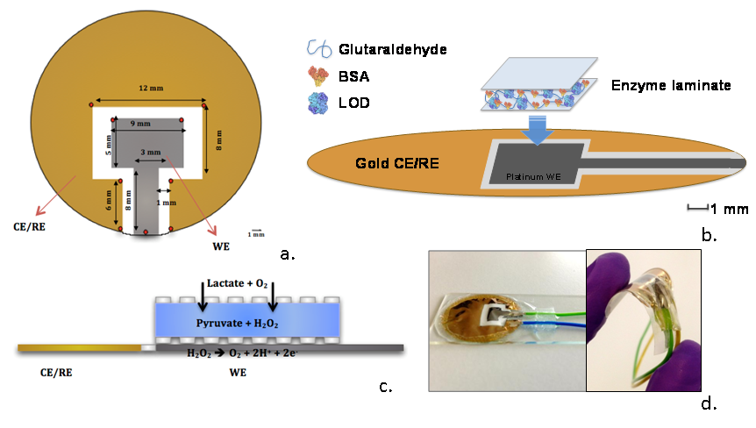
Fig. 2.

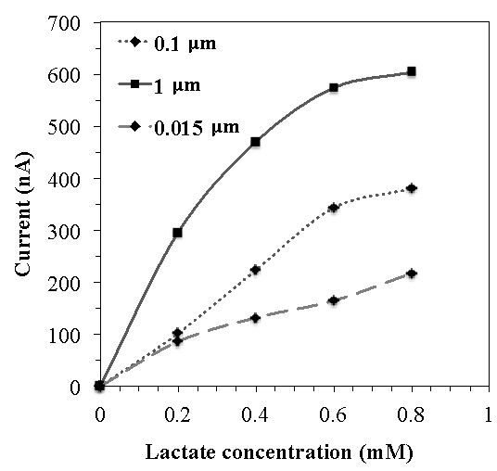
Fig. 3.

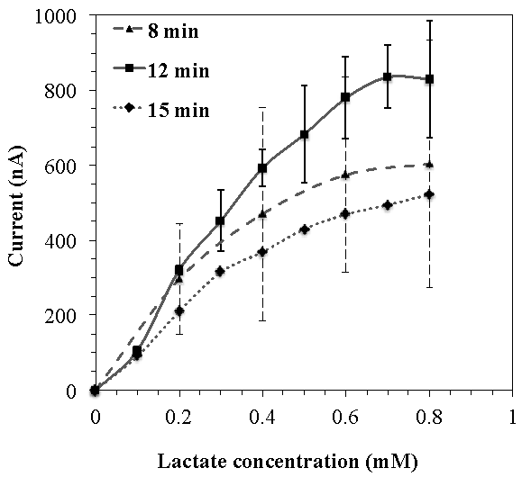
Fig. 4.
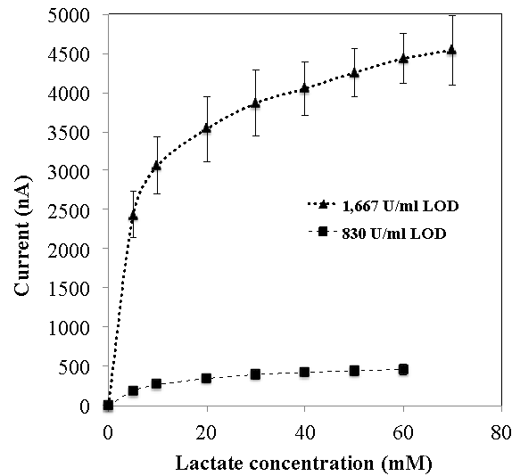

Fig. 5.
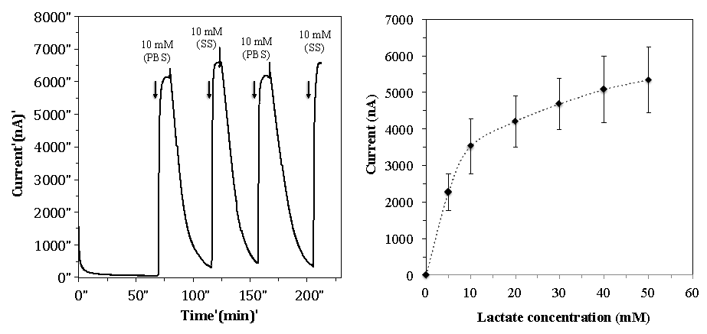

Fig. 6.
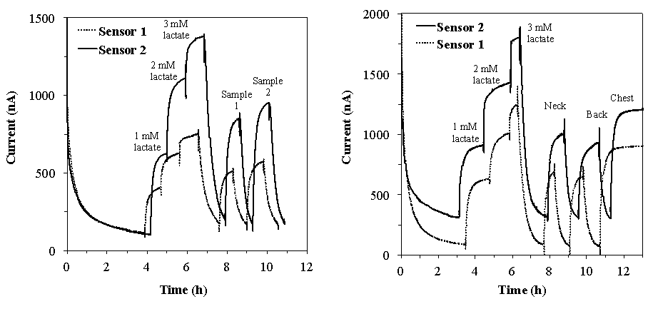
Fig. 7.

