On the lowest rung of the ladder:
How social exclusion, perceived economic inequality and stigma increase homeless people’s resignation

Authors: Marco Marinucci, Paolo Riva, Michela Lenzi, Camilla Lasagna, Daniel Waldeck, Ian Tyndall, & Chiara Volpato

British Journal of Social Psychology
Abstract
Despite the relevance of social exclusion and economic inequality for homelessness, empirical studies investigating how these issues relate to homeless people’s psychological well-being are scarce. We aimed to fill this gap by conducting two quasi-experimental studies on homeless and non-homeless groups. The first study (N=200) showed that homeless (vs. non-homeless) people presented higher levels of resignation, characterized by depression, alienation, helplessness, and unworthiness. The second study (N=183) replicated the findings from Study 1 and showed that perceived economic inequality could increase homeless people’s resignation by emphasizing perceptions of social exclusion. Additional analyses found that identification with the stigmatized homeless group could mediate the relationship between perceived inequality and social exclusion, increasing the resignation. Overall, the results showed that chronic social exclusion of homeless people is associated with higher levels of resignation. Moreover, they showed the role of perceived economic inequality and homeless group stigmatized identification as group-specific mechanisms favoring social exclusion and ultimately worsening psychological well-being.

Keywords: Social Exclusion; Homeless People; Resignation stage; Economic Inequality; Social Identity; Stigma.

“People see that you are homeless…even if you dress well, it is like you have a mark. It is a mark that is stuck to you in your daily life…even if you have two cents and go to a cafè, people leave you aside and stay at a distance…”

L., homeless man, ~60 years old
(Study 2’s participant)

Homeless people are among the most vulnerable populations in societies worldwide. Homelessness is inherently characterized by poverty, social exclusion, and poor health conditions (Bramley & Fitzpatrick, 2018; Van Straaten et al., 2018). Extreme poverty is considered the major predictor of homelessness (Burns, 2001), and homeless people are listed among the most excluded social groups (European Commission, 2010). The majority of research on homelessness has primarily adopted juridical, sociological, ethnographic, or community psychological approaches to investigate policies, sociodemographic background, living conditions, and housing programs (Greenwood et al., 2020; Bramley & Fitzpatrick, 2018; Parsel & Parsel, 2012; Lynch & Stagoll, 2002). The sociological research suggests that the impact of social exclusion on homeless people’s lives largely overcomes the implications of poverty (Van Straaten et al., 2018). The sociological perspective conceptualizes social exclusion as a broad concept including material deprivation (e.g., financial debts), inadequate access to social rights (e.g., housing, health insurance), limited social participation (e.g., unemployment), insufficient cultural integration (e.g., criminal records; Jehoel-Gijsbers et al., 2009). Longitudinal findings based on this framework show that a reduction in social exclusion over time was associated with reduced psychological distress (Van Straaten et al., 2018). Qualitative findings report that the most excluded homeless people presented the worst physical and mental health, substance abuse, criminal records, and lower education (Anderberg & Dahlberg, 2019).
Differing from the broad sociological indicators of social exclusion, the social psychological literature conceptualizes social exclusion as a relational threat that occurs at the interpersonal and intergroup levels and harms well-being (Baumeister & Leary, 1995). The social psychological literature investigating social exclusion and its consequences on homeless people’s mental health is rather scarce. In the current research, we investigated the psychological repercussions of social exclusion for homeless people who are among the most vulnerable, stigmatized, and neglected social groups in western societies. Also, we examined if individual and group processes related to the perception of economic inequality and identification with the homeless group could relate to the perception of social exclusion and its adverse implications.
Social Exclusion of Homeless People
The social psychological perspective defines social exclusion as the experience of being separated from others physically or emotionally (Riva & Eck, 2016). Daily episodes of social exclusion have been categorized into rejection- and ostracism-based events (Wesselmann & Williams, 2017). Rejection occurs when people receive direct negative attention from others, as in cases of discrimination, stigmatization, dehumanization, or microaggression (Andrighetto et al., 2016; Smart Richman et al., 2016; Sue et al., 2007). Differently, ostracism consists in not receiving attention from others, as when one is ignored, forgotten, unanswered, unspoken to, or not given eye contact (Nezlek et al., 2012; King & Geise, 2011; Dotan-Eliaz et al., 2009).
Homeless people are often victims of interpersonal episodes of social exclusion. Research investigating homeless people’s experience of interpersonal exclusion – although scarce – showed that they are likely to be discriminated against due to their homeless status from multiple sources (police, family; Milburn et al., 2006) with negative repercussions for well-being (Johnstone et al., 2015). Daily discrimination and the overall perception of exclusion were related to depressive symptoms and threats to fundamental needs of belonging, self-esteem, control, and meaningful existence (Van Zalk & Smith, 2019).
Theoretically, the Temporal Need-Threat Model of Ostracism (Williams, 2009) may account for the long-term psychological consequences of interpersonal social exclusion. The model focuses on three stages of individuals’ responses to social exclusion while unfolding over time. In the first reflexive stage, victims of social exclusion experience negative emotions and a threat to their fundamental psychological needs (belonging, self-esteem, control, and meaningful existence). In the following reflective stage, individuals react prosocially or antisocially toward the source of exclusion or by seeking solitude to recover their threatened needs and emotions (Ren et al., 2021). If social exclusion persists over time and people fail to recover their needs, they will enter the resignation stage, characterized by chronic feelings of depression, unworthiness, alienation, and helplessness.
The resignation stage has received the least empirical attention due to the methodological challenges of measuring persistent social exclusion in general or marginalized populations (Wesselmann & Williams, 2017). Also, research has largely neglected the investigation of risk and protective factors facilitating or hindering entry into the resignation stage. Emerging findings supported the persistent exclusion-resignation link in the general population (Rudert et al., 2021; Zamperini et al., 2020; Riva et al., 2016) and in marginalized social groups like prisoners (Aureli et al., 2020) and immigrants (Marinucci et al., 2022a; Marinucci & Riva, 2021a; Marinucci & Riva, 2021b; Mazzoni et al., 2020).
Some of these recent studies identified specific intervenient factors that could influence the development of the resignation stage. Zamperini et al. (2020) showed that people could recover from the resignation stage by affiliating with new social groups like religious ones. A longitudinal study showed that the resignation stage induced by the persistent lack of face-to-face interaction during the Covid-19 lockdown could be reduced by online social interactions (Marinucci et al., 2022b). Aureli et al. (2020) showed that support groups within prisons could reduce the gap between inmates’ and free citizens’ overall resignation. Studies on immigrants showed that social connections with the national group reduced the impact of exclusion on the resignation, whereas connections with other immigrants aggravated it (Marinucci et al., 2022a; Marinucci & Riva, 2021a).
Given the condition of extreme marginalization that define homelessness, homeless people could be at risk of entering the resignation stage. Indeed, homelessness has also been conceptualized as a situation of capabilities deprivation (i.e., the freedom to be and do in a given context; Batterham, 2019) and failure (Shinn, 2015). The lack of opportunities to develop one’s resources and competencies likely facilitates feelings of unworthiness, helplessness, alienation, and depression.
However, research has not investigated the resignation stage in the homeless population nor considered group-specific factors that could influence its development. The current research sought to fill this gap by investigating if the persistent exclusion inherently associated with homelessness would lead homeless people into the resignation stage. Also, we investigate if the perception of economic inequality could influence the development of the resignation stage among homeless people. Indeed, perceived economic inequality could increase homeless participants’ resignation levels by emphasizing their perception of being excluded from society.
Objective and Perceived Economic Inequality
Economic inequality, the asymmetric distribution of income and wealth between the rich and poor, is considered a major political, economic, and social challenge (Easterbrook, 2021). Researchers have started focusing on the individuals’ perception of economic inequality, thought to be a reliable determinant of its psychosocial consequences (Willis et al., 2022). Perceived economic inequality refers to how individuals think inequality exists around them. Research showed that higher inequality related to higher levels of psychological distress besides overall worse health condition and lower subjective well-being (Schmalor & Heine, 2022a; Gugushvili et al., 2020; Oshio & Urakawa, 2014).
Two psychological mechanisms can drive the adverse effects of economic inequality: status competition and social distance (Willis et al., 2022; Buttrick et al., 2017). Status competition refers to the competition to maintain or improve one’s position on the social ladder. In more unequal societies, people are more likely to perceive socioeconomic differences between individuals, categorize the social world along class lines, and emphasize the importance of one’s economic position as a way to be respected and admired (Buttrick et al., 2017; Paskov et al., 2013). In more unequal societies, people tend to identify more strongly with their socioeconomic group, mainly if they belong to the lower economic status groups (Andersen & Curtis, 2012). They are also likely to become more worried about their financial position in comparison with others (i.e., status anxiety; Pickett & Wilkinson, 2015), and more sensitive to upward disadvantaged comparison with negative repercussions on well-being (Hannay, 2022; Roth et al., 2017). The consequences of inequalities might be stronger for people at the bottom of the socioeconomic ladder, for whom socioeconomic stratification might create even starker contrasts of social class.
Economic inequality also increases the social distance between groups and individuals. It fuels people’s perception that others are diverse on a socioeconomic basis and have concerns and values distant from their own (Uslaner & Brown, 2005). Social distance impairs the development of interpersonal ties – especially across class lines (Rothstein & Uslaner, 2005) – and the sense of togetherness (Delhey & Dragolov, 2014; Nishi et al., 2015). Ultimately, mistrust and separation decrease individuals’ well-being (Buttrick et al., 2017; Delhey & Dragolov, 2014). Inequality threatens social cohesion for all socioeconomic groups. Still, at the bottom of the social hierarchy, the perceived distance between one’s and others’ interests, habits, and values might be vast and turn into social exclusion.
The status competition and social distance processes can be traced back to a social identity-based theory (Jetten et al., 2017, Tajfel & Turner, 1979). The perception of inequality increases the salience of wealth as a critical basis for categorizing the self and others, inducing interpersonal and intergroup comparisons along wealth lines to monitor one’s self- and group esteem conveyed by the position on the social ladder, generating social competition (Jetten et al., 2017). Based on Jetten et al. (2017), social identity dynamics and the derived intergroup relations seem to embed the mechanisms of status competition and social distance. In the context of homelessness, the perception of economic inequality should increase homeless people’s identification with their socioeconomic group and the awareness of their group’s socioeconomic status, which is defined by marginalization and exclusion on the lowest rung of the socioeconomic ladder (Van Straaten et al., 2018). In this process, social identification would play a crucial role in carrying the negative impact of the perception of economic inequality on homeless people’s psychological well-being.
Group Identification: A Hazard for Homeless People’s Well-Being
The social cur(s)e literature suggests that group identification could be a burden when people belong to stigmatized social groups (Kellezi et al., 2012; 2019; Wakefield et al., 2019). Findings showed that membership with low-esteemed or stigmatized groups impaired well-being (e.g., Korkmaz & Cingöz-Ulu, 2021; DeMarco & Newheiser, 2019; Kyprianides et al., 2019). The cursing effect of derogated social identities could be conveyed by the social identity component of the identity centrality (aka identity salience, conceptualizing the group’s relevance to the self; Cameron, 2004; Leach et al., 2008). Rubin and Stuart (2018) proposed the amplification hypothesis, in which individuals whose group identity is highly relevant to the self are more sensitive to the psychological implications of their group status, whether positive or negative. They showed that the negative association between social class and mental health was higher among individuals with a more central identification with their social class. The literature on group identification and social exclusion among stigmatized groups suggests that the social identity components promoting distinctiveness (i.e., centrality, salience) – in contrast with those strengthening the group bonds (e.g., similarity, ties) – could increase the negative impact of social exclusion (e.g., Bilewicz et al. 2021; 2022; Begeny & Huo, 2017; Çelebi et al., 2017; Branscombe et al., 1999).
The literature on homelessness suggests that the stigma might exacerbate the sense of isolation and reduce the perception of social support, with negative consequences for homeless people’s well-being (Dashora, 2016; Teo & Chiu, 2016). The recent work from Rea (2022) suggests that homeless people’s stigmatized social position negatively affected their self-esteem and increased feelings of depression and anxiety. Also, the author highlighted that the perception of stigma might further increase their isolation and exclusion by making homeless people conceal their status, withdraw from social interaction, and prevent them from seeking social support.
In conclusion, group identification could be a critical link in a cascade process carrying the adverse effects of inequality and social exclusion on homeless people’s well-being. On the one hand, the perception of economic inequality would increase the identification with one’s socioeconomic group (i.e., the homeless group) and the salience of one’s position in the social hierarchy (i.e., the most excluded and marginalized status). On the other, identification with the homeless group – primarily through the identity centrality component – would emphasize experiences of social exclusion, with negative repercussions on well-being.
The Present Research
The present research consists of two studies focusing on homeless people. In both studies, we adopted a quasi-experimental approach to compare homeless and non-homeless participants’ levels of resignation, perception of social exclusion, and economic inequality. The first study provided a preliminary test of the resignation stage from Williams’ (2009) model. We hypothesized that homeless people would present higher levels of resignation than non-homeless participants due to the state of chronic social exclusion that characterizes homelessness. The second study, besides replicating the findings from the first one, aimed at testing if the perception of economic inequality and group identification with the homeless group could be risk factors aggravating the perception of social exclusion and, ultimately, resignation.
The questionnaires, dataset, and analysis codes are available at https://osf.io/hdyax/?view_only=d62e081eabe545958a75e18eafbadc2d. The studies were not preregistered. The Ethics Committee of the University of [blinded for peer review] approved the studies.
Study 1
Study 1 tested the prediction made by the resignation stage of Williams’s theory (2009; see also Smart-Richman & Leary, 2009) that chronic experiences of social exclusion would uniquely result in feelings of alienation, unworthiness, helplessness, and depression. We expected that homeless participants would present higher levels of adverse outcomes characterizing the resignation stage (i.e., alienation, unworthiness, helplessness, and depression) compared to non-homeless individuals).
Method
Participants and Procedure
An a priori power analysis was conducted for sample size estimation (using GPower 3.1; Faul et al., 2007). With an alpha = .05 and power = 0.80, the projected sample size needed to detect a medium effect size (d=.05) is N = 128 for a between-groups comparison (t-test). In total, we recruited 200 participants in a quasi-experimental design that was subdivided into two groups.
Homeless people were asked to participate in the study on-site at the homeless shelters in the Municipalities of [blinded for peer-review] with the full knowledge and support of the staff. Collecting data at the shelter ensured a standardized setting that reduced potential hazards for participants and researchers. Participants were informed that there would not be a reward for participation and that they were free to interrupt the study at any moment. Data were collected with paper-based questionnaires. As the comparison group, we recruited (right after recruiting the homeless group) a group of non-homeless participants living in a house or an apartment they owned or rented. Participants received the same questionnaire package used for the homeless group. All participants in the non-homeless group reported living in a home and not having experienced homelessness.
Table 1 reports the sociodemographic information and the two groups’ comparisons.

Table 1. Sociodemographic information and group comparisons – Study 1
 | Homeless  (n = 100) | Non-homeless  (n = 100) | Group comparison
Gender | 49 Women  50 Men  (1 missing) | 50 Women  50 Men | Χ²(1) = 0.00  p = 1
Mean age (SD) | 52.5 (11.1) | 52.1 (10.3) | t(195) = 0.72  p = .784
Nationality | 98 Italians  (2 missings) | 100 Italians | -
Education | 15.3% Primary school  46.9% Middle school  31.6% High school  6.1% University | 10% Primary school  33% Middle school  41% High school  16% University | Χ²(3) = 9.05*  p = .029
Marital status | 43.4% Single  12.1% Married  40.4% Separated  4% Widowed | 10% Single  74% Married  11% Separated  5% Widowed | Χ²(3) = 81.84***  p < .001
Occupational status | 16% Employed  76.6% Unemployed  7.4% Retired | 81.4% Employed  3.1% Unemployed  15.5% Retired | Χ²(2) = 109.94***  p < .001
Mean months homelessness | 9.13 (9.50) | -
Note. *** p < .001, * p < .05.
We balanced the two groups on gender, age, and nationality to control for possible confounders. The characteristics of the homeless group and the differences compared to the non-homeless group align with the features of the homeless population in Western countries, as found in large-scale reports and systematic reviews (e.g., Philippot et al., 2007).
Measures
All participants were asked to complete the following four scales measuring each of the constructs (e.g., alienation) predicted by Williams’s (2009) resignation stage. Participants were instructed to respond to each of the following scales based on how they felt during the past six months. Unless otherwise stated, participants responded using a 5-point Likert scale (ranging from 1=totally disagree to 5=totally agree).
Depression. The Beck Depression Inventory (Beck, 1996) was used to assess depression. For ethical reasons, we dropped the item related to suicidal thoughts, leaving twenty items rated on 4-point scale (e.g., “I feel sad much of the time”, range = 0 - 3; Cronbach’s α_{homeless} = 0.89, Cronbach’s α_{non-homeless} = 0.84). We averaged the items to create an overall index with higher scores indicating higher depression.
Alienation. To assess alienation, we used the Sense of Belonging Instrument (Hagerty & Patusky, 1995). The scale consists of eighteen items (e.g., “I feel like an outsider in most situations”; Cronbach’s α_{homeless} = 0.90, Cronbach’s α_{non-homeless} = 0.83). Higher scores indicating higher alienation.
Unworthiness. The Self-Esteem Scale (Rosenberg, 1965) measured unworthiness. The scale consisted of ten items (e.g., “On the whole, I am satisfied with myself”; Cronbach’s α_{homeless} = 0.88, Cronbach’s α_{non-homeless} = 0.86). Higher scores indicate more feelings of unworthiness.
Helplessness. The Beck Hopelessness Scale (Beck, 1974) measured helplessness, as helplessness largely overlaps with hopelessness. The scale included 20 items designed to detect three main domains: 1) negative feelings about the future (e.g., “My future seems dark”), 2) loss of motivation (e.g., “I could give up because I cannot make things better for me”), and 3) negative expectations (e.g., “Things do not go as I want them to go”). We created an overall index (Cronbach’s α_{homeless} = 0.89, Cronbach’s α_{non-homeless} = 0.87) with higher scores indicating stronger feelings of helplessness.
Overall Resignation. Lastly, we created an overall index of resignation stage outcomes by averaging the items from the four scales (Cronbach’s α_{homeless} = 0.96, Cronbach’s α_{non-homeless} = 0.94).
Table 2 reports the correlations between the measures.

Table 2. Correlations between the variables – Study 1
 |  | 1 | 2 | 3 | 4 | 5
1. | Depression | - | .71*** | .71*** | .68*** | .88***
2. | Alienation | .55*** | - | .57*** | .64*** | .86***
3. | Unworthiness | .60*** | .58*** | - | .75*** | .84***
4. | Helplessness | .51*** | .56*** | .52*** | - | .89***
5. | Overall Resignation | .78*** | .85*** | .79*** | .83*** | -
Note. *** p < .001; values above the diagonal refer to the homeless sample; values below the diagonal refer to the non-homeless sample.
Results
At first, we confirmed that the four outcomes of the resignation stage converged into a single factor equivalently among the homeless and non-homeless subsamples (see supplementary analysis 1). Then, as the main hypotheses-testing, we conducted a series of Welch two-sample t-tests to investigate if homeless people would show higher levels of the resignation stage. The results, reported in Table 3 and displayed in Figure 1, supported the hypotheses.
Table 3. Mean (SD) and group differences in the main variables – Study 1
 | Homeless  M (SD) | Non-homeless  M (SD) | Group  Comparison | Cohen’s d
Depression | 1.03 (1.19) | 0.48 (0.32) | t(151) = 8.03, p <.001 | 1.14
Alienation | 3.07 (0.92) | 1.93 (0.57) | t(163) = 10.52, p <.001 | 1.50
Unworthiness | 2.67 (0.92) | 2.20 (0.63) | t(175) = 4.23, p <.001 | 0.60
Helplessness | 2.97 (0.74) | 2.39 (0.51) | t(175) = 6.50, p <.001 | 0.92
Resignation | 2.38 (0.68) | 1.68 (0.40) | t(160) = 8.86, p <.001 | 1.26

Overall, the analyses showed that the experience of homelessness is associated with higher levels of resignation stage outcomes compared to a non-homeless condition, as predicted by the theoretical models (Williams, 2009; Smart Richman & Leary, 2009). However, in Study 1, we did not measure the perception of social exclusion or possible intervening factors contributing to the exclusion resignation link. Study 2 sought to address these issues while replicating and extending the findings from Study 1.
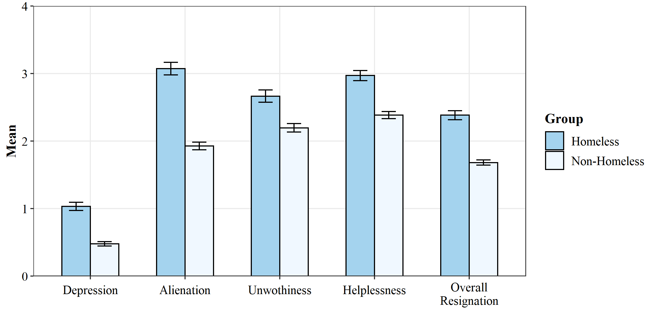
Figure 1. Mean (SE) of the main variables by groups – Study 1
Study 2
Study 2 investigated if the perception of economic inequality could influence homeless people’s feelings of resignation by increasing their perception of social exclusion. We adopted a quasi-experimental design involving homeless and non-homeless groups to control that the hypothesized process would be specific to the homeless group.
As preliminary hypotheses, we expected that homeless people would report a higher perception of social exclusion and feelings of resignation than non-homeless people. We explored group differences in the perception of economic inequality. As the main hypotheses, we based the predictions on the literature showing that economic inequality increases the salience of one’s socioeconomic status (Buttrick et al., 2017; Andersen & Curtis, 2012). Given that homeless people’s social status is inherently characterized by social exclusion (Van Straaten et al., 2018; European Commission, 2010), we hypothesized that the perception of economic inequality would increase homeless people’s awareness of being excluded in society. Ultimately, the emphasized perception of social exclusion would increase their sense of resignation, as theorized by the Temporal Need-Threat Model (Williams, 2009). Hence, we hypothesized that perceived inequality would increase the resignation among the homeless group by heightening the perceived social exclusion. We expected the link between inequality and exclusion to be specific only to the homeless group, in contrast to the non-homeless group. Since the latter group’s socioeconomic position is not characterized by extreme marginalization, we did not expect perceived inequality to translate into heightened feelings of social exclusion. We tested a multigroup mediation model hypothesizing that the perception of inequality would promote the resignation stage by increasing the awareness of social exclusion only among the homeless group.
Also, focusing on the homeless sample, we tested the role of identification with the homeless group as a critical mediator in the cascade process harming homeless people’s well-being. Indeed, inequality prompts identification with one’s socioeconomic group (Jetten et al., 2017), particularly for low-status groups like the homeless (Andersen & Curtis, 2012), and identification with one’s stigmatized group increases the salience of social exclusion (mainly through identity centrality; e.g., Rubin & Stuart, 2018). Hence, we hypothesized that inequality would increase the identification with the stigmatized homeless group that, in turn, would highlight the condition of social exclusion, which ultimately aggravates resignation. We tested a serial mediation model hypothesizing that perceived inequality would indirectly increase resignation by heightening identification with the homeless group and perception of social exclusion.
Method
Participants and Procedure
We recruited a convenience sample of homeless (n = 92) and non-homeless (n = 91) participants. Using the R package WebPower (Zhang & Yuan, 2018), we conducted a multigroup mediation model simulation (as the study’s primary analysis) with 100 Monte Carlo repetitions and 1000 bootstrap draws (Thoemmes et al., 2010). We set the effect of perceived inequality on resignation to 0.34 (Schmalor & Heine, 2022a), the effect of social exclusion on resignation to 0.56 (Marinucci & Riva, 2021a), and expected a medium effect (β = 0.30) of perceived inequality on social exclusion for the homeless group and a null one (β = 0) for the non-homeless group. Results showed that the recruited sample size allowed us achieving the minimum conventional statistical power of 0.82 in detecting the indirect effect of perceived inequality on resignation via social exclusion among the homeless group.
Table 4. Study 2 - Sociodemographic information and group comparisons – Study 2
 | Homeless  (n = 92) | Non-homeless  (n = 91) | Group comparison
Gender | 15 Women  76 Men | 24 Women  67 Men | Χ²(1) = 2.09  p = .148
Mean age (SD) | 52.5 (12.5) | 52.4 (12.4) | t(137) = 0.06  p = .949
Nationality | 88 Italians  4 Other | 90 Italians  1 Other | Χ²(1) = 0.80  p = .371
Education | 13% Primary school  40.2% Middle school  33.7% High school  13% University | 4.4% Primary school  30.8% Middle school  44% High school  20.9% University | Χ²(3) = 7.96*  p = .046
Marital status | 55.6% Single  1.1% Married  42.2% Separated  1.1% Widowed | 17.6% Single  65.9% Married  12.1% Separated  4.4% Widowed | Χ²(3) = 91.25***  p < .001
Occupational status | 15.7% Employed  84.3% Unemployed | 79.1% Employed  20.9% Unemployed | Χ²(1) = 69.95***  p < .001
Spend the night in… | 24.2% Street  62.6% Shelter  11% Apartment (housing programs)  2.2% Other | 100% Home
Mean months homelessness | 49.84 (49.1) | -
Note. *** p < .001, * p < .05.
To approach homeless people, we contacted several associations providing services for homeless people in the Municipalities of [blinded for peer-review]. We asked the associations to enter their facilities or flank them during their activities on the streets to help us contact homeless people in a friendly and trustworthy climate. Then, we asked homeless people if they wanted to participate in the study, explaining that participation was not related to the associations’ activities, that they were free to participate, and that there was no compensation.
Data were collected using self-reported paper-and-pencil questionnaires distributed by trained research assistants that supported participants in case of need. Data from the non-homeless people were gathered using an online self-reported questionnaire implemented in Qualtrics. The online link was distributed using social media platforms (e.g., Facebook) and the snowball sampling method. We collected data from the non-homeless sample right after the homeless one by recruiting participants with similar sociodemographic characteristics.
Table 4 reports the sociodemographic information and group comparisons of the two samples. We balanced the two groups on gender, age, and nationality to control for possible confounders.
Measures
The self-reported questionnaires for the homeless and non-homeless groups were largely overlapping, with some constructs being specifically assessed only for one of the two groups. Both groups answered the study’s primary interest measures on a 5-point Likert scale (1 = “not at all”, 5 = “extremely”) as follows.
Perceived Economic Inequality. Awareness of inequality was assessed with the Subjective Inequality Scale (Schmalor & Heine, 2022a). The scale consisted of eight items theoretically loading on two factors measuring the perceived extent of inequality (e.g., “Only those at the top own any wealth at all”) and the perceived unfairness of economic inequality (e.g., “It is extremely unfair if the overall amount of economic inequality is very high”). Multigroup factor analysis supported metric invariance of the measure across the homeless and non-homeless groups (see supplementary analysis 2b). Given that the study’s main focus was on the overall perception of economic inequality (regardless of its component) and the significant correlations between the two factors, we averaged the eight items in a composite score of perceived inequality that showed good reliability in both the samples (Cronbach’s α_{homeless} = 0.83; Cronbach’s α_{non-homeless} = 0.77). Higher scores indicated a higher perceived extent and unfairness of inequality.
Social Exclusion. Social exclusion was measured with four items created ad hoc. Two items (“During the last six months, I have been ignored/rejected”) were based on the literature categorizing experiences of social exclusion into instances of ostracism and rejection (Wesselmann & Williams, 2017). Two items measured the frequency of social exclusion from homeless and non-homeless people (“During the last six months, I have been excluded by homeless/non-homeless people”). The four items were averaged in a composite score measuring the frequency of social exclusion experiences. The scale showed good reliability, factor structure and configural invariance across samples (see supplementary analysis 2c; Cronbach’s α_{homeless} = 0.77; Cronbach’s α_{non-homeless} = 0.74).
Resignation. The overall level of resignation was assessed by measuring its four associated outcomes, reducing the number of items compared to Study 1 to prevent participants’ fatigue. Depression was measured with three items from the Depression-Anxiety-Stress Scale – depression subscale (Bottesi et al., 2015; e.g., “In the last three months, I felt down-hearted and blue”), unworthiness with three items from the Rosenberg Self-Esteem Scale (Rosenberg, 1965; e.g., “In the last three months, I was satisfied with myself”, reverse item), alienation with three items from the Social Connectedness Scale – alienation subscale (Lee & Robbins, 2000; e.g., “In the last three months, I felt distant from others”), and helplessness with two items from the Beck Depression Inventory (Beck et al., 1974; e.g., “In the last three months, my future have seemed dark to me”) and one item from the Beck Hopelessness Scale (Beck et al., 1996; e.g., “In the last three months, I thought that my future was hopeless and could only get worse”). Multigroup confirmatory factor analysis showed that the four resignation outcomes were adequately explained by the single latent factor of the resignation stage, while also supporting the configural invariance of the measure between the homeless and non-homeless groups (see supplementary analysis 2a). Therefore, we averaged the set of items in an overall score of resignation that showed good reliability in both the samples (Cronbach’s α_{homeless} = 0.91; Cronbach’s α_{non-homeless} = 0.86).
Identification with the homeless group. Only the homeless participants answered five items measuring their social identity as a homeless person. The five items were adapted from Cameron’s (2004) Three-Factor Model of Social Identity, which considers ties, affects, and centrality as the primary components of social identity with one’s ingroup. Three items measured identity ties (e.g., “I have a lot in common with other homeless people”); two items assessed identity centrality (e.g., “I often think about the fact that I am a homeless person”); one item measured negative identity affect (“I often regret that I am a homeless person”). Exploratory factor analysis and parallel analysis suggested the adoption of two factors. The factor “Stigmatized Identity” (items’ loadings: 0.50 – 0.91) measured a negative identity centrality. It included the identity centrality and the negative affects items, therefore measuring a social identity which is very important for the self but also a source of negative emotions and distress. The factor “Identity Ties” (items’ loadings: 0.28 – 0.80) included the items of the identity tie component, measuring the perception of similarity and connection with other homeless people. We scored the two factors separately.
Besides these measures, both the homeless and the non-homeless groups answered items measuring the adequacy of one’s financial resources (i.e., “Does the money you have cover your needs?”), the access to welfare services (e.g., “In the last six months, how often did you use: food assistance services/public shelters/public showers?”; 12 items; Cronbach’s α_{homeless} = 0.84, Cronbach’s α_{non-homeless} = 0.75), and the adequacy of living conditions (i.e., “How safe/comfortable/private/large/pleasant is the space where you live in?”; 5 items; Cronbach’s α_{homeless} = 0.87, Cronbach’s α_{non-homeless} = 0.88). Table 5 reports correlations between the constructs.
Table 5. Correlations between the variables – Study 2
 |  | 1 | 2 | 3 | 4
1. | Perceived Inequality | - | -.09 | .06 | -
2. | Social Exclusion | .26* | - | .33*** | -
3. | Resignation | .24* | .50*** | - | -
4. | Stigmatized Identity | .31*** | .33*** | .36*** | -
5. | Identity Ties | .01 | .00 | .05 | .21⁺
Note. *** p < .001, * p < .05, ⁺ p = .05; values below (above) the diagonal refer to the (non-)homeless sample.

Participants answered other constructs not related to the study’s aims (see the OSF repository).
Results
Homeless and non-homeless group differences
We conducted a series of Welch two-sample t-tests to assess the group differences in the primary study variables. In doing so, we could evaluate the face validity of the membership in the homeless and non-homeless groups and replicate Study 1’s findings regarding the group differences in the levels of perceived inequality, social exclusion, and resignation. Results are reported in Table 6 and displayed in Figure 2.

Table 6. Mean (SD) and group differences in the main variables – Study 2
 | Homeless  M (SD) | Non-homeless  M (SD) | Group  Comparison | Cohen’s d
Financial adequacy | 2.44 (1.19) | 4.14 (0.87) | t(163) = 10.94, p <.001 | 1.64
Living space adequacy | 2.92 (1.09) | 3.60 (0.78) | t(163) = 4.81, p <.001 | 0.72
Use of welfare services | 2.56 (0.92) | 1.05 (0.20) | t(90) = 14.74, p <.001 | 2.29
Perceived Inequality | 3.14 (0.97) | 3.16 (0.70) | t(156) = 0.21, p =.831 | 0.03
Social Exclusion | 2.37 (1.07) | 1.59 (0.66) | t(144) = 5.86, p <.001 | 0.89
Resignation | 2.49 (0.97) | 1.71 (0.52) | t(131) = 6.64, p <.001 | 1.01

Figure 2. Mean (SE) of the main variables by groups – Study 2
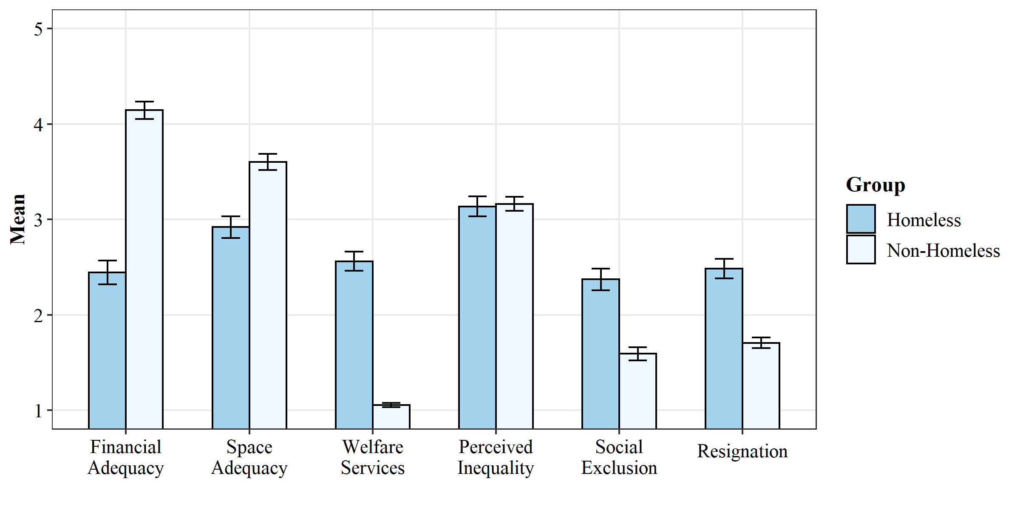
The findings confirmed the expected characteristics of the two groups. The results confirmed that homeless people reported significantly higher perceptions of social exclusion and feelings of resignation than the non-homeless group. Furthermore, findings showed that the homeless and non-homeless participants did not differ in their perception of economic inequality.
Social exclusion explains the relation between homeless status and the resignation
To further corroborate that the mere status of being homeless over time could induce the resignation stage, we conducted a mediation model testing whether the homeless status predicted the resignation stage indirectly via social exclusion. In doing so, we also included the sociodemographic variables of the marital status, education, and occupational status as covariates of both the relation between homeless status and social exclusion, and the link between the homeless status and the resignation stage. We did so to control that the homeless status effects on social exclusion and the resignation would not be affected by these sociodemographic characteristics, which were significantly different between the homeless and non-homeless groups. The analysis was conducted using the ‘lavaan’ package (Rosseel, 2012) on the RStudio software (version 4.2.0; R Core Team, 2022). Results are reported in Figure 3. The findings confirmed that the status of being homeless was significantly associated with the resignation stage, both directly and indirectly via social exclusion. Also, results showed that the differences in sociodemographic variables were not relevant confounders of the hypothesized processes.
Figure 3. The influence of the homeless status on the resignation stage via social exclusion, controlled for significant sociodemographic differences.
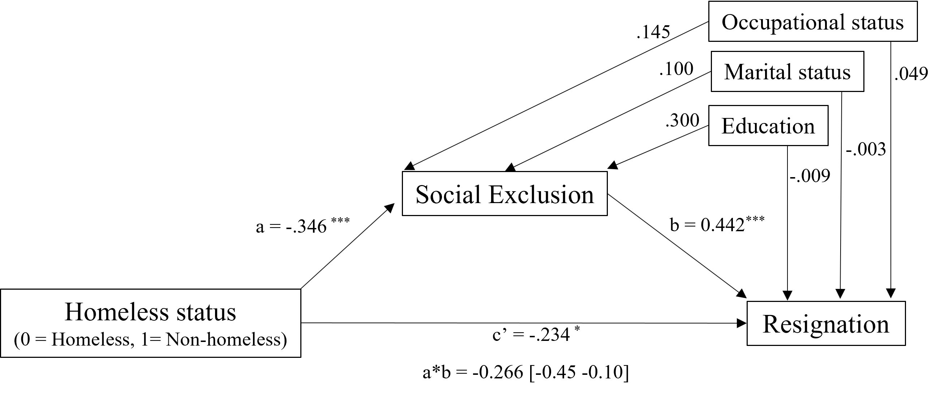
Note. ** p < .01, *** p < .001. Bootstrapped standard errors (1000 bootstrap draws). Standardized coefficients.

Perceived inequality and social exclusion on homeless people’s resignation
To assess the primary hypothesis that the perception of economic inequality would increase resignation by fostering the perception of social exclusion among the homeless participants, we adopted a Structural Equation Modelling approach. We compared the model fit of a multigroup mediation model, estimating the path from economic inequality to social exclusion separately for the homeless and non-homeless groups (M1) with the model fit of a null-model estimating only one path from inequality to exclusion (M0). In both models, we allowed intercepts and variances to vary across the groups, as the preliminary analyses showed significant group differences in the main variables. The model comparison tested if a mediation model assuming that the paths and indirect effect of inequality on resignation via social exclusion are different for the homeless and non-homeless groups was better than a unique model assuming that the effects did not differ between the two groups. The model fit assessment was based on the same criteria as Study 1. The analyses were conducted using the ‘lavaan’ package (Rosseel, 2012) on the RStudio software (version 4.2.0; R Core Team, 2022). The models’ fit and comparison are reported in Table 7. The two models and their coefficients are displayed in Figure 4.
 | Χ²(df); p | TLI | CFI | RMSEA | SRMR | Model comparison  (M0 vs. M1)
M0 | 7.33 (3); .062 | 0.769 | 0.884 | 0.128 | 0.085 | ΔΧ²(1) = 6.11, p = .013  M1 is better
M1 | 1.22 (2); .544 | 1.06 | 1.00 | 0.00 | 0.04
Table 7. Models’ fit and comparison

Figure 4. Multigroup mediation models
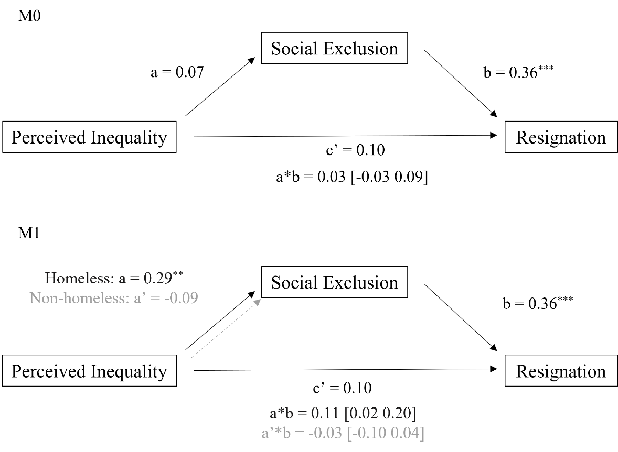
Note. ** p < .01, *** p < .001. Bootstrapped standard errors (1000 bootstrap draws). Unstandardized coefficients. Non-significant paths are in dashed gray lines.

Results showed that the null model M0 not assuming any multigroup path had a poor, unacceptable fit on all the indices. Differently, M1 showed a good fit and the chi-square difference test suggested that the specification of the additional multigroup path of M1 significantly improved the model goodness compared to M0. The results supported the study’s hypothesis. The perception of economic inequality was significantly associated with social exclusion only among the homeless group. In turn, social exclusion was positively associated with the resignation stage. The bootstrapped test of the indirect effects supported that perceived inequality was positively associated with the resignation indirectly via social exclusion only among the homeless participants. Also, building from M1 we tested two additional models specifying a multigroup path from social exclusion to resignation (M2) and from perceived inequality to resignation (M3). Neither M2 (ΔΧ²(1) = 1.10, p = .293) nor M3 (ΔΧ²(1) = 0.20, p = .655) showed a better fit than M1, meaning that the exclusion-resignation and the perceived inequality-resignation paths were stable between the homeless and non-homeless groups.
Overall, the results showed that the perception of economic inequality could make homeless people’s excluded status more salient, thus increasing their resignation. Differently, the perception of economic inequality was not associated with social exclusion among the non-homeless participants – as their social status is not characterized by social exclusion. Therefore, inequality did not affect the resignation via social exclusion for the non-homeless participants.
The role of identification with the homeless group
Focusing on the homeless group, we investigated if identification with the homeless group could further explain how perceived inequality related to social exclusion affects the resignation stage. We conducted a parallel serial mediation model, simultaneously considering the role of the two social identity components (stigmatized identity and identity ties) as parallel mediators of the link between perceived inequality and social exclusion and as serial mediators, along with social exclusion, of the inequality-resignation link. The model and the coefficients are displayed in Figure 5; the indirect effects are reported in Table 8.
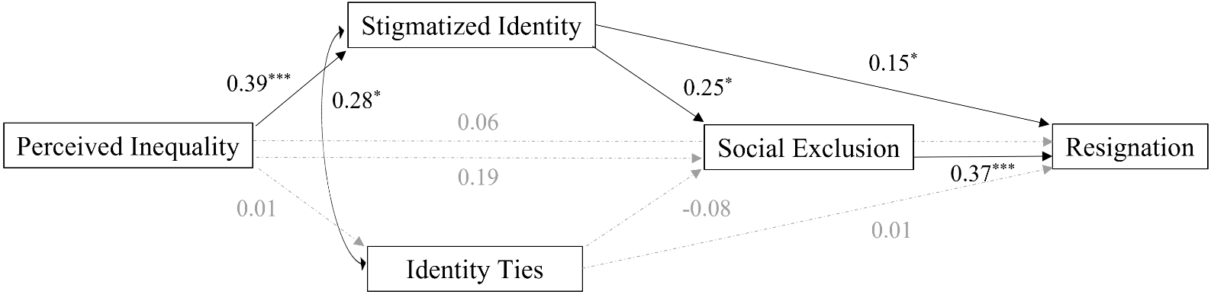
Figure 5. The role of identification with the homeless group

Note. * p < .05, *** p < .001. Bootstrapped standard errors (1000 bootstrap draws). Unstandardized coefficients. Non-significant paths are in dashed gray lines.

Table 8. Indirect effects
Path | Unstandardized effect | 95% CI
Outcome: Resignation  Inequality Stigmatized Identity Exclusion  Inequality Stigmatized Identity  Stigmatized Identity Exclusion  Inequality Exclusion  Inequality Identity Ties Exclusion  Inequality Identity Ties  Identity Ties Exclusion | 0.04  0.06  0.09  0.07  0.00  0.00  -0.03 | 0.004 – 0.082  0.006 – 0.135  0.012 – 0.184  -0.017 – 0.172  -0.016 – 0.014  -0.014 – 0.037  -0.130 – 0.063
Outcome: Social Exclusion  Inequality Stigmatized Identity  Inequality Identity Ties | 0.10  0.00 | 0.013 – 0.205  -0.041 – 0.033

The results confirmed the hypothesized role of the negative identity centrality component as a key mechanism that triggers cascade processes explaining how the awareness of economic inequality can make more salient an exclusionary status that increases feelings of resignation. The perception of economic inequality may increase the resignation stage serially by increasing the salience of the stigmatized identity and perception of social exclusion. In the first step of the process, the negative identification with the homeless group mediated the link between perceived inequality and social exclusion. Then, in the second step, the perception of being excluded mediated the effect of the stigmatized identity on the resignation stage. Overall, the awareness of economic inequality may increase the identification with one’s socioeconomic group (the stigmatized homeless group), emphasizing the perception of being excluded with negative repercussions for well-being.
Differently, none of the paths concerning the identity ties component were significant. On the one hand, this indicated that the impact of inequality on the resignation could be uniquely relayed by the negative identity centrality path, not the identity ties. On the other hand, it also showed that social bonds with other homeless people were not an effective source of protection against the perception of social exclusion and the resignation stage.
General Discussion
In two quasi-experimental studies comparing homeless and non-homeless samples, the present research investigated if persistent social exclusion could lead homeless people into the resignation stage, characterized by chronic depression, alienation, helplessness, and unworthiness (Williams, 2009). Also, Study 2 tested if the perception of economic inequality and identification processes with the homeless group could further influence the perception of social exclusion and the resignation stage. Study 1 showed that homeless people presented higher levels of resignation than the non-homeless control group. Study 2 first replicated the findings from Study 1. Then, it showed that the perception of economic inequality was associated with the identification with their stigmatized group (e.g., Jetten et al., 2017) that, in turn, was associated with social exclusion (e.g., Rubin & Stuart, 2018), which ultimately led to higher levels of resignation.
The focus on the homeless group allowed us to contribute to a) understanding the psychological repercussions of interpersonal social exclusion among the extremely marginalized homeless group; b) uncovering group-specific mechanisms by which the perception of economic inequality could influence homeless people’s well-being; c) highlighting how specific social identity components could exert a negative influence on homeless people well-being; and d) providing a more comprehensive picture of the mechanisms hindering the psychological health of the vulnerable homeless populations.
Thus, overall, the present research can be of fourfold theoretical contribution to social psychology.
First, the study extends the literature on the psychological impact of social exclusion in marginalized social groups. Indeed, the social psychological literature has not empirically investigated the resignation stage in homeless people, nor have they considered possible factors that could aggravate or reduce the resignation among the homeless population. The present research provided replicated evidence that homeless people presented higher levels of resignation than the non-homeless group. Also, Study 2 showed that homeless people experience higher interpersonal social exclusion, and supplementary analyses – although correlational – suggest that homelessness may induce the resignation stage due to the exposition to social exclusion. These findings align with the literature showing that homelessness is inherently characterized by social exclusion according to sociological indicators (e.g., Van Straaten et al., 2018). Even more, these results extend the literature by providing quasi-experimental evidence compared to the non-homeless population that the pervasive condition of exclusion experienced by homeless people also occurs at the interpersonal level through episodes of ostracism and rejection. Results indicated that homeless people, similar to other marginalized social groups (e.g., prisoners, asylum-seekers, and refugees; Aureli et al., 2020; Marinucci & Riva, 2021b), are at risk of entering the resignation stage (Williams, 2009). Moreover, the indirect effects of inequality on resignation via group identification and exclusion emphasized that the perception of economic inequality and identification with one’s stigmatized group might increase the perception of social exclusion and its health impact. Therefore, the current findings enrich the research on the factors facilitating or hindering entry into the resignation stage among marginalized social groups, particularly homeless individuals.
Second, the research advances our knowledge of economic inequality’s psychosocial impact. The study uncovered a process linking the perception of economic inequality to one’s stigmatized identity and the awareness of being victims of episodes of social exclusion, which negatively affected homeless people’s psychological health. The study extended the knowledge about how inequality can affect health, specifically among marginalized social groups, by suggesting that inequality can trigger negative construals about one’s marginalized group (i.e., stigma, exclusion), eventually increasing feelings of resignation. The findings contributed to the research on economic inequality by focusing on a neglected social group at particular risk for the health repercussions of inequality and identifying specific processes that could convey the inequality’s harmful implications.
Additional analyses described in supplementary analysis 5 showed that the subjective and unfair inequality subdimensions (Schmalor & Heine, 2021) yield the same results as the overall perception of inequality. Both dimensions increased the awareness of homeless people’s stigmatized identity, the salience of social exclusion, and – indirectly – the resignation. Although the research on the general population suggests distinguishing inequality and unfairness as they might trigger different processes (Starmans et al., 2017), our work highlights this might not be the case for homeless people. For homeless people unfairness might represent an indivisible facet of economic inequality. It could be that homeless people might only appraise economic inequality as unfair and illegitimate because economic inequality contributes to maintainig their group relegated to extreme marginalization and inhuman living conditions. This interpretation aligns with a research showing that homeless people attributed the most important cause of the socioeconomic inequality fostering their marginalization and social exclusion to flawed and unfair governmental policies in housing and taxation programs (Barman-Adhikari et al., 2019). Hence, besides the subjective perception of inequality, also its perceived unfairness might emphasize homeless people’s awareness of being the socioeconomic group most hit by economic inequality and its unfairness, increasing the perception of the stigma and exclusion attached to their group identity.
Also, as shown by the preliminary analyses, homeless and non-homeless people did not differ in their perception of economic inequality. This result could be surprising given that one would expect that homeless people, who are themselves a signal of economic inequality (Garcìa-Sánchez et al., 2018), would be more sensitive to economic inequality than individuals with higher socioeconomic status. Instead, the present finding suggests that the perception of economic inequality could be unrelated to people’s socioeconomic status, as highlighted by some previous studies (Schmalor & Heine, 2022b; Norton & Ariely, 2011). Among other unconsidered processes (e.g., reference ingroup effect when answering the items), it could be that the awareness of economic inequality would not be different for individuals from different socioeconomic backgrounds when they share the same environment (e.g., same city).
Third, the findings can be relevant for studying social identity processes among marginalized individuals. A relevant hint concerning how homeless people consider their group identity comes from the factorial structure of the items used to measure the identity centrality, affects, and ties components (Cameron, 2004). The exploratory factor analysis on the items measuring the homeless group identification suggested that the identity centrality component – the extent to which being homeless was a relevant and fundamental attribute for the self-definition – was inherently characterized by negative affects (i.e., the regret of being homeless). This highlighted how the identification as a homeless person was a negative identity, a source of negative affect and stigma that hurt psychological well-being. These findings align with the research from the social curse literature (e.g., Wakefield et al., 2019) that highlights how group identification can, under specific conditions, become a threat to well-being rather than a source of support. Here, we argue that the disregard, stigma, and marginalization that define homelessness in western societies (e.g., Harris & Fiske, 2006) permeated the homeless people’s self-view, which turned into self-regret with negative repercussions for well-being.
Furthermore, results confirmed that the centrality of the identification with one’s low-status group could make experiences of discrimination and social exclusion more salient (e.g., Rea, 2022; Bilewicz et al., 2021; Rubin & Stuart, 2918; Begeny & Huo, 2017). Indeed, scholars argued that, when highly central and relevant to the self, the marginalized identity can promptly become the cognitive schema through which individuals interpret their social experiences. As a result, individuals become more sensitive to episodes of social exclusion they are exposed to as homeless people and perceive them more frequently (Begeny & Huo, 2017; Operario & Fiske, 2001). Furthermore, the stigmatized identity can also make people withdraw and conceal from others, ultimately increasing the sense of exclusion and isolation (Rea, 2022). The current research contributed to understanding how the perception of economic inequality can be a crucial trigger of such harmful stigmatized identity and its derived perceptions.
The findings on identity ties (the attachment to other group members) showed that the connections with other homeless people were not an effective source of protection for well-being nor contributed to reducing the perception of social exclusion, as they were associated neither with the perception of social exclusion nor with resignation stage. Also, supplementary analysis 3 showed that the identity ties did not moderate the negative effect of social exclusion on resignation, confirming that the identity bonds with other homeless were not an effective source of protection against social threats. The results align with the research from Rea (2022), showing that social support from homeless friends was not associated with better mental health. These latter findings align with the literature confronting the rejection-identification model in low-status marginalized groups (e.g., Bilewicz et al., 2021). Such literature suggests that the connections with other marginalized individuals might not constitute a strong enough source of positive psychological resources that buffer neither the perception of social exclusion nor its adverse effect on health (e.g., Marinucci et al., 2022a). Overall, the present research contributed to the knowledge of the psychological health conditions of homeless people by highlighting the harm of specific processes including the perception of economic inequality, group identification with the homeless group, and interpersonal social exclusion for homeless people’s well-being.
Limitations and Future Research
The presented results must be taken with caution as we did replicate only the findings about the higher levels of resignation among the homeless group. Additional concurrent evidence is needed to provide more conclusive findings on the research questions concerning the processes related to the impact of perceived inequality and group identification on homeless people’s well-being. Additional limitations concern the self-reported measures. To keep the survey short, we selected only some items from the validated scales measuring social identity components. Despite the factor structure goodness and the robustness of the results when considering only the identity centrality items (see supplementary analysis 4), this could yield a suboptimal assessment of the constructs and biased results. Also, the measure of social exclusion was based on ad-hoc created self-report items. Therefore, future research could improve the constructs’ assessment by using validated scales or developing specific instruments to measure the complexity of the episodes of social exclusion to which marginalized individuals are exposed in their daily lives.
Also, the mediation models were based on cross-sectional data that do not allow to rule out the possibility of alternative explanations based on a different order of the considered variables. Previous longitudinal studies assessed the directionality of the effects confirming that social exclusion can lead over time to resignation among marginalized groups (Marinucci & Riva, 2021b) and depression among the general population (Rudert et al., 2021). Nevertheless, the interpretation of the directionality of the current findings should be taken with care. Indeed, alternative explanations could be made considering the reversal of causal links between the Study 2 outcomes and predictors. For instance, rather than being the identity centrality making the perception of social exclusion more salient, it could be the opposite: social exclusion could increase the negative salience of the homeless participants’ identity. It could also be that participants with a higher baseline level of the resignation stage are more likely to make more negative attribution about their homeless identity, and their experiences of exclusion. Also, it is possible that feeling excluded or feeling that being homeless is a core part of one’s identity would lead individuals to judge society more harshly, as highly unequal and unfair.
Future longitudinal studies could study the temporal relationships between perceived inequality, identity, social exclusion, and resignation, ruling out confounders related to the order of the mediators. Future studies should replicate the non-significant effect of perceived inequality on the resignation in the non-homeless population. Our findings deviated from the literature that perceived inequality lowers well-being (e.g., Schmalor & Heine, 2022a). Research should investigate if this was due to the specific outcome considered in the present study (i.e., the resignation stage), the sociodemographic characteristics of the sample, or unconsidered factors.
Furthermore, in both studies, the control group of non-homeless people had a slightly higher education, better occupational status, and different marital status than the homeless samples. Study 2 showed that these sociodemographic differences did not influence the perception of social exclusion, the resignation stage, or the relations between perceived inequality, exclusion, and the resignation stage. However, future research should seek more balanced and appropriate control samples, for instance, surveying people low in socioeconomic status but not homeless.
As we did not include a measure of identification with one’s socioeconomic group for the non-homeless sample, future researchers could test if the perception of inequality would increase the identification with the socioeconomic group among the non-homeless. In addition, future research should investigate protective factors reducing the negative psychological effects of perceived inequality among homeless people or yielding positive social outcomes. The present work highlighted how inequality harms homeless people’s health but not the processes protecting it or generating positive outcomes. For instance, the research could identify possible mediators or moderators leading to confronting inequality (e.g., Salvador Casara et al., 2022) aiming at social change and investigate the role of community integration in the inequality-resignation link. Applied studies could test if the cascade process could be broken, for instance, testing if intervention detaching the centrality component from the homeless group identification or promoting community integration would interrupt these harmful processes and protect their well-being.
Conclusion
The present research showed that the perception of economic inequality could harm homeless people’s psychological well-being by increasing the salience of their stigmatized identity and the related awareness of being rejected and excluded by others. The research sought to identify the mechanisms through which inequality harms well-being, focusing on homeless people who, despite being an icon signaling social and economic injustice in Western societies, are regularly neglected by scientific research and policies tackling economic inequality. We hope the research will reinvigorate the efforts to reduce disparities and stigma and improve the living conditions of marginalized groups, like homeless people, who are most affected by inequality on the lowest rung of the socioeconomic ladder.
References
Anderberg, M., & Dahlberg, M. (2019). Homelessness and social exclusion in two Swedish cities. European Journal of Homelessness, 13(1), 31-58.
Andersen, R., & Curtis, J. (2012). The polarizing effect of economic inequality on class identification: Evidence from 44 countries. Research in Social Stratification and Mobility, 30(1), 129-141.
Andrighetto, L., Riva, P., Gabbiadini, A., & Volpato, C. (2016). Excluded from all humanity: Animal metaphors exacerbate the consequences of social exclusion. Journal of Language and Social Psychology, 35, 628–644. http://doi.org/10.1177/0261927X16632267
Aureli, N., Marinucci, M., & Riva, P. (2020). Can the chronic exclusion‐resignation link be broken? An analysis of support groups within prisons. Journal of Applied Social Psychology, 50(11), 638-650.
Barman‐Adhikari, A., DeChants, J. P., M. Brydon, D., Portillo, A., & Bender, K. (2019). On the fringes: How youth experiencing homelessness conceptualize social and economic inequality–A Photovoice study. Journal of Community Psychology, 47(4), 924-942. https://doi.org/10.1002/jcop.22164
Batterham, D. (2019). Homelessness as capability deprivation: A conceptual model. Housing, Theory and Society, 36, 274–297.
Baumeister, R. F., & Leary, M. R. (1995). The need to belong: Desire for interpersonal attachments as a fundamental human motivation. Psychological Bulletin, 117(3), 497–529. https://doi.org/10.1037/0033-2909.117.3.497
Begeny, C. T., & Huo, Y. J. (2017). When identity hurts: How positive intragroup experiences can yield negative mental health implications for ethnic and sexual minorities. European Journal of Social Psychology, 47(7), 803–817. https://doi.org/ 10.1002/ejsp.2292
Bilewicz, M., Skrodzka, M., Olko, J., & Lewi´nska, T. (2021). The double-edged sword of identification. The divergent effects of identification on acculturation stress among Ukrainian immigrants in Poland. International Journal of Intercultural Relations, 83, 177–186. https://doi.org/10.1016/j.ijintrel.2021.06.009
Bilewicz, M., Mirucka, M., & Olko, J. (2022). Paradoxical Effects of Ethnic Identification on Threat and Anxiety During COVID-19 Pandemic. A Study of Ethnic Minority and Immigrant Groups. American Journal of Orthopsychiatry. Advanced Online Publication. http://dx.doi.org/10.1037/ort0000647
Bramley, G., & Fitzpatrick, S. (2018). Homelessness in the UK: who is most at risk?. Housing Studies, 33(1), 96-116.
Branscombe, N. R., Schmitt, M. T., & Harvey, R. D. (1999). Perceiving pervasive discrimination among African Americans: Implications for group identification and well-being. Journal of personality and social psychology, 77(1), 135.
Buttrick, N. R., Heintzelman, S. J., & Oishi, S. (2017). Inequality and well-being. Current opinion in psychology, 18, 15-20.
Cameron, J. E. (2004). A three-factor model of social identity. Self and Identity, 3(3), 239–262. https://doi.org/10.1080/13576500444000047
Çelebi, E., Verkuyten, M., & Bagci, S. C. (2017). Ethnic identification, discrimination, and mental and physical health among Syrian refugees: The moderating role of identity needs. European Journal of Social Psychology, 47(7), 832–843. https://doi.org/ 10.1002/ejsp.2299
Dashora, P. (2016) Swimming against the tide: suffering and strengths of homeless youth. Youth Voice Journal, 6, 2–23.
Delhey, J., & Dragolov, G. (2014). Why inequality makes Europeans less happy: The role of distrust, status anxiety, and perceived conflict. European sociological review, 30(2), 151-165.
DeMarco, T. C., & Newheiser, A. K. (2019). When groups do not cure: Group esteem moderates the social cure effect. European Journal of Social Psychology, 49(7), 1421-1438.
Dotan-Eliaz, O., Sommer, K. L., & Rubin, Y. S. (2009). Multilingual groups: Effects of linguistic ostracism on felt rejection and anger, coworker attraction, perceived team potency, and creative performance. Basic and Applied Social Psychology, 31, 363–375. http://doi.org/10.1080/01973530903317177
Easterbrook, M. J. (2021). The social psychology of economic inequality. WIDER Working Paper 2021/43. Helsinki: UNU-WIDER.
European Commission (2010). Joint report on social protection and social inclusion 2009: social inclusion, pensions, healthcare and long-term care: summary, Publications Office. https://data.europa.eu/doi/10.2767/37533
Greenwood, R. M., Manning, R. M., O’Shaughnessy, B. R., Vargas‐Moniz, M. J., Loubière, S., Spinnewijn, F., ... & Tinland, A. (2020). Homeless adults’ recovery experiences in housing first and traditional services programs in seven European countries. American Journal of Community Psychology, 65(3-4), 353-368.
Gugushvili, A., Reeves, A., & Jarosz, E. (2020). How do perceived changes in inequality affect health?. Health & Place, 62, 102276.
Hannay, J. (2022). Economic inequality causes an increased preference to make upward social comparisons (Order No. 29065085). Available from ProQuest Dissertations & Theses Global. (2667829513). Retrieved from https://www.proquest.com/dissertations-theses/economic-inequality-causes-increased-preference/docview/2667829513/se-2?accountid=16562
Harris, L. T., & Fiske, S. T. (2006). Dehumanizing the lowest of the low: Neuroimaging responses to extreme out-groups. Psychological Science, 17(10), 847-853.
Jehoel-Gijsbers, G., Smits, W., Boelhouwer, J., & Bierings, H. (2009). Sociale uitsluiting: een meetinstrument [Social exclusion: A measuring instrument]. The Hague.
Jetten, J., Wang, Z., Steffens, N. K., Mols, F., Peters, K., & Verkuyten, M. (2017). A social identity analysis of responses to economic inequality. Current Opinion in Psychology, 18, 1-5.
Johnstone, M., Jetten, J., Dingle, G. A., Parsell, C., & Walter, Z. C. (2015). Discrimination and well-being amongst the homeless: the role of multiple group membership. Frontiers in Psychology, 6, 739.
Kellezi, B., & Reicher, S. (2012). Social cure or social curse? The psychological impact of extreme events during the Kosovo conflict. In J. Jetten, C. Haslam, & S. A. Haslam (Eds.), The social cure: Identity, health and well-being. New York, NY: Psychology Press.
Kellezi, B., Bowe, M., Wakefield, J. R., McNamara, N., & Bosworth, M. (2019). Understanding and coping with immigration detention: Social identity as cure and curse. European Journal of Social Psychology, 49(2), 333–351. https://doi.org/10.1002/ejsp.2543
Kenny, D. A., Kaniskan, B., & McCoach, D. B. (2015). The performance of RMSEA in models with small degrees of freedom. Sociological Methods & Research, 44(3), 486-507. https://doi.org/10.1177/0049124114543236
King, L. A., & Geise, A. C. (2011). Being forgotten: Implications for the experience of meaning in life. The Journal of Social Psychology, 151, 696–709. http://doi.org/10.1080/00224545.2010.522620
Kyprianides, A., Easterbrook, M. J., & Cruwys, T. (2019). “I changed and hid my old ways”: How social rejection and social identities shape well‐being among ex‐prisoners. Journal of Applied Social Psychology, 49(5), 283-294.
Korkmaz, L., & Cingöz-Ulu, B. (2021). The Immigrant and the Citizen: Outgroup Evaluations and Well-Being of Turkish Immigrants from Bulgaria. Psychological Reports, 124(5), 2203–2228. https://doi.org/10.1177/0033294120954136
Leach, C. W., Van Zomeren, M., Zebel, S., Vliek, M. L., Pennekamp, S. F., Doosje, B., … Spears, R. (2008). Group-level self-definition and self-investment: A hierarchical (multicomponent) model of ingroup identification. Journal of Personality and Social Psychology, 95(1), 144. https://doi.org/10.1037/0022-3514.95.1.144
Lynch, P. & Stagoll, B. (2002). Promoting equality: homelessness and discrimination. Deakin Law Review, 7(2), 295-321.
Marinucci, M., Mazzoni, D., Pancani, L., & Riva, P. (2022a). To whom should I turn? Intergroup social connections moderate social exclusion’s short-and long-term psychological impact on immigrants. Journal of Experimental Social Psychology, 99, 104275.
Marinucci, M., Pancani, L., Aureli, N., & Riva, P. (2022b). Online social connections as surrogates of face-to-face interactions: A longitudinal study under Covid-19 isolation. Computers in Human Behavior, 128, 107102.
Marinucci, M., & Riva, P. (2021a). How intergroup social connections shape immigrants’ responses to social exclusion. Group Processes & Intergroup Relations, 24(3), 411-435.
Marinucci, M., & Riva, P. (2021b). Surrendering to social emptiness: Chronic social exclusion longitudinally predicts resignation in asylum seekers. British Journal of Social Psychology, 60(2), 429-447.
Mazzoni, D., Pancani, L., Marinucci, M., & Riva, P. (2020). The dual path of the rejection (dis) identification model: A study on adolescents with a migrant background. European Journal of Social Psychology, 50(4), 799-809.
Milburn, N. G., Ayala, G., Rice, E., Batterham, P., & Rotheram-Borus, M. J. (2006). Discrimination and exiting homelessness among homeless adolescents. Cultural Diversity and Ethnic Minority Psychology, 12(4), 658.
Nezlek, J. B., Wesselmann, E. D., Wheeler, L., & Williams, K. D. (2012). Ostracism in everyday life. Group Dynamics: Theory, Research, and Practice, 16, 91–104. https://doi.org/10.1037/a0028029
Nishi, A., Shirado, H., Rand, D. G., & Christakis, N. A. (2015). Inequality and visibility of wealth in experimental social networks. Nature, 526(7573), 426-429.
Norton, M. I., & Ariely, D. (2011). Building a better America—One wealth quintile at a time. Perspectives on psychological science, 6(1), 9-12.
Operario, D., & Fiske, S. (2001). Ethnic identity moderates perceptions of prejudice: Judgments of personal versus group discrimination and subtle versus blatant bias. Personality and Social Psychology Bulletin, 27(5), 550–561. https://doi.org/10.1177/0146167201275004
Oshio, T., & Urakawa, K. (2014). The association between perceived income inequality and subjective well-being: Evidence from a social survey in Japan. Social Indicators Research, 116(3), 755-770.
Paskov M., Gerxhani K., & van de Werfhorst H.G. (2013). Income inequality and status anxiety. Growing Inequality Impacts, 90, 1-46
Philippot, P., Lecocq, C., Sempoux, F., Nachtergael, H., & Galand, B. (2007). Psychological research on homelessness in Western Europe: A review from 1970 to 2001. Journal of Social Issues, 63(3), 483-503.
Pickett, K. E., & Wilkinson, R. G. (2015). Income inequality and health: a causal review. Social Science & Medicine (1982), 128, 316–326. https://doi.org/10.1016/j.socscimed.2014.12.031
R Core Team (2022). R: A language and environment for statistical computing. R Foundation for Statistical Computing, Vienna, Austria. https://www.R-project.org/.
Rea, J. (2022). Social relationships, stigma, and wellbeing through experiences of homelessness in the United Kingdom. Journal of Social Issues, 79(1), 465-493. https://doi.org/10.1111/josi.12572
Ren, D., Wesselmann, E. D., & van Beest, I. (2021). Seeking Solitude After Being Ostracized: A Replication and Beyond. Personality and Social Psychology Bulletin, 47(3), 426–440. https://doi.org/10.1177/0146167220928238
Riva, P., & Eck, J. (2016). The many faces of social exclusion. In P. Riva & J. Eck (Eds.), Social exclusion: Psychological approaches to understanding and reducing its impact (pp. ix–xv). Cham, Switzerland: Springer International.
Rosseel, Y. (2012). lavaan: An R package for structural equation modeling. Journal of statistical software, 48, 1-36.
Roth, B., Hahn, E., & Spinath, F. M. (2017). Income inequality, life satisfaction, and economic worries. Social Psychological and Personality Science, 8(2), 133-141.
Rothstein, B., & Uslaner, E. M. (2005). All for all: Equality, corruption, and social trust. World Politics, 58(1), 41-72.
Rubin, M., & Stuart, R. (2018). Kill or cure? Different types of social class identification amplify and buffer the relation between social class and mental health. The Journal of Social Psychology, 158(2), 236–251. https://doi.org/10.1080/00224545.2017.1327405
Rudert, S. C., Janke, S., & Greifeneder, R. (2021). Ostracism breeds depression: Longitudinal associations between ostracism and depression over a three-year-period. Journal of Affective Disorders Reports, 4, 100118.
Salvador Casara, B. G., Filippi, S., Suitner, C., Dollani, E., & Maass, A. (2022). Tax the élites! The role of economic inequality and conspiracy beliefs on attitudes towards taxes and redistribution intentions. British Journal of Social Psychology. Advanced Online Publication.
Schmalor, A., & Heine, S. J. (2022a). The Construct of Subjective Economic Inequality. Social Psychological and Personality Science, 13(1), 210–219.
Schmalor, A., & Heine, S. J. (2022b). Subjective economic inequality decreases emotional intelligence, especially for people of high social class. Social Psychological and Personality Science, 13(2), 608-617.
Shinn, M. (2015). Community psychology and the capabilities approach. American Journal of Community Psychology, 55, 243–252. https://doi.org/10.1007/s10464-015-9713-3
Smart Richman, L., & Leary, M. R. (2009). Reactions to discrimination, stigmatization, ostracism, and other forms of interpersonal rejection: a multimotive model. Psychological Review, 116(2), 365.
Smart Richman, L., Martin, J., & Guadagno, J. (2016). Stigma-based rejection and the detection of signs of acceptance. Social Psychological and Personality Science, 7, 53–60. https://doi.org/10.1177/1948550615598376
Starmans, C., Sheskin, M., & Bloom, P. (2017). Why people prefer unequal societies. Nature Human Behaviour, 1(4), 1-7.
Sue, D. W., Capodilupo, C. M., Torino, G. C., Bucceri, J. M., Holder, A., Nadal, K. L., & Esquilin, M. (2007). Racial microaggressions in everyday life: Implications for clinical practice. American Psychologist, 62, 271–286. https://doi.org/10.1037/0003–066X.62.4.271
Tajfel, H., & Turner, J. (1979). An integrative theory of intergroup conflict. In W. G. Austin, & S. Worchel (Eds.), The social psychology of intergroup relations (pp. 33–47). Monterey, CA: Brooks/Cole.
Teo, P.L. & Chiu, M.Y.L. (2016) An ecological study of families in transitional housing – ‘housed but not homed’. Housing Studies, 31(5), 560–577. https://doi.org/10.1080/02673037.2015.1106064
Thoemmes, F., MacKinnon, D. P., & Reiser, M. R. (2010). Power analysis for complex mediational designs using Monte Carlo methods. Structural Equation Modeling, 17(3), 510-534.
Uslaner, E. M., & Brown, M. (2005). Inequality, trust, and civic engagement. American politics research, 33(6), 868-894.
Van Straaten, B., Rodenburg, G., Van der Laan, J., Boersma, S. N., Wolf, J. R., & Van de Mheen, D. (2018). Changes in social exclusion indicators and psychological distress among homeless people over a 2.5-year period. Social Indicators Research, 135(1), 291-311.
Van Zalk, N., & Smith, R. (2019). Internalizing profiles of homeless adults: Investigating links between perceived ostracism and need-threat. Frontiers in Psychology, 10, 350.
Wakefield, J. R., Bowe, M., Kellezi, B., McNamara, N., & Stevenson, C. (2019). When groups help and when groups harm: Origins, developments, and future directions of the “Social Cure” perspective of group dynamics. Social and Personality Psychology Compass, 13(3), e12440. doi: 10.1111/spc3.12440
Wesselmann, E. D., & Williams, K. D. (2017). Social life and social death: Inclusion, ostracism, and rejection in groups. Group Processes & Intergroup Relations, 20, 693–706. https://doi.org/10.1177/1368430217708861
Williams, K. D. (2009). Ostracism: A temporal need-threat model. Advances in Experimental Social Psychology, 41, 275–314. https://doi.org/10.1016/S0065–2601(08)00406–1
Willis, G.B., García-Sánchez, E., Sánchez-Rodríguez, Á. et al. (2022). The psychosocial effects of economic inequality depend on its perception. Nature Reviews Psychology. https://doi.org/10.1038/s44159-022-00044-0
Zhang, Z., & Yuan, K.-H. (2018). Practical Statistical Power Analysis Using Webpower and R (Eds). Granger, IN: ISDSA Press.
Zamperini, A., Menegatto, M., Mostacchi, M., Barbagallo, S., & Testoni, I. (2020). Loss of close relationships and loss of religious belonging as cumulative ostracism: From social death to social resurrection. Behavioral Sciences, 10(6), 99.

The results of Study 2 remain the same even when the item referring to exclusion from other homeless people is omitted from the scale
A linear moderated regression confirmed that the interaction effect of Group (Homeless vs. Non-homeless)*Perceived Inequality on Social exclusion was significant (b = -0.37, p < .05).

