Title: Effect of Substitution Time on Physical, Technical and Cognitive Performance in Sub-Elite Male Field Hockey Players

Authors: THOMAS W. SPOONER*, ANDREW T. WEST‡, and MARK E.T. WILLEMS‡

Affiliation: Institute of Sport, Nursing and Allied Health, University of Chichester, College Lane, Chichester PO19 6PE, West Sussex, UNITED KINGDOM

Student/Professional Status: *Denotes undergraduate student author, ‡Denotes professional author

ABSTRACT
We examined the effects of substitution time (i.e. recovery time) in a simulated field hockey test on physical, technical and perceptual/cognitive performance. Nine sub-elite male field hockey players (age: 20±2 yrs, height: 1.81±0.06 m, body mass: 71±10 kg, body fat: 10.3±3.7%, $\dot{V}$O_{2max}: 67±3 $\text{mL∙}{\text{kg}}^{\text{-1}}\text{∙}{\text{min}}^{\text{-1}})$completed four 8-min 40-s bouts of high-intensity intermittent exercise with 2-min and 5.5-min substitution time replicating the demands of a 4-quarter field hockey match. After each bout, a 15-m maximal sprint, agility/dribbling test, passing accuracy test, and a cognitive task were completed. Heart rate (P<0.001) and rating of perceived exertion (RPE) (P<0.001) increased with every bout. RPE was higher for the 5.5-min condition during the 2nd and 4th bout. No differences were observed between the substitution times and the number of bouts on 15-m maximal sprint time (2-min: 2.03±0.14 s, 5.5-min: 2.07±0.12 s), average reaction time (2-min: 347.19±30.78 ms, 5.5-min: 346.69±38.73 ms), cognitive error rate (2-min: 0.86 ± 0.77; 5.5-min: 0.44 ± 0.37), passing accuracy (2-min: 6±1, 5.5-min: 6±1) and agility/dribbling time (2-min: 7.06±0.41 s, 5.5-min: 7.23±0.55 s). It was concluded that a longer recovery time (i.e. substitution time 5.5-min) did not provide better physical and technical performance than 2-min during a simulated 4-quarter field hockey test. Further research with a larger sample size should address whether the shorter 2-min substitution time seemed to result in lower cognitive performance.

KEY WORDS: Fatigue, team sport, ability, psychology, exercise physiology

INTRODUCTION

Field hockey is a team invasion sport (23, 29) with an estimated 30 million players globally (17). According to the International Hockey Federation (17), a form of the sport was played 4000 years ago in Egypt with the modern game emerging in England in the mid-19th century. Rule changes by the International Hockey Federation were aimed to increase the pace of the game and number of goal scoring opportunities. Removal of the offside rule (2), introduction of the self-pass rule (46), and game duration was changed from two 35-min halves to four 15-min quarters (10). Field hockey requires players to sustain prolonged periods of high intensity intermittent exercise, demanding large aerobic energy contribution and frequent anaerobic maximal efforts (11, 43). In the 60-min game, a playing duration (38:47±8:49 minutes) and total distance covered (4861±867 m) were observed (18). In addition, players spend a greater percentage of time running at high-speed (>15 $\text{km∙}{\text{h}}^{\text{-1}}$) (16). The rule changes to four 15-min quarters (8) has led to hockey play with enhanced bouts of high-intensity exercise. James et al (18) reported a strong negative relationship between playing duration and the average speed of players. In addition, the distance covered and the number of accelerations and decelerations at moderate intensity decrease each quarter; however, there is no detriment to high-speed activity between quarters (34). These findings could be attributed to the introduction of quarters and unlimited player rotations, allowing high-intensity exercise to be maintained across the duration of the match by more frequent recovery periods. In general, high-intensity outputs allow the rapid development of fatigue. Fatigue is a phenomenon recognized for its complexity [for a recent review see Behrens et al (4)] and the physical demands of hockey play with intermittent high-intensity outputs will develop activity-induced state fatigue which can alter motor (6) and cognitive performance (31) as well as the subjective experience of hockey tasks.
Repeated sprint ability is essential to success in field hockey, indicating that athletes with a greater repeated sprint ability will perform better than those without (6). In addition, the ability to dribble with the ball without decreasing running speed requires a high level of technical skill and is essentially autonomous for elite players (39). Lemmink et al (25) reported a progressive decline in dribbling performance as exercise duration increased. In contrast, field hockey passing ability was maintained in elite players under fatigued conditions (15). Although physical and technical ability are important in field hockey, Malcolm et al (31) reported the effects of a field hockey match on cognitive function, illustrating a decline in working memory and interestingly an improvement in response times of a simple perception task at full time. A half time improvement in response time to a complex executive function task was also reported (31).
Due to the physical demands of hockey, an effective substitutional strategy allowing some recovery from fatigue is required to ensure players can maintain high-intensity outputs (27). Substitution time is a quantitative measure of the duration that players spend off the field of play recovering in preparation to return back to play on their subsequent substitution. Durations and frequency of substitutions are usually dictated by the team manager. As far as we know, there is no literature stating the optimal substitution durations in field hockey. However, Balsom et al (3) reported that longer recovery durations are beneficial to repeated sprint performance, which has been identified as an important component of field hockey (6). Therefore, it could be suggested that longer substitution durations should benefit field hockey performance.
In field hockey, teams are granted unlimited substitutions; there is no restriction on the number of times a single player can be substituted during a match (10). Each match, a maximum of sixteen players per team can be selected to play, eleven on pitch players and five substitutes, allowing coaching staff to substitute up to five players simultaneously (10). Linke and Lames (27) used time-motion analysis to assess the substitutional strategy and physical outputs of thirteen professional male field hockey players during three international tournament matches. They reported an average of 58.0±4.6 substitutions per match, during which the average player performed 4.7±0.8 individual substitutions (27). The average on-field playing duration was 7.18±2.14 minutes, with a recovery period of 5.4±1.2 minutes per substitution; interestingly, players playing the centre half position averaged significantly greater recovery durations than inside forwards strikers (27). A key finding of Linke and Lames (27) was that players re-entering play from a substitution experienced a 'first-minute rush affect', where they covered a significantly greater distance than the team average. This indicates that substitutions are effective at returning players in a recovered state; however, this finding should be taken with caution as the cause of the increase in distance covered could be solely due to players returning to their assigned position, potentially requiring them to run to the other side of the pitch as quickly as possible. Anecdotally, most substitutions occur when teams are in possession of the ball, as coaches are hesitant to substitute players when defending as it disrupts structural formation, potentially leaving gaps in the defensive press. Hence, the increase in distance during the first minute could be because of players sprinting to help teammates create an attacking overload during a counterattack.
A high substitutional frequency has been shown to increase the total number of technical outputs in international hockey players (30). Strikers produced the most attacking outputs and attacking entries into the circle when under the high substitution frequency condition; the number of technical outputs also increased as the number of substitutions increased (30). This indicates that off the ball, players had more available energy to create space and make attacking leads when provided with a greater number of substitutions. There was no significant difference in the distance covered in speed zones across all three substitution conditions; however, less decrement in high-intensity running was observed in the high substitution frequency condition (30). These findings suggest that if a coach was to increase the substitution frequency of a team, it should result in greater technical contributions of strikers and reduce the decrements in physical outputs due to fatigue (30). Both Linke and Lames (27) and Lythe and Kilding (30) provided sufficient preliminary investigation into the understanding of substitutions in elite men’s field hockey; however, there is no indication previously mentioned in literature on the optimal substitution time.
Therefore, the purpose of the present study is to examine the effects of 2-min and 5.5-min substitution times on physical and psychological field hockey performance parameters. The 5.5-min duration replicates an average substitution time with the 2-min duration a short tactical substitution. It is hypothesised that the 5.5-min substitution time will result in greater physical, technical, and cognitive outputs compared to the 2-min substitution time.

Methods

Participants
Nine sub-elite male field hockey players (age: 20±2 yrs, height: 1.81±0.06 m, body mass: 71±10 kg, body fat: 10.3±3.7%, $\dot{V}$O_{2max}: 67±3 $\text{mL∙}{\text{kg}}^{\text{-1}}\text{∙}{\text{min}}^{\text{-1}}$) playing National League Hockey in the Men’s Conference West (United Kingdom) provided written informed consent after the experimental procedures and the associated risks of participation were explained. In the UK, the Conference West is three leagues below the Men’s Premier Division, i.e. top division in England with players classified as elite. For the present study, therefore, players were classified as sub-elite. Participants were required to have played at least one full season of National League Hockey or higher. Participants were excluded when they had sustained serious injuries throughout the season and missing matches. Therefore, all participants were deemed match fit. All participants were familiar with the testing procedures. Ethical approval was obtained according to regulations by the University of Chichester Research Ethics Committee and complied with the ethics statements in Navalta et al (35).

Protocol
The study used a randomized, cross-over design. Participants completed an intermittent fatiguing protocol and performance measurements under two different recovery conditions, a 2-min and 5.5-min recovery duration. Participants were instructed to abstain from alcohol, strenuous exercise, and caffeine 24 hours prior to any testing. All hockey balls used during testing were International Hockey Federation approved regulation balls (10). Participants were required to wear standard field hockey attire, including field hockey specific shoes and use their own hockey stick.
A pilot study was conducted to determine whether the fatiguing protocol should be self-paced by the individual participant with GPS units measuring the work intensity or if the work intensity should be fixed using an audio cue, standardizing the exercise intensity for all participants. Fixing the work intensity using an audio cue was selected for the actual testing as it stopped participants using difference pacing strategies that might give them an unfair advantage over others in subsequent performance measures, which was identified as possible during pilot testing. The pilot testing provided participants to become familiar with the testing procedures and highlighted technical issues with the GPS units, which made the choice of using an audio cue to fix the exercise intensity more desirable.
Participants attended three testing sessions. In the first session, height was measured using a stadiometer (Seca 213 Portable Stadiometer, Seca Medical Scales, Birmingham, UK) and body mass was recorded using a scale (Seca Model 880, Seca Ltd Birmingham, UK). Body fat% was recorded using bioelectrical impedance analysis (Tanita BC-418MA, Tanita, Amsterdam, The Netherlands). The visit was completed with the multi-stage shuttle test (24) to estimate $\dot{V}$O_{2max} with the equation from Kilding et al (21). In the second and third visit, the simulated field hockey test was completed on an outdoor astro turf pitch. Participants were fitted with Polar heart rate (HR) monitor (V800, Polar Electro UK Ltd, Warwick, UK) and completed for warm-up 5-min of slow jogging around the pitch perimeter, followed by a dynamic stretching protocol (37) and 10-min of ball passing to allow familiarisation with the pitch surface. Subsequently, participants completed four bouts of the fatiguing protocol with each bout lasting 8-min and 40-s, replicating the duration of play before a substitution as the average on-field playing duration is 7.18±2.14 min (27). Immediately after completing the fatiguing protocol, HR and rating of perceived exertion (RPE) on the Borg CR10 scale (8) were recorded. Participants then completed the performance measures in the following order: 15 m maximal sprint, agility and dribbling test, passing accuracy test, and cognitive test. The recovery duration (i.e. 2-min or 5.5-min) started once the passing accuracy test had been completed; participants were randomly assigned either 2-min or 5.5-min recovery (one week between conditions). After completing the recovery period, which replicated a substitution, the participants completed three more bouts of the fatiguing protocol with completion of the sequence of performance measures after each bout. For the participants in the present study, the total time for completing the 4 bouts was 34-min and 40-s with the aim to match total playing duration (38:47±08:49 min) recorded during international matches (18).

Multi-stage shuttle test: The multi-stage shuttle test (MSST) (24) was conducted on the University of Chichester AstroTurf pitch to estimate maximum oxygen uptake. Prior to the MSST, participants completed a standardized warm-up (38). Participants completed 20-m shuttles in response to an audio cue (20-m Shuttle Run Test CD, Australian Sports Commission). The frequency of audio cues increased by 0.5 $\text{km∙}{\text{h}}^{\text{-1}}$every minute from a starting speed of 8.5 $\text{km∙}{\text{h}}^{\text{-1}}$. Participants completed as many levels and shuttles as possible and standardized verbal encouragement was provided to ensure all participants continued until maximal exertion. If the participant was unable to reach the shuttle turning point before the 'beep' on two consecutive occasions, they were removed from the test and the number of levels and shuttles they completed were recorded (21).

Field hockey simulation protocol: The fatiguing protocol was constructed using a Soccer Simulation Protocol (SSP) (44). The movement patterns in elite field hockey are very similar to those in elite soccer, making the SSP accurate at recreating the physical demands of a field hockey match (42). The SSP required participants to complete repeated 20-m shuttles runs at running speeds dictated by a pre-recorded audio cue (Figure 1). The order and speed to cover the 20-m shuttles were as follows: 1) 3 X 20 m at a walking pace of 5.148 $\text{km∙}{\text{h}}^{\text{-1}}$, 2) 1 X sprint-agility run at maximal intensity (20 s for sprint and recovery), 3) 3 X 20 m at a jogging speed of 9 $\text{km∙}{\text{h}}^{\text{-1}}$ and 4) 3 X 20 m at a running speed of 14.4 $\text{km∙}{\text{h}}^{\text{-1}}$. The SSP was repeated four times to create for each a total time of 8-min and 40-s.

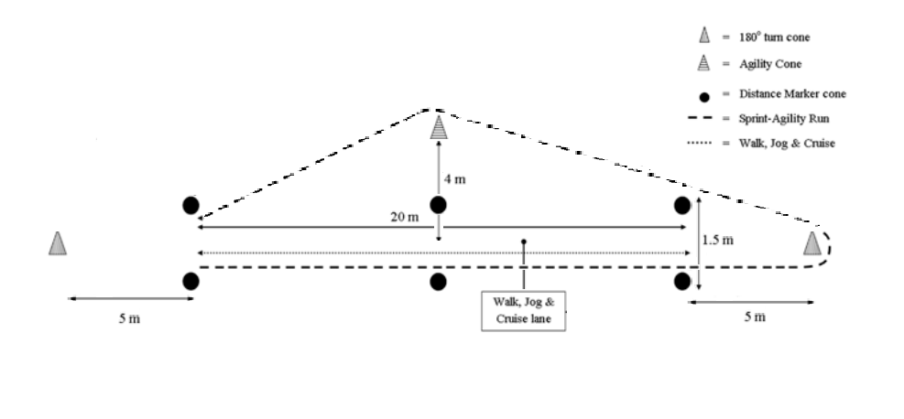

Figure 1. Schematic representation of an adapted version of the SSP layout (44).

15-m sprint test: Participants were instructed to complete the 15-m sprint distance as fast as possible with standardized verbal encouragement. Participants were given a 10-m running start at a self-selected pace, making the sprint more match realistic (Figure 2). The average sprint duration during an elite men’s field hockey match is 1.8±0.4 seconds (42); hence, a distance of 15 m was selected to assess sprint performance. Times were recorded using light gates (Fusionsport SmartspeedTM System, Fusion Sport, Nottingham, UK).

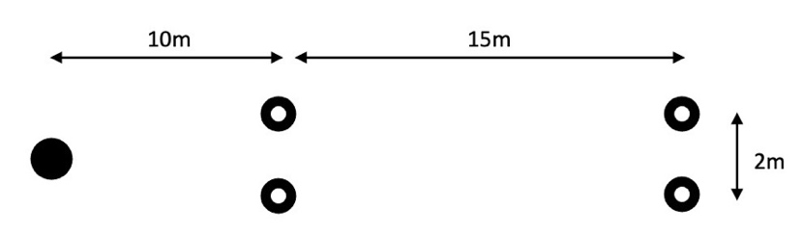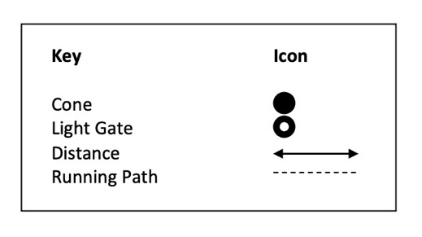

Figure 2. Schematic representation of maximal sprint test.

Agility/dribbling test: An adapted version of Lemmink et al (25) slalom sprint and dribble test (slalomSDT) was used as a performance measure to assess participants' agility, speed and technical ball control (Figure 3). The slalomSDT has been shown to be a reliable measure of sprint and dribbling performance in young elite field hockey players (25). Participants completed the agility/dribbling test as quickly as possible while maintaining tight control of the ball. If ball control was lost or a cone was moved out of position, the participant was allowed to start again. For each attempt, participants had to follow the running path illustrated in Figure 3; participants were required to move their body and the ball around each cone.
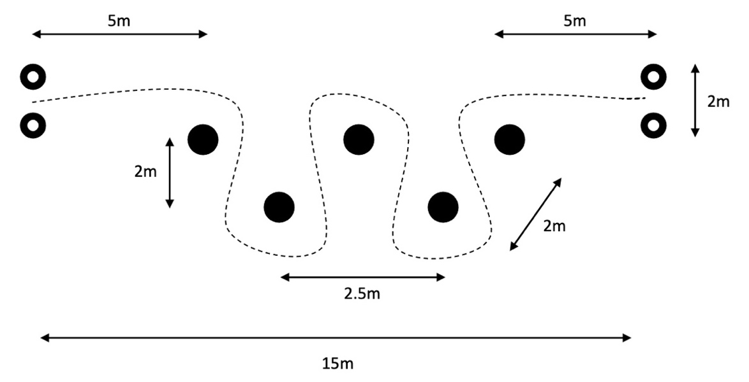

Figure 3. Schematic representation of agility/dribbling test.

Passing accuracy test: An adapted version of Paterson et al (37) push pass task was used to assess the participants passing accuracy (Figure 4). Participants were required to stand behind a marked-out line 16 m away from the targets. They were instructed to push pass the ball through the gates created by the cones; each gate was valued based on the size of aperture and difficultly to pass the ball through it. The middle two cones were separated by 0.3 m, the cones on either side of these were separated by 0.5 m and the outer gates had an aperture of 1 m, scoring three points, two points and one point, respectively. The total score from three attempts was recorded for each participant, allowing for a maximum score of 9 points, higher scores indicated greater passing accuracy.
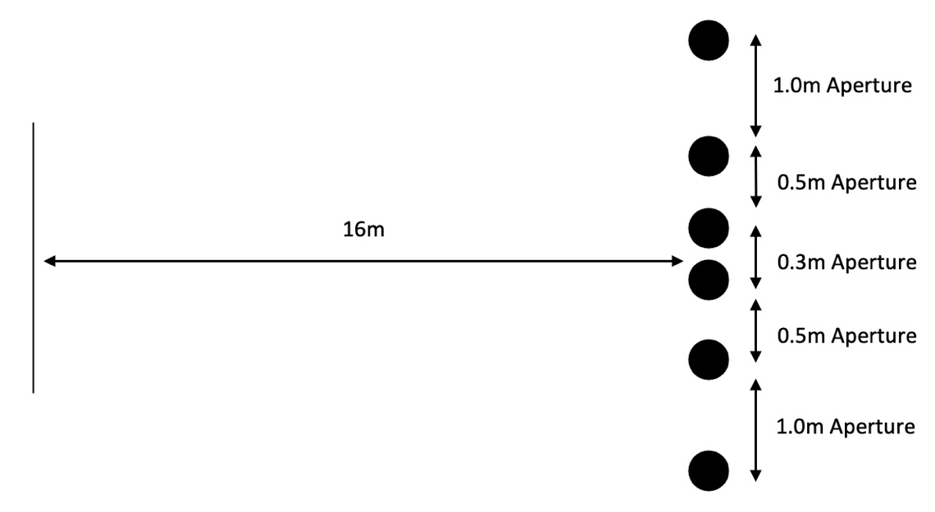
Figure 4. Schematic representation of passing accuracy test.

Cognitive testing: For cognitive testing, an online go/no-go task (39) was completed on a laptop (MacBook Air, Apple, California, USA) to measure reaction time and decision making. Participants were instructed to tap the space bar when the go stimulus was displayed on the screen and refrain from tapping the space bar when the no-go stimulus was displayed. The average reaction time it took to respond to the stimulus and the number of errors made were recorded.

Statistical Analysis
Power calculation provided a sample size of 9 based on an effect size of 0.7 for sprint performance and an α of 0.05 and 1-β of 0.8. Checks for normal distribution indicated slight skewness with z_{skewness} and z_{kurtosis} exceeding the +2 to -2 criteria for normality (36). An ANOVA is robust against violations of normality assumption (7); therefore, further statistical analysis was completed. Mauchly’s test of sphericity was completed to assess whether sphericity had been met and equality of error variance had been achieved (32). If assumptions of sphericity had been met a two-way repeated measures ANOVA was used to determine the effect each recovery condition had on sprint time, agility/dribbling time, passing accuracy, reaction time, cognitive errors, HR, percentage of HR_{max} and RPE. If assumption of sphericity had been violated, then the Greenhouse-Geisser correction was applied (1). Descriptive statistics are presented as mean and standard deviation. Paired samples t-test were used for follow-up tests to determine the source of the effect. Partial Eta Squared (η_{p}²) and Cohen’s d were used as effect size statistics (9). Statistical significance was set at α<0.05. All analysis was completed in JASP V10.

RESULTS

Table 1 provides the ability, cognition and physiological observations after each bout and for the 4 bouts for the 2-min and 5.5-min substitution time conditions. For 15-m sprint times, agility time, passing accuracy, and cognitive errors, there was no effect of substitution time, bout, or interaction (all P>0.05, Table 1). For reaction time, there was no effect of substitution time and bout (both P>0.05, Table 1). However, there was a large interaction effect between recovery condition and bouts for reaction time (η_{p}²=0.381, P=0.008). For %HR_{max}, there was a large effect of bout number (η_{p}² = 0.852, P<0.001). There were no effects of substitution time or interaction for % HR_{max} (all P>0.05, Table 1).

Table 1. Ability, cognition and physiological observations (mean±SD) for substitution time conditions across four bouts of high-intensity intermittent exercise (n=9).

Parameter | Substitution time | Bout 1 | Bout 2 | Bout 3 | Bout 4 | Mean±SD
15-m sprint time (s) | 2-min  5.5-min | 2.03±0.14  2.06±0.12 | 2.02±0.13  2.09±0.11 | 2.04±0.15  2.09±0.13 | 2.04±0.15  2.06±0.14 | 2.03±0.14  2.07±0.12
agility/dribbling time | 2-min  5.5-min | 7.26±0.39  7.31±0.80 | 7.01±0.50  7.35±0.79 | 6.90±0.37  7.15±0.39 | 7.04±0.50  7.10±0.57 | 7.06±0.41  7.23±0.55
passing accuracy | 2-min  5.5-min | 6±2  6±2 | 6±1  6±1 | 6±1  7±1 | 6±1  7±1 | 6±1  6±1
reaction time (ms) | 2-min  5.5-min | 357±23  345±35 | 341±41  358±34 | 342±42  351±54 | 348±30  332±39 | 347±31  347±39
cognitive errors | 2-min  5.5-min | 0.89±1.54  0.56±0.88 | 0.56±0.73  0.33±0.50 | 1.00±1.12  0.33±0.50 | 1.00±0.87  0.56±0.73 | 0.86±0.77  0.44±0.37
%maximal heart rate | 2-min  5.5-min | 70±9  69±12 | 81±7  77±11 | 83±8  79±12 | 85±7  81±10 | 80±7  76±11
Figure 5 shows that HR increased every bout, with a large main effect of bout number on heart rate (η_{p}²=0.833, P<0.001). No effect of substitution time or interaction (both P>0.05, Figure 5) was observed.

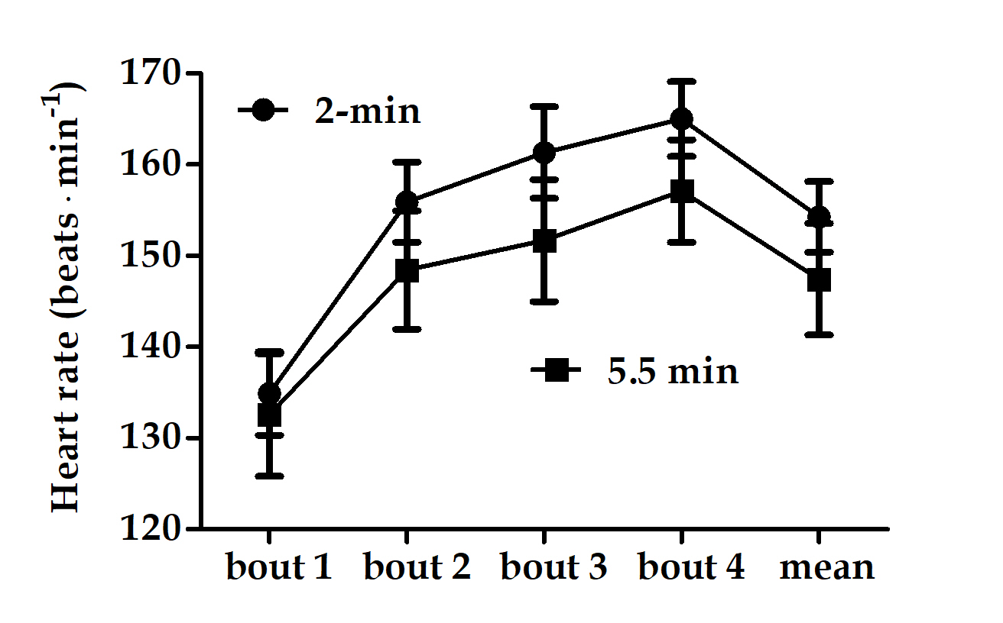

Figure 5. Heart rate (mean±SD) for each substitution time condition across all four bouts (n=9).

Figure 6 shows that the RPE increased with every bout, with a large effect of bout number (η_{p}²=0.942, P<0.001). Substitution time had a large main effect on RPE (η_{p}² = 0.464, P=0.030). Participants reported higher RPE for the second (d=1.054, P=0.013) and fourth bout (d=0.843, P=0.035) for the 5.5-min substitution time, both with a large effect size. No interaction (P>0.05, Figure 6) was observed.

Figure 6. RPE (mean±SEM) for each substitution time condition across all four bouts (n=9). *, indicates higher values for the the 5.5-min substitution time.

DISCUSSION

The present study examined the effect of a short (i.e. 2-min) and long (i.e. 5.5-min) substitution time during a simulated 4-quarter field hockey match on physical, perceptual, technical and cognitive performance parameters. The long (i.e. 5.5-min) substitution time is the average substitution time in game settings (27). Regardless of the substitution time, participants passing accuracy, reaction time, 15-m maximal sprint, and agility/dribbling performance were unaffected. The main observation was that the participants perceived the high-intensity intermittent exercise to be harder in the condition with a long substitution time. Another finding was that in the condition with the short substitution time, the number of cognitive errors in response to a visual stimulus seem to have been increased by 95% compared to the long substitution time (P=0.11), but the study may have been underpowered to detect significance due to large SDs for the measurement. Therefore, shorter recovery time seem to detriment cognitive error rate, potentially impairing athletes’ decision making but further research with a larger subject number needs to address this.

In each substitution condition, HR progressively increased with every bout. HR has been shown to have a linear relationship with exercise intensity (20). Our HR data seems to indicate that heart rate was higher after the first bout in the 2-min substitution condition compared to the 5.5-min condition, potentially indicating that the physiological stress was greater in the 2-min recovery condition as participants had a shorter recovery period to remove the accumulation of metabolic by-products (13) and oxygen debt (22) sustained during the high-intensity intermittent exercise protocol. Due to the association between the RPE and HR (48); it is unsurprising that the RPE also increased with every bout. However, unlike the HR data, the RPE was greater each bout and higher during the second and fourth bout in the 5.5-min substitution time condition. This indicates that participants perceived the high-intensity intermittent exercise protocol to be harder when given a 5.5-min recovery between bouts, which contradicts the HR data collected that would suggest participants were working harder in the 2-min recovery condition. Anecdotal information from participants supports these findings of RPE, as participants expressed they felt higher muscular discomfort during the high-intensity intermittent exercise in the 5.5-min recovery condition, potentially as a result of skeletal muscle cooling during the recovery period hindering muscular contractions (14). Bergh and Ekblom (5) reported a 4-6% decrease in power output, maximal dynamic strength, jumping, and sprinting performance for every one degree (°C) decrease in muscle temperature.

The present study reported no difference between the substitution time conditions and the number of bouts on 15-m maximal sprint time. This is in contrast with previous research that suggested after the completion of a simulated game circuit, replicating the physical demands of a field hockey match, the time taken to complete a 15-m maximal sprint significantly increases (6). The differences in results could potentially be attributed to disparities between methodologies. The present study allowed participants to complete a running start into the 15-m maximal sprint, whereas participants within the Bishop et al (6) study completed the maximal sprints from a stationary start, requiring them to accelerate from a velocity of zero, which potentially could have affected sprint time under fatigue. Another reason for dissimilarities between results could be due to the use of different fatiguing protocols, meaning exercise intensity was not equal in both studies.

The present study reported no difference between the substitution time conditions and the number of bouts on agility/dribbling performance. This is in contrast with previous research that reported a decline in dribbling performance as exercise duration increased (25). However, the disparity in results could be due to the ability level and age of the participants, as Lemmink et al (25) collected data on youth male and female hockey players, whereas the current study used only adult male sub-elite hockey players. Potentially implying that ability level determines whether players can sustain dribbling performance when exposed to exercise-induced fatigue, as dribbling at high speeds requires a high level of technical skill (40). Furthermore, the present study reported no differences between the substitution time conditions and the number of bouts on passing accuracy performance. Providing supporting evidence to Hollville et al (15) who suggested due to a complex interaction between physiological and cognitive function that elite hockey players can preserve passing accuracy under fatigued conditions. Interestingly this finding may only be apparent in elite male players as Hollville et al (15) and the present study used similar participant samples; therefore, further research is warranted to determine whether passing accuracy can also be maintained under fatiguing conditions in other populations of hockey players.

The present study reported no difference between the substitution time conditions and the number of bouts on reaction time. However, an interaction between recovery conditions and bouts was observed. Some previous studies also provided observations that reaction time increases during intermittent exercise (26, 31, 41). The increase in reaction time has been attributed to a moderate increase in arousal during exercise (12); however, if arousal is too low or too high it could cause detriment to reaction time, as suggested by the inverted U theory (50). Previous research has also suggested that fatigue (46), especially mental fatigue (19), has a detrimental effect on reaction time. Conflicting research has reported no effect of exercise and fatigue on reaction time during a soccer skill test (33), supporting the present study's findings.

The present study reported no difference between the substitution time conditions and the number of bouts on cognitive error rate. However, the results showed that the number of cognitive errors made in the 2-min recovery condition seems to be greater, with a 95.45% increase in average cognitive errors made in the 2-min compared to the 5.5-min recovery condition. There was no statistically significant increase likely because of the large standard deviations observed, as due to the nature of the cognitive test minimal errors were made per trial; hence, when participants made several errors in one trial, it caused a large deviation away from the mean. These findings support previous literature that reported elite male ballgames athletes performed a greater number of accuracy errors during a computer-based perceptual-cognitive task when fatigued (45). Reporting an average increase of 63.64% in decision-making accuracy errors post fatigue (45), suggesting that in the present study participants were more fatigued in the 2-min recovery condition. In the Thomson et al (45) study there was in total 163 male participants; whereas the current study had a smaller sample size (n=9) based on sprint performance outcomes, which could potentially indicate that if a greater sample size was used then the mean number of cognitive errors made may decrease.

The main limitation of the present study was in the absence of baseline measurements, it is not known whether the 15-m maximal sprint time, agility/dribbling time, passing accuracy, reaction time and cognitive error rate were altered by the high-intensity intermittent exercise. However, focus of the study was to record potential differences due to different substitution time. Another limitation was that the cognitive reaction and passing accuracy tests both lacked ecological validity. The cognitive reaction test accurately measured reaction speed and cognitive error rate; however, the test had very little relation to field hockey as was completed on a laptop. Therefore, future research should assess whether similar results are produced when participants complete a sport-specific reaction test. A limitation of the passing accuracy test was that it was completed without the presence of any external pressures. Field hockey is played in an open-skill environment (49), meaning players are constantly having to react to opposite and own team players position, skill and experience in order to successfully complete a pass; hence, future research should use a more ecologically sound method of assessing passing ability.

The results of the study suggest that a 2-min substitution time replicating a short tactical substitution would be sufficient in maintaining sub-elite male hockey players' physical and technical outputs during subsequential periods of high-intensity match play. However, the short recovery time seemed to detriment cognitive error rate, potentially impairing players' decision making. Therefore, short duration time substitutions are only recommended to provide a tactical advantage over the opposition. The present study also demonstrated that the traditional substitution time of 5.5-min are effective at preserving physical, technical, and cognitive performance; hence, coaches should continue to use existing substitutional strategies.

An area of focus for future research should be to investigate whether individual playing positions require tailored substitutional strategies to the match the physical and mental demands of each playing position, as previous research has identified the physiological demands of field hockey can vary from position to position (28). Another recommendation would be to determine whether the findings in the present study are replicated in novice and intermediate hockey players, as it had been suggested that hockey ability was maintained under fatigued conditions due to the players' previous experience and skill level.

The main findings of this study demonstrated that a 2-min and 5.5-min substitution times were both effective at maintaining physical, technical, and cognitive performance across four bouts of high-intensity intermittent exercise, which replicated the physical demands of a field hockey match. However, in the 5-5-min condition, the high-intensity intermittent exercise bouts were deemed more physically challenging; therefore, future research is warranted to assess the mechanisms causing an increase in perceived exertion.

REFERENCES

1. Abdi H. (2010). The Greenhouse-Geisser Correction. Encyclopedia of research design. Thousand Oaks, CA, Sage; 2010.
2. Asembo JM, Andanje M, Njororai WWS. The effect of the offside rule abolition on selected offensive actions, fouls and injuries in field hockey. Afr J Phys Health Edu Recreat Dance 4: 9-22, 1998.
3. Balsom PD, Seger JY, Sjödin B, Ekblom B. Maximal-intensity intermittent exercise: effect of recovery duration. Int J Sports Med 13(7): 528-533, 1992.
4. Behrens M, Gube M, Chaabene H, Prieske O, Zenon A, Broscheid KC, Schega L, Husmann F, Weippert M. Fatigue and Human Performance: An Updated Framework. Sports Med 53(1): 7-31, 2023.
5. Bergh U, Ekblom B. Influence of muscle temperature on maximal muscle strength and power output in human skeletal muscles. Acta Physiol Scand 107(1): 33-37, 1997.
6. Bishop D, Spencer M, Duffield R, Lawrence S. The validity of a repeated sprint ability test. J Sci Med Sport 4(1): 19-29, 2001.
7. Blanca MJ, Alarcon R, Arnau J, Bono R, Bendayan R. Non-normal data: Is ANOVA still a valid option? Psicothema 29(4): 552-558, 2017.
8. Borg G. Borg's perceived exertion and pain scales. Human kinetics, 1998.
9. Cohen J. Statistical power analysis for the behavioral sciences. Academic Press, 2013.
10. FIH Rules of Hockey. https://fih.ch/media/13523568/fih-rules-of-hockey-jan2022-final-updated_001.pdf, 2022.
11. Gaitanos GC, Williams C, Boobis LH, Brooks S. Human muscle metabolism during intermittent maximal exercise. J Appl Physiol 75(2): 712-719, 1993.
12. Gould D, Krane V. The arousal–athletic performance relationship: Current status and future directions. In TS Horne (ed.) Advances in sport psychology, 119-142, Human Kinetics, 1992.
13. Green HJ. Mechanisms of muscle fatigue in intense exercise. J Sports Sci 15(3): 247-256, 1997.
14. Halder A, Gao C. Muscle cooling and performance: A review. Med Sport (Roma) 2(1): 39-46, 2015.
15. Hollville E, Le Croller V, Hirasawa Y, Husson R, Rabita G, Brocherie F. Effect of Prior Fatiguing Sport-Specific Exercise on Field Hockey Passing Ability. Int J Sports Physiol Perform 13(10), 1324-1330, 2018.
16. Ihsan M, Yeo V, Tan F, Joseph R, Lee M, Aziz AR. (2021). Running demands and activity profile of the new four-quarter match format in men's field hockey. J Strength Cond Res 35(2): 512-518, 2021.
17. International Hockey Federation. https://www.fih.hockey.
18. James CA, Gibson OR, Dhawan A, Stewart CM, Willmott AG. Volume and Intensity of Locomotor Activity in International Men's Field Hockey Matches Over a 2-Year Period. Front Sports Act Living 3: 653364, 2021.
19. Jaydari Fard S, Tahmasebi Boroujeni S, Lavender AP. Mental fatigue impairs simple reaction time in non-athletes more than athletes. Fatigue: Biomed, Health Behav 7(3): 117-126, 2019.
20. Karvonen J, Vuorimaa T. Heart rate and exercise intensity during sports activities. Sports Med 5(5): 303-311, 1988.
21. Kilding AE, Aziz AR, Teh KC. Measuring and predicting maximal aerobic power in international-level intermittent sport athletes. J Sports Med Phys Fitness 46(3): 366-372, 2006.
22. Knuttgen HG. Oxygen debt after submaximal physical exercise. J Appl Physiol 29(5): 651-657, 1970.
23. Lamas L, Senatore JV, Fellingham G. Two steps for scoring a point: Creating and converting opportunities in invasion team sports. Plos one 15(10): e0240419, 2020.
24. Léger LA, Mercier D, Gadoury C, Lambert J. The multistage 20 metre shuttle run test for aerobic fitness. J Sports Sci 6(2): 93-101, 1988.
25. Lemmink KAPM, Elferink-Gemser MT, Visscher C. (2004). Evaluation of the reliability of two field hockey specific sprint and dribble tests in young field hockey players. Br J Sports Med 38(2): 138-142, 2004.
26. Lemmink KA, Visscher C. (2005). Effect of intermittent exercise on multiple-choice reaction times of soccer players. Percept Mot Skills 100(1): 85-95, 2005.
27. Linke D, Lames M. (2016). Substitutions in elite male field hockey–a case study. Int J Perform Anal Sport 16(3): 924-934, 2016.
28. Lombard WP, Cai X, Lambert MI, Chen X, Mao L. Relationships between physiological characteristics and match demands in elite-level male field hockey players. Int J Sports Sci Coach 16(4): 985-993, 2021.
29. Lord F, Pyne DB, Welvaert M, Mara JK. Field hockey from the performance analyst’s perspective: A systematic review. Int J Sports Sci Coach 17(1): 220-232, 2022.
30. Lythe J, Kilding AE. The effect of substitution frequency on the physical and technical outputs of strikers during field hockey match play. Int J Perform Anal Sport 13(3): 848-859, 2013.
31. Malcolm R, Cooper S, Folland JP, Tyler CJ, Sunderland C. The Influence of a Competitive Field Hockey Match on Cognitive Function. Front Hum Neurosci 16, 829924, 2022.
32. Mauchly JW. (1940). Significance test for sphericity of a normal n-variate distribution. Ann Math Stat 11(2): 204-209, 1940.
33. McMorris T, Sproule J, Draper S, Child R. Performance of a psychomotor skill following rest, exercise at the plasma epinephrine threshold and maximal intensity exercise. Percept Mot Skills 91(2): 553-562, 2000.
34. Morencos E, Romero-Moraleda B, Castagna C, Casamichana D. (2018). Positional comparisons in the impact of fatigue on movement patterns in hockey. Int J Sports Physiol Perform 13(9): 1149-1157, 2018.
35. Navalta J, Stone W, Lyons T. Ethical issues relating to scientific discovery in exercise science. Int J Exerc Sci 12(1): 1-8, 2019.
36. O'Donoghue P. Statistics for sport and exercise studies: An introduction. Routledge, 2013.
37. Paterson, G, van der Kamp J, Bressan E. Savelsbergh G. The differential effects of task difficulty on the perception of passing distance and subsequent passing action in a field hockey push pass task. Acta Psychol 197: 16-22, 2019.
38. Perrier ET, Pavol MJ, Hoffman MA. The acute effects of a warm-up including static or dynamic stretching on countermovement jump height, reaction time, and flexibility. J Strength Cond Res 25(7): 1925-1931, 2011.
39. PsyToolkit. Go/No-go task. https://www.psytoolkit.org/experiment-library/go-no-go.html, 2021.
40. Reilly T, Bretherton S. (1986). Multivariate analysis of fitness of female field hockey players. players. Perspectives in kinanthropometry. Champaign, IL: Human Kinetics, 1986.
41. Schapschröer M, Lemez S, Baker J, Schorer J. Physical load affects perceptual-cognitive performance of skilled athletes: A systematic review. Sports Med-open 2(1), 1-16, 2016.
42. Spencer M, Lawrence S, Rechichi C, Bishop D, Dawson B, Goodman C. (2004). Time–motion analysis of elite field hockey, with special reference to repeated-sprint activity. J Sports Sci 22(9): 843-850, 2004.
43. Stagno KM, Thatcher R, van Someren KA. Seasonal variation in the physiological profile of high-level male field hockey players. Biol Sport 22(2): 107-115, 2005.
44. Stone KJ, Oliver JL, Hughes MG, Stembridge MR, Newcombe DJ, Meyers RW. Development of a soccer simulation protocol to include repeated sprints and agility. Int J Sports Physiol Perform 6(3): 427-431, 2011.
45. Thomson K, Watt AP, Liukkonen J. (2009). Differences in ball sports athletes speed discrimination skills before and after exercise induced fatigue. J Sports Sci Med 8(2): 259-264, 2009.
46. Tromp M, Holmes L. (2011). The effect of free-hit rule changes on match variables and patterns of play in international standard women’s field hockey. Int J Perform Anal Sport 11(2): 376-391, 2011.
47. Welford A. Choice reaction time: Basic concepts. Reaction times, 73-128, 1980.
48. Williams N. The Borg rating of perceived exertion (RPE) scale. Occup Med 67(5): 404-405, 2017.
49. Young WB, Dawson B, Henry GJ. Agility and change-of-direction speed are independent skills: Implications for training for agility in invasion sports. Int J Sports Sci Coach 10(1): 159-169, 2015.
50. Zaichkowsky LD, Naylor AH. Arousal in sport. Encyclopedia of applied psychology 1: 155-161, 2004.

