The effect of approach velocity on pelvis and kick leg angular momentum conversion strategies during Football instep kicking

Simon Augustus¹, Penny E. Hudson¹ & Neal Smith¹
¹ Chichester Institute of Sport
University of Chichester
College Lane
Chichester
West Sussex, UK
PO19 6PE

Corresponding author: Simon Augustus, s.augustus@chi.ac.uk

Abstract
During football instep kicking, whole-body deceleration during the final stride has been associated with greater kick leg angular momentum and enhanced foot and ball velocities, but the influence of approach velocity on these mechanisms is unknown. This study assessed how approach velocity affects momentum conversion strategies of experienced players performing fast and accurate kicks. Eleven semi-professional footballers performed instep kicks from self-selected (3.34 ± 0.43 m/s), fast (3.71 ± 0.33 m/s) and slow (2.77 ± 0.32 m/s) approaches. Kicking motions and GRFs under the support leg were captured using 3D motion analysis (1000Hz). The players responded to perturbations in approach velocity by using the support leg to regulate whole-body deceleration and create ideal conditions for co-ordinated pelvic and kick leg momentums during the downswing. Further, the pelvis was key for generating transverse momentum at the kick leg, but the participants displayed distinctly different pelvis transverse rotation strategies. Identification of these inter-individual strategies may provide a basis for technical and strength training practices to be tailored for individual players. Future research might investigate if training practices that expose footballers to varying approach velocities of between 2.5 – 4.0 m/s promotes development of movement strategies that are robust to perturbations in approach conditions.

Keywords: Soccer, centre of mass, pelvis, support leg, biomechanics.

Word Count: 4712

Introduction
Performing a fast yet accurate instep kick represents an advantage for a footballer. Maximising ball velocity and accuracy increase the chances of scoring a goal when shooting (Dorge et al., 2002) and enables effective attacking plays by speeding up a team’s movement about the pitch (e.g. switching the ball to the opposite flank; Turner & Sayers, 2010). Researchers have thus determined the kinematic, kinetic and electromyographic characteristics of instep kicking that are associated with these parameters (Apriantono et al., 2006; Dorge et al., 2002; Kellis & Katis, 2007; Lees et al., 2010; Nunome et al., 2006). Rapid centre of mass (CoM) deceleration during the kicking stride is one feature of skilled kicking that is suggested to aid performance (Ball, 2011; Potthast et al., 2010). However, to date, the mechanisms by which whole-body momentum acquired during the approach is converted to kick leg angular momentum have not been established. These mechanisms are likely regulated by: a) the support leg as it brakes forward motion of the body following support foot touchdown (SFTD; Augustus et al., 2017; Ball, 2008; 2011; 2013; Inoue et al., 2014), and b) the pelvis as it rotates about the support leg to precede proximal to distal sequencing of the kick leg (Inoue et al., 2014; Langhout et al., 2015; Lees et al., 2009; Levanon & Dapena, 1998; Shan & Westerhoff, 2005). Identification of how the support leg and pelvis facilitate transfer of momentum to the kicking leg following SFTD might therefore reveal important insights regarding the strategies used to perform skilled instep kicking.
Additionally, to date, studies have not considered interactions between approach velocity, CoM deceleration and kick leg angular momentum. During match play, a player often approaches the ball at slower or faster velocities than desired (e.g. with pressure from a defender; Egan et al., 2007; Katis & Kellis, 2011), and the question remains if these perturbations are detrimental to performance (i.e. slower ball velocities and decreased accuracy), or if a player can adapt their movement pattern to maintain performance? Andersen & Dorge (2011) noted ball velocities declined with approach velocities faster or slower than if self-selected and concluded this was indicative of disrupting intersegmental control of the movement. Unfortunately, they did not include kinematic data to verify their assumption. The aim of this study was thus to assess how approach velocity affects angular momentum conversion strategies during instep kicking. Knowledge of these mechanisms will highlight how players mitigate perturbations in approach conditions during match play. This information could then be used by future studies to help inform training of the skill. Specifically, three research questions were addressed. First, is there an optimal CoM approach velocity for production of fast and accurate kicks? Second, how does the support leg and pelvis facilitate transfer of momentum to the kicking leg following SFTD? And third, do whole-body deceleration and momentum conversion strategies change with different approach velocities?

Materials and methods

Participants
Eleven male footballers volunteered (mean ± SD; mass 79.9 ± 7.7 kg, height 1.79 ± 0.06 m, age 24.3 ± 4.4 years). All were right-footed, had at least 10 years competitive playing experience, and were affiliated to a semi-professional club within the English FA national league system. Ethical approval was granted by the University’s local ethics committee, and all participants completed written informed consent prior to data collection.

Data Collection & Procedures
Participants wore tight fitting lycra shorts and a standardised indoor football shoe (Spoiler Futspeed, Nomis., Australia). They kicked a FIFA approved size 5 football (Mitre Monde, Mitre Intl., UK) in a carpeted laboratory with the instep of their preferred foot as ‘fast and accurately’ as possible towards a target (circle with 0.5 m radius) placed on a catching net 4 m from the ball. Trials were first performed with self-selected (SS) approach velocities, then with both slower (Slow) and faster (Fast) approaches than SS. The first five successful kicks (i.e. accurate trials) performed in each condition were included for further analysis and trials discounted if the ball did not hit any part of the target (i.e. were inaccurate). The order of Slow and Fast conditions performed following SS were counterbalanced to remove order effects and no specific instructions were given for these conditions. While this method did not strictly control variation in approach velocities, it was chosen to enable identification of the strategies utilised by individuals to adapt to the perturbations. Approach distance was controlled to 3 m (allowing a 3-5 step run up) and approach angle was controlled to 30° (as the angle which most participants chose for SS kicks).
Kicking motions and ground reaction forces (GRFs) under the support leg were captured using a 10-camera, opto-electronic 3D motion analysis system (T40S, Vicon Motion Systems, UK) and piezoelectric force platform (9287C, Kistler, UK) sampling at 1000 Hz. Reflective markers were attached so the position and orientation of seven rigid segments (bilateral feet, shanks and thighs, and the pelvis) were incorporated into a 6 DOF model (Augustus et al., 2020b; see supplemental material). Each segment was modelled as a rigid-body expressed as a geometrical volume scaled to participant height and mass (Hanavan, 1964). Inertial characteristics were derived according to de Leva (1996) (feet, shank, and thigh) or Pearsall et al. (1996) (pelvis), and the mass of the boot (0.3 to 0.4 kg) was added to the feet. Following static calibration, segment motion was tracked using triad marker clusters (Cappozzo et al., 1995), and joint centres determined using functional methods (Schwartz & Rozumalski, 2005). Coordinate systems were defined at the proximal end of each segment, where positive Z was congruent with the long axis of the segment, X pointed to the right, and Y anteriorly (see supplemental material). Joint rotations were expressed by the distal segment relative to the proximal (Grood & Suntay, 1983) using an X-Y-Z cardan rotation sequence (Lees et al., 2010). Six semi-hemispherical markers were also attached to the anterior portion of the ball to define its geometric centre and enable calculation of ball velocity as described by Inoue et al. (2014).

Data Analyses
Marker trajectories were exported to Visual 3D (V6, C-Motion, Rockville, USA) for further analysis and those attached to the kicking foot and shank were low-pass filtered using a time-frequency, fractional Fourier filter (FrFF) in Matlab (MATLAB 2017b, Mathworks Inc, Natick, USA). Unlike conventional filtering methods, the FrFF processes trajectories in consecutive Fourier domains and can produce valid lower leg kinematics during both leg-swing and foot-to-ball-contact phases of a kick (Augustus et al., 2020a). The cut-off frequency was set as 18 Hz for the swing phase and ranged from 150 – 300 Hz for the contact phase (Augustus et al., 2020b). Markers attached to all other segments were low-pass filtered with a conventional fourth-order, dual-pass Butterworth digital filter (cut-off frequency 18Hz, determined by residual analysis), and ball markers left unfiltered. Selected kinematic and kinetic parameters were subsequently determined. Discrete measures (Table 1) were determined as either peak values or at the instance of ball contact start (BCS), and time-series parameters were time-normalised to 101 points between kicking foot take off (KFTO) and ball contact start (BCS) (Nunome et al., 2002).
The contributions of kick leg thigh, shank and foot segments to whole-body angular momentum were estimated using previously established methods (Bahamonde, 2000; Dapena; 1978). Briefly, the angular momentum of each segment was determined at each time frame from its local (owing to rotation of segment about its own CoM) and remote terms (owing to segment rotation about whole-body CoM). The instantaneous remote term for each segment was:
$$R_{i}=m_{i} ∙(r_{i} × v_{i})$$
Where $R_{i}$ is the remote angular momentum of the segment about whole-body CoM, $m_{i}$ the mass of the segment, $r_{i}$ the 3D displacement vector between the segment’s CoM to whole-body CoM, and $v_{i}$ the translational velocity of segment CoM relative to the whole-body CoM.
The instantaneous local term was:
$$L_{i}=I_{i} ∙ ω_{i}$$
Where $L_{i}$ is the angular momentum of the segment about its own CoM, $I_{i}$ is the segment moment of inertia and $ω_{i}$ is the segment angular velocity about its own CoM. Remote and local terms from each segment were summed at each time frame to determine the contribution of that segment to whole-body angular momentum. The shank and foot were combined into a ‘lower-leg’ segment so that time-series contributions of the kick leg thigh and lower leg were defined. Angular momentum values were expressed about three orthogonal axes passing through the whole-body centre of mass of the kicker (X = sagittal, Y = frontal and Z = transverse; Bezodis et al., 2007). Forward rotation of the distal end of the thigh and lower leg about X towards the ball during the downswing and about Z towards the non-kick side were positive in magnitude (i.e. in an anti-clockwise direction) (see supplemental material). Motion about the frontal Y axis is minimal during ball kicking (Bezodis et al., 2007; Lees et al., 2009), so pelvic angular velocities and angular momentum of the thigh and lower leg are reported about the sagittal (X) and transverse (Z) axes only.

Statistical Analyses
Discrete variables were assessed for normality using the Shapiro-Wilks test and visual inspection of histograms and Q-Q plots. Then, one-way repeated measures ANOVAs were conducted for each variable. Alpha for main effects was Bonferroni adjusted to account for multiple comparisons (N = 17, α = 0.003) and effect sizes (partial eta squared; η_{p}²) classified according to Cohen (1988; > 0.01 = small, > 0.06 = medium, > 0.13 = large). Planned contrasts examined pairwise differences between each Slow and Fast conditions with SS if a significant main effect was obtained and pairwise effect sizes calculated according to Cohen (1988) (trivial d < 0.2, small d = 0.2 - 0.5, medium d = 0.5 - 0.8, large d > 0.8). Since this method of contrasts in non-orthogonal, the α-level of pairwise contrasts was also adjusted for the number of comparisons per variable (N = 2, α = 0.025) and this method was chosen as a balanced approach to mitigate against likelihood of both Type I (i.e. due to familywise error inflation) and Type II error (i.e. due to reduced statistical power) (Toothaker, 1993). All discrete statistical tests conducted using SPSS (V23, IBM, New York, USA).
To compare time-series variables, statistical parametric mapping (SPM) was conducted (SPM1D V0.4; Pataky, 2012) in Matlab to remove the bias of analysing one-dimensional biomechanical waveform data using zero-dimensional (discrete) methods (Pataky et al., 2015). Alpha for main effects was Bonferroni adjusted to α = 0.007 to account for multiple comparisons (N = 7). If a significant main effect was identified, post-hoc, two-tailed, SPM paired t-tests (SPM{t}) were conducted in the same manner to identify where pairwise differences occurred. Alpha for pairwise contrasts was adjusted for the number of comparisons per dependent variable (N = 3, α = 0.017).

Results

Discrete Variables
Approach velocities were different between approach conditions (p < 0.001, η_{p}² = 0.91). Slow approaches were slower (2.77 ± 0.32 m/s; p < 0.001, d = 1.51) and Fast approaches were faster (3.71 ± 0.33 m/s; p < 0.001, d = 1.02) than SS (3.34 ± 0.43 m/s). A summary of discrete variables is presented in Table 1. Peak ball velocity was different between approaches (p < 0.001, η_{p}² = 0.58). Ball velocities from Slow approaches were not different to SS (24.4 ± 1.1 m/s vs 25.7 ± 2.0, p = 0.044, d = 0.69), but Fast approaches induced faster ball velocities (26.9 ± 1.6 m/s) than SS (p = 0.014, d = 0.86). Foot velocity at BCS also showed a main effect (p < 0.001, η_{p}² = 0.65), where foot velocities were slower and faster in the Slow (17.2 ± 0.9 m/s, p = 0.013, d = 0.92) and Fast (19.2 ± 1.0 m/s, p = 0.015, d = 1.01) conditions compared to SS (18.1 ± 1.1 m/s), respectively. Kicking knee extension velocities at BCS were also different (p < 0.001, η_{p}² = 0.48), where extension velocities were maintained from Slow approaches compared to SS (1752 ± 204 vs 1848 ± 272 °/s, p = 0.155, d = 0.40), but were greater in the Fast condition (2023 ± 172 °/s, p = 0.017, d = 0.77). Pelvic transverse ROM was different between approaches (p = 0.001, η_{p}² = 0.46), where ROM was smaller from Slow approaches (17.4 ± 4.6°) compared to SS (21.1 ± 5.2°, p < 0.001, d = 0.72), yet Fast approaches (25.3 ± 5.7°) were not different to SS, despite a large effect size (p = 0.034; d = 0.78).
*Table 1 near here**

Time-Series Variables
Support leg, pelvis and kick leg time-series data are shown in Figures 1 - 4. The pelvis was slowly tilting backwards and transversely rotating the kicking hip towards the ball during flight (0 – 200 °/s) (Figure 2). Following SFTD, the pelvis then rapidly accelerated in each of these directions to peak velocity (200 - 450°/s) at ~75-80% of the kick, before decelerating again by BCS. Pelvic tilt and transverse rotation velocities between KFTO and BCS were not different between conditions, but the high level of variability (large SD) was of note for pelvic transverse rotation following SFTD (47-100% of kicking motion, Figure 2).
**Figures 1 and 2 near here**
The kicking thigh gained a small amount of anti-clockwise (+ve) angular momentum (0 - 3 kg.m²/s) about the sagittal (X) and transverse (Z) axes (rotation of distal end of thigh towards ball) between KFTO and SFTD. Following SFTD, anti-clockwise thigh angular momentum increased to peaks of 8 - 11 kg.m²/s (sagittal) and 6 – 9 kg.m²/s (transverse) at 75% of the kick, before reversing to values close to zero at BCS (Figures 3 & 4, respectively). Thigh angular momentum about the sagittal axis was not different between the three conditions but was different about the transverse axis between 53 - 72% of the kick (p < 0.001). The SS and Fast approaches induced greater anti-clockwise (+ve) transverse thigh angular momentum than Slow following SFTD (49 - 75%, p = 0.010 and 42-87%, p < 0.001, respectively).
Following KFTO, the lower (kick) leg displayed clockwise (-ve) angular momentum about the sagittal axis (~ -10 kg.m²/s) and negligible angular momentum about the transverse axis (~0 kg.m²/s). In both sagittal and transverse axes, this angular momentum increased throughout the kick, where sagittal reversed to anti-clockwise (+ve) at SFTD, and transverse reversed at ~10% of the kick. Both increased to a peak at BCS (sagittal = 25 - 29 kg.m²/s, and transverse = 15 - 22 kg.m²/s; Figures 3 & 4, respectively). Lower leg angular momentum was different about the transverse axis between 64 - 92% of the kick (p < 0.001). SS and Fast approaches produced greater clockwise (-ve) angular momentum about the transverse axis than Slow soon after KFTO (5 – 7%, p = 0.016; & 1 - 11% of kick, p = 0.009, respectively), and greater anti-clockwise (+ve) angular momentum during the downswing (55 – 96%, p < 0.001 & 49 -100%, p < 0.001, respectively).
*Figures 3 and 4 near here**

Discussion
Kicking Performance
The aim of this study was to assess how approach velocity affects momentum conversion strategies of experienced players performing fast and accurate kicks. Regarding the first research question, SS approaches (3.3 – 3.7 m/s) created conditions for production of fast and accurate kicks. These approaches were similar to those previously reported for experienced male players performing football instep (3.3 – 3.7 m/s; Lees & Nolan, 2002; Orloff et al., 2008) and AFL punt kicks (3.2 – 3.8 m/s; Ball, 2011b; 2013) for maximal speed and accuracy. Conversely, the Slow approach velocities corresponded to literature that considered instep kicking with an accuracy component only (i.e. no ball velocity requirement; 2.4 – 2.6 m/s; Lees & Nolan, 2002), and Fast approaches at the upper limits of approach velocities reported for different football codes (~ 4 m/s; Ball, 2011; 2013; Lees & Nolan, 2002).
Despite these changes in approach velocity, the participants maintained their performance at levels previously reported in the literature. Peak ball and foot velocities fell within ranges of kicks for maximal speed and accuracy (22 - 28 m/s and 16 - 24 m/s, respectively; Apriantono et al., 2006; Ball 20011; Dorge et al., 2002; Kellis & Katis, 2007; Lees et al., 2010; Nunome et al., 2006), and while both these parameters were negatively affected by slower approaches (i.e. to ~83% of SS), small increases of approach velocity (~110% of SS) were beneficial for generating faster foot and ball velocities. A player aiming to perform faster kicks might therefore benefit from adopting slightly faster approaches than SS. Indeed, since the mean number of kicks needed to obtain five successful trials was 5.2 ± 0.3 and 5.5 ± 0.3 in each SS and Fast, accuracy was not negatively affected by these increases in approach velocity. Furthermore, ball to foot velocity ratios were unchanged, suggesting the precise impact mechanics needed for an accurate kick were achieved in each condition. It should be noted however, that the accuracy constraint was relatively simple for experienced players (i.e. a straight kick over 4 m). It is not currently known if maintenance of accuracy at faster approaches extends to more complex tasks, such as performing a free kick or penalty task. Previous research has noted an optimal relationship between approach velocity and foot (Ball, 2011b) and ball velocities (Anderson & Dorge, 2011). That is, slower approaches directly limit: a) the relative swing velocity of the foot compared to CoM as the body moves towards BCS (Anderson & Dorge, 2011; Ball, 2008), and b) the total amount of energy available to the body at the instance of SFTD (Naito et al., 2012). In contrast, Ball (2011) noted associations between slower approaches and greater foot velocities in AFL punt kicking (r = - 0.95). Given the multi-articular nature of ball kicking, these findings suggest work performed by muscular input may compensate for the loss in approach velocity to maintain foot velocities (Anderson & Dorge, 2011). However, no study has confirmed these assertions, and the correlations reported by Ball (2011) were from a very small sample of participants (N = 5).
In contrast to the current finding that ball and foot velocities were enhanced with greater approach velocities, Anderson & Dorge (2011) previously reported performance reductions at faster approaches. They concluded increasing approach velocity restricts the ability of the support leg to withstand high decelerative forces following SFTD, limits the time available to adjust kicking foot swing trajectory and interferes with the intersegmental control of the kick leg. However, they noted these decrements occurred at 125% and 150% of SS. Additionally, the SS approaches reported by Anderson & Dorge (2011) were both faster than any observed during the current study (4.6 ± 0.6 m/s), and performed in the absence of an accuracy constraint. When kicks were performed with an accuracy constraint, Anderson & Dorge (2011) noted reductions in approach and ball velocities to 80% of SS (~3.7 m/s and 22 - 28 m/s, respectively). Taken together, these findings indicate that to conserve accuracy, experienced players approach the ball slightly slower than SS for maximal production of foot and ball velocities. Limiting approach velocity likely allows more time to make the subtle adjustments to the trajectory of the kicking leg needed to produce a precise foot-to-ball interactions and impart momentum on the ball in the intended direction of travel.
Momentum Conversion Strategies
Regarding the second and third research questions, the support leg regulated CoM deceleration to ensure optimal conditions for the coordinated action of the pelvis and kick leg at any given approach velocity. Rapid reduction of CoM velocity has previously been associated with faster foot and ball velocities in football and AFL kicking (Ball, 2011, Potthast et al., 2010). Given these associations, and that whole-body momentum of the kicker increases at faster approaches (Naito et al., 2012), it was expected the players would exhibit greater CoM deceleration and kick leg angular momentum at faster approaches. However, CoM deceleration impulses did not change with varying approaches, and were maintained between 90 - 145 kg.m/s. These values concurred with those of Ball (2011) and Potthast et al. (2010) and suggests this level of deceleration is beneficial for kicking performance. This could partly explain why enhanced foot velocities were seen in the SS and Fast conditions, compared to Slow. Approach velocities were inherently faster, but CoM deceleration impulses were kept constant so the relative contribution of forward CoM velocity to foot velocity at the instance of BCS was greater.
Large braking forces have previously been shown to slow the forward motion of the body (Ball, 2011; 2013; Potthast et al., 2010) and it has been suggested this action facilitates energy transfer to the kicking leg (Augustus et al., 2017; Inoue et al., 2014). However, the current study observed that CoM deceleration and braking GRF impulses were not different under varying approach velocities. Instead, the players used the support leg to regulate absorption of GRFs and ensure optimal CoM deceleration for a given kick. For example, although knee flexion ROM was unchanged, knee flexion velocities were slower in the Slow compared to SS and Fast approaches between SFTD and BCS (Figure 1). The Slow approaches were thus performed with a more extended support leg to compensate for the lack of forward velocity and ensure that CoM deceleration was similar to the SS and Fast kicks. Existence of such a strategy might explain why some research has advocated maximising braking during the final kicking stride (Ball, 2011; 2013), whereas others have recommended ‘treading lightly’ and minimising braking (Orloff et al., 2008; Lees et al., 2009). It may instead be more appropriate to recommend that a player should adopt a support leg strategy that ensures an optimal CoM deceleration for a given approach velocity.
In agreement with previous findings (Inoue et al., 2014; Lees et al., 2009), SFTD also induced considerable pelvic backwards tilt and transverse rotation of the kicking hip towards the ball (Figure 2). Along with torso and kicking thigh flexion, pelvic backwards tilt has been cited as a key mechanism by which the ‘tension arc’ between torso, pelvis and kicking thigh (Shan & Westerhoff, 2005) is released, and momentum is proposed to be transferred from the torso to the kicking leg (Ball, 2008; Lees et al., 2009; Langhout et al., 2015; Naito et al., 2012). The concurrent timing of peak and subsequent reductions of pelvic tilt velocity and thigh angular momentum about the sagittal axis support the kicking thigh is coupled to the pelvis at the hip joint, and momentum is passed from the torso to the lower limb (Figure 2 & 3). Further, since pelvis backwards tilt angular velocity, pelvic tilt ROM, and generation of anti-clockwise thigh and lower leg angular momentum about the sagittal axis were unchanged at varying approaches, it is surmised whole-body deceleration functions to create ideal conditions for this mechanism to occur. Indeed, the magnitude of sagittal lower leg angular momentum was remarkably consistent irrespective of approach velocity (Figure 4), suggesting the players achieved efficient proximal-to-distal transfer of angular momentum from the pelvis to the kicking leg. Bezodis et al. (2007) previously observed a proximal to distal sequencing of thigh and lower leg angular momentum in rugby place kicking. A similar pattern was shown here, with anti-clockwise sagittal angular momentum of the lower leg peaking at the instance of BCS.
Conversely, SS and Fast approaches elicited greater anti-clockwise kicking leg (thigh and lower leg) transverse angular momentum for large proportions of the downswing (Figures 3 and 4). Faster approaches therefore transferred greater transverse momentum (about the body’s vertical axis) to the kicking leg. This added momentum might explain the greater foot and ball velocities observed in these conditions. Since Inoue et al. (2014) noted pelvic transverse rotation was induced as it pivots about the support leg following SFTD, it is likely that this momentum originated from rotation of the pelvis, rather than rotation of the thigh about the hip. Furthermore, as pelvic transverse ROMs were dependent on approach velocity (i.e. greater ROM at faster approaches), faster approaches might induce greater transverse rotation of the pelvis as a precursor to the additional angular momentum of the kicking leg about the same axis. Two explanations exist to explain how this might occur. First, greater CoM velocities might induce passive transverse rotation of the body as it pivots about the support leg. Second, greater approach velocities might be indicative of a longer final kicking stride (Anderson & Dorge, 2011). A longer final stride affords greater retraction of the pelvis to the kick leg side and lengthening of the tension arc between the torso and thigh (Langhout et al., 2015; Shan & Westerhoff, 2005). An elongated tension arc would in turn increase the potential for subsequent concentric work to be performed on the kicking thigh during the downswing (Anderson & Dorge, 2011).
Interestingly, despite trends towards faster pelvis transverse rotation velocities at faster approaches, there were no differences in this variable between conditions. Instead, large variations were observed at BCS (range = -100 - 300°/s, Figure 2), which may have concealed different inter-individual patterns of pelvic rotation. To identify the existence of such patterns, the individual strategies of pelvic transverse rotation were analysed qualitatively (i.e. via visual inspection) following the main analysis (Figure 5). The analysis showed two possible pelvic transverse rotation strategies. Five of the participants exhibited a strategy whereby a large peak velocity was obtained at ~70-80% of the kick before ‘reversing’ to value close to 0 °/s at BCS. The other six exhibited a strategy whereby a smaller peak velocity was obtained following SFTD, that was ‘maintained’ until BCS. The presence of inter-individual strategies might explain why previous descriptions of pelvic transverse rotation have been varied. Lees et al. (2009) noted an increase in pelvic rotation prior to BCS, whereas Inoue et al. (2014) and Langhout et al., (2015) that pelvic transverse rotation slowed prior to contact. However, it is important to note that despite this considerable inter-individual variation, intra-individual pelvic rotation strategies (i.e. within participant kick to kick variation) were remarkably consistent across the three approach conditions. This suggested the footballers did not deviate from their ‘preferred’ strategy when responding to changes in approach velocity.
**Figure 5 near here**
These different transverse pelvic rotation strategies might be indicative of varying kick leg strategies during the downswing. Ball (2008) previously distinguished between AFL punt kickers who adopted a ‘thigh’ (relatively greater hip angular velocity compared to knee angular) or ‘knee’ strategy (relatively greater knee angular velocity than hip angular velocity) to generate foot velocity at BCS. It seems logical to extend Ball’s (2008) classifications to include that pelvic ‘maintainers’ correspond to those utilising a ‘thigh’ strategy, whereas reversers exhibited a more ‘knee’ dominant strategy. Indeed, the contribution of thigh angular momentum about the transverse axis at BCS for those identified as ‘maintainers’ was 2.18 ± 0.56 kg.m²/s, compared to only 1.16 ± 0.31 kg.m²/s for ‘reversers’, whereas lower leg angular momentum was 21.02 ± 1.33 kg.m²/s for ‘reversers’ and 17.66 ± 2.7 kg.m²/s for ‘maintainers’. While it is acknowledged this supposition is based on a small sample and is not statistically robust, future research might explore the interaction between pelvic rotation and kicking leg strategies in more detail. As has been recently advocated, it may be pertinent to move away from group-based analyses and adopt more individual-based analyses (Bates et al., 2004; Glazier & Mehdizadeh, 2018). Future research might therefore aim to classify players by their pelvic transverse rotation strategy and tailor subsequent training and conditioning practices to these ‘groups’ of kickers.
The limitations of this study that should be considered when interpreting the findings. First, a restricted sample size meant statistical power was slightly lower than the minimally accepted 0.80 (Abt et al., 2020). Post hoc analysis revealed that given large main effects (mean η_{p}² = 0.34), α = 0.05, and a sample of 11 participants the study achieved a power of 0.76 (ANOVA: Repeated measures, within factors; G*Power 3.1.9.4). Unfortunately, external factors (e.g. injury, limited squad size) meant it was not feasible to recruit more footballers. Second, the low reliability of pelvic tilt obtained from 3D motion analysis is acknowledged. Post hoc assessment of pelvic tilt ROM and peak pelvic tilt angular velocities revealed only ‘fair to good’ (Fleiss, 1986) between session reliability (ICC(3,1) for agreement = 0.632 and 0.596, respectively). These values agree with previous assessment of the reliability of pelvic tilt during gait (McGinley et al, 2009).

Conclusions
To maintain instep kicking performance (i.e. ball velocity and accuracy) from faster and slower approaches than self-selected, experienced footballers used the support leg to: a) control whole-body deceleration following SFTD and b) create consistent conditions for conversion of linear momentum (gained during the approach) to co-ordinated pelvic and kick leg angular momentum during the downswing. This mechanism is likely regulated by pelvis transverse rotations about the support leg to induce effective proximal-to-distal transfer of momentum through the kicking leg. However, since distinctly different pelvis transverse rotation strategies were identified, further research is warranted to understand pelvic function during football instep kicking. From a practical perspective, training practices that expose footballers to common perturbations to approach velocity that occur during match play (e.g. pressure from a defender) may promote development of movement strategies that are robust to such perturbations. The present results suggest a range of approaches between 2.5 – 4.0 m/s are appropriate to help induce these adaptations, but further research is needed to confirm this. Identification of inter- and intra-individual strategies may ultimately provide a basis upon which technical and strength training practices can be tailored for individual players.
Disclosure of interest
The authors report no conflict of interest.
Funding
No funding was received for this study.
References
Abt, G., Boreham, C., Davison, G., Jackson, R., Nevill, A., Wallace, E., & Williams, M. (2020). Power, precision, and sample size estimation in sport and exercise science research. Journal of Sports Sciences, 38, 1933–1935. https://doi.org/10.1080/02640414.2020.1776002
Andersen, T. B., & Dorge, H. C. (2011). The influence of speed of approach and accuracy constraint on the maximal speed of the ball in soccer kicking. Scandinavian Journal of Medicine & Science in Sports, 21(1), 79–84. https://doi.org/10.1111/j.1600-0838.2009.01024.x
Augustus, S., Amca, A.M., Hudson, P.E., Smith, N. (2020a). Improved accuracy of biomechanical motion data obtained during impacts using a time-frequency low-pass filter. Journal of Biomechanics, In press.
Augustus, S., Amca, A. M., Hudson, P. E., & Smith, N. (2020b). Choice of low-pass filter influences practical interpretation of ball kicking motions: the effect of a time-frequency filter method. Sports Biomechanics, In Press.
Augustus, S., Mundy, P., & Smith, N. (2017). Support leg action can contribute to maximal instep soccer kick performance: an intervention study. Journal of Sports Sciences, 35(1), 89–98. https://doi.org/10.1080/02640414.2016.1156728.
Bahamonde, R. E. (2000). Changes in angular momentum during the tennis serve. Journal of Sports Sciences, 18(8), 579–592. https://doi.org/10.1080/02640410050082297.
Ball, K. (2008). Biomechanical considerations of distance kicking in Australian Rules football. Sports Biomechanics, 7(1), 10–23. https://doi.org/10.1080/14763140701683015.
Ball, K. (2011). Centre of mass motion during the punt kick. Portuguese Journal of Sport Sciences, 11 (Suppl.), 45–48.
Ball, K. (2013). Loading and performance of the support leg in kicking. Journal of Science and Medicine in Sport, 16(5), 455–459. https://doi.org/10.1016/j.jsams.2012.10.008.
Bates, B. T., James, C. R., & Dufek, J. S. (2004). Single-subject analysis. In N. Stergiou (Ed.), Innovative analyses of human movement: analytical tools for human movement research (pp. 3–28). Champaign: Human Kinetics.
Bezodis, N., Trewartha, G., Wilson, C., & Irwin, G. (2007). Contributions of the non-kicking-side arm to rugby place-kicking technique. Sports Biomechanics, 6(2), 171–186. https://doi.org/10.1080/14763140701324487.
Cappozzo, A., Catani, F., Della Croce, U., & Leardini, A. (1995). Position and orientation in space of bones during movement: anatomical frame definition and determination. Clin Biomech (Bristol, Avon), 10(4), 171–178.
Cohen, J. (1988). Statistical power analysis for the behavioral sciences (2nd ed.). Hillsdale, NJ: Lawrence Erlbaum.
de Leva, P. (1996). Adjustments to Zatsiorky-Seluyanov’s Segment Inertia Parameters. Journal of Biomechanics, 29(9), 1223–1230.
Dorge, H. C., Anderson, T. B., Sorensen, H., & Simonsen, E. B. (2002). Biomechanical differences in soccer kicking with the preferred and the non-preferred leg. Journal of Sports Sciences, 20(4), 293–299. https://doi.org/10.1080/026404102753576062.
Egan, C. D., Verheul, M. H., & Savelsbergh, G. J. (2007). Effects of experience on the coordination of internally and externally timed soccer kicks. Journal of Motor Behaviour, 39(5), 423–432. https://doi.org/10.3200/JMBR.39.5.423-432.
Fleiss, J.L. (1986). The Design and Analysis of Clinical Experiments. New York, NY: Wiley.
Glazier, P. S., & Mehdizadeh, S. (2018). Challenging Conventional Paradigms in Applied Sports Biomechanics Research. Sports Medicine. https://doi.org/10.1007/s40279-018-1030-1.
Grood, E. S., & Suntay, W. J. (1983). A joint coordinate system for the clinical description of three-dimensional motions: Application to the knee. Journal of Biomechanical Engineering, 105, 136–144.
Hanavan, E. P. (1964). A mathematical model of the human body (Vol. 18).
Inoue, K., Nunome, H., Sterzing, T., Shinkai, H., & Ikegami, Y. (2014). Dynamics of the support leg in soccer instep kicking. Journal of Sports Sciences, 32(11), 1023–1032. https://doi.org/10.1080/02640414.2014.886126
Katis, A., & Kellis, E. (2011). Is soccer kick performance better after a “faking” (cutting) maneuver task? Sports Biomechanics, 10(1), 35–45. https://doi.org/10.1080/14763141.2010.547594.
Kellis, E., & Katis, A. (2007). Biomechanical characteristics and determinants of instep soccer kick. Journal of Sports Science and Medicine, 6, 154–165.
Langhout, R., Weber, M., Tak, I., & Lenssen, T. (2015). Timing characteristics of body segments during the maximal instep kick in experienced players. The Journal of Sports Medicine and Physical Fitness, 7(1).
Lees, A. N., & Nolan, L. (2002). Three-dimensional kinematic analysis of the instep kick under speed and accuracy conditions. In A. Murphy, T. Reilly, & W. Spinks (Eds.), Science and Football IV. London: Routledge.
Lees, A., Barton, G., & Robinson, M. (2010). The influence of Cardan rotation sequence on angular orientation data for the lower limb in the soccer kick. Journal of Sports Sciences, 28, 445–450.
Lees, A., Steward, I., Rahnama, N., & Barton, G. (2009). Lower limb function in the maximal instep kick in soccer. Contemporary Sport, Leisure and Ergonomics, 1, 149–160.
Levanon, J., & Dapena, J. (1998). Comparison of the kinematics of the full-instep and pass kicks in soccer. Medicine & Science in Sports & Exercise, 30(6), 917–927.
McGinley, J. L., Baker, R., Wolfe, R., & Morris, M. E. (2009). The reliability of three-dimensional kinematic gait measurements: A systematic review. Gait and Posture, 29, 360–369. https://doi.org/10.1016/j.gaitpost.2008.09.003
Naito, K., Fukui, Y., & Maruyama, T. (2012). Energy redistribution analysis of dynamic mechanisms of muti-body, multi-joint kinetic chain movement during soccer instep kicks. Human Movement Science, 31, 161–181.
Nunome, H., Asai, T., Ikegami, Y., & Sakurai, S. (2002). Three-dimensional kinetic analysis of side-foot and instep soccer kicks. Medicine & Science in Sports & Exercise, 34(12), 2028–2036. https://doi.org/10.1249/01.MSS.0000039076.43492.EF
Nunome, H., Ikegami, Y., Kozakai, R., Apriantono, T., & Sano, S. (2006). Segmental dynamics of soccer instep kicking with the preferred and non-preferred leg. Journal of Sports Sciences, 24(5), 529–541. https://doi.org/10.1080/02640410500298024.
Orloff, H., Sumida, B., Chow, J. Y., Habibi, L., Fujino, A., & Kramer, B. (2008). Ground reaction forces and kinematics of plant leg position during instep kicking in male and female collegiate soccer players. Sports Biomechanics, 7, 237–247.
Pataky, T. C. (2012). One-dimensional statistical parametric mapping in Python. Computer Methods in Biomechanical and Biomedical Engineering, 15(3), 295–301. https://doi.org/10.1080/10255842.2010.527837.
Pataky, T., Vanrenterghem, J., & Robinson, M. (2015). Zero- vs. one-dimensional, parametric vs. non-parametric, and confidence interval vs. hypothesis testing procedures in one-dimensional biomechanical trajectory analysis. Journal of Biomechanics, 48(7), 1277–1285.
Pearsall, D. J., Reid, J. G., & Livingston A., L. (1996). Segmental Inertial Parameters of the Human Trunk as Determined from Computed Tomography. Annals of Biomedical Engineering, 24, 198–210.
Schwartz, M. H., & Rozumalski, A. (2005). A new method for estimating joint parameters from motion data. Journal of Biomechanics, 38(1), 107–116. https://doi.org/10.1016/j.jbiomech.2004.03.009.
Shan, G., & Westerhoff, P. (2005). Full-body kinematic characteristics of the maximal instep soccer kick by male soccer players and parameters related to kick quality. Sports Biomechanics, 4(1), 59–72. https://doi.org/10.1080/14763140508522852.
Toothaker, L.E. (1993). Multiple Comparison Procedures. Newbury Park, CA: Sage.

Tables
Table 1. Mean ± SD values for discrete variables per approach condition. If a significant main effect was found, planned contrasts examined pairwise differences between each Slow and Fast conditions with Self-Selected. Alpha for pairwise contrasts was adjusted for the number of comparisons per variable (N = 2, α = 0.025). Pairwise effect sizes (d) were calculated according to Cohen (1988).
 |  | Condition - Mean ± SD [Effect Size (d)]
 |  | Slow | Self-Selected | Fast
Performance Variables | Approach Velocity (m/s) | 2.77 ± 0.32* [1.51] | 3.34 ± 0.43 | 3.71 ± 0.33* [1.02]
 | Peak Ball Velocity (m/s) | 24.4 ± 1.1 [0.69] | 25.7 ± 2.0 | 26.9 ± 1.6* [0.86]
 | Kicking Foot Velocity BCS (m/s) | 17.2 ± 0.9* [0.92] | 18.1 ± 1.1 | 19.2 ± 1.0* [1.01]
 | Ball to Foot Velocity Ratio | 1.42 ± 0.04 [0.00] | 1.42 ± 0.06 | 1.41 ± 0.05 [0.02]
 | CoM Deceleration Impulse (kg.m/s) | 110.5 ± 22.6 [0.35] | 117.2 ± 15.1 | 125.2 ± 12.0 [0.08]
 | Kicking Knee Extension Velocity BCS (°/s) | 1752 ± 204 [0.40] | 1848 ± 272 | 2023 ± 172* [0.77]
Support Leg | Braking GRF Impulse (Ns) | 55.0 ± 15.9 [0.23] | 58.9 ± 18.6 | 57.7 ± 20.9 [0.06]
 | Support Knee Flexion ROM (°) | -17.3 ± 1.7 [0.55] | -21.4 ± 7.4 | -21.2 ± 8.5 [0.02]
 | Peak Support Knee Flexion Angular Velocity (°/s) | -587 ± 113* [0.64] | -644 ± 134 | -697 ± 79 [0.58]
Pelvis | Pelvic Tilt (X) ROM (°) | 43.7 ± 6.2 [0.02] | 43.8 ± 3.8 | 42.9 ± 5.9 [0.18]
 | Pelvic Transverse (Z) ROM (°) | 17.4 ± 4.6* [0.72] | 21.1 ± 5.2 | 25.3 ± 5.7 [0.78]
 | Peak Pelvic Tilt (X) Angular Velocity (°/s) | 380 ± 48 [0.39] | 400 ± 57 | 393 ± 88 [0.09]
 | Peak Pelvic Transverse (Z) Angular Velocity (°/s) | 298 ± 70 [0.62] | 328 ± 79 | 384 ± 100 [0.44]
Kicking Leg | Peak Thigh Angular Momentum (X) (kg.m²/s) | 9.74 ± 2.28 [0.24] | 10.23 ± 1.76 | 10.65 ± 2.03 [0.22]
 | Peak Thigh Angular Momentum (Z) (kg.m²/s) | 6.44 ± 1.57* [0.61] | 7.29 ± 1.18 | 7.93 ± 1.06 [0.57]
 | Peak Lower Leg Angular Momentum (X) (kg.m²/s) | 27.5 ± 3.0 [0.15] | 27.9 ± 2.8 | 27.6 ± 2.4 [0.11]
 | Peak Lower Leg Angular Momentum (Z) (kg.m²/s) | 17.6 ± 3.3* [0.50] | 19.2 ± 2.7 | 20.5 ± 1.7 [0.65]
* indicates significantly different (pairwise) to self-selected condition (by discrete paired t-test), P < 0.025.
Figures
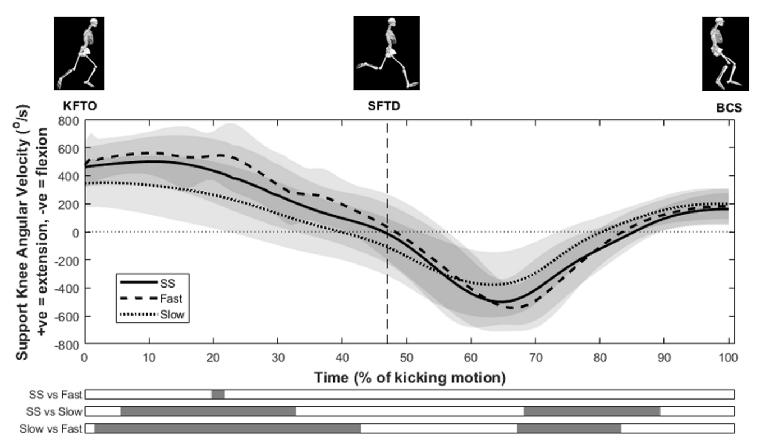
Figure 1. Mean ± SD support knee angular velocities from self-selected (SS), Fast and Slow approaches. Data are shown between the instances of kicking foot take off (KFTO) and ball contact start (BCS), where +ve = extension and -ve = flexion. The average instance of support foot touchdown (SFTD) is shown by vertical dashed line at 47% of kicking motion. Shaded areas on the bars under the main plot show the locations of pairwise differences between conditions (α = 0.017).

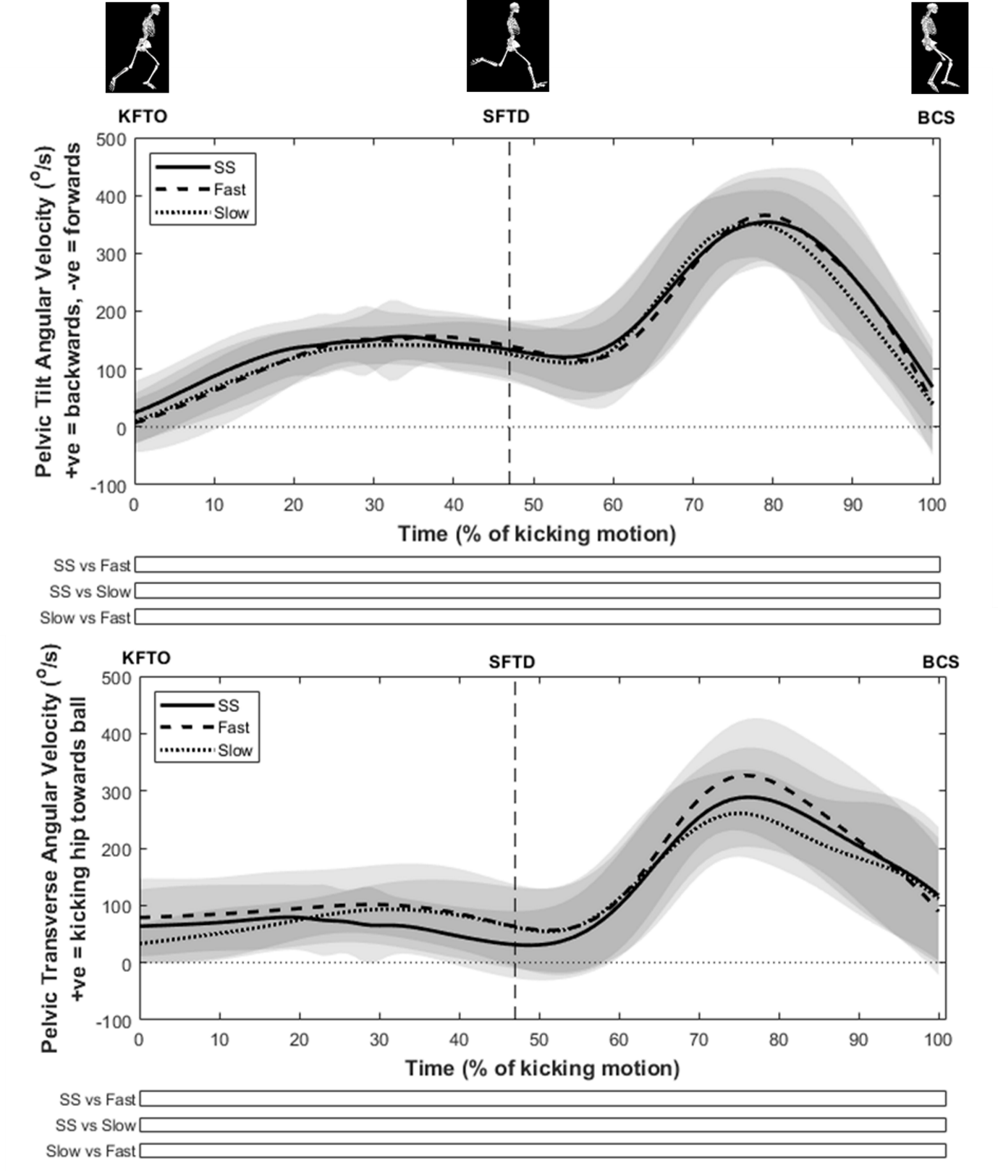
Figure 2. Mean ± SD pelvic tilt and transverse angular velocities from self-selected (SS), Fast and Slow approaches. Data are shown between the instances of kicking foot take off (KFTO) and ball contact start (BCS). The average instance of support foot touchdown (SFTD) is shown by vertical dashed line at 47% of kicking motion. No pairwise differences are shown as there was no main SPM{F} effect.

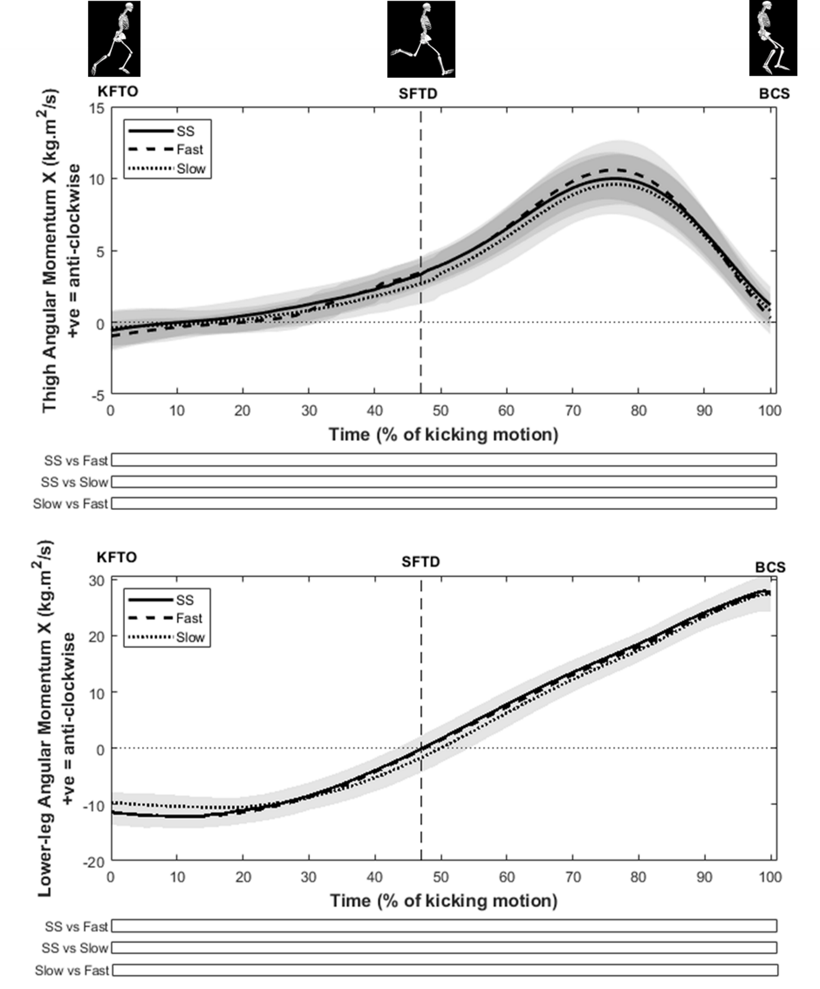
Figure 3. Mean ± SD thigh and lower leg angular momentum about X from self-selected (SS), Fast and Slow approaches. Data are shown between the instances of kicking foot take off (KFTO) and ball contact start (BCS), where +ve = extension and -ve = flexion. The average instance of support foot touchdown (SFTD) is shown by vertical dashed line at 47% of kicking motion. No pairwise differences are shown as there was no main SPM{F}effect.

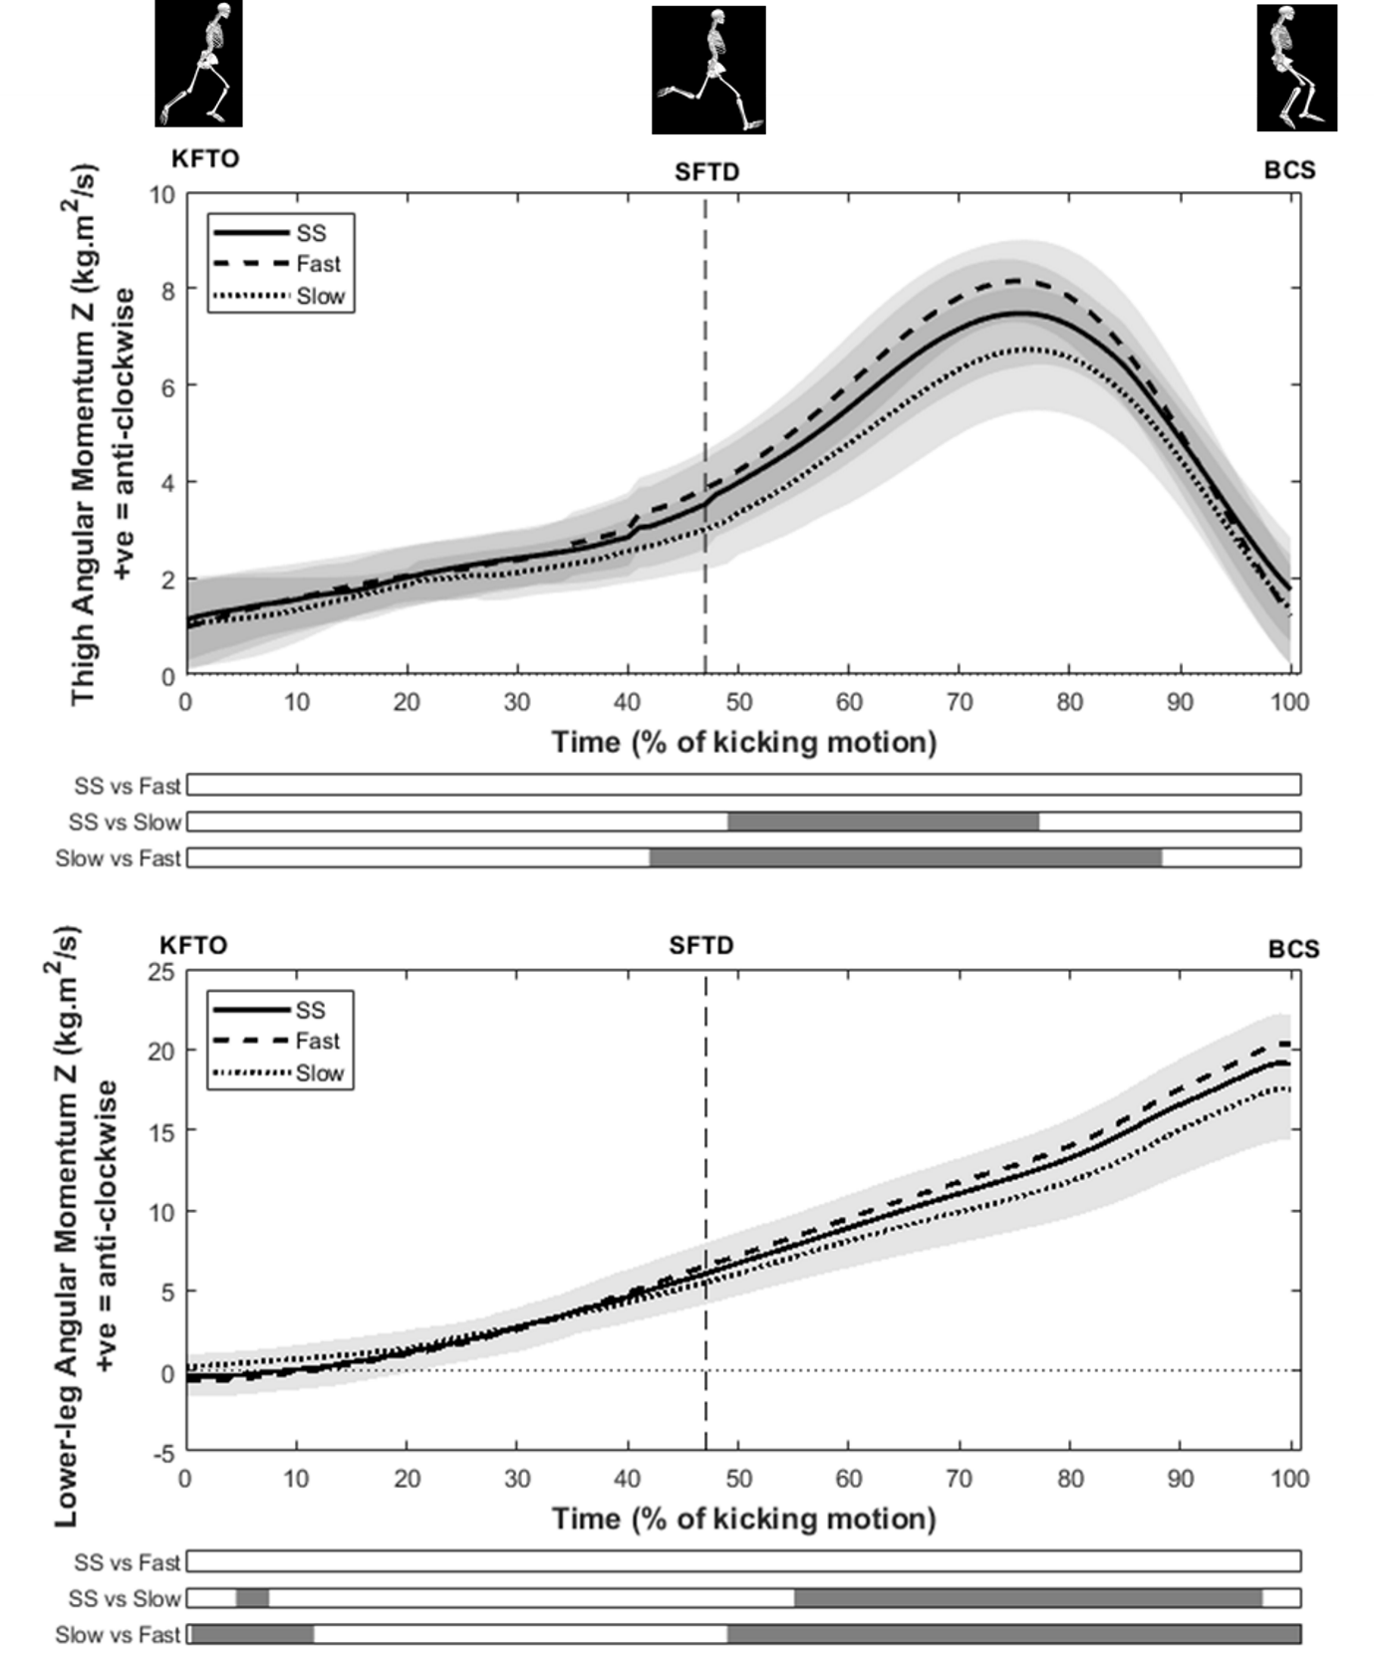
Figure 4. Mean ± SD thigh and lower leg angular momentum about Z from self-selected (SS), Fast and Slow approaches. Data are shown between the instances of kicking foot take off (KFTO) and ball contact start (BCS), where +ve = extension and -ve = flexion. The average instance of support foot touchdown (SFTD) is shown by vertical dashed line at 47% of kicking motion. Shaded areas on the bars under the main plot show the locations of pairwise differences between conditions (α = 0.017). Exact p-values for supra-threshold clusters are provided in text.

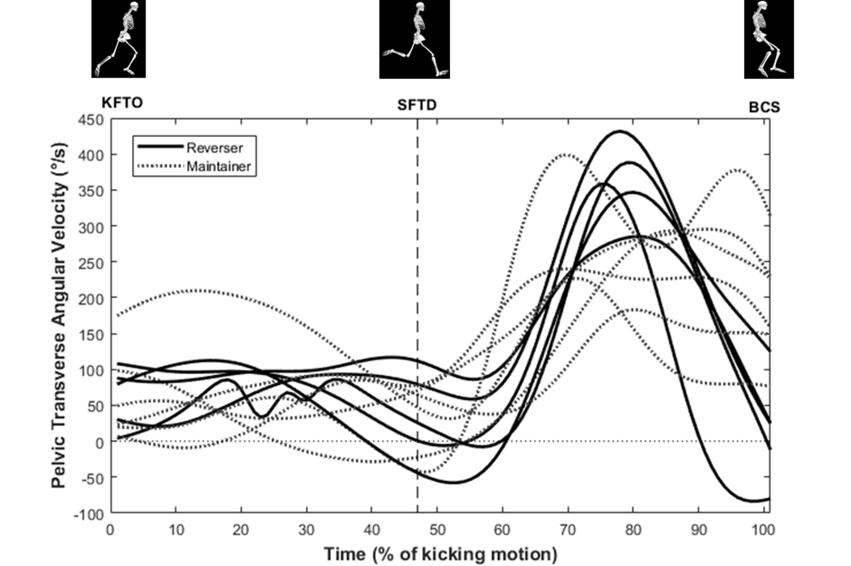
Figure 5. Mean curve for each of the 11 participants (mean value of five kicks in self-selected condition) showing pelvic transverse angular velocities between kicking foot take off (KFTO) and ball contact start (BCS). Dashed lines indicate possible ‘Maintainers’, whereas bold lines indicate ‘Reversers’. +ve = rotation of kicking hip towards ball.

Figure Captions
Figure 1. Mean ± SD support knee angular velocities from self-selected (SS), Fast and Slow approaches. Data are shown between the instances of kicking foot take off (KFTO) and ball contact start (BCS), where +ve = extension and -ve = flexion. The average instance of support foot touchdown (SFTD) is shown by vertical dashed line at 47% of kicking motion. Shaded areas on the bars under the main plot show the locations of pairwise differences between conditions (α = 0.017).
Figure 2. Mean ± SD pelvic tilt and transverse angular velocities from self-selected (SS), Fast and Slow approaches. Data are shown between the instances of kicking foot take off (KFTO) and ball contact start (BCS). The average instance of support foot touchdown (SFTD) is shown by vertical dashed line at 47% of kicking motion. No pairwise differences are shown as there was no main SPM{F} effect.
Figure 3. Mean ± SD thigh and lower leg angular momentum about X from self-selected (SS), Fast and Slow approaches. Data are shown between the instances of kicking foot take off (KFTO) and ball contact start (BCS), where +ve = extension and -ve = flexion. The average instance of support foot touchdown (SFTD) is shown by vertical dashed line at 47% of kicking motion. No pairwise differences are shown as there was no main SPM{F} effect.
Figure 4. Mean ± SD thigh and lower leg angular momentum about Z from self-selected (SS), Fast and Slow approaches. Data are shown between the instances of kicking foot take off (KFTO) and ball contact start (BCS), where +ve = extension and -ve = flexion. The average instance of support foot touchdown (SFTD) is shown by vertical dashed line at 47% of kicking motion. Shaded areas on the bars under the main plot show the locations of pairwise differences between conditions (α = 0.017). Exact p-values for supra-threshold clusters are provided in text.
Figure 5. Mean curve for each of the 11 participants (mean value of five kicks in self-selected condition) showing pelvic transverse angular velocities between kicking foot take off (KFTO) and ball contact start (BCS). Dashed lines indicate ‘Maintainers’, whereas bold lines indicate ‘Reversers’. +ve = rotation of kicking hip towards ball

