Developing Powerful Athletes
Part 2: Practical Applications

Anthony N. Turner, Paul Comfort, John McMahon, Chris Bishop, Shyam Chavda, Paul Read, Peter Mundy, Jason Lake

Abstract
In part 1 of this two-part review, we addressed the recent criticisms of the use of terms such as power, rate of force development, and explosiveness, over impulse. These terms were distinguished mechanically and conceptually for the benefit of the scientist and coach. In part 2, we use the key mechanical parameters underpinning power development and its relationship to the force-time characteristics and force-velocity profile of sporting movements, to evidence the planning of training drills, and assist the strength and conditioning coach in devising periodized training programs.
Key words: impulse; momentum; work; force; strength; speed

Introduction
In part one, we discussed that given most sporting actions occur in < 0.3 s, rate of force development (RFD) may supersede peak force capability as a proxy measure of sports performance. Equally, we identified that given the variety of motor skills encompassed in any one sport, it is important to train power (or the ability to produce force at high and low velocities) across a spectrum of loads. Thus, the aim of this paper (part 2) is to discuss training methods that achieve these goals. We will start by addressing methods to increase RFD, before examining those that improve power, and then finally investigating the impact that strength training has on these goals. In doing so, we also aim to demonstrate the interdependence of each type of training method and why athletes are recommended to develop power from a solid foundation of strength.

Rate of Force Development
While strength training typically targets peak force (e.g. the highest point noted in a force-time curve of an isometric mid-thigh pull), ballistic training is generally advised to increase RFD, i.e., force capability at the onset of movement (Figure 1). The capacity to increase RFD, or explosive strength as it is termed by many coaches and athletes, is largely attributed to the capacity to increase efferent neural drive, particularly by increases in the firing frequency of motor units (Aagaard, 2003). Thus, RFD is a function of neuromuscular activation and represents an individual’s ability to accelerate objects (Behm & Sale, 1993; Haff, et al., 1997; Winchester, et al., 2008). Given this summation of RFD, the recommendation to utilize ballistic training can also be explained when examining the influence of different loads on the force-time characteristics generated while squatting. Kubo et al. (2018) examined back squats at loads of 0%, 12%, 27%, 42%, 56%, 71% and 85% of one-repetition-maximum (1RM), and identified that at all loads there was a deceleration phase (and thus negative impulse) at the conclusion of the concentric portion, and that the relative duration of this phase increased as the load decreased. This therefore makes it difficult to stimulate the neuromuscular system throughout the full range of motion. This issue is naturally avoided during ballistic training (and reduced during weightlifting exercises and variable resistance training) where the barbell can be accelerated throughout the whole range of movement.
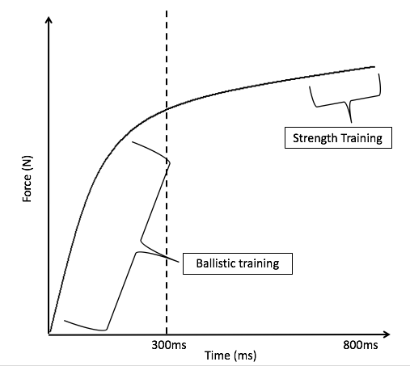
Figure 1. While the interdependence of strength and power training dictates that both modalities affect all regions of the force-time curve, ballistic training is preferred to improve the rate of force development (or epoch defined impulse), generally within the first 300 ms of movement, while strength training is the preferred method to improve the peak height of the curve.
Ballistic exercises may be best described as “explosive” movements (rapid acceleration against resistance), whereby the mass of interest (barbell and/or lifter) becomes a projectile. Plyometric training, medicine ball throws, and weightlifting and their respective derivatives are possibly best suited to train RFD, as in addition to their ability to be adapted to the specifics of the sport, they encourage full acceleration, with deceleration of the system achieved mainly due to the effects of gravity, rather than due to the neuromuscular system actively decelerating the system. Also, weightlifting and its derivatives produce some of the highest power outputs of any exercise modality (Suchomel & Comfort, 2017). For example, the relatively low velocities involved in powerlifting exercises such as the deadlift, results in approximately 12 watts per kg of body mass of power. In contrast, weightlifting derivatives can produce power outputs as high as 80 watts per kg of body mass; for a review of relative power outputs across exercises, readers are directed to Suchomel and Comfort (2017).
It is also worth noting that the second pull is the phase of weightlifting that has been shown to generate the greatest vertical ground reaction forces, RFD, and power output (Hakkinen, Kauhanen, & Komi, 1984; Souzam, Shimada, & Koontz, 2002). For example, Comfort et al. (2011) found that for force-time characteristics, mid-thigh clean pulls (i.e., taking the bar from the mid-thigh and concluding without the catch phase) produced higher values compared to power cleans, and even hang power cleans (taking the bar from just above the knee). This finding is unsurprising however, as there is a reduced displacement and therefore time available during a mid-thigh clean variation, compared to from the knee or hang. As such, force has to be higher to produce the impulse required to accelerate the system to ensure adequate displacement, especially if catching the bar. This information should be greeted with relief by strength and conditioning coaches, as some athletes can find learning or achieving the body positions of the full versions of weightlifting challenging and cannot realize their benefits until an extended period has been spent mastering them. Also, the fact that performing the lift starting from the mid-thigh may be better than from the floor, means issues regarding athlete mobility (e.g. limited dorsiflexion) can be avoided.
Again to the coaches’ avail, Suchomel et al. (2014) found that the jump shrug (again initiated from above the knee and via a countermovement) produced significantly greater peak force, velocity, and power, than both the hang clean and the high pull across all tested loads (30, 45, 65 and 80% 1RM hang clean). This was also confirmed by Suchomel and Sole (2017), with differences between the lifts attributed to specific task constraints. For example, they note that the goal of the jump shrug is to jump as high as possible, whereas for the clean, it is to catch the load. The intent to catch may lead to incomplete triple extension, especially at heavier loads (Suchomel, Wright, Kernozek, & Kline, 2014). In turn, this may decrease RFD and potentially, over time, result in a diminished training stimulus (Suchomel & Sole, 2017). Furthermore, with the goal of the jump shrug being to jump as high as possible, it naturally requires acceleration throughout almost the entire movement, leading to greater force and velocity characteristics; again partly explained by the data of Kubo et al. (2018) highlighted above. Of course, however, this can also be explained using Newton’s second law. That is, this need to jump (as opposed to drop under the bar and catch) requires a greater net impulse, which, when coupled with further reductions in displacement (and thus movement time), places a greater demand on the rapid application of force and therefore RFD. Table 1 identifies some ballistic exercises that, based on the information above, should form the basis of power training. The programming of these is discussed in the latter part of this paper and readers are also directed to the work of Suchomel et al. (2017) for information on how weightlifting derivatives can be manipulated for the same purpose.

Table 1. Example ballistic exercises aimed at increasing explosive strength. MD = Medicine ball.
Exercise | Coaching notes
MD chest pass, slam, overhead throws, and throws with rotation | It is important to note that these MD exercises are for the legs, so if the athlete does not load with a countermovement, or is not encouraged to jump when releasing it, it gravitates towards an upper body exercise.
Weightlifting and their derivatives | While weightlifting is an excellent resource, novice lifters may benefit most from pulls above the knee and from mid-thigh. Lifts from above the knee negate athlete mobility issues, with many unable to correctly attain a deep squat position. The best (and simplest) exercise may be jump shrugs, which also ensures a full triple extension action.
Loaded jump squats | This exercises produces high impact forces at landing so the athlete must progress gradually. Arguably, without the use of an electromagnetic braking device, jump shrugs and hex bar jumps may be better advised.
Slow and fast Plyometrics | There is an abundance of drills available here from jumping up to a box, landing from a box and drop jumps, including multiple hops and in various directions
Seated MD throws (similar to above) | Similar to the MD drills identified above, however, being seated directs all force development to the upper body
Bench press throw | This is a good way of performing an upper-body ballistic lift with very heavy load (of course lighter weights can also be used), which is not available with a MD. If the weight cannot be ‘thrown’ consider using bands and chains to enable full acceleration throughout the lift.
MB = Medicine ball; GCT = ground contact time.

Power and the Force-Velocity Curve
In part 1 we noted that the velocity at which we can move an object is determined by its mass and that when lifting to maximize power output, our intent should always be to apply maximal and rapid force (thus ensuring maximal neural recruitment) (Aagaard, 2003). This is because as long as we are maximizing force output, we can improve impulse over a given time period, which in turn would increase velocity. Furthermore, we noted that most sports use a variety of motor skills that span the entire force-velocity curve, thus it is considered prudent to ensure that training programs adequately cover all points. This is principally achieved by manipulating training load, with training velocity an outcome of this. Furthermore, the importance of using multiple loads (and therefore velocities) is evidenced by studies demonstrating that neuromuscular adaptations are specific to training velocity (Jones, Bishop, Hunter, & Fleisig, 2001; Kawakami & Haff, 2004; McBride, Triplett-McBride, Davie, & Newton, 2002; Pereira & Gomes, 2003); this has also been summarized by Haff and Nimphius (2012). Across these studies, strength training has been shown to predominantly shift the high-force region of the force-velocity curve to the right (Figure 2), while training focusing on the generation of speed, predominately shifts the high-velocity region of the curve to the right (Figure 3). Training at maximum power output predominantly effects the curve at the region corresponding best to the exercise used (Figure 4). These findings explain why a mixed methods approach to training is generally advised, where strength and power are trained simultaneously, but one is subject to greater emphasis during a particular training block (Haff & Nimphius, 2012; Turner, 2011). Furthermore, the use of multiple exercises (and not just multiple loads within the same exercise) can be a useful training tool, as the kinematics of some exercises are better matched to certain loads. For example, pulling-based derivatives of weightlifting exercises enable the use of loads above an athletes 1RM clean (as the lifter is no longer constrained by having to catch the bar), and thus can further emphasize the high-force (strength-speed) region of the force-velocity curve, above catch-based derivatives. Similarly, jump shrugs enable lighter loads to be used than those permitted during catch-based weightlifting variations (given that when attempting to catch, technique is compromised if the load is too light) and some pulling variations (as the bar may either be rapidly accelerated toward the chin or too high vertically), and thus allow further emphasis on the high-velocity (speed) region of the force-velocity curve. Suchomel and Comfort (2017) show how a spectrum of loads can be best paired with exercises to support power-based training, by plotting a theoretical force-velocity curve with respect to weightlifting derivatives (see Suchomel and Comfort (2017) for further reading).

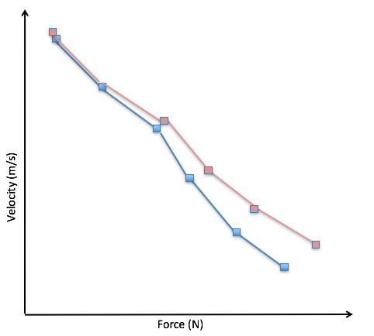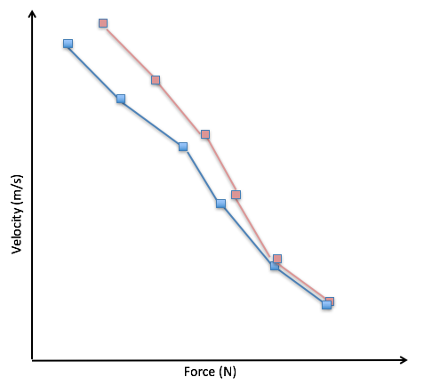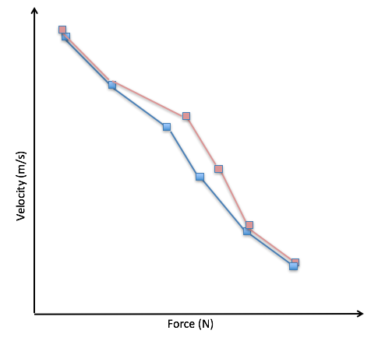
Figure 2 – 4 (left to right). Hypothetical change in F-v curve based on training load. Figure 2 = strength-based power training; Figure 3 = velocity-based power training; Figure 4 = training at P_{max} (i.e., the load that maximize average power). Of note, however, the position at which the line flattens is exercise dependent, as Pmax often occurs at varying loads.

Speed-Strength and Barbell Velocity Zones
Within the strength and conditioning community, velocity and force are often regarded as synonymous with speed and strength respectively, and hence, power is often referred to as speed-strength. Furthermore, a distinction can be made between speed-strength and strength-speed (Verkhoshansky, 1966), suggesting these are separate physical capacities pertaining to defined areas of the curve, and are an important division when prescribing strength and conditioning programs. Speed-strength can be defined as the ability to quickly execute a movement against a relatively small external load and is assessed in terms of speed of movement. Conversely, strength-speed may be considered as the ability to quickly execute a movement against a relatively large external load and is assessed in terms of mass lifted. These terms are intended to signify a gradual shift in training emphasis from strength (low velocity) to speed (high velocity) as the athlete journeys along the force-velocity curve ensuring full coverage. This can be achieved through appropriate exercise selection and the gradual reduction in load (i.e., % 1RM) as emphasis shifts from strength, strength-speed, speed-strength, and finally to speed (Table 2). While the demarcation of which load corresponds to speed-strength and strength-speed is rather arbitrary, one may suggest that up to, and including the load that produces peak average power for a particular exercise, signifies speed-strength; above this load and up to the 6RM load (i.e., strength training load) would be classed as strength-speed (Figure 5).
These demarcations can now also be defined using devices that measure barbell velocity (see Table 2 and Figure 5). Typically, for powerlifting type exercises, mean concentric velocity (MCV) is utilized due to its high reliability (Jidovtseff & Cronin, 2011; Jidovtseff, et al., 2006) and better representation of concentric velocity, when compared to peak concentric velocity (Jidovtseff & Cronin, 2011). It is well reported that the MCV achieved at maximal loads can vary between individual strength levels (Zourdos, et al., 2016; Helms, et al., 2017) and exercises (Sanchez-Medina, Pallares, Perez, Moran-Navarro, & Gonzalez-Badillo, 2017; Loturco, et al., 2017; Helms, et al., 2017), which would therefore affect the velocity zones that relate to strength, strength-speed, speed-strength, and speed. This variation, including that noted between different devices, therefore warrants the need for individualized velocity profiling to be conducted. In contrast to these traditional lifts (but following the same principles), weightlifting exercises should use peak velocity to determine load, as they are ballistic in nature and the entirety of the movement is not as critical for the evaluation of the lift (Mann, Ivey, & Sayers, 2015). Furthermore, and as expected given the discussion above, peak velocity occurs during the second pull of the clean and snatch (Harbili & Alptekin, 2014), with this point marking the critical moment of the exercise, because it determines the subsequent barbell displacement, and thus is a clearer determinant of success (Mann, Ivey, & Sayers, 2015).

To help monitor and regulate training to ensure the athlete is training in a velocity range that best represents the bio-motor in which they are trying to elicit change, the implementation of velocity cut-offs can help determine when a set is complete, based off a pre-defined decrement in velocity. For example, an athlete looking to develop lower-body strength-speed may perform 4 sets of jump squats at 75% of bodyweight, which is where the greatest impulse is produced (Mundy, Smith, Lauder, & Lake, 2017) – see part 1. During the first set the athlete may achieve a MCV of 0.95 m/s, which is also their fastest rep. The velocity loss allowed maybe set at 20% from that value (0.76 m/s). Thus, when the prescribed percentage velocity loss limit (20%) is exceeded, the set would be terminated. This method has previously been shown to (a) increase strength gains and (b) enhance ballistic outcome measures such as jump height, more so than higher cut offs of 40% (Blanco-Pareja, et al., 2017; Blanco-Pareja, Sanchez-Median, Suarez-Arrones, & Gonzalez-Badillo, 2017), despite a 40% difference in training volume (Pareja‐Blanco, et al., 2017). Furthermore, in ensuring the athlete performs all repetitions within an acceptable proximity of the intended velocity, fatigue across the set and indeed the training session, is comparatively less, given the subsequent reduction in volume. Finally, we should state that high velocity training, when performed under load, it not necessarily attempting to replicate the actual movement velocities attained in sport. Anecdotally (acknowledging that as of yet there is no peer reviewed research to support its efficacy), this can be achieved and even superseded through bungee cords and resistance bands for example. In the case of the former, it is also often necessary to spend sufficient time accelerating to achieve such speeds.
Table 2. Example exercises based on training emphasis. It should be noted that the emphasis of an exercise can be altered by changes in loading. As noted above, a change in load will inversely affect the velocity. While velocity zones (mean values for strength exercises and peak values for power exercises) are provided, it should be noted that these are likely to change based on the device used and thus readers are advised to determine their own velocity zones.
Strength | Strength-Speed | Speed-Strength | Speed
Bench press  (0.10- 0.4 m/s) | Bench press throw | Plyometric Push-up | Seated medicine ball chest pass  (>1.5 m/s)
Squat  (0.23 – 0.6 m/s) | Jump shrug from hang  (>1.0 m/s) | Jump to box | Med ball throw  (>1.5 m/s)
 | Jump squat (40%BM) | Jump squat (20% BM) | Jump squat (BM)  (>2.0 m/s)
Deadlift | Power clean  (>1.2 m/s) | Power Snatch  (>1.5 m/s) | Jump to box  (>2.0 m/s)
BM= body mass
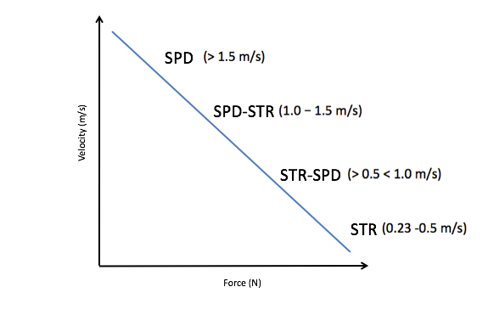
Figure 5. Adaptation of F-V curve, substituting force for strength (STR) and velocity for speed (SPD). Velocity bands shown are for the back squat and may vary between individuals.

Developing RFD and Power Through Strength
Strength training is a fundamental component in the development of power, given that power is largely dependent on the ability to exert high forces (and is thus subject to an athlete’s strength capacity). This can be noted by the high and positive correlation between peak power and maximum strength (r = 0.77-0.94) (Asci & Acikada, 2007), in both the upper-body and lower-body (Baker, 2001; Baker, Nance, & Moore, 2001; Baker & Newton, 2008). It is not difficult to corroborate the interdependence of strength and power (beyond the obvious mechanics that P = F * v) by using v = F * t/m (where P = power; F = force; m = mass; a = acceleration; v = velocity; t = time). This equation represents a rearrangement of Newton's second law of motion: F = ma → F = m* v/t → v = F * t/m. The equation (v = F * t/m) now reveals that to increase velocity (v), it is necessary to increase the magnitude or duration of the force applied (or both), which results in an increase in impulse, or alternatively decrease the mass of the system. However, not all of these are possible as the athlete may be unable to decrease system mass (either body mass or mass of a sports implement), or increase the duration of movement; in fact, a decrease in duration may be wanted or even needed. Consequently, only one option remains, namely to increase force production (strength). Furthermore, the influence of force can also be explained when we consider the work – energy theorem (see part 1), which states that the net work performed on an object is equal to the change in kinetic energy. In the context of jumping and noting that jump height should be calculated based on take-off velocity (as per the impulse-momentum theorem), velocity can be calculated as follows: v = √ (2 * F * s / m). Given mass is limited in its ability to alter (assuming a lean athlete) and push-off distance is anatomically constrained (or the optimization is outside the control of the strength and conditioning coach), force is the variable that exerts the most influence. Lastly, as mentioned, the impulse-momentum theorem is also an important consideration for power activities as for example, jump height is determined by take-off velocity, which in turn, is determined by net impulse (the impulse applied to body mass). The equation shows that a large impulse is needed to produce a large change of momentum. Again, force must dominate because of the short duration of most sports movements. Clearly however, force and time must be measured if athlete improvement is to be appropriately monitored, ideally through analysis of a force-time trace. Figure 6 illustrates how increases in strength (and thus RFD) can change the jump profile of an athlete, such that performance (height and duration) is improved (Suchomel & Comfort, 2017). These conclusions lead to a common question; how strong should we make our athletes? Clearly the underpinning physics suggest that there is no upper limit, with researchers suggesting that athletes who can lift 2 x body mass (BM) during a back squat, can express higher power outputs in vertical and horizontal jumping than their weaker (e.g., 1.6 x BM) counterparts (Barker, et al., 1993; Ruben, et al., 2010; Stone, Moir, Glaister, & Sanders, 2002; Wisløff, Castagna, Helgerud, Jones, & Hoff, 2004; Cormie, McGuigan, & Newton, 2010; Cormie & McBride, 2007); thus this appears to be an appropriate benchmark, although this should not be considered a ceiling from strength.

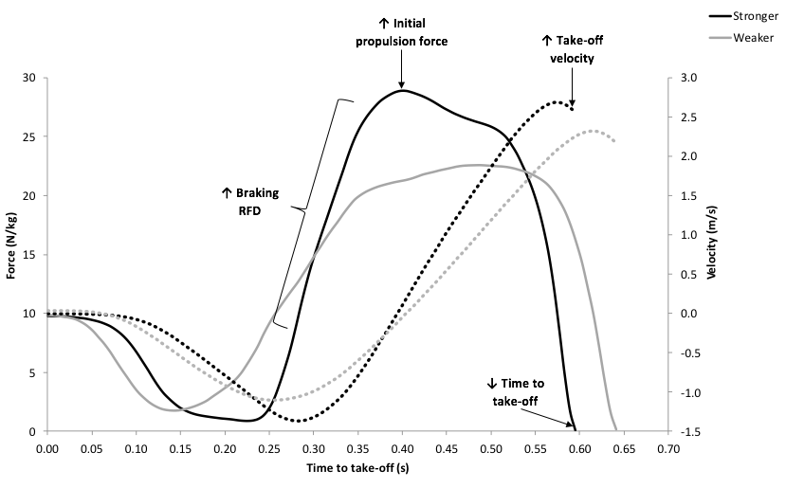
Figure 6: Figure 6: Figure 6: Comparison of force (solid lines), rate of force development (RFD), velocity (dotted lines), and time to take-off, during a countermovement jump, between stronger and weaker athletes. Adapted from Suchomel and Comfort (2017).

Bompa and Carrera (2005) effectively describe the interrelationship between strength training and ballistic training. They propose that power is developed through a physiological strategy involving two phases. The first phase involves the recruitment and training of fast-twitch fibers through strength training as described by the size principle of motor unit recruitment (Henneman, Clamann, Gillies, & Skinner, 1974); i.e., you have to lift heavy enough to actually recruit Type IIa, and especially Type IIx fibres. The strength-training phase is considered fundamental given the high correlation (r = 0.75) between the percentage of type II fibers and power output, and their role as velocity increases (Coyle, Costill, & Lesmes, 1979). The second phase involves increasing the firing frequency of these fibers (which are now of a greater volume) through ballistic training. Remember, P = F * v, so maximum gains will occur if both of these components are trained. For example, Cormie et al. (2007) compared a power-training group (seven sets of six jump squats with the optimal load for maximal power output, i.e., BM) with a strength-power group (five sets of six jump squats at the optimal load for maximal power output and three sets of three squats with 90% of their 1RM). Results revealed that combined lower-body strength–power training was as effective as power training for improving maximum jump height and maximum power output in the jump squat, and it was more effective than power training at producing all-around (i.e., from BM to 80 kg) improvements in the load–power relationship of the jump squat. Unfortunately, no results were presented to illustrate whether there were any differences in jump strategy (e.g., to the duration of or force applied to each phase), to determine if there was a different response regarding how changes in impulse result in an increase in jump height. Perhaps the best example of athletes involved in this combined (mixed methods) strength and power training are weightlifters. These athletes are reported to produce the highest (ratio-scaled) values for isometric RFD and power output in weighted and un-weighted vertical jumps (Harris, Stone, O’Bryant, Proulx, & Johnson, 2000).
Cormie et al. (2010) have also shown that in weaker individuals, both modes (strength and power) are equally effective at enhancing power and overall athleticism. In this study, relatively weak men (1RM back squat < 1.6 x BM) had their jumping and sprinting performances, along with changes to their force-velocity profile, muscle architecture, and neural drive tested, following a 10-week (3/week) training intervention of either strength training or ballistic-power training. Both groups showed similar improvements in the performance measures but via different mechanisms. The ballistic-power training group increased the rate of electromyography rise during jumping, producing more force and increasing RFD, resulting in greater acceleration and movement velocity in shorter periods. In the strength training group, results were consequent to maximal neural drive (demonstrated through increases in maximal integrated EMG) and muscle thickness, which increased contractile capacity and thus reducing the relative load. This enabled greater force and RFD, and the ability to accelerate their mass to a greater degree, and again over a shorter time period.
It is apparent therefore, that maximum strength is a key factor in developing high power outputs and that, to fully develop an athlete’s power potential, strength and conditioning coaches should include strength training within their periodized programs. Of note, because strength levels may only be maintained for 2 weeks (Hortobagyi, et al., 1993), it is prudent to incorporate strength sessions throughout the entirety of a periodized program so as to optimize and maintain high levels of power output through training and come the time of competition (Turner, 2011). Suchomel et al. (2016) nicely surmise that strength should be perceived as a “vehicle” for driving the enhancement of power and RFD, and we recommend reading Suchomel et al. (2018) for a more in-depth analysis of the significance of strength and how it may be trained.

Conclusion and Practical Applications
Armed now with this deeper understating of the interdependence of strength and power, we must return to the profiles of athlete A and B, as presented in part 1 (see Figure 7 below). This figure can now be seen as a simplification of how the force-time curves of athletes can be used to classify training windows, given that (a) increases in impulse naturally accompany increases in strength (when time is held constant), (b) weaker individuals benefit most from strength training, regardless of their profile, and (c) while it is desirable to have a high RFD, it is still essential that the athlete produce the required force over a given duration (impulse). As such, when reporting force-time traces, it is important to note the relative force capacity along the y-axis, to ensure the athlete has sufficient strength to now engage in a periodized approach of mixed methods training.
Given peak force in both athletes is above the recommended 1.6 x BM (Figure 7), the trace may be interpreted as follows: Athlete A would benefit most from an emphasis on ballistic training while reducing the focus on strength development, while athlete B would benefit most from an emphasis on strength training, with a reduced focus on ballistic training. As they undertake this training, the graphs would reverse, albeit now with higher values (Figure 8). In the next training block therefore, they would swap training emphasis’s, with this pattern of periodization continuing throughout the meso- or macrocycle. Importantly however, had strength capacity been < 1.6 x BM in both athletes, then they should simply continue with a strength emphasis. We should also reiterate that a training emphasis infers that (normally) one biomotor is targeted for improvement, while others are maintained as best as possible. So, a power emphasis implies the goal of this training block is to increase an athlete’s rapid expression of force (at high and low loads). Strength is still trained however, albeit with much less volume, to ensure this biomotor quality (i.e., peak force capacity) is maintained as best as possible (therefore frequency and intensity may remain). This approach is guided by their interdependence, e.g., power training will appear ineffective if strength capacity diminishes.

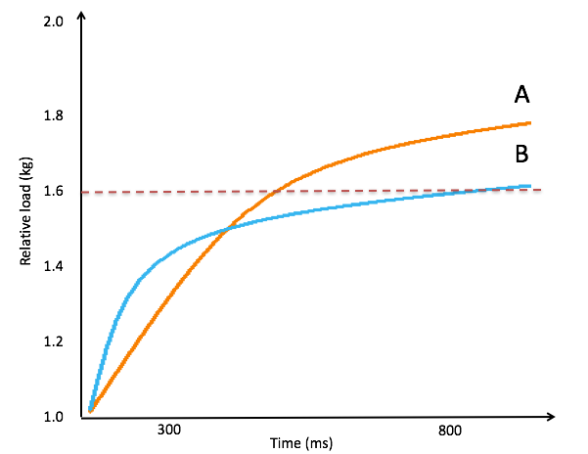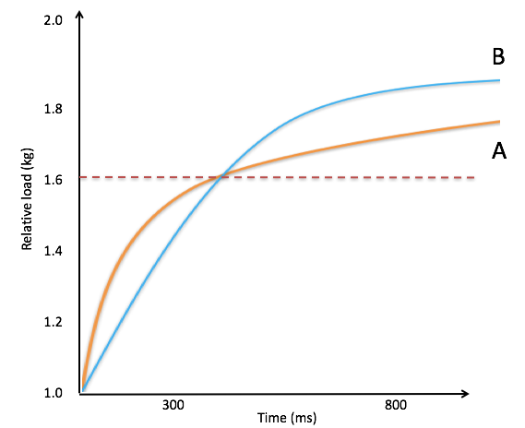

Figure 7 (left) and 8 (right). To appropriately use the force time curve, relative force must be labelled along the y-axis. This is because while having a high RFD is certainly a desirable characteristic, it is still essential that an athlete have the requisite strength (~1.6 x body weight) from which to engage in mixed methods training Given peak force in both athletes has surpassed this threshold, the trace may be interpreted as follows: Athlete A would benefit most from ballistic training while athlete B would benefit most from strength training. Naturally, their training swaps in the next mesocycle, given the force-time traces should then appear as per Figure 8.

References
- Aagaard, P. (2003). Training –induced changes in neural function. Exerc. Sport Sci. Rev, 32, 61-67.
- Asci, A., & Acikada, C. (2007). Power production among different sports with similar maximum strength. J. Strength Cond. Res, 21, 10-16.
- Baker. (2001). The effects of an in-season of concurrent training on the maintenance of maximal strength and power in professional and college-aged rugby league football players. J. Strength Cond. Res, 15, 172-177.
- Baker, D., & Newton, R. (2008). Observation of 4-year adaptations in lower body maximal strength and power output in professional rugby league players. J. Aust. Strength Cond, 18, 3-10.
- Baker, D., Nance, S., & Moore, M. (2001). The load that maximises the average mechanical power output during explosive bench press throws in highly trained athletes. J. Strength Cond. Res, 15, 20-24.
- Barker, M., Wyatt, T., Johnson, R., Stone, M., O'bryant, H., Poe, C., & Kent, M. (1993). Performance factors, psychological assessment, physical characteristics, and football playing ability. The Journal of Strength & Conditioning Research, 7(4), 224-233.
- Behm, D., & Sale, D. (1993). Intended rather than actual movement velocity determines velocity specific training response. Journal of Applied Physiology, 74, 359–368.
- Blanco-Pareja, F., Rodriguez-Rosell, D. S.-M., Sanchis-Moysi, J. D., Mora-Custodio, R., Calbet, J., & Gonzalez-Badillo, J. (2017). Effects of velocity loss during resistance training on athletic performance, strength gains and muscle adaptation. Scand J Med Sci Sports, 27(7), 724-735.
- Blanco-Pareja, F., Sanchez-Median, L., Suarez-Arrones, L., & Gonzalez-Badillo, J. (2017). Effects of velocity loss during resistance training on performance in professional soccer players. Int J Sports Physiol Perform, 12(4), 512-519.
- Bompa, T., & Carrera, M. (2005). Periodisation Training for Sports. Champaign, IL: Human Kinetics.
- Comfort, P., Allen, M., & Graham-Smith, P. (2011). Comparisons of peak ground reaction force and rate of force development during variations of the power clean. The Journal of Strength & Conditioning Research, 25(5), 1235-1239.
- Cormie, P. M., & McBride, J. (2007). Power versus strength-power jump squat training: influence on the load-power relationship. Medicine & Science in Sports & Exercise, 39(6), 996-1003.
- Cormie, P., McGuigan, M., & Newton, R. (2010). Adaptations in athletic performance after ballistic power versus strength training. Medicine & Science in Sports & Exercise, 42(8), 1582-1598.
- Coyle, E., Costill, D., & Lesmes, G. (1979). Leg extension power and muscle fiber composition. Med. Sci. Sports, 11, 12-15.
- Haff, G., & Nimphius, S. (2012). Training principles for power. Strength & Conditioning Journal, 34(6), 2-12.
- Haff, G., Stone, M., O’Bryant, H., Harman, E., Dinan, C., Johnson, R., & Han, K. (1997). Force-time dependent characteristics of dynamic and isometric muscle actions. Journal of Strength and Conditioning Research, 11, 269 - 272.
- Hakkinen, K., Kauhanen, H., & Komi, P. (1984). Biomechanical changes in the Olympic weightlifting technique of the snatch and the clean & jerk from submaximal to maximal loads. Scand.J. Sports Sci. , 6, 57–66.
- Harbili, E., & Alptekin, A. (2014). Comparative kinematic analysis of the snatch lifts in elite male adolescent weightlifters. Journal of sports science & medicine, 13(2), 417.
- Harris, G., Stone, M., O’Bryant, H., Proulx, C., & Johnson, R. (2000). Short-term performance effects of high power, high force, or combined weight-training methods. . J. Strength Cond. Res, 14, 14-20.
- Helms, E., Storey, A., Cross, M., Brown, S., Lenetsky, S., Ramsay, H., . . . Zourdos, M. (2017). RPE and velocity relationship for the back squat, bench press and deadlift in powerlifters. J Strength Cond Res, 31(2), 292-297.
- Henneman, E., Clamann, H., Gillies, J., & Skinner, R. (1974). Rank order of motorneurons within a pool: Law of combination. J. Neurophysiol, 37, 1338-1349.
- Hortobagyi, T., Houmard, J., Stevenson, J., Fraser, D., Johns, R., & Israel, R. (1993). The effects of detraining on power athletes. Med. Sci. Sports Exerc, 25, 929-935.
- Jidovtseff, B. H.-J., & Cronin, J. (2011). Using the load-velocity relationship for 1RM prediction. J Strength Cond Res, 25(1), 267-270.
- Jidovtseff, B., Croisier, J., Lhermerout, C., Serre, L., Sac, D., & Crielaard, J. (2006). The concept of iso-inertial assessment: Reproducability analysis and descriptive data. Isokinetic Exerc Sci, 11, 53-62.
- Jones, K., Bishop, P., Hunter, G., & Fleisig, G. (2001). The effects of varying reisitance-training loads on intermediate-and high-velocity-specific adaptations . J. Strength Cond. Res, 15, 349-356.
- Kawakami, N., & Haff, G. (2004). The optimal training load for the development of muscular power. J. Strength Cond. Res, 18, 675-684.
- Kubo, T., Hirayama, K., Nakamura, N., & Higuchi, M. (2018). Influence of Different Loads on Force-Time Characteristics during Back Squats. Journal of Sports Science & Medicine, 17(4), 617-622.
- Loturco, I., Kobal, R., Moraes, J., Kitamura, K., Cal Abad, C., Pereira, L., & Nakamura, F. (2017). Predicting the maximum dynamic strength in bench press: The high precision of the bar velocity approach. J Strength Cond Res, 31(4), 1127-1131.
- Mann, J., Ivey, P., & Sayers, S. (2015). Velocity-based training in football. Strength & Conditioning Journal, 37(6), 52-57.
- McBride, J., Triplett-McBride, T., Davie, A., & Newton, R. (2002). The effect of heavy-vs. light-load jump squats on the development of strength, power, and speed. . J. Strength Cond. Res, 16, 75-82.
- Mundy, P., Smith, N., Lauder, M., & Lake, J. (2017). The effects of barbell load on countermovement vertical jump power and net impulse. Journal of Sports Sciences, 35(18), 1781-1787.
- Pareja‐Blanco, F., Rodríguez‐Rosell, D., Sánchez‐Medina, L., Sanchis‐Moysi, J., Dorado, C., Mora‐Custodio, R., & González‐Badillo, J. (2017). Effects of velocity loss during resistance training on athletic performance, strength gains and muscle adaptations. Scandinavian journal of medicine & science in sports,, 27(7), 724-735.
- Pereira, M., & Gomes, P. (2003). Movement velocity in resistance training. Sports Med, 33, 427-428.
- Ruben, R., Molinari, M., Bibbee, C., Childress, M., Harman, M., Reed, K., & Haff, G. (2010). The acute effects of an ascending squat protocol on performance during horizontal plyometric jumps. The Journal of Strength & Conditioning Research, 24(2), 358-369.
- Sanchez-Medina, L., Pallares, J., Perez, C., Moran-Navarro, R., & Gonzalez-Badillo, J. (2017). Estimation of relative load from bar velocity in the full back squat exercise. Int J Sports Med, 38(6), 480-488.
- Souzam, A., Shimada, S., & Koontz, A. (2002). Ground reaction forces during the power clean. J Strength Cond Res, 16(3), 423-427.
- Stone, M., Moir, G., Glaister, M., & Sanders, R. (2002). How much strength is necessary? Physical Therapy in Sport, 3(2), 88-96.
- Suchomel, T., & Comfort, P. (2017). Developing muscular strength and power. In A. Turner, & P. Comfort, Advanced strength and conditioning: evidence-based practice (pp. 13 - 38). London: Routledge.
- Suchomel, T., & Comfort, P. (2017). Weightlifting for sports performance. In A. Turner, & P. Comfort, Advanced Strength and Conditioning; An Evidence-based approach (pp. 249-273). London: Routledge.
- Suchomel, T., & Sole, C. (2017). Force-Time–Curve Comparison Between Weight-Lifting Derivatives. International journal of sports physiology and performance, 12(4), 431-439.
- Suchomel, T., Comfort, P., & Lake, J. (2017). Enhancing the Force–Velocity Profile of Athletes Using Weightlifting Derivatives. Strength & Conditioning Journal, 39(1), 10-20.
- Suchomel, T., Nimphius, S., & Stone, M. (2016). The importance of muscular strength in athletic performance. Sports medicine, 46(10), 1419-1449.
- Suchomel, T., Nimphius, S., Bellon, C., & Stone, M. (2018). The Importance of Muscular Strength: Training Considerations. Sports Medicine, 1-21.
- Suchomel, T., Wright, G., Kernozek, T., & Kline, D. (2014). Kinetic comparison of the power development between power clean variations. The Journal of Strength & Conditioning Research, 28(2), 350-360.
- Turner, A. (2011). The science and practice of periodization: a brief review. Strength & Conditioning Journal, 33(1), 34-46.
- Verkhoshansky, Y. (1966). Perspectives in the development of speed-strength preparation in the development of jumper. Track and field, 11-12.
- Winchester, J., McBride, J., Maher, M., Mikat, R., Allen, B., Kline, D., & McGuigan, M. (2008). Eight weeks of ballistic exercise improves power independently of changes in strength and muscle fiber type expression. Journal of Strength and Conditioning Research, 22, 1728-1734.
- Wisløff, U., Castagna, C., Helgerud, J., Jones, R., & Hoff, J. (2004). Strong correlation of maximal squat strength with sprint performance and vertical jump height in elite soccer players. British journal of sports medicine, 38(3), 285-288.
- Zourdos, M., Klemp, A. C., Quiles, J., Schau, K., Jo, E., Helms, E., . . . Blanco, R. (2016). Novel resistance training-specific rating of perceived exertion scale measuring repetitions in reserve. J Strength Cond Res , 31(1), 267-275.

