Abstract— Millimeter-wave imaging may be used to assist in the problem of wastepaper recognition during the sorting and recycling process. Currently there are a variety of techniques which are used within materials recovery facilities to sort waste paper and card, however improvements in sorting capability can be realized by using a multiple sensors to provide complementary (orthogonal) data. This paper discusses the issues related to the processes which are currently used for sorting of recycled wastepaper and the phenomenology for millimeter-wave imaging of waste paper material. Experimental measurements and images in the millimeter wave band are presented which support the proposed application.
Millimeter-Wave Imaging for Recycled Paper Classification
S. Shylo, Fellow, IEEE and S.W. Harmer

Index Terms—MICR, SYST

INTRODUCTION
Paper production is an important industrial activity in many countries. According to statistics from the Food and Agriculture Organization (FAO), in 2012, global production of recycled paper and paperboard amounted to 400 million tons, with a total cost of $108 billion [1]. This total divides into 107.3 million tons of printing and writing paper, 263 million tons of other paper and paperboard and 31.1 million tons of newsprint [2].
The majority of paper and printed products eventually become wastepaper, which contributes to environmental pollution. Waste paper, by weight, accounts for approximately 40% of all solid waste generated by people. According to some estimates, users of personal computers with printers dispose of as much as 115 billion pages of printing paper annually. It is well known that recycling of paper saves wood (1 ton of recycled paper saves about 4 cubic meters of wood) and helps to mitigate deforestation. Waste paper can be recycled 5-7 times before its fibers become too short and unsuitable for further paper production. According to statistical data, the current collection fraction of waste paper is about 49% globally; with 50% in the USA and 59.4% in Europe. The highest level of waste paper collection was recorded in Germany at 73.6%. Globally, in paper and cardboard manufacture, waste constitutes about 43% of the feedstock, i.e. it is a major component. However, the suitability of certain wastepaper types for recycling is dependent on quality and is separated as follows:
i) high quality recovered wastepaper (white paper);
ii) medium quality (waste cardboard, corrugated cardboard, books, magazines);
iii) low quality (waste newspapers and newsprint and impregnated and coated wastepaper and paperboard)
The process of wastepaper treatment includes several stages, the first of which is the sorting of the waste, which is often carried out manually and this significantly impacts on the cost of the recycling process.
Machines for automated sorting of wastepaper are relatively new, and there is still considerable scope for improvement in the capability of these systems. Current limitations on the discrimination of waste paper types by automated sorting machines, as well as their high cost and power consumption, result in about 95% of wastepaper still be hand sorted [3]. Throughput of these lines range from 700-4500 kg per hour, per an employee with a separation efficiency of 60-95% [4]. More efficient automated sorting of wastepaper would help reduce operating costs, and with this aim, production lines with automatic sorting machines have been developed by a number of companies in the US and the EU. [5,6]. Currently, automatic paper sorting machines use optical sensors to view paper moving along a conveyor belt, allowing the discrimination and sorting of waste paper. For example, machines are able to differentiate between a sheet of newsprint and white sheets of office paper and discriminate glossy paper from matt paper. The company MMS Inc. produces a machine on which the raw waste paper passes on a conveyor belt with the waste paper arranged uniformly across the conveyor belt, so that the optical sensors are able to detect the color of individual sheets of paper, and measure their reflection coefficient to ascertain whether they have a matte or glossy surface. However, despite progress in automated separation of wastepaper into fractions, the efficacy of paper separation into fractions with optical sensors is low.
The proposal to use multiple sensors operating at optical, infrared, microwave and millimeter-wave (MMW) frequencies is not a new one. For example, in the invention disclosed in one patent [7] it is proposed to use a combination of optical and infrared detectors and a coherent active imaging system in the microwave or MMW band.
The implementation of the system disclosed in [7] has some significant technical difficulties associated with the coherent illumination and the need to form an electromagnetic field with uniform amplitude and phase distribution along the receiver array. This condition is necessary for correct comparison of the signals received by various elements of the array.

Discrimination of Paper with a radiometer

A better solution for the implementation of a MMW band system to classify waste paper, would be by radiometric methods [8, 9, 10]. An absorbing material (black body) is heated to a predetermined temperature significantly higher than that of the surroundings. This distributed heat source provides isotropic and incoherent MMW radiation. In this way, the transmitting antennas required in [7] are redundant, and separation of viewing directions in space is realized with a single antenna, and a simple, single-channel MMW receiver.
The main advantage of using a radiometric MMW approach is the ability to measure the bulk properties of paper objects; optical and IR radiation is highly attenuated by these materials and can only make surface or near surface measurements of material properties. A MMW radiometric method is shown in Fig. 1. A thermal noise source with a temperature higher than that of the surroundings is used to produce MMW contrast. The thermal source is located on one side of the sample, which is in contact with a substrate used to support the sample, and a receiver is positioned on the other side of the sample. The measured brightness temperature when the sample is present is different to that measured when the sample is absent. This temperature difference is related to the dielectric properties and thickness of the sample.

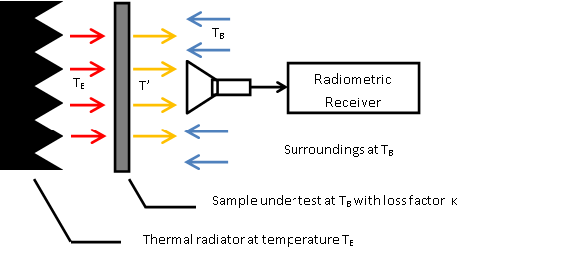
Fig. 1. The brightness temperatures of the thermal radiator, paper layer and surroundings and measurement of the apparent brightness temperature at the outer surface of the sample.

At MMW frequencies, paper has a dielectric constant $ε^{'}≈2−3\text{.}5$ and dielectric loss factor $\text{tan}δ≈2−3×{\text{10}}^{−2}$(depending on the paper type/grade) [11]. By measuring the reduction in intensity caused by transmission and scattering through the paper sample, the type of paper may be determined. Dielectric constants may be determined based on differences in brightness temperature of the radiation by a simple relationship [12].
Thermally emitted MMW radiation is attenuated when propagating through the sample layer. The electromagnetic characteristics of the material, transmittance, reflectance, absorption and scattering due to surface roughness all influence the degree to which MMW radiation is attenuated by the sample. Also, the sample itself emits according to its temperature T_{S} and reflects MMW radiation from the surroundings, which are at a temperature T_{B}. If the sample and the surroundings are in thermodynamic equilibrium (i.e. at the same temperature, T_{S} = T_{B}), and the antenna is positioned in the near-field zone, the total loss of the radiation associated with the effects of absorption within the layer and the reflection at the boundaries of media may be determined by a simple relationship between temperatures [12]. In general, the recorded brightness temperature of the sample is due to four effects: The reflection of thermal background radiation (at temperature T_{B}); the reflection of thermal radiation emitted from the receiver (at temperature T_{R}); the transmission of thermal radiation (at temperature T_{E}) through the sample and the thermal emission (at temperature T_{S}) of the sample itself. Because the receiver is near to the sample, some of the thermal radiation from the surrounding environment is obscured by the receiver antenna, this obscured fraction, f, is dependent upon the geometry of the receiver antenna, the frequency of MMW radiation and the distance from the sample. The receiver has a finite noise temperature and a fraction (1-f ) of the reflected thermal noise from the receiver is recorded. In the MMW band, the intensity of thermally emitted radiation is proportional to the product of the temperature and emissivity of the body, this product is known as the brightness temperature. Therefore, the observed brightness temperature, $T^{'}$, of the sample is given by ,

$T^{'}={\text{fT}}_{B}R+\left(1−f\right)T_{R}R+T_{E}τ+T_{S}A$ (1)

where, R is the reflectance of the sample; τ is the transmittance of the sample, and A is the absorptance (emissivity) of the sample. Conservation of energy implies that, $1=R+τ+A$. Although the receiver will add noise, the placement of a circulator between the antenna and receiver mitigates (~ -20 dB) the emission of the receiver radiation back through the antenna. Since the circulator is at ambient temperature, then T_{R} = T_{B.} Also, if the sample is in thermal equilibrium with the surroundings (T_{S} = T_{B}) then, applying the conservation of energy relation, equation 1 simplifies to,

$T^{'}=\left(T_{E}−T_{B}\right)τ+T_{B}$ (2)

Thus, the observed brightness temperature is proportional to the temperature difference between the thermal emitter and the background and the transmittance of the sample. In the above analysis the effect of scattering from rough surfaces is not included but this may be accounted for by replacing the transmittance with a quantity κ, which we here term ‘loss factor,’ and which includes surface roughness effects. Thus, equation 2 may be written as,

$T^{'}={κT}_{E}+\left(1−κ\right)T_{B}$ (3)

Or, expressing the loss factor in terms of temperature differences,

$κ= \frac{Т^{'}−Т_{B}}{Т_{E}−Т_{B}}$ (4)

For more sensitive measurements, the difference in temperature between the thermal source and the surroundings can be increased to provide a larger temperature contrast, $Т_{E}−Т_{B}$. The loss factor $κ$is an oscillating function in frequency space because of thin film interference effects within the sample layer (see Fig. 5 for an example).
However, a wide frequency band of thermal noise combined with a lossless substrate that is suitably thick and substantial absorption losses in the sample material largely suppress these interference effects.
By measuring the spatial (x,y) variation in the brightness temperature difference $\left(Т^{'}−Т_{B}\right)\left(x,y\right)$with a MMW imaging radiometer at different points, a spatial map of $κ\left(x,y\right)$ may be formed in accordance with 4. This map will show variations in the sample thickness, variations in complex permittivity of the sample and variations in the sample’s surface roughness. The mean value of $κ\left(x,y\right)$ over the sample’s total area is indicative of the thickness and type of sample. If one of these parameters is independently measured, a-priori, for example, by using an optical image, then there exists the possibility of determining the other parameter based on the results of MMW radiometric measurements. Using other sensor modalities, such as an optical band camera and/or IR camera that provide information, which is independent to the information obtained from MMW imagery, allows a more definite determination of the type of waste paper material present to be made. For example, a visible band sensor may determine whether a paper material is blank or printed upon or has a matt or glossy finish, whereas the MMW sensor will be able to determine the thickness of that sample.

Laboratory Measurements of paper samples
For the purpose of determining loss measurements of various paper samples a W-band, single-channel, radiometric receiver was utilized. The block diagram of the installation and a photograph of the apparatus is shown in Fig. 2. The parameters of the system used are listed in Table 1.
The radiometric receiver is placed in a fixed position, with its aperture plane parallel to the plane of the paper sample. The distance between the antenna and the sample surface was fixed at 3cm to mitigate variations due to interference effects. An isotropic noise source (thermal radiator) is located below a radio transparent window, which provides mechanical support for the sample. The measuring carriage is movable on rails, enabling plane-parallel motion of a sample relative to the receiving antenna, as would be the case in a sorting facility.
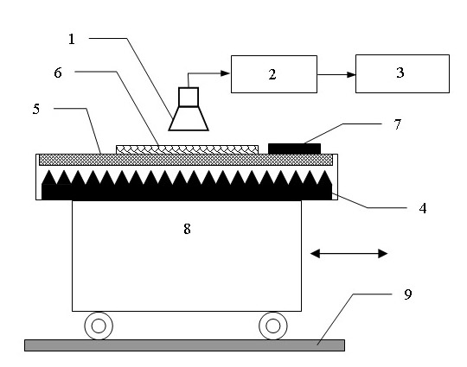

Fig. 2. Block diagram of the measuring device for loss measurements of paper samples: 1 – horn antenna; 2 – radiometric receiver; 3 –recorder; 4 – illuminating device (in cross section) - distributed isotropic radiator at the temperature T_{E}; 5 – radio-transparent window; 6 – a sample under test (paper layer at air temperature T_{B}); 7 – black body (absorbing layer) at air temperature T_{B}; 8 – moving carriage; 9 – rails

The distributed isotropic radiator is a heat-conducting foam material with high absorption and low reflectance at W-band, this approximates a black body emitter well at MMW frequencies. The radiator is placed in a thermally stabilized chamber, having one face made from radio-transparent material (polystyrene foam). Due to the higher temperature of this absorbing material (T_{E}) relative to the surrounding temperature (which is measured using the blackbody at room temperature shown in Fig. 2.), the brightness temperature contrast Т_{E} – Т_{B} exists, which is recorded by the receiver when the sample is absent, i.e. κ = 1. With a sample present, $0≤κ≤1$, and the recorded brightness temperature difference $Т^{'}−Т_{B}$ is $κ\left(Т_{E}−Т_{B}\right)$and in accordance to Equation 4, the loss factor of the sample is determined based on the measured change of temperature contrast. An example of recorded loss factor for a sample is shown in Fig. 3. During measurements, several types of sheet paper with different densities were used: office paper; newsprint, corrugated packaging; magazines; journals and books. In order to compare data, the density of the paper samples in kg/m² was used as this measure is common in the paper industry. The mass of the samples was measured by precision electronic scales with a measurement error of 1 mg. Descriptions of the samples are provided in Table 2.

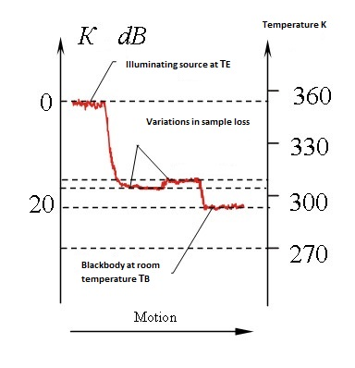
Fig. 3. An example of the measured loss factor of a layer of semi-transparent material passing through the measuring radiometric system

Fig. 4. shows the dependence of the loss factor (in dB) in paper upon the density ρ kg/m² for tested samples of paper in typical indoor conditions – the measured temperature was 21° С and the humidity 52%. It should be noted that variations in the observation angle of ±30° from the vertical have practically no effect on the magnitude of the measured loss values. The results show that the loss factor increases with the density of the material, regardless of its type. High density samples (magazines, books etc.) can be separated
TABLE I
radiometric apparatus details
Parameter | Value | Remarks
Wavelength | 3.16 mm
Centre frequency (f₀) | 95 GHz
Bandwidth | 2 GHz
Temperature sensitivity | 0.2 K | Obtained by computing the standard deviation of the receiver output voltage over 1 second. This corresponds to an effective system temperature of ~ 8900 K.
Integration time | 1 s
Aperture size of the receiving horn antenna | 15х20 mm²
Black body Reflection coefficient | -20 dB | at W-band
Emissivity | 0.99 | at W-band
Viewing angles | ±60° | relative to the normal to the plane of the radio transparent window
Average operating temperature of hot load | +54°С (327 K) | corresponds to brightness temperature as emitter is a blackbody
Irregularity of radiator temperature | ±1.5°C
Radiating area | 500х500 mm²

from less dense samples (cardboard, newspaper, thin booklets) on the basis of their differing loss values. Three successive series of measurements were carried out and are indicated by different shaped markers on the graph. Two layer packaging cardboard has a greater loss factor than newspapers, brochures, or separate sheets of office paper, however the difference in loss factor alone does not provide robust discrimination of the samples without additional, orthogonal information from different sensors. Fig. 5. shows the results of measurements of loss factor for standard blank (without printing) office paper of 80 g/m² with increasing number of A4 sheets (0 to 100 sheets in increments of 5 sheets) under typical room conditions (temperature 20° C, relative humidity about 50%). It is observed that the loss factor increases monotonically with small periodic oscillations. These oscillations are the result of interference effects within the paper as the thickness increases. From theory, one would expect to observe oscillations in loss factor with sample thickness separated by ~$λ2n$, where n is the real part of the refractive index of the material. The measured oscillation period, in terms of sample density is about 1.2 kg/m²(see Fig. 5), which corresponds to a change in thickness of 1.4 mm, indicating a refractive index of ~ 1.14.
TABLE II
loss factors measured for samples

Objectª | Density  Kgm⁻² | Mean Thickness  mm | Mean^{b} Loss Factor dB
P1 | 0.82 | 0.5 | 0.97
P2 | 0.32 | 0.25 | 0.67
C1 | 0.70 | 2.5 | 1.4
C2 | 0.87 | 6.2 | 2.6
C3 | 0.49 | 0.7 | 1.1
J1 | 3.4 | 2.8 | 3.7
J2 | 5 | 5.8 | 6.2
B1 | 7 | 12.5 | 9.5
B2 | 7 | 12.5 | > 16
a – P1 - 10 sheets of A4 paper with density of 80 g/m²;
P2 - 4 sheets of newspaper; C1 - Corrugated cardboard; C2 - Double corrugated cardboard (2 corrugated sheets between 3 flat sheets); C3 - Flat packing cardboard (non-corrugated); J1 - Paperback journal (48 pages + 2 cover sheets); J2 - Paperback magazine (53 sheets + 2 cover sheet); B1 - Paperback magazine (53 sheets + 2 cover sheet); B2 - Hardback book (86 pages).
b - Three loss measurements were made for each sample and the mean value is presented.

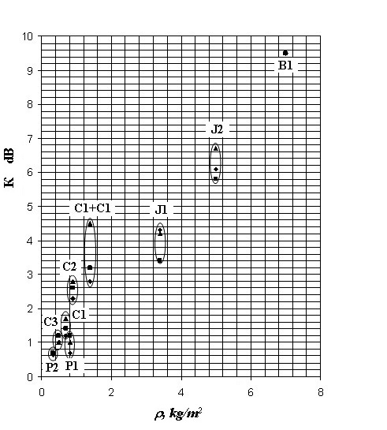

Fig. 4. Dependence of loss factors for tested samples upon their density (a series of 3 measurements, indicated by different shaped markers, are taken).
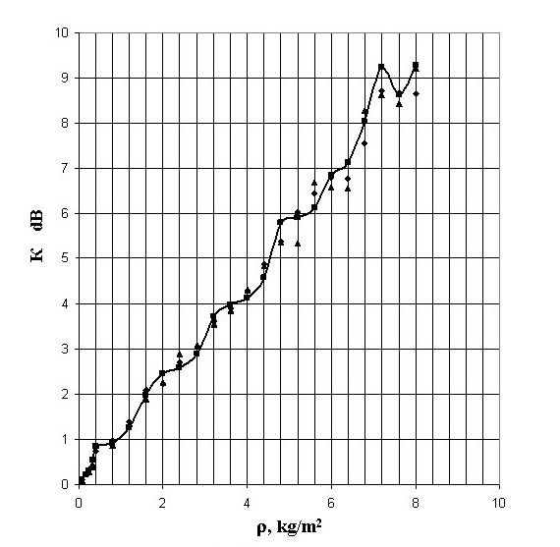

Fig. 5. Dependence of loss factor in for a package of office paper upon the density of the package (right).

The difference in attenuation between blank office paper and similar paper, which has been printed upon, is also observable with a significant number of printed sheets. The presence of absorbing, graphite-based, toner leads to an increased loss factor. Also, paper is a rather hygroscopic material and absorbs moisture from the air at high humidity. Moisture leads to an increase in both the real and imaginary parts of the dielectric constant of paper and a subsequent increase in loss factor. Fig. 6. presents results of experiments conducted at W-band, measuring the loss factor of sheets of office paper at 50% humidity and at 90%. humidity. For this purpose, individual sheets of paper were kept in a vertical position in a closed chamber with forced circulation of air in the presence of a water tray. Humidity was measured with a digital psychrometer. This experiment confirms results of other studies showing the significant effect of moisture content on the loss factor of paper in the MMW band.
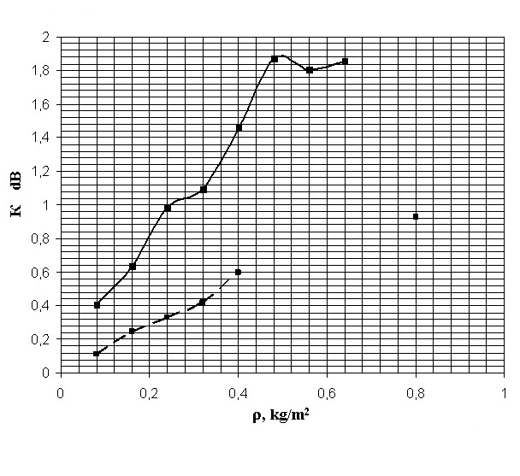
Fig. 6. - Dependence of the loss factor in paper sheets maintained at typical room conditions (dashed line, humidity 50%) and high at humidity (continuous line, 90%).

radiometric millimeter imaging results
As a proof of concept exercise, experiments were also carried out with passive W-band MMW images for selected paper materials. A prototype MMW imaging system was used, which was developed as a passive radiometric scanner for imaging people in the interests of security [13]. The principle of image formation in this system is based on mechanical rotation of a diffraction antenna with the creation of a multi-beam pattern around a horizontal axis [14]. By means of a dielectric lens, antenna beams are focused on the image plane located at distance 1.5 m from the plane of the receiving antenna aperture. Due to rotation of the antenna, a circular aspect image is formed with 64 pixels across the diameter of the image. In the presented images a blue-green-red palette is used, low values of brightness temperature correspond to blue, mean temperatures to green, and high temperatures to red.
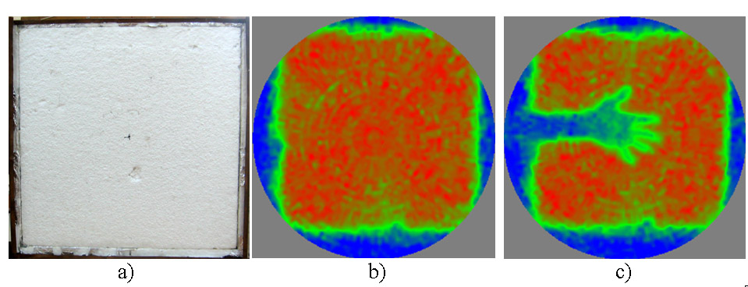

Fig. 6. A photograph of the thermal radiator (a), a W-band radio-thermal image of the same radiator (b) and an example of the radio thermal image of a person’s arm and hand placed in front of the thermal radiator (c) (right).

In the course of experiments, objects were fixed on the emitting surface of an isotropic thermal radiator, vertically installed in the focal plane of the antenna at distance 1.5 m. The radiation temperature of the source was maintained at 327±1.5 K (~54 °C). Typical MMW images from the W-band imager are presented in Fig. 6.
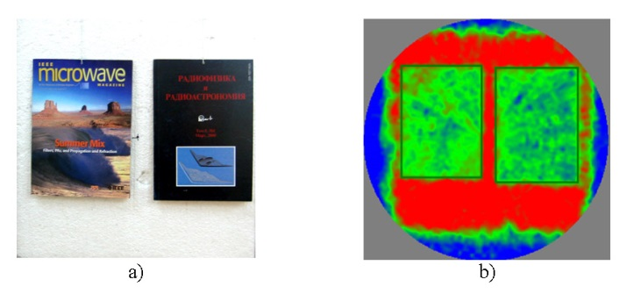
Figure 7 - Photograph of the illumination source with two journals (J1, J2 in Table 2) placed on its surface (a) and the corresponding MMW image of the scene at distance 1.5 m (b). The rectangular green outlines around the objects were applied artificially to delineate the object edges more clearly.

Thick journals, ~ 50 pages, such as objects J1 and J2 significantly attenuate at MMW frequencies, having loss factors of around 4 and 6 dB respectively. This attenuation is clearly evident in the MMW images of these objects, see Fig. 7.
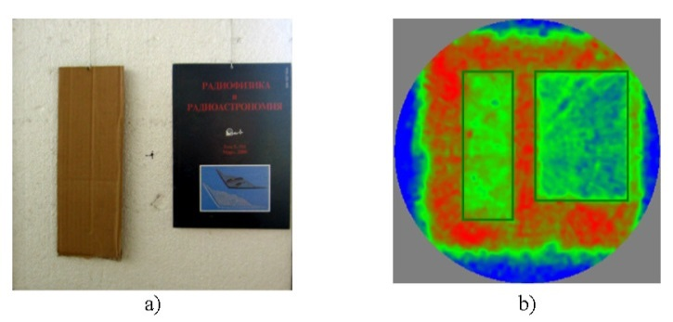
Figure 8 - Photograph of the illumination source with test objects (C2, J2 in Table 2) (a) and the corresponding MMW image of them at a distance of 1.5 m (b). The rectangular green outlines around the objects were applied artificially to delineate the object edges more clearly.

The 2 dB difference in the loss factors between journal J1 and J2 is also observable in the MMW image by the colder, blue/green image associated with J2. A lower loss object, such as C2 (corrugated card board) with a loss factor of ~ 2.5 dB is clearly seen at a higher brightness temperature than the more lossy journal, J2. Their images are shown in Fig. 8. In the case of very low loss objects, such as object P2 (4 sheets of newsprint), which has a loss factor of ~ 0.7 dB, the attenuation is still just observable in the MMW image, see Fig. 9. It should be noted that the selected RGB palette provides a relatively a small dynamic range, which makes visual discrimination of objects with similar values of loss factor difficult. Significant improvement in recognition may be achieved by locating an object’s boundaries by using an optical image of the same scene. A more accurate comparison of average loss factors by means of data averaging over whole objects can then be made.

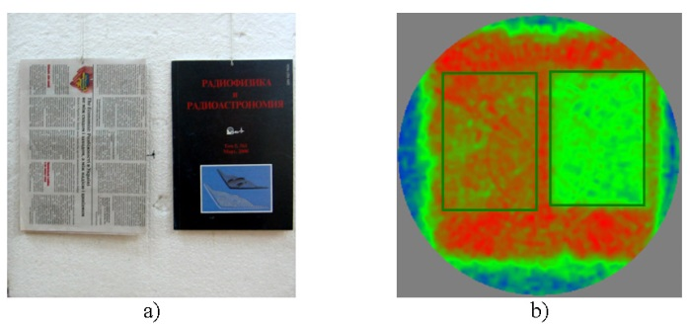
Figure 9 - Photograph of the illumination source with test objects (P2, J2 in Table 2) (a) and the corresponding MMW image of them at a focal distance 1.5 m (b) The rectangular green outlines around the objects were applied artificially to delineate the object edges more clearly.

Conclusion
Measurements in the MMW band clearly show that the loss factor provides a capability to differentiate between differing thicknesses of paper materials. Using a radiometric imaging system, operating in the MMW band, the authors have demonstrated the feasibility of measuring the loss factor associated with reflection and attenuation in a variety of paper samples. Illumination, in transmission mode, is provided using a MMW absorbing material uniformly heated to ~ 54 °C, with the surrounding temperature around 20 °C. Brightness temperature differences in the MMW imagery are linearly related to the loss factor and permit the differentiation of thin and thick paper objects from one another. This information is orthogonal to that provided by visible and infrared band sensors currently employed in waste paper sorting, enabling more information to be gathered about paper objects. A configuration of visible, infrared and MMW sensors for the task of sorting waste paper could be as follows: An optical sensor with a source of visible band illumination to allow a fixed brightness, continuous imagery of the waste objects to be captured ; A source of uniform infrared illumination, to heat the waste paper prior to infrared imaging. The heating device should be placed before the infrared imaging sensor so that the thermal properties of the waste paper items can be ascertained [7,15]; A heated absorber providing uniform, incoherent MMW illumination, which is located under the conveyor belt and in the field of view of the MMW imager. The conveyor belt in this area should be composed of a material with a low coefficient of absorption of radiation in the MMW band, for example, from polyethylene or mylar. Discrimination of differing paper objects might be realized by making a simple comparison between the measured loss factor with pre-determined, representative values for common cases. As an example, a three level comparison might be followed, where a measured loss factor К > К₃ indicates a thick book or booklet; a measured loss factor К₂ < К< К₃ indicates a magazine, journal or thick cardboard and a measured loss factor К₁ < К< К₂ indicates newspaper or office paper. The values of К₁, К₂ and К₃ may ne heuristically determined from the measured data presented in this article (i.e. Fig. 4): К₁ ~ 1 dB, К₂ ~ 2 dB, К₃ ~ 3.5 dB . These levels of losses can be measured sufficiently accurately using radiometric systems having a sensitivity of 0.5-1 Kelvin, provided that a temperature difference of ~ 50 K exists between the thermal source and room temperature. With this maximum contrast, К ~ 3 dB corresponds to a change of contrast of ~ 25 K and К ~ 1dB corresponds to a change of contrast of ~ 10 K. The minimum detectable loss factor for a system with sensitivity ~ 1 K is ~ 0.1 dB. For paper objects presenting loss factors > 17 dB there is no ability to discriminate higher loss materials, due to the samples apparent temperature approaching that of the background, i.e. T’ = T_{B}.
Although this article makes measurements on paper and card items, other commonly recycled materials, such as, plastics, household batteries and small metal parts may also be amenable to improved sorting using a MMW sensor to provide additional, orthogonal information to visible and infrared sensing.

References
[1] http://www.fao.org/forestry/statistics/80938/en/
[2] http://faostat.fao.org/site/626/DesktopDefault.aspx?PageID=626#ancor
[3] http://www.kxmnt.ru/garb/production.pdf.
[4] http://ztbo.ru/o-tbo/lit/texnologii-otxodov/ruchnaya- sortirovka-musora-i-otxodov-tbo
[5] http://www.magsep.com/material-sorting- equipment/paper-sorting-equipment/
[6] http://www.redwave.at/ru/
[7] Process and installation for inspection and/or sorting combining surface analysis and volume analysis: patent US2013141115: IPC⁸ G01J3/28 / Bourely A., Mouneyrac D., Coutaz J.-L., Garet F., Blampey B. - appl. US201213705351 05.12.12; publication 06.06.13, http://worldwide.espacenet.com.
[8] Goldsmith P.F., Huguenin G.R., Kapitzky J. “Focal Plane Imaging Systems for Millimeter Wavelengths,” IEEE Transactions on Microwave Theory and Techniques,” v. MTT-41, No.10, October 1985, pp. 1664-1675.
[9] Huguenin G.R. “Millimeter Wave Concealed Weapon Detection and Through-the-Wall Imaging Systems,” Proc. SPIE, Vol. 2938, 1996, - pp. 152-159.
[10] Yujiri L., Shoucri M., Moffa P. “Passive Millimeter-Wave Imaging,” IEEE Microwave Magazine, September, 2003, pp. 39- 50.
[11] https://en.wikipedia.org/wiki/Permittivity
[12] Bardati F., Solmini D. “Radiometric sensing of biological layered media,” Radio Science.-1983.-Vol.18, № 6. - pp.1393-1401.
[13] Shylo S., Sydorenko Yu., Wheeler D., Dundonald D. “A W-band passive imaging system implemented with rotating diffraction antenna technology,” Proc. of SPIE, Vol. 8900, pp. 890008-1890010 (2013).
[14] Method for formation of radiometric images and an antenna for implementation of the method : patent (US) # 8836598 / IPC⁸ H01Q3/00 / Shylo S., Sydorenko Yu., appl. # PCT/GB2008/0512018 19.12.08, publication 16.09.14, http://worldwide.espacenet.com
[15] Method and machine for automatically inspecting and sorting objects according to their thickness : patent US2008/0302707A1: МПК8 B01C5/34 / Bourly A. - № PCT/FR2006/002900 application 28.12.2006; publication. 22.12.2008, http://worldwide.espacenet.com

 S. Shylo is with the Usikov Institute of Radio Physics and Electronics National Academy of Sciences of Ukraine, P.O. Box 61085 IRE NASU, Kharkov, Ukraine, (e-mail shilo@ire.kharkov.ua) S.W Harmer is with Manchester Metropolitan University, Centre for Sensing & Imaging, School of Engineering, John Dalton Building, Chester Street, Manchester, UK, M1 5GD (e-mail s.harmer@mmu.ac.uk).

