UNIVERSITY OF CHICHESTER COACHING HUB FIRST ANNUAL COACHING SYMPOSIUM
WEDNESDAY 19TH JUNE 2019, CLOISTERS, BISHOP OTTER CAMPUS, UNIVERSITY OF CHICHESTER

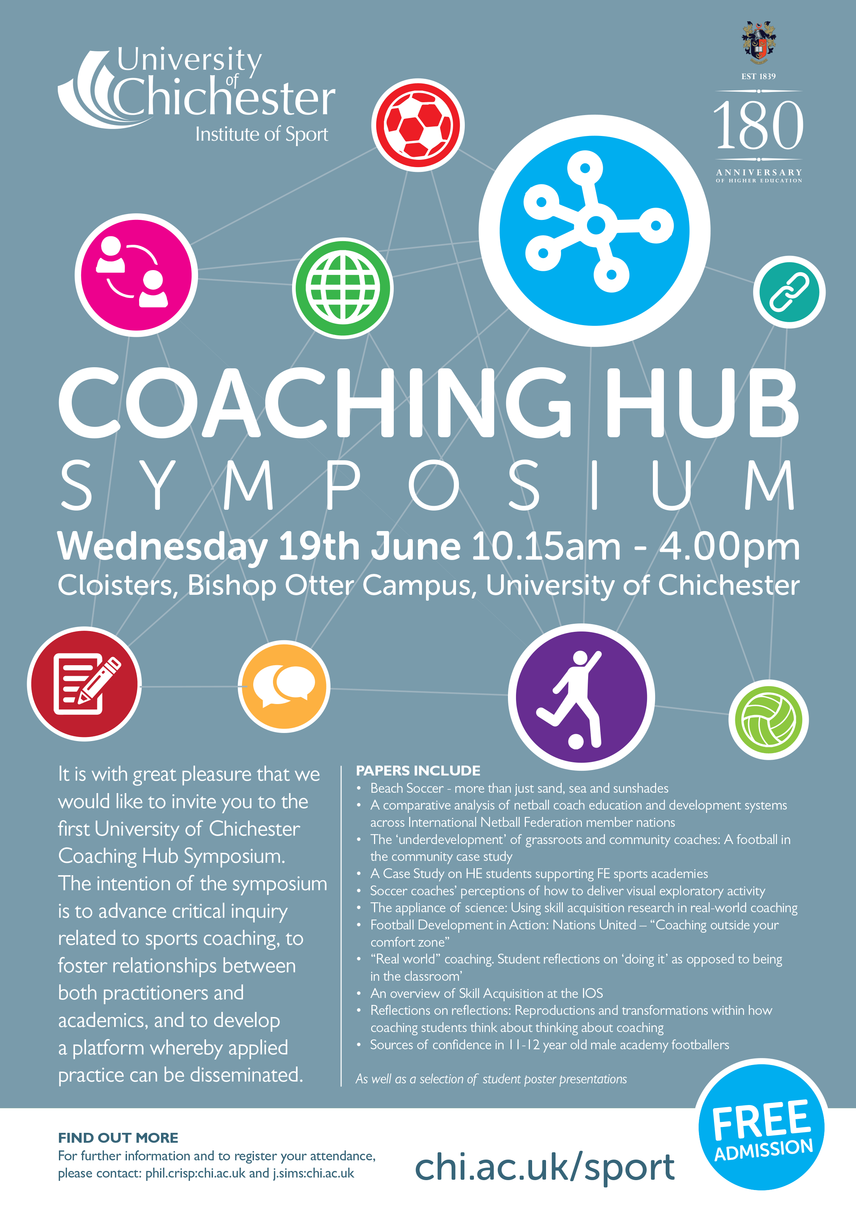

[Date]
Editors: PhilIPPE Crisp AND JAMIE SIMS
University of Chichester
Institute of Sport
conference proceedings

Sports coaching is considered a complex process that involves an interaction between multiple disciplines. This is irrespective of where the coaching sits in relation to the domains of performance, community, or school sport.

The first UCCA Coaching Hub Symposium took place on the 19th June 2019 at the University of Chichester. The intention of this event was to advance critical inquiry related to sports coaching, to foster relationships between both practitioners and academics, and to develop a platform whereby applied practice can be disseminated.
The schedule, abstracts, and bios of the presenters are included in these proceedings.

Schedule
Time | Session | Speaker | Role | Topic
10.15 | Arrival
10.30 – 10.35 | Welcome and introduction
10.35 – 10.55 | Session 1 | Jane Lomax | Field Leader Sport Coaching Institute of Sport | A comparative analysis of netball coach education and development systems across International Netball Federation member nations
10.55 – 11.15 | Session 1 | Perry Northeast | Women’s High Performance Centre | 'Beach Soccer - more than just sand, sea and sunshades'
11.15 – 11.35 | Session 1 | Paul Brackley and Philippe Crisp | AITC | The ‘underdevelopment’ of grassroots and community coaches: A football in the community case study.
11.35 – 11.50 | Session 1 | Bev Stevenson and Tim Bennett | East Sussex College | A Case Study on HE students supporting FE sports academies
11.50 – 12.05 | Questions to panel 1
12.05 – 12.20 | Break
12.20 – 12.40 | Session 2 | Craig Pulling and Dave Eldridge | Field Leader Sport PE Institute of Sport, and Senior Lecturer in Physical Education | Soccer coaches’ perceptions of how to deliver visual exploratory activity
12.40 – 1.00 | Session 2 | Oliver Runswick | Programme leader Sport Science and Coaching | The appliance of science: Using skill acquisition research in real-world coaching.
1.00 – 1.20 | Session 2 | Dave Bright | Senior Lecturer in Sport Coaching | Skill Acquisition at the IOS
1.20 – 1.40 | Questions to panel 2
1.40 – 2.10 | Session 3 | Student poster presentations |  | Student poster presentations
2.10 –2.30 | Session 4 | Danny Potter | Programme leader Football Performance and Coaching | Football Development in Action: Nations United - 'Coaching outside your comfort zone'
2.30 – 2.50 | Session 4 | Philippe Crisp | Programme leader Sport Development and Coaching | ‘Real world’ coaching. Student reflections on ‘doing it’ as opposed to being in the classroom.
2.50 – 3.10 | Session 4 | Jamie Sims | Programme leader Community Sport Coaching | Reflections on reflections: Reproductions and transformations within how coaching students think about thinking about coaching
3.10 – 3.30 | Session 4 | Iain Greenless, Sarah Murray, Esther Burkitt, and Aimee Parr | Iain Greenlees: Professor of Sport Psychology | Elite youth soccer players’ sources and types of sport self-confidence
3.30 – 3.50 | Questions to panel 4
3.50 – 4.00 | Concluding remarks

University of Chichester Coaching Hub first Annual Coaching Symposium
Wednesday 19th June 2019, Cloisters, Bishop Otter Campus, University of Chichester
CONFERENCE ABSTRACTS AND BIOS

SESSION 1

Jane Lomax

Title: A comparative analysis of netball coach education and development systems across International Netball Federation member nations

Abstract:
This presentation will give an insight into ongoing research exploring the coach education and development systems currently employed within different netball nations with a view to helping map the experiences developing coaches receive throughout their training. The research aims to explore the knowledge and skills covered within each system together with the approaches taken by each nation to train their coaches. This presentation focuses on early research findings and forms part of Jane's current Professional Doctorate programme of study, based at the University of Gloucester, and working in conjunction with the international Netball Federation.

Profile

Jane is currently Head of Sports Coaching at the University of Chichester Institute of Sport with over 20 years experience working in coaching, sports psychology and teaching. Jane is a BASES Accredited Sports Science support worker (Sports Psychology) and it is her work within that field, including a number of years with England Netball, that was instrumental in taking Jane into coaching, coach education and development. Jane has coaching experience in tennis, skiing and mostly Netball and she is currently an England Netball coach educator and developer across all levels of qualification.

Perry Northeast

Title: 'Beach Soccer - more than just sand, sea and sunshades'

Abstract:
This presentation will offer coaches an insight into the sport of Beach Soccer and how England prepare for the demands of International competition. We explore how the National Women's team pursue success with limited resource and minimal research, applying the Burch's Hierarchy of Competence model (1970) to drive forward player development
Profile

Perry is UEFA A Licensed coach and Coach Educator for the Football Association, responsible for the development of football coaches within Sussex and Hampshire. Perry's main experience is within Women's and Girls football and was previously Portsmouth FC Women's 1st Team manager between 2013-2016. Alongside his experiences within the grass game, Perry has long been an advocate of Beach Soccer which is an adaptation of the grass format of the sport. Having previously been capped at International level, he is now the Head Coach of the National Women's team who are currently ranked no1 in Europe.

Paul Brackley and Philippe Crisp

Title: The ‘underdevelopment’ of grassroots and community coaches: A football in the community case study.

Abstract:
Over the last 20 years in the UK a number of skills sectors and professions have become increasingly professionalised. Coaching, for instance, has benefited from the United Kingdom Coaching Certificate (UKCC) system, one that oversees assistant to master roles within coaching and is aligned to NGB coaching awards. However, whilst there a number of advantages related to the use and promotion of NGB type courses remain, questions related to the extent to which they continue to promote what can be seen as the more performance related elements of coaching (i.e. skill acquisition, biomechanics, and physiology) persist. What this means, as many authors testify (e.g. Taylor and McEwan, 2012; Griffiths and Armour, 2013; Crisp, 2016), is that coaches’ development within other sports coaching contexts can be limited. One such context is within the domain of community/grass roots sports coaching, and this study presents the findings developed from using data collected from four years’ observations of, and subsequent feedback given to 12 new community/grassroots coaches working with Albion in the Community (AITC) on either a part time or full time basis. The findings revealed that emerging community/grassroots coaches generally suffer from a lack of expertise related to the specific environment within which they operate, despite being appropriately qualified at NGB level 2. This is in terms of outcomes, practice design, and perpetuating a focus on providing competitive (team) environments above individual player development. The implications for this are that in order to improve community/grassroots coaching we must look to improve not only the content of coach education programmes, but further the support systems around these coaches to promote continued development and best practice. These principles of further support systems will be discussed within the paper.

Profile

As an experienced disability sports professional and Disability Manager at AITC, Paul is passionate about seeing disability sport develop and flourish on a local, regional, national and even international stage. Paul has developed an in-depth knowledge of pan-disability, disability-specific, elite and community sport initiatives, having been involved in disability sport as a player, volunteer, coach, mentor and development manager for over 20 years.
Bev Stevenson and Tim Bennett

A Case Study on HE students supporting FE sports academies

Abstract:
This presentation will give a reflective account of student coaches and mentors experiences of attempts to embed HE student coach development in FE sports academies. The HE course is delivered in an FE college where the environment provides a unique safety net for the students to develop and refine their coaching techniques under the watchful eyes of mentors. The presenters aim to unpick exactly what the acute impacts and the wider/broader implications of the project were and how to improve the model of HE delivery moving forwards.

Profiles
Bev Stevenson
Bev is an experienced PE lecturer and the lead netball coach at East Sussex College, Eastbourne. Her training was in secondary school PE whilst at University, and has since worked across secondary and further education establishments. She has led a range of different events in these roles and has most recently taken on the challenge of developing the netball academy from scratch. Her passion is for anything involving physical activity and fitness, and is a qualified personal trainer. She believes in enjoyment of sport and physical activity and that sport should be inclusive to all, even at academy level.

Tim Bennett
Tim is an FA Level 2 coach, PGCE graduate, 1st Class honours degree student in the field of Sports Coaching, and current lecturer at East Sussex College - Eastbourne. He has a passion for creating an inclusive culture of development for those that he teaches/coaches to assist the fulfilment of potential. Tim is keen to embed coaching theory to practice and promote honest self and peer-reflection on the efficacy of this application.

SESSION 2

David Eldridge and Craig Pulling

Title: Soccer coaches’ perceptions of how to deliver visual exploratory activity

Abstract:
The aim of the study was to explore soccer coaches’ perceptions of how to deliver visual exploratory activity (VEA). Initially, a total of 303 current soccer coaches completed an online survey. Following this, semi-structured interviews were conducted with four UEFA A Licence coaches to provide information and diagrams about practices that they believed would develop VEA. The responses to the online survey were subjected to inductive content analysis and the findings revealed three higher order themes: (1) When to introduce VEA; (2) Delivery of VEA training; and (3) Evaluating VEA. From the semi-structured interviews a total of 17 practices were drawn by the four coaches. It was found that 11 of these practices were classified into training form, with the remaining six categorised as playing form. Coaches predominantly believe that VEA should be introduced from a young age and reported various methods to deliver VEA in training sessions, these included direct instruction, applying constraints and questioning performers. There were however conflicting opinions on the type of practices to develop VEA. It would be suggested that coaches should reflect on their planning, selection and delivery of coaching practices to support the development of VEA in soccer players.

Profiles

David Eldridge
David Eldridge is currently a senior lecturer in Physical Education and Sports Coaching at the University of Chichester. David is a UEFA A Licence coach who has previously coached the Under 13-16 age range in a Premier League Club’s Academy. Alongside his role at the University he currently runs his own football coaching business working with players who have been released from professional clubs and ones who aspire to progress into the academy environment. David has completed his MSc in Sports Performance Analysis and has worked with teams and individuals in this field during his postgraduate studies. His main research interest and publications lie in the area of visual exploratory activity.

Craig Pulling
Craig is currently the Head of Physical Education at the University of Chichester. He has been a Senior Lecturer for the past nine years within the area of Physical Education and Sports Coaching. Craig is a Football Association qualified coach and has been involved with football coaching for the past 15 years. Craig has written many publications on coaching and teaching, and these have primarily focused on the analysis of sporting performance and the pedagogical behaviours displayed by coaches and teachers.

Dave Bright

Title: The appliance of science: Using skill acquisition research in real-world coaching

Abstract:
The positive findings for contextual interference in the learning of a novel skill are numerous, but few recommendations are made for its application to the coaching environment. This presentation will review the attempts of a traditional martial arts coach to apply contextual interference to the training environment, and discusses how it was applied, where those methods were effective, and how increased cognitive effort can be maintained with the use of both contextual interference and appropriate questioning. Recommendations are made for coaches to be aware of the research literature and be open to experimentation when planning and implementing their coaching practice, therefore playing their part in bridging the gap between research and applied practice.

Profile
Dave has been involved in martial arts training and coaching for over two decades, and since 2010 has been a student and then lecturer in sports coaching at the University of Chichester. These elements combined have motivated him to ask questions of whether the methods of teaching and coaching traditionally in place in the martial arts are appropriate for the skills being developed, and whether the skill acquisition literature might provide more effective methods. He also regularly writes about himself in the third person.

Oliver Runswick

Title: Skill Acquisition at the IOS

Abstract:
The term ‘‘skill-acquisition specialist’’ can be used to describe those with academic training and applied experience in areas related to motor control and learning, motor behaviour, experimental psychology, and neuroscience (Williams & Ford, 2009). While this definition focuses on the psychological underpinnings of the field, many of the applied implications of skill acquisition research are directly relevant to the coaching domain. Here at the University of Chichester we are in a fortunate position to have faculty positions dedicated to skill acquisition. This enables a close relationship between the psychology and coaching groups in the Institute of Sport and an opportunity to apply experimental findings directly to our delivery of coaching and psychology courses. In this presentation, I will overview the research being produced by both staff and students in the broad area of skill acquisition. We have a keen focus on applied cognitive and vision sciences with work extending to motor learning and training design. I will then overview how this research is relevant to coaches and its application to the teaching and delivery of high quality coaching. Following this broad overview there will be an opportunity to view current and recent projects in more detail in the poster section.

Profile

Oliver is as a Senior Lecturer in Sport and Exercise Psychology (Skill Acquisition) and Programme Co-ordinator for the BSc (Hons) Sport Science and Coaching. Oliver's research focuses on applied cognitive and vision science, particularly information use in anticipation, cognitive load in learning environments and classification in vision-impaired sport. He is part of the Optimising Cognitive Performance theme within the Occupational Performance Research Group and is a conference organiser for the Expertise and Skill Acquisition Network. The International Paralympic Committee (IPC) and International Blind Sports Federation (IBSA) currently fund Oliver for research on sport-specific classification for Football 5-a-side.

SESSION 3: Student Poster Presentations

Titles:
To follow

SESSION 4

Danny Potter

Title: Football Development in Action: Nations United - 'Coaching outside your comfort zone’

Abstract:
This session aims to discuss the rewards and issues associated with coaching refugees and young unaccompanied asylum seekers in the U.K. The session will draw upon first-hand experience of leading a football project for refugees and young unaccompanied asylum seekers in West Sussex.

Profile
Danny started as a Senior Lecturer at the University of Chichester in August 2011 having worked previously as an Associate Lecturer at both Southampton Solent University and the University of Chichester since 2010. Danny has extensive knowledge in football coaching & performance, sport development and community sport coaching; he is also involved in a host of sport development projects and coaching initiatives. Danny is the programme leader for BSc (Hons) Football Coaching and Performance at the university and is a UEFA B FA Coach and also a FA Tutor for Levels one and two.

Philippe Crisp

Title: ‘Real world’ coaching. Student reflections on ‘doing it’ as opposed to being in the classroom.

Abstract:
Whilst the issue of how best to educate sports coaches in the UK persists there is, however, a consensus that the use of informal learning helps foster deeper engagement with the process of reflection (Knowles et al. 2006; Crisp, 2018). This consensus outlines how the cycles of experience, consideration of practice, and subsequent future action can challenge existing coach behaviour and develop greater self-regulated skills of reflection. Much of these reflective skills are seen to develop with more prolonged, supported incidences of coaching and periods devoted to professional practice. In this context, and consistent with previous coach learning literature related to explaining the experiences of student-coaches (Turner and Nelson, 2009; Stoszkowski and Collins, 2018), this study builds upon previous work advocating the benefits of experiential learning for student-coaches. It does this through exploring some of the meanings given to a non-campus based one academic year coaching experience that 48 student-coaches enrolled on sport coaching programmes over a three year period highlighted. This was undertaken through using a qualitative approach, specifically journal and autobiographical entries. Using the student-coaches’ recollections of their one year coaching ‘journey’ that were chronicled in their end of year journals, the findings revealed that the student-coaches felt that the use of external, longer learning processes challenged them in a way that other coaching and traditional, classroom based learning could not. These recollections also emphasised that any meaningful changes in their coaching practice had come from what they termed ‘real world’ coaching, a term that repeatedly appeared as a consistent theme. The implications are discussed within the paper.

Profile
Philippe Crisp is a Senior Lecturer in Sport Coaching, and programme leader for Sport Development and Coaching, in the University of Chichester’s Institute of Sport. Philippe has a playing background in performance sport yet much of his research is based upon coaching issues related to participation and youth sport, and the facilitation of learning for student-coaches. Philippe is also an advocate of promoting the rights, experiences, and opportunities for those with disabilities through promoting disability sports and initiatives on the University of Chichester campus.

Jamie Sims

Title: Reflections on reflections: Reproductions and transformations within how coaching students think about thinking about coaching

Abstract:
There are several models regarding epistemological beliefs about learning within the literature, perhaps the best known being Perry (1970, 1988) who proposed a nine-stage model commencing with basic duality and culminating in relative position and beliefs. Among others, King and Kitchener (1994) proposed a seven-stage model commencing with concrete through to probabilistic reasoning. Kember (2010) suggests that all such models commence with the epistemological position commencing with a belief that there is only right or wrong, progressing through an understanding of uncertainty and multiple possibilities, to the necessity of making judgements against contextual evidence. Informal experiential observation of sports students suggest a dual-pathway through degree programmes, typically either being part of a group able to progress along the developmental levels, or those unable or unwilling to do so, with the difference between these two groups typically manifesting as the ability to achieve grades above 58% on non-practical assignments. Submitted work from 58 student submissions, on an final-year assignment specifically requiring a reflective narrative of a mentoring relationship, was examined using a pragmatic framework approach, specifically focusing on evidence of the above progression. Evidence was broadly compared with the students programme grade profile."

Profile

Jamie lectures full-time at Chichester, along with completing a research degree in Public Health at Oxford. He works as a coach education and assessment consultant for Badminton England and is responsible for both player and coach development across Wiltshire. Prior to commencing work at Chichester Jamie had worked as a sport development manager in the private leisure industry and within psychological service provision for the NHS.

Iain Greenlees, Sarah Murray, Esther Burkitt, and Aimee Parr

Title: Elite youth soccer players’ sources and types of sport self-confidence

Abstract:
Sport confidence is widely considered to be a vital psychological characteristic for youth soccer players to possess. Whilst research (e.g. Hays, Maynard, Thomas & Bawden, 2007) with elite, adult performers has suggested that sport confidence comes from a range of sources, no research has systematically explored the types and sources of sport confidence important to elite youth performers in professional soccer academies. Semi-structured interviews were conducted with 11 academy footballers, aged 11 or 12, and analyzed using an inductive thematic analysis. The key sources identified by players were performance accomplishments, coaching, social support, preparation and mood. Types of confidence included achievement, skill execution, psychological factors, superiority to opposition and tactical awareness. Although the dimensions reported were similar to Hays et al.’s research, a number of novel sub-themes of confidence sources emerged, including coach recognition, negative impact of teammates and mood states. The results demonstrate the importance of considering maturation levels and social context when seeking to understand and develop confidence in youth performers.

Profile

Iain Greenlees is a Professor of Sport Psychology in the Chichester Institute of Sport. He has published over 70 peer-reviewed articles, book chapters and books and is also an Associate Editor for the Sport and Exercise Psychology Review. His main research interests are psychological predictors of long-term performance and athletic development, the role of personality in sport, team dynamics and motivation.

