A Practical Guide to Analysing the Force-Time Curve of Isometric Tasks in Excel

Abstract
Understanding force generating capabilities of athletes is an important facet of strength diagnostics. The utilisation of isometric tasks such as the isometric squat and isometric mid-thigh pull are therefore popular methods used to gain a deeper understanding of as to what strength characteristics have changed over a given period. This article aims to provide information on how to understand and analyse the force time curve of isometric tasks in Microsoft Excel, thus providing practitioners an inexpensive and accessible alternative to readily available software on the market

Introduction
Lower-body neuromuscular force production characteristics have previously been determined utilising isometric tasks such as the isometric mid-thigh pull (IMTP) (34, 36, 41, 42, 43, 48, 50), isometric squat (IS) (3, 12, 36, 38, 46), isometric leg press (7, 54), and isometric dynamometry (37, 40, 45). Relative to multi-joint isometric assessments, such as the IS and IMTP, isolating a single joint requires specialist equipment such as a dynamometer which in most cases will not be financially viable or practical. Although testing multi-joint isometrics requires a force plate and a specialised isometric rack, a variety of testing systems are available ranging from customised laboratory standard set ups (Figure 1a), to more portable and affordable set ups (figure 1b).. Previous literature has shown conflicting evidence regarding single joint isometrics and their correlations to dynamic performance (15, 35, 37, 39, 52), suggesting that they do not simulate body positions representative of dynamic tasks such as jumping (2, 53), and do not best represent the transfer of forces through the kinetic chain and are therefore considered a poor indicator of athletic performance (36). Conversely, the IS and IMTP are used more frequently (12, 23, 26, 28, 36, 46, 48, 50), potentially due to affordability (relative to a dynamometer), set up efficiency, and greater replication of multi-joint positions demonstrated within sporting actions. Although inconsistencies in methodologies and analysis of the force time curve is evident among the literature (14), variables assessed during multi-joint isometric assessments still demonstrate stronger relationships to dynamic tasks in comparison to single-joint isometric assessments (23, 24, 33, 34, 44, 46, 51), with less conflicting evidence reported (36). Therefore, it is unsurprising that multi-joint isometric tests such as the IS and IMTP are a more popular choice amongst practitioners and will therefore be the focus of this article.
The IS and IMTP data have been measured using crane scales (49), single -axial load cells (28) and more commonly force plates, that are positioned underneath a fixed bar or within a custom testing rack (Figure 1 a and b). The effort an athlete applies to the bar by pushing (IS) or pulling (IMTP) against the bar is transmitted through the ground and, in accordance with Newton’s third law of motion, the ground pushes back. Therefore, it is the vertical ground reaction force (vGRF) that the force plate(s) record. Important methodological factors that can influence the quality of this vGRF data are set up and sampling frequency (5, 14, 19, 31). Additionally, subsequent analysis of the force-time data can be affected by the way in which the start of the pull / push is determined (17). Therefore, the aim of this article is to provide readers with methodological guidelines for IS and IMTP data collection and a practical guide on how to develop a spreadsheet to analyse the force-time curve to obtain appropriate variables of interest.

Which Variables to Consider
Peak Force
Typically, the IS and IMTP are used to identify an athlete’s ability to generate maximal force during a given task, this is termed peak force (PF). This variable has been shown to be produced at between 200 and 400 ms of test performance (23, 29) and represents the largest value on the force-time curve (Figure 2). Researchers have found strong relationships between PF and dynamic tasks, such as one repetition maximum (1RM) back squats (r = 0.79 - 0.97) (3, 34, 50), weightlifting performance (r = 0.80) (4, 26), vertical jump height (r = 0.72 – 0.95) (29, 34, 48), change of direction (r = -0.657) and short sprint (5, 10, 15 and 20 meters) performance (r = -0.62 - 0.69) (48). It has been posited that this is because the ability to generate large maximal forces (both absolute and relative) underpins one’s capacity to accelerate sports-related mass, typically referring to the athlete during jumping, sprinting, and changing direction (44, 46, 51). Since PF is a highly reliable variable in both IMTP (CV = 1.7% -3.7%, ICC = 0.97- 0.99) (16, 18, 26) and IS (CV = 0.9%, ICC = 0.97) (6), and strongly related to performance. This would suggest that the ability to produce high forces is desirable for athletic performance. However, to provide practitioners with valuable information that isoinertial tests cannot, insights into what specific strength quality has improved to contribute to a specific outcome (e.g. jumping higher or throwing an implement further) (3) would typically be related to time. Since, the execution of dynamic athletic tasks such as jumping are generally constrained by time (i.e. the athlete cannot afford to execute the task over more time or would need to reduce the time of execuion), PF alone may not provide enough information about the adaptation of strength qualities. This may be why force at specific time points and the rate of force development (RFD) (12, 34, 37, 38, 41, 42, 43, 45, 46, 48, 50) are useful to include into IS and IMTP force-time data analysis to help maximise insight into an athlete’s performance capacity.

**INSERT FIGURE 2 HERE – FTC IMAGE**

RFD
RFD describes the gradient (steepness) of the force-time curve and is underpinned by differentiation of the force time curve. This is achieved by dividing the change in force (∆F [where ∆ = change) by the change in time (∆t) (26). The RFD is typically calculated across specific epochs associated with athletic movements as shown in Figure 2. Average RFD (aRFD) is calculated by dividing PF by time to PF. However, this metric has low reliability (CV <15%, ICC = 0.74) (26), potentially due to PF being achieved at different time points between trials, day and individuals, thus creating large variability. Therefore, to address this and to provide practitioners with a clearer picture of force generating capabilities during times relevant to sporting tasks, utilising pre-determined epochs is a preferred method of analysis (12, 16, 17, 18, 19, 26, 28, 46, 50). RFD can be calculated from the initiation of the start of the task (0 ms) to a specific time point (e.g., 0-100 ms) of which the force at 100 ms is then simply divided by 0.100 (100 ms) (1). In order to define the steepest part of the curve researchers have also utilised peak RFD (pRFD) where epochs of equal length sequentially measure RFD using consecutive time periods up the slope (i.e, 50-100, 100-150 ms, etc). Haff et al (26) demonstrated that pRFD is reliable when a 20 ms moving average was used as opposed to 50, 30, 10, 5 and 2 ms, all of which displayed greater CV greater than 15% and lower ICC’s.
The relationship between measures of RFD and athletic performance have previously demonstrated moderate to strong relationships (3, 48) in tasks such as hang clean 1RM (r = 0.668- 0.701), vertical jump height (r = 0.556-0.570) and 1RM squat, both full and partial (r = 0.423-0.554), with small and non-significant relationships also having been reported within front squat 1RM (r = 0.119 – 0.466), pro and lane agility (r = -0.179- -0.378) and countermovement and squat jump (CMJ and SJ, respectively) height (r = -0.04 – 0.13), (34, 43, 48). This disparity may be attributed to a multitude of factors such as, small epochs being too sensitive and therefore unreliable (31), different onset thresholds and different sampling frequencies utilised in the research. Dos’Santos et al. (16) concluded that to obtain reliable RFD and time-specific force values data could be sampled as low as 500 Hz, however, in order to capture all relevant signals, the authors suggest a capture frequency of 1,000 Hz where possible. Also due to inherent noise experienced from the force plate an onset threshold of pre-pull quiet standing mean + 5 standard deviations (5SD) sufficiently and robustly accounts for both signal and human ‘noise’ (17). However, in fixed laboratory set ups (figure 1a) noise may likely be less and therefore a lower standard deviation may suffice. Since using either an automated method (e.g. + 5 standard deviations) or manual inspection to determine the onset will have an impact on RFD (and all time-related force variables) more research is needed to determine the best onset method based on the set-up in which the data is being collected.

Another potential reason why RFD and in particular early phase RFD (<50 ms) may be so unreliable is because of electro-mechanical delay (EMD). This is effectively the time between the onset of muscle activity and the onset of mechanical output. This is best described by Folland et al (21) who utilised a dynamometer to measure a series of voluntary and electrically evoked isometric contractions of the quadriceps. Their findings reported high interindividual variability (CV = 48%) in RFD during 0-50 ms during isometric knee extension, with electrically evoked contractions showing over half this variability in the twitch (CV = 22%) and octet (eight pulses at 300 Hz) (CV = 19%) conditions. They conclude that this variability is caused by neural factors, supported by the high interindividual variability (CV = 38%) presented in the activation of the quadriceps, as identified through electromyography (EMG). Since EMD is <13 ms for voluntary contractions (47), the advised sampling frequency of 1,000 Hz by the authors makes it less likely to miss any signal relevant to the isometric task. It should also be noted that as a virtue of differentiating the force-time data signal noise is amplified, therefore potentially accounting for the variability often reported in RFD measures.
An infinite number of time points can be used to analyse RFD and the efficacy of RFD is unquestionable from a practical standpoint, where developing force within specific time constrained movements will always favour the athlete with the ability to generate force faster than their competition. However, with the disparity of variability presented in the literature, the authors suggest that the reader should consider the duration of force application during the sporting movement being executed by their population to help inform what RFD time points are of interest, followed by determining their reliability prior to interpretation.

Time related force values
Force at specific time points is another metric often reported in the literature (17, 18, 28, 50). This metric simply reports the force value at a given time point and can provide insight about the change in force at time points of interest following training interventions. That is to say that if an athlete is able to produce 800 N of force at 100 ms one would hope for an upward shift following a training intervention focused on speed and power so that they may then achieve 950 N at the same time point. Time related force values have demonstrated reliability (CV = 2.3%-2.7% and 6.2-8.0%, ICC = 0.95-1.00 and 0.921-0.968) (18, 26). Force at 0 -90, -100. -150, 200 and -250 ms have also been shown to have moderate to strong correlations with back squat 1RM (r = 0.757-0.816), (28), CMJ height (r = 0.346), RSImod (r = 0.416-0.426) and 1 RM power clean performance (r = 0.569-0.659) (18). Given its relationship to athletic tasks, and its reliability, force at specific time points may provide a useful insight into the athlete’s physical capacity. Following an intervention an increase in this value at given time point (i.e 200 ms) would infer that RFD and impulse (discussed below) would have also increased relative to the onset (i.e baseline) (Figure 2). Since the calculation of RFD amplifies signal noise using force at specific time points would introduce less error and simplify data analysis.

Impulse
Impulse (area under the curve) is of high importance in sporting tasks since it explains the change in momentum (mass × velocity) as a consequence of the product of how much net force (force less body [and additional external] weight) and how long it is applied for. During isometric tasks, impulse can be calculated using the same approach as that mentioned for RFD, multiplying instead of dividing force by time:
F∆t = m∆v
Where F is force, t is time, m is mass, and v is velocity. Since velocity is 0 throughout isometric tasks and should therefore not be presented, the amount of force an athlete can apply and the time over which they can apply it, can provide insight into the athlete’s velocity capacity to enable change in their momentum during non-isometric athletic tasks. Therefore, at a constant body mass, a greater impulse at a given epoch would suggest an increase in the athlete’s capacity to generate greater movement velocity. Since impulse can be achieved through a variation of high force and less time as well as low force and more time, it is important to understand that during sporting tasks the athlete will rely on the amount of force they can apply with respect to the time they have to apply it. For example, during top end sprinting it is undesirable for the athlete to generate greater vertical impulse through longer ground contact, applying more force in the typically shorter available time is desirable. In lesser time constrained movements, such as throwing an implement (i.e., a shot putt), the athlete who applies the greatest net force over a longer time period would be able to throw the implement further since they have a longer time to apply force to the shot. Relationships between impulse and non-time constrained athletic tasks have been found to have moderate correlations. For example, IS impulse at 250 ms, and at 90-120 degrees knee flexion, both displayed strong to moderate correlation with 1RM squat (r = 0.7, 0.58) (3). This is unsurprising because back squat 1RM movement velocity is low (due to the inverse load-velocity relationship). This means that the athlete is therefore required to produce the necessary force over any time period to complete bar and body mass displacement.
Literature on impulse collected from isolated joint isometrics have reported similar CV and ICC value to that of RFD, with early phase force production (0- 50 ms) shown to be the most variable (CV = 16.6% and 18.7%, ICC= 0.80 and 0.77), although this improves at 0-100 ms (CV= 6.8% and 9.8%, ICC= 0.90 and 0.82 ) and 100-150 ms (CV= 10.5% and 8.4% , ICC= 0.62 and 0.77 ) for RFD and impulse respectively (10). Guppy et al (22) had also reported that during IMTP, measures of impulse across a range of epochs were more reliable (CV = 4.3 – 8.70%, ICC = 0.89 – 0.97) than RFD when assessing different hip and knee angles. It should therefore be noted that as a virtue of differentiating the force-time curve RFD can be more susceptible to increased error and is magnified when using smaller epochs (31). Therefore, the reader may wish to check the reliability of RFD and impulse within their population to help determine which is more reliable, noting that impulse is indicative of sporting actions.

Set up: Isometric Mid-Thigh Pull
For users to collect PF, RFD and impulse, the correct set up of the IMTP and IS must be considered to ensure testing consistency. The IMTP is a position with high similarities to that of the power position in the clean, whereby the largest vGRF is produced when the torso is in an upright position (20, 23, 26). There has been a variety of set up methods used in the literature for the IMTP ranging from a set position at the mid-point of the knee and hip joint (14, 50), and individualised knee and hip angles based on the clean power position (start of the second pull) (22, 23, 26, 29, 36, 42). Research from Comfort et al (13) compared varying hip and knee angles commonly used in previous research (125° and 145°, and 120°,130°,140° and 150°, respectively) to a self-selected position, where the bar was situated at the mid-thigh. They reported that there were no significant differences between kinetic variables at the differing angles for 100 ms, 200 ms and 300 ms, but it is worth noting that the self-selected posture, based on the start of the second pull, resulted in joint angles in line with Haff et al (23, 24, 25). Within- and between-session reliability was also reported to be highly reliable for all kinetic measures (ICC = 0.849 – 0.993), with impulse at 130° knee flexion and 125° hip flexion the least reliable at all time points (ICC = 0.731-0.739). This may suggest that the hip and knee angle can be self-selected, and then recorded for reproducibility by the participant, providing the bar is situated at the mid-thigh and the angles closely replicate the individuals 2nd pull clean position. More recent research from Dos’ Santos and colleagues (19) investigated the effects of hip angle on PF and RFD. They concluded that to optimise kinetic output (peak force, RFD and net force values) and reduce pre-tension during the weighing period (period prior to onset) a hip and knee angle of 145° should be adopted. This is further supported by the findings of Guppy et al (22) who presented greater means across PF, force at specific time points and impulse at specific epochs during traditional IMTP set up (145° at knee and hip) compared to 3 alternative positions (145° and 120°, 120° and 125° and 120° and 145° for the knee and hip angles, respectively.). They also reported moderate to low CV’s (4 – 11.10%) and high ICC’s (0.86 – 0.98) suggesting that utilising a knee and hip position of ~145° may not only optimise kinetic performance, but also provide highly reliable data. Standardising a knee and hip angle utilising a goniometer is best practice because it enables reproducibility of the test within the same individual, which is critical if utilising the IMTP for monitoring purposes. The angle ranges represented at the knee and hip are presented in Figure 3, and are typical of that previously presented in the literature (22, 23, 26, 29, 36, 42).

**INSERT FIGURE 3 HERE – IMTP POSITION IMAGE**

It should also be noted that to enable the athlete to generate maximum force during the IMTP prior research suggests utilising weightlifting straps and where possible athletic tape to strap the hands of the athlete to the bar to prevent the grip being compromised, which may limit the force output (23, 26, 29).

Set Up: Isometric Squat
Different knee and hip angles have been used for the isometric squat, ranging from 90 - 140° of knee flexion and 110 - 140° of hip flexion (9). Research from Marchetti et al. (32) has shown that 90° of knee flexion produces the highest overall muscle activation in the quadriceps, hamstrings, and glutes when compared to 20° and 140°. The limitation of this study however, was that they only compared muscle activity and not ground reaction force. Therefore, it would be unjust to assume that a higher muscle activity at 90° would produce higher vGRF as the heightened muscle activity may also be due to stabilisation at such depth. Since the IMTP replicates the power position of the clean during which the greatest amounts of force (relative to other positions) have been shown to be produced, it would seem logical to utilise a knee angle ~140° for the IS (Figure 4). This has been examined by Brady et al (8) who compared the reliability of specific force-time variables during IMTP and IS using the same knee and hip angle (knee angle 136 ± 3° and hip angle 137 ± 2°). Their results suggested that absolute peak force, relative peak force, allometrically scaled peak force, RFD at 0 – 200 and 250 ms and impulse between 0 – 300 ms were deemed reliable (CV < 10%, ICC >0.8).

**INSERT FIGURE 4 HERE – IS POSITION IMAGE **

It is important that when athletes set up for these tasks that they take a low-level of pre-tension (47), conversely the athlete should not take so much tension that they are actively pushing or pulling against the bar. Since all of the of force acquisition software that the authors are aware of display force-time data as it is recorded and/or at trial completion, the authors suggest that the reader visually inspect the force-time curve and discard any readings that do not appear to have a flat baseline or display an obvious countermovement before force application (Figure 5 a and b, respectively). Alternatively, the reader could use a more robust post analysis method of inclusion and exclusion criteria of trials which is later discussed in the “Exclusion of Trials” section. Trials with clear countermovements should not be used because this will lead to difficulties in determining trial initiation thus compromising the accuracy of time related data. This issue can be avoided by providing clear and concise verbal instruction, instructing the athlete to “get into position” and to “focus on pushing the ground as hard and as fast as possible” (27). Providing these kinds of instructions has been shown to produce significantly greater peak force (p < 0.001, ES = 0.33, CI 95%) than internal focus of attention (27).

**INSERT FIGURE 5a and b HERE – FORCE TRACE EXAMPLE **

An important factor to consider with the IMTP and IS that is often overlooked is the type of rig (where rig refers to the way the bar is positioned) and bar that is used. Where possible, users are recommended to use a purpose-built isometric rig with minimal to no movement and a cold rolled steel bar. This is to minimise the amount of force lost via bar flexion or rig movement. Not doing this may potentially provide misleading outputs, particularly with respect to RFD and other time related variables. It becomes clear that obtaining force-time data during isometric tasks requires a consistent and reliable method to be used from test set-up to data extraction (as outlined by Comfort (14) (refer to instruction table below)). Since there is such a large discrepancy in the research on position and reliability, the authors suggest readers use table 1 as a guideline to best fit their practice and to then test the reliability of the chosen isometric task within their own settings.

Table 1. Instructions to collect IS and IMTP data.
Isometric Mid-Thigh Pull | Isometric Squat
1) Zero the force plate while the athlete is not stood on it.
2) Set the bar up so the athlete’s knee and hip angles are between 130-145 and 140-145°, respectively (as shown in Figure 3).  ** Ensure the athletes grip is optimised by using straps and athletic tape. | 2) Set the bar up so the athlete’s knee and hip angles are between 90-120 and 120-150°, respectively (as shown in Figure 4).
3) Once the athlete has taken their respective position they should be instructed to remain as still as possible without actively pulling or pushing on the bar.
4) Instruct the athlete that following a countdown from 3 they must “focus on pushing the ground as hard and as fast as possible” and continue doing so until told to stop.
5) Acquire a trial length of ~5 seconds which would include a ~2 second quiet stance and ~3-4 second pull.
6) Provide consistent encouragement throughout trials to ensure maximum effort.
7) Analyse the force-time curve to ensure there is no increase in force or a large countermovement before the pull (refer, to figure 5 a and b).

Extrapolating the variables from Excel

Setting up the template
Firstly, a template should be created so that the raw data can be copied into and the variables of interest calculated. All equations presented in appendix 1 will relate to the row and column numbers presented in Figure 6, however, readers can adjust the layout as they see fit.

**INSERT FIGURE 6 HERE – DATA TEMPLATE IMAGE **

Calculating a Quiet Standing Baseline
In order to best collect a quiet baseline, the authors suggest calibration of the force plate without the athlete on it. This will zero the force plate and lessen the likelihood of noise from perturbations generated by the athlete. Secondly, since not all software’s will give a live reading it is pivotal that the athlete is strapped to the bar and is in position in order to obtain a good, stable baseline (with no counter movement) in which the 5SD is calculated. From this point the acqutisition of data can begin and the baseline would likely be very low if 1) they are familiar with the test and 2) have stayed still once in position. Once the data has been reliably collected and the data extracted, the raw force-time data can be pasted into cells A2 and B2, where the net force needs to be calculated. This is important so that subsequent variables can be calculated in column C, labelled “Net Force (N)”. If key variables are then derived from the raw force-time data athletes with greater mass will be favoured. Unlike other common athletic tasks collected on a force plate (i.e., countermovement jump), there is no period where body weight can be calculated from the force-time data. The tension taken on the bar will create a vertical force in addition to the athlete’s bodyweight. Therefore, an average period of approximately 1-2 s should be calculated from the flattest part of the force-time data before initiation (Figure 5a) (equation b). This now needs to be subtracted from the absolute force in column B, to provide net force in column C.

Defining the start
There has been a considerable lack of consistency with the way that the start of isometric tasks has been identified in force-time, with previous literature utilising absolute values (28) and manual detection (45). More recently a comparison of reliability on PF and RFD measures between manual and algorithm-based detection was conducted by Carroll et al. (11). Results showed near perfect reliability for both methods, but manual detection yielded greater CV’s for RFD measures, both within (CV = 16.25 - 20.59%) and between testers (CV = 32.27 – 42.17%) with greater reliability prevalent in the larger epochs (200ms vs 50ms). Thus, proving problematic when using manual based analysis for detection of significant change. Carroll et al. (11) conclude that utilising an automated start point for isometric testing may provide superior between tester reliability when compared to manual suggesting that different examiners can be used when collecting data, thus potentially saving time and resources. However, it should be noted that the automated start point presented by Carroll et al (11) is not defined within the paper and that further research is needed to determine if this method is more reliable than other methods of detection. With this is mind the authors suggest utilising a five-standard deviation threshold relative to the baseline noise (i.e., when the athlete has taken pre- tension), for multiple reasons, 1) it accounts for any noise or perturbations in force during quiet standing, and 2) it provides greater certainty that the onset of contraction identifies a true change in force (16), and 3) it requires less time than manually analysing data which may not be conducive to the reader’s work flow. Before defining this point, it is suggested that the reader creates a “scatter with smooth lines” graph of the absolute data to determine where a quiet period exists before the initiation of force application. This would be represented by a relatively constant force for a period of no less than one second. From this the reader can hover the cursor over the graph and obtain row values relating to a “Baseline Start” and “Baseline End” and insert these values in cells G4 and G5 respectively. For example, the flattest period may exist between row 500 and 1500, which equates to 1 s if data are collected at 1000 Hz.
Now the baseline is determined the starting threshold can be determined using equations c to e (appendix 1). This will calculate and present the average force and 5 SD from this period, summing them to provide the start threshold. This method accounts for both signal and human noise and provides more certainty that the onset of contraction identifies a true change in force, as previously explained. However, some fixed isometric racks may experience less noise, therefore a smaller SD may be used at the user’s discretion. Combining the MATCH and INDEX functions, the location (spreadsheet row) of this value can be found (equation g and h, appendix 1).

Exclusion of Trials
The – 5 SD exclusion method can be integrated easily into the sheet to show the user whether the trial is to be kept or discarded. In column I10 to I14 insert the headings as outlined in appendix 1. Insert the relevant calculations in J10- J14, this will in turn 1) calculate the baseline – 5 SD and 2) look for the lowest value between the end of the baseline (user defined) and the start of the task. From this an IFS function can be utilised to tell the user whether the minimum value (i.e. the countermovement) is lower than that of the bassline – 5SD.
Alternatively, those with software’s displaying live force-time curves, a threshold baseline of 10% bodyweight can be used to ensure that the athlete is holding a stable position without too much pretension or unloading, therefore potentially pertaining to a better onset, however, further research is needed.

Calculating Peak force
Because peak force is the greatest value achieved by the athlete during the task, the MAX function can be used to find this value from the “Net Force (N)” data range (equation i, appendix 1). Once found, the row it occurs at can be located using a MATCH function, this can then be converted to a time in seconds by multiplying it by 1/sampling frequency. Finally, the time between the onset and peak force can also be calculated using equations j and l (appendix 1), respectively.

Calculating RFD and force at specific time points
Average RFD is the first RFD value that can be calculated by dividing the peak force by the time to peak force (equation m, Appendix 1) although this has found to be unreliable (26). To calculate RFD from the onset to pre-determined time points, the reader first need to determine what time points they are interested in. For this example, we use 100 ms, but once one understands how this is done the same methods can be applied to any time interval. In the RFD cell (G23) type in the time frame of interest in seconds (i.e. 100ms is 0.1s). From here 100 ms can be located relative to the onset (equation n, Appendix 1), thus allowing the use of a MATCH function to define the cell number (equation o, Appendix 1) of where this time exists. This can be used to then determine force occurring at 100ms (equation p, Appendix 1), which when subtracted from the onset force and divided by the time point of interest, will provide RFD (equation q, Appendix 1). For all other time points of interest, readers can repeat this process, alternatively, the time point of interest (cell G23) can be changed, which in turn will change the corresponding RFD values.
Peak RFD provides information on the steepest part of the curve using consecutive epochs up the force-time curve (e.g. 100ms to 200ms). To calculate this variable, the two-time points must first be defined. If the reader has already set up pre-determined time points for RFD and force at specific time points as discussed above, then extraction of peak RFD is simplified. For the time points of interest simply insert equation t (Appendix 1), where “Fz of above (N)” for each time point is taken away from each other (e.g. Fz of above at 100 ms – Fz of above at 200 ms), divided by the time interval of interest (e.g. 100 ms).

Calculating Impulse
Impulse can be calculated from any period of interest (e.g. 0 – 100 ms or 100-200 ms). To do this, force specified at a specific time point can be multiplied by the time point of interest. column D must be set up using equation s (Appendix 1) which in turn will calculate impulse for each time point. Then an INDEX function can be used to sum the impulse between two-time points (using their row number) already defined during the RFD calculation, this can be repeated for any other time period (equation t, Appendix 1).

Displaying Points of Interest
Graphical representation of the isometric task can be useful for the reader to plot time points of interest on to the force-time curve, which in turn can help athletes and coaches contextualise the meaning of some of the variables. To do this, first select column C “Fz-BW (N)” and create a “Scatter with smooth lines”. Then points of interest, such as peak force and time related variables (e.g. RFD, impulse) can be highlighted within the force-time data by right clicking on the graph, selecting “Select data”, “Add” and adding in the name of the point of interest (e.g. peak force) followed by the cell it is situated in under “Series X values” followed by the value in the “Series Y values”. To make this visible within the force-time curve, right click and select “Change chart type”, where the point of interest “chart type” can be changed to scatter. This will need to be completed for all points of interest should users want them to be define on the force-time curve and when complete will look similar to that depicted in Figure 7.

**INSERT FIGURE 7 HERE – POI IMAGE**

Conclusion
When collecting IS or IMTP vGRF data it is clear that there are common variables of interest as reported within the research (3, 17, 18, 26, 28, 34, 50) . These include peak force, RFD (and their associated measures), force at specific time points, and impulse. Generally, it is agreed that a majority of the variables are reliable, with the exception of average RFD. The reliability of RFD and their associated measures needs to be approached with caution since there is a large disparity within the literature which suggests that earlier time points may not be reliable. The efficacy of these variables will also be dependent on the onset threshold used, the sampling frequency and the position the isometric task is conducted, as well as the type. The authors suggest that the reader tests the reliability and sensitivity of extrapolated variables within their own working environment and can do so by collecting multiple trials and checking the variables CV. Utilising a consistent methodology and the suggestions presented in this article will help readers ensure they are obtaining the best possible information within their practice.

(a)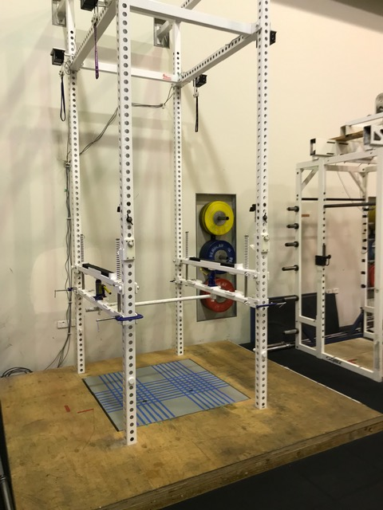 (b)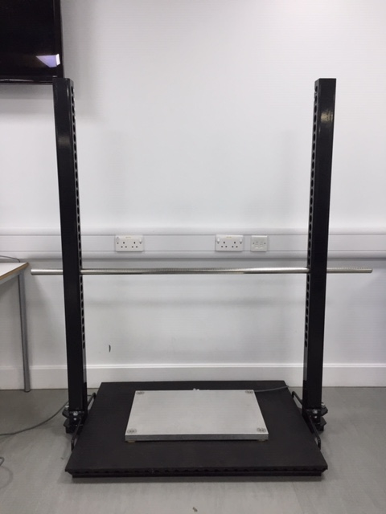
Figure 1. Laboratory fixed isometric rack set up (a) and portable isometric rack set up (b).

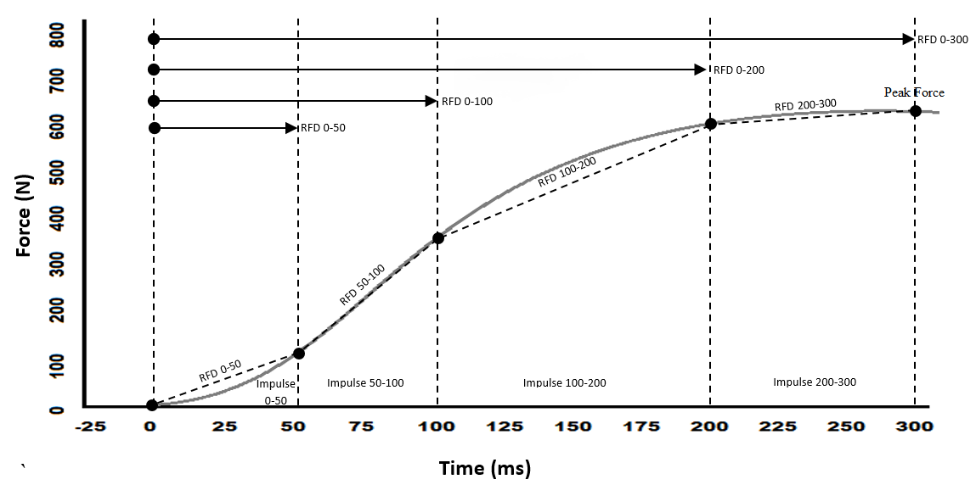
Figure 2. Force Time curve highlighting typical variables of interest.

Figure 3. Isometric Mid-Thigh (IMTP) Pull Set up and force applied by the subject (red arrows) and the corresponding vGRF (green arrows).

Figure 4. Isometric Squat (IS) set up and force applied by the subject (red arrows) and the corresponding vGRF (green arrows)

(a)
2023 N
(b)
1826 N
Figure 5. Example of a raw force time curve displaying a steady baseline (a) and a baseline with a countermovement (b), with force on the x axis and cell number on the y axis. Each trial met a peak force of 1826 and 2023 N, respectively. In this instance both trials fall within the 250 N exclusion range.

Figure 6. Data extrapolation template.

Figure 7. Line graph depicting the points of interest as calculated within the spreadsheet.

