Contrasting yield responses to phosphorus applications on mineral and organic soils from extensively managed grasslands: implications for P management in high ecological status catchments

J.L. González Jiménez^{a*, b}, M.G. Healy^{b}, W. M. Robertsª, K. Dalyª

ª Teagasc, Johnstown Castle, Environment Research Centre, Co Wexford, Rep. of Ireland,
^{b} Civil Engineering, National University of Ireland, Galway, Co. Galway, Rep. of Ireland
*Corresponding author: J. L. Gonzalez Jiménez. E-mail: jose.gonzalez@teagasc.ie

Abstract

Phosphorus (P) loss from grassland production is one of the main causes affecting high status water bodies in Europe. Soils with a high content in organic matter (OM), even if extensively managed, are particularly vulnerable to P losses due to their poor P sorption capacities, and can affect the water quality of high status catchments if the dynamics of applied P in these soils is not well understood. The aim of this study was to assess dry matter yield, herbage P content and P use efficiency in six soils deficient in P and ranging in OM content from 8.7 % to 76.4 % in a pot experiment under increasing P applications using the Mitscherlich equation. Of the six soils investigated, there was a better response in dry matter yield and greater P use efficiency in the soils with greater OM content than the mineral soils. The Mitscherlich model described grass response precisely in organic soils due to the higher plant availability of applied P as a consequence of the poor P sorption capacities of these soils. Despite the higher availability of applied P for plants in organic soils, the P requirements to meet the threshold herbage P content for dietary P supply to ruminants were still very high, which may pose a risk of P loss to the environment if P fertiliser is applied based on recommendations obtained from plant analysis. These results indicate that P fertilisation of organic soils in sensitive catchments poses a potentially high risk of P transfer to water bodies.

Keywords: fertilizer, P uptake, herbage P content, P use efficiency, Mitscherlich, build up.

Introduction
Phosphorus (P) is one of the most important elements for grass and animal health, and is typically applied as fertiliser to replace P exported in products (meat, milk, grass) in either chemical or organic (manure and/or slurry) forms. When applied in excess of crop requirements, it may transfer to the surrounding water bodies via leaching and overland flow, causing eutrophication (Carpenter, 2008).
In the European Union (EU), the Water Framework Directive (WFD; OJEC, 2000) has established targets for all the member states to achieve at least “good” ecological status for all water bodies and maintain “high” ecological status. High status water bodies (HSW) are those reflecting minimally disturbed ecological conditions (called reference conditions; Pardo et al., 2012), and are sensitive even to small anthropogenic activities such as extensively managed grasslands with low P inputs. Additionally, in line with the general intensification of agriculture in Europe (EEA, 2013), many countries have set growth strategies for the agri-food sector in recent years. For example, the Irish Government has enacted Food Harvest 2020 (DAFF, 2010) and Food Wise 2025 (DAFM, 2015). Whilst these strategies promote agricultural expansion in a sustainable manner, it inevitably requires reclamation of marginal land in sensitive catchments, whose suitability for agricultural production may be compromised.
Histosols account for soils with an elevated proportion of partially decomposed organic material derived from plants, and represent about 7 % of the total land area in Europe, with Finland (9.84 M ha), Sweden (9.08 M ha), United Kingdom (4.45 M ha) and the Republic of Ireland (1.27 M ha) among the countries with the largest areas covered by this soil type (Montanarella et al., 2006). In Ireland, approximately 66 % of this area is located in upper parts of mountain ranges (Renou-Wilson et al., 2011). It is in these upland areas where HSW under extensive grassland enterprises are more vulnerable to loss of high ecological status (Roberts et al., 2016; White et al., 2014). Organic soils, comprising mainly histosols and other related organic matter-rich soils such as histic and humic top horizons (Creamer et al., 2014), typically have a high percentage of organic matter (OM) content, low pH and low aluminium (Al) and iron (Fe) content, and are therefore associated with a low P sorption capacity (Daly et al., 2001; Guppy et al., 2005; Kang et al., 2009). Consequently, the commonly applied concept of “build-up and maintenance” for mineral soils (Olson et al., 1987; Voss, 1998), where a soil deficient in P has first to increase its reserves before it becomes plant available, may increase the likelihood of P losses via leaching and/or runoff when applied to organic soils. Whilst some preliminary work suggests that organic soils under P fertilisation show similar herbage production than mineral soils (O’Connor et al., 2001), the relevance of the concept of build-up of soil P under P fertiliser applications in organic soils is poorly understood (Daly et al., 2015, 2001; Roberts et al., 2017).
Historically, crop production is based on the law of the diminishing returns, in which the yield response of a crop to incrementally increasing amounts of an applied nutrient asymptotically declines (Black, 1993). Among the different models used to explain these yield response curves, the Mitscherlich equation is one of the best available due to its inherent nature to represent biological concepts such as the maximum yield attainable and the efficiency of the added nutrient in increasing the yield or the initial fertility of the soil (Black, 1993). Currently, P fertiliser recommendations in Ireland are based on (1) a national P index that classifies mineral soils into deficient, low, optimum and excessive in available P using Morgan’s P extractant as a soil P test and (2) minimum herbage P concentration of 3 g kg⁻¹ that ensures dietary requirements for ruminants. There is a positive relationship between soil Morgan’s P levels and the risk of P loss to waters, so that soils classified as deficient/low in the national P index system are deemed to receive P fertiliser, whereas soils classified as optimum/excessive are considered to receive only maintenance or no P fertiliser additions, respectively (Coulter and Lalor, 2008; Schulte and Herlihy, 2007). However, it has been reported that Morgan’s extractant overestimates P availability in organic soils and therefore is not a suitable indicator of P status in these soil types (Roberts et al., 2017).
The objectives of this study were to (1) examine and quantify grass responses to P fertiliser in soils with contrasting amounts in OM using the Mitscherlich equation, and (2) evaluate these responses with a view to developing appropriate strategies for P applications that optimise biomass and herbage P content and reduce the potential risk to water quality. To achieve these objectives, a pot experiment, in which six soils ranging in OM content received different P fertilisation rates, was conducted. Cumulative dry matter (DM) yield and herbage P concentration data were evaluated to assess the management of P on organic soils.

Materials and methods
Soil Sampling
Soil samples were collected from six sites, representing predominant grassland soils in high status catchments in the Republic of Ireland. The sites selected included two sites at the River Black catchment in Co. Galway, two sites at the River Allow catchment in Co. Cork, and two sites at the River Urrin catchment in Co. Wexford (Roberts et al., 2017). Soils were selected based on their OM content and deemed to be deficient in P as no P fertiliser applications were made in the years before soil collection, with the exception of Galway peaty mineral, which received an average of 32 kg P ha⁻¹ the year before soil collection. At each site, three bulk samples were randomly selected to a depth of 20 cm below the soil surface, air dried and manually sieved through a 1.2 cm mesh. They were then thoroughly mixed to get a homogenised sample. Fresh bulk density was determined at each site at the time of sampling and gravimetric water content (on a wet basis) was calculated to recreate field conditions when packing the soil in the pots.
A subsample from each homogenised soil sample was oven-dried at 40° C for three days, sieved through a 0.2 cm mesh and analysed for physico-chemical characteristics. Soil pH (v/v, 1:2) in water was measured according to van Reeuwijk (2002). The soil OM content was determined using loss-on-ignition at 550° C for 16 hr (Storer, 1984), which is the standard procedure implemented in the accredited labs in which the soil samples were analysed. Particle size was determined by the hydrometer method (Day, 1965). The core method (Wilke, 2005) was used for the determination of both fresh and dry bulk density. Analysis for total carbon and total nitrogen were carried out on a LECO Truspec C-N analyser (LECO Corporation, Michigan, USA). The plant available phosphorus was determined using Morgan’s extractant. Total P was determined using the U.S. EPA method 3052 (USEPA, 1996), in which a 0.5 g sample was suspended in 2 ml of deionized water, followed by a combination of 7.5 ml nitric acid (69 % purity) and 2.5 ml concentrated hydrochloric acid. The mixture was then digested at 180° C in a microwave over a ramping time period of 20 min and held for another 20 min at the same temperature. The digestate was analysed using ICP-OES. The Mehlich-3 soil test was used to determine the concentration of Al, calcium (Ca), Fe and magnesium (Mg) for each soil (Mehlich, 1984).

Pot experiment
Before starting the experiments, soils were rewetted to bring them to the gravimetric water content at the time of sampling and packed in 18.5 L-capacity pots (30 cm upper diameter 30 x cm height) up to 3 to 4 cm below the rim. This large size of the pots maximized the growth potential of the grass, in addition to ensuring that the water status of the containers remained more stable in comparison to smaller pots (Spomer et al., 1997). A 3 cm-deep layer of gravel/coarse sand mix was placed over the drainage holes in the pots. The pots were left outdoors under natural conditions for two weeks to equilibrate before application of the P treatments. Fourteen P fertiliser treatments, with two replications per treatment, in the form of single superphosphate (16 % P content) were applied uniformly to the surface of each soil at rates equivalent to 0, 10, 15, 20, 25, 30, 35, 40, 45, 50, 55, 70, 100 and 145 kg P ha⁻¹. One week prior to the application of superphosphate, all pots received an initial application of N as calcium ammonium nitrate and potassium (K) as potassium chloride, at a rate equivalent to 55 kg ha⁻¹ and 245 kg ha⁻¹, respectively. Maintenance applications of N at the same rate as the initial one were applied after each harvest to ensure no N limitation to ryegrass growth during the experiment. After nutrient applications, all pots were left to incubate for two weeks. Pots were sown with perennial ryegrass (Lolium perenne L.) at a rate equivalent to 28 g m⁻² and maintained in environment-controlled chambers according to a randomized complete block design under conditions similar to those that occur in the growing months in Ireland (Walsh, 2012): (1) photoperiod of 16 hr light (2) day and night temperatures of 14° C and 8° C (± 2° C) (3) relative humidity of 85 ± 10 % during the day and 75 ± 10 % during the night, and (4) photosynthetically active radiation (PAR) of 450 ± 50 µmol m⁻²s⁻¹. Pots were held between 60 to 90 % field capacity by weighting them regularly and watering three times per week using tap water with a maximum dissolved reactive P (DRP) concentration of 0.0025 mg L⁻¹. Aphids were treated with insecticide every time they were detected. The grass was cut manually when it attained a length of 22 to 26 cm above the soil surface. A total of six harvests were taken. The total duration of the experiment, from the planting of ryegrass seeds to the last grass harvest, was eight months.

Herbage yield, herbage P content, P uptake, P balance and P Use Efficiency (PUE)
All grass collected at each harvest was oven-dried at 70 °C for 72 hr and weighed. This combination of temperature and drying time ensured complete drying of the ryegrass blades while minimizing potential losses due to partial combustion of the plant tissues. Cumulative DM yield for each soil type and P fertiliser treatment was calculated by summing the harvests of the six cuts. Total P uptake was calculated by multiplying the cumulative DM yield at each P rate by the average herbage P content. The P balance was calculated as the difference between the total P uptake and the P fertiliser applied. The Phosphorus Use Efficiency (PUE) was estimated using (Johnston et al., 2014):
$PUE=\frac{\left(U_{p}-U_{0}\right)}{F_{p}}$ [1]
where $U_{p}$ is the P uptake (kg ha⁻¹) by ryegrass at a given P rate, $U_{0}$ is the P uptake (kg ha⁻¹) by ryegrass at a zero P rate, and $F_{p}$ is the applied P rate (in kg ha⁻¹).

Mitscherlich model
The Mitscherlich model was used to describe the yield response to applied P. The Mitscherlich equation (Black, 1993) is defined by:
$Y=A[1-e^{-c(x+b)}]$ [2]
where $Y$ is the cumulative dry matter yield (kg DM ha⁻¹), $x$ is the amount of P fertiliser added (kg P ha⁻¹), $b$ is the initial plant available P in the soil determined by the Morgan’s P soil test (kg P ha⁻¹), $A$ is the maximum yield obtained as $x$ increases indefinitely (kg DM ha⁻¹), and $c$ is a proportionality constant related to how quickly $Y$ reaches A.
The coefficient of determination (R²) was computed using:
R² = (sst – sse)/sst [3]
where sst is the total sum of squares (total variation) and sse is the variation not explained by the regression. Optimum rates of P fertiliser values were considered to be at 95 % of the theoretical maximum yields from each response equation. The choice of this proportion is arbitrary, but choosing an optimum P value of 95 % of the maximum yield ensures that the estimates of the maximum theoretical yield are likely to be within a relatively broad 5 % of the standard error of the estimate and near-maximum grass production.

Statistical Analysis
Data sets were tested prior to analysis for normality (Shapiro-Wilk test) and homogeneity (Bartlett’s test) of variance. For each soil type, the total DM yield was subjected to a one-way analysis of variance. Regression analyses were carried out using R statistical software, version 3.4.2 (R Core Team, 2017).

Results and discussion
Soil physico-chemical properties
Table 1 shows the main properties of the soils used in this study. Organic matter content showed a broad spectrum, ranging from 8.7 % (Wexford Mineral) to 76.4 % (Galway Peat). Cork peaty mineral had a strongly acidic pH (4.5), followed by Cork mineral and Galway Peat (5.1 and 5.3, respectively), with soils from Wexford and Galway peaty mineral having the largest values. Cork mineral and Wexford mineral had the highest values in clay content, with approximately 297 and 182 g kg⁻¹, respectively, followed by Wexford peaty mineral with 101 g kg⁻¹. Mehlich-3 extractable Al and Fe ranged from 2.6 to 991.44 mg kg⁻¹ and from 116.99 to 507.39 mg kg⁻¹, respectively, with the highest values of Al for the soils from the Wexford site. Mehlich-3 extractable Al contains crystalline (e.g., gibbsite) and amorphous Al (Kuo, 1996) and does not necessarily imply phytotoxicity as the soluble, plant available Al may only be a small fraction. This is in line with Fay et al. (2007), who reported the highest concentration of Al in the south east of the country. Extractable Ca was lowest for the more acidic soils, and increased at more neutral pH values, except for Galway peat, which had the second highest value (7812 mg kg⁻¹) of the soils examined, and an acidic pH (5.3).

Herbage yield
There was no statistically significant response to P treatments (p > 0.05) for both soils from Cork. In contrast, both soils from Galway and Wexford peaty mineral had a significant total DM response to P fertiliser applications (p < 0.0001). The response of Wexford mineral soil was weaker but still statistically significant (p < 0.04). Cork peaty mineral was moderately acidic (4.5), leading to immobilization and sorption reactions between applied P and Al and Fe oxides. Soil pH has a direct impact on the availability of added P, as adsorption and precipitation reactions with Al and Fe oxides make it plant unavailable (McLaughlin et al., 2011; Oburger et al., 2011). Previous studies showed that P applications can have a limited effect on grass yield in organic soils deficient in P, so that liming should be a priority to increase the yield in these soils (Valkama et al., 2016). The content of clay in Cork mineral soil was approximately 300 g kg⁻¹ which, along with the slightly acidic pH (5.1), implies a significant interaction with freshly applied P. Clay content and extractable Al and Fe have been correlated with P sorption capacity of soils elsewhere (Bolland et al., 2003; Gérard, 2016). According to the concept of build-up and maintenance, added P was rapidly sequestered in Cork mineral and, to a lesser extent, in Wexford mineral soils via sorption and fixation reactions with mineral and clay components into unavailable P forms to fill sorption sites and redress the P deficiency. In this scenario, soil P is largely unavailable for plant uptake until it can reach a threshold or critical point over several fertilization sessions at which time it is soluble and available for uptake. Daly et al. (2015) demonstrated this concept across a range of mineral acid and neutral soils, where the relationship between the ratio of extractable Al:P and plant available, soluble P indicated that P in soils with low amounts of physico-chemically sorbed P relative to amounts of Al (high Al:P) was fixed and insoluble. However, as more P is added to soil and sorbed to mineral components, the Al:P is lowered and P is released as plant available and soluble forms. Under the concept of build-up, mineral soils can sorb P after P fertilizations and make it slowly available in succeeding harvests, when the P in soil solution becomes depleted by plant uptake. The poor response of sites deficient and low in soil P has been observed in previous studies (Herlihy et al., 2004; Valkama et al., 2016).
Galway peat had the strongest yield response to P fertilisations, followed by Galway peaty mineral and Wexford peaty mineral. All these soils had a considerable percentage of OM (Table 1). Organic soils typically have a low P retention due to the little mineral fraction present in the soil (Daly et al., 2001; Guppy et al., 2005). Moreover, humic acids derived from the partial decomposition of the OM are mostly negatively charged, and therefore compete with orthophosphates for sorption sites in mineral particles (McDowell and Condron, 2001). On the other hand, humic acids can form complexes with metals such as Al⁺³ and Fe⁺³ and, in turn, adsorb P, thereby contributing to the sorption capacities of the soils (Gerke, 2010). The determination of organically bound Al/Fe through the sodium pyrophosphate extraction method (van Reeuwijk, 2002) and the development of phosphate saturation indices (PSI) that relate the oxalate-extractable P, Al and Fe (Janardhanan and Daroub, 2010) can be a good way to evaluate the potential of OM to sorb P in organic soils. In the current study, the results indicate that the negative relationship between OM and yield response was the predominant event taking place in the organic soils studied, likely due to the low “labile” or organically bound Al/Fe concentrations. Under this scenario, the build-up concept is then limited by the amount of OM present in the soils, and freshly applied P will remain in the soil solution, supplying P directly to the plant. Considering the particular climatology of Ireland with frequent rainfall events over the year, the presence of P in the soil solution increases the risk of losses via leaching and runoff to water bodies. Therefore, organic soils that have been drained and brought into agricultural production should be fertilised only in the growing period (March-April), when the grass requirements for P are highest, to minimize the risk of P losses due to their inability to sorb and retain applied P in the soil matrix.
Additionally, the national P index, where soils are classified from deficient to excessive in available P based on Morgan’s soil test, should not be applied to organic soils, as it has been suggested that the acidic Morgan’s extractant may overestimate available P in these soils, probably due to the hydrolysis of part of the organic P forms (Roberts et al., 2017). Other soil tests such as water-extractable P have been used in organic soils as a proxy for the plant-available P (Castillo and Wright, 2008) and may be more suitable for describing the P status of these type of soils.

Mitscherlich model
The Mitscherlich response curves for each soil type and the equation parameter values, along with the R² values, are shown in Figure 1 and Table 2, respectively. Values of A (the maximum yield attainable under unlimited P supply) ranged between 7,300 and 11,000 kg DM ha⁻¹. Galway peat and Galway peaty mineral had the highest values of A (11,000 and 10,100 kg DM ha⁻¹, respectively), whereas Wexford mineral soil was the least productive. The greater response in organic soils compared to mineral soils under similar soil P status is in agreement with other studies (Valkama et al., 2016). The reason for this is likely due to diminished P sorption capacity in organic soils, leaving applied P in the soil solution and readily available for plant uptake. There was a large range in values for c (the proportionality constant, i.e., how fast the yield approaches A), which ranged from 0.04 for soils with high R² to 1.1 for the soil with lower R² values. The proportionality constant c has been correlated with the buffering capacity of soils in previous studies (Brennan and Bolland, 2003). The c parameter in Cork Mineral, Wexford mineral and, to a lesser extent, Cork peaty mineral had the highest values, supporting the concept of P build-up in these soils. The main strength of the Mitscherlich model to describe yield response curves lies in its ability to give a good description of the yield when the range of P applications is large and a maximum yield is achieved at high P rates (Colwell et al., 1988). This is the case for the soils from Galway and for Wexford peaty mineral, where the response to P fertiliser was well described along the whole set of P rates (high R²). However, the Mitscherlich model becomes less accurate when an asymptote is not reached at higher P rates. Both soils from Cork and Wexford mineral did not reach maximum yields at maximum or near maximum P rates, so the accuracy of the Mitscherlich model was relatively poor.

Herbage P content
The average herbage P concentration across the fourteen P applications declined in all the sites over the timeline of the pot trial. The second cut at each soil had the highest herbage P concentrations for all the soils, with values above the threshold limit of 3 g kg⁻¹, followed by a steady decline in each subsequent cut and remaining stable around 1.5-2 g kg⁻¹ after the 5th cut for all the soils (data not shown). The decline on herbage P concentration observed in this experiment agrees with other studies (Bailey et al., 1997 and references within), although this pattern is not consistent in the literature (Burkitt et al., 2010). The decline of herbage P throughout the year after one single P application at the start of the grazing period can have negative implications in the health of ruminants if the P requirements are not met for the intermediate to late grazing period (Sheil et al., 2016). Under this scenario, a “little and often” approach, where P fertiliser applications allocated for the whole year are split in two or more smaller rates, would be more suitable to maintain herbage P concentrations within the critical range of 3 to 3.5 g kg⁻¹.
Figure 2 shows the cumulative DM yield plotted against the average P concentration in the herbage. Galway peat and Cork peaty mineral soils reached the threshold herbage P concentration of 3 g kg⁻¹ at near-maximum yield, around the 50 to 55 kg ha⁻¹ P fertiliser application rate, whereas the other soils reached it when the P fertiliser applications were at 100 to 145 kg ha⁻¹. Herbage P concentration continued to increase in Galway peat, Cork peaty mineral and, to a lesser extent, Wexford peaty mineral beyond the critical concentration, although the yield remained the same, thus reflecting a luxurious consumption of P in these soils. Results showed that the P fertiliser requirements to reach a critical P level of 3 g kg⁻¹ were higher than those required to reach 95 % of the maximum yields from the Mitscherlich model. This is also in agreement with previous findings (Morton et al., 1999; Schulte and Herlihy, 2007). As a result, the fertiliser P required to obtain a critical herbage P concentration around 3 g kg⁻¹ would satisfy the P fertiliser requirements to obtain near-to-maximum yields, maximizing grass production. However, these high fertiliser rates can pose an elevated risk of P losses for organic soils due to their poor P retention capacities as it has been shown above, and hence P fertilizer recommendations derived from plant analysis may not seem suitable for these soils.

P uptake, P balance and P Use Efficiency (PUE)
The P uptake, P balance and PUE at each P fertiliser rate and site are shown in Figure 3. Phosphorus uptake increased in all sites as the P fertiliser rates increased. Galway peat had the highest P uptakes at the maximum P fertiliser rates. This increase in P uptake with increased P application rates is in line with the fact that uptake is a function of the DM yield and the herbage P content, which in turn increased with P fertilisations.
The P balance was negative at zero P fertiliser rate for all soils and at 10 kg P ha⁻¹ for Galway peat, Cork mineral, Cork peaty mineral and Wexford mineral, which indicated a depletion of any stable P reserves in the soil. The P balance became positive for the rest of treatments in all soils, indicating an accumulation of P in the soils. The positive P balance obtained in all soils and almost all P treatments reflected that inputs (P fertiliser) exceeded offtakes (P uptake by the grass), so the surplus of P applied to the soil was either retained in the soil or lost via leaching throughout the duration of the experiment, or a combination of both.
The greatest PUE were at low P rates, decreasing in all soils as P rates increased. Galway peat soil had the highest P efficiency, with an average PUE of 54 % across P treatments. Cork mineral and Cork peaty mineral had moderate-to-high PUE at low P rates, but decreased markedly as P application rates raised, attaining an average efficiency of 33 % and 35 %, respectively. Wexford mineral, Wexford peaty mineral and Galway peaty mineral had a low P efficiency over all P application rates, with averages efficiencies of 20 %, 28 % and 25 %, respectively. With the exception of Galway peat, the mean PUE of the other soils were similar to those reported in other studies with ryegrass for low soil P status (Herlihy et al., 2004) and agrees with the tendency for there to be a low PUE in the same year of P application (Johnston et al., 2014). The overall P efficiency of Galway peat, with a high OM content (76 %) was considerably higher than the other soils, indicating that interactions between P fertiliser and the soil mineralogy were minimal and hence applied P was readily available in the soil solution for plant uptake throughout the duration of the experiment.

Conclusions
In this study, grass response to P fertiliser varied between organic and mineral soils with P deficiencies. When grass yield was modelled using the Mitscherlich equation, mineral soils had a weak response to P applications due to the need to first build up their soil P reserves, whereas more organic soils showed a large response to P applications, which indicated no requirement to build up P reserves. This illustrates the potential risk of P losses to waters if P fertilisers are applied to organic soils even when they are deficient in P. Additionally, the high fertiliser P requirements derived from plant analysis to meet the critical herbage P concentration may not be suitable for organic soils if environmental aspects have to be considered. Losses from these soils can be minimized if P is applied during the growing season only, and under a “little and often” approach rather than one single application, as P will be taken up by the plants shortly after its application. However, these implications might not be feasible in reality, as fields with organic soils may be located far from the farmyard and therefore may be fertilised in one single application to reduce costs and time. In this scenario, bringing new organic soils into agricultural production may be less desirable than intensification of existing agricultural land if they are within high status or sensitive catchments.

Acknowledgements
This work was funded by the Irish Department of Agriculture, Forestry and the Marine (project reference 13/S488) as part of the Research Stimulus Fund 2013. The authors would like to thank the landowners for generously providing the soil used in this study. We would also thank the support and assistance of L. Moloney-Finn, C. O’Connor, S. Colfer and C. Somers for their support and advice in the use of Teagasc Johnstown Castle laboratories and facilities. The authors are very grateful to the Editor and the two anonymous Reviewers for their helpful comments and suggestions

References
Bailey, J. S., Beattie, J. A. M., Kilpatrick, D. J. (1997): The diagnosis and recommendation integrated system (DRIS) for diagnosing the nutrient status of grassland swards: I. Model establishment. Plant Soil 197, 127–135.
Black, C. A. (1993): Soil fertility evaluation and control, 1st Editio. ed. Lewis Publishers, Boca Raton, Florida.
Bolland, M. D., Allen, D. G., Barrow, N. J. (2003): Sorption of phosphorus by soils: how it is measured in Western Australia. Dep. Agric. Food, West. Aust. Perth, Bull. 4591.
Brennan, R. F., Bolland, M. D. A. (2003): Soil properties as predictors of yield response of clover (Trifolium subterraneum L.) to added P in soils of varying P sorption capacity. Soil Res. 41, 653–663.
Burkitt, L. L., Donaghy, D. J., Smethurst, P. J. (2010): Low rates of phosphorus fertiliser applied strategically throughout the growing season under rain-fed conditions did not affect dry matter production of perennial ryegrass (Lolium perenne L.). Crop Pasture Sci. 61, 353–362.
Carpenter, S. R. (2008): Phosphorus control is critical to mitigating eutrophication. Proc. Natl. Acad. Sci. U. S. A. 105, 11039–11040.
Castillo, M. S., Wright, A. L. (2008): Soil phosphorus pools for Histosols under sugarcane and pasture in the Everglades, USA. Geoderma 145, 130–135.
Colwell, J. D., Suhet, A. R., van Raij, B. (1988): Statistical procedures for developing general soil fertility models for variable regions. CSIRO, Australia.
Coulter, S., Lalor, L. (2008): Major and Minor Micronutrient Advice for Productive Agricultural Crops. Dublin.
Creamer, R., Simo, I., Reidy, B., Carvalho, J., Fealy, R., Hallet, S., Jones, R., Holden, A., Holden, N., Hannam, J., Massey, P., Mayr, T., McDonalds, E., O’Rourke, S., Sills, P., Truckell, I., Zawadzka, J., Schulte, R. (2014): Irish Soil Information System: Integrated Synthesis Report. Environmental Protection Agency, Johnstown Castle, Wexford, Ireland.
DAFF (2010): Food Harvest 2020. A vision for Irish Agri-Food and Fisheries. Department of Agriculture Fisheries and Food.
DAFM (2015): Food Wise 2025. Department of Agriculture Fisheries and the Marine, Ireland.
Daly, K., Jeffrey, D., Tunney, H. (2001): The effect of soil type on phosphorus sorption capacity and desorption dynamics in Irish grassland soils. Soil Use Manag. 17, 12–20.
Daly, K., Styles, D., Lalor, S., Wall, D. P. (2015): Phosphorus sorption, supply potential and availability in soils with contrasting parent material and soil chemical properties. Eur. J. Soil Sci. 66, 792–801.
Day, P. R. (1965): Particle Fractionation and Particle Size Analysis, in: Black, C. (ed.): Methods of Soil Analysis, Part 1. American Society of Agronomy, Madison, WI, pp. 545–567.
EEA (2013): Land accounts for Europe 1990,200,2006. European Environment Agency, Copenhagen, Denmark.
Fay, D., Kramers, G., Zhang, C., McGrath, D., Grennan, E. (2007): Soil geochemical atlas of Ireland. Teagasc and Environmental Protection Agency.
Gérard, F. (2016): Clay minerals, iron/aluminum oxides, and their contribution to phosphate sorption in soils — A myth revisited. Geoderma 262, 213–226.
Gerke, J. (2010): Humic (Organic Matter)-Al(Fe)-Phosphate Complexes. Soil Sci. 175, 417–425.
Guppy, C. N., Menzies, N. W., Moody, P. W., Blamey, F. P. C. (2005): Competitive sorption reactions between phosphorus and organic matter in soil: A review. Aust. J. Soil Res. 43, 189–202.
Herlihy, M., McCarthy, J., Breen, J., Moles, R. (2004): Effects over Time of Fertiliser P and Soil Series on P Balance, Soil-Test P and Herbage Production. Irish J. Agric. Food Res. 43, 147–160.
Janardhanan, L., Daroub, S. H. (2010): Phosphorus Sorption in Organic Soils in South Florida. Soil Sci. Soc. Am. J. 74, 1597.
Johnston, a. E., Poulton, P. R., Fixen, P. E., Curtin, D. (2014): Phosphorus. Its Efficient Use in Agriculture., in: Spark, D. (ed.): Advances in Agronomy. Elsevier Academic Press Inc., 525 B Street, suite 1900, San Diego, CA 92101-4495 USA, pp. 177–228.
Kang, J., Hesterberg, D., Osmond, D. L. (2009): Soil Organic Matter Effects on Phosphorus Sorption: A Path Analysis. Soil Sci. Soc. Am. J. 73, 360.
Kuo, S. (1996): Phosphorus, in: Methods of Soil Analysis Part 3—Chemical Methods. Soil Science Society of America, American Society of Agronomy, Madison, WI, pp. 869–919.
McDowell, R., Condron, L. (2001): Influence of soil constituents on soil phosphorus sorption and desorption. Commun. Soil Sci. Plant Anal. 32, 2531–2547.
McLaughlin, M., McBeath, T., Smernik, R., Stacey, S., Ajiboye, B., Guppy, C. (2011): The chemical nature of P-accumulation in agricultural soils - implications for fertiliser management and design: an Australian perspective. Plant Soil 349, 69–87.
Mehlich, A. (1984): Mehlich 3 Soil Test Extractant: A Modification of Mehlich 2 Extractant. Commun. Soil Sci. Plant Anal. 15, 1409–1416.
Montanarella, L., Jones, R. J. A., Hiederer, R. (2006): The distribution of peatland in Europe. Mires Peat 1.
Morton, J. D., Smith, L. C., Metherell, A. K. (1999): Pasture yield responses to phosphorus, sulphur, and potassium applications on North Otago soils, New Zealand. New Zeal. J. Agric. Res. 42, 133–146.
O’Connor, M. B., Longhurst, R. D., Johnston, T. J. M., Portegys, F. N. (2001): Fertiliser requirements for peat soils in the Waikato region. Proc. New Zeal. Grassl. Assoc. 47–51.
Oburger, E., Jones, D. L., Wenzel, W. W. (2011): Phosphorus saturation and pH differentially regulate the efficiency of organic acid anion-mediated P solubilization mechanisms in soil. Plant Soil 341, 363–382.
OJEC (2000): Council directive 2000/60/EEC of 23 October 2000 of the European Parliament and of the council: establishing a framework for community action in the field of water policy. Off. J. Eur. Communities.
Olson, R. A., Anderson, F. N., Frank, K. D., Grabouski, P. H., Rehm, G. W., Shapiro, C. A. (1987): Soil testing interpretations: Sufficiency vs. build-up and maintenance., in: Brown, J. R. (ed.): Soil Testing, Sampling, Correlation, Calibration, and Interpretation. Soil Science Society of America, Madison, WI, pp. 41–52.
Pardo, I., Gómez-Rodríguez, C., Wasson, J.-G., Owen, R., van de Bund, W., Kelly, M., Bennett, C., Birk, S., Buffagni, A., Erba, S., Mengin, N., Murray-Bligh, J., Ofenböeck, G. (2012): The European reference condition concept: A scientific and technical approach to identify minimally-impacted river ecosystems. Sci. Total Environ. 420, 33–42.
R Core Team (2017): R: A language and environment for statistical computing.
Renou-Wilson, F., Bolger, T., Bullock, C., Convery, F., Curry, J., Ward, S., Wilson, D., Müller, C. (2011): BOGLAND - Sustainable Management of Peatlands in Ireland. Environmental Protection Agency, Johnstown Castle, Wexford, Ireland.
Roberts, W. M., Fealy, R. M., Doody, D. G., Jordan, P., Daly, K. (2016): Estimating the effects of land use at different scales on high ecological status in Irish rivers. Sci. Total Environ. 572, 618–625.
Roberts, W. M., Gonzalez-Jimenez, J. L., Doody, D. G., Jordan, P., Daly, K., Gan, J. (2017): Assessing the risk of phosphorus transfer to high ecological status rivers: Integration of nutrient management with soil geochemical and hydrological conditions. Sci. Total Environ. 589, 25–35.
Schulte, R. P. O., Herlihy, M. (2007): Quantifying responses to phosphorus in Irish grasslands: Interactions of soil and fertiliser with yield and P concentration. Eur. J. Agron. 26, 144–153.
Sheil, T. S., Wall, D. P., Culleton, N., Murphy, J., Grant, J., Lalor, S. T. J. (2016): Long-term effects of phosphorus fertilizer on soil test phosphorus, phosphorus uptake and yield of perennial ryegrass. J. Agric. Sci. 154, 1068–1081.
Spomer, L., Berry, W., Tibbitts, T. (1997): Plant culture in solid media, in: Langhans, R. W., Tibbitts, T. W. (eds.): Plant Growth Chamber Handbook. Iowa State University of Science and Technology, pp. 105–118.
Storer, D. A. (1984): A simple high sample volume ashing procedure for determination of soil organic matter. Commun. Soil Sci. Plant Anal. 15, 759–772.
USEPA (1996): Microwave Assisted acid digestion of siliceous and organically based matrices (Method 3052), EPA Publication.
Valkama, E., Virkajärvi, P., Uusitalo, R., Ylivainio, K., Turtola, E. (2016): Meta-analysis of grass ley response to phosphorus fertilization in Finland. Grass Forage Sci. 71, 36–53.
van Reeuwijk, L. (2002): Procedures for soil analysis. Tech. Pap. 09. International Soil Reference and Information Centre, FAO, Wageningen.
Voss, R. (1998): Fertility recommendations: past and present. Commun. Soil Sci. Plant Anal. 29, 1429–1440.
Walsh, S. (2012): A Summary of Climate Averages for Ireland 1981-2010. Met Eireann, Dublin.
White, B., Moorkens, E., Irvine, K., Glasgow, G., Ní Chuanigh, E. (2014): Management strategies for the protection of high status water bodies under the Water Framework Directive. Biol. Environ. Proc. R. Irish Acad. 114B, 129–142.
Wilke, B.-M. (2005): Determination of Chemical and Physical Soil Properties, in: Monitoring and Assessing Soil Bioremediation SE - 2. Springer Berlin Heidelberg, pp. 47–95.

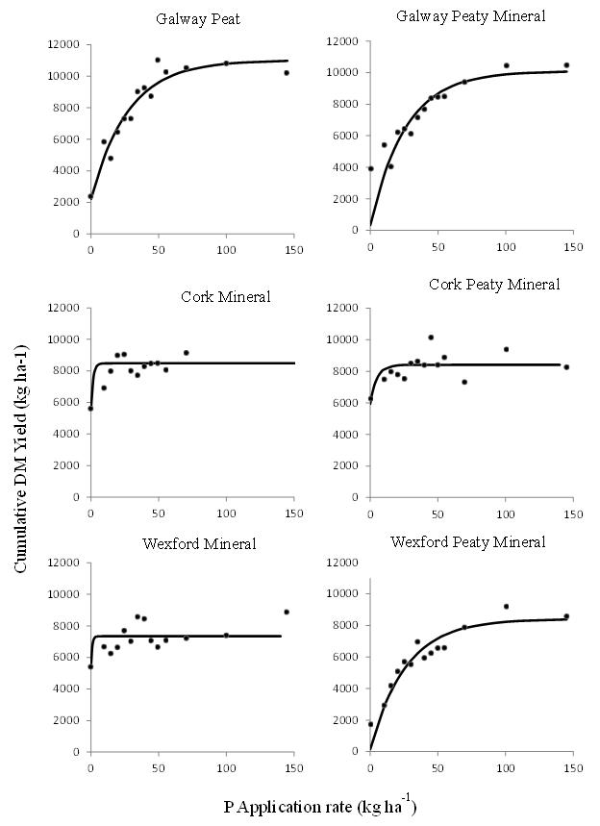
Figure 1. Cumulative DM yield response to increasing P fertiliser rates for each soil. Dots represent average observed values and lines the fit regression curves from the Mitscherlich equation.
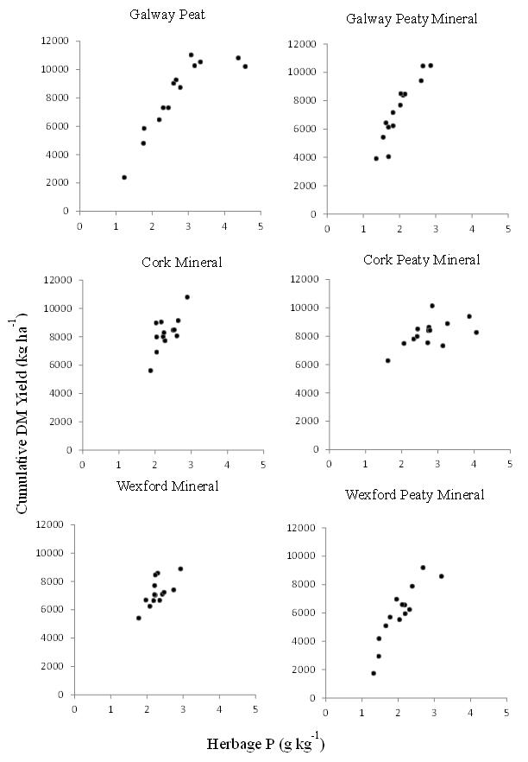
Figure 2. Cumulative grass DM yield versus herbage P content for each soil.
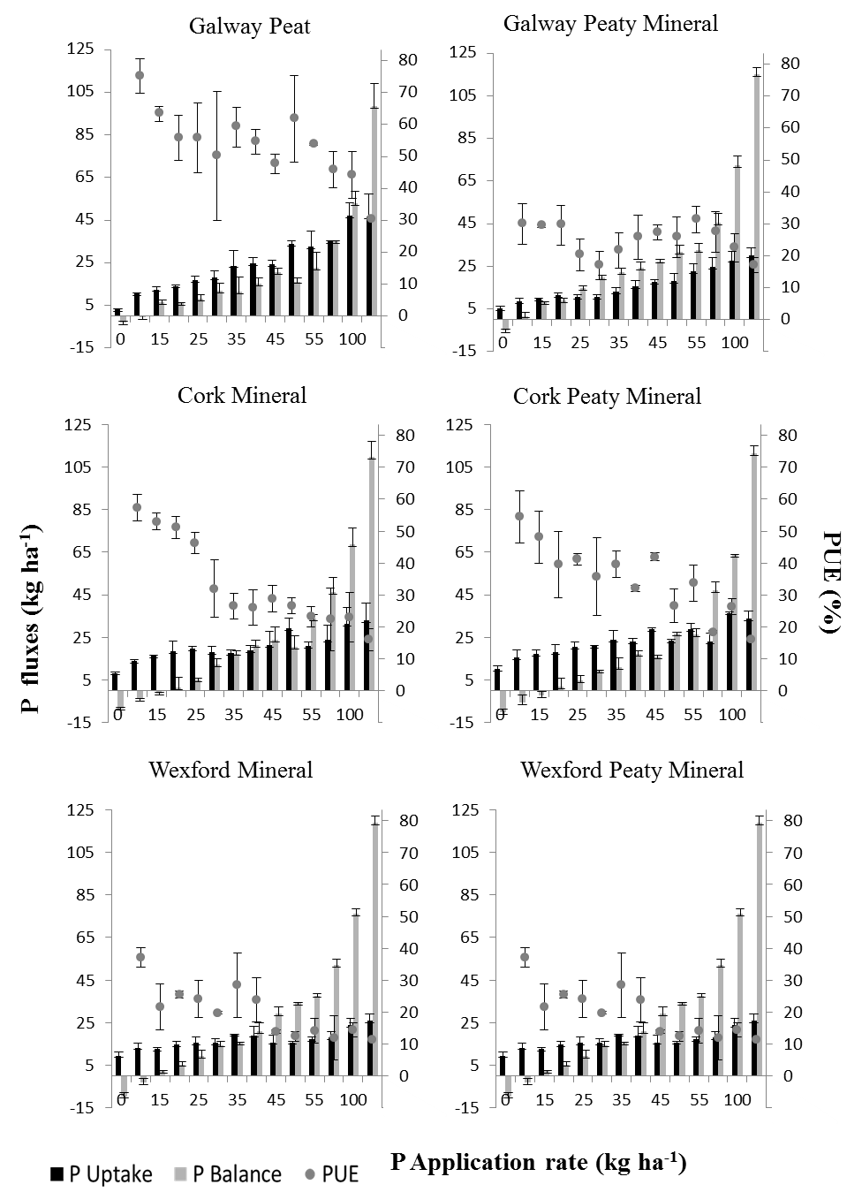
Figure 3. Phosphorus (P) uptake and P balance (kg ha⁻¹) and P use efficiency (PUE) (%) for each P fertiliser rate and soil site. Error bars represent standard deviations.

Table 1. Soils classification and main parameters of the soils used in the study.

Site | Soil Classification¹ | pH | OM² | Particle Size |  |  | Texture³ | Fresh bulk density | Dry bulk density | Total C | Total N | Morgan's P | Total P | Mehlich-3
 |  |  |  | Sand | Silt | Clay |  |  |  |  |  |  |  | Al | Ca | Fe | Mg
 |  |  | % | % |  |  |  | (g cm⁻³) |  | % |  | (mg l⁻¹) |  | (mg kg⁻¹)
Galway Peat | Drained Ombrotrophic Peat | 5.3 | 76.4 | 73.7 | 8.6 | 17.7 | Sandy Loam | 0.9 | 0.2 | 40.3 | 1.6 | 6.2 | 96.3 | 2.63 | 7812.6 | 222.1 | 422.3
Galway Peaty Mineral | Humic Surface-water Gley | 6.6 | 35.8 | 56.0 | 28.7 | 15.2 | Sandy Loam | 1.3 | 0.6 | 17.0 | 1.4 | 0.9 | 609.6 | 61.5 | 8216.0 | 238.5 | 109.8
Cork Mineral | Typical Surface-Water Gley | 5.1 | 9.1 | 29.3 | 38.0 | 32.7 | Clay Loam | 1.2 | 0.6 | 4.2 | 0.3 | 1.7 | 145.2 | 884.9 | 656.1 | 262.4 | 137.6
Cork Peaty Mineral | Humic Surface-water Gley | 4.5 | 66.8 | 61.0 | 17.6 | 21.4 | Sandy Clay Loam | 0.9 | 0.2 | 34.7 | 2.2 | 5.9 | 182.7 | 605.0 | 2114.0 | 507.4 | 193.6
Wexford Mineral | Typical Brown Earth | 6.0 | 8.7 | 40.1 | 40.0 | 19.9 | Loam | 1.5 | 1.2 | 3.1 | 0.3 | 1.2 | 1065.2 | 947.0 | 1103.1 | 117.0 | 199.8
Wexford Peaty Mineral | Typical Brown Podzolic | 6.2 | 14.1 | 66.6 | 21.6 | 11.8 | Sandy Loam | 1.0 | 0.7 | 7.0 | 0.4 | 0.5 | 290.0 | 991.4 | 2405.6 | 256.4 | 517.0
¹ World Reference Base 2014 ² Organic Matter ³ U.S Soil Taxonomy
Table 2. Parameters of the fit Mitscherlich equation for each soil site. Parameter A is in kg DM ha⁻¹. Standard errors in brackets.
Site | Max yield attainable under unlimited P-supply, A | Optimum P rate | Proportionality constant,  c | R²
 | kg ha⁻¹
Galway Peat | 11020 (476) | 82 | 0.04 (4.3 x 10⁻³) | 0.93
Galway Peaty Mineral | 10100 (831) | 78 | 0.04 (8.5 x 10⁻³) | 0.67
Cork Mineral | 8482 (277) | 5 | 0.64 (2.0 x 10⁻¹) | 0.43
Cork Peaty Mineral | 8415 (223) | 14 | 0.21 (5.3 x 10⁻²) | 0.39
Wexford Mineral | 7348 (227) | 3 | 1.10 (3.6 x 10⁻¹) | 0.31
Wexford Peaty Mineral | 8415 (499) | 79 | 0.04 (6.0 x 10⁻³) | 0.88

Present affiliation: Department of Business School, University of Chichester, Chichester, United Kingdom.

