Running Head: INTEGRATION OF INFORMATION IN ANTICIPATION

The temporal integration of information during anticipation

Oliver R. Runswick (o.runswick@chi.ac.uk)¹ ²
André Roca¹
A. Mark Williams¹ ³
Allistair P. McRobert ⁴
Jamie S. North¹

¹ Expert Performance and Skill Acquisition Research Group, School of Sport, Health and Applied Science, St Mary’s University, Twickenham, London, UK

² Department of Sport and Exercise Science, University of Chichester, Chichester UK
³ Department of Health, Kinesiology and Recreation, College of Health, University of Utah, Salt Lake City, USA

⁴ Research Institute for Sport and Exercise Sciences, Liverpool John Moores University, UK

Accepted for Publication in Psychology of Sport and Exercise on 02/05/2018
DOI: https://doi.org/10.1016/j.psychsport.2018.05.001

Corresponding author:
Oliver Runswick
Department of Sport and Exercise Sciences
University of Chichester
College Lane
Chichester
West Sussex
PO19 6PE
Email: o.runswick@chi.ac.uk
Abstract
Objectives When performing actions under severe time pressure, the ability to anticipate is vital to performance. Skilled anticipation is underpinned by the use of both kinematic cues and contextual information, yet there have been few published reports examining how, and when, these two sources interact during anticipation.
Design This study employed a mixed experimental design. The between participants factor was skill level (skilled vs less-skilled) and the repeated measures factor was occlusion point (pre-run, mid-run, pre-release, post-release).
Method Altogether, 18 skilled and 18 less-skilled cricket batters anticipated deliveries from bowlers in a video-based simulation task where the footage was occluded at four-time points relative to ball release. Participants rated the importance of different sources of information when making their judgements at each occlusion point.
Results Skilled batters anticipated the deliveries significantly more accurately than the less-skilled group at all occlusion points (p < 0.05). The skilled group judged the use of both contextual information and visual information to be more important when anticipating compared to the less-skilled group. Kinematic cues were only considered important to anticipation in the final moments of the bowling sequence (i.e., immediately prior to ball release), whereas contextual information was used throughout the action, albeit mostly by the skilled group.
Conclusions Findings enhance our understanding of the processes underpinning anticipation and present implications for the design of training programmes to improve anticipation.

Key Words: perceptual-cognitive expertise; context; cricket; postural cues.

The temporal integration of information during anticipation
In domains that involve making decisions and executing actions under severe time constraints, the ability to accurately anticipate future events is vital for performance. In emergency medicine (McRobert et al., 2013), military combat (Williams, Ericsson, Ward, & Eccles, 2008) and sport (Loffing & Cañal-Bruland, 2017; Williams, Ford, Eccles, & Ford, 2011), experts have been shown to be more efficient at extracting relevant information from the environment and integrating this information with pre-existing knowledge to develop probabilistic judgements regarding future events. Two broad categories of information have been identified as being crucial during anticipation. First, skilled performers have been shown to pick up visual sources of information such as kinematic cues from the postural orientation of opponents before an action (Abernethy & Zawi, 2007). Second, skilled performers use contextual information, such as the score of the game, to build probabilities and facilitate anticipation (Loffing & Cañal-Bruland, 2017). In this paper, we use a novel approach to investigate how, and when, visual and contextual sources of information interact dynamically in the time period leading up to a key event.
To date, most researchers have focused on identifying what kinematic sources of information are used during skilled anticipation and when these information sources are most informative (e.g., Abernethy & Zawi, 2007; Müller, Abernethy, & Farrow, 2006; Savelsbergh, Williams, Van der Kamp, & Ward, 2002; Williams & Davids, 1998). An extensive body of research exists that has identified how performers pick up visual information from an opponent’s actions, what part of the opponent’s body this is picked up from, and when this information becomes available to the observer (see Mann, Williams, Ward, & Janelle, 2007). Savelsbergh et al. (2002) showed that expert goalkeepers in soccer were better able to predict penalty kick direction at earlier occlusion points than less-skilled goalkeepers. Moreover, they recorded gaze behaviour to show that experts spent longer periods of time focusing on the kicking leg, non-kicking leg, and the ball, particularly as the moment of foot-ball contact approached. Although the majority of researchers have sought to identify the most critical kinematic or postural cues that underpin anticipation, it is apparent that contextual information plays a crucial role (Cañal-Bruland & Mann, 2015; Loffing & Cañal-Bruland, 2017; Müller & Abernethy, 2012; Roca & Williams, 2016).
The term context has been used to describe a large variety of information sources that may be employed by skilled performers to underpin anticipation. Runswick, Roca, Williams, Bezodis, and North (2017) differentiated between situation-specific and nonsituation-specific contextual information. First, situation-specific context refers to sources of information that are changeable and unique to each event, such as the time left in a game and the score line. In contrast, nonsituation-specific context refers to more stable sources of information such as past team performances or the action capabilities of an opponent (e.g., Cañal-Bruland, Filius, & Oudejans, 2014; Loffing, Stern, & Hagemann, 2015). In this paper, we focus on situation-specific context, which comprises several different sources of information. For example, knowledge of game score (Farrow & Reid, 2012), the sequence in which information is displayed (McRobert, Ward, Eccles, & Williams, 2011), information concerning opponent positioning (Loffing & Hagemann, 2014), and the position of opposing players and teammates (Paull & Glencross, 1997) have all been shown to enhance anticipation. Yet, there remains a paucity of research investigating the role that context plays in anticipation and how and when it may interact with the emergence of visual information.
In their two-stage model, Müller and Abernethy (2012) propose that, when executing an interceptive action, performers are likely to use a combination of contextual and kinematic information to guide early movements, such as foot position. Information from ball flight is then used to fine-tune a movement response (such as manipulating the bat face). However, the authors acknowledge the paucity of research investigating contextual sources of information and the lack of knowledge relating to when in the process context is used and how it interacts with the kinematic information available prior to ball-flight. Cañal-Bruland and Mann (2015) identified three key areas for future research in an effort to develop a clearer picture of the processes underpinning skilled anticipation: (i) identifying sources of contextual information; (ii) investigating how these sources are integrated; and (iii) developing a picture of how different circumstances shape the use of contextual information. Murphy et al. (2016) addressed the call to highlight the importance of context in anticipation by using a novel approach in which tennis rallies were animated and, therefore, postural information was removed entirely from the display. Skilled performers made more accurate anticipation judgements compared to novices despite the complete absence of postural cues, suggesting that the skilled participants were able to use contextual information to inform their anticipation judgments. While Murphy et al. (2016) provide evidence for the importance of contextual information, researchers have seldom evaluated the importance of contextual information in conjunction with postural cues or identified the key time periods during which each source of information may be used. Published research may be presenting a somewhat incomplete picture of the perceptual and cognitive processes underpinning anticipation, and particularly when different sources of information are used and how they interact.
In one recent exception, Runswick et al. (2018) collected verbal reports in a cricket anticipation task that focused on the first stage of Müller and Abernethy’s (2012) model and manipulated multiple sources of contextual information (e.g., game score, field placings, time of match). These authors reported more accurate anticipation when context was present, while verbal reports suggested that skilled performers used current and previously available contextual sources of information in a more equitable manner than less-skilled performers. These results suggest that the addition of context underpinned anticipation in skilled performers. However, in the study by Runswick et al. (2018) all stimuli were occluded at the same time point (i.e., immediately prior to ball release), such that the issue of when in the action different sources of information are used and how they dynamically interact with one another as their relative importance varies over time were not examined. We address these limitations in the current paper by examining how multiple sources of information (both visual and contextual) contribute to anticipation across different time points.
Previously, researchers have identified that when anticipating, experts report greater use of higher-order cognitive processes compared to their less-skilled counterparts; the latter relying more so on bottom-up processing (McRobert et al., 2011; Murphy et al., 2016). Runswick et al. (2018) extended this work by identifying a link between higher-order statements and the use of contextual information. Verbal reports were categorised based on the higher-order planning, prediction, and evaluation statements, and stimulus-driven monitoring statements (cf., McRobert et al., 2011; Murphy et al., 2016; North, Ward, Ericsson & Williams, 2011). However, in a refinement to previous approaches, the verbal reports were categorised in terms of the use of contextual and visual information sources. It was reported that the processing of kinematic cues was linked to monitoring statements that were typically articulated by less-skilled performers, while the high-order statements used more by skilled performers were linked to the use of contextual information. Skilled performers were more likely to make judgements through the use of contextual information providing them with a crucial advantage in the anticipation process. Less-skilled counterparts are more reliant on kinematic information meaning judgements. The use of contextual information that is available early could inform earlier anticipatory judgement. However, it remains unclear exactly when in the process these information sources are used and how they interact during anticipation.
In the current paper, we use a video-based cricket anticipation task to manipulate the time points at which visual and contextual sources of information were presented. We build on the work of Abernethy (1990), who asked participants to rate the importance of different visual sources of information during anticipation, by also including categories of contextual information available before the action begins. We predicted, based on previous research (e.g., Loffing & Hagemann, 2014; Müller & Abernethy, 2012; Murphy et al., 2016), that skilled players would anticipate more accurately than the less-skilled group across occlusion conditions. Furthermore, based on previous research involving verbal reports (McRobert et al., 2011; Murphy et al., 2016), we predicted that skilled performers would rate contextual information as being more useful than less-skilled performers. Moreover, we predicted that skilled performers would use visual information from kinematic cues that become available later in the process to update situational probabilities already formed using sources of context. In contrast, given previously published verbal report data which suggest less-skilled performers do not utilise contextual sources of information (McRobert et al., 2011; Murphy et al., 2016), we predicted that these participants would rate contextual information sources as being less important across all occlusion conditions and would solely rely on visual information that emerges in the later occlusion conditions. Finally, we predicted that, as more sources of information emerge (i.e., as the sequence evolves over time) that anticipation accuracy will improve, with the highest accuracy being observed when early ball flight information is present (Müller & Abernethy, 2012).

Method
Participants
Altogether, 18 skilled cricket batsmen (M age = 24.9 ± 7.7 years) who played at least at club level in the UK (M experience = 15.2 ± 7.9 years) and 18 less-skilled participants (M age = 27.9 ± 9.6 years) with no experience of playing competitive cricket volunteered to participate. A total of 8 of the skilled players had experience at national representative level (minor county or above). The less-skilled group all resided in a cricket-playing nation and therefore could have experienced some exposure to non-competitive cricket in a physical education or street-sport context. As a result, this group was labelled as less-killed rather than novice. We conducted an a-priori power analysis using G*power (Faul, Erdfelder, Lang, & Buchner, 2007). The calculation was based on main effect sizes for anticipation accuracy for group and context from McRobert et al. (2011) who used the same task and group classifications across two context conditions. The within-factor effect size was lower than the between factor effect size was used (η_{p}² = 0.49). We set a moderate correlation (r = 0.3) and power at 0.8. The total sample size required was n = 6. The research was conducted in accordance with the ethical guidelines of the lead institution and written informed consent was obtained from all participants at the outset.
Stimuli
We used the same stimuli as employed by McRobert, Williams, Ward, and Eccles (2009). Ten (M age = 19.5 ± 2.5 years) county-level cricket bowlers (six fast; four spin) were recruited to create the video-based test stimuli. A camera was positioned on the batting crease at a height of 1.7 m and in line with middle stump so that it represented a typical viewing perspective while batting. The different bowlers were recorded delivering a full over (six deliveries) as they would in a game situation, yielding 60 unique deliveries. One of these original deliveries was selected from each bowler based on the ability to build a realistic congruent field setting and game situation to match the ball location. A panel of three independent and qualified cricket coaches viewed the full non-occluded footage and agreed upon a game situation and field that would be tactically appropriate for the location of each delivery, aiming to maintain congruence between visual and contextual information and avoid context becoming deceptive. The selected delivery from each bowler was occluded at four-time points to create 40 trials, ten unique deliveries repeated across four occlusion conditions. These included: (i) pre-run, participants were only exposed to contextual information (the game situation and field setting) and received no kinematic information (the bowler was not shown); (ii) mid-run, the trial was occluded mid run-up, this point was defined as the frame midway between the bowlers run-up initiation and ball release, chosen in order to investigate a time point directly between pre-run and pre-release; (iii) pre-release, the trial was occluded immediately prior to ball release to allow participants to see all relevant kinematic cues prior to ball flight (Runswick et al., 2018); (iv) post-release, the clip was occluded after 80ms of ball flight to investigate the use of early ball flight information (McRobert et al., 2009; 2011). Participants were unaware that they were seeing repeated deliveries and trials from a single bowler were shown in blocks to allow for sequencing effects and to be more realistic to a game (Broadbent et al., 2017; McRobert et al., 2011). The order in which occlusion conditions were shown was counterbalanced to negate order effects. For every trial, participants received information on the game score, which included the number of overs bowled, runs scored, and wickets taken prior to seeing the delivery (as looking at a scoreboard). Participants were informed that the format was a one-day international (50 over) match and all field settings were designed for deliveries bowled to right-handed batters. The field settings were displayed on a schematic representation prior to seeing the bowler (see Runswick et al., 2017; Figure 1).

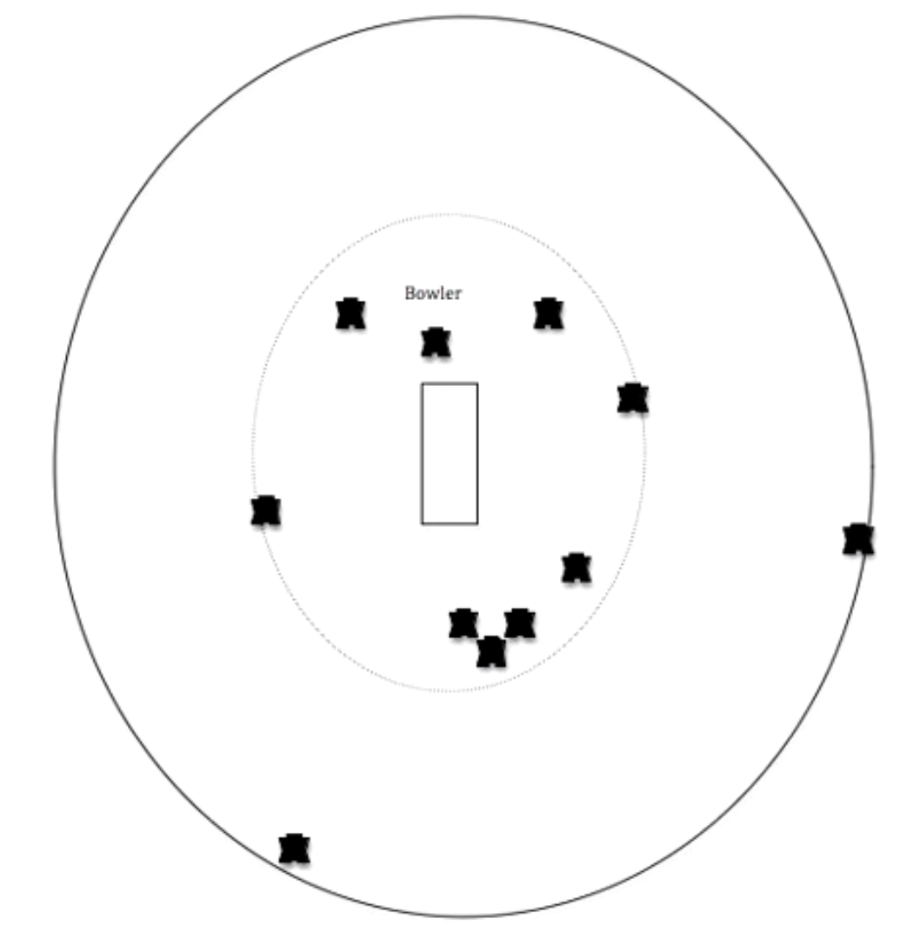
Figure 1. Example schematic showing location of opposition players (dotted line represents the 30 yard circle used for the fielding restrictions in One-Day International matches).

Dependent Measures
Anticipation Accuracy. Participants marked the predicted location the ball would have passed the stumps on diagrams scaled down to eight × smaller than game size to fit a single A4 sheet. The radial error from correct ball location was measured and scaled back up to quantify anticipation accuracy at game scale (i.e., how far the bat would have been from the ball; see McRobert et al., 2011).
Information Scores. Participants rated the usefulness of five different sources of information during anticipation on a Likert-scale from zero to ten, where zero indicated the information was not present or had no use at all, and ten indicated the source of information was extremely useful during anticipation. Sources were not ranked, and multiple sources could receive the same score with a maximum total information score of 50 across all five information sources. This approach has been used previously in the literature. Abernethy (1990) asked participants to rate the importance of seven specific visual cue sources; the player's head, racket, lower body, trunk, playing side arm, other arm, and court position. In our approach, categories were adapted to include sources of contextual information and were linked to sources of information previously identified in the literature as contributing to anticipation and identified in a previous study using verbal reports in a cricket batting task (Runswick et al., 2018). The possible information sources included: (i) bowler’s body, visual information gained from cues from the bowler’s body or run up (Müller et al., 2006); (ii) sequencing, information gained from events of previous deliveries or actions (McRobert et al., 2011); (iii) game situation, information gained from the score or time left in the game (Farrow & Reid, 2012; Paull & Glencross, 1997); (iv) field positioning, information gained from the position of the opposition fielders (Loffing & Hagemann, 2014; Paull & Glencross, 1997); and (v) ball flight, visual information gained from the flight of the ball (Abernethy, 1990; Müller et al., 2009). To compare the use of contextual information and visual information directly, the five sources were placed in categories of contextual and visual sources. The contextual information referred to sources of information gained prior to the initiation of the delivery. Visual sources referred to novel visual information emerging during the process of a delivery. The means were taken from sequence, game situation and field setting scores to create a context score, and from bowler’s body and ball flight scores to create a visual information score.
Procedure
Participants were initially instructed how to use response sheets for both ball location predictions and information source scores. For each trial, when the screen occluded, participants were asked to mark the predicted point the ball would have passed the stumps on a scaled diagram. Previously, researchers (e.g., McRobert et al., 2011) have shown the importance of sequencing effects (seeing multiple deliveries from the same bowler consecutively) for gaining information to aid anticipation. To allow for this information to be used, multiple deliveries from the same bowler were shown consecutively as would be experienced in a game and information score ratings were taken on the third and fourth trial from each bowler. By counterbalancing the order in which clips were shown, five sets of information scores were available for each occlusion condition per participant, a total of 20 scores from the 40 trials.
Data Analysis
In order to ensure participants were using the contextual information presented to them without relying on consistent predictions (i.e., top of off stump), the coordinates of skilled responses were recorded from three of the ten pre-run trials in which the bowler was not shown. This procedure allowed us to quantify the direction of change between predictions related to the presentation of context. Trials with different outcomes were selected for this analysis: full length and close to off stump; good length and wide outside off stump; and a short length delivery over leg stump. Pearson’s correlation coefficients were used to analyse relationships between the change in coordinates of the correct response (which context was designed to lead to) and the change in skilled predictions. To examine anticipation accuracy, a two-way mixed design ANOVA was used to analyse between-participant effects (skilled and less-skilled groups) and occlusion condition within-participant effects (pre-run, mid-run, pre-release, and post-release occlusion conditions). To examine the information scores, a separate three-way mixed design ANOVA was used to analyse the effects of group (skilled and less-skilled), occlusion condition (pre-run, mid-run, pre-release, and post-release), and source of information (bowler’s body, sequencing, game situation, field setting, ball flight). To further examine the information scores, the sources of information were grouped in to visual information and contextual information and a three-way mixed design ANOVA was used to analyse the effects of group (skilled and less-skilled), occlusion condition (pre-run, mid-run, pre-release, and post-release), and source of information (visual, contextual). The alpha level (p) for statistical significance was set at 0.05. A Bonferroni adjustment was employed when multiple comparisons were being made in order to lower the significance threshold and avoid Type I errors (McLaughlin & Sainani, 2014). The corrected alpha level was p = .009 for occlusion condition post hoc comparisons and the corrected alpha level was p = .005 for information source post hoc comparisons. Corrected p values are displayed for post hoc analyses. Violations of sphericity were corrected for by adjusting the degrees of freedom using the Greenhouse Geisser correction when epsilon was less than 0.75 and the Huynh-Feldt correction when greater than 0.75 (Girden, 1992). Partial eta squared (η_{p}²) was used as a measure of effect size for all analyses.

Results
Context Check
The change in prediction locations that were displayed in pre-run trials where only context was presented are shown in Figure 2. Changes in correct outcome coordinates and predicted outcome coordinates for both vertical (r = .99, p = .04) and horizontal coordinates (r = .99, p = .02) displayed significant correlations, confirming that the context presented was being used to influence responses.

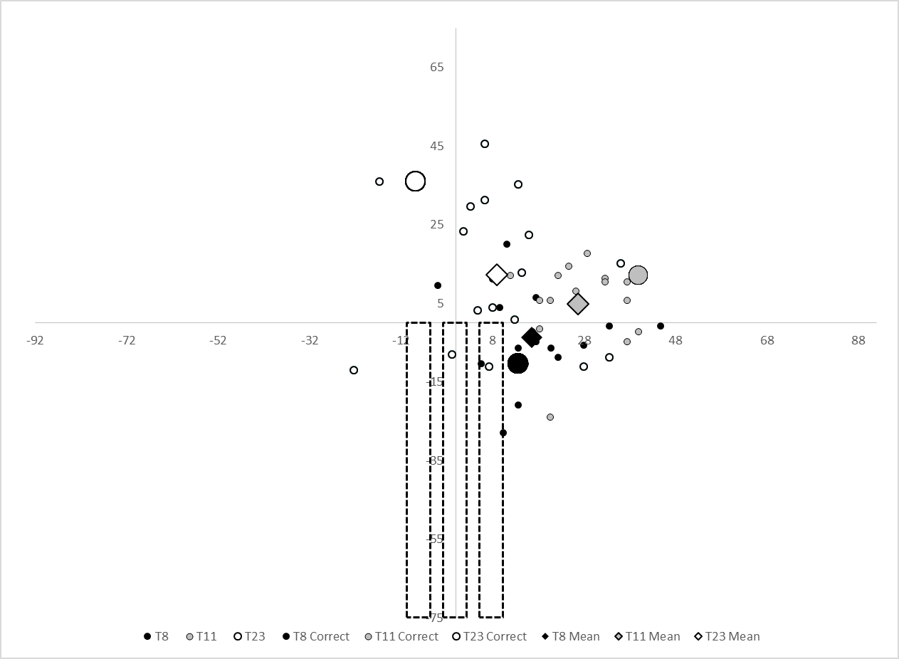
Figure 2. A scale set of cricket stumps with the top of middle representing (0, 0) and axis scales showing distance scaled up to game size (cm). Coordinates of skilled responses to three pre-run trials (T8, T11 & T23) that only showed context are represented with small circles, correct response with a large circle, and the mean response of skilled participants with a large diamond.

Anticipation Accuracy
Main Effects. The anticipation accuracy scores for skilled and less-skilled groups across occlusion conditions are presented in Figure 3. The two-way mixed design ANOVA showed that the skilled group (M _{radial error} ± SD; 26.9 ± 4.1 cm) were more accurate at anticipating ball location than the less-skilled group (37.8 ± 7.9 cm; F_{3, 32} = 26.84, p < .01, η_{p}² = .44). There was a significant effect of occlusion condition on the anticipation accuracy of both groups (F_{3, 32} = 10.14, p < .01, η_{p}² = .23). There was no interaction between skill level and occlusion condition (F_{3, 32} = 0.59, p = .59, η_{p}² = .02).
Post Hoc Analysis. The skilled (pre-run 27.6 ± 4.7 cm, post-release 23.7 ± 4.2 cm) and less-skilled groups (pre-run 38.4 ± 8.7 cm, post-release 36.1 ± 9.9 cm) anticipated more accurately in the post-release condition than the pre-run condition (p = .006). The skilled (mid-run 26.0 ± 4.2cm, pre-release 30.2 ± 6.7 cm) and less-skilled (mid-run 36.6 ± 7.6 cm, pre-release 40.1 ± 9.9cm) groups anticipated more accurately in the mid-run condition than the pre-release condition (p < .001). Both skilled (pre-release 30.2 ± 6.7 cm, post-release 23.7 ± 4.2 cm) and less-skilled (pre-release 40.1 ± 9.9 cm, post-release 36.1 ± 9.9 cm) groups anticipated more accurately in the post-release condition than the pre-release condition (p < .001). There was no difference in anticipation accuracy between the pre-run and mid-run, mid-run and post-release condition and the pre-run and pre-release conditions (p > .009).

Figure 3. Mean anticipation accuracy for skilled and less-skilled groups across the four occlusion conditions (+ 1 SE).
Information Scores
Main Effects. The total information score reported in each occlusion condition by skilled and less-skilled groups are reported in Figure 4. The three-way mixed design ANOVA showed that there was a significant effect of group on the information scores reported, with the skilled group reporting information sources as being more useful to anticipation across all temporal occlusion conditions (F_{1, 34} = 23.59, p < .01, η_{p}² = .41). There was a significant effect of occlusion condition on the information scores reported (F_{3, 32} = 109.29, p < .01, η_{p}² = .76) and a significant difference between the scores given to the different information sources (F_{4, 31} = 77.86, p < .01, η_{p}² = .70). There was a significant interaction between information sources and group (F_{4, 31} = 11.94, p < .01, η_{p}² = .26). Skilled participants reported higher use of game situation and field settings across all occlusion conditions, as well as higher use of ball-flight information in the post-release condition. In addition, there was a significant occlusion condition × information source interaction (F_{12, 23} = 148.91, p < .01, η_{p}² = .81), showing that the perceived importance of each information source was highly dependent on the occlusion condition for both groups. The information scores provided by skilled and less-skilled groups across the occlusion conditions and categories are highlighted in Figure 5. A significant occlusion condition × group interaction (F_{3, 32} = 4.66, p = .01, η_{p}² = .12) and a significant three-way occlusion condition × information source × group interaction (F_{12, 23} = 3.241, p = .01, η_{p}² = .09) showed that the contextual information sources of game situation, field settings, and sequencing information were dominant in early occlusion conditions for both groups, but the skilled group reported higher scores. Visual information (bowler’s body and ball-flight) became more important later on, particularly in the post-release condition in which skilled performers reported ball flight information of higher importance than less-skilled players.

Figure 4. Mean total information scores for skilled and less-skilled groups across the four occlusion conditions (+ 1 SE).

Post Hoc Analysis. Significant increases in the total information scores were reported at later occlusion conditions (i.e., participants reported they were able to extract more useful/meaningful information to aid anticipation as the sequence evolved) (p’s < .005), apart from between mid-run and pre-release conditions (p = .009). In total, across occlusion conditions all information sources were scored higher overall than ball flight (p < .001). The field setting was scored higher than the use of game situation and bowler’s body (p < .001) but not different to sequencing (p = .011). Sequencing was scored higher than bowler’s body (p = .005) with no difference between sequencing and game situation (p = .007) or bowler’s body and game situation (p = 1.00).

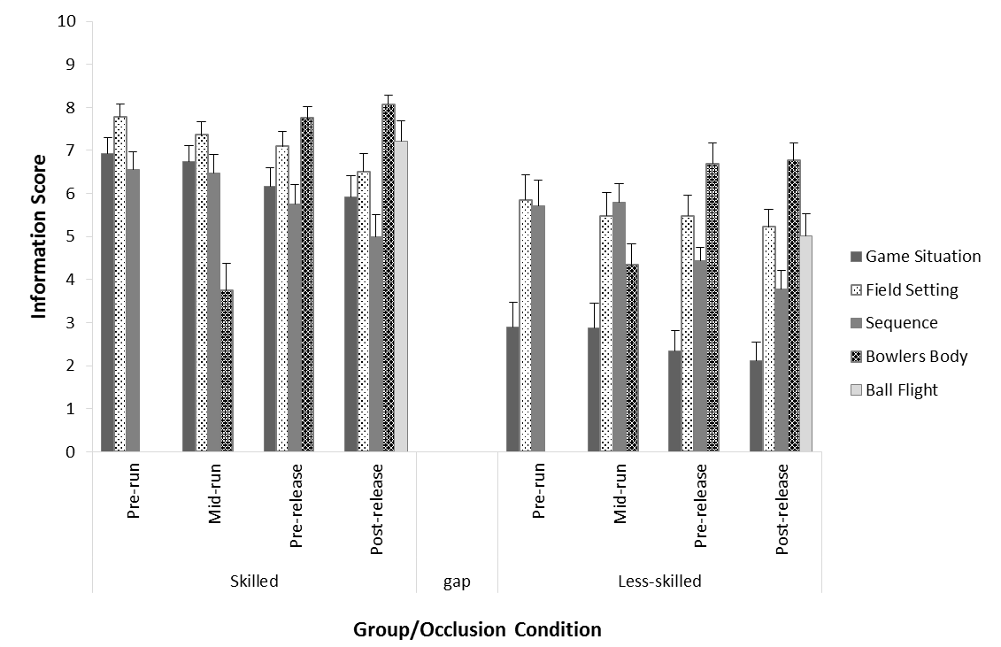
Figure 5. Mean information scores for each source for Skilled and Less-skilled groups. Shown across the four occlusion conditions (+ 1 SE).

Contextual and Visual Information
Main Effects. The increase in importance of visual information across occlusion conditions is highlighted in Figure 6. In the post-release condition, the skilled performers again reported ball flight information to be of higher importance than less-skilled counterparts. The three-way mixed ANOVA showed a significant effect of information sources (F_{1, 34} = 124.82, p < .01, η_{p}² = .79). There was a significant interaction between information source and group (F_{1, 34} = 17.11, p < .01, η_{p}² = .34) with skilled participants reporting higher use of contextual information sources throughout and visual information at post-release than the less-skilled group, who showed a consistently lower score for contextual information. Also, there was a significant interaction between occlusion condition and information source (F_{12, 23} = 322.77, p < .01, η_{p}² = .91), showing a dominance of contextual information over visual information at pre-run and mid-run occlusion conditions with visual information becoming dominant at pre-release. There was a significant occlusion condition × group interaction (F_{3, 32} = 6.87, p < .01, η_{p}² = .17) and a significant three-way occlusion condition × information source × group interaction (F_{3, 32} = 6.286, p = .01, η_{p}² = .16). These interactions showed that contextual information was the dominant information source at early pre-run and mid-run conditions for both groups, but the skilled group reported higher scores for context across all occlusion conditions.
Post Hoc Analysis. Tests showed a significant difference in the reported contextual and visual information scores in all occlusion conditions; information scores were not the same for any two occlusion conditions (p’s < .01).

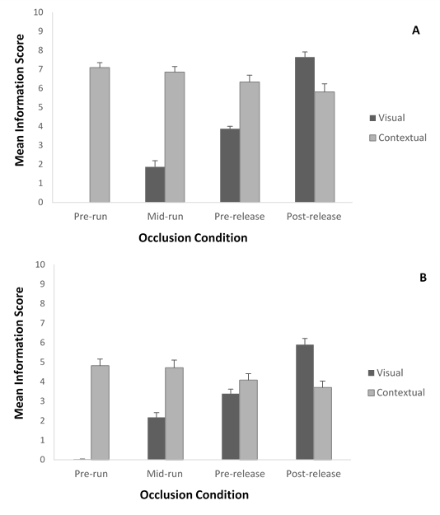
Figure 6. Mean (+ 1 SE) information scores for (A) Skilled and (B) Less-skilled participants grouped into visual (bowlers body and ball flight) and contextual (sequence, game situation and field setting) information sources. Shown across the four occlusion conditions.

Discussion
We examined the temporal integration of visual and contextual information during anticipation. We predicted that skilled performers would anticipate more accurately than less-skilled performers (e.g., McRobert et al., 2011; Murphy et al., 2016). We hypothesised that skilled performers would prioritise the use of contextual information and update predictions when more up to date visual information became available later in the action. Conversely, we predicted that less-skilled performers would be less able to use contextual information and would rely on visual information (Murphy et al., 2016; Runswick et al., 2018). As more sources of information appeared during the sequence, anticipation accuracy was predicted to improve, with the highest accuracy being predicted to be observed when early ball flight information is present (cf., Müller & Abernethy, 2012; Müller et al., 2009).
As predicted, the skilled group were more accurate in anticipating than the less-skilled group across all occlusion conditions. This finding supports a large body of literature showing that skilled performers are better able to use available information to make accurate judgements about the outcomes of events in the near future (see Loffing & Cañal-Bruland, 2017). However, there was no interaction between skill level and occlusion condition. The absence of the predicted interaction between skill group and occlusion condition suggests that the anticipation performance of both groups changed in the same fashion as more visual information became available. While the temporal integration of information across time points did not differ for skilled and less-skilled performers, skilled performers rated all sources of information as being more useful. The use of contextual information underpinned the skill level difference up until the ball was released, whereas later differences were underpinned by superior use of visual information from early ball-flight.
The skilled group showed superior ability to accurately anticipate the outcome of the delivery in the pre-run condition, in which no information from the bowler was present. This finding supports the assertion that sources of contextual information must a play a key role in anticipation. When the only information that was available was the position of the opposition fielders, the game situation, and information gained from preceding events, skilled performers were able to anticipate significantly more accurately than less-skilled performers (despite being presented with no information whatsoever from the bowler). Findings support previous suggestions that contextual information is used prior to ball-flight (Farrow & Reid, 2012; Loffing & Hagemann, 2014; McRobert et al., 2011; Müller & Abernethy, 2012; Paull & Glencross, 1997). Skilled performers were more accurate in their anticipation judgements and reported more use of contextual information sources compared to less-skilled performers, supporting previous published reports which show that skilled performers employ the use of contextual information (McRobert et al., 2011; Murphy et al., 2016; Runswick et al., 2018). While much of the literature investigating anticipation has focused on the use of visual kinematic information, we have built on this evidence base by showing that the use of contextual information available prior to the initiation of the event is a key feature of skilled anticipation. Furthermore, we have shown that this information can be used earlier in the action before any visual cues from the opponent appear and that previous researchers who have investigated anticipation using only visual information sources without context may not have included all relevant information in their experimental designs.
When early sources of visual information from the bowler became available in the mid-run condition, which showed the first half of the bowler’s run up, anticipation accuracy did not improve in either group compared to the pre-run condition. Both groups did, however, report some limited use of information from the bowler’s body in this period. This finding suggests that, despite participants reporting some use of postural cues, the visual kinematic information that was present at this early part of the sequence was not pertinent to the outcome of the delivery. It is possible that participants did consider using information from the bowler’s body to predict the nature of the delivery (i.e., fast or spin), but this information is not sufficiently powerful to inform judgement of the delivery location. Previously, researchers using the temporal occlusion paradigm have focused on identifying the time at which key sources of kinematic information emerge and have typically reported that early time points contain relatively little meaningful information (e.g., Savelsbergh et al., 2002). Our data supports these conclusions, but in addition show that the presence of contextual information at these early time points contains valuable information that can be used to inform future anticipation judgements and the visual information that follows may confirm rather than improve these predictions.
Following the mid-run condition, anticipation accuracy was significantly worse in the pre-release occlusion condition that occurred after the run up and bowling action had been completed. It was predicted, based on previous literature (Müller et al., 2009), that due to the presence of pertinent postural cues in this condition, anticipation accuracy in the skilled group would improve compared to pre-run and mid-run conditions and to a greater extent than the novice group. However, contrary to these predictions, participants were less accurate compared to mid-run and post-release conditions, suggesting visual information available later in the run up and during the bowling action had a negative effect on anticipation accuracy. Triolet et al. (2013) displayed a similar decrease in the anticipation accuracy of tennis players between 120 ms prior to ball contact and 60 ms after ball contact. This finding was explained by later anticipatory decisions being caused by neutral tactical situations, meaning predictions were based on kinematic rather than tactical information. Our findings support this conclusion by showing the use of visual information increased in the pre-release condition and was accompanied by a drop in accuracy. While postural cues still offer information for anticipation, this may not lead to responses as accurate as those produced using contextual or early ball flight information.
When just 80ms of ball flight was displayed in the post-release occlusion condition, there was a dramatic improvement in anticipation accuracy compared to pre-release. Previously, researchers have identified the importance of using early ball flight information in cricket, especially in skilled performers (e.g., Abernethy, 1990; Müller & Abernethy, 2012). The skilled group scored the use of ball flight higher in the post-release condition and showed a greater improvement in anticipation accuracy than the less-skilled group. Skilled performers in fast-ball sports are still able to intercept balls that are projected at high velocity from projection machines, from which no postural cues are available at all (Pinder, Renshaw, & Davids, 2009). Therefore, final anticipatory judgements may need to occur post-ball release in early ball flight. This means, in fast ball sports, the final judgement may not occur until after a response action has had to be initiated, with these movements being initiated in such a way that they can be updated based on later predictions (see Bootsma & van Wieringen, 1990; Stone, Panchuk, Davids, North, & Maynard, 2014).
In this paper, we have extended the two-stage model proposed by Müller and Abernethy, (2012) by showing that contextual information (available prior to visual information from an opponent) remains important to anticipation judgements consistently throughout a trial. The perceived use of visual information develops through the trial as additional sources of information appear, until it finally becomes more useful than contextual information at ball release. We have built on findings reported by Runswick et al. (2018) who used clips occluded at ball release and showed, using verbal report data, that skilled performers reported a balanced use of information sources. The current study adds to these findings by showing when information is important and that the use of context begins early in the anticipation process, while visual information is added later and gains more importance nearer ball release.
We have produced novel findings by identifying the time at which different sources of information are used in anticipation and the effect this has on performance. We have addressed a gap in the literature by investigating the integration of different information sources over time during anticipation. However, this study was limited in its use of a simple pen and paper response and requirement for participants to explicitly monitor the information used. It is possible that skilled performers do not always have conscious awareness of how they make judgements and perform actions, so care should be taken when interpreting explicit judgements. While it is difficult to measure information use without encouraging explicit monitoring processes, findings should be replicated in tasks that integrate decisions and movement responses (Dicks, Button, & Davids, 2010). Moreover, information use could be affected by the time at which a final decision is made and this time point can be variable depending on the situation (Triolet et al., 2013). In future, researchers should further establish the relative contribution of information sources and develop refined methods to measure this issue at the point in time at which final judgements are made in-situ. In this study, the information sources were designed to be congruent with one another and lead to the same probabilities, yet this relationship between information sources may not always occur in performance environments (Cañal-Bruland & Schmidt, 2009; Gray, 2002). Further research is needed to examine whether congruent or incongruent (visual and contextual information leading to contrasting probabilities) relationships between information sources can affect anticipation.
In summary, we report that skilled performers are better able to anticipate based on contextual information alone and that they make more use of contextual information throughout the anticipation process when compared with less-skilled counterparts. Furthermore, we have reported the first study to investigate the time that contextual information is utilised in the anticipation process and when the use of this information may be integrated with stimulus driven kinematic information. We report that contextual information is present and employed throughout the process with visual information being added later as the action evolves. Findings suggest that, where relevant, it is important to present access to both context and visual information in future research designs, as well as in practice designs, in order to more accurately represent the conditions that exist during performance.

References
Abernethy, B. (1990) Anticipation in squash: Differences in advance cue utilization between expert and novice players. Journal of Sports Sciences, 8, 17-34, DOI: 10.1080/02640419008732128
Abernethy, B., & Zawi, K. (2007). Pickup of essential linematics underpins expert perception of movement patterns. Journal of Motor Behaviour, 39, 353-367, DOI: 10.3200/JMBR.39.5.353-368
Bootsma, R. J., & van Wieringen, P. C. W. (1990). Timing an attacking forehand drive in table tennis. Journal of Experimental Psychology: Human Perception and Performance, 16, 21-29, DOI: 10.1037/0096-1523.16.1.21
Broadbent, D. P., Ford, P. R., O'Hara, D. A., Williams, A. M., Causer, J. (2017). The effect of a sequential structure of practice for the training of perceptual-cognitive skills in tennis. PLoS One, DOI: 10.1371/journal.pone.0174311
Cañal Bruland, R., Filius, M. A., & Oudejans, R. R. D. (2015). Sitting on a fastball. Journal of Motor Behavior, 47, 267-270, DOI:10.1080/00222895.2014.976167
Cañal-Bruland, R., & Mann, D. L. (2015). Time to broaden the scope of research on anticipatory behaviour: a case for the role of probabilistic information. Frontiers in Psychology , 6:1518. DOI: 10.3389/fpsyg.2015.01518
Cañal Bruland, R., & Schmidt, M. (2009). Response bias in judging deceptive movements. Acta Psychologica. 130: 235-240, DOI: 10.1016/j.actpsy.2008.12.009
Dicks, M., Button, C., & Davids, K. (2010). Examination of gaze behaviours under in situ and video simulation task constraints reveals differences in information pickup for perception and action. Attention, Perception & Psychophysics, 72, 706-720, DOI: 10.3758/APP.72.3.706
Farrow, D., & Reid, M. (2012). The contribution of situational probability information to anticipatory skill. Journal of Science and Medicine in Sport , 15, 368-373, DOI: 10.1016/j.jsams.2011.12.007
Faul, F., Erdfelder, E., Lang, A.-G., & Buchner, A. (2007). G*Power 3: A flexible statistical power analysis program for the social, behavioral, and biomedical sciences. Behavior Research Methods, 39, 175-191, DOI: 0.3758/BF03193146
Girden, E. R. (1992). ANOVA: Repeated Measures. Newbury Park, CA: Sage.
Gray, R. (2002). Behaviour of college baseball players in a virtual batting task. Journal of Experimental Psychology Human Perception and Performance, 11, 1131-1148, DOI: 10.1037//0096-1523.28.5.1131
Loffing, F., & Cañal-Bruland, R. (2017). Anticipation in sport. Current Opinion in Psychology, 16, 6-11, DOI: 10.1016/j.copsyc.2017.03.008
Loffing, F., & Hagemann, N. (2014). On-court position influences skilled tennis players' anticipation of shot outcome. Journal of Sport and Exercise Psychology, 36, 14-26, DOI: 10.1123/jsep.2013-0082
Loffing, F., Stern, R., & Hagemann, N. (2015). Pattern-induced expectation bias in visual anticipation of action outcomes. Acta Psychologica , 161, 45-53, DOI: 10.1016/j.actpsy.2015.08.007
Mann, D. Y., Williams, A. M., Ward, P., & Janelle, C. M. (2007). Perceptual–cognitive expertise in sport: A meta-analysis. Journal of Sport and Exercise Psychology, 29, 457–478, DOI: 10.1123/jsep.29.4.457
McLaughlin, M. J., & Sainani, K. L. (2014). Bonferroni, Holm, and Hochberg corrections: Fun names, serious changes to p values. PM & R , 6, 544-546, DOI: 10.1016/j.pmrj.2014.04.006
McRobert, A. P., Causer, J., Vassiliadis, J., Watterson, L., Kwan, J., & Williams, A. M. (2013). Contextual information influences diagnosis accuracy and decision making in simulated emergency medicine emergencies. BMJ Qual Saf, 22, 478-484, DOI: 10.1136/bmjqs-2012-000972
McRobert, A. P., Ward, P., Eccles, D. W., & Williams, A. M. (2011). The effect of manipulating context-specific information on perceptual-cognitive processes during a simulated anticipation task. British Journal of Psychology, 102, 519-534, DOI: 10.1111/j.2044-8295.2010.02013.x.
McRobert, A. P., Williams, A. M., Ward, P., & Eccles, D. W. (2009). Tracing the process of expertise in a simulated anticipation task. Ergonomics, 52 (4), 474-483, DOI: 10.1080/00140130802707824.
Morris-Binelli, K., Müller, S. (2017). Advancements to the understanding of expert visual anticipation skill in striking sports. Canadian Journal of Behavioural Science
Müller, S., & Abernethy, B. (2012). Expert anticipatory skill in striking sports: A review and a model. Research Quarterly for Exercise and Sport, 83, 175-187.
Müller, S., Abernethy, B., & Farrow, D. (2006). How do world-class cricket batsmen anticipate a bowler's intention? The Quarterly Journal of Experimental Psychology, 59, 2162-2186, DOI: 10.1080/02643290600576595
Müller, S., Abernethy, B., Reece, J., Rose, M., Eid, M., McBean, R., Hart, T., & Abrew, C. (2009). An in-situ examination of the timing of information pick-up for interception by cricket batsmen of different skill levels. Psychology in Sport and Exercise, 10, 644-652, DOI: 10.1016/j.psychsport.2009.04.002
Murphy, C. P., Jackson, R. C., Cooke, K., Roca, A., Benguigui, N., & Williams, A. M. (2016). Contextual information and perceptual-cognitive expertise in a dynamic, temporally-constrained task. Journal of Experimental Psychology Applied, 22 (4), 455-470, DOI: 10.1037/xap0000094
North, J. S., Ward, P., Ericsson, K. A., & Williams, A. M. (2011). Mechanisms underlying skilled anticipation and recognition in a dynamic and temporally constrained domain. Memory, 19, 155-168, DOI: 10.1080/09658211.2010.541466
Paull, G., & Glencross, D. (1997). Expert perception in decision making in Baseball. International Journal of Sport Pscyhology, 28, 35-56.
Pinder, R. A., Renshaw, I., & Davids, K. (2009). Information-movement coupling in developing cricketers under changing ecological practice constraints. Human Movement Science, 28, 468-479, DOI: 10.1016/j.humov.2009.02.003.
Roca, A., & Williams, A. M. (2016). Expertise and the interaction between different perceptual-cognitive skills: Implications for testing and training. Frontiers in Psychology, 7:792, DOI: 10.3389/fpsyg.2016.00792
Runswick, O. R., Roca, A., Williams, A. M., Bezodis, N. E., & North, J. S. (2017). The effects of anxiety and situation-specific context on perceptual-motor skill: A multi-level investigation. Psychological Research, DOI: 10.1007/s00426-017-0856-8
Runswick, O. R., Roca, A., Williams, A. M., Bezodis, N. E., McRobert, A. P., & North, J. S. (2018). The impact of contextual information and a secondary task on anticipation performance: An interpretation using Cognitive Load Theory. Applied Cognitive Psychology. DOI: 10.1002/acp.3386
Savelsbergh, G. J. P., Williams, A. M., van der Kamp, J., & Ward, P. (2002). Visual search, anticipation and expertise in soccer goalkeepers. Journal of Sports Sciences, 20, 279-287, DOI: 10.1080/026404102317284826
Stone, J.A., Maynard, I.W., North, J.S., Panchuck, D., & Davids, K. (2015). Emergent perception-action couplings regulate postural adjustments during performance of externally timed dynamic interceptive actions. Psychological Research, 79, 829-843, DOI: 10.1007/s00426-014-0613-1
Triolet, C., Benguigui, N., Le Runigo, C., & Williams, A. M. (2013). Quantifying the nature of anticipation in professional tennis. Journal of Sports Sciences, DOI: 10.1080/02640414.2012.759658
Williams, A. M., & Davids, K. (1998). Visual search strategy. selective attention, and expertise in soccer. Research Quarterly for Exercise and Sport , 69, 111-128, DOI: 10.1080/02701367.1998.10607677
Williams, a. M., Ericsson, K. A., Ward, P., & Eccles, D. W. (2008). Research on Expertise in Sport: Implications for the Military. Military Psychology, 20(sup1), S123–S145, DOI: 10.1080/08995600701804863
Williams, A. M., Ford, P. R., Eccles, D. W., & Ward, P. (2011). Perceptual-cognitive expertise in sport and its acquisition: Implications for applied cognitive psychology. Applied Cognitive Psychology, 25, 432–442, DOI:10.1002/acp.1710
Williams, A. M., Ward, P., Knowles, J. M., Smeeton, N. J. (2002). Anticipation skill in a real-world task: Measurement, training and transer in tennis. Journal of Experimental Psychology: Applied, 8, 259-270, DOI: 10.1037/1076-898X.8.4.259

