Steve McDade
Margins of the Lane The Otter Gallery
The exhibition and Symposium focused set up a debate around painting and its relation to its history This exhibition explored particular relationships between some of The Otter Gallery collection of British Modernist painters (Heron, Sutherland, Hitchings, Lanyon) and new research driven work that explored concepts extensions and interpretations of landscape derived paintings My own work focused on particular qualities and properties summed up as follows: :
Edges/Hedges/Fences/Gates
Borders/Verges/Margins
Propositions/Refusals
My paintings are part of a continuing series of speculative approaches to landscape. I was interested in trying to fathom a way of responding to painting landscape in the face of what seemed to me an impossibility. The historical precedents and the long established genre of landscape painting presents an enormous challenge. The traditions of academic painting, of realism, of expressionism, of vanguard-ism and of abstraction have already ‘mapped the territory’ and to a very large extent bordered off all the available modalities of what painted landscapes can be. ‘Landscape’ is already captured ground. Nevertheless, this ‘impossibility’ was itself a proposition and an incitement to walk again down this particular lane!
In contemporary terms the position of landscape is being re-configured around notions of edge-land. The previous binary of Urban/Landscape is now being reunited at the liminal space of the edge(s) of the built environment. There isn’t any part of this ‘United Kingdom’ which is not bordered or annexed in one way or another.
My paintings ‘square up’ to this annexation of the land and use the notion of borders, verges and gateways as motifs and as points of departure.
The paintings are constructed responses to the space(s) between the built environment and the natural environment. The use of the specific motifs of fences, verges and gates represent the borders and edges between spaces (gardens, farmland, and motorways). These motifs are also signifiers of an autobiographical dimension acting as metaphors of a more personal nature but these signs too are annexed away from the easily readable.
How to paint? The question remains central to the creation of new work and central to the notion of practice as research. The endeavour to explore and extend the (one’s) scope and ‘the reach’ of painting; to work both within a visual history and to then challenge it remains at the core of the enterprise of making paintings
To make a painting is to struggle with every painting that has ever existed.
The canvas clean, taut, white, primed is a tabula rasa. Not so! It is already swamped with images, histories-a kind of pre-knowledge. To make paintings is to negotiate this pre-given and to respond or get marginalised by the weight of history. This is especially true for me. The innumerable images shown in a lifetime of lecturing produces what André Malraux has referred to as ‘The Museum without Walls’; my head and the canvas already full of paintings to fight with
As Gilles Deleuze points out:
“ It is a mistake to think that the painter works on a white surface. The figurative belief follows from this mistake. If the painter were before a white surface, he could reproduce on it an external object functioning as a model, but such is not the case[. ………. …. ] the painter does not have to cover a blank surface but rather would have to empty it out, to clear it, to clean it…….In short, what we have to define are all these ‘givens’ that are on the canvas before the painter’s work begins, and determine amongst these givens, which are obstacles, which are helps……..”
Deleuze. G, (2002) Francis Bacon, The Logic of Sensation. Minneapolis. UMT Press (p71)
By using painting’s methods and processes my paintings play with the ‘idea’ of painting. The strategies used in their production such as the use of different media, mediums, surface marks and painterly properties together with the dynamic of representation dissolving into abstraction, of material reality, of photography’s indexical signs and of illusionism and reflection supply a kind of discourse about painting and ‘the pictured’.
There is an immediate reference to some of the paintings in the collection. This interrelation is at the centre of this research and is a key factor in the construction of my works. The painting by Minchin with its stagey theatricality and the Sutherland with its signature yellow are obvious referents to my work. But so too are the implications of edges, contours and surface present in all of the other works from the collection.

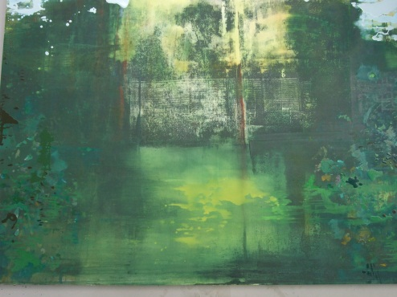
Border Oil on Canvas 2012
This is based around a photo-screen print. The photographic indexical signs of fence and tree provide a backdrop for that very domestic piece of land - the garden. The painted marks ‘fly’ to the edges and create the margins with all the energy of the work driven to the sides where the interplay of surface ‘push and pull’ from the picture plane is activated in the borders of the stage like setting.
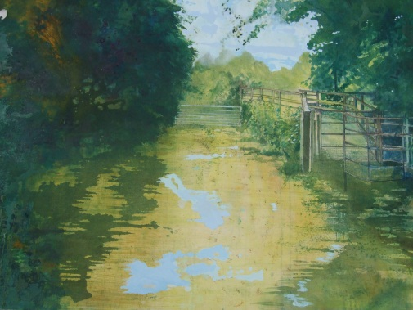
Trespass: Oil on Canvas 2012
The interplay of line drawing and abstraction provides the discourse around representation and surface marks. The opposition between ‘academic representation’ and gestural application of paint engages with a ‘mini history’ of tradition(s) of painted landscapes from 15th C works in which the landscape was a background setting to 18th C ‘idylls’ to 20th C Abstract Expressionism and process led ‘action’ work. The barred gate literally figures a refusal (do not trespass) whilst the kissing gate towards the raised path signifies a possible entrance to the world beyond the end of the lane (and another kind of trespass)

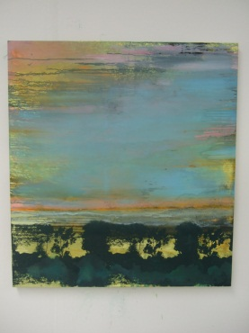
Verge:(first version) Oil on Canvas 2012

This painting is the result of the seemingly endless journeys up and down the M 27 and A 27!
It is there that the hard edges of the roadway and crash barriers meet the silhouetted trees against impossible cloudscapes. The image is both screen print and paint and verges, in a rhetorical way, on the screened image (windscreens, cinema screens, tv screens, computer screens) that provide the virtual world from which our ideas of ‘ landscape’ are often derived.

