Lecture: Neurophenomenology of Flow and Meditative Moving
10th Feb. 2016 (University of Chichester Dept. Dance – MA programme)

“Flow” – by Mihaly Csikszentmihalyi
Mainly examined in the field of psychology, but also neuroscience, sports science, and technology.
[Sensations]
- Focused concentration
- Sense of control
- Merging of action and awareness
- Loss of self-consciousness
- Losing track of time
- Autotelic or self-rewarding experience
Addictive ‘high’ feeling, and is said to involve extended high performance, increased accuracy, speed, etc.
[Conditions]
- Clear goals and immediate feedback
- Equilibrium between the level of challenge and personal skill
Example activities:
Skiing, surfing, reading, calculating, video games, playing music, cooking…
Meditation = somewhat different? deeper concentration (introspective, self-referential nature)

Mindfulness & meditation – Mindfulness or meditation (Vago, 2012):
- Focused Attention Concentration: attention to mental or sensory object – repeated sound, mantra, imagery, visceral or somatic sensations (leading to non-conscious meta-awareness)
- Open Monitoring Receptive meditation: active monitoring, accepting, and labeling of sensations and thoughts, without bias or judgement, leading to conscious psychological development of meta-awareness.
- [Affection-enhancing practices: conceptual elimination of barriers between self & others, as well as compartmentalization between “good” people and “bad” people / contemplative unraveling of irrational judgements = most explicit, conceptual meta-awareness.]

Eastern influences in dance:
- Somatics & Dance Movement Therapy: e.g. Detta’s classes ⇒ close to Open Monitoring
- Improvisation: Almost every dancer does this nowadays, either as training or performance ⇒ often times a combination of Open Monitoring and Focused Attention
- Nihon-buyo & Butoh: This is my specialty field. Significance is unconscious spontaneity, letting go of self-monitoring (non-conscious meta-awareness), and eventually letting go of subjective experience as well ⇒ done mainly through Focused Attention

East – West difference??
- E: Focus, refinement, introspection VS W: Creativity, novelty, expression
- E: Strong emphasis on embodiment, enaction, quieting the mind through body motion VS
W: Physical skills, technique, outward projection, end products.

The neuroscience of ‘flow’– what actually goes on in the brain?
[Systems & anatomy of the brain]
Explicit system (“conscious”, “aware”, attention-shifting, decision-making, analyzing) = governed by the dorsolateral-prefrontal cortex & operated in other areas of the cerebral cortex – we are programmed through society to use this area.
Implicit system (“sub/un-conscious”, “unaware”, habit, intuition, instinct) = deactivation of the prefrontal cortex / direct communication between other cortical areas, limbic system and cerebellum
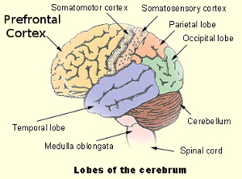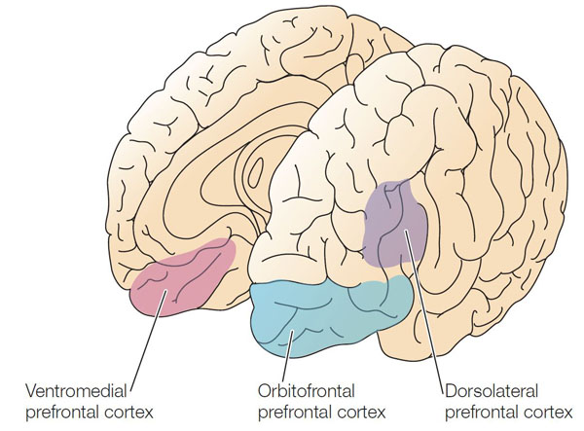
Explicit 1. Narrative Self: autobiographical, conceptual, social sense of self (objective)
↕ 2. Experiential Self (EES & EPS): immediate, sensory, bodily (subjective)
Implicit 3. Self-Less: lack of sense of self and agency (no subjectivity or objectivity)
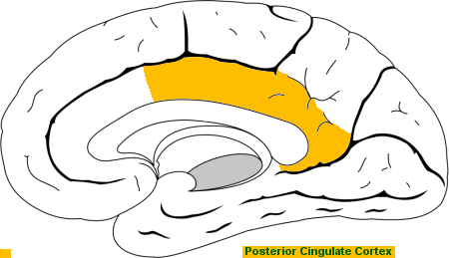
- Narrative Self = Default Mode Network: idle, mind-wandering, self-reflection (VMPFC, PCC)
- Experiential Self = Task Positive Network: attention & focus on immediate task (DLPFC, TOP)
- Self-Less = no explicit network activated: “automatic” actions (TOP and other limbic systems)
Default Mode Network shuts down as the Task Positive Network takes over.
As the Task Positive Network also shuts down, a hypo-frontality (decrease in cerebral blood flow in the prefrontal cortex) occurs.
‘Flow’ COULD be measured through fMRI.
While many dance activities involving mindfulness stops at 2. (still reaching ‘flow’), some meditative dancers try to reach the state of 3. (a “deeper flow”).

[FLOW cycle: brain waves & chemicals]
- Beta (rapid) phase: alert, ready for action, struggling to find a solution, or to resolve something
- Cortisol (stress hormone responsive to stress, metabolism, blood pressure control)
- Norepinephrine / Noradrenaline (neurotransmitter allowing focused activity in the Task Positive Network & speeding up muscle reaction, mobilization for action)
= High heartrate, fight-or-flight state
- Excess increase of adrenaline = too much stress resulting in break down & cognitive impairment
- Conscious lowering of adrenaline = slowing respiratory system resulting in relaxation (Alpha)…
- Alpha (regular) phase: relaxing, finding a point of resolution and releasing tension
- Nitric Oxide (neurotransmitter allowing effective learning and memory formation)
- Endorphin (morphine-like pain reliever & sedative neuropeptide)
- Theta (slower) & Gamma-bursts (hyper-rapid) phase: just before going to sleep OR ‘Flow’
- Dopamine (neurotransmitter causing reward-motivated behavior, increased motor control)
- Anandamide (neurotransmitter enhancing pleasure and non-linear, lateral thinking or spontaneous linking of disparate ideas)
- Serotonin (neurotransmitter responsible for positive moods and blocking anxiety)
- Endorphin (continued from Alpha)
- Delta (slowest) phase: recovering from previous brain activity & solidifying thoughts
- Oxytocin (hormone responsible for feelings of affection & desire for social bonding)
- Serotonin (continued from Theta-Gamma)
‘Flow’ COULD be measured through EEG.
According to this evidence, ‘flow’ may be a chronological, cyclical state-occurrence; this suggests that ‘flow’ cannot be permanently sustained.
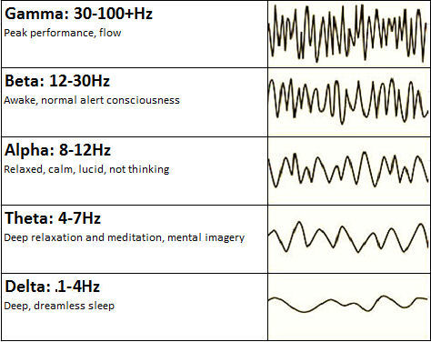
Reference:
Brewer, J. A., Worhunsky, P. D., Gray, J. R., Tang, Y.-Y., Weber, J., & Kober, H. (2011). Meditation experience is associated with differences in default mode network activity and connectivity. Proceedings of the National Academy of Sciences of the United States of America, 108(50).
De Kock, Frederick Gideon (2014) The neuropsychological measure (EEG) of flow under conditions of peak performance, University of South Africa, Pretoria.
Nakamura, J., & Csikszentmihalyi, M. (2014). The concept of flow. In Flow and the Foundations of Positive Psychology (pp. 239-263). Springer Netherlands.
Vago, D. R., & David, S. A. (2012). Self-awareness, self-regulation, and self-transcendence (S-ART): a framework for understanding the neurobiological mechanisms of mindfulness. Frontiers in human neuroscience, 6, 296.

Websites:
http://www.fastcolabs.com/3024647/how-your-brain-activity-changes-when-youre-in-the-zone
https://www.psychologytoday.com/blog/beautiful-minds/201006/schizotypy-flow-and-the-artist-s-experience

