Reference values for performance test outcomes relevant to English female soccer players

Naomi Datson¹ ², Matthew Weston³, Barry Drust⁴, Greg Atkinson², Lorenzo Lolli² and Warren Gregson²

¹ Institute of Sport, Nursing and Allied Health, University of Chichester, Chichester, UK

² Football Exchange, Research Institute of Sport Sciences, Liverpool John Moores University, Liverpool, UK
³ Institute of Sport, Physical Education and Health Sciences, The University of Edinburgh, Edinburgh, UK

⁴School of Sport, Exercise and Rehabilitation Sciences, University of Birmingham, Birmingham, UK

Address for Correspondence:

Naomi Datson PhD

Institute of Sport, Nursing and Allied Health

University of Chichester

Chichester

UK

N.Datson@chi.ac.uk

Reference values for performance test outcomes relevant to English female soccer players

Abstract

The purpose of this study was to present reference standards for physical performance test outcomes relevant to elite female soccer players. We analysed mixed-longitudinal data (n = 1715 observations) from a sample of 479 elite youth and senior players as part of the English Football Association’s national development programme (age range: 12.7 to 36.0 years). Semi-parametric generalized additive models for location, scale and shape (GAMLSS) estimated age-related reference centiles for 5-m sprinting, 30-m sprinting, countermovement jump (CMJ) height, and Yo-Yo Intermittent Recovery Test Level 1 (Yo-Yo IR1) performance. The estimated reference centiles indicated that the median of the distribution of physical performance test scores varied non-linearly with advancing chronological age, improving until around 25 years for each performance variable. These are the first reference ranges for performance test outcomes in elite English female soccer players. These data can assist practitioners when interpreting physical test performance outcomes to track an individual’s progress over time and support decision making regarding player recruitment and development.

Keywords: Fitness testing; football; player tracking; physical performance; age-related reference ranges; GAMLSS

Introduction
Physical performance testing provides an opportunity to evaluate a player’s physical qualities (1) and represents an integral component of an elite soccer player’s development programme (2). Information derived from physical performance testing can support the decision-making processes of coaches and practitioners involved in talent identification, player selection and development (3). A wide range of physical performance tests are available (1,4,5) with measurement of linear speed, lower limb body power (i.e., jumping based tests) and high-intensity intermittent endurance (6) considered important by coaches and practitioners (e.g., face and content validity) (3,7–11).

Despite women’s soccer research being comparatively under-researched relative to male soccer (12), the area of physical performance testing has received moderate attention (13), with a focus on exploring age group differences (2,14). Previous research has shown high-intensity endurance capacity to differentiate between age groups with national team senior players achieving higher scores than their U15, U17 and U20 counterparts (2,14,15). Similarly, a general improvement in linear speed performance has been demonstrated through adolescence to the age of 23 years in national team players (16), with senior players also exhibiting faster 20 m linear speed times compared to U15, U17 and U20 national team players (14). However, 40 m linear speed was consistent in elite players from U18 to > 25 years (17). Jumping performance has also been shown to increase through adolescence in high-level (18) and elite (19) female players with higher values reported in senior national team players compared to youth (U15 and U17) players (2,14). However, these observations are not consistent as countermovement jump (CMJ) performance did not differ in elite players from U18 to > 25 years (17) and U19 national team players jumped higher than senior players (19).

Previous literature has largely focused on relatively small samples of sub-elite (20,21), elite youth (22,23) or players competing in governing body age categories, i.e., U17, U20 and seniors (2,14,19) with the majority of studies being cross-sectional in nature. Cross sectional studies lack temporality and therefore the information provided across these broad age categories does not allow for specific year by year progressions to be considered (16). While recent research (16) explored trends in physical test performance at different ages in female soccer players from Canada (age range: 12 – 34 years), there are no reference centiles values available for benchmarking physical test performance of the elite female soccer player. Reference centiles are commonly used in clinical settings as a tool to understand changes in function and relative standing (24,25). In elite sport, information from reference values can assist practitioners when interpreting physical test performance data by indicating the player performance level at a given chronological age (24). The purpose of this study, therefore, was to develop age-related reference centiles for physical performance variables relevant to elite female soccer players.

Methods

Design
Mixed-longitudinal field-based physical performance testing data were collected from elite youth and senior soccer players as part of the English Football Association’s national development programme. Players from this development programme were selected to represent England at all age groups (seniors and youth squads). Data were collected from 479 female soccer players covering the youth-to-senior spectrum (age range: 12.7 to 36.0 years) and analysed retrospectively. With some players measured once and others more than once (range: 1 to 12 assessments), the present study sample included goalkeepers and outfield players tested at multiple time points across four seasons for a total of 1715 individual observations. Performance tests were conducted at three time points (start (September), middle (January) and end of season April)) throughout the year. Performance data were collected as a condition of employment in which player physical performance is routinely assessed (26). All data were anonymised prior to analysis to ensure player confidentiality and appropriate institutional ethics committee approval was granted. At the time of testing, an average training week for the senior players consisted of 4-6 pitch-based training sessions, 2-3 strength sessions and 1-2 competitive matches, whereas U15 players completed 2-3 pitch-based training sessions, 1 strength session and 1 match per week.

Procedures
A standardised warm-up was completed, consisting of generic warm-up activity prior to commencing the physical performance tests. Specific warm-ups were also completed prior to each of the performance tests. To ensure consistency between testing occasions, National federation staff coached the warm-up activity. Prior to assessment, all players had previously completed each test on at least one occasion. All performance tests were performed on third generation turf (indoor arena). Tests were completed in a single session and in the same order on each test occasion. Countermovement jump (CMJ) was completed first, followed by linear speed and finally the Yo-Yo Intermittent Recovery Test Level 1 (Yo-Yo IR1). Reliability assessments were undertaken, with 140 players completing physical performance testing on two separate occasions separated by seven days (27).

Countermovement jump
Estimations of player’s lower limb muscular power were assessed via a CMJ on a jump mat (KMS Innervations, Australia). The jump mat was placed on a firm, concrete surface at the edge of the third-generation turf (indoor arena). Following the generic and jump-specific warm-up activity, the player was permitted an additional practice jump on the mat before performing three recorded trials. The player was instructed to step on to the mat and place their feet in the middle of the mat (a comfortable distance apart) with their hands on their hips. The player started from an upright position and was instructed to jump as high as possible while keeping their hands on their hips. Players self-selected the depth of flexion prior to take off and were instructed to keep their legs straight whilst in the air and refrain from bringing their legs into a pike position or flicking their heels. The highest jump height recorded to the nearest 0.1 cm was used as the criterion measure of performance. The estimated standard error of the measurement (SEM) for this test was 1.1 cm (95%CI, 0.9 cm to 1.2 cm) and the coefficient of variation (CV) was 3.9% (95%CI, 3.4% to 4.3%) (27).

Linear speed
Player’s linear speed times were evaluated using electronic timing gates (Brower TC Timing System, USA) over distances of 5-m and 30-m. A 50 m steel tape measure (Stanley, UK) was used to measure the 30 m distance and markers were placed at 0, 5 m and 30 m, in addition, a marker was placed 1 m behind the zero line. Tripods were placed directly over each marker at a height of 0.87 m above ground level and a timing gate (transmitter) was fitted to each tripod. Opposite each tripod, at a distance of 2 m, another tripod and timing gate (receiver) was positioned. Following the generic and speed-specific warm-up activity, the player was permitted an additional practice sprint through the course before performing three recorded trials. Each sprint was separated by a 3-min recovery period. The player commenced each sprint with their preferred foot on a line 1 m behind the first timing gate. The fastest time at each distance to the nearest 0.01 s was used as the criterion measure of performance. The estimated SEM was 0.024 s (95%CI, 0.021 s to 0.027 s) and 0.057 s (95%CI, 0.051 to 0.064 s) for 5 m and 30 m linear sprinting respectively (27). The CV was 1.2% (95%CI, 1.1% to 1.4%) and 3.9% (95%CI, 3.4% to 4.3% for 5-m and 30-m sprinting respectively (27).

Yo-Yo Intermittent Recovery Test Level 1
Estimations of player’s high-intensity endurance capacity were assessed using the Yo-Yo IR1. During the test, participants completed a series of repeated 20 m shuttle runs with a progressively increasing running speed (10-19 km.h⁻¹) interspersed with 10 s rest intervals (28). The SEM for this test was 74 m (95%CI, 67 m to 84 m) and the CV was 7.2% (95%CI, 6.3% to 8.1%) (27).

Statistical analysis
Semi-parametric generalized additive models for location, scale and shape (GAMLSS) estimated physical performance age-related reference centiles (29). The lms function determined the smoothing degrees of freedom and the distribution of physical performance data based on the model minimising the global deviance score (29). Models estimated nine reference centiles at 0.38th, 2.27th, 9.12th, 25.25th, 50th, 74.75th, 90.88th, 97.72th, and 99.62th values spaced ⅔ of a standard deviation score apart (30). Postestimation diagnostics were performed to identify outliers from the fitted model with values greater than +3.5 or lower than $-$3.5 residuals based on the visual inspection of the worm plot prior to final analysis (31). Reference standards analyses were performed using the gamlss package (27).

Results

Predicted reference centiles for 5-m sprinting, 30-m sprinting, CMJ height, and Yo-Yo IR1 mixed-longitudinal data are illustrated in Tables 1-4, respectively. The functions for the models estimating predicted reference centiles for the 5-m sprinting and CMJ variables with Box‐Cox Cole‐Green distribution, whereas models for the 30-m sprinting and Yo-Yo IR1 variables used Box‐Cox t and Box‐Cox power exponential distributions, respectively. In general, physical test performance improved non-linearly with chronological age for each physical test performance measure until approximately 25 years (Figures 1-4). Residuals diagnostics revealed the presence of 1 outlier in the 5-m sprinting, 30-m sprinting, and Yo-Yo IR1 datasets. Following the exclusion of the identified outliers, visual inspection of the worm plots suggested adequate model fit (Fig. 5).

Discussion
This is the first study to present reference values for physical performance outcomes based on a large-scale sample of elite English female soccer players. The estimated reference centiles indicated that the median of the distribution of physical performance test scores varied non-linearly with advancing chronological age, improving up to around 25 years. These data are novel and provide practitioners with information relevant to different processes from practical and medical standpoints, with a particular reference to inform decisions regarding talent identification, player selection and development, and return to play of individual female soccer players. Specifically, the construction of age-related reference centiles facilitates the interpretation of real-world performance data for tracking the individual player over different career stages (32).

Importantly, estimation of reference centiles that may be informative for coaches and practitioners depends on the study design (33,34). In clinical research, the construction of growth references generally entail the adoption of a cross-sectional study design using one-off measurements only (32). However, centile values determined from cross-sectional data might be uninformative for individual tracking purposes (32,35,36). Also, the construction of age-related reference centiles using cross-sectional data requires relatively larger sample sizes than mixed- or longitudinal designs where some or all of the athletes are measured at least twice (37,38). With our study framework informed by methodological guidelines for the construction of reference values (32,37–39), our investigation is the first to use a mixed-longitudinal design for the development of age-related reference centiles that may support the screening of the individual elite female soccer player throughout their professional career.

To demonstrate how the reference centiles illustrated in the present study can serve as a tool for practitioners to track an individual player’s progress over time, consider an individual player who registers a CMJ of 27 cm at 17 years of age and then 35 cm at 21 years of age. Using the predicted reference centiles for CMJ (Table 3), it can be shown that the player has moved from the 25th centile at 17 years of age to the 75th centile at 21 years of age, thus highlighting the simplicity and practicality of tracking the individual player’s relative performance standing over time. Additionally, the predicted reference centiles provide a framework which permits simple comparisons between equivalent datasets. However, the present lack of data from other countries similar to that illustrated in our study precluded formal comparisons with other populations of elite female soccer players. What our illustration aimed to address was the need for translating empirical findings into performance-based solutions for the creation of an operational framework in clubs and federations that may support the development of the elite female soccer player (40).

Within the settings of modern academies and national federations, reference values for measures used to support decisions on the individual player would enable coaches, managers, and executives more objective value judgments (41). In practice, the need for benchmarking player physical performance demands the development of reference standards for establishing minimum criteria for the individual player to pursue a career at a professional level. While useful for appraising the degree to which needs for physical performance development are being met during the academy stages (42), reference values might also provide valuable insights regarding the expected time before a player may reach peak performance. For example, our results suggest that physical performance test scores improve until around 25 years. This finding aligns with previous explorations in elite female soccer players suggesting players reach peak physical performance between ~22 and ~25.5 years across a range of physical performance tests (e.g., 30-15 intermittent fitness test, CMJ, squat jump, broad jump, 10-m and 40-m sprinting) (16).

The present study is not without limitations. We used data gathered from players selected for a national development programme and, therefore, our findings may be deemed prone to biases in player selection and training programme design, thereby limiting the generalisabilty of our results in other contexts. Players were selected to the development programme based on a combination of physical and technical criteria and consequently the reference values presented in this study may be influenced by the physical profile of players selected to the programme. Secondly, while in line with the clinical literature, we presented reference centiles by chronological age only, and not by biological age. Researchers in this field suggested that the assessment of biological age via reference methods (i.e., skeletal age; secondary sex characteristics) can be important to support player development strategies (43). However, this data was not available in the current study, and, notably, gathering consistent biological age measurements may not be feasible throughout an individual player's career. Thirdly, the sample size in the current study was not sufficient to permit splitting the available dataset for the estimation of reference centiles by playing position (38). Likewise, our sample composition, involving subjects measured once and others more than once, precluded a formal estimation of unbiased pointwise confidence bands for individual centile curves. In our study context, estimating the uncertainty for a given centile curve represented a design issue (39). The use of mixed-longitudinal data is a valuable compromise to address ethical and study cost issues typical of other study designs (37). Specifically, adopting a cross-sectional design requires a relatively larger number of study participants yet providing information about distance that may be comparable to estimations conducted in smaller-scale study settings (44). While bootstrapping procedures are currently available for our modelling methods, inappropriate treatment of mixed-longitudinal data can result in deriving misleadingly inflated standard errors yielding overly precise confidence bands (39). In conventional cross-sectional study designs with normally distributed data, confidence bands approximate $±$ 2 standard errors (45). However, in the context of our study, clear procedures for estimating confidence bands for reference centiles based on mixed-longitudinal data remains unexplored and warrants future methodological work in this field of research. Finally, the menstrual cycle phase was not recorded during physical performance testing and is acknowledged that this may have influenced performance. However, existing research on this particular aspect remains inconsistent (46).

Conclusions
The present study provided, for the first time in female soccer, reference centiles for performance test outcomes relevant to English female soccer players. The reference centiles provide novel data for coaches and practitioners involved in player recruitment and development by enabling the tracking of the individual players progress over time against benchmark values derived from the reference population. The development of reference centiles for performance test outcomes in players from other countries deserves consideration for longitudinal tracking purposes and to allow comparison of estimations between different contexts.

Acknowledgments
The authors would like to express their gratitude to the English FA for providing access to the current data as well as staff and players for their co-operation during data collection. The authors wish to thank Prof. Tim Cole for sharing his insights and considerations about sample size and composition relevant to reference centiles development studies.

Disclosure of Interest
The authors report no conflict of interest.

References

1. Emmonds S, Morris R, Murray E, Robinson C, Turner L, Jones B. The influence of age and maturity status on the maximum and explosive strength characteristics of elite youth female soccer players. Sci Med Footb. 2017 Sep 2;1(3):209–15.
2. Manson SA, Brughelli M, Harris NK. Physiological Characteristics of International Female Soccer Players. J Strength Cond Res. 2014 Feb;28(2):308–18.
3. Datson N, Weston M, Drust B, Gregson W, Lolli L. High-intensity endurance capacity assessment as a tool for talent identification in elite youth female soccer. J Sports Sci. 2020 Jun 17;38(11–12):1313–9.
4. Gonaus C, Birklbauer J, Lindinger SJ, Stöggl TL, Müller E. Changes Over a Decade in Anthropometry and Fitness of Elite Austrian Youth Soccer Players. Front Physiol. 2019 Mar 28;10:333.
5. Dugdale JH, Arthur CA, Sanders D, Hunter AM. Reliability and validity of field-based fitness tests in youth soccer players. Eur J Sport Sci. 2019 Jul 3;19(6):745–56.
6. Dodd KD, Newans TJ. Talent identification for soccer: Physiological aspects. J Sci Med Sport. 2018 Oct;21(10):1073–8.
7. Datson N, Drust B, Weston M, Jarman IH, Lisboa PJ, Gregson W. Match Physical Performance of Elite Female Soccer Players During International Competition. J Strength Cond Res. 2017 Sep;31(9):2379–87.
8. Faude O, Koch T, Meyer T. Straight sprinting is the most frequent action in goal situations in professional football. J Sports Sci. 2012 Apr;30(7):625–31.
9. Mohr M, Krustrup P, Andersson H, Kirkendal D, Bangsbo J. Match Activities of Elite Women Soccer Players at Different Performance Levels. J Strength Cond Res. 2008 Mar;22(2):341–9.
10. Impellizzeri FM, Marcora SM. Test Validation in Sport Physiology: Lessons Learned From Clinimetrics. Int J Sports Physiol Perform. 2009 Jun;4(2):269–77.
11. Stolen T, Chamari K, Castagna C, Wisl??ff U. Physiology of Soccer: An Update. Sports Med. 2005;35(6):501–36.
12. Okholm Kryger K, Wang A, Mehta R, Impellizzeri FM, Massey A, McCall A. Research on women’s football: a scoping review. Sci Med Footb. 2021 Jan 8;1–10.
13. Datson N, Hulton A, Andersson H, Lewis T, Weston M, Drust B, et al. Applied Physiology of Female Soccer: An Update. Sports Med. 2014 Sep;44(9):1225–40.
14. Ramos GP, Nakamura FY, Penna EM, Mendes TT, Mahseredjian F, Lima AM, et al. Comparison of Physical Fitness and Anthropometrical Profiles Among Brazilian Female Soccer National Teams From U15 to Senior Categories. J Strength Cond Res. 2021 Aug;35(8):2302–8.
15. Bradley PS, Bendiksen M, Dellal A, Mohr M, Wilkie A, Datson N, et al. The Application of the Yo-Yo Intermittent Endurance Level 2 Test to Elite Female Soccer Populations: Yo-Yo IE2 testing in female soccer players. Scand J Med Sci Sports. 2014 Feb;24(1):43–54.
16. Poehling RA, Tsai M-C, Manson SA, Koehle MS, Meylan CMP. Physical performance development in a female national team soccer program. J Sci Med Sport. 2021 Jun;24(6):597–602.
17. Haugen TA, Tønnessen E, Seiler S. Speed and Countermovement-Jump Characteristics of Elite Female Soccer Players, 1995–2010. Int J Sports Physiol Perform. 2012 Dec;7(4):340–9.
18. Vescovi JD, Rupf R, Brown TD, Marques MC. Physical performance characteristics of high-level female soccer players 12-21 years of age: Performance characteristics of female soccer players. Scand J Med Sci Sports. 2011 Oct;21(5):670–8.
19. Castagna C, Castellini E. Vertical Jump Performance in Italian Male and Female National Team Soccer Players. J Strength Cond Res. 2013 Apr;27(4):1156–61.
20. Andersen E, Lockie R, Dawes J. Relationship of Absolute and Relative Lower-Body Strength to Predictors of Athletic Performance in Collegiate Women Soccer Players. Sports. 2018 Sep 29;6(4):106.
21. Ramirez-Campillo R, García-Pinillos F, García-Ramos A, Yanci J, Gentil P, Chaabene H, et al. Effects of Different Plyometric Training Frequencies on Components of Physical Fitness in Amateur Female Soccer Players. Front Physiol. 2018 Jul 17;9:934.
22. Emmonds S, Sawczuk T, Scantlebury S, Till K, Jones B. Seasonal Changes in the Physical Performance of Elite Youth Female Soccer Players. J Strength Cond Res. 2020 Sep;34(9):2636–43.
23. Wright MD, Atkinson G. Changes in Sprint-Related Outcomes During a Period of Systematic Training in a Girls’ Soccer Academy. J Strength Cond Res. 2019 Mar;33(3):793–800.
24. Cole TJ. The development of growth references and growth charts. Ann Hum Biol. 2012 Sep;39(5):382–94.
25. Cole TJ, Stanojevic S, Stocks J, Coates AL, Hankinson JL, Wade AM. Age- and size-related reference ranges: A case study of spirometry through childhood and adulthood. Stat Med. 2009 Feb 28;28(5):880–98.
26. Winter EM, Maughan RJ. Requirements for ethics approvals. J Sports Sci. 2009 Aug;27(10):985–985.
27. Datson N, Lolli L, Drust B, Atkinson G, Weston M, Gregson W. Inter-methodological quantification of the target change for performance test outcomes relevant to elite female soccer players. Sci Med Footb. 2021 Jun 27;1–14.
28. Krustrup P, Mohr M, Amstrup T, Rysgaard T, Johansen J, Steensberg A, et al. The Yo-Yo Intermittent Recovery Test: Physiological Response, Reliability, and Validity: Med Sci Sports Exerc. 2003 Apr;35(4):697–705.
29. Stasinopoulos M, Rigby R, Heller G, Voudouris V, De Bastiani F. Flexible regression and smoothing: using gamlss in r. S.l.: Chapman and Hall; 2017.
30. Cole TJ. Do growth chart centiles need a face lift? BMJ. 1994 Mar 5;308(6929):641–2.
31. Buuren S van, Fredriks M. Worm plot: a simple diagnostic device for modelling growth reference curves. Stat Med. 2001 Apr 30;20(8):1259–77.
32. Cole TJ. The Use and Construction of Anthropometric Growth Reference Standards. Nutr Res Rev. 1993 Jan;6(1):19–50.
33. Cole TJ. Commentary: Methods for calculating growth trajectories and constructing growth centiles. Stat Med. 2019 Aug 30;38(19):3571–9.
34. Ohuma EO, Altman DG, for the International Fetal and Newborn Growth Consortium for the 21 Century (INTERGROWTH-21 Project). Design and other methodological considerations for the construction of human fetal and neonatal size and growth charts. Stat Med. 2019 Aug 30;38(19):3527–39.
35. Cole TJ, Williams AF, Wright CM. Revised birth centiles for weight, length and head circumference in the UK-WHO growth charts. Ann Hum Biol. 2011 Jan;38(1):7–11.
36. Cole TJ, Statnikov Y, Santhakumaran S, Pan H, Modi N, on behalf of the Neonatal Data Analysis Unit and the Preterm Growth Investigator Group. Birth weight and longitudinal growth in infants born below 32 weeks’ gestation: a UK population study. Arch Dis Child - Fetal Neonatal Ed. 2014 Jan;99(1):F34–40.
37. Cole TJ. The International Growth Standard for Preadolescent and Adolescent Children: Statistical Considerations. Food Nutr Bull. 2006 Dec;27(4_suppl5):S237–43.
38. Altman D, Ohuma E, for the International Fetal and Newborn Growth Consortium for the 21st Century (INTERGROWTH-21st). Statistical considerations for the development of prescriptive fetal and newborn growth standards in the INTERGROWTH-21 ^{st} Project. BJOG Int J Obstet Gynaecol. 2013 Sep;120:71–6.
39. Cole T. Sample size and sample composition for constructing growth reference centiles. Stat Methods Med Res. 2021 Feb;30(2):488–507.
40. Drust B, Green M. Science and football: evaluating the influence of science on performance. J Sports Sci. 2013 Sep;31(13):1377–82.
41. Dendir S. When do soccer players peak? A note. J Sports Anal. 2016 Oct 20;2(2):89–105.
42. Wright EM, Royston P. Calculating reference intervals for laboratory measurements. Stat Methods Med Res. 1999 Apr;8(2):93–112.
43. Malina RM, Rogol AD, Cumming SP, Coelho e Silva MJ, Figueiredo AJ. Biological maturation of youth athletes: assessment and implications. Br J Sports Med. 2015;49(13):852-9
44. Pan H, Cole TJ. A comparison of goodness of fit tests for age-related reference ranges. Stat Med. 2004;23(11):1749-65
45. Wright EM, Royston P. A comparison of statistical methods for age-related reference intervals. Journal of the Royal Statistical Society: Series A (Statistics in Society). 1997;160(1):47-69.
46. Randell RK, Clifford T, Drust B, Moss SL, Unnithan VB, De Ste Croix MBA, et al. Physiological Characteristics of Female Soccer Players and Health and Performance Considerations: A Narrative Review. Sports Med. 2021 Jul;51(7):1377–99.

Table 1. Predicted reference centiles for 5-m sprinting time by chronological age (N=416, n=1191)
Age | 0.4th | 2nd | 9th | 25th | 50th | 75th | 91st | 98th | 99.6th
13 | 0.91 | 0.95 | 0.99 | 1.03 | 1.07 | 1.12 | 1.17 | 1.23 | 1.28
15 | 0.94 | 0.97 | 1.01 | 1.04 | 1.08 | 1.12 | 1.16 | 1.21 | 1.25
17 | 0.95 | 0.97 | 1.00 | 1.03 | 1.06 | 1.10 | 1.13 | 1.18 | 1.21
19 | 0.94 | 0.96 | 0.99 | 1.02 | 1.05 | 1.09 | 1.12 | 1.16 | 1.20
21 | 0.93 | 0.95 | 0.99 | 1.02 | 1.05 | 1.09 | 1.13 | 1.18 | 1.22
23 | 0.93 | 0.95 | 0.98 | 1.02 | 1.05 | 1.09 | 1.13 | 1.18 | 1.23
25 | 0.93 | 0.95 | 0.98 | 1.01 | 1.05 | 1.08 | 1.12 | 1.17 | 1.21
27 | 0.94 | 0.96 | 0.99 | 1.02 | 1.05 | 1.08 | 1.12 | 1.16 | 1.21
29 | 0.95 | 0.98 | 1.00 | 1.03 | 1.06 | 1.10 | 1.13 | 1.18 | 1.21
Age range: 12.7 years to 36.0 years. Sparse data for chronological age > 25 years

Table 2. Predicted reference centiles for 30-m sprinting time by chronological age (N=436, n=1327)
Age | 0.4th | 2nd | 9th | 25th | 50th | 75th | 91st | 98th | 99.6th
13 | 4.28 | 4.41 | 4.56 | 4.70 | 4.85 | 5.00 | 5.16 | 5.34 | 5.51
15 | 4.19 | 4.31 | 4.45 | 4.57 | 4.71 | 4.85 | 4.99 | 5.16 | 5.32
17 | 4.11 | 4.22 | 4.34 | 4.46 | 4.58 | 4.71 | 4.84 | 5.00 | 5.15
19 | 4.10 | 4.20 | 4.32 | 4.42 | 4.53 | 4.65 | 4.77 | 4.92 | 5.06
21 | 4.13 | 4.23 | 4.33 | 4.43 | 4.53 | 4.64 | 4.76 | 4.90 | 5.04
23 | 4.12 | 4.21 | 4.32 | 4.41 | 4.50 | 4.60 | 4.70 | 4.84 | 4.99
25 | 4.09 | 4.18 | 4.28 | 4.36 | 4.45 | 4.54 | 4.64 | 4.77 | 4.93
27 | 4.10 | 4.20 | 4.30 | 4.38 | 4.46 | 4.54 | 4.64 | 4.78 | 4.97
29 | 4.17 | 4.30 | 4.42 | 4.50 | 4.57 | 4.65 | 4.75 | 4.92 | 5.19
Age range: 12.7 years to 36.0 years. Sparse data for chronological age > 25 years

Table 3. Predicted reference centiles for CMJ height by chronological age (N=471, n=1629)
Age | 0.4th | 2nd | 9th | 25th | 50th | 75th | 91st | 98th | 99.6th
13 | 18.3 | 20.1 | 22.4 | 24.8 | 27.3 | 29.9 | 32.7 | 35.9 | 38.7
15 | 19.3 | 21.2 | 23.7 | 26.1 | 28.7 | 31.4 | 34.2 | 37.4 | 40.3
17 | 20.0 | 22.0 | 24.5 | 27.0 | 29.7 | 32.4 | 35.3 | 38.4 | 41.2
19 | 21.2 | 23.2 | 25.8 | 28.2 | 30.9 | 33.6 | 36.3 | 39.4 | 42.0
21 | 22.9 | 24.9 | 27.4 | 29.8 | 32.3 | 34.9 | 37.5 | 40.4 | 42.9
23 | 24.7 | 26.7 | 29.2 | 31.6 | 34.1 | 36.6 | 39.2 | 42.0 | 44.4
25 | 25.7 | 27.8 | 30.4 | 32.8 | 35.3 | 37.9 | 40.5 | 43.3 | 45.7
27 | 25.0 | 27.1 | 29.7 | 32.2 | 34.7 | 37.3 | 39.9 | 42.7 | 45.2
29 | 23.6 | 25.7 | 28.4 | 30.8 | 33.4 | 36.0 | 38.7 | 41.5 | 43.9
Age range: 12.7 years to 36.0 years. Sparse data for chronological age > 25 years

Table 4. Predicted reference centiles for Yo-Yo IR1 distance by chronological age (N=436, n=1308)
Age | 0.4th | 2nd | 9th | 25th | 50th | 75th | 91st | 98th | 99.6th
13 | 340 | 436 | 580 | 754 | 981 | 1249 | 1531 | 1850 | 2132
15 | 410 | 523 | 690 | 890 | 1153 | 1444 | 1713 | 1980 | 2193
17 | 462 | 596 | 788 | 1012 | 1297 | 1595 | 1850 | 2086 | 2264
19 | 482 | 637 | 849 | 1085 | 1372 | 1659 | 1893 | 2101 | 2254
21 | 518 | 705 | 945 | 1201 | 1500 | 1786 | 2011 | 2206 | 2346
23 | 575 | 812 | 1098 | 1386 | 1706 | 2004 | 2233 | 2430 | 2569
25 | 580 | 863 | 1181 | 1480 | 1795 | 2080 | 2300 | 2490 | 2626
27 | 535 | 849 | 1183 | 1470 | 1753 | 2003 | 2203 | 2381 | 2512
29 | 499 | 831 | 1175 | 1447 | 1691 | 1906 | 2088 | 2260 | 2391
Age range: 12.7 years to 36.0 years. Sparse data for chronological age > 25 years

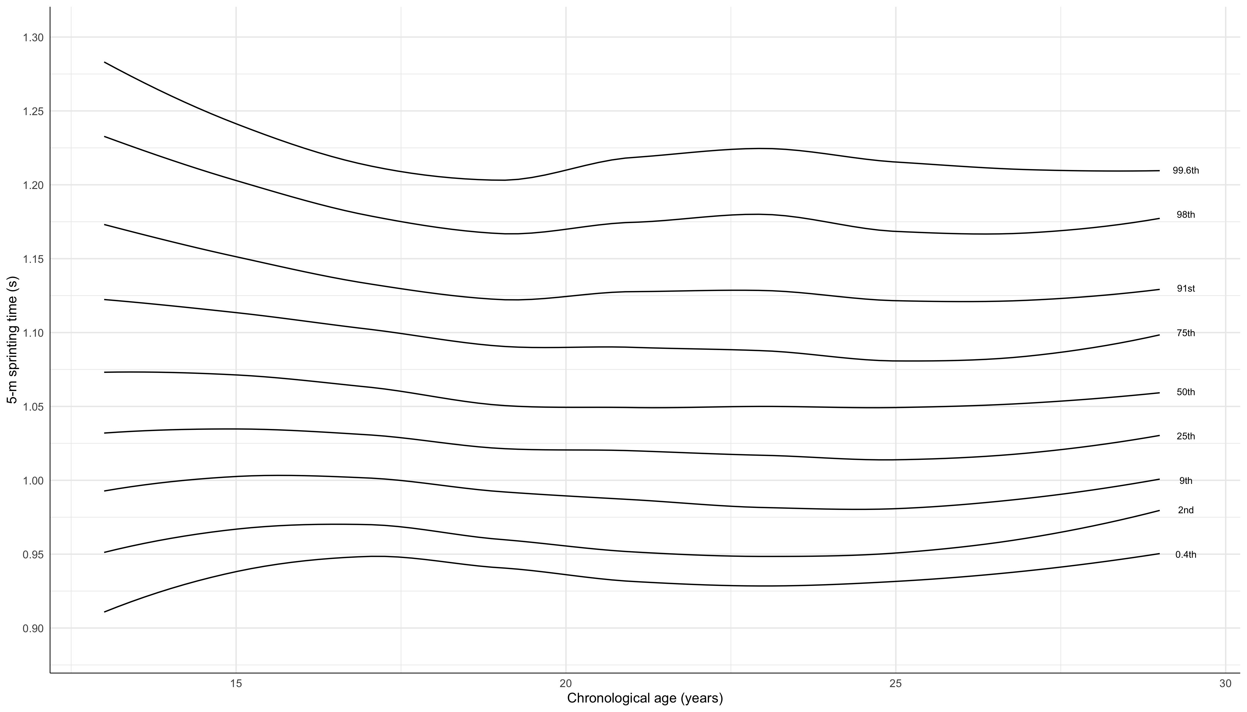

Figure 1. Predicted reference centiles for 5-m sprinting time by chronological age (N=416, n=1191)

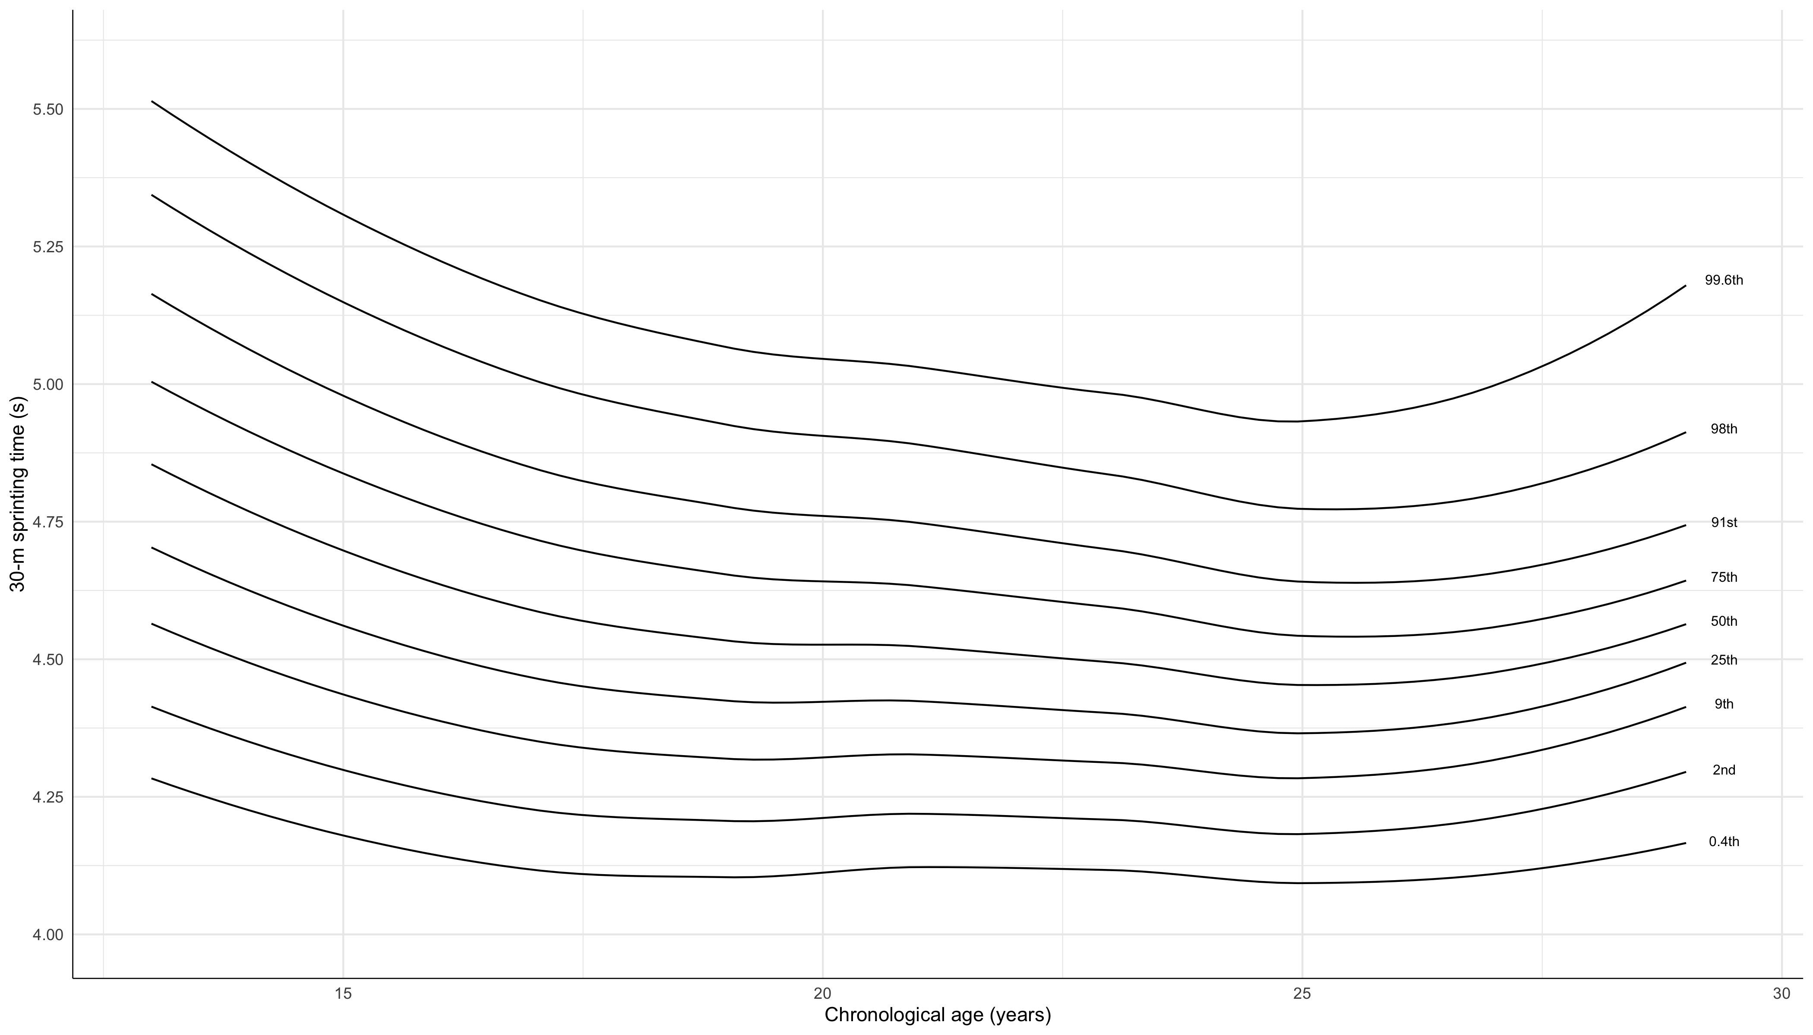
Figure 2. Predicted reference centiles for 30-m sprinting time by chronological age (N=436, n=1327)

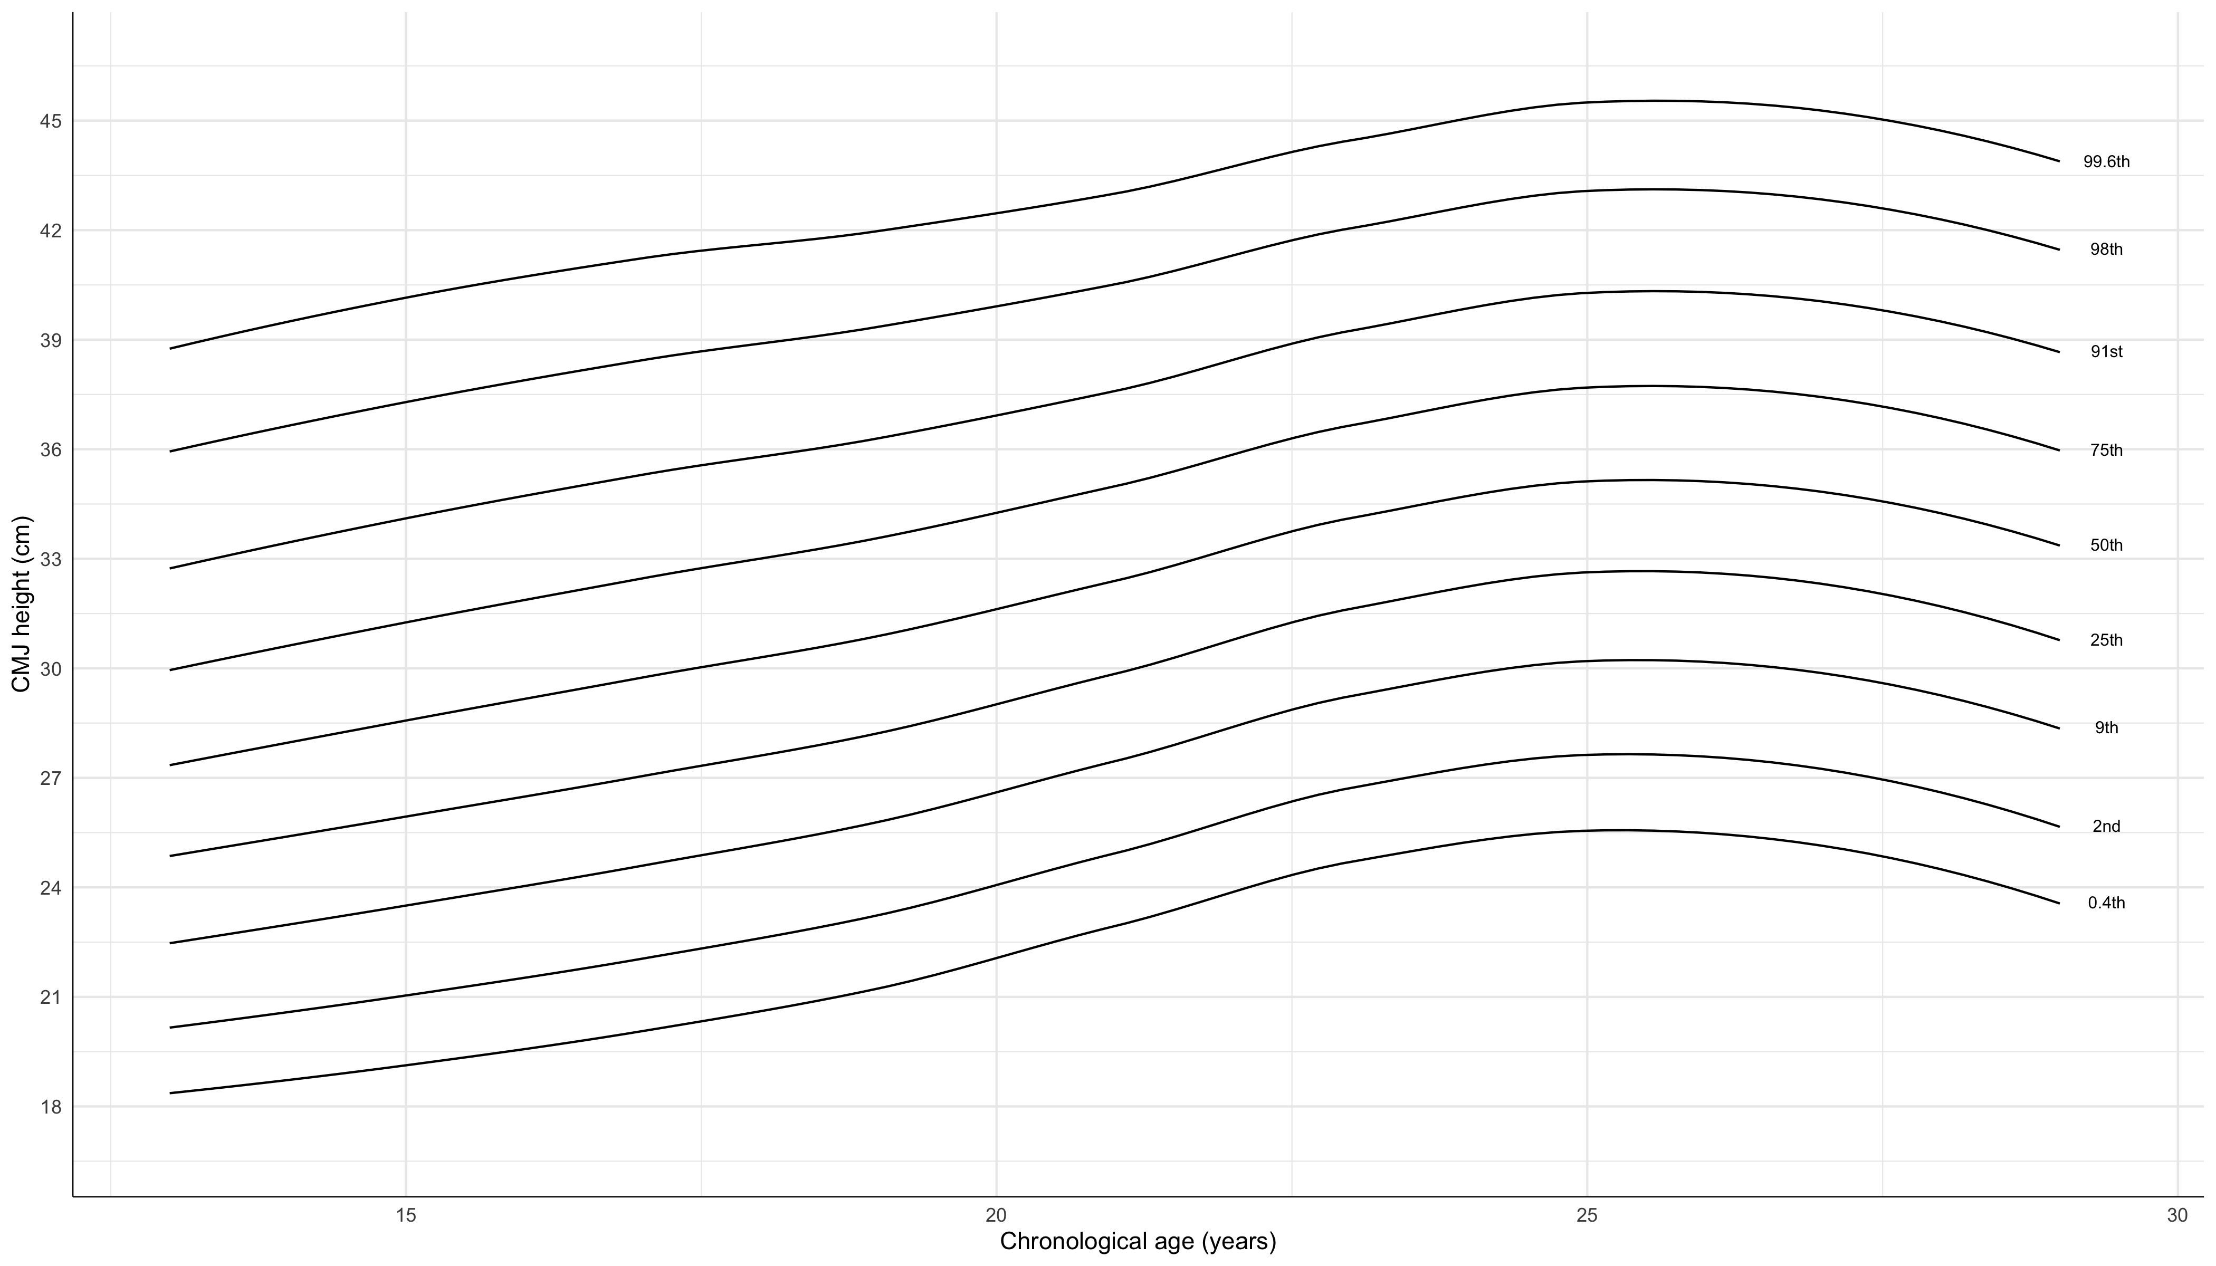

Figure 3. Predicted reference centiles for CMJ height by chronological age (N=471, n=1629)

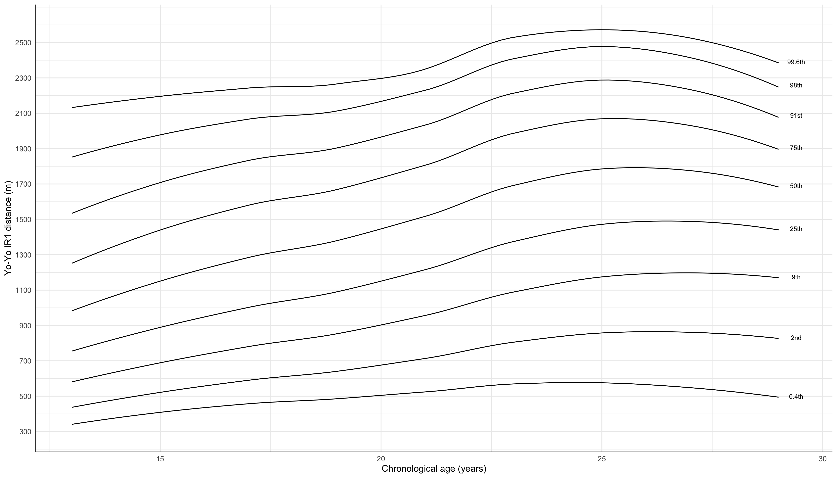

Figure 4. Predicted reference centiles for Yo-Yo IR1 distance by chronological age (N=436, n=1308)

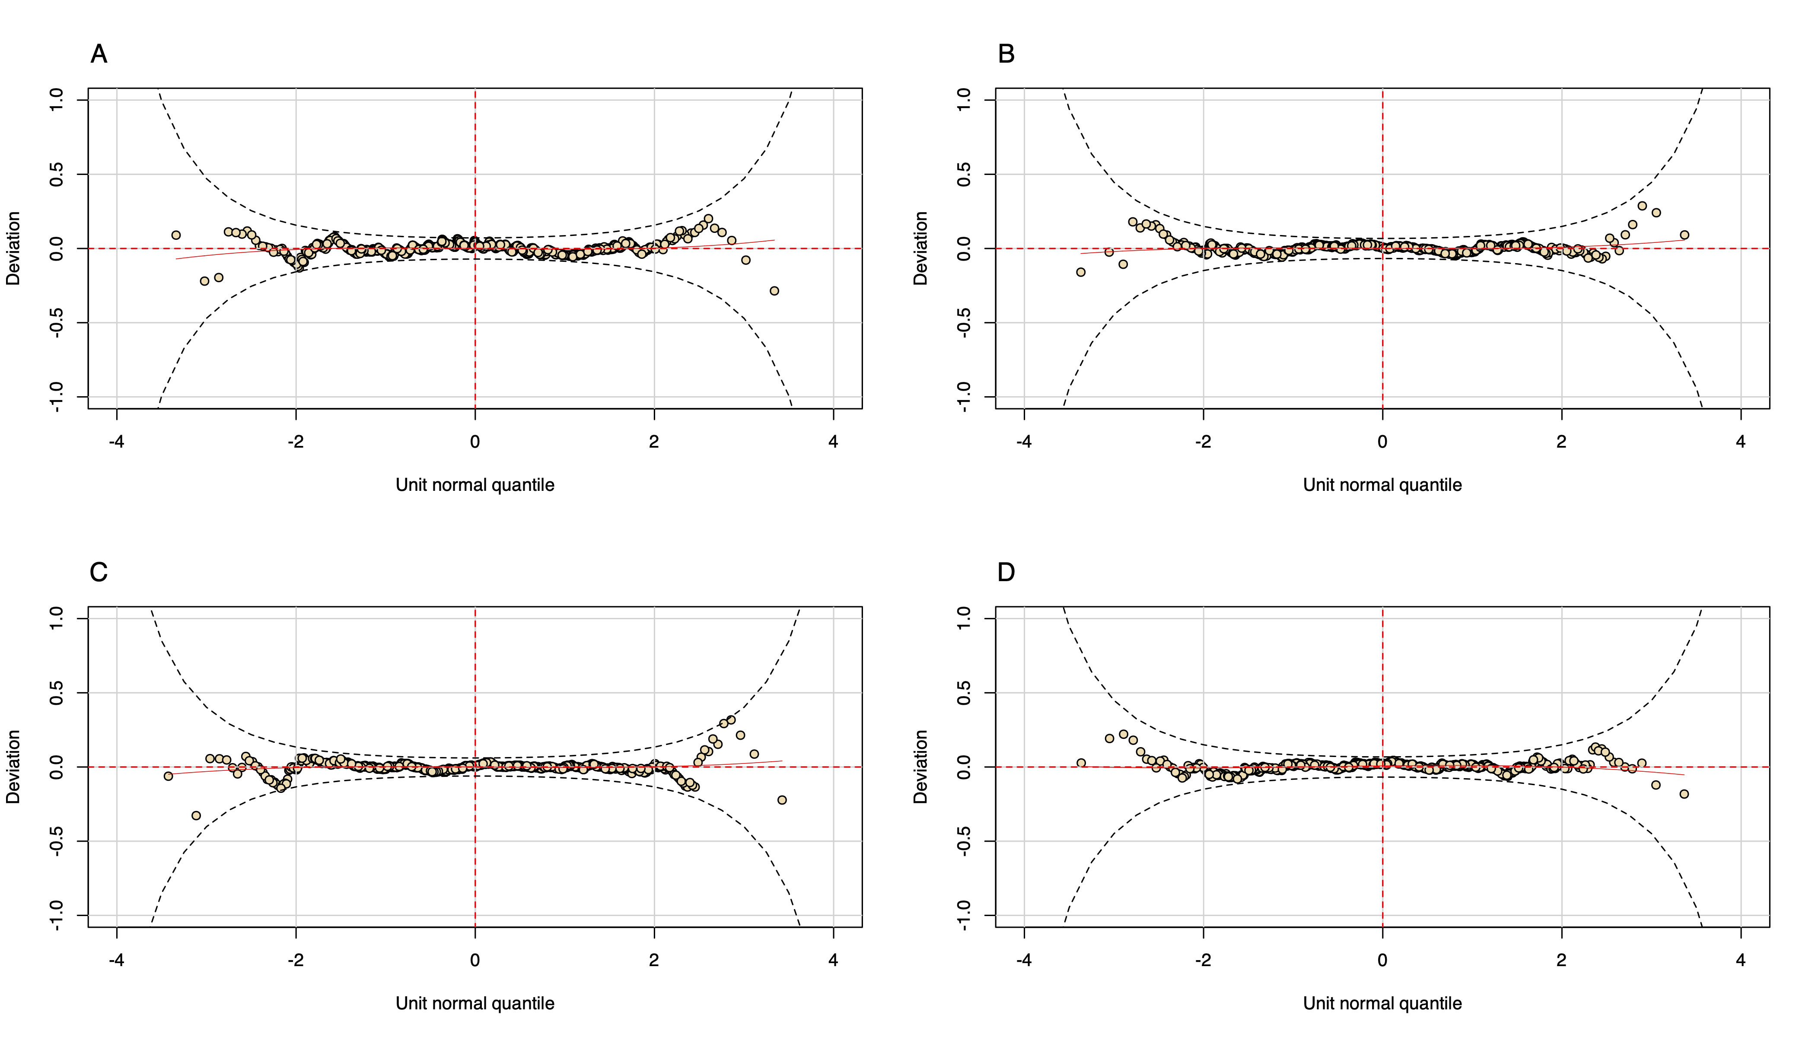

Figure 5. Worm plots from the 5-m sprinting (A), 30-m sprinting (B), CMJ (C), and Yo-Yo IR1 (D) models

