Running Head: MANIPULATING INDIVIDUAL CONSTRAINTS IN PLACE KICKING

Effects of manipulating specific individual constraints on performance outcomes, emotions, and movement phase durations in Rugby Union place kicking

Chris Pococka,b

St Mary’s University, Twickenham; University of Chichester

Neil E. Bezodisc

Swansea University

Keith Davidsd

Sheffield Hallam University

Jamie S. Northa

St Mary’s University, Twickenham

aFaculty of Sport, Allied Health and Performance Science, St Mary’s University, Twickenham, U.K.

bChichester Institute of Sport, University of Chichester, U.K.

cApplied Sports, Technology, Exercise and Medicine Research Centre, Swansea University, U.K.

dSport & Human Performance Research Group, Sheffield Hallam University, U.K.

Correspondence concerning this article should be addressed to Dr Chris Pocock, Chichester Institute of Sport, University of Chichester, Chichester, PO19 6PE. Tel: 01243 816309; Email: c.pocock@chi.ac.uk

Word count: 5,002.

**Accepted for publication in Human Movement Science on 9th July 2021.**

Abstract

Place kicks present valuable opportunities to score points in Rugby Union, contributing almost half of all points scored at international level. From an ecological dynamics perspective, place kickers adapt to interacting task, environmental, and individual constraints in performance environments. The aim of this study was to analyse effects of specific manipulations of individual constraints (fatigue; expectation for success) on place kicking performance, movement phase durations, heart rate and self-reported emotions. Under representative task and environmental constraints on an outdoor training pitch, 12 experienced, male place kickers completed four testing sessions under every combination of manipulated high/low expectation for success and manipulated levels of high/low acute fatigue. Within each session of 12 place kicks, performance outcomes from three kicking locations of varying difficulty were recorded. ANOVA revealed a two-way interaction between fatigue and expectation manipulations on mean success percentage (*p* < 0.05), with higher success under low fatigue + low expectation (*M* ± SD = 58 ± 13%) and high fatigue + high expectation (*M* ± SD = 56 ± 14%), compared with separate manipulations of high expectation (*M* ± SD = 49 ± 14%) or high fatigue (*M* ± SD = 51 ± 14%). There were no significant effects on any movement phase durations. Manipulating expectation significantly heightened mean heart rate (*p* < 0.05) and influenced emotions reported by place kickers, including higher anger scores when there was high expectation for success. Coaches are encouraged to integrate place kicking into representative game scenarios in practice environments to faithfully represent key performance constraints (e.g. fatigue; expectation for success) in preparing kickers for competitive situations.

Key words: Constraints manipulations, ecological dynamics, expectation, fatigue, place kick, practice environments

1. **Introduction**

In sporting domains such as Rugby Union, skilful behaviour can be viewed through the theoretical lens of ecological dynamics as the (re)organisation of functionally adaptive movements, which satisfy interacting task, environmental, and individual constraints to achieve performance aims (Davids, Araújo, Vilar, Renshaw, & Pinder, 2013; Newell, 1986). A key implication for practitioners and researchers adopting an ecological dynamics approach to skill acquisition is to design learning environments that offer opportunities to practice under interacting constraints which closely simulate those of competitive performance environments (Woods, McKeown, Shuttleworth, Davids, & Robertson, 2019). Manipulation of key task constraints in practice environments, such as distance between defenders and pitch boundaries, has been suggested to improve decision-making and movement exploration within open play scenarios in Rugby Union (e.g. Correia, Araújo, Duarte, Travassos, Passos, & Davids, 2012; Passos, Araújo, Davids, & Shuttleworth, 2008; McKay, Davids, Robertson, & Woods, 2021). However, to date, no empirical studies have focused on manipulating task, environmental, or individual constraints to study performance of discrete skills in Rugby Union, such as a lineout throw or place kick. Given the contribution of place kicking to the outcome of Rugby Union matches (45% of all international points scored during 2002 – 2011; Quarrie & Hopkins, 2015), it is important to understand key constraints on place kicking. Furthermore, understanding key constraints on place kicking can support the design of practice environments which faithfully represent performance environments to enhance skill transfer.

Since the conceptualisation of the Representative Learning Design framework (Pinder, Davids, Renshaw, & Araújo, 2011a), comparisons of practice and performance environments have been the focus of investigation in several sports, such as cricket (Pinder, Davids, Renshaw, & Araújo, 2011b), tennis (Krause, Farrow, Reid, Buszard, & Pinder, 2018), and springboard diving (Barris, Davids, & Farrow, 2013). Within these comparisons, researchers have studied the influence of task (e.g. ball projection versus live bowler delivery; Pinder et al., 2011b) and environmental constraints (e.g. dry versus aquatic environments; Barris et al., 2013) on movement patterns and showed significant differences in emerging behaviours when these constraints were manipulated. To extend these comparisons of task and environmental constraints in practice and performance contexts, more recent studies have recognised the important role of emotions and cognitions as individual constraints which can influence performers in practice and competition (e.g. Connor, Farrow, & Renshaw, 2018; Maloney et al., 2018). The Affective Learning Design framework, proposed by Headrick et al. (2015a), recognises the powerful influence that thoughts and emotions have on performers when in competitive performance environments, partly due to fluctuating contextual factors (e.g. score margin, time remaining). Individual constraints, such as thoughts, emotions, and fatigue induced during competition, are therefore important to consider when designing practice environments which aim to faithfully represent the demands of competitive performance.

To understand key constraints in Rugby Union place kicking, performance analytical approaches have revealed fluctuations in performance as specific task constraints (e.g. distance and angle to goalposts) and contextual factors (e.g. score margin, time remaining and previous performance of the kicker) vary (Nel, 2013; Pocock, Bezodis, Davids, & North, 2018; Quarrie & Hopkins, 2015). Furthermore, experiential knowledge of professional place kickers and experienced coaches has highlighted key individual constraints on place kicking performance, such as feelings of expectation for success and acute fatigue (Pocock, Bezodis, Davids, Wadey, & North, 2020). Understanding the experiential knowledge of practitioners and athletes, as well as insights from performance analysis, can help to identify key performance constraints which should be simulated in representative practice designs (Rothwell et al., 2020). The present study combines the findings of performance analyses of place kicking (e.g. Pocock et al., 2018; Quarrie & Hopkins, 2015) and experiential knowledge of professional place kickers and experienced coaches (Pocock et al., 2020) to inform a novel experimental design of individual constraints in place kicking. Manipulating specific individual constraints, such as expectation for success and acute fatigue, in a representative learning environment can also develop an understanding of their effects on emotions of place kickers during performance. Therefore, the aim of this study was to analyse effects of specific manipulations of individual constraints (fatigue; expectation for success) on place kicking performance, movement phase durations, heart rate and self-reported emotions.

1. **Methods**
   1. ***Participants***

Twelve experienced male place kickers (M ± SD age = 21 ± 2 years; height = 1.79 ± 0.03 m; body mass = 81.1 ± 5.9 kg) were recruited. All participants had at least three years of place kicking experience (M ± SD experience = 7 ± 3 years) at university (N = 6), club (N = 4), or school (N = 2) level. Eight participants were right-foot dominant and four were left-foot dominant. Ethical approval was granted by the lead author’s University ethics committee. Prior to testing, all participants completed a Physical Activity Readiness Questionnaire (PAR-Q) and provided written informed consent.

* 1. ***Procedure***

Participants attempted 12 place kicks in four separate testing sessions over a six-week period on a full-sized, outdoor Rugby Union pitch. The four testing sessions were counter-balanced, with each of the four sessions designed to manipulate one of the four possible combinations of fatigue and expectation for success (high or low fatigue; high or low expectation).

Participants were not cognisant of the specific aims of the study, and, to represent high expectation for success, each participant was informed of being matched with an anonymous participant who had achieved 9/12 successful place kicks. Participants were challenged to equal or better their matched participant’s score of 75%, to earn themselves and the anonymous participant a monetary reward of £10, similar to the approach used by Runswick et al. (2018) to induce pressure through expected performance levels. No monetary rewards or challenges were offered in the two testing sessions with low expectation for success. All participants were paid a total of £20 each, following completion of the study, regardless of performance.

To represent high fatigue, participants performed Rugby Union related exercises for three minutes before each place kick to represent acute fatigue induced by a prior passage of play. The fatigue protocol repetitions were adapted from the Bath University Rugby Shuttle Test (BURST) (Roberts, Stokes, Weston, & Trewartha, 2010), which is a specific exercise protocol for Rugby Union forwards that has been shown to be reproducible (Roberts et al., 2010) and previously used to be representative of Rugby Union match demands (Green, Kerr, Olivier, Meiring, Dafkin, & McKinon, 2017). Minor alterations to the BURST were made to be representative of a place kicker’s match demands, which is typically in the position of fly-half. Therefore, the fatigue protocol repetitions included passing, kicking out of hand and carrying the ball, which are the most frequent actions completed by fly-halves during a competitive match (James, Mellalieu, & Jones, 2005), combined with periods of walking, jogging and sprinting.

Each fatigue protocol repetition started and ended with a 15 m sprint, which was used as a performance test and was recorded using timing gates (Brower Timing Systems, Utah, USA). The fatigue protocol repetition lasted approximately one minute in duration and included a 20 m walk, 180° turn, 20 m cruise, 10 m jog before performing one of three actions (pass, kick out of hand, 10 m carry), and a 10 m jog. This sequence was repeated three times before each place kick so that the participant could complete each of the three actions in a randomised order.

Within each testing session, participants performed four sets of place kicks from three locations, which were completed in a non-sequential order to ensure changes in task constraints between every kick, representing competitive environments. Therefore, the order of place kicks was different in each of the four testing sessions for each participant. The categorisation of the three kicking locations were made relative to the distance and angle from the goalposts (Figure 1). These locations of varying task difficulty were based on evidence from the experiential knowledge of professional place kickers and experienced coaches (Pocock et al., 2020), and based on data from performance analysis of place kicking in the 2015 Rugby World Cup (Pocock et al., 2018). The first kicking location was situated directly in front of the goalposts (0° to goalposts) on the 22 m line, categorised as an “easy” location. The second kicking location was situated 15 m infield from the left touchline for right-footed participants (symmetrically positioned for left-footed participants), which had a distance of 32 m to the goalposts and was categorised as a “threshold” location. The third kicking location was situated on the left touchline (symmetrically positioned for left-footed participants). This kick location was 42 m from the goalposts and was categorised as a “difficult” location, designed to be a challenging place kick for experienced place kickers.

|  |
| --- |
|  |
| Figure 1. Kicking locations for right footed and left footed place kickers. Angles annotated on the figure are relative to a kick from directly in front of the goalposts being 0°. Locations for the right-footed kickers are on the left side of the pitch; locations for left-footed kickers are on the right side of the pitch and are reflections about the 0° line. |

Participants used size 5 Gilbert G-TR 3000 Rugby Union balls throughout the study, which were fully inflated before each testing session. For familiarity, participants used their own kicking tees and no instructions regarding routines or kicking preparation were provided. Participants completed each testing session individually, with two researchers recording dependent measures and no other participants present. Before each testing session, participants completed a self-directed warm-up and were allowed two practice kicks from any location. Two 50 Hz cameras (Panasonic HC-V210 HD Camcorder, Panasonic, Berkshire, U.K.) were positioned behind the goalposts to assist with recording kicking performance measures. To determine the phase durations of participants’ movements whilst completing each kick, a camera recording at 50 Hz (Panasonic HC-V720 HD Camcorder, Panasonic, Berkshire, U.K.) was used for the preparation phase and a portable electronic tablet (Apple Inc., California, USA) recording at 240 Hz was used for the approach phase, kicking phase and follow through phase (see *Phase Durations* for definitions). Participants wore a heart rate monitor (Polar V800, Polar Electro Oy, Kempele, Finland) to record heart rate continuously during testing sessions. Full heart rate data were available for 41 of 48 testing sessions, which allowed mean heart rate to be calculated for each of the four combinations of experimental manipulations. Heart rate data for seven testing sessions were unavailable due to a technical fault.

Testing sessions only took place in dry weather conditions with a wind speed below 8 m/s, which is categorised as a moderate breeze on the Beaufort Scale. Before each testing session, the air temperature was recorded (M ± SD temperature = 16.0 ± 3.8°C) and wind speed (M ± SD wind speed = 1.7 ± 1.4 m/s) was measured to ensure that extremely varying environmental conditions did not interfere with the study outcomes.

* 1. ***Dependent Measures***
     1. *Performance Measures*

Each place kick was recorded as successful (ball passed between goalposts and above crossbar) or unsuccessful (ball did not pass between goalposts and above crossbar), to record mean success percentage as a performance outcome.

* + 1. *Phase Durations*

For each place kick, four temporal phases (Figure 2) were identified based on definitions from previous research (Bezodis, Atack, & Winter, 2017; Jackson & Baker, 2001) and the durations of each phase were determined using Kinovea (version 0.8.15). The first phase, the preparation phase, began when both hands of the participant were no longer touching the ball, and ended when one of the participant’s feet first left the pitch as they initiated their movement towards the ball. The second phase, the approach phase, began from this movement initiation instant and ended when the non-kicking foot (support foot) contacted the pitch next to the ball. The third phase, the kicking phase, began at support foot contact and ended when the kicking foot first contacted the ball. The fourth phase, the follow through phase, began at ball contact and ended when the kicking foot first contacted the pitch following the kicking action.

|  |  |
| --- | --- |
|  |  |
| Figure 2. Start and end frames for each of the four phase durations, with events identified above the images (see methods for full definitions) and corresponding phases between each event identified below the images. Note: the spacing and sizing of the images are not scaled to time. |  |

* + 1. *Psychological Measures*

To measure emotions of participants during testing sessions, two questionnaires were used. The Mental Readiness Form-Likert (MRF-L; Krane, 1994) was completed by participants at five time points in each testing session; before the first kick, after three kicks, after six kicks, after nine kicks, and after 12 kicks. The three scales required participants to rate their cognitive anxiety (1 = calm, 11 = worried), somatic anxiety (1 = relaxed, 11 = tense), and their confidence (1 = confident, 11 = scared).

The Sport Learning and Emotions Questionnaire (SLEQ; Headrick, Renshaw, & Davids, 2015b) was used to measure the emotions of participants before the first place kick and after the 12th place kick of each testing session, consistent with previous research (Connor et al., 2018). The SLEQ is comprised of 17 words which participants rated on a scale from 0 (not at all) to 4 (extremely). The 17 ratings are categorised into four main themes (enjoyment, nervousness, fulfilment, anger). The shorter MRF-L was used during testing sessions and the longer SLEQ was used before and after testing sessions to maintain the timings of the fatigue protocol.

* + 1. *Physiological Measures*

Mean heart rate was recorded throughout the testing session for all four combinations of experimental manipulations. Consistent with previous research of kicking tasks under fatigue manipulations (e.g. Coventry, Ball, Parrington, Aughey, & McKenna, 2015), 15 m sprint times were compared throughout the 12 fatigue protocol repetitions.

* 1. ***Statistical Analysis***

Several, separate, two-way repeated measures ANOVAs were used to analyse effects of experimental manipulations (fatigue; expectation) on mean success percentage, mean heart rate, and each phase duration. A number of separate three-way repeated measures ANOVAs were used to analyse effects of experimental manipulations (fatigue; expectation) and kicking location on mean success percentage; experimental manipulations (fatigue; expectation) and time point on MRF-L and SLEQ scores. A one-way repeated measures ANOVA was used to analyse effects of fatigue protocol repetition number on 15 m sprint times. Any violations of sphericity for repeated measures variables (*p* < 0.05 on Mauchly’s test) were corrected for by adjusting the degrees of freedom using the Greenhouse-Geisser correction when Epsilon (ε) was less than 0.75 and the Huynh-Feldt correction when ε was greater than 0.75. Post hoc analyses using pairwise comparisons included a Bonferroni correction. Effect sizes are reported using partial eta squared (*ηp*2) and alpha level (*p*) for statistical significance was set at 0.05.

1. **Results**
   1. ***Performance Measures***
      1. *Mean Success Percentage*

ANOVA revealed a significant two-way interaction between fatigue and expectation manipulations on mean success percentage of kicks (*F* (1,11) = 7.53, *p* < 0.05, *ηp*2 = 0.41). There were no significant main effects of fatigue manipulation (*p* > 0.99), or expectation manipulation (*p* = 0.52) as mean success percentage was higher in the low fatigue, low expectation manipulation (*M* ± SD = 58 ± 13%) and in the high fatigue, high expectation manipulation (*M* ± SD = 56 ± 14%), compared with low fatigue, high expectation manipulation (*M* ± SD = 49 ± 14%) and high fatigue, low expectation manipulation (*M* ± SD = 51 ± 14%) (Figure 3).

|  |
| --- |
|  |
| Figure 3. Mean ± SD success percentages under manipulations of fatigue (diagonal shading if high) and expectation (light grey fill if high). A significant two-way interaction between fatigue and expectation was present. |

* + 1. *Success Percentages across Different Kicking Locations*

ANOVA revealed no significant three-way interaction between fatigue manipulation, expectation manipulation and kicking location on mean success percentage (*F* (2,22) = 0.69, *p* = 0.51, *ηp*2 = 0.06). There were no significant two-way interactions between fatigue manipulation and kicking location (*p* = 0.75), or between expectation manipulation and kicking location (*p* = 0.26). There were no significant main effects of fatigue (*p* > 0.99), or expectation manipulation (*p* = 0.52) on mean success percentage. There was a significant main effect of kicking location on mean success percentage (*F* (2,22) = 124.91, *p* < 0.05, *ηp*2 = 0.92). Post hoc analyses revealed that mean success percentage was significantly higher from the “easy” location (*M* ± SD = 83 ± 18%) compared with the “threshold” location (*M* ± SD = 63 ± 26%; *p* < 0.05), from the “threshold” location compared with the “difficult” location (*M* ± SD = 14 ± 22%; *p* < 0.05), and from the “easy” location compared with the “difficult” location (*p* < 0.05) (Figure 4).

|  |
| --- |
|  |
| Figure 4. Mean ± SD success percentages from the “easy” location, “threshold” location, and “difficult” location under manipulations of fatigue and expectation. * indicates significant differences in mean success percentage between kicking locations (*p* < 0.05). |

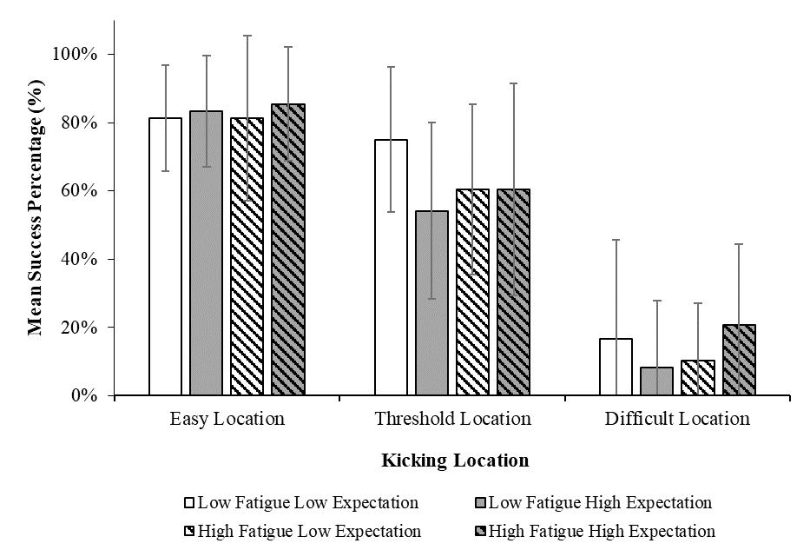

*

*

*

* 1. ***Phase Durations***

Mean ± SD phase duration values for each of the four phases are presented in Table 1. ANOVAs revealed no significant interaction between fatigue and expectation manipulations on mean duration time of the preparation phase (*p* = 0.20), approach phase (*p* = 0.59), kicking phase (*p* = 0.95) or follow through phase (*p* = 0.82).

|  |  |  |  |  |
| --- | --- | --- | --- | --- |
| Table 1. Mean ± SD phase duration values under manipulations of fatigue and expectation. | | | | |
| **Phase Duration** | **Low Fatigue, Low Expectation** | **Low Fatigue, High Expectation** | **High Fatigue, Low Expectation** | **High Fatigue, High Expectation** |
| Preparation Phase (s) | 18.71 ± 8.88 | 18.07 ± 6.98 | 17.75 ± 7.03 | 18.73 ± 6.87 |
| Approach Phase (s) | 2.09 ± 0.62 | 2.10 ± 0.54 | 2.02 ± 0.50 | 2.00 ± 0.53 |
| Kicking Phase (s) | 0.11 ± 0.01 | 0.11 ± 0.01 | 0.11 ± 0.01 | 0.11 ± 0.01 |
| Follow Through Phase (s) | 0.37 ± 0.10 | 0.36 ± 0.10 | 0.37 ± 0.09 | 0.35 ± 0.08 |

* 1. ***Emotions***
     1. *Mental Readiness Form – Likert (MRF-L)*

ANOVA revealed no significant three-way interaction between fatigue manipulation, expectation manipulation and time point on mean MRF-L scores (*p* = 0.70). There were no significant two-way interactions between fatigue manipulation and time point (*p* = 0.06), expectation manipulation and time point (*p* = 0.18), or fatigue and expectation manipulations (*p* = 0.41).

There was a significant main effect of time point on mean MRF-L scores (*F* (2.01, 22.08) = 14.55, *p* < 0.05, *ηp*2 = 0.57), with post hoc analyses revealing that mean MRF-L scores were significantly higher after three kicks (*M* ± SD = 3.82 ± 1.58; *p* < 0.05), six kicks (*M* ± SD = 4.09 ± 1.93; *p* < 0.05), nine kicks (*M* ± SD = 4.38 ± 1.84; *p* < 0.05), and 12 kicks (*M* ± SD = 4.15 ± 1.67; *p* < 0.05), compared with before first kick (*M* ± SD = 3.09 ± 1.30). There were no significant main effects of fatigue manipulation (*p* = 0.30) or expectation manipulation (*p* = 0.17) on mean MRF-L scores (Figure 5).

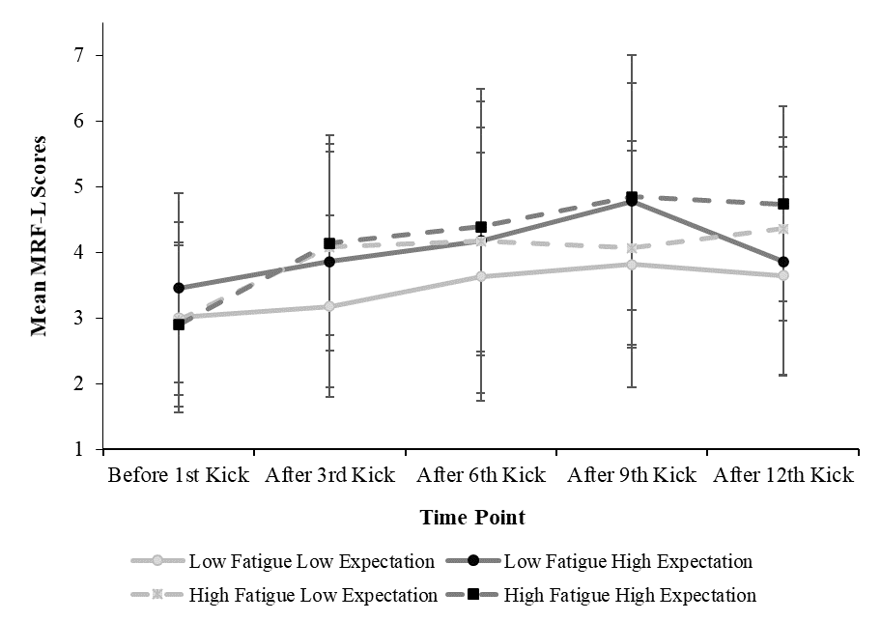

*

*

*

*

|  |
| --- |
|  |
| Figure 5. Mean ± SD Mental Readiness Form – Likert (MRF-L) scores before the first place kick, after three place kicks, after six place kicks, after nine place kicks, and after 12 place kicks, under manipulations of fatigue and expectation.* indicates a significant pairwise difference (*p* < 0.05). |

* + 1. *Sport Learning and Emotions Questionnaire (SLEQ)*

ANOVA revealed a significant three-way interaction between fatigue manipulation, expectation manipulation, and time point on mean SLEQ scores (*F* (1, 11) = 5.07, *p* < 0.05, *ηp*2 = 0.32). There were no significant two-way interactions between fatigue manipulation and time point (*p* = 0.32), expectation manipulation and time point (*p* = 0.54), or fatigue manipulation and expectation manipulation (*p* = 0.48) on mean SLEQ scores. There were no significant main effects of fatigue manipulation (*p* = 0.70) or expectation manipulation (*p* = 0.15).

There was a significant main effect of time point (*F* (1, 11) = 14.85, *p* < 0.05, *ηp*2 = 0.57), with mean SLEQ scores significantly higher after the 12th kick (*M* ± SD = 1.43 ± 0.34) compared with before first kick (*M* ± SD = 1.20 ± 0.36). After the 12th kick, mean SLEQ scores were higher in the high fatigue, high expectation manipulation (*M* ± SD = 1.51 ± 0.28), compared with low fatigue, low expectation manipulation (*M* ± SD = 1.36 ± 0.39), low fatigue, high expectation manipulation (*M* ± SD = 1.42 ± 0.41), and high fatigue, low expectation manipulation (*M* ± SD = 1.41 ± 0.30).

ANOVAs revealed no significant three-way interaction between fatigue manipulation, expectation manipulation and time point on sub-sections of Enjoyment (*p* = 0.44), Nervousness (*p* = 0.63), Fulfilment (*p* = 0.54), or Anger (*p* = 0.60) within the SLEQ.

There was a significant two-way interaction between expectation manipulation and time point on Anger scores (*F* (1, 11) = 5.74, *p* < 0.05, *ηp*2 = 0.34; Figure 6), with Anger scores in the high expectation manipulations higher after 12 kicks (*M* ± SD = 1.36 ± 0.86), compared with low expectation manipulations after 12 kicks (*M* ± SD = 0.96 ± 0.75). There was a significant main effect of time point on Anger scores (*F* (1, 11) = 38.40, *p* < 0.05, *ηp*2 = 0.78), but no significant main effect of expectation manipulation (*p* = 0.17). There were no significant two-way interactions of fatigue manipulation and time point (*p* = 0.15), or fatigue manipulation and expectation manipulation (*p* = 0.91) on Anger scores.

|  |
| --- |
|  |
| Figure 6. Mean ± SD Anger scores (SLEQ) before the first place kick and after the 12th place kick under low and high manipulations of expectation. A significant two-way interaction between time point and expectation manipulation was present. |

* 1. ***Physiological Responses***
     1. *Heart Rate*

ANOVA revealed no significant interaction between fatigue and expectation manipulations on mean heart rate (*p* = 0.90). There was a significant main effect of fatigue manipulation on mean heart rate (*F* (1, 6) = 41.65, *p* < 0.05, *ηp*2 = 0.87), with mean heart rate in high fatigue manipulations (*M* ± SD = 137 ± 15 bpm) higher than in low fatigue manipulations (*M* ± SD = 109 ± 11 bpm). There was also a significant main effect of expectation manipulation on mean heart rate (*F* (1, 6) = 10.23, *p* < 0.05, *ηp*2 = 0.63), with mean heart rate in high expectation manipulations (*M* ± SD = 124 ± 20 bpm) higher than in low expectation manipulations (*M* ± SD = 122 ± 18 bpm).

* + 1. *Sprint Times in Fatigue Protocol*

ANOVA revealed there was a significant main effect of fatigue protocol repetition number on mean 15 m sprint times (*F* (3.59, 82.51) = 8.15, *p* < 0.05, *ηp*2 = 0.26). Post hoc analyses revealed that mean sprint times in repetition 12 (*M* ± SD = 2.91 ± 0.32 s) were significantly longer than in repetition 1 (*M* ± SD = 2.72 ± 0.15 s; *p* < 0.05), repetition 2 (*M* ± SD = 2.74 ± 0.16 s; *p* < 0.05), repetition 3 (*M* ± SD = 2.81 ± 0.29 s; *p* < 0.05), and repetition 4 (*M* ± SD = 2.80 ± 0.28 s; *p* < 0.05) (Figure 7).

|  |
| --- |
|  |
| Figure 7. Mean ± SD 15 m sprint times before each place kick within high fatigue manipulations. * indicates a significant pairwise difference (*p* < 0.05). |

1. **Discussion**

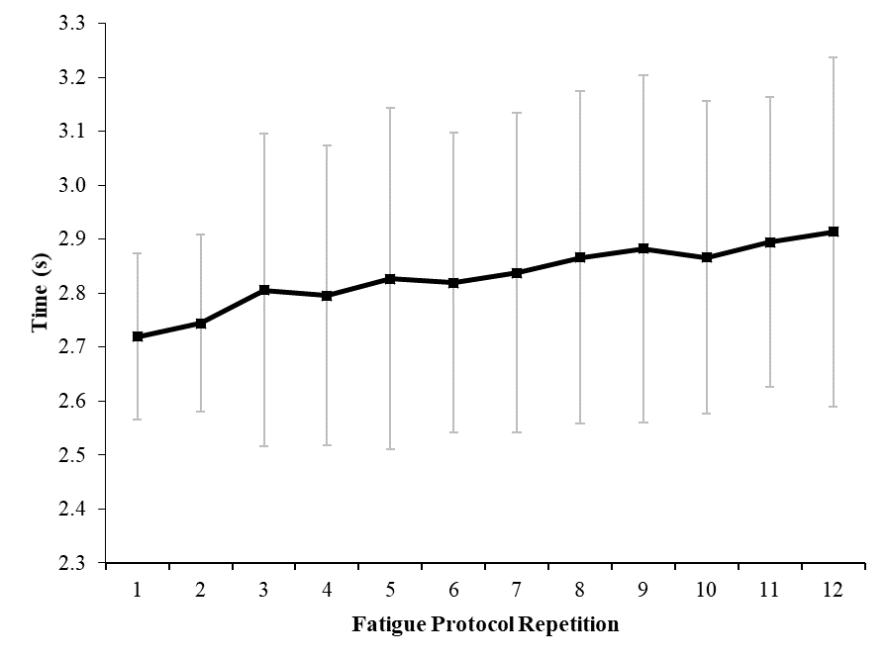

*

*

*

*

The aim of this study was to analyse effects of specific manipulations of individual constraints (fatigue; expectation for success) on place kicking performance, movement phase durations, heart rate and self-reported emotions. A significant two-way interaction between fatigue and expectation manipulations showed that mean success percentage was higher in the low fatigue, low expectation manipulation and the high fatigue, high expectation manipulation, compared with separate manipulations of high fatigue or high expectation. Results suggested that the acute fatigue protocol used in this study was effective, with participants recording significantly longer 15 m sprint times in later repetitions compared with the first repetition of the fatigue protocol in high fatigue manipulations. Moreover, participants recorded significantly higher mean heart rate in high fatigue manipulations, compared with low fatigue manipulations. There was also a significant main effect of expectation on mean heart rate and a significant two-way interaction between expectation manipulation and time point on Anger scores.

Expectation for successful performance has been associated with increased anxiety, with similar manipulations to those used in this study (e.g. peer comparison; monetary rewards) showing performance decrements (e.g. Runswick et al., 2018; Wilson, Vine, & Wood, 2009). Mean success percentage of place kickers was lowest under low fatigue and high expectation, particularly at the threshold location, which has previously been shown as a pitch area where place kicking performance drops below mean success (Pocock et al., 2018). However, the interaction between high expectation for success and high fatigue, and their combined effects on performance, is more complex.

Previous research has shown that manipulating fatigue and increasing pressure using expected success levels can influence additive effects of manipulations, leading to lowest performance levels when fatigue and expectation are both high (e.g. Vickers & Williams, 2007). In contrast, the present study demonstrates that place kicking performance can be maintained under high fatigue and high expectation for success, where manipulations were designed to be representative of performance environments. This maintenance of performance is consistent with that previously observed in military environments, where shooting accuracy was higher under high fatigue and high expectation for success, compared with low fatigue and high expectation for success (Nibbeling, Oudejans, Ubink, & Daanen, 2014). Furthermore, Nibbeling et al. (2014) observed performance on cognitive tasks, such as mathematical performance, to decline under fatigue. Unlike generic fatiguing protocols which may be laboratory based or unrelated to the task, designing representative fatiguing protocols which simulate demands of performance environments appear to potentially enable a maintenance in performance under high fatigue and high expectation for success. Place kicking with *either* high fatigue *or* high expectation decoupled the combination of high fatigue and high expectation (e.g. typical performance environment) or low fatigue and low expectation (e.g. typical practice environment; Pocock et al., 2020) and this was detrimental to performance. These findings highlight the powerful, interactive influence that key individual constraints (e.g., fatigue; expectation for success) can have on place kicking performance and that their interactions should be considered when designing practice environments. For example, manipulating high expectation for success without considering the fatigue induced by previous passages of play may be detrimental to performance in practice. Moreover, this manipulation is not representative of performance environments due to the perceived unfamiliarity of kicking under pressure without the presence of any acute fatigue effects, which may influence the reciprocal relationship between perception and action. To maintain perception-action coupling, key constraints should be represented in practice to ensure that place kickers are attuning to similar affordances (opportunities for action) to those encountered in competition (Passos et al., 2008). Specialist place kicking coaches are encouraged to incorporate place kicking into game situations in practice to represent the combination of high fatigue and high expectation for success and to enhance skill transfer to performance environments.

To extend beyond the analysis of performance outcomes, timings of place kickers’ actions were analysed during four specific phases (preparation phase, approach phase, kicking phase, follow through phase). Despite fluctuations in performance outcomes under different combinations of manipulations, perhaps unsurprisingly, there were no significant differences in timings of any of the four specific phases. It is therefore suggested that aspects other than these temporal movement phase durations were changing to shape the fluctuating performance outcomes under manipulations of fatigue and expectation. For example, changes in any spatial aspects of technique during the kicking action could contribute to the fluctuations in performance observed. Future research would benefit from kinematic measures of the techniques of place kickers in representative environments. This type of research can help to understand the movement patterns which contribute to observed performance fluctuations under varying levels of fatigue and expectation of success.

Analyses of MRF-L (Krane, 1994) and SLEQ (Headrick et al., 2015b) results revealed various changes in emotions throughout testing sessions. These changes included a significant main effect for time point on mean MRF-L and SLEQ scores, which suggest that emotions were heightened during and after the 12 place kicks. Within the SLEQ, which is made up of four constructs (Enjoyment, Nervousness, Fulfilment, Anger), there was a significant two-way interaction between expectation manipulation and time point on Anger scores. Mean Anger scores were comprised of three statements: “annoyed”, “angry”, and “frustrated”; and scores were significantly higher after the 12th kick in manipulations of high expectation, compared with before the first kick. Most place kickers did not achieve the expected target of 9/12 successful place kicks under high expectation (92% of testing sessions). These findings suggest that the deliberate manipulation of a challenging target influenced athlete task engagement, reflected in the reported increase in feelings of annoyance, anger and frustration. Coaches are encouraged to introduce similar manipulations, or vignettes, with meaningful consequences in practice environments to allow place kickers to practice under varying emotional states and learn to self-regulate when facing potential emotional perturbations to performance. However, this decision is dependent on individual needs and differences since more achievable performance targets relative to skill level could be also used, which may increase engagement through enhanced enjoyment and fulfilment. Previous research has highlighted the reduced frequency of emotions in practice environments, compared with performance environments (e.g. Maloney et al., 2018). The Affective Learning Design framework (Headrick et al., 2015a) advocates greater recognition of emotions in practice environments to enhance athlete engagement, opportunities for self-regulation, skill transfer and adaptability. Therefore, coaches are encouraged to design scenarios in practice environments which simulate emotional perturbations of competitive performance environments to encourage adaptability and self-regulation in place kickers.

Several measures were used to check that the fatigue protocol was successful. Sprint times were significantly slower in later repetitions, compared with earlier repetitions and mean heart rate was significantly higher in high fatigue manipulations, compared with low fatigue manipulations. Interestingly, mean heart rate values were also significantly higher under high expectation manipulations, compared with low expectation manipulations. Increased heart rate is generally assumed to provide an indication of increased anxiety in tasks with comparable levels of physical exertion (see Oudejans & Pijpers, 2009). This observation suggests that manipulations of high expectation may have induced increased levels of performance anxiety in participants, compared with manipulations of low expectation. To further explore effects of manipulating expectation for success on place kicking preparation, gaze behaviours and verbal reports of place kickers could be studied to understand effects of participant perceptions of task difficulty. The recording of physiological measures such as heart rate, combined with psychological measures of emotions, provide initial insights into the influence of individual constraints on place kicking. Furthermore, these insights highlight the need for future interdisciplinary research to understand key underpinnings of expertise when performing skills (Gobet, 2018). Within applied sport performance and practice settings, Rugby Union clubs can apply the theoretical concepts of ecological dynamics to guide practice designs during training, intended to prepare athletes for competition (McKay et al., 2021). Clubs can use the collaborative expertise of coaches, performance analysts, strength and conditioning trainers, sport psychologists, and skill acquisition specialists in a department of methodology (Rothwell et al., 2020) to understand the influence of key interacting task, environmental and individual constraints on place kicking performance and inform representative practice design.

1. **Conclusion**

Effects of key individual constraints (fatigue; expectation for success) on place kicking performance were analysed in a representative Rugby Union environment. Fatigue and expectation for success had a significant interaction effect on performance outcomes, with mean success percentage higher under manipulations of low fatigue, low expectation and high fatigue, high expectation, compared with separate manipulations of high expectation or high fatigue. However, there were no significant differences in any of the four specific movement phase durations of a place kick across any manipulations.

Whilst there were no significant changes in reported emotions under manipulations of fatigue, anger scores of place kickers increased significantly under high expectation, which highlights the influence of expectation for success on emotions of place kickers. There was a significant main effect of expectation on heart rate of place kickers and it is suggested that this was a potential indication of increased anxiety, whilst the significant main effect of fatigue on heart rate and significant changes in sprint times were indications of an effective fatiguing protocol.

The present study highlighted how manipulating key individual constraints of fatigue and performance expectations, whilst standardising task constraints in a representative practice environment, influenced mean success percentage outcomes of place kicking performance. Given the influence of key individual constraints on performance in this study, coaches are encouraged to design representative practice environments for place kickers which simulate cognitions, emotions and fatigue experienced in performance environments.

Acknowledgements

The authors would like to thank Ollie Rossi for his assistance with data collection.

Funding

This research did not receive any specific grant from funding agencies in the public, commercial, or not-for-profit sectors.

References

Barris, S., Davids, K., & Farrow, D. (2013). Representative learning design in springboard diving: Is dry-land training representative of a pool dive? *European Journal of Sport Science*, *13*(6), 638-645. <https://doi.org/10.1080/17461391.2013.770923>

Bezodis, N. E., Atack, A., & Winter, S. (2017). The biomechanics of place kicking in Rugby Union. In H. Nunome, E. Hennig & N. Smith (Eds.), *Football Biomechanics* (pp. 24-35). London: Routledge.

Connor, J. D., Farrow, D., & Renshaw, I. (2018). Emergence of skilled behaviors in professional, amateur and junior cricket batsmen during a representative training scenario. *Frontiers in Psychology*, *9*(2012), 1-14. <https://doi.org/10.3389/fpsyg.2018.02012>

Correia, V., Araújo, D., Duarte, R., Travassos, B., Passos, P., & Davids, K. (2012). Changes in practice task constraints shape decision-making behaviours of team games players. *Journal of Science and Medicine in Sport*, *15*(3), 244-249. <https://doi.org/10.1016/j.jsams.2011.10.004>

Coventry, E., Ball, K., Parrington, L., Aughey, R., & McKenna, M. (2015). Kinematic effects of a short-term fatigue protocol on punt-kicking performance. *Journal of Sports Sciences*, *33*(15), 1596-1605. <https://doi.org/10.1080/02640414.2014.1003582>

Davids, K., Araújo, D., Vilar, L., Renshaw, I., & Pinder, R. (2013). An ecological dynamics approach to skill acquisition: Implications for development of talent in sport. *Talent Development and Excellence*, *5*(1), 21-34.

Gobet, F. (2018). The future of expertise: The need for a multidisciplinary approach. *Journal of Expertise*, *1*(2), 1-7.

Green, A., Kerr, S., Olivier, B., Meiring, R., Dafkin, C., & McKinon, W. (2017). A simulated rugby match protocol induces physiological fatigue without decreased individual scrummaging performance. *South African Journal of Sports Medicine*, *29*(1), 1-6.

Headrick, J., Renshaw, I., Davids, K., Pinder, R. A., & Araújo, D. (2015a). The dynamics of expertise acquisition in sport: The role of affective learning design. *Psychology of Sport and Exercise*, *16*, 83-90. <https://doi.org/10.1016/j.psychsport.2014.08.006>

Headrick, J., Renshaw, I., and Davids, K. (2015b). *Affective learning design: A principled approach to emotion in learning*. Ph.D. thesis, Queensland University of Technology, Brisbane, Australia.

Hutto, D. D. (2012). Truly enactive emotion. *Emotion Review*, *4*(2), 176-181. <https://doi.org/10.1177/1754073911430134>

Jackson, R. C., & Baker, J. S. (2001). Routines, rituals, and rugby: Case study of a world class goal kicker. *The Sport Psychologist*, *15*(1), 48-65. <https://doi.org/10.1123/tsp.15.1.48>

James, N., Mellalieu, S., & Jones, N. (2005). The development of position-specific performance indicators in professional rugby union. *Journal of Sports Sciences*, *23*(1), 63-72. <https://doi.org/10.1080/02640410410001730106>

Krane, V. (1994). The Mental Readiness Form as a measure of competitive state anxiety. *The Sport Psychologist, 8*, 189–202. <https://doi.org/10.1123/tsp.8.2.189>

Krause, L., Farrow, D., Reid, M., Buszard, T., & Pinder, R. (2018). Helping coaches apply the principles of representative learning design: validation of a tennis specific practice assessment tool. *Journal of Sports Sciences*, *36*(11), 1277-1286. <https://doi.org/10.1080/02640414.2017.1374684>

Maloney, M. A., Renshaw, I., Headrick, J., Martin, D. T., & Farrow, D. (2018). Taekwondo fighting in training does not simulate the affective and cognitive demands of competition: Implications for behavior and transfer. *Frontiers in Psychology*, *9*(25). <https://doi.org/10.3389/fpsyg.2018.00025>

McKay, J., Davids, K., Robertson, S., & Woods, C. T. (2021). An ecological insight into the design and integration of attacking principles of play in professional Rugby Union: a case example. *International Sport Coaching Journal*, *1*, 1-6. <https://doi.org/10.1123/iscj.2020-0065>

Nel, J. (2013). Estimating success probability of a rugby goal kick and developing a measure for ranking rugby union goal kickers. *South African Journal for Research in Sport, Physical Education and Recreation*, *35*(1), 133-142.

Newell, K. M. (1986). Constraints on the development of coordination. In M. G. Wade & H. T. A. Whiting (Eds.), *Motor development in children: aspects of coordination and control* (pp. 341-360). Dordrecht, Netherlands: Martinus Nijhoff. <https://doi.org/10.1007/978-94-009-4460-2_19>

Nibbeling, N., Oudejans, R. R., Ubink, E. M., & Daanen, H. A. (2014). The effects of anxiety and exercise-induced fatigue on shooting accuracy and cognitive performance in infantry soldiers. *Ergonomics*, *57*(9), 1366-1379. <https://doi.org/10.1080/00140139.2014.924572>

Oudejans, R. R. D., & Pijpers, J. R. (2009). Training with anxiety has a positive effect on expert perceptual–motor performance under pressure. *The Quarterly Journal of Experimental Psychology*, *62*(8), 1631-1647. <https://doi.org/10.1080/17470210802557702>

Passos, P., Araújo, D., Davids, K., & Shuttleworth, R. (2008). Manipulating constraints to train decision making in rugby union. *International Journal of Sports Science & Coaching*, *3*(1), 125-140. <https://doi.org/10.1260/174795408784089432>

Pinder, R. A., Davids, K., Renshaw, I., & Araújo, D. (2011a). Representative learning design and functionality of research and practice in sport. *Journal of Sport and Exercise Psychology*, *33*(1), 146-155. <https://doi.org/10.1123/jsep.33.1.146>

Pinder, R. A., Davids, K., Renshaw, I., & Araújo, D. (2011b). Manipulating informational constraints shapes movement reorganization in interceptive actions. *Attention, Perception, & Psychophysics*, *73*(4), 1242-1254. [https://doi.org/10.3758/s13414-011- 0102-1](https://doi.org/10.3758/s13414-011-%090102-1)

Pocock, C., Bezodis, N. E., Davids, K., & North, J. S. (2018). Hot hands, cold feet? Investigating effects of interacting constraints on place kicking performance at the 2015 Rugby Union World Cup. *European Journal of Sport Science, 18*(10), 1309- 1316. <https://doi.org/10.1080/17461391.2018.1486459>

Pocock, C., Bezodis, N. E., Davids, K., Wadey, R., & North, J. S. (2020). Understanding key constraints and practice design in Rugby Union place kicking: Experiential knowledge of professional kickers and experienced coaches. *International Journal of Sport Science and Coaching, 15*(5-6), 631-641. <https://doi.org/10.1177/1747954120943073>

Quarrie, K. L., & Hopkins, W. G. (2015). Evaluation of goal kicking performance in international rugby union matches. *Journal of Science and Medicine in Sport*, *18*(2), 195-198. <https://doi.org/10.1016/j.jsams.2014.01.006>

Roberts, S. P., Stokes, K. A., Weston, L., & Trewartha, G. (2010). The Bath University rugby shuttle test (BURST): A pilot study. *International Journal of Sports Physiology and Performance*, *5*(1), 64-74. <https://doi.org/10.1123/ijspp.5.1.64>

Rothwell, M., Davids, K., Stone, J., O'Sullivan, M., Vaughan, J., Newcombe, D., & Shuttleworth, R. (2020). A department of methodology can coordinate transdisciplinary sport science support. *Journal of Expertise*, *3*(1), 55-65.

Runswick, O. R., Roca, A., Williams, A. M., Bezodis, N. E., & North, J. S. (2018). The effects of anxiety and situation-specific context on perceptual–motor skill: A multi- level investigation. *Psychological Research*, *82*(4), 708-719. <https://doi.org/10.1007/s00426-017-0856-8>

Vickers, J. N., & Williams, A. M. (2007). Performing under pressure: The effects of physiological arousal, cognitive anxiety, and gaze control in biathlon. *Journal of Motor Behavior*, *39*(5), 381-394. <https://doi.org/10.3200/JMBR.39.5.381-394>

Wilson, M. R., Vine, S. J., & Wood, G. (2009). The influence of anxiety on visual attentional control in basketball free throw shooting. *Journal of Sport and Exercise Psychology*, *31*(2), 152-168. <https://doi.org/10.1123/jsep.31.2.152>

Woods, C. T., McKeown, I., Shuttleworth, R. J., Davids, K., & Robertson, S. (2019). Training programme designs in professional team sport: An ecological dynamics exemplar. *Human Movement Science*, *66*, 318-326. <https://doi.org/10.1016/j.humov.2019.05.015>