Title: Field Validation Of The Heat Strain Decision Aid During Military Load Carriage
Authors: Kirsty A.M. Waldock^{a,*}, Ben J. Lee^{b.c}, Steven Powell^{c}, Sophie L. Wardle^{a,d}, Sam D. Blacker^{c}, Stephen D. Myers^{c}, Tessa D. Maroni^{c}, Faye S. Walker^{c}, David P. Looney^{e}, Julie P. Greeves^{a,d,f} & Adam W. Potter^{e}
Affiliations:
ª Department of Army Health and Performance Research, Andover, Hampshire, UK
^{b} Occupational and Environmental Physiology Group, Centre for Sport, Exercise and Life Sciences, Coventry University, UK
^{c} Occupational Performance Research Group, University of Chichester, UK.
^{d} Division of Surgery and International Science, UCL, London, UK
^{e} Biophysics and Biomedical Modeling Division, U.S. Army Research Institute of Environmental Medicine, 10 General Greene Avenue, Bldg 42, Natick, MA 01760, USA
^{f} Norwich Medical School, University of East Anglia, Norwich, UK.
* Corresponding author.
Email address: kirsty.waldock100@mod.gov.uk
Address: Dr Kirsty Waldock, Scientific Officer, Army Health and Performance Research, Army Health Branch, Blenheim Building, IDL 6, Marlborough Lines, Andover, SP11 8HT
Word count (excluding abstract and references): 3,025
Abstract word count: 250
Number of Tables: 1
Number of Figures: 2
Disclaimer: The views expressed in this work are those of the authors and do not reflect the official policy of the Department of Army, Department of Defense, or the U.S. Government.
Abstract
Objectives: We aimed to determine the agreement between actual and predicted core body temperature, using the Heat Strain Decision Aid (HSDA), in non-Ground Close Combat (GCC) personnel wearing multi terrain pattern clothing during two stages of load carriage in temperate conditions.
Design: Cross-sectional.
Methods: Sixty participants (men = 49, women = 11, age 31 ± 8 years; height 171.1 ± 9.0 cm; body mass 78.1 ± 11.5 kg) completed two stages of load carriage, of increasing metabolic rate, as part of the development of new British Army physical employment standards (PES). An ingestible gastrointestinal sensor was used to measure core temperature. Testing was completed in wet bulb globe temperature conditions; 1.2-12.6°C.
Predictive accuracy and precision were analysed using individual and group mean inputs. Assessments were evaluated by bias, limits of agreement (LoA), mean absolute error (MAE), and root mean square error (RMSE). Accuracy was evaluated using a prediction bias of ± 0.27°C and by comparing predictions to the standard deviation of the actual core temperature.
Results: Modelling individual predictions provided an acceptable level of accuracy based on bias criterion; where the total of all trials bias ± LoA was 0.08 ± 0.82°C. Predicted values were in close agreement with the actual data: MAE 0.37°C and RMSE 0.46°C for the collective data. Modelling using group mean inputs were less accurate than using individual inputs, but within the mean observed.
Conclusion: The HSDA acceptably predicts core temperature during load carriage to the new British Army non-GCC PES, in temperate conditions.
Keywords: Thermoregulation; Heat Stress; Core Body Temperature; Modelling; Safety; HSDA
Introduction
Military personnel are at risk of heat strain during training and operations, in the UK and abroad (1). The requirement to wear personal protective clothing (e.g., body armour) and work in a range of hot and humid environments increases the heat strain and heat injury risk (1, 2). High work intensity and often prolonged activities often conducted by military personnel further increases heat injury risk, regardless of environmental conditions (3). Adequate mission planning can aid decisions around work intensity and mitigate the risk of heat injuries (1, 4, 5).
Thermoregulatory models and computational decision aids provide quantitative guidance that can be tailored to specific groups and scenarios to actively mitigate heat casualty risks. These tools can also be used to optimise work intensity and duration, rest and recovery (6), logistical planning related to clothing and equipment (5, 7, 8), and hydration strategies (9-11). As such, developing accurate models, methods, and usable decision aids for predicting thermoregulatory responses based on groups or individuals and their exposure to various clothing, activities, and environmental conditions is of significant interest to public, private, and military organisations (12). Typically, these modeling approaches make predictions of core body and skin temperatures (T_{c} and T_{sk}), and indication of sweat loss or hydration status, and can be as simplistic as using heart rate data to predict T_{c} (13).
The Heat Strain Decision Aid (HSDA), developed by the US Army, is a hybrid thermoregulatory model that predicts T_{c} and sweat rate, and can be used to inform work / rest cycles (14). The HSDA predictions are based on inputs of the human individual (or group mean), environment, clothing biophysics, and activity (14, 15). Human inputs include height (Ht), body mass (BM), hydration status, and initial T_{c} and T_{sk}. Environmental condition inputs include ambient temperature (T_{a}; °C), relative humidity (RH; %), wind velocity (V; m/s) and mean radiant temperature (T_{mr}; °C). Required clothing biophysical properties include thermal and evaporative resistances and coefficients for wind effects. Activity inputs are estimations of metabolic heat production and external work, entered as watts (W).
The HSDA has been used to generate guidance in the form of tables for military training doctrine (6), emergency response efforts (16), and military clothing evaluation (17, 18). Prior studies have shown the HSDA to be a reliable predictor of T_{c} in healthy civilians (19), and soldiers in chemical protective clothing during rest and exercise in laboratory and field conditions (20). However, the HSDA has not previously been used to predict core body temperature during annual mandatory physical testing [e.g. Physical Employment Standards (PES)] in military personnel.
The aim of this study was to examine the predictive accuracy of HSDA for active duty British Army personnel wearing military multi-terrain pattern clothing in temperate environmental conditions during staged, field-based, load carriage exercise which will form part of the new British Army PES.
Methods
Eighty-five deployable British Army personnel (men n = 73, women n = 12) from 10 different non-GCC role-groups (i.e. job roles where the primary role is not to make direct contact with the enemy) volunteered for the study. Core body temperature data were available for 60 participants (men n = 49; age 31± 8 years; height 1.79 ± 0.09 m; body mass 79.2 ± 8.8 kg; body surface area 1.98 ± 0.18 m² women n = 11; age 32 ± 8 years; height 1.71 ± 0.07 m; body mass 73.4 ± 11.3 kg; calculated body surface area 1.86 ± 0.16 m² (21)).
This research formed part of the development of the British Army’s Physical Employment Standards (PES). Potential participants were provided a participant information sheet 24 hours prior to a voluntary study briefing. The verbal briefing explained the purpose and risks of the study and participants provided written informed consent. All participants were free from injury and classed as “Medically Fully Deployable”. The study received a favourable opinion by the Ministry of Defence Research Ethics Committee (993/MODREC/19).
Participants were split into three cohorts and completed load carriage testing on one of three testing days. Data were collected at South Cerney Barracks, UK with measured wet bulb globe temperatures (WBGT) (QUESTemp 34, ITS, USA) ranging from 1.2 to 12.6 °C across three days. The evening prior to load carriage testing, participants height (SECA, Birmingham, UK) and body mass (SECA, Birmingham, UK) were measured, and participants ingested a T_{c} sensor (CorTemp® Sensor, HQ inc, USA)under researcher supervision, at least eight hours prior to testing The T_{c} sensors either transmitted at a frequency of 262 or 300 Hz and were activated and paired to individual data loggers (CorTemp® data recorder, HQ inc, USA) prior to ingestion.
Participants reported to the researchers the following morning, prior to load carriage testing. Baseline T_{c} was recorded, and data loggers were placed within a purpose-made belt worn around the participants waist throughout testing. The load carriage exercise consisted of two stages which were completed wearing multi terrain pattern clothing, boots, webbing, rifle and a different rucksack for each stage. During load carriage stage one (LC1) all participants walked at a 4.8 km⁻¹ covering a distance of 2 or 4 km carrying a total external load of 14 to 40 kg (depending on the participant’s non-GCC role-group requirements for PES). Upon completion of LC1, a spot check of T_{c} was completed by the researchers prior to each participant’s transition into load carriage stage two (LC2). In load carriage stage two (LC2) participants walked or ran over a distance of 1 or 2 km carrying a total external load of 5 to 25 kg (depending on the participant’s non-GCC role-group requirements). On days one and two of testing, participants completed LC2 at an individual ‘best effort’ with a maximum time allowance (15 to 17 min; depending on the participant’s non-GCC role-group requirements). In order to compare a best effort and paced administration on thermal response, on day three the LC2 was paced to each individuals respective role-group standards (between 7.1 and 8.0 km.h⁻¹, 15 to 17 min). A final T_{c} was recorded on completion of LC2.
Table 1 provides the inputs used in the HSDA for human, environment, clothing, and activity rates based on mean values from each group. For the analysis, individual data were used to model each participant to assess the acceptable accuracy of the data by individual.
[Add Table 1 near here please]

Inputs for human variables were the group means. Individual height and body mass were measured, and participants were assumed to be unacclimated, therefore, 0 was inputted for the numbers of days of heat acclimation. Hydration status is represented as percentage of body water loss (i.e., level of dehydration); a level of ‘normal dehydration’ was assumed as 1.24 % for all groups (14). An initial skin temperature of 33°C was assumed for each individual and load carriage period. Individual T_{c} was used for the initial T_{c} (iT_{c}) for LC1 at baseline. Values for LC2 iT_{c} for each individual were based on HSDA predicted values after 50 mins (i.e., end of LC1 value). The mean ± standard deviation (SD) of the human inputs for both groups are presented in Table 1.
Environmental inputs were measured values of ambient temperature (T_{a}; °C) and relative humidity (RH; %) from each of the testing days; mean radiant temperature (T_{mr}; °C) was assumed to be equal to ambient temperature as it was cloudy on all three testing days. Inputs of V (m/s) were based on the average movement speed of each group. The four clothing biophysical inputs were; thermal resistance (clo; 1.00), evaporative potential (i_{m}/clo; 0.45) and an estimation of coefficient values of wind effects for thermal resistance (I_{T}Vg; -0.23) and evaporative potential (i_{m}/cloVg; 0.28). Evaporative potential (i_{m}/clo) represents the balance ratio of insulation (i.e., clo) and vapor permeability (i_{m}) that is often used to categories clothing performance related to its ability to allow for heat dissipation related to various environments (22-24). These values are specific to the multi terrain pattern clothing worn by the participants and derived from thermal manikin assessments (24).
Predicted metabolic rates of locomotion were used as inputs based on average or paced speeds for each individual (25). While some participants adopted higher movement speeds, no adjustments to the locomotion equation for running were made (25). Metabolic heat production was considered 80 %, and external work 20 %, of predicted metabolic rate. Mean ± SD of these groups are presented in Table 1.
Statistical analyses were performed using MATLAB (The MathWorks, Inc., Natick, MA). Descriptive statistics are presented as means ± SD. The bias, limits of agreement (LoA), mean absolute error (MAE) and root mean square error (RMSE) were used to compare HSDA predictions to the observed T_{c}. Bias was used to indicate whether the model over- or underpredicted T_{c}, calculated as the mean difference between predictions and observed measurements. Predetermined criterion for acceptable accuracy was set as a mean bias of ± 0.27 °C, and by comparing predictions to within the SD of the observed T_{c} data. (20, 26) Two additional acceptable accuracy criterion were set based on comparisons of the RMSE and MAE to the observed Tc data (27); where if RMSE and MAE values were within the ± SD, within ±1.5*SD, or within ± 2.0*SD of the observed, errors were considered acceptable (28). The MAE is the average of absolute prediction errors (e_{i}); while RMSE applies a greater weight to larger errors. MAE and RMSE are calculated using the following formulae:
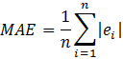

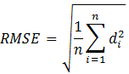
where is the number of data points, is difference between observed and predicted T_{c} and is the absolute error.
Results
Observed and modelled predictions were in close agreement for the collective data (Obs., 38.15 ± 0.53; Mod., 38.23 ± 0.43°C), as well as for each of the groups, paced (Obs., 38.08 ± 0.46; Mod., 38.08 ± 0.26°C) and best effort (Obs., 38.20 ± 0.53; Mod., 38.27 ± 0.47°C), the error was within ± 1°C (± 0.82 LoA) (Figure 1A and 1B). There was a small positive bias that was within the predetermined criterion (± 0.27°C) for the collective (0.08°C), paced (0.12°C), and best effort (0.07°C) groups (Figure 1B). Additionally, modelled MAE, and RMSE were within the observed standard deviation for the collective data (Obs., ± 0.53; Mod., ± 0.43; 0.37; 0.46°C), paced (Obs., ± 0.46; Mod., ± 0.26; 0.33; 0.37°C), and best effort (Obs., ± 0.53; Mod., ± 0.47; 0.38; 0.49°C) groups, respectively (Figure 1B). Furthermore, observed T_{c} compared to modelled predictions at measured end points for LC1 and LC2 trial intervals (end of LC1 50 minutes into trial and end of LC2 70 minutes into the trial) highlights a close agreement (Figure 1C).
[Add Figure 1 near here please]

Our data show that the HSDA meets both of the RMSE acceptable accuracy criteria (27, 28). Using the criterion mean bias (± 0.27 °C) and the observed SD, an acceptable LoA for these predictions is ± 1.16°C. Comparisons of the modelled with the observed data revealed 98% of errors within ± 1.16°C, 76 % were within ± 0.50°C, and 78 % were within the total SD (0.53°C). From the established criterion for RMSE (27, 28), 92 % of all data were within 1.5*SD, and 97 % of all data were within 2*SD of the observed data (Figure 1A).
Individual differences make modelling using group representative inputs (e.g., mean characteristics) a challenge. Figure 2 represents modelling predictions based on four representative inputs and their predictions compared to the mean of the observed data (Mean Obs.); for the best effort group (Figure 2A) and the paced group (Figure 2B). The four representative inputs included: 1) mean of the Ht, BM, iT_{c}, and metabolic rate (Mean Mod.), 2) individual with lowest iT_{c} (Lowest iT_{c}), 3) individual with highest iT_{c} (Highest iT_{c}), and 4) individual with largest body surface area (Largest BSA). Modelling based on the mean inputs (Mean Mod.) and based on the individuals with the largest BSA from each group gave the best predictions of mean values observed and within the SD of the observed data (Figure 2). The most conservative approach for predicting T_{c} using the HSDA would be to use inputs based on the highest iT_{c} observed within the group (Figure 2).
[Add Figure 2 near here please]

Discussion
The HSDA acceptably predicted T_{c} during staged military load carriage which will form part of the new PES for British Army non-GCC personnel in temperateconditions. These results suggest that the HSDA can be used to accurately predict T_{c} in these environmental conditions during military activity at a set pace, to best effort or when assessed collectively. Given the non-direct measurement provided by the HSDA method, the additional validation criteria of LoA, MAE, and RMSE showed individual predictions could be made within acceptable accuracy; while group mean inputs could be made reasonably for close agreement with mean measured outputs.
Mitigation of heat related injuries for military populations is a complex and persistent issue. Heat related injuries can be mitigated through several strategies including modifying exercise intensity, choice of clothing, implementing rest periods, or seeking shade. However, in military settings, it is not always possible to implement these mitigations. While several methods have sought to obtain direct measures or estimates of heat stress for individuals during activities using wearable sensors, these efforts are often complicated by unobtainable equipment demands (e.g., scalability), logistical or tactical constraints (e.g., network availability, detectability), or lack the accuracy or durability for military activities (e.g., dynamic work in challenging environments). Mathematical modeling uses non-direct measures of known variable inputs to make reasonable predictions that enable improved risk mitigation planning, and also have the potential for transitioning to near- or real-time computational methods (e.g., embedded into wearables). One mathematical model, the ECTempTM algorithm, predicts T_{c} from heart rate and has been reported to accurately predict T_{c} (-0.10 ± 0.37°C) in Royal Marines recruits completing a 9 mile (14.5 km⁻¹) speed march at 6 mph (9.7 km⁻¹) with 9.6 kg load, in a 16 °C, 84 RH % environment with a T_{c} < 39.5°C, but over predicted T_{c} (0.34 ± 0.40°C) when recruits had T_{c} > 40°C (29). The authors identified participant characteristics as a possible factor for differences in the accuracy of the model; the HSDA uses a greater number of input variables and may be more accurate at predicting T_{c} than the ECTempTM algorithm. The present study has demonstrated that the HSDA is an accurate model for the prediction of T_{c} during dynamic military activity (load carriage), emphasizing its utility in management of thermal burden, without the need for direct measures of core temperature.
The use of non-direct measures are often useful but can come with some significant limitations. This is especially true with respect to metabolic rates, as they have the greatest influence on heat gain for an individual. This influence is mathematically reflected in HSDA. For practical reasons, our study used the average movement speed for each individual as an input for predicting their individual metabolic rates. While the accuracy of HSDA was shown to be within the established statistical criterion; there are still area that could be improved upon. Some research has shown that adjustments could be made to correct predictions of metabolic rates during dynamic activities by using global positioning system (GPS) sensors (30). This type of adjustment could be used to correctly account for self-paced and complex movement activities.
The HSDA requires further validation in different environments, occupational settings and populations. An evaluation of the HSDA in soldiers completing a broader range of military specific exercise tasks in warmer environmental conditions will enable evaluation of the accuracy of the HSDA in more thermally challenging scenarios, where risk of heat injury is higher. The HSDA may also be a valuable tool for predicting T_{c} in other occupational populations that are at risk of heat injury due to the requirement to wear personal protective equipment or their environmental conditions; for example, technicians and firefighters (31, 32).
Future work to validate and expand the application of the HSDA are of significant interest, to include elements specifically related to vulnerable populations (e.g., age, health status). These types of improvements could allow for a method like HSDA to be applied as a public health tool for populations that are vulnerable to heat-related illness, including the elderly who are at high risk of heat-related mortality during periods of heat stress (33). The elderly population could utilise a method similar to the HSDA to protect them against severe heat illness whilst maintaining activities of daily living (34). Establishing the accuracy of the HSDA across various populations and environmental conditions will facilitate implementation of the HSDA into military, occupational and health policy and planning, to predict T_{c} of activities and mitigate the risk of heat injury.
Conclusion
The HSDA acceptably predicts T_{c} for individual soldiers completing paced and best effort load carriage activities which will form part of the new British Army non-GCC PES, in temperate conditions. Predicted accuracy of this modelling method were within pre-established acceptable bias criterion (± 0.27 °C) often used for direct measurements as well as within error criterion for comparing models of thermal responses for observed data. Further research is required in different populations and in more thermally challenging environments to understand the validity of the HSDA in wider contexts.

Highlights

- The Heat Strain Decision Aid (HSDA) has not previously been used to model core temperature responses to in UK military personnel completing staged load carriage activities.
- We demonstrate that the HSDA acceptably predicts core body temperature, in men and women, during staged military load carriage in temperate conditions, with improved accuracy when load carriage is paced rather than conducted to best-effort.
- The HSDA has potential utility in military mission planning to reduce the risk of heat injuries.

Acknowledgments
The work was funded by UK Ministry of Defence; KW, SW and JG are employed by the UK Ministry of Defence as Government scientists. The views expressed in this work are those of the authors and do not reflect the official policy of the Department of Army, Department of Defense, or the U.S. Government.

We would like to thank the US Army Research of Environmental Medicine Senior Scientist, Dr. Karl E. Friedl, for facilitating this joint collaboration. We also acknowledge the invaluable contributions of the participants that have made this analysis possible.
References
1. MoD. JSP 539: Heat Illness and cold injury: Prevention and management. Part 2 guidance. . 2019.
2. Larsen B, Netto K, Aisbett B. The effect of body armor on performance, thermal stress, and exertion: a critical review. Military medicine. 2011;176(11):1265-73.
3. Stacey MJ, Parsons IT, Woods DR, Taylor PN, Ross D, Brett SJ. Susceptibility to exertional heat illness and hospitalisation risk in UK military personnel. BMJ open sport & exercise medicine. 2015;1(1):e000055.
4. Friedl KE, Mallis MM, Ahlers ST, Popkin SM, Larkin W. Research requirements for operational decision-making using models of fatigue and performance. Aviation, space, and environmental medicine. 2004;75(3):A192-A9.
5. Friedl KE. Predicting human limits-the special relationship between physiology research and the Army mission. Military Quantitative Physiology: Problems and Concepts in Military Operational Medicine: Problems and Concepts in Military Operational Medicine. 2012:1-38.
6. TBMED-507. Heat stress control and heat casualty management. Headquarters, Department of the Army and Air Force, Washington, D.C.; 2003 2003.
7. Looney DP, Potter AW, Pryor JL, Bremner PE, Chalmers CR, Mcclung HL, et al. Metabolic Costs of Standing and Walking in Healthy Military-Age Adults: A Meta-regression. Medicine & Science in Sports & Exercise. 2019;51(2):346-51.
8. Potter AW, Looney DP, Santee WR, Gonzalez JA, Welles AP, Srinivasan S, et al. Validation of new method for predicting human skin temperatures during cold exposure: The Cold Weather Ensemble Decision Aid (CoWEDA). Informatics in Medicine Unlocked. 2020:100301.
9. Gonzalez RR, Cheuvront SN, Ely BR, Moran DS, Hadid A, Endrusick TL, et al. Sweat rate prediction equations for outdoor exercise with transient solar radiation. Journal of applied physiology. 2012;112(8):1300-10.
10. Carter R, Cheuvront S, Montain SJ, Sawka M, editors. Prediction and Validation of Warfighter Fluid Requirements. NATO Research and Technology Organization HFM-086 Symposium on “Maintaining Hydration: Issues, Guidelines, and Delivery” Boston, MA; 2003.
11. Charkoudian N, Kenefick RW, Lapadula AJ, Swiston AJ, Patel T, Blanchard LA, et al. Planning military drinking water needs: development of a user-friendly smart device application. Military medicine. 2016;181(9):1142-50.
12. Havenith G, Fiala D. Thermal indices and thermophysiological modeling for heat stress. Comprehensive Physiology. 2011;6(1):255-302.
13. Looney DP, Buller MJ, Gribok AV, Leger JL, Potter AW, Rumpler WV, et al. Estimating resting core temperature using heart rate. Journal for the Measurement of Physical Behaviour. 2018;1(2):79-86.
14. Potter AW, Blanchard LA, Friedl KE, Cadarette BS, Hoyt RW. Mathematical prediction of core body temperature from environment, activity, and clothing: The heat strain decision aid (HSDA). Journal of Thermal Biology. 2017;64:78-85.
15. Gonzalez R, McLellan T, Withey W, Chang SK, Pandolf K. Heat strain models applicable for protective clothing systems: comparison of core temperature response. Journal of applied physiology. 1997;83(3):1017-32.
16. Potter AW, Gonzalez JA, Xu X. Ebola response: modeling the risk of heat stress from personal protective clothing. PloS one. 2015;10(11):e0143461.
17. O'Brien C, Blanchard LA, Cadarette BS, Endrusick TL, Xu X, Berglund LG, et al. Methods of evaluating protective clothing relative to heat and cold stress: thermal manikin, biomedical modeling, and human testing. J Occup Environ Hyg. 2011;8:588-99.
18. Potter AW, Gonzalez JA, Karis AJ, Xu X. Biophysical assessment and predicted thermophysiologic effects of body armor. PloS one. 2015;10(7):e0132698.
19. Glisson KE. The Ability of the US Army Heat Strain Decision Aid (HSDA) to Predict a Limiting Heat Stress Exposure. 2017.
20. Potter AW, Hunt AP, Cadarette BS, Fogarty A, Srinivasan S, Santee WR, et al. Heat Strain Decision Aid (HSDA) accurately predicts individual-based core body temperature rise while wearing chemical protective clothing. Computers in Biology and Medicine. 2019;107:131-6.
21. Looney DP, Sanford DP, Li P, Santee WR, Doughty EM, Potter AW. Formulae for calculating body surface area in modern US Army Soldiers. Journal of Thermal Biology. 2020;92:102650.
22. Woodcock AH. Moisture permeability index - a new index for describing evaportative heat transfere through fabric systems. 1961 1961. Report No.: EP-149.
23. Gonzalez RR. Biophysics of heat transfer and clothing considerations. In: Pandolf KB, Sawka MN, Gonzalez RR, editors. Human Performance Physiology and Environmental Medicine at Terrestrial Extremes. Indianapolis, IN: Benchmark Press, Inc.; 1988. p. 45-95.
24. Potter AW. Method for estimating evaporative potential (im/clo) from ASTM standard single wind velocity measures. US Army Research Institute of Environmental Medicine, Natick, MA, 01760, USA, Technical Report; 2016.
25. Pandolf KB, Givoni B, Goldman RF. Predicting energy expenditure with loads while standing or walking very slowly. J Appl Physiol. 1977;43(4):577-81.
26. Casa DJ, Becker SM, Ganio MS, Brown CM, Yeargin SW, Roti MW, et al. Validity of devices that assess body temperature during outdoor exercise in the heat. Journal of athletic training. 2007;42(3):333.
27. Castellani JW, O'Brien C, Tikuisis P, Sils IV, Xu X. Evaluation of two cold thermoregulatory models for prediction of core temperature during exercise in cold water. Journal of applied physiology. 2007;103(6):2034-41.
28. Cadarette BS, Montain SJ, Kolka MA, Stroschein LA, Matthew WT, Sawka MN. Cross validation of USARIEM heat strain prediction models. Aviat Space Environ Med. 1999;70:1-11.
29. Buller MJ, Davey T, Fallowfield JL, Montain SJ, Hoyt RW, Delves SK. Estimated and measured core temperature responses to high-intensity warm weather military training: implications for exertional heat illness risk assessment. Physiological measurement. 2020;41(6):065011.
30. Potter AW, Santee WR, Mullen SP, Karis AJ, Blanchard LA, Rome MN, et al. Complex Terrain Load Carriage Energy Expenditure Estimation Using GPS Devices. Medicine & Science in Sports & Exercise (MSSE). 2018.
31. Stewart IB, Townshend A, Rojek R, Costello J. Bomb disposal in the tropics: a cocktail of metabolic and environmental heat. Journal of Ergonomics. 2013;2(001).
32. Watkins ER, Hayes M, Watt P, Richardson AJ. Heat tolerance of fire service instructors. Journal of thermal biology. 2019;82:1-9.
33. Smith S, Elliot AJ, Hajat S, Bone A, Smith GE, Kovats S. Estimating the burden of heat illness in England during the 2013 summer heatwave using syndromic surveillance. J Epidemiol Community Health. 2016;70(5):459-65.
34. Waldock K, Hayes M, Watt P, Maxwell N. Physiological and perceptual responses in the elderly to simulated daily living activities in UK summer climatic conditions. Public health. 2018;161:163-70.

Legends
Table 1: Heat Strain Decision Aid (HSDA) input variables for best effort and paced groups.
Figure 1: Agreement and error between observed (Obs.) and modelled (Mod.) core body temperature (T_{c}; °C). Panel A represents the Limits of Agreement between observed and modelled core body temperature for the collective data. Solid line represents the Bias, the dotted lines represent the 95% upper and lower limits of agreement, outer solid grey lines represent the criterion limits of agreement. Panel B represents the mean ± SD of the observed and modelled data, bias, mean absolute error and root mean square error data for collective, paced and best effort groups Panel C represents the line of equality between observed and modelled core body temperature. Abbreviations: Obs., Observed; Mod., modelled; MAE, mean absolute error; RMSE, root mean square error.
Figure 2: Representative inputs to predict within the mean ± SD of the observed (Mean Obs.) for predicting core body temperature in best effort (panel A) and paced groups (panel B). Abbreviations: Obs., Observed; Mod., modelled; iTc, initial core body temperature; BSA, body surface area.
Table 1: Heat Strain Decision Aid (HSDA) input variables for best effort and paced groups.
 | Variable | Group
 | Variable | Best Effort  N = 46 |  | Paced  N = 14
 | Variable | LC1* | LC2 | LC1 |  |  | LC2
Human | Height (m) | 1.71 ± 0.08 |  | 1.71 ± 0.10
Human | Body mass (kg) | 79.0 ± 11.3 |  | 75.3 ± 12.2
Human | Acclimation status (number of days of heat acclimation) | 0
Human | Hydration status (%) | 1.24
Human | Initial skin temperature (°C) | 33.00
Human | Initial core body temperature (°C) | 37.35 ±0.44 | 37.94±0.42 |  | 37.34±0.34 | 37.93±0.42
Environment | Wind velocity (m/s) | 1.33 | 3.11± 0.51 | 1.33 |  |  | 2.06 ± 0.11
Environment | Relative humidity (%) | 86.6 ± 4.2 |  | 88.0 ± 6.0
Environment | Ambient temperature (°C) | 10.7 ± 1.0 |  | 6.2 ± 2.6
Environment | Mean radiant temperature (°C) | 10.7 |  | 6.2
Clothing | Total thermal resistance (clo) | 1.00
Clothing | Thermal resistance wind velocity coefficient (ITVg) | -0.23
Clothing | Evaporative potential (im/clo) | 0.45
Clothing | Evaporative potential wind velocity coefficient (im/colVg) | 0.28
Activity Rate | Metabolic heat production (W) | 360±42 | 1224±414 | 372±31 |  |  | 604±87
Activity Rate | External work (W) | 90±11 | 306±104 | 93±8 |  |  | 151±22
Activity Rate | Total metabolic rate (W) | 450±53 | 1530±518 | 465±39 |  |  | 755±109
Abbreviations: LC1 and LC2; Load carriage stages 1 and 2. *LC1 was paced for both groups. Note: The values inputted into the HSDA were the mean values, values that do not have a SD are assumed values.

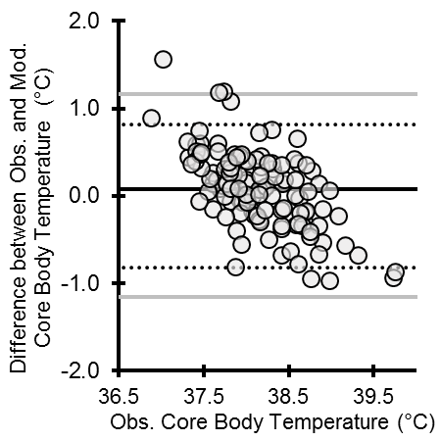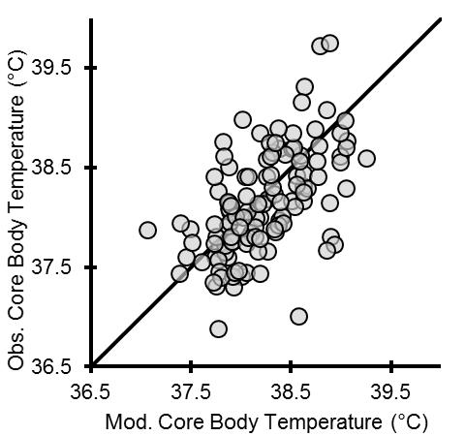
A
B
C

 | Observed (°C) | Modelled (°C) | Bias (°C) | MAE (°C) | RMSE (°C)
Collective Data | 38.15 ± 0.53 | 38.23 ± 0.43 | 0.08 | 0.37 | 0.46
Paced | 38.08 ± 0.46 | 38.08 ± 0.26 | 0.12 | 0.33 | 0.37
Best Effort | 38.20 ± 0.53 | 38.27 ± 0.47 | 0.07 | 0.38 | 0.49

Figure 1. Agreement and error between observed (Obs.) and modelled (Mod.) core body temperature (T_{c}; °C). Panel A represents the Limits of Agreement between observed and modelled core body temperature for the collective data. Solid line represents the Bias, the dotted lines represent the 95% upper and lower limits of agreement, outer solid grey lines represent the criterion limits of agreement. Panel B represents the mean ± SD of the observed and modelled data, bias, mean absolute error and root mean square error data for collective, paced and best effort groups Panel C represents the line of equality between observed and modelled core body temperature. Abbreviations: Obs., Observed; Mod., modelled; MAE, mean absolute error; RMSE, root mean square error.
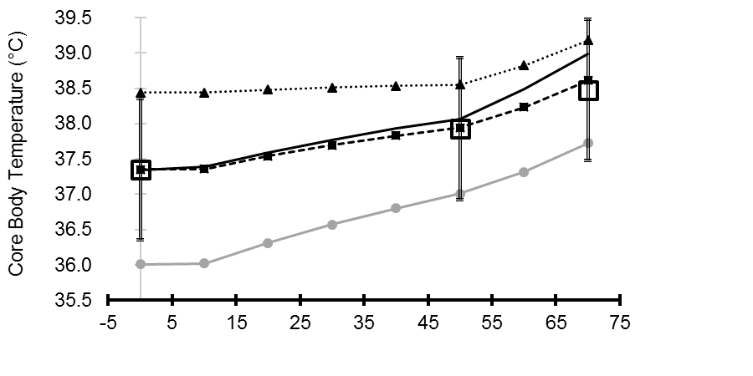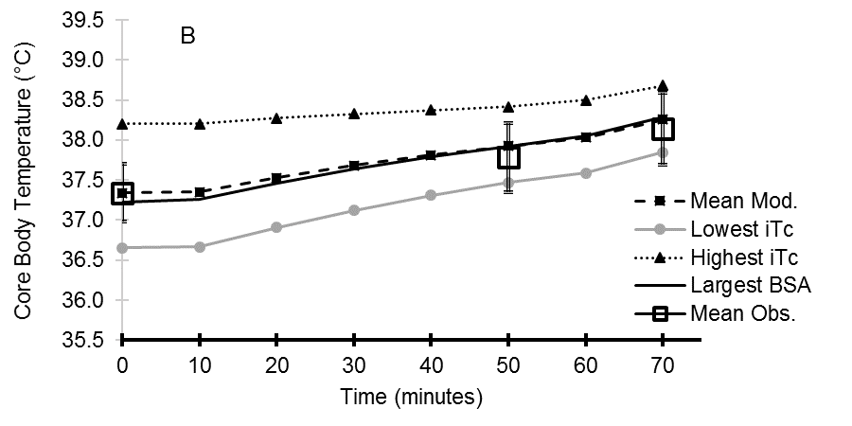
A
Figure 2: Representative inputs to predict within the mean ± SD of the observed (Mean Obs.) for predicting core body temperature in best effort (panel A) and paced groups (panel B). Abbreviations: Obs., Observed; Mod., modelled; iTc, initial core body temperature; BSA, body surface area.

