Running Head: TRANSFER FROM ESPORT TO TRADITIONAL SPORT

“Esport expertise benefits perceptual-cognitive skill in (traditional) sport”

Colm P. Murphy¹
Andy Wakefield¹
Phil D. J. Birch²
Jamie S. North¹

¹ Expert Performance and Skill Acquisition Research Group, Faculty of Sport, Allied Health and Performance Science, St Mary’s University, Twickenham, London, UK

² Department of Sport and Exercise Sciences, University of Chichester, UK

Corresponding author:
Colm Murphy
Faculty of Sport, Allied Health and Performance Science
St Mary’s University
Waldegrave Road
Twickenham
London
United Kingdom
TW1 4SX
Email: colm.murphy@stmarys.ac.uk
Phone: +44 (0)20 8240 4220
Word count: 4,156

Abstract
The ability to recognise patterns in developing sequences of play is a characteristic of experts that consistently distinguishes them from less-skilled performers. In addition to in situ training, researchers and practitioners seek alternative, simulated practice activities that may assist in the development of such perceptual-cognitive skills, whilst limiting physical load. In this study, we investigated whether pattern recognition skills of esport experts transferred to traditional sport. Expert esport (FIFA) players, skilled soccer players and a control group of novices in both FIFA and soccer completed two pattern recognition tasks, one that involved viewing and identifying previously seen footage of structured sequences from competitive FIFA 19 matches and another displaying sequences from soccer matches. Both skilled groups recognised previously viewed sequences significantly more accurately than the control group irrespective of viewing condition. Moreover, although expert FIFA players were more accurate than skilled soccer players in the FIFA 19 condition, no difference was observed between the two groups in the soccer condition. Positive transfer of pattern recognition skill was therefore stronger from FIFA to soccer than in the other direction. The findings suggest that engagement in esport may aid the development of perceptual-cognitive skills required for expert performance in traditional sport.

Keywords: Perception; memory; transfer; soccer; esports

Introduction
In dynamic and temporally constrained tasks such as soccer, aviation, and esports, the ability to anticipate future events is a distinguishing characteristic of expert performers (Triolet et al., 2013). One perceptual-cognitive skill underpinning this advantage is the ability to perceive and recognise patterns within displays (North & Williams, 2019). Retrospective data from expert performers indicates that extensive practice over many years is necessary to develop such perceptual-cognitive skills (see Ericsson, Krampe, & Tesch-Romer, 1993; Roca, Williams, & Ford, 2012). As a result, researchers and practitioners have sought to identify methods and interventions that may support the development of these skills (Hoffman et al., 2014). While in situ practice activities are important (Ford, Ward, Hodges, & Williams, 2009; Hendry & Hodges, 2018), there are nevertheless concerns over injury risk and burnout (Baker, Cobley, & Stephen-Thomas, 2009). Increasingly, efforts are being made to develop virtual environments that provide engaging and varied opportunities for domain-specific practice whilst minimizing injury risk (Stone, Strafford, North, Toner, & Davids, 2019). An alternative, but currently more accessible and affordable, activity that may contribute to the development of perceptual-cognitive skills is competitive electronic sports (esports; Boot, 2015). Although it is intuitively appealing to suggest that engagement in esports may facilitate transfer of perceptual-cognitive skills to the traditional sports they simulate (e.g., EA Sports FIFA and soccer), research investigating this notion is scarce.
Pattern perception has been shown to distinguish skilled from lesser-skilled performers in multiple domains (e.g., basketball: Allard, Graham, & Paarsalu, 1980; map reading: Gilhooly, Wood, Kinnear, & Green, 1988; medical diagnosis: Sowden, Davies, & Roling, 2000). At a practical level, the ability to perceive emerging sequences early in their development affords expert performers additional time and enables them to demonstrate their anticipation advantage (North & Williams, 2019). This domain-specific expertise is thought to arise through extended engagement in domain-specific practice that results in the development of specialised cognitive knowledge structures which support processes of encoding, storage, and retrieval that ultimately enable quicker and more accurate judgments (see Ericsson & Kintsch, 1995). An early study by Allard and Starkes (1992) investigated pattern perception in expert basketball and ice hockey players when viewing sequences from both sports, revealing that basketball players recalled sequences more accurately when viewing basketball stimuli, while ice hockey players were more accurate on ice hockey trials, highlighting the domain-specific nature of pattern perception.
Despite the proposed domain-specificity of perceptual-cognitive expertise and the sport expertise × recognition task interaction reported by Allard and Starkes (1992), the authors nevertheless noted that recall accuracy of both groups in the non-domain-specific task was significantly above chance, suggesting that experts were able to perceive and encode meaning from such displays. If perceptual-cognitive skills did transfer between domains, there may be scope to develop such skills away from one’s primary sport, potentially in a less physically demanding way, thus reducing the risk of injury and burnout (Stone et al., 2019). Positive transfer of perceptual-cognitive skills is most likely to be observed between tasks that share similar characteristics (see Causer & Ford, 2014; Roca & Williams, 2017; Rosalie, & Müller, 2014). For example, Smeeton, Ward, and Williams (2004) investigated the transfer of perceptual-cognitive skill between sports that were thought to share similar perceptual features and processing strategies (soccer and field hockey) and another sport thought to be dissimilar on these factors (volleyball). Using a recognition task, the researchers reported that soccer and field hockey players each recognised previously seen soccer and field hockey sequences more quickly than volleyball players, demonstrating positive transfer between structurally similar sports. Similarly, Abernethy, Baker, and Côté (2005) used a pattern recall task to demonstrate that expertise in one sport enabled positive transfer to related sports. Experts demonstrated superior levels of recall accuracy for domain-specific sequences but nevertheless recalled patterns from other similar sports more effectively than non-experts. Collectively, the findings suggest that perceptual-cognitive skills may transfer between similar domains
In their Identical Elements theory, Thorndike and Woodworth (1901) suggested that transfer of learning is dependent on the number of similar elements between the tasks, these elements being perceptual, motor or strategic in nature. For example, soccer and field hockey may share similar perceptual and strategic elements due to the number of players involved, the pitch size and the formations employed. In contrast, Lee’s (1988) Transfer-Appropriate Processing theory suggests that transfer occurs when tasks share similar perceptual and cognitive processing demands. For example, comparable visual search strategies in sports like soccer and field hockey are likely to facilitate the type of encoding and retrieval processes that lead to positive transfer (Helsen & Starkes, 1999; Smeeton et al., 2004; Williams, Swarbrick, Grant, & Weigelt, 1999). Therefore, time spent engaging in secondary activities that involve similar perceptual and strategic elements and/or processing demands could facilitate the development of perceptual-cognitive skills in an athlete’s primary sport.
Esports involve individuals or teams competing in video games either in person or online, for trophies, ranking points or prize money (Ruvalcaba, Shulze, Kim, Berzenski, & Otten, 2018). Like traditional sport, expert esports performance requires highly developed perceptual-cognitive skills that, depending on the game, underpin quick and effective anticipation and decision making under time constraints (Latham, Patston, & Tippett, 2013; Pedraza-Ramirez, Musculus, Raab, & Laborde, 2020). Once merely a popular pastime, the prevalence of professional esports has increased drastically in recent years (Pluss et al., 2020). While early video games were limited in their realism (Boot, 2015), current versions are increasingly realistic, both in gameplay and graphics, creating a highly engaging environment (Towne, Ericsson, & Sumner, 2014). Esports therefore provide an ideal domain within which to study expertise (Pluss et al., 2019) and may also be suitable to supplement the development of perceptual-cognitive skills in other domains, without adding extra physical demand. Engagement with video simulations of real-world actions has been shown to aid the development of perceptual-cognitive skills that are transferrable to in situ performance (Broadbent, Causer, Ford, & Williams, 2015; Müller & Abernethy, 2014; Smeeton, Williams, Ward, & Hodges, 2005). However, creation of test stimuli for such methods is time consuming and can lack variation, therefore participation in esports that simulate an athlete’s sport may provide a readily available, cost-effective alternative.
The aim of the current study was to investigate whether pattern recognition skills can be transferred between esport (FIFA) and traditional sport (soccer). We compared the performance of expert FIFA players, skilled soccer players and a control group of novices on two pattern recognition tasks, one in which sequences from competitive FIFA 19 matches were presented and another presenting sequences from competitive soccer matches. As expert performers have been shown to transfer perceptual skills between similar tasks (Lee, 1988; Smeeton et al., 2004; Thorndike & Woodworth, 1901), we hypothesized that the two skilled groups would recognize sequences more accurately than the control group regardless of the viewing condition, thus demonstrating positive transfer. However, based on previous research highlighting the expert advantage in pattern perception on domain-specific tasks (Abernethy et al., 2005), we hypothesized that the two skilled groups would nevertheless outperform one another when responding to footage from their own domain.
Method
Participants
Sample size was calculated using G*Power 3.1 (Faul, Erdfeldner, Lang, & Buchner, 2007). A total of 42 participants were calculated as being sufficient to detect a medium effect size (f = .25) with power set at 0.80 for the within-between interaction. In total, 58 participants completed the experiment, 22 of whom were expert FIFA players (M_{age} = 22.8, standard deviation [SD] = 3.5), 17 were skilled soccer players (M_{age} = 21.2, SD = 6.1), and 19 participants who had limited experience in both soccer and FIFA acted as a control group (M_{age} = 25.7, SD = 10.2). Expert FIFA players reported having achieved a FIFA 19 (EA Sports, 2019) ranking of Elite 2 or higher (rankings are on a twelve-tier system with Elite 2 being the second highest tier outside the top 100 World rankings). At the time of the study, they reported playing a mean of 26.8 (SD = 12.0) hours’ FIFA 19 per week. Skilled soccer players played semi-professionally and competitively in the 8th tier of English soccer or above. They reported currently playing a mean of 3.4 (SD = 4.6) hours’ soccer per week. Expert FIFA players who reported playing soccer regularly were excluded from the study, as were skilled soccer players who reported regular engagement in FIFA video games. The control group played both soccer and FIFA irregularly and did not take part in either activity competitively. Written informed consent was provided by each participant with ethical approval granted from each of the institutions at which data collection took place.
Test Stimuli
Four sets of test stimuli were created; two for use as viewing and recognition phases in the FIFA 19 condition and two for use in the soccer condition. Each set of stimuli consisted of 30 trials, edited to be five seconds in duration. In both conditions, sequences were originally selected for use if they included a key pass, e.g., a through ball or a cross. For the FIFA 19 condition, test stimuli were generated from live streams of competitive FIFA 19 events (EA Sports FIFA 19 Ultimate Team, 2019). Originally, 96 sequences of play were generated and edited to remove recognizable superficial features such as the score line, face camera shots and energy bars. For the soccer condition, 92 sequences of play were originally generated from internationally broadcast footage. To avoid presenting footage that had previously been viewed by participants, none of the selected footage was of matches played by English teams. As in the FIFA 19 condition, score lines were removed from this condition. All footage was of a side-on, birds-eye view perspective (see Figure 1).
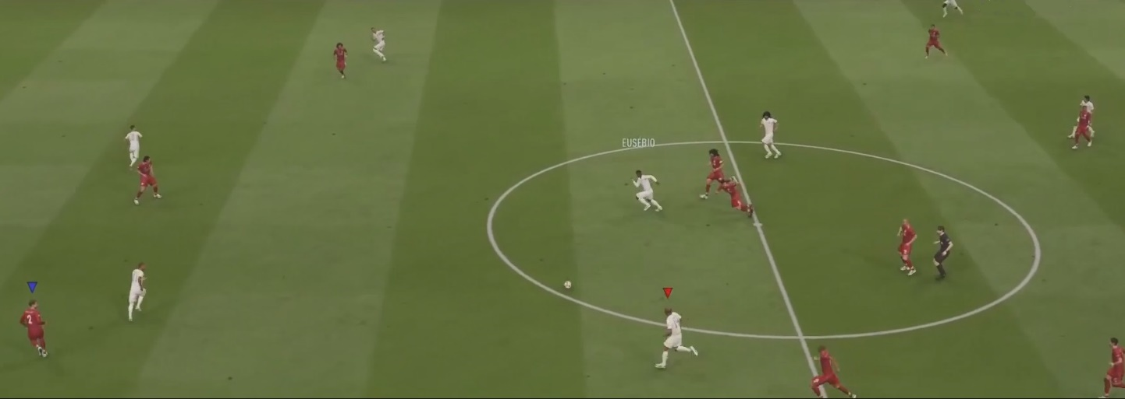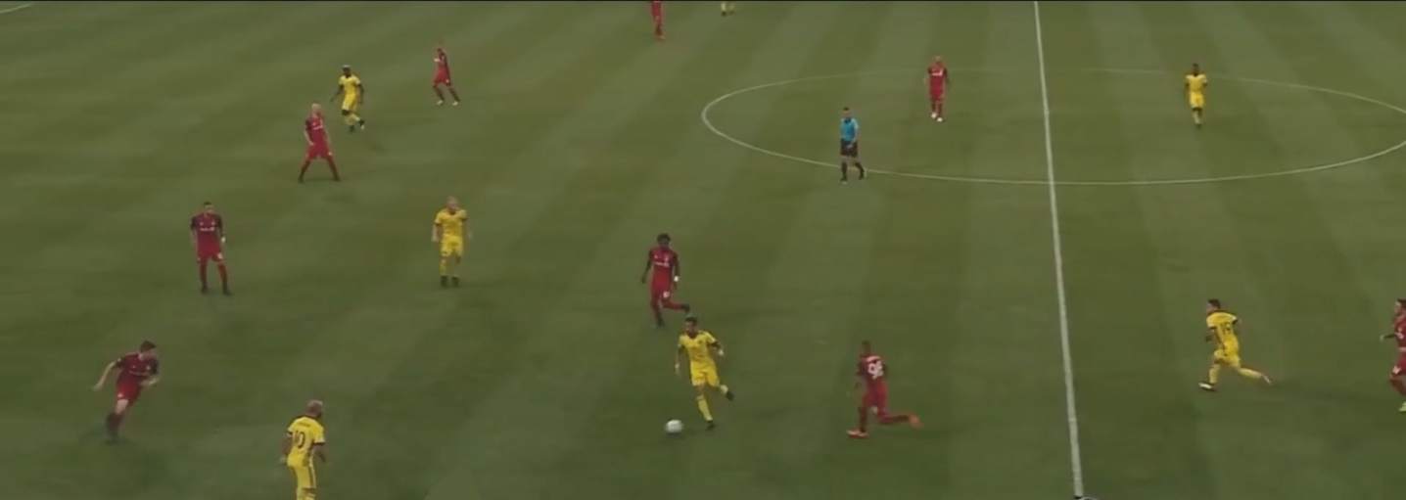
Figure 1. Example FIFA 19 (top) and soccer (bottom) test stimuli
A professional FIFA player with a higher ranking than any of the participants rated the level of structure in each of the FIFA 19 clips on a Likert scale of 0 to 10 (based on the extent to which the sequences represented what would occur in a competitive setting; 0 being not at all structured, 10 being highly structured). Similarly, a semi-professional soccer player rated the level of structure in the selected soccer sequences. This process of ensuring structure within sequences has been used by other researchers studying expert pattern perception (Gorman, Abernethy, & Farrow, 2012; North, Williams, Hodges, Ward, & Ericsson, 2009). In both tasks, the 45 sequences receiving the highest structure rating were used as experimental test stimuli. From this base of 45 sequences, 30 were randomly selected for presentation in the viewing phase. The remaining 15 sequences formed the ‘new’ trials to be presented in the recognition phase. These were presented along with 15 randomly selected trials from the viewing phase that acted as ‘previously seen’ trials. The ‘new’ and ‘previously seen’ trials were randomly ordered within the recognition phases.
Apparatus and set-up
Test stimuli were edited using Davinci Resolve 15 software (Blackmagic Design, Fremont, CA, USA). Participants viewed footage on a standard laptop or desktop computer. The laptop/computer on which footage was viewed was not consistent between participants but the screen was always of personal computer size. Participants sat approximately 40 cm from the screen, yielding a viewing angle of approximately 45 degrees on a standard 15.6” screen, similar to previous research (North et al., 2009; North, Hope, & Williams, 2016).
Procedure
Data collection was carried out in one of two ways; either in person with the researcher or remotely, via telephone. In those instances of remote participation, participants viewed footage via uploaded videos from Google Drive (Mountain View, CA, USA). First, participants were told that they would be presented with a series of sequences of play from competitive FIFA 19 or soccer matches and that they were required to view the footage. Half of the participants in each group viewed the soccer test stimuli first with the other half viewing the FIFA 19 test stimuli first. Having completed the initial viewing phase, participants completed a playing history questionnaire to ascertain their level of experience and engagement in the activity corresponding to the viewing condition. The questionnaire was completed during a break of approximately 15 minutes. Next, participants were informed that they would view a further series of sequences, but that on this occasion some of the sequences had already been shown in the initial viewing phase, whereas others had not. Participants were asked to highlight those previously seen as “old” and those that had not yet been seen as “new”. An inter-trial interval of 5 seconds was employed throughout. Participant responses were either written or typed depending on whether data was collected in person or remotely, respectively. Upon completion of the first recognition phase, participants took a short break prior to completing the same procedure in the other viewing condition.
Data Analysis
First, recognition accuracy scores were converted to percentages (%). The data were then screened for outliers using box plots and were subsequently tested for normality. No outliers were detected and the Shapiro-Wilk test showed the data met the parametric assumption of normality. Moreover, significant skewness or kurtosis was not observed in any of the variables for any of the groups. Next, a 3 (Group [Control, Skilled Soccer Players, Expert FIFA Players]) × 2 (Viewing Condition [Soccer, FIFA 19]) mixed Analysis of Variance (ANOVA) with repeated measures on the latter factor was conducted to determine whether domain-specific expertise affected ability to recognise patterns of play across conditions. Percentage recognition accuracy (%) acted as the dependent variable. In the case of main effects or interactions, Bonferroni-corrected pairwise comparisons were employed to control for family-wise error. Partial eta squared (η_{p}²) and Cohen’s d are used to report effect sizes. 95% confidence intervals are reported on d and the alpha level was set at .05.
Results
Mean (and standard error) recognition accuracy scores are presented in Figure 2. ANOVA revealed a main effect of Group, F (2,55) = 24.27, p < .01, η_{p}² = 0.47. Compared to the control group (M = 60.09 %, SD = 10.12), recognition accuracy was higher for both the expert FIFA players (M = 78.41 %, SD = 10.10, p < .01, d = 1.81, 95 % confidence interval [CI] = [1.29, 2.33]) and the skilled soccer players (M = 73.53 %, SD = 11.04 p < .01, d = 1.27, 95 % CI = [0.76, 1.78]). A main effect of Viewing Condition was also observed, F (1,55) = 7.26, p = .01, η_{p}² = 0.12. Recognition accuracy was higher in the soccer (M = 72.70 %, SD = 12.57) than the FIFA 19 condition (M = 69.25 %, SD = 13.25).

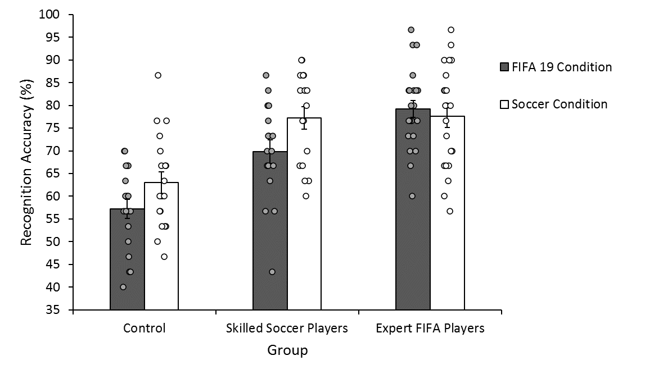
Figure 2. Mean (SE) recognition accuracy (%) across groups and viewing conditions.
A Group × Viewing Condition interaction was observed, F (2,55) = 4.05, p = .02, η_{p}² = 0.13. In the soccer condition, the control group (M = 62.98 %, SD = 10.42) were significantly less accurate than both the skilled soccer players (M = 77.26 %, SD = 10.22, p < .01, d = 1.38, 95 % CI = [0.64, 2.11]) and expert FIFA players (M = 77.58 %, SD = 11.37, p < .01, d = 1.33, 95 % CI = [0.65, 2.01]), with no difference observed between the two latter groups (p = .93, d = 0.03, CI = [-0.60, 0.66]). In contrast, in the FIFA 19 condition, while the control group (M = 57.19 %, SD = 9.18) was again significantly less accurate than the skilled soccer players (M = 69.80 %, SD = 10.83, p < .01, d = 1.26, 95 % CI = [0.54, 1.97]), the soccer players were, in turn, significantly less accurate than the expert FIFA players (M = 79.24 %, SD = 8.84, p = .01, d = 0.97, 95 % CI = [0.29, 1.63]). The expert FIFA players were also significantly more accurate than the control group (p < .01, d = 2.45, CI = [1.62, 3.26]).
Discussion
To determine whether perceptual-cognitive skill transfers between esports and the traditional sports they simulate, we compared performance of expert FIFA players, skilled traditional sports (soccer) players and novices (control) on two pattern recognition tasks in which sequences from competitive FIFA 19 or soccer matches were presented. Consistent with research demonstrating positive transfer between similar tasks (Abernethy et al., 2005; Lee, 1988; Thorndike & Woodworth, 1901; Smeeton et al., 2004), we expected the skilled participants to outperform the control group regardless of the viewing condition. Moreover, based on previous research demonstrating expertise effects on domain-specific pattern perception tasks (Abernethy et al., 2005), we expected the skilled participants to be more accurate than the other groups when viewing sequences from their domain of expertise.
In line with our first hypothesis, both skilled groups recognised structured sequences of play more effectively than the control group regardless of whether they were viewing footage from competitive FIFA 19 or soccer matches. Skilled participants not only made more accurate recognition judgments than participants in the control group when viewing sequences from their own domain of expertise (e.g., soccer players viewing soccer sequences, North et al., 2009; North, Ward, Ericsson, & Williams, 2011) but they were able to maintain this advantage in the non-domain specific viewing condition, highlighting positive transfer of pattern recognition skill between tasks. While previous research has demonstrated positive transfer of perceptual-cognitive skills between sports (Moore & Müller, 2014; Rosalie & Müller, 2014; Smeeton et al., 2004), this is the first study to our knowledge to demonstrate positive transfer between esport and traditional sport.
The similarity between the two tasks is likely to be a driving factor behind the observed transfer. Given that FIFA 19 aims to simulate soccer through a video game medium, by design the two tasks share common elements, e.g., the number of players, formations and underlying strategies (Thorndike & Woodworth, 1901). The degree of positive transfer between the two tasks is therefore not surprising. It is equally unsurprising that differences in superficial features between the viewing conditions (i.e., computer graphics vs real players) did not prevent positive transfer from being observed. Pattern recognition is underpinned by the effective processing of dynamic relational information between features, as demonstrated by the maintenance of an expert advantage when surface level features are removed from visual displays using point-lights (North et al., 2009; Williams, Hodges, North, & Barton, 2006; Williams, North, & Hope, 2012). In the current study, both groups of experts were able to effectively encode and retrieve task-relevant information from memory when required for both tasks, despite superficial differences between display conditions.
Partially in line with our second hypothesis, while the expert FIFA players were more accurate than skilled soccer players when viewing the FIFA 19 footage, the two groups achieved comparable accuracy on the soccer task. The positive transfer of perceptual-cognitive skill from FIFA to soccer was therefore stronger than in the other direction. These findings contrast with those of Abernethy et al. (2005) which showed that although pattern recall skills transferred positively between similar sports, the degree of transfer did not result in as high performance levels as those of domain experts. While the sports used by Abernethy et al. (2005) were similar in that they were all team-based invasion sports (basketball, field hockey and netball), factors such as player numbers, pitch size and strategy all differed between the sports. As a video game based simulation of soccer, FIFA 19 is likely to be highly similar to soccer both in terms of the perceptual and strategic elements involved (Thorndike & Woodworth, 1901), and the cognitive processes underpinning effective pattern recognition on the task (Lee, 1988).
Although researchers have previously demonstrated that engagement with video games may be associated with enhanced perceptual and cognitive abilities (Bediou et al., 2018; Green & Bavelier, 2003; Wu & Spence, 2013), these are the first findings, to our knowledge, that demonstrate positive transfer of perceptual-cognitive skill from esport to traditional sport. In non-sporting contexts, it has previously been shown that enhanced perceptual and cognitive processing is associated with engagement in video games that share common demands to the transfer task. For example, engagement in first-person shooter games that require fast and accurate decisions in dynamic, time constrained environments has resulted in more efficient visual search strategies on laboratory based tasks that share these demands (Green & Bavelier, 2007; Hubert-Wallander, Green, Sugarman, & Bavelier, 2011). The findings presented here suggest that engagement in esports which simulate traditional sports may lead to the development of perceptual-cognitive skills that underpin expert performance in the sport. Of course, it is possible that rather than positive transfer of pattern recognition skills, the superior performance of skilled participants was due to enhanced generic visual recognition. However, as our findings align with a large body of research demonstrating the domain-specific nature of effective pattern perception (Gorman et al., 2012; North et al., 2011; North, Hope, & Williams, 2017), we consider this possibility unlikely.
The Group × Viewing Condition interaction revealed that transfer of pattern recognition skill was stronger from FIFA to soccer than in the other direction. We suggest two possible explanations for this. First, while viewing perspective was maintained as consistently as possible between the two tasks for the purpose of control, the aerial side-on viewing perspective was more representative of the performance environment normally experienced by FIFA players than soccer players. Tasks that are less representative of the performance environment, e.g., via the viewing perspective or response employed, have been shown to yield smaller expertise effects (see Farrow & Abernethy, 2003; Mann, Abernethy, & Farrow, 2010). It follows that the visual search and cognitive processing strategies of soccer players in the soccer viewing condition may have been different, and in turn less effective, than those normally employed from a pitch level first-person viewing perspective (Mann, Farrow, Shuttleworth, & Hopwood, 2009). We therefore recommend that future research replicate the current findings while manipulating the viewing perspective employed. A second potential explanation, and in turn an associated limitation of the study, is that the FIFA players were competing at a higher level and spent more time engaging in their domain than the soccer players. The FIFA players were therefore likely to have attained a higher level of expertise than the soccer players, thus facilitating more effective transfer of perceptual-cognitive skill. In line with this suggestion, researchers have previously observed that the degree of transfer of perceptual-cognitive skill between domains is moderated by expertise level of performers (Abernethy et al., 2005; Rosalie & Müller, 2014).
From an applied perspective, of particular interest is the positive transfer from esport to traditional sport because the high level of physical activity associated with traditional sports like soccer carries with it an inherent risk of injury and burnout (Baker et al., 2009). Our findings, therefore, show promise for the use of esports to develop perceptual-cognitive skills in traditional sports and may provide a substitute for physical training when players are injured or resting. It is important to note that our findings do not suggest engagement in esport to be more beneficial than participating in traditional sport itself, nor do our findings demonstrate that engagement in esport actually leads to enhanced performance in traditional sport. Rather, we suggest that engaging in simulated activities may provide a challenging, varied practice environment that yields continued motivation over time (Gray, 2019), while contributing to the development of perceptual-cognitive expertise. We thereby recommend that future research employs interventions to investigate the effect of engagement in esport on perceptual-cognitive skill development and indeed, the ability to transfer skills to traditional sport and enhance performance. First, like research which has previously investigated the link between video games and general perceptual and cognitive abilities, intervention based studies would provide evidence as to whether there is a causal link between engagement in esport and perceptual-cognitive skill in traditional sport (Blacker, Curby, Klobusicky, & Chein, 2014; Toril, Reales, & Ballesteros, 2014). Second, research is needed to investigate whether the degree of transfer displayed in this study is still observed in more ecologically valid tasks, such as in-situ (on field) tests of anticipation and decision making. Finally, research that employs engagement in esport as a training intervention to determine its effect on traditional sports performance (i.e., on field performance) is required. Such systematic investigation would provide valuable information for practitioners exploring the possibility of using esport as a training tool for traditional sport.
In this paper we have reported novel findings that show positive transfer of perceptual-cognitive skill between esport (FIFA) and traditional sport (soccer). Moreover, we have demonstrated positive transfer to be more pronounced from FIFA to soccer than in the other direction. Findings suggest there may be scope to use video game based simulations to develop perceptual-cognitive skills for traditional sport, thus alleviating risk of overtraining through increased physical load. We have recommended several avenues of further investigation to examine these ideas. Thus, the current findings highlight the ability of expert performers to transfer perceptual-cognitive skill between similar domains and the potential of esports to act as a training tool for these skills in traditional sports.
References
Abernethy, B., Baker, J., & Côté, J. (2005). Transfer of pattern recall skills may contribute to the development of sport expertise. Applied Cognitive Psychology, 19, 705-718.
Allard, F., Graham, S., & Paarsalu, M. E. (1980). Perception in sport: Basketball. Journal of Sport Psychology, 2, 14-21.
Allard, F., & Starkes, J. S., (1992). Motor-skill experts in sports, dance, and other domains. In K. A. Ericsson & J. Smith (Eds.), Towards a General Theory of Expertise: Prospects and Limits (pp. 126-153). Cambridge University Press: Cambridge.
Baker, J., Cobley, S., & Fraser‐Thomas, J. (2009). What do we know about early sport specialization? Not much!. High Ability Studies, 20, 77-89.
Bediou, B., Adams, D. M., Mayer, R. E., Tipton, E., Green, C. S., & Bavelier, D. (2018). Meta-analysis of action video game impact on perceptual, attentional, and cognitive skills. Psychological Bulletin, 144, 77-110.
Blacker, K. J., Curby, K. M., Klobusicky, E., & Chein, J. M. (2014). Effects of action video game training on visual working memory. Journal of Experimental Psychology: Human Perception and Performance, 40, 1992-2004.
Boot, W. R. (2015). Video games as tools to achieve insight into cognitive processes. Frontiers in Psychology, 6, 3.
Broadbent, D. P., Causer, J., Ford, P. R., & Williams, A. M. (2015). Contextual interference effect on perceptual–cognitive skills training. Medicine & Science in Sports & Exercise, 47, 1243-1250.
Causer, J., & Ford, P. R. (2014). “Decisions, decisions, decisions”: Transfer and specificity of decision-making skill between sports. Cognitive Processing, 15, 385-389
Ericsson, K. A., & Kintsch, W. (1995). Long-term working memory. Psychological Review, 102, 211-245.
Ericsson, K. A., Krampe, R. T., & Tesch-Römer, C. (1993). The role of deliberate practice in the acquisition of expert performance. Psychological Review, 100, 363-406.
Farrow, D., & Abernethy, B. (2003). Do expertise and the degree of perception—action coupling affect natural anticipatory performance?. Perception, 32, 1127-1139.
Faul, F., Erdfelder, E., Lang, A. G., & Buchner, A. (2007). G* Power 3: A flexible statistical power analysis program for the social, behavioral, and biomedical sciences. Behavior Research Methods, 39, 175-191.
Ford, P. R., Ward, P., Hodges, N. J., & Williams, A. M. (2009). The role of deliberate practice and play in career progression in sport: the early engagement hypothesis. High Ability Studies, 20, 65-75.
Gilhooly, K. J., Wood, M., Kinnear, P. R., & Green, C. (1988). Skill in map reading and memory for maps. The Quarterly Journal of Experimental Psychology, 40, 87-107.
Gorman, A. D., Abernethy, B., & Farrow, D. (2012). Classical pattern recall tests and the prospective nature of expert performance. Quarterly Journal of Experimental Psychology, 65, 1151-1160.
Gray, R. (2019). Virtual environments and their role in developing perceptual-cognitive skills in sport. In A. M. Williams & R. C. Jackson (Eds.), Anticipation and Decision Making in Sport (pp. 342-358). Routledge: Oxon.
Green, C. S., & Bavelier, D. (2003). Action video game modifies visual selective attention. Nature, 423, 534-537.
Green, C. S., & Bavelier, D. (2007). Action-video-game experience alters the spatial resolution of vision. Psychological Science, 18, 88-94.
Helsen, W. F., & Starkes, J. L. (1999). A multidimensional approach to skilled perception and performance in sport. Applied Cognitive Psychology, 13, 1-27.
Hendry, D. T., & Hodges, N. J. (2018). Early majority engagement pathway best defines transitions from youth to adult elite men's soccer in the UK: A three time-point retrospective and prospective study. Psychology of Sport and Exercise, 36, 81-89.
Hoffman, R. R., Ward, P., Feltovich, P. J., DiBello, L., Fiore, S. M., & Andrews, D. H. (2014). Accelerated Expertise: Training for High Proficiency in a Complex World. New York, NY: Psychology Press.
Hubert-Wallander, B., Green, C. S., Sugarman, M., & Bavelier, D. (2011). Changes in search rate but not in the dynamics of exogenous attention in action videogame players. Attention, Perception, & Psychophysics, 73, 2399-2412.
Latham, A. J., Patston, L. L., & Tippett, L. J. (2013). Just how expert are “expert” video-game players? Assessing the experience and expertise of video-game players across “action” video-game genres. Frontiers in Psychology, 4, 941.
Lee, T. D. (1988). Transfer-appropriate processing: a framework for conceptualizing practice effects in motor learning. Advances in Psychology, 50, 201-215.
Mann, D. L., Abernethy, B., & Farrow, D. (2010). Action specificity increases anticipatory performance and the expert advantage in natural interceptive tasks. Acta Psychologica, 135, 17-23.
Mann, D. L., Farrow, D., Shuttleworth, R., & Hopwood, M. (2009). The influence of viewing perspective on decision-making and visual search behaviour in an invasive sport. International Journal of Sport Psychology, 40, 546-564.
Moore, C. G., & Müller, S. (2014). Transfer of expert visual anticipation to a similar domain. Quarterly Journal of Experimental Psychology, 67, 186-196.
Müller, S., & Abernethy, B. (2014). An expertise approach to training anticipation using temporal occlusion in a natural skill setting. Technology, Instruction, Cognition, and Learning, 9, 295-312.
North, J. S., Hope, E., & Williams, A. M. (2016). The relative importance of different perceptual-cognitive skills during anticipation. Human Movement Science, 49, 170-177.
North, J. S., Hope, E., & Williams, A. M. (2017). Identifying the micro-relations underpinning familiarity detection in dynamic displays containing multiple objects. Frontiers in Psychology, 8, 963.
North, J. S., Ward, P., Ericsson, K. A., & Williams, A. M. (2011). Mechanisms underlying skilled anticipation and recognition in a dynamic and temporally constrained domain. Memory, 19, 155-168.
North, J. S., & Williams, A. M. (2019). Familiarity detection and pattern perception in sport. In A. M. Williams & R. C. Jackson (Eds.), Anticipation and Decision Making in Sport (pp. 25-43). Routledge: Oxon.
North, J. S., Williams, A. M., Hodges, N., Ward, P., & Ericsson, K. A. (2009). Perceiving patterns in dynamic action sequences: Investigating the processes underpinning stimulus recognition and anticipation skill. Applied Cognitive Psychology, 23, 878-894.
Pedraza-Ramirez, I., Musculus, L., Raab, M., & Laborde, S. (2020). Setting the scientific stage for esports psychology: A systematic review. International Review of Sport and Exercise Psychology, 1-34.
Pluss, M. A., Bennett, K. J., Novak, A. R., Panchuk, D., Coutts, A. J., & Fransen, J. (2019). Esports: the chess of the 21st century. Frontiers in Psychology, 10, 156.
Pluss, M. A., Novak, A. R., Bennett, K. J., Panchuk, D., Coutts, A. J., & Fransen, J. (2020). Perceptual-motor Abilities Underlying Expertise in Esports. Journal of Expertise, 3, 133-143.
Roca, A., Williams, A. M., & Ford, P. R. (2012). Developmental activities and the acquisition of superior anticipation and decision making in soccer players. Journal of Sports Sciences, 30, 1643-1652.
Roca, A., & Williams, A. M. (2017). Does decision making transfer across similar and dissimilar sports?. Psychology of Sport and Exercise, 31, 40-43.
Rosalie, S. M., & Müller, S. (2014). Expertise facilitates the transfer of anticipation skill across domains. Quarterly Journal of Experimental Psychology, 67, 319-334.
Ruvalcaba, O., Shulze, J., Kim, A., Berzenski, S. R., & Otten, M. P. (2018). Women’s experiences in esports: Gendered differences in peer and spectator feedback during competitive video game play. Journal of Sport and Social Issues, 42, 295-311.
Smeeton, N. J., Ward, P., & Williams, A. M. (2004). Do pattern recognition skills transfer across sports? A preliminary analysis. Journal of Sports Sciences, 22, 205-213.
Smeeton, N. J., Williams, A. M., Hodges, N. J., & Ward, P. (2005). The relative effectiveness of various instructional approaches in developing anticipation skill. Journal of Experimental Psychology: Applied, 11, 98-110.
Stone, J. A., Strafford, B. W., North, J. S., Toner, C., & Davids, K. (2018). Effectiveness and efficiency of virtual reality designs to enhance athlete development: an ecological dynamics perspective. Movement & Sport Sciences-Science & Motricité, 102, 51-60.
Sowden, P. T., Davies, I. R., & Roling, P. (2000). Perceptual learning of the detection of features in X-ray images: a functional role for improvements in adults' visual sensitivity?. Journal of Experimental Psychology: Human Perception and Performance, 26, 379-390.
Thorndike, E. L., & Woodworth, R. S. (1901). The influence of improvement in one mental function upon the efficiency of other functions. Psychological Review, 8, 247.
Toril, P., Reales, J. M., & Ballesteros, S. (2014). Video game training enhances cognition of older adults: a meta-analytic study. Psychology and Aging, 29, 706-716.
Towne, T. J., Ericsson, K. A., & Sumner, A. M. (2014). Uncovering mechanisms in video game research: suggestions from the expert-performance approach. Frontiers in Psychology, 5, 161.
Triolet, C., Benguigui, N., Le Runigo, C., & Williams, A. M. (2013). Quantifying the nature of anticipation in professional tennis. Journal of Sports Sciences, 31, 820-830.
Williams, A. M., Hodges, N. J., North, J. S., & Barton, G. (2006). Perceiving patterns of play in dynamic sport tasks: Investigating the essential information underlying skilled performance. Perception, 35, 317-332.
Williams, A. M., North, J. S., & Hope, E. R. (2012). Identifying the mechanisms underpinning recognition of structured sequences of action. Quarterly Journal of Experimental Psychology, 65, 1975-1992.
Williams, A. M., Swarbrick, L. C., Grant, A., & Weigelt, C. (1999). Visual search strategy, recall ability, and expertise in field hockey. Journal of Sport and Exercise Psychology, 21, S123.
Wu, S., & Spence, I. (2013). Playing shooter and driving videogames improves top-down guidance in visual search. Attention, Perception, & Psychophysics, 75, 673-686.

Acknowledgements and Funding
There was no external funding supporting this work.

Authors’ Declarations
The authors report no conflicts of interest. The authors declare that they are not able to make the dataset publicly available but are able to provide it upon request.

