Who provides physical activity support in the workplace? Implications for peer led interventions

Sarah Edmundsª, Matthew Sitch^{b} and Ruth Lowryª

ªInstitute of Sport, University of Chichester, West Sussex, UK
^{b}School of Natural and Social Sciences, University of Gloucestershire, Cheltenham, UK

Abstract:
Objective: Social support is one mechanism through which peer support physical activity (PA) interventions influence behaviour. The aim of this study was to explore the sources and characteristics of social support for PA amongst office-based work colleagues.
Design: A sequential mixed methods approach was used. First, social network analysis was utilised to map the sources of social support. Then interviews and focus groups were used to explore the characteristics of this support.
Setting: One UK public sector employer in the south of England.
Method: Using an online survey 99 employees (40 men; M_{age}= 40±12 years) reported their PA and named specific colleagues who provided four forms of social support for PA (emotional, informational, companionship, validation). Social network diagrams for each support network were visualised using UCINET and Netdraw. Individuals identified as most frequently providing support for PA participated in one-to-one interviews (n=6) to discuss their perspective on social support for PA in the workplace. Three focus groups explored the characteristics of social support for PA amongst employees identified within the networks as support seekers or disconnected. These qualitative data were analysed thematically.
Results: Different patterns of relationships between employees were demonstrated for the four forms of support with informational support provided most frequently and validation least frequently. Qualitative data illustrate how each form of support was provided and received, as well as further perceived characteristics of social support.
Conclusion: These findings could help inform the future selection and training of peer PA champions in workplace settings and more widely.

Keywords: Physical activity, workplace, social support, peer support, social network analysis, mixed methods, qualitative

Corresponding author:
Sarah Edmunds, Institute of Sport, University of Chichester, College Lane, Chichester PO19 6PE

Introduction

The health benefits of a physically active lifestyle are well established (Lee et al., 2012; World Health Organisation, 2011). Despite this, in the UK 37% of men and 42% of women do not do sufficient physical activity (PA) to maintain their health (Sport England, 2017). Efforts to increase PA by promoting PA guidelines have been attempted at regional and national levels with typically modest rises in participation but no sustained activity engagement (Bull and Bauman, 2014). Thus, further research to understand the characteristics of effective PA programmes and interventions is warranted.

One PA intervention which shows promise for promoting behaviour change but has received relatively little research attention is the interpersonal approach provided by peer support interventions. In this approach, individuals adopt the role of mentors to their peers with the objective of facilitating behavioural change and maintenance. Peer helpers are members of an existing social network to whom others naturally turn for advice because they are well respected and responsive to others’ needs (Eng et al., 1997; Heaney and Israel, 2008). A systematic review of peer delivered PA interventions (Martin Ginis et al., 2013) identified 10 such studies of which 6 were randomised controlled trials (RCTs). They concluded that these interventions significantly increased PA, were as effective as professionally delivered interventions and were more effective than control conditions. These interventions targeted populations of older adults (n=5), children (n=1), adults with chronic health conditions (n=2) and adults with disabilities (n=2). A more recent meta-analysis of 17 RCTs of peer led self-management programmes which assessed PA as an outcome found a statistically significant, moderate pooled effect on PA (SMD=0.4, p<0.001) with effect sizes ranging from 0.1 to 1.1 (Best et al., 2016). All but two of these studies focused on individuals with chronic conditions.

A further population for whom peer delivered PA interventions may be effective is workplace employees. It has been argued that the workplace is an ideal setting for the delivery of PA promotion initiatives as it overcomes the commonly cited barrier of ‘lack of time’ and provides access to a large and diverse cross-section of society (Dugdill et al., 2008). Additionally, workplaces contain existing social networks that provide a framework around which peer support interventions can be designed. There is evidence for the business benefits of workplace PA programmes with a 20% reduction in absenteeism and 27% fewer sick days reported (Health, Work and Wellbeing Programme, 2008). Guidance from the National Institute for Health and Care Excellence (2008) in the UK recommends that employers develop a PA policy or plan and implement an organisation wide PA programme. They suggest employees should be encouraged to be more physically active at work and while travelling to work through provision of information, support and advice. Despite this, detailed advice on how to apply recommendations within individual workplaces is not obvious and the advice given is often weak (Knox et al., 2017).

Reviews of workplace PA interventions have reported evidence of their effectiveness (Abraham and Graham-Rowe, 2009; Conn et al., 2009), although there is some heterogeneity among study outcomes (Chu et al., 2014; Malik et al., 2014; Pereira et al., 2015). Although these reviews do not focus specifically on peer support interventions, a moderator analysis by Conn et al. (2009) found that interventions delivered by employees were more effective at promoting behavioural change compared to those delivered by people external to the organisation. Furthermore, a peer support intervention based in 17 small and medium sized enterprises significantly increased PA and psychological health over 6 months (Edmunds et al., 2013). A review of workplace based peer support interventions for a variety of health behaviour outcomes concluded that these have promising results that are consistent with results from the general peer support literature (Linnan et al., 2013).

There is, however, limited understanding of the factors that moderate the success of peer support PA interventions (Linnan et al., 2013; Martin Ginis et al., 2013). Recently, Wilcox et al. (2015) found that compared to group members, individuals who volunteered as walk group leaders had higher levels of self-regulation for goal setting, higher self-efficacy for overcoming common barriers to exercise, and reported receiving more social support to be physically active from their family and friends. These psychosocial characteristics are consistent with walk leaders having greater readiness for behaviour change than group members. In another recent study, ratings of peer champions as expressing confidence and enthusiasm, and persisting despite adversity, were shown to be positively associated with perceived success of a weight loss programme (Aoun et al., 2017). Peers indicated that these champions acting as a role model motivated them. Further motivating factors of champions were displaying leadership characteristics, showing enthusiasm for the programme, and being a pleasant and kind person. Questioned about motivation for volunteering as a health champion the most frequent response (two-thirds of individuals) was their belief ‘in the importance of prevention in health’ (Aoun et al., 2013b). Qualitative studies exploring peer supporters’ experiences of PA promotion (Edmunds and Clow, 2016) and obesity reduction (Aoun et al., 2013a) indicated that the role was enjoyable and led to personal health improvements but was also challenging and required relentless effort to sustain motivation for the role. Thus, there is a need for further exploration of the types of support offered, how these are perceived and the personal characteristics of those who provide PA support.

One theoretical perspective through which to understand peer-delivered PA interventions is the framework of social support. An important aspect of this framework is the distinction between structural and functional forms of social support (Verheijden et al., 2005). Structural support refers to the availability of significant others such as friends and co-workers, these are also referred to as sources of social support. Functional support is a subjective measure of an individual’s perception of support that they have received. Wills and Shinar (2000) further categorised functional support into five types: informational (e.g. providing advice or information about resources); companionship (e.g. providing a partner for PA); emotional (e.g. allowing discussion of feelings or worries, or caring about and accepting a person); validation (e.g. providing social comparison and information about the normativeness of PA behaviour); and instrumental (e.g. providing practical support such as transportation, childcare or money). Perceptions of support are strongly influenced by the expectations of those receiving it and how they view the personal characteristics of the support providers. Wellbeing has been shown to correlate more strongly with these perceptions of support than with actual support received (Verheijden et al., 2005), suggesting that functional support would be an important element to target in PA interventions. A better understanding of which types and sources of support have the strongest influence on PA could aid the development of more effective peer support PA interventions.

In summary, peer support PA interventions show promise as an intervention approach in various settings, including the workplace. However, there is as yet limited understanding of the factors that moderate the effectiveness of this approach. The framework of social support provides a means to further explore the factors influencing the success of peer support PA interventions. The aim of the present study was to understand the sources and characteristics of social support for PA in one office-based organisation.

Methods

The organisation recruited for this study was a public sector employer with approximately 600 predominately office-based employees, located in an urban area in the south of England. The majority of employees were based in one office building. The organisation had no formal PA intervention in place at the time of data collection. However, the organisation did support a number of PA initiatives, for example subsidised gym membership, tax free bikes (via a cycle to work scheme), flexible working patterns and informal exercise groups.

The study comprised of two phases and used an explanatory sequential mixed methods design. This design uses quantitative methods initially and then qualitative methods to help explain the quantitative results in more depth (Creswell, 2015). Phase one utilised social network analysis to map the structural elements of social support, i.e. support providers and receivers within the workplace. In phase two interviews and focus groups were used to explore the functional aspects of this social support for PA.

Ethical approval for the study was gained from the University of Chichester ethics committee. All participants provided informed consent to participate.

Phase One

Ninety-nine employees (40 male, 59 female; mean age= 40 ± 12 years) responded to an advertisement placed on the organisation’s employee intranet inviting employees to complete a brief survey about their PA and social support for PA, with the chance to win a GBP 100 voucher in a prize draw. PA was assessed using the International Physical Activity Questionnaire Short Form (IPAQ-SF; Craig et al., 2003). To assess social support, participants were provided with definitions of four types of support: informational, emotional, companionship, and validation (adapted from Wills and Shinar, 2000) and for each type were asked to name up to eight work colleagues who provided them with that type of support for PA.

For example, for informational support participants would read: “Providing information: for example a person who provides advice, instruction and feedback on how to (i.e. instruction) or where to (i.e. location of sessions) exercise. Provide the names of people within the organisation whom you seek information from in relation to PA (from 0 up to 8 names)”. Each colleague could be nominated as providing up to four types of support. Instrumental support was not assessed as it was hypothesised to have limited relevance to this population (Wills and Shinar, 2000). Demographic data (age, gender, highest educational attainment, department and contract type) were collected to identify support providers and to enable more detailed analysis of the networks.

The PA data were analysed according to the IPAQ-SF guidelines and metabolic equivalent (MET) minutes were calculated (International Physical Activity Questionnaire, 2005). Following these guidelines MET minutes were then used to categorise participants into one of three groups: below UK PA recommendations (≤599 MET minutes), within PA recommendations (600-2999 MET minutes), or exceeds PA recommendations (≥3000 MET minutes).

A matrix was created for each type of social support with all the participants’ names listed as row (participant data) and column (support provider) headings. Individuals nominated as support providers were recorded on the appropriate matrix as a 1 (a connection) and remaining cells recorded as 0 (no connection). Centrality (in degree) was calculated, namely, the number of times each individual was nominated as providing each type of support. Social network diagrams for each support network were visualised using UCINET 6.0 (Borgatti et al., 1999) and Netdraw (Borgatti, 2002).

Phase Two

The interviews

Those identified in phase one as most frequently providing support for PA were interviewed (n=6). These individuals were each named by at least five colleagues as providing support. The interview schedule was semi-structured. Topics explored were the participant’s own PA, the support related to PA that they offered their colleagues, and the support that they received from others for PA. Interviews were held during work hours in a private room within the participants’ workplace. All interviews were conducted by MS. They lasted between 27 and 41 minutes (mean 32.8 ± 4.5 minutes), were audio-recorded and transcribed verbatim.

The focus groups

Three focus groups were undertaken. Two were with individuals who sought support for PA from at least one colleague (labelled support seekers) and one was with individuals who did not seek any social support for PA from colleagues (labelled disconnected). Sixty-seven of those who completed phase one indicated willingness to participate in phase two. Six individuals participated in the support seekers groups and six in the disconnected group. Maximum diversity sampling based on physical activity level, gender and age was used to ensure a representative sample of these employees were invited to participate in the focus groups. Discussions lasted between 33 and 54 minutes (mean 41.0 ± 11.4 minutes), were conducted by MS, and were audio recorded and transcribed verbatim. The topics explored in each focus group were: support received for PA; the ideal characteristics of a peer PA champion in the workplace (these were written on a flip chart); and perceived facilitators and barriers to PA. Copies of the interview and focus groups schedules are available on application to the corresponding author. Table 1 provides further demographic characteristics of the participants.

[Table 1 about here]

The interview and focus group data were analysed using thematic analysis (Braun and Clarke, 2006; Clarke and Braun, 2014). In the first stage of the analysis, the transcripts were read and re-read to gain familiarity with the data and to note any initial ideas in the transcripts. These notes were used to create initial codes which were in turn used to organise the data into meaningful sets. The codes were both semantic (summarising the surface meaning of the data) and latent (based on assumptions underpinning the semantic content) ( Clarke and Braun, 2014). The semantic codes were inductive and prioritised the meanings in the data while the latent codes were deductive and examined the data through Wills and Shinar’s (2000) model of social support. Once all the data had been initially coded and collated, codes were sorted into specific sub-themes and broader overarching themes. The themes and subthemes were reviewed and refined through a process of reading the collated data extracts for each theme to ensure they formed a coherent pattern. Themes were also reviewed in relation to the entire qualitative data set to ensure the themes accurately reflected the meanings in that data set as a whole. The procedure was facilitated by the use of nVivo (v.8).

Several steps were taken to ensure the trustworthiness of the data and analysis. Two authors (MS and SE) analysed all transcripts independently. Initially, both authors independently read and analysed a sample of transcripts and discussed emerging themes to evolve the coding framework. Where there was disparity between researchers’ analysis, discussion was held and the primary data re-analysed. Additionally, the cohesiveness and hierarchical structure of themes were discussed in meetings between all the authors (SE, MS & RL) at several stages of the analysis.

A visual inspection of the social networks demonstrated different support structures for the four forms of social support. These structures are represented in Figures 1-4 below. Integration between the quantitative and qualitative data occurred through a process whereby the qualitative data were used to illustrate how each form of support was provided and received (Creswell, 2015). More specifically, the themes that were deductively derived using Wills and Shinar’s model were used to help explain the findings from the social network analysis.

Results

Social support

Analysis of the survey data showed the number of times individuals within the workplace were nominated as providing any type of social support was 312 in total. Just under one-third of these (101) were nominations for the 6 individuals who were identified as the most frequent support providers and subsequently interviewed. Nominations for informational support were most frequent and nominations for validation support the least frequent (see Table 2).

Informational support

[Figure 1 about here]

In total, 66 traceable nominations (i.e. participants named other participants) and 38 untraceable nominations (i.e. participants named colleagues who had not themselves completed the social support survey) for informational support were made. Participants shown on the left-hand side of Figure 1 did not nominate any of the other 98 participants, and were not themselves nominated as providing informational support. Informational support was most frequently sought from two male employees (SP3 and SP5). Women were more likely to seek informational support than provide it. All those providing support met or exceeded the PA recommendations. However, having an equal or greater PA level than oneself was not a prerequisite for seeking support from an individual, for example participant 95 (exceeded PA recommendations) nominated participant 74 (met PA recommendations). Evidence of diffusion of information through the network can be seen, for example participant 84 nominated SP6 who in turn nominated SP1, who in turn nominated SP3 and SP5.

Qualitative data reveal that SP3 identified himself as a recognised source of information about PA within the workplace and felt confident in this role. He perceived that his own exercise experience and commitment was the reason for this recognition. He tended to provide information on a one-to-one basis and conversations were initiated by the individuals seeking support:

“I think because I am recognised as someone that does exercise and has knowledge and also because the department that I work in you can approach and get advice about training and diet, to get thoughts even if they are knowledgeable themselves we can have a discussion around what you think about this. So, I have had lots of conversations with people about their training goals, what they are currently doing.” (SP3, male, age 35).

The focus groups with support seekers reinforced this view as they described a characteristic of a support provider as someone who is ‘knowledgeable about PA’.

Female support provider SP1 was nominated as providing informational support by four women and one man. She explained that colleagues might initiate a conversation with her about her body shape and she would use this as an opportunity to explain how exercise has changed her weight. Conversations described by SP1 tended to be more ad hoc and less structured than those of SP3.

Those disconnected employees provided some insight into what information they would be interested in receiving. For example, a man meeting the PA recommendations said:

“and be more personal, so rather than this is the message, or the messages and I am just going to give the same thing to everyone, it’s just about taking the time to talk to individuals as individuals” (D3, male, age 41).

This suggests that he was not interested in hearing standard PA promotion messages but might be engaged by someone who initiated a conversation about his personal PA preferences and barriers.

Companionship support

[Figure 2 about here]

In total, 63 traceable and 34 untraceable nominations were made. Participants shown on the left-hand side of Figure 2 did not nominate any of the other 98 participants and were not themselves nominated as providing companionship support. Figure 2 shows that employees formed two main groups which provided companionship support to each other. These groups were predominantly comprised of men and there were both reciprocated and unreciprocated ties within the groups. The two groups were connected by an unreciprocated pair of men. Women formed less dense connections seeking companionship support from one, or a small number of individuals. Many of these connections were unreciprocated.

SP4 was nominated as providing companionship support by 3 women. In her interview she explained that she regularly attended a local gym and exercise classes herself and had offered to accompany colleagues to classes initially where lack of confidence to do so on their own was a barrier to participation. She further explained that her motivation for taking on this role was not purely altruistic, she enjoyed the process of encouraging others to become active and having people to exercise with:

“I do get things out of it so I’m not sort of whiter than white, my halo is shining, it benefits me as well so yeah I love it.” (SP4, female, age 38).

In the support seeker focus group SS2 described how an informal exercise group had developed within the organisation:

“I have received quite a lot of encouragement from colleagues not necessarily about things run by [name of organisation] or anyone involved but just in terms of, you know I play table tennis with my boss and got a couple of other people from other departments involved as well.” (SS2, male, age 30).

Emotional support

[Figure 3 about here]

In total, 48 traceable and 21 untraceable nominations for emotional support were made. Participants shown on the left-hand side of Figure 3 did not nominate any of the other 98 participants, and were not themselves nominated as providing emotional support. Figure 3 indicates that emotional support followed a similar network structure to companionship support, although with fewer connections overall. Two main groups could be seen, with one unreciprocated tie between them. Emotional support was more frequently unreciprocated compared to companionship support and it was frequently gender matched.

SP1 was nominated by 6 individuals as providing emotional support. In her interview she explained that she consciously tried to encourage those around her at work to be more active by engaging in supportive conversations about PA. These conversations were within the office suggesting that this encouragement was focused on those situated in the same part of the office as SP1.

In the support seekers focus group, one of the men gave a description of the characteristics of individuals who he perceived as providing emotional support for PA:

“the characters I remember putting on my form they are engaging, they encourage you it is fun it’s something that they almost do on a day to day basis and its almost routine and it doesn’t fill people with fear, rather than putting them off they really do encourage.” (SS1, male, age 43)

It appears that for this individual it is important that support is provided in a positive and non-threatening way. The disconnected group did not mention specific examples of emotional support for PA that they had received in the workplace.

Validation support

[Figure 4 about here]

In total, 29 traceable and 13 untraceable nominations were made. Participants shown on the left-hand side of Figure 4 did not nominate any of the other 98 participants, and were not themselves nominated as providing validation support. Validation was the least frequently sought form of support. Men were more likely to select a male role model whereas women selected both men and women. Interestingly, more individuals meeting PA recommendations were nominated than individuals exceeding PA recommendations. In other words, high PA level was not necessarily a desirable criterion for providing validation support for PA.

Qualitative data provided further insight into the influence of PA level on perception of validation support. One woman in the support seekers focus group explained:

“because sometimes these really proactive people will just put you off because you think I just can’t compete with that” (SS6, female, age 31).

However, another support seeker said that for him, seeing other individuals who were fit was something that motivated him:

“some of the role models that I put forward are people that are fit already so they have got that mind-set, and it’s not I aspire to be like them because I probably don’t now at my age but you think I could have a bit of that” (SS1, male, age 43).

Age was also identified as influencing validation support:

“… at 55 if I can still make the effort and find the time, and you know I have a children and a home and dogs and everything else a full time job, I work full-time. And I think that is maybe where people have looked at me and said well if you do it I can do it.” (SP6, female, age 55).

Inductive analysis

Inductive analysis of the focus group and interview data identified three further themes. These relate to perceptions of how a workplace PA champion could, or could not, support activity. In addition, the ideal characteristics of a workplace PA champion, as described by the focus group participants, are summarised in Table 3.

Facilitating networks

Both support seekers and disconnected employees identified that a useful role that could be filled by a PA champion was one of facilitating PA networks within the workplace. Employees generally felt that they wanted to maintain choice and control over what activities they did and who with, but that the process of identifying others who were motivated to be active was a barrier. There was a sense among participants that there were individuals within the workplace who would be suitable exercise companions but that no mechanism existed for identifying these people. They felt that someone with a role to promote PA would be able to stimulate the required conversations and create a system for PA networking.

Support as organic

Two further themes emerged specifically from the focus group of disconnected employees. The first was the idea that companionship and emotional support would only be helpful if it was from a friend who they had personally chosen. Their rationale was that this level of relationship was necessary for the support offered to be appropriately personalised and genuine:

“A friend knows how to motivate you, someone who is paid to do it isn’t really going to take the time to really get to know you, like how to get you going, how to pick you up when you are down.” (DC6, male, age 29).

The implication here is that assigning someone to a role which involved providing these forms of support within the organisation would not engage them.

Respect for autonomy

The second theme to emerge from the focus group of disconnected employees was the importance of respecting individual employees’ autonomy as to whether they chose to engage in PA or not and if they do then what they choose to do:

“no one likes that hard sell do they? Whether it’s PPI [Payment Protection Insurance] or enjoy the gym or whatever, we like to do things that we are in control of” (DC2, male, age 59).

This desire to maintain control could represent anxiety or fear around exercise. However, DC2 was already exceeding PA recommendations which suggests that other factors, for example personality characteristics, may be more influential. As this theme did not emerge from the focus groups with employees who sought support for PA from colleagues it would be interesting to explore further how a desire for autonomy influences willingness to engage in workplace PA initiatives and how this could be minimised as a barrier.

[Table 3 about here]

Discussion

. In this study we explored naturally occurring support rather than the support offered by nominated and trained PA champions because we wanted to understand who individuals turn to, what support they provide and how helpful recipients of support find this within existing workplace social networks.. Triangulation between quantitative social network data and the deductively derived qualitative data set adds strength to the findings (Jick, 1979).

Support providers had similar demographic characteristics (age, educational attainment and employment contract) to the sample as a whole. However, support providers tended to be more active than the sample as a whole, 83% and 25% exceeded PA guidelines respectively. The similarity in demographic characteristics between support providers and seekers is in-line with the concept of homophily (McPherson et al., 2001). Homophily is an important contributor in the formation of friendships with individuals having a preference to interact with other individuals who are similar to oneself (Lazarsfeld and Merton, 1954). In contrast, a previous comparison of the characteristics of walking group leaders and members within naturally occurring social networks found that group leaders were significantly older and that leaders and members had similar PA levels (Wilcox et al., 2015). These differences may be due to Wilcox et al’s study considering support offered by a leader as opposed to the peer-to-peer support which is focused upon in the present study. In other words, there may be differences in the characteristics of hierarchical and lateral support.

The four types of functional support assessed in the current study were provided by individuals in the workplace we studied. This support was perceived as facilitative of PA behaviour, in line with previous research (Edmunds and Clow, 2016). Each type of support showed a different pattern of connection between individuals, suggesting different mechanisms of influence. This is informative as it indicates that in naturally occurring support systems different individuals may be providing particular types of support and exploring each separately may help us understand this complex area more fully.

Informational support was the most frequently sought form of support. . Five out of six of those nominated as Support Providers exceeded the PA recommendations but interestingly when looking across all participants at nominations for informational support employees sought this from individuals who were less active than themselves as well as from those with the same or greater PA. This is in line with Bandura’s (1989) Social Cognitive Theory and suggests that support seekers turn to achievable models as providers of informational support rather than those whose behaviour may have been regarded as unattainable. Informational support also showed evidence of diffusion within the network. This is in line with a ‘ripple out’ effect which has previously been described in a workplace PA peer intervention (Edmunds et al., 2013).

Some individuals put a substantial amount of time into providing companionship support without this being a formalised role. A motivation given for this was that it benefitted the individual offering support, highlighting the reciprocal nature of companionship support. Support reciprocity has long been considered key to the efficacy of social support perception and provision (Antonucci, 1985; Jung, 1990). However, the role of reciprocity in reference to companionship per se has not been previously highlighted in PA social support literature and warrants additional research. However, a sense of fulfilment and enjoyment have been described previously by peer PA champions (Aoun et al., 2017; Edmunds and Clow, 2016) and volunteers (Booth et al., 2009; Van Willigen, 2000). Perhaps the benefits to support providers could be explored further and this could be used to aid recruitment of peer supporters in future interventions. However, maintaining motivation has been identified as a challenge for PA champions (Aoun et al., 2017; Edmunds and Clow, 2016) as well as volunteers more broadly (Costa et al., 2006). The experience of promoting activity in one’s own time and with high autonomy may be different psychologically to promoting it as part of a programme where others have expectations of you, even if the role was entered into autonomously in the first place.

Emotional and validation support were reported less frequently than informational or companionship support. It is interesting to consider whether this was a function of the actual support offered or the participants’ perception of availability. It may be that informational and companionship support are more tangible forms of support compared to emotional and validation support which were recalled more readily by participants when completing the questionnaire. This may be a particularly important type of support as it has been found that individuals who report higher levels of emotional support are more likely to initiate and maintain PA (Kouvonen et al., 2012).

Validation support was provided more frequently by individuals meeting PA recommendations than by individuals exceeding those recommendations. This again fits with Bandura’s (1989) Social Cognitive Theory. In addition, role modelling emerged as an important attribute in a previous study which asked about helpful peer champion characteristics following a weight loss program (Aoun et al., 2017).

The three emergent themes, respect autonomy, support as organic and facilitating networks, can be considered to illustrate the three universal needs of autonomy, competence and relatedness described within Self Determination Theory (Ryan and Deci, 2000). The theory indicates that environments which provide conditions that support these universal needs are associated with self-determined, autonomous motivation. Autonomous motivation is linked to greater behavioural adherence and enhanced wellbeing (Teixeira, 2012). Therefore, it is recommended that training for peer PA champions includes the development of the skills required to promote a need supportive environment, for example through offering choice of activities and information that is specific to the particular barriers faced by an individual. Organisations may consider providing and promoting an app on their intranet where employees can post information about formal or informal group activities (e.g. a regular badminton court booking) and find exercise companions (e.g. using a similar approach to car share schemes).

Negative experiences of social support were alluded to in the themes of ‘respect autonomy’ and ‘support as organic’ by disconnected employees. These negative experiences of social support (e.g. feeling pushed into activity, and one’s motivation not being understood) have been found to be negatively associated with PA whereas positive experiences of social support (e.g. warmth and friendliness) have no association with PA (Croezen et al., 2012). Negative experiences of social support could be explored further to understand how to avoid them in future peer support PA interventions. More specifically, research should explore the possibility that support, however well-intentioned, may thwart the needs for autonomy, competence and relatedness, leading to negative PA experiences and undermining behaviour change (Ntoumanis et al., 2018).

The ideal characteristics which focus group members attributed to a workplace PA champion are similar to those reported in the existing literature. For example, Eng et al. (1997) described peer helpers as well respected and responsive to others’ needs. Aoun et al. (2017) found programme participants described peer helpers as motivating when they showed similar characteristics to the ideal characteristics described in the current study. It would be interesting to explore further the relative importance of personality versus actions in terms of being an effective PA champion.

Limitations

These data are limited by the fact that they were collected within one workplace. The paper provides a case study design which requires replication in other workplaces and different settings. It would be interesting to explore whether the PA supportive culture that was present in this case study occurs in other organisations or whether there is something particular about the organisation described here. Social support is a broad construct and it was not possible to consider all elements within this study. We took one of a number of approaches to defining and exploring social support. Although social network analysis does allow researchers to acknowledge the inter-connected nature of social support within an organisational structure, it is limited by data collection. Not all employees in the organisation volunteered to participate and so we do not know the full extent to which social support for PA was present within the workplace studied.

Conclusion

Findings from this study could help inform the selection and training of peer PA champions in future intervention programmes. Rather than thinking of social support as a single construct practitioners should develop separate intervention strategies to provide informational, companionship, emotional and validation support. Support providers with similar PA characteristics as the support recipients may be most effective. Champions’ training should include education on how to support individuals’ needs for autonomy, competence and relatedness in a PA context. Finally, the findings may have implications in the wider peer support literature as well as for PA interventions.

Acknowledgements

We thank the individuals who participated in this study for their time and input as well as the management where the study was conducted who facilitated the research process.

References

Abraham C and Graham-Rowe E. (2009) Are worksite interventions effective in increasing physical activity? A systematic review and meta-analysis. Health Psychology Review 3: 108-144.
Antonucci TC. (1985) Social support: theoretical advances, recent findings and pressing issues. In: Sarason IG (ed) Social Support: Theory, Research and Applications. Netherlands: Springer, pp.21-37.
Aoun S, Sainsbury K, Mullan B, et al. (2017) "Champion" behavior in a community obesity reduction program: Feedback from peers. Journal of Health Psychology 22: 148-157.
Aoun S, Shahid S, Le L, et al. (2013a) Champions in a lifestyle risk-modification program: reflections on their training and experiences. Health Promotion Journal of Australia 24: 7-12.
Aoun S, Shahid S, Le L, et al. (2013b) The role and influence of ‘Champions’ in a community-based lifestyle risk modification programme. Journal of Health Psychology 18: 528-541.
Bandura A. (1989) Human agency in social cognitive theory. American Psychologist 44: 1175-1184.
Best KL, Miller WC, Eng JJ, et al. (2016) Systematic Review and Meta-Analysis of Peer-Led Self-Management Programs for Increasing Physical Activity. International Journal of Behavioral Medicine 23: 527-538.
Booth JE, Park KW and Glomb TM. (2009) Employer-supported volunteering benefits: Gift exchange among employers, employees, and volunteer organizations. Human Resource Management 48: 227-249.
Borgatti SP. (2002) NetDraw Software for Network Visualization. Lexington, Kentucky.
Borgatti SP, Everett MG and Freeman LC. (1999) UCINET 6.0 Version 1.00. Natick.
Braun V and Clarke V. (2006) Using thematic analysis in psychology. Qualitative Research in Psychology 3: 77-101.
Bull F and Bauman A. (2014) Physical activity guidelines and national population-based actions. In: Clow A and Edmunds S (eds) Physical Activity and Mental Health. Champaign, IL: Human Kinetics, pp.17-40.
Chu AH, Koh D, Moy FM, et al. (2014) Do workplace physical activity interventions improve mental health outcomes? Occupational Medicine 64: 235-245.
Clarke V and Braun V. (2014) Thematic analysis. In: Michalos AC (ed) Encyclopaedia of Quality of Life and Well-Being Research. Dordrecht, Netherlands: Springer, pp.6626-6628.
Conn VS, Hafdahl AR, Cooper PS, et al. (2009) Meta-Analysis of Workplace Physical Activity Interventions. American Journal of Preventive Medicine 37: 330-339.
Costa CA, Chalip L, Christine Green B, et al. (2006) Reconsidering the Role of Training in Event Volunteers’ Satisfaction. Sport Management Review 9: 165-182.
Craig CL, Marshall AL, Sjostrom M, et al. (2003) International physical activity questionnaire: 12-country reliability and validity. Medicine and Science in Sports and Exercise 35: 1381-1395.
Creswell JW, (2015) A concise introduction to mixed methods research. London: Sage Publications.
Croezen S, Picavet HS, Haveman-Nies A, et al. (2012) Do positive or negative experiences of social support relate to current and future health? Results from the Doetinchem Cohort Study. BMC Public Health 12: 65.
Dugdill L, Brettle A, Hulme C, et al. (2008) Workplace physical activity interventions: a systematic review. International Journal of Workplace Health Management 1: 20-40.
Eng E, Parker E and Harlan C. (1997) Lay health advisor intervention strategies: A continuum from natural helping to paraprofessional helping. Health Education & Behavior 24: 413-417.
Heaney CA and Israel BA. (2008) Social networks and social support. In: Glanz K, Rimer BK and Viswanath K (eds) Health behavior and health education: theory, research, and practice. 4th ed. San Francisco: Jossey-Bass, pp.189-210.
Health, Work and Wellbeing Programme (2008) Working for a healthier tomorrow. London: The Stationery Office.
International Physical Activity Questionnaire. (2005) Guidelines for data processing and analysis of the international physical activity questionnaire (IPAQ) - short and long forms. Available at: https://sites.google.com/site/theipaq/scoring-protocol.
Jick TD. (1979) Mixing Qualitative and Quantitative Methods: Triangulation in Action. Administrative Science Quarterly 24: 602-611.
Jung J. (1990) The Role of Reciprocity in Social Support. Basic and Applied Social Psychology 11: 243-253.
Knox ECL, Musson H and Adams EJ. (2017) Workplace policies and practices promoting physical activity across England: What is commonly used and what works? International Journal of Workplace Health Management 10: 391-403.
Kouvonen A, De Vogli R, Stafford M, et al. (2012) Social support and the likelihood of maintaining and improving levels of physical activity: the Whitehall II Study. European Journal of Public Health 22: 514-518.
Lazarsfeld PF and Merton RK. (1954) Friendship as a social process: A substantive and methodological analysis. Freedom and Control in Modern Society 18: 18-66.
Lee IM, Shiroma EJ, Lobelo F, et al. (2012) Effect of physical inactivity on major non-communicable diseases worldwide: an analysis of burden of disease and life expectancy. The Lancet 380: 219-229.
Linnan L, Fisher EB and Hood S. (2013) The power and potential of peer support in workplace interventions. American Journal of Health Promotion 28: TAHP2-10.
Malik SH, Blake H and Suggs LS. (2014) A systematic review of workplace health promotion interventions for increasing physical activity. British Journal of Health Psychology 19: 149-180.
Martin Ginis KA, Nigg CR and Smith AL. (2013) Peer-delivered physical activity interventions: an overlooked opportunity for physical activity promotion. Translational Behavioral Medicine 3: 434-443.
McPherson M, Smith-Lovin L and Cook JM. (2001) Birds of a Feather: Homophily in Social Networks. Annual Review of Sociology 27: 415-444.
National Institute for Health and Care Excellence (NICE) (2008) Promoting physical activity at the workplace: how to encourage employees to be physically active. Available at: www.nice.org.uk/guidance/ph13.
Ntoumanis N, Quested E, Reeve J, et al. (2018) Need supportive communication: Implications for motivation in sport, exercise, and physical activity. In: Jackson B, Dimmock J and J. Compton (eds) Persuasion and Communication in Sport, Exercise, and Physical Activity. Abingdon, Oxon: Routledge, pp. 155-169.
Pereira MJ, Coombes BK, Comans TA, et al. (2015) The impact of onsite workplace health-enhancing physical activity interventions on worker productivity: a systematic review. Occupational and Environmental Medicine 72: 401-412.
Ryan RM and Deci EL. (2000) Self-determination theory and the facilitation of intrinsic motivation, social development and well-being. American Psychologist 55: 68-78.
Scarapicchia TMF, Amireault S, Faulkner G, et al. (2017) Social support and physical activity participation among healthy adults: a systematic review of prospective studies. International Review of Sport and Exercise Psychology 10: 50-83.
Sport England. (2017) Active lives adult survey, May 2016/17 report. Sport England.
Teixeira PJ. (2012) Exercise, physical activity, and self-determination theory: A systematic review. International Journal of Behavioral Nutrition and Physical Activity 9: 78.
Van Willigen M. (2000) Differential benefits of volunteering across the Life course. The Journals of Gerontology: Series B 55: S308-S318.
Verheijden MW, Bakx JC, van Weel C, et al. (2005) Role of social support in lifestyle-focused weight management interventions. European Journal of Clinical Nutrition 59 S179-S186.
Wilcox S, Forthofer M, Sharpe PA, et al. (2015) Characteristics of Walking Group Leaders as Compared to Walking Group Members in a Community-Based Study. Journal of Physical Activity & Health 12: S26-S30.
Wills TA and Shinar O. (2000) Measuring perceived and received social support. In: Cohen S, Underwood LG and Gottlieb BH (eds) Social support measurement and intervention. A guide for health and social scientists. Oxford: Oxford University Press, pp.86-135.
World Health Organisation. (2011) Global Status Report on noncommuicable diseases 2010. Geneva, Switzerland: World Health Organisation.

Table 1: Demographic characteristics of participants in Phase 1 and Phase 2

 |  | Phase 1 | Phase 2
 |  | All participants (n=99) | Interviewees: Support providers (n=6) | Focus group: Support seekers (n=6) | Focus group: Disconnected (n=6)
Age (mean±SD) |  | 40±12 years | 39.8±10.7 years | 39.7±7.1 years | 41.7±13.5 years
Gender (n(%)) | Male | 40 (40.4%) | 3 (50%) | 2 (33.3%) | 3 (50%)
 | Female | 59 (59.6%) | 3 (50%) | 4 (66.7%) | 3 (50%)
Highest educational attainment (n(%)) | Higher degree | 53 (53.5%) | 4 (66.7%) | 4 (66.7%) | 3 (50.0%)
 | A-levels or equivalent¹ | 24 (24.2%) | 1 (16.7%) | 2 (33.3%) | 1 (16.7%)
 | GCSEs or equivalent² | 22 (22.2%) | 1 (16.7%) | 0 (0%) | 2 (33.3%)
Employment contract  (n(%)) | full-time permanent | 79 (79.8%) | 5 (83.3%) | 6 (100%) | 6 (100%)
 | part-time permanent | 13 (13.1%) | 0 (0%) | 0 (0%) | 0 (0%)
 | temporary | 7 (7.1%) | 1 (16.7%) | 0 (0%) | 0 (0%)
Physical activity (n(%)) | < recommendations | 12 (12%) | 0 (0%) | 1 (17%) | 0 (0%)
 | met recommendations | 59 (60%) | 1 (17%) | 5 (83%) | 3 (50%)
 | > recommendations | 28 (28%) | 5 (83%) | 0 (0%) | 3 (50%)
¹ qualification taken in Year 13 in England, usually at age 18 years old
² qualification taken in Year 11 in England, usually at age 16 years old

Table 2: This shows the number of nominations for social support that were received by, the entire sample, interviewees and focus group participants.

Nominations received | Total sample (n=99) | Support Providers¹ (n=6) | Support Seekers² (n=6) | Disconnected³ (n=6)
Total | 312 | 101 | 10 | 1
Informational | 104 | 42 | 2 | 0
Companionship | 97 | 24 | 4 | 0
Emotional | 69 | 25 | 1 | 1
Validation | 42 | 10 | 3 | 0
¹ Those identified in phase one as most frequently providing support for PA and subsequently interviewed.
² Individuals who sought support for PA from at least 1 colleague and subsequently participated in a focus group.
³ Individuals who did not seek any social support for PA from colleagues and subsequently participated in a focus group.

Table 3: Ideal characteristics of a workplace physical activity champion, as described by focus group participants.

Support provider’s personality characteristics | Support provider’s knowledge and understanding | Support provider’s behavioural and demographic characteristics
- Good communication skills  - Outgoing and charismatic  - Friendly  - Kind  - Enthusiastic and positive outlook  - Approachable, not intimidating  - Encouraging  - Informal  - Competitive | - Knowledgeable about PA  - Know you personally  - Understands needs  - Understands barriers  - Balanced, not support obsessed in your face  - Encourages little goals  - Consistently supportive  - Realistic expectations | - Physically active themselves  - Average, like us  - Role model  - Someone I can relate to  - Similar age

Figure 1: Nominations for informational support made by participants.

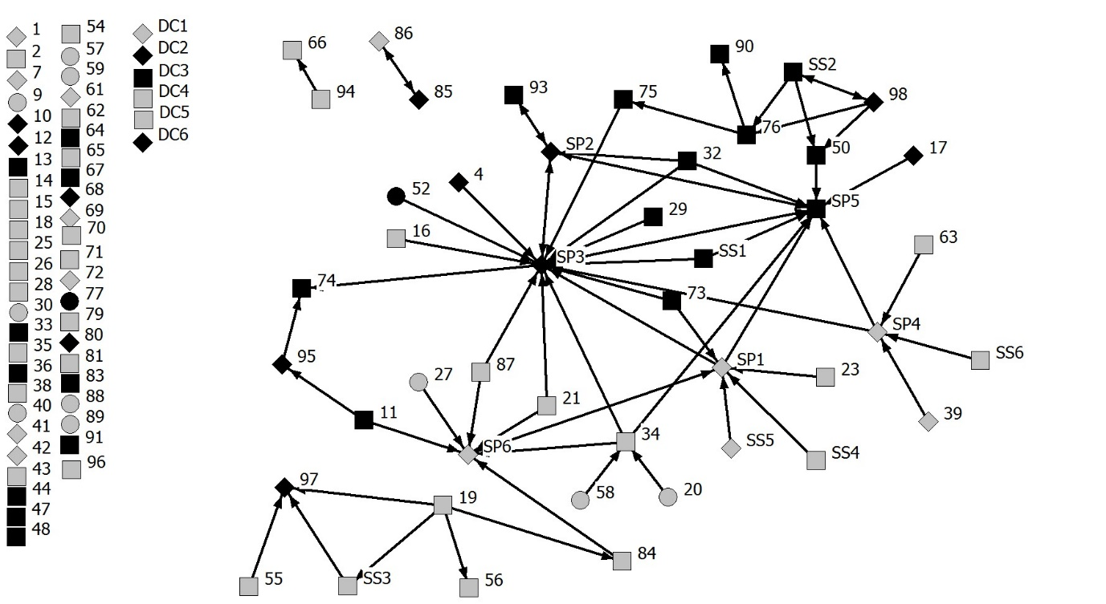
Numbers indicate the unique participant number. Arrows indicate nominations between participants and the arrow-head indicates the direction of these nominations. Black = Male; Grey = Female; = <PA recommendations, = Met PA recommendations, = >PA recommendations; SP = support provider; SS = support seeker; DC = disconnected

Figure 2: Nominations for companionship support made by participants.

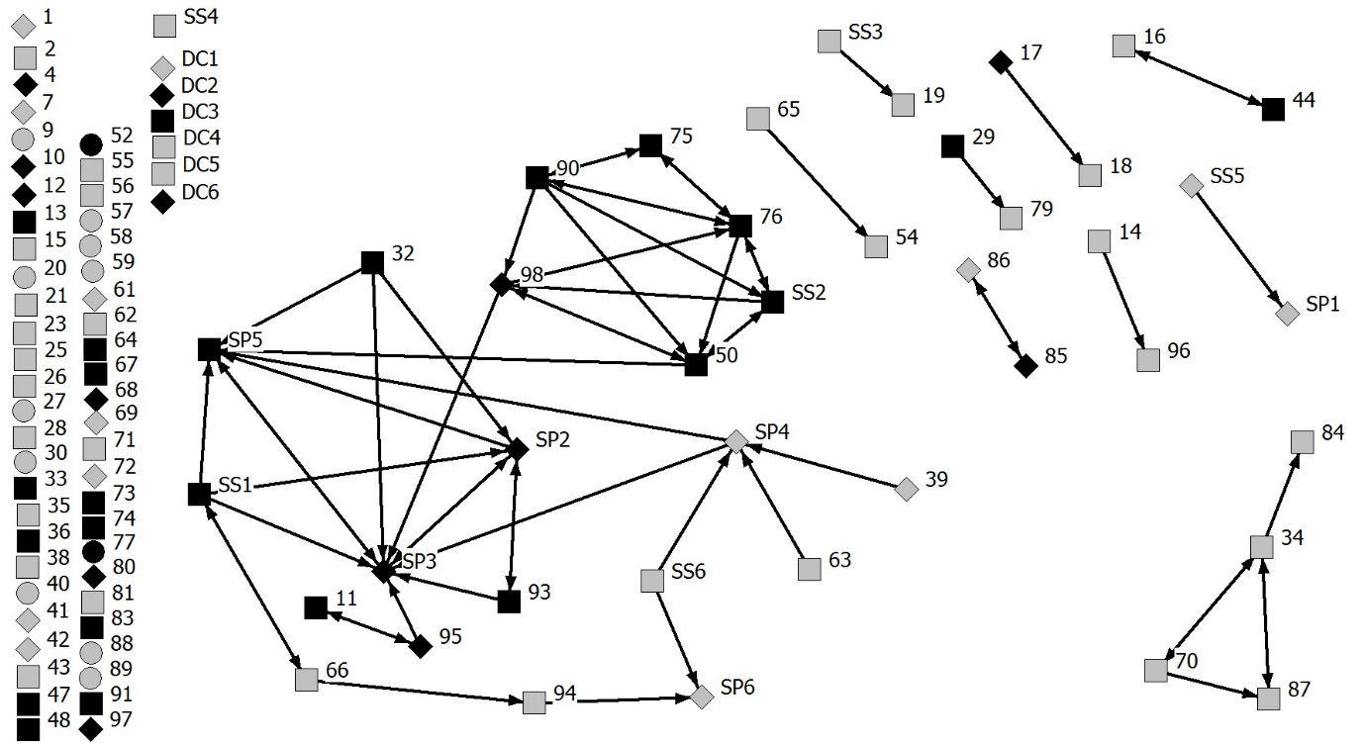
Numbers indicate the unique participant number. Arrows indicate nominations between participants and the arrow-head indicates the direction of these nominations. Black = Male; Grey = Female; = <PA recommendations, = Met PA recommendations, = >PA recommendations; SP = support provider; SS = support seeker; DC = disconnected

Figure 3: Nominations for emotional support made by participants.

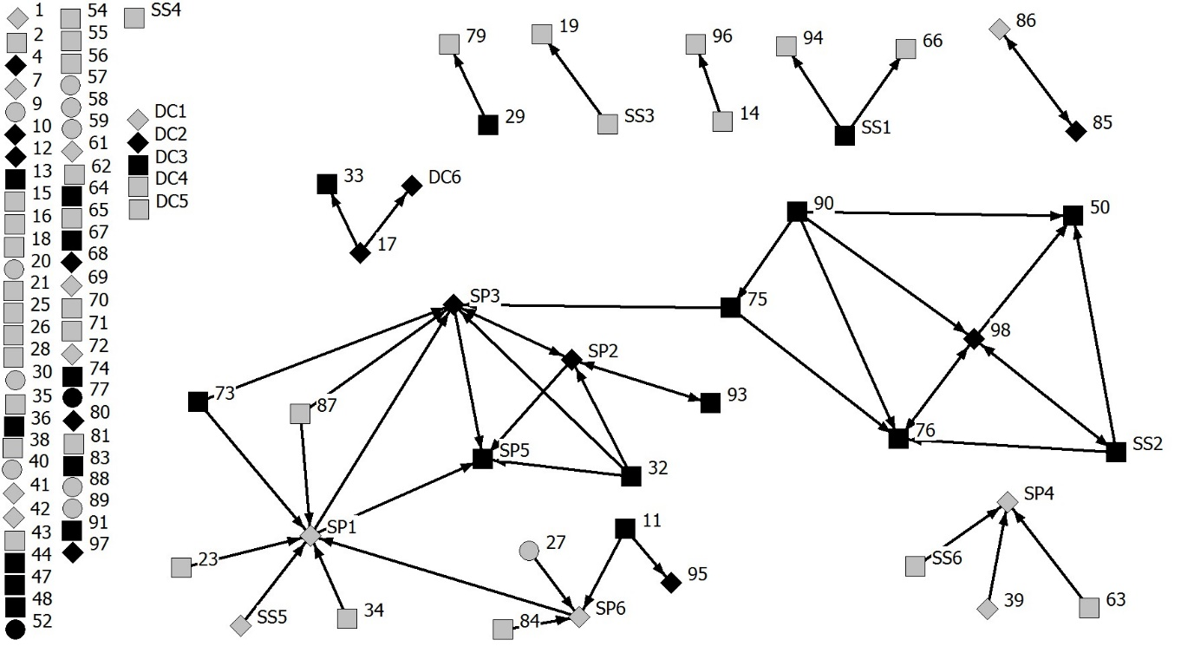
Numbers indicate the unique participant number. Arrows indicate nominations between participants and the arrow-head indicates the direction of these nominations. Black = Male; Grey = Female; = <PA recommendations, = Met PA recommendations, = >PA recommendations; SP = support provider; SS = support seeker; DC = disconnected

Figure 4: Nominations for validation support made by participants.

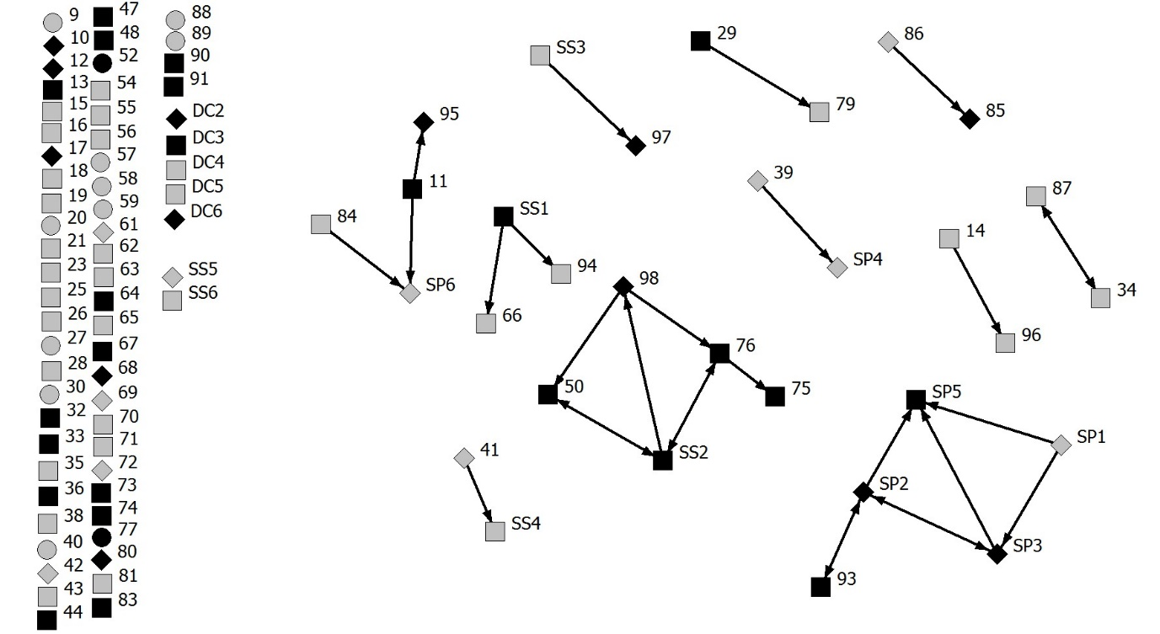
Numbers indicate the unique participant number. Arrows indicate nominations between participants and the arrow-head indicates the direction of these nominations. Black = Male; Grey = Female; = <PA recommendations, = Met PA recommendations, = >PA recommendations; SP = support provider; SS = support seeker; DC = disconnected

