Interaction between ambient temperature, hypoxia and load carriage on respiratory muscle fatigue
Katrina Hinde MSc¹, Chris Low PhD¹, Ray Lloyd PhD² and Carlton Cooke PhD²
¹ School of Sport, Leeds Beckett University
² School of Social and Health Sciences, Leeds Trinity University

Address correspondence and reprint requests to Katrina Hinde, Leeds Beckett University, Carnegie Hall G05, Headingley Campus, Leeds, West Yorkshire, England, LS6 3QS, Email address: k.hinde@leedsbeckett.ac.uk

Suggested short title: Load carriage in cold hypoxia.

Manuscript metrics
Word count for abstract: 172
Word count for main text: 5477
Number of references: 39
Number of tables: 4
Number of figures: 4

Abstract
Background: While respiratory muscle fatigue is present following load carriage activity at sea level, the effect of environmental conditions on respiratory strength while undertaking load carriage is unknown. Methods: The effect of thoracic load carriage during walks (5.5 km) in four environments [(thermo-neutral sea level (SL), -10°C (C), 4300m (H) and 4300m at -10°C (HC)] was evaluated on respiratory muscle fatigue. Ten subjects completed 8 self-paced randomised treadmill walks comprising a variety of gradients, unloaded and loaded (18.2 kg), across the four environments. Respiratory muscle strength was measured via maximal inspiratory pressure (P_{imax}) and expiratory pressure (P_{emax}) assessments. Results: Submaximal walking in HC elicited respiratory muscle fatigue when compared to SL. Inspiratory muscle fatigue was independent of load. The relative change in P_{imax} from baseline was significantly greater in HC compared to SL (9.6% vs 1.3%). P_{emax} showed a significant reduction during HC (-22.3cmH₂O, -14.4%) when compared to the other 3 environments. Conclusion: These results highlight the need to focus on respiratory muscle strength in preparation for exercise in cold hypoxic conditions.

Keywords

Load carriage, hypoxia, cold

Introduction
Millions of individuals travel to areas of high altitude every year to explore, trek or work. Mountaineering and occupational tasks are regularly undertaken at altitude and are rarely experienced without concomitant exposure to the cold. Such activities also frequently involve load carriage (LC) which poses challenges to respiratory muscles by loading or restricting the chest wall, reducing lung volumes^{10, 31} and causing respiratory muscle fatigue (RMF)¹¹. RMF is defined as an exercise-induced reduction in the force generating capacity of the respiratory muscles³⁷. The extent of this reduction however is ill-defined as both thresholds of a 10% and ≥15% reduction have been used to represent RMF¹⁹. Nevertheless, most studies do not use a threshold, acknowledging that a significant reduction in inspiratory or respiratory muscle strength from baseline is indicative of a reduction in inspiratory muscle function^{11,25,31}.
Faghy et al. reported that loads of < 20 kg did not elicit RMF, as neither maximal inspiratory pressure (P_{imax}) nor maximal expiratory pressure (P_{emax}) were significantly reduced, concluding that lighter loads do not force breathing mechanics outside of the compliance zone of the pressure-volume curve¹². This however was only investigated at sea level (SL). Hypoxia (H) augments the work of breathing (WOB) done during exercise¹⁶ and can cause significant changes in central motor drive¹ while cold exposure alone has been shown to cause significant muscle fatigue, attributed to reduced contractile function²⁹. Lloyd et al. reported an additive effect of combined cold-hypoxia on forearm fatigue development, producing a significantly greater level of fatigue when compared to thermo-neutral, normoxic environments²⁴. Additional reductions in end-expiratory lung volume (EELV) and end-inspiratory lung volume (EILV) by carrying heavier loads, increased ventilation at altitude and/or reduced mechanical efficiency in the cold could lead to an overall greater WOB¹⁰ and ultimately greater RMF. The effects of cold and very high altitude upon the pressure-generating capacity of the respiratory muscles in conjunction with LC are yet to be determined.
RMF has been shown to impair performance, increase perceptions of dyspnea and result in earlier termination of exercise¹⁵. RMF has important consequences for occupational and recreational LC activities^{11,12}. Identifying RMF during exercise in cold and hypoxic environments would enable preparation strategies to be implemented which may act as an ergogenic aid, assisting individuals in having a healthier, safer and more positive experience. Therefore, the purpose of this study was to examine the effects of LC upon RMF at very high altitude and in the cold, measured through volitional inspiratory and expiratory mouth pressures. We hypothesised that respiratory muscle strength would be significantly reduced following 5.5 km of loaded walking during hypoxia, cold exposure and hypoxic-cold, but not at sea level. Furthermore, the severity of RMF would be greater in hypoxic-cold conditions.

Methods

Subjects
Following ethics approval by the Research Ethics Committee at Leeds Beckett University, 13 individuals (8 men, 5 women) provided written consent to participate in the study and were screened. However, only 10 completed all trials (5 men, 5 women, age: 22.4 ± 3.3 years, height: 172.6 ± 7.0 cm, body mass: 71.0 ± 9.3 kg, normoxic V̇O_{2max}: 51.5 ± 10.1 ml.kg⁻¹.min⁻¹). Subjects were also screened for sickle cell trait as hypoxia is a strong stimulus for sickling with the risk of a splenic infarction being a rare but actual risk for those with this trait³⁸. Only individuals with a negative test result could participate. Subjects were habitually active and experienced in carrying loads. Before exercise, subjects resting blood pressure (< 140/90 mmHg) and resting heart rate (HR) (<100 beats.min⁻¹) were measured according to ACSM guidelines³³, to ensure that they were apparently healthy and safe to test. Resting blood pressure was measured using the Boso Medicus (Bosch, Jungingen, Germany) blood pressure device whilst resting HR was measured using a Polar T31 codedTM transmitter and FT1 watch (Polar, Kempele, Finland).

Equipment and procedures
All trials were completed in a normobaric environmental chamber (TISS, Peak Performance Chamber Series 2009, Hampshire, UK). Humidity was controlled at 50% and wind speed was 2.9 m.s⁻¹. Subjects undertook spirometry and respiratory pressure familiarisation. Measures were performed according to the guidelines of the American Thoracic Society² and European Respiratory Society²⁷. Using a respiratory pressure meter (MicroRPM, Carefusion, Basingstoke, UK) subjects performed the ‘Mueller’ manoeuvre. Maximal inspiratory and expiratory efforts from either residual volume or total lung capacity for a minimum of two seconds were measured. Maximal efforts were repeated at least 3 times every 30 seconds until the results were stable (< 10% variance in 3 consecutive manoeuvres)²⁵. The highest value was used in all measurements. Spirometry measures: forced vital capacity (FVC), forced expiratory volume in one second (FEV₁) and peak expiratory flow (PEF) were obtained through hand-held spirometry (Micro I, Carefusion, Basingstoke, UK). Maximal inhalation followed immediately by a maximal exhalation for as long as possible was performed whilst standing. Manoeuvres were considered acceptable if they were free from artefacts such as leaks or obstructed mouthpieces, had good starts and showed satisfactory exhalation (≥ 6 seconds). Measurements were repeated three times unless the two largest values for FEV₁ or FVC values were not within 0.15 L of each other². Baseline respiratory pressure and spirometry measures were performed without a load, all subsequent measures were conducted loaded.
Following a 5-minute rest period, an unloaded maximal exercise test to exhaustion was conducted to determine maximal oxygen consumption (V̇O_{2max}). V̇O_{2max} tests were conducted at sea level (SL) and 4300m only to establish baseline fitness levels and the reduction due to hypoxia as a previous investigation by the current researchers found that V̇O_{2max} did not differ between SL at 18°C and SL at -10°C (56.2 ± 11.9 and 55.1 ± 8.4 ml.kg⁻¹.min⁻¹ for SL and -10°C respectively, p = 0.602, d = 0.11, unpublished data). To achieve an altitude of ~4300m, an FiO₂ of ~11.8% was used considering water vapour partial pressure⁹ and daily fluctuations of barometric pressure. Subjects selected a speed to run at which remained constant throughout the test, this ranged from 9.0– 12.5 km.hr⁻¹ at SL and 7.0- 10.5 km.hr⁻¹ in H, while treadmill gradient, initially 1%, increased by 1% every minute.
Once familiarisation and preliminary tests were completed, at least 24h separated the start of the walking trials. Environmental conditions during the walking trials were sea level (SL) at 20°C, very high altitude (H, 4300m, ~11.8% O₂ at 20°C), cold at SL (C, -10°C) and very high altitude in the cold (HC, ~11.8% O₂ at -10°C). There were 8 walking trials performed on 8 separate occasions, each of the 4 environmental conditions were performed unloaded (0 kg) and loaded (18.2 kg). Subjects’ exposure to the different environmental conditions was assigned using a counter-balanced Latin square and at least 24 h separated trials. Data for peripheral oxygen saturation (SpO₂), P_{imax}, P_{emax}, HR and minute ventilation (V̇e) were tested for order effects to establish that the randomised exposure sequence did not have any significant influence on the data. SpO₂, HR and V̇e were chosen as they are the variables most likely to be affected by repeated hypoxic exposures. P_{imax} and P_{emax} was also assessed for any order effect on respiratory muscle strength. Results confirmed data were not affected by the sequence of exposure for all 5 variables (p ≥ 0.130, η_{p}² ≤ 0.164).
Subjects wore shorts, t-shirt and training shoes for thermo-neutral trials. For -10°C exposures, subjects wore trousers, a long-sleeved top, hat, gloves and a winter jacket weighing 1.49 kg. Skin temperature was measured using a Squirrel Data Logger (400 Series: 401/451, Wessex Power, Dorset, UK). Three values over a 30 second period were taken with the mean of these recorded. Mean skin temperature (MST) was estimated as:
MST= [0.3 (chest+ arm)] + [0.2 (thigh + leg)]³²
For each trial, following the completion of baseline spirometry, P_{imax}, P_{emax} and MST measures, subjects entered the chamber for a 15-minute standardised period of rest during which HR, SpO₂ (PM10N, NellcorTM, Covidien, Mansfield, USA) and MST were measured before a 5.5 km walk at a self-selected pace was performed involving a variety of gradients (0%, 5% and 10%). The order of gradient and distances were as follows: 0-1 km at 0%, 1-1.5 km at 5%, 1.5-2 km at 10%, 2-3 km at 0%, 3-3.5 km at 5%, 3.5-4 km at 10%, 4-5 km at 5% and 5-5.5km at 0%. The self-selected initial walking speed for each environment was attained during a 1-minute walking period prior to the 5.5 km section starting. This speed could also be adjusted by the subject throughout the protocol within each trial. HR, RPE_{whole} using the Borg Scale, RPE_{breathing}, RPE_{legs} using a Borg CR10 Scale⁶ and SpO₂ were recorded every 0.5 km. Expired gas using an online gas analyser (Cortex Metalyzer 3B, Leipzig, Germany) was measured during the first 0.5 km at 0% gradient and in the last 0.5 km at 0% gradient. Between these two periods, subjects were allowed to remove the face mask. Spirometry measures, P_{imax}, P_{emax} and MST were measured at baseline (distance 0 km) and following the walk (distance 5.5 km).
The load carried consisted of items usually taken on trekking/mountaineering trips. One backpack (Wynnster Equador) was used by all subjects for the whole study. The backpack was fitted to each subject before their trial started and was altered depending on subjects’ height. The weight of the loaded pack was 18.2 kg with load justification coming from previous LC research¹⁸.
An individual’s speed would change as gradient increased when trekking or mountaineering. Therefore, allowing walking speed to vary instead of using one fixed absolute speed provides a more ecological measure of the effect of exercise on P_{imax} and P_{emax}. As the protocol was conducted at self-selected speeds, external vertical work-rate was established across each of the conditions²⁸:
External vertical work-rate (watts) = total mass (kg) x gravitational acceleration (9.81 m.s⁻¹) x velocity (m.s⁻¹) x sin (angle of inclination)

Statistical analysis
Data were analysed using IBM SPSS 22 with significance tested at 95% confidence intervals, p < 0.05. Descriptive statistics (mean ± SD) were calculated for all outcome measures. All data were normally distributed (Shapiro-Wilk, p > 0.05). A Pearson’s correlation was used to assess relationships between variables with r defined for effect size as small; r = 0.1, medium = 0.3 and large = 0.5⁸. Changes in dependent variables over 5.5 km were assessed using a 3-way repeated measures analysis of variance (RMANOVA, 4 x 2 x 2; environment x load x distance) with Bonferroni post hoc analysis. In cases when the assumption of sphericity was violated, if ε < 0.75, the Greenhouse-Geisser correction factor was applied, if ε > 0.75, the Huynh-Feldt correction factor was applied. Effect sizes for RMANOVA were calculated using partial eta squared (η_{p}²). For significant main effects, post hoc analysis used paired sample t-tests to establish differences. Two-way and three-way interactions were reported and classification of interactions were identified according to Lloyd and Havenith²³. As hypoxia is rarely experienced without some reduction in ambient temperature, SL was also directly compared to HC using a 3-way RMANOVA (2 x 2 x 2; environment x load x distance) with Bonferroni post hoc analysis.

Results

Respiratory function
Baseline measures of P_{imax} were not different between trials (p = 0.568, η_{p}² = 0.071). Absolute changes in P_{imax} in all 4 environments, both unloaded and loaded are shown in Figure 1a. Following a 5.5 km walk, P_{imax} values were significantly lower (100.7 ± 20.5 cmH₂O) than baseline values [106.3 ± 19.2 cmH₂O, main effect of distance, F(1,9) = 9.182, p = 0.014, η_{p}² = 0.505] and there was a trend for P_{imax} to be reduced following the 5.5 km walk during HC exposure [interaction effect between environment x distance, F(3,27) = 2.53, p= 0.078, η_{p}² = 0.219]. During HC, P_{imax} decreased by 6.1 cmH₂O (5.5%) and 14.6 cmH₂O (13.6%) in unloaded and loaded conditions respectively, compared to much smaller changes in the other three environmental conditions (Figure 1a).
Relative changes from baseline in P_{imax} responses at SL compared to HC only were significantly different [main effect for environment, F(1,9) = 8.745, p = 0.016, η_{p}² = 0.493] During HC exposure, P_{imax} was reduced by 9.6 ± 6.2% compared to SL which was reduced only by 1.3 ± 7.0%. Despite a larger %ΔP_{imax} when loaded during HC, there was no significant interaction between environment and load (p = 0.542, η_{p}² = 0.043).
Baseline measures of P_{emax} were not different between trials (p = 0.640, η_{p}² = 0.060). P_{emax} was significantly reduced following a 5.5 km walk [from 143.2 ± 34.6 to 133.4 ± 30.2, F (1,9) = 23.994, p = 0.001, η_{p}² = 0.727]. In addition, a significant interaction was reported for environment and distance [F(1.75,15.77) = 8.543, p = 0.004, η_{p}² = 0.487]. With load averaged across trials, P_{emax} was significantly reduced (-22.3 cmH₂O) following the 5.5 km walk during HC exposure when compared to SL (0.5 cmH₂O), H (-12.7 cmH₂O) and C (-4.6 cmH₂O).
P_{emax} was significantly reduced from baseline by 17.8 ± 12.1% during HC exposure when compared to SL only [main effect for environment, F(1,9) = 17.172, p = 0.003, η_{p}² = 0.656]. Similar to P_{imax}, despite a larger %ΔP_{emax} when loaded during HC (Figure 1b), there was no significant interaction between environment and load (p = 0.125, η_{p}² = 0.242).
[Fig #1 here]
Changes in FEV_{1,} FVC and PEF across load, distance and environmental conditions are shown in Table I. FVC was significantly lower during HC (4.1 ± 0.9L) compared to the other environments [4.3 ± 0.9, 4.2 ± 0.9 and 4.2 ± 0.8 for SL, H and C respectively, F(3,27) = 3.544, p = 0.028, η_{p}² = 0.283]. FEV₁ and PEF were not significantly different between environments (p = 0.387, η_{p}² = 0.104 and p = 0.249, η_{p}² = 0.139 respectively). Following a 5.5 km walk, there were significant reductions in FEV₁ (from 3.7 ± 0.6 to 3.5 ± 0.6 L), FVC (4.4 ± 0.8 to 4.1 ± 0.8 L) and PEF (488.1 ± 120.1 to 469.4 ± 117.2) compared to baseline values (p ≤ 0.024, η_{p}² ≥ 0.452).
A significant interaction, environment x distance, was reported for FVC [F(3,27) = 3.577, p = 0.027, η_{p}² = 0.284] with a greater absolute reduction in FVC during HC (0.44 L) compared to SL (0.20 L), H or C (both 0.30 L). The interaction was hyper-additive as HC conditions led to a greater decrease (-11.5 ± 6.1%) than the stressors as individual effects added (-4.5 ± 3.1% and -0.9 ± 3.9% for distance and environmental condition respectively).
A significant hyper-additive interaction was also found for FEV₁ between load and distance [F(1,9) = 12.172, p = 0.007, η_{p}² = 0.575]. When assessed as individual stressors, the effect of distance on the reduction of FEV₁ was greater than the effect caused by load. The combined effect of load and distance elicited a greater reduction (-8.0 ± 2.9%) than the stressors as individual factors combined (-3.9 ± 3.7% and -0.1 ± 2.6%).
[Table # I here]

Cardiorespiratory responses and walking speed
Table II shows that minute ventilation (V̇e) and oxygen consumption (V̇O₂) were significantly increased by LC, regardless of the environment [F(1,9) = 11.412, p = 0.008, ηp² = 0.559 and F(1,9) = 9.977, p = 0.012, ηp² = 0.526 respectively]. V̇O₂ during C was higher than H (p = 0.006, d = 1.38), V̇O₂ was higher at SL than H (p = 0.047, d = 0.79) and there was a trend for V̇O₂ to be higher during C compared to HC (p = 0.079, d = 1.15). For V̇e, there was no main effect of environment (p = 0.624, ηp² = 0.062) yet there was a significant interaction between environment and distance [F(3,27) = 3.242, p = 0.038, ηp² = 0.265] highlighting that the increase in V̇e as exercise progressed was different between environmental conditions. Figure 2 shows that during SL, there were minor increases in both V̇e (26.7 ± 7.5 to 28.0 ± 8.9 L.min⁻¹) and walking speed (4.8 ± 0.7 to 5.0 ± 0.7 km.hr⁻¹). The increase in V̇O₂ and V̇e during C can be partly explained by the increased walking speed. However, during exposure to H and HC, ventilation increased with distance, but there was no change in walking speed.
[Fig #2 here]
[Table # II here]
Table III shows the reduction in SpO₂ associated with hypoxia [F(3,7) = 192.489, p < 0.001, η_{p}² = 0.955]. Prolonged exercise also had a negative effect on SpO_{2,} with values being significantly reduced at 5.5 km when compared to 0.5 km when averaged across loads and environments [F(1,9) = 33.947, p < 0.001, η_{p}² = 0.790]. The reduction in SpO₂ was more severe following exposure to HC (↓6.2%) causing a significant interaction between environment and distance [F(3.27) = 11.524, p < 0.001, η_{p}² = 0.561]. Both H and HC environments produced a hyper-additive effect compared to SL responses. It is noteworthy that the total decrease of H and C combined (-27.9 ± 6.8% and -1.2 ± 1.4% at 0.5 km or -33.4 ± 9.3% and -1.3 ± 1.4% at 5.5 km) was very similar, although slightly lower, than HC (-29.3% and -35.6% at 0.5 and 5.5km respectively). H caused a significant increase in HR compared to normoxic environments (p ≤ 0.004, d ≥ 0.74).
Whilst variations in walking speed could affect physiological responses, there were no significant differences in walking speed across the 4 different environments, 2 loads and 2 distances (first and last 0.5 km of the walking trial, no significant 3-way interaction, p > 0.05). Walking speed did however show a significant difference between environments [F(3,27) = 9.864, p < 0.001, ηp² = 0.523]. Averaged across loads and distance, walking speeds were 4.9 ± 0.7, 4.4 ± 0.4, 5.0 ± 0.7 and 3.9 ± 0.4 km.hr⁻¹ for SL, H, C and HC respectively. Significant differences were found between SL with HC (p = 0.032, d = 1.81) and C with HC (p = 0.027, d = 1.95) highlighting the stress caused by the combination of environments. Load negatively influenced walking speed from 5.0 ± 0.5 to 4.1 ± 0.3 km.hr⁻¹ [F(1,9) = 37.029, p < 0.001, ηp² = 0.804]. Walking speed also showed a significant interaction between environment and load [F(3,27) = 5.718, p = 0.004, ηp² =0.388]. Further investigation showed greater reductions in walking speed at HC compared to the other environments. The difference in speed between unloaded and loaded walking was -1.4 km.hr⁻¹ from 4.6 ± 0.4 to 3.2 ± 0.5 km.hr⁻¹.
[Table # III here]
External vertical work-rate showed a significant interaction of environment x load [F(1.38,12.42) = 6.27, p = 0.020, ηp² =0.411]. Table IV shows that in SL and C, when load was added, speed was reduced slightly, but not enough to offset the effect of load, resulting in an increase in vertical work-rate. In H, when unloaded, speed was reduced relative to SL which reduced vertical work-rate. When load was added, speed was further reduced but only enough to balance the effect of load, and thus work-rate was similar to unloaded values. HC caused the greatest reduction in speed and work-rate relative to SL. When load was added, there was a further reduction in walking speed, which was large enough to more than offset the increase in work-rate when loaded, leading to an overall significant reduction in work-rate when compared to SL and C (p ≤ 0.014, d ≥ 1.53).
[Table # IV here]

Perceptual responses and skin temperature
All three RPE scores were significantly higher following 5.5 km of walking (main effect of distance, p ≤ 0.016, η_{p}² ≥ 0.495). Figure 3 shows a significant main effect of environment for RPE (whole and breathing, p ≤ 0.001, η_{p}² ≥ 0.625) with RPE scores significantly higher during HC when compared to SL. RPE_{legs} was not significantly different between environments (p = 0.076, η_{p}² = 0.287). Despite RPE_{breathing} being significantly higher during HC and the greater degree of inspiratory muscle fatigue observed in HC, there was no significant correlation reported between ΔRPE_{breathing} and ΔP_{imax} from baseline (p = 0.275, r = -0.441, R² = 0.19).
[Fig #3 here]
Significant interactions existed for environment x distance in RPE_{breathing} [F(3,27) = 3.629, p = 0.025, η_{p}² = 0.287] and a trend was identified for RPE_{legs} [F(3,27) = 2.932, p = 0.051, η_{p}² = 0.246]. Figure 4a indicates that the change in RPE_{breathing} scores with increasing distance was different between environments, with responses to HC noticeably greater than for other conditions. Figure 4b shows that when comparing SL with HC, change in environmental conditions had a greater effect on RPE_{breathing} scores than increased distance. When comparing RPE_{breathing} at 5.5 km across the environments, both hypoxic exposures showed a hyper-additive interaction. Exposure to -10°C however showed a hypo-additive interaction as the combined effect of environment and increased distance elicited smaller changes to RPE_{breathing} (135.0 ± 82.6%) than the stressors as individual factors combined (108.3 ± 66.3% for distance and 66.7 ± 68.5% for environment).
[Fig #4 here]
Clothing ensembles were different in 20°C and -10°C trials, and despite subjects wearing a winter mountaineering jacket in -10°C exposures, there was a significant thermal stress during C and HC with significantly reduced mean skin temperatures [F(3,27) = 118.735, p < 0.001, η_{p}² = 0.937].
Discussion
The study investigated the effects of cold, hypoxia and LC during walking upon RMF, pulmonary function, perceptual and cardiorespiratory responses. In contrast to previous published work, RMF was shown to be independent of load and RMF occurred following low intensity exercise (< 50%V̇O_{2max}) in HC conditions.
RMF post-LC has previously been suggested to arise from a combination of factors including the restrictive nature of a backpack and the greater metabolic demands when performing heavy LC¹¹. Restrictive ventilatory impairment associated with LC demonstrated through reductions in FVC and FEV₁¹¹, EILV and EELV suggest the diaphragmatic muscle fibres work at a sub-optimal portion of the length-tension curve^{10,11,31}. The present study however found load did not significantly reduce FEV₁ and FVC and load per se had no effect on the degree of inspiratory muscle fatigue. Faghy et al. identified a possible threshold (< 20 kg) after which EELV was reduced and lung function was likely compromised during LC¹². Our findings at SL agree with this hypothesis, however our data in HC challenge this. Although significant changes in respiratory muscle pressures were not consistently identified in the current study, the data present a strong argument for the effect of HC on RMF, especially when compared with SL only. An absolute threshold for eliciting RMF may be inappropriate depending on environmental conditions. The present study suggests that the conclusions by Faghy et al. should only apply to LC activities performed at SL.
Early research work reported RMF as being prevalent following high intensity exercise > 85%V̇O_{2max} (20), this was lowered to < 70%V̇O_{2max}³⁶ and reduced further to ~58%V̇O_{2max} when LC was involved^{11,12,31}. The present study adds to the body of literature that lower intensity exercise may elicit RMF. The occurrence of RMF during high intensity exercise has been found to be as a consequence of a respiratory muscle metaboreflex, whilst during lower intensity exercise, RMF was attributed to the restrictive nature of LC¹². Whilst the low intensity at HC (~40%V̇O_{2max}) might lead to discounting the metaboreflex as a possible cause of RMF, Romer and Polkey identified that exercise duration, not only intensity played an important role in diaphragm fatigue³⁵. Furthermore, during heavy exercise when SpO₂ < 87%, diaphragm fatigue has been shown to be exacerbated compared to SL responses⁴. Exercise duration in the present study was prolonged (over 2 hours) and oxygen delivery was reduced (SpO₂ was 66.7 ± 5.0% in HC) implying that the metaboreflex response may have contributed to RMF.
Cold exposure alone had little effect on RMF and while hypoxia alone had a greater effect, it was still relatively small. A combination of the two environments (HC) did cause significant RMF when compared to SL responses. RMF in HC has not been previously investigated and therefore the exact explanations for this are unknown. Four possible mechanisms may have contributed to the RMF seen in HC. Firstly, spirometry data indicates that high altitude is associated with reductions in FVC, increased PEF and relatively stable FEV₁³⁹, which is typical of restrictive ventilatory impairment¹¹. Reductions in FVC may have multifactorial causes including reduced respiratory muscle power, increases in pulmonary blood volume and subclinical pulmonary oedema, with the latter two being the most plausible³⁹. The evidence associated with spirometry and reductions in ambient temperature is equivocal. In healthy individuals, some literature has shown that cold exposure does not affect spirometry measures²² while others have reported reductions of FVC and FEV₁, only present when exposure involved significant facial cooling¹³. The results from the present study showed a hyper-additive reduction in FVC during HC, with no effect on FEV₁. Decreased FVC reduces the volume of air the lungs can support which increases WOB, reduces lung compliance and may lead to RMF. Secondly, at altitude, V̇e increases to maintain levels of oxygen consumption similar to that at sea level for a given task due to the reduced barometric pressure¹⁶. Evidence shows an increase in EELV during acute hypoxia in humans²¹ which may be a result of increased post-inspiratory inspiratory activity implying electrical activity of the inspiratory muscles continues into the early expiratory phase⁵. This activity brakes expiratory flow and inhibits the thorax from collapsing and resuming its relaxed position⁵. The only way to meet ventilatory demands is to increase BF, but due to working at a higher lung volume, inspiratory muscles are prevented from developing force effectively, increasing WOB, which may develop into RMF. Evaporative water loss and recruitment of the small airways during the humidifying process upon the inspiration of cold air, has been suggested to elicit effects similar to exercise-induced bronchoconstriction (EIB)³. Mediano et al. found that EIB caused a significant increase in EELV during exercise, resulting in individuals working at higher lung volumes, which ultimately may lead to RMF²⁶. The combination of these two environments may have led to an increase in EELV, causing greater RMF.
Third, as RMF develops, accessory muscles such as sternocleidomastoid, scalene, abdominals and trapezius are recruited and serve to lift the ribcage, enabling ventilation to be maintained^{4,20}. The increased use of accessory respiratory muscles as exercise is prolonged may distort the chest wall (causing reductions in abdominal dimension), reduce the efficiency of the respiratory muscles and increase the blood flow and metabolic demands^{35,37}. Fatiguing respiratory muscles during high intensity exercise (≥ 80%V̇O_{2max}) or conditions that cause inadequate O₂ transport (SpO₂ is ≤ 85%) elicit increased competition for available cardiac output between the respiratory and working locomotor muscles⁴. During heavy exercise, respiratory muscles are prioritised causing a sympathetic vasoconstriction response in limb muscles, which promotes perfusion limitation and induces locomotor muscle fatigue, resulting in greater perception of effort in the limbs¹⁵. This effect has also been seen during submaximal exercise in hypoxia⁴. Finally, cold exposure alone has been shown to cause significant muscle fatigue²⁹, due to reduced muscle temperatures resulting in reduced mechanical efficiency as a result of increased co-activation, slowed calcium uptake and a reduction in cross-bridge force kinetics^{24,29}. Furthermore, vasoconstriction occurring in the cold reduces muscle blood flow, decreases O₂ delivery and increases the build-up of metabolic by-products²⁹. Hypoxia also increases muscle fatigue due to the increase in relative exercise intensity as well as an increase in the percentage of type II fibres recruited¹. When hypoxia and cold are combined, Lloyd et al. reported an additive effect on forearm fatigue development as significantly greater levels of fatigue were detected in HC but the two environments did not interact with each other²⁴. H resulted in early fatigue, whereas the impact of cooling occurred later in the exercise protocol meaning reductions in maximal voluntary contraction were subject to both fast and progressive reductions in HC. These potential mechanisms and explanations are founded on a theoretical basis only and require further investigations to establish clarity regarding mechanisms of response.
Alongside the findings of RMF in HC, the study also revealed greater levels of dyspnea when performing LC in HC. Perceptions of dyspnea may be altered by recruiting additional accessory muscles. There is evidence that the force generating capacity of the diaphragm is greater than that of accessory inspiratory muscles¹⁷. Therefore, increased sensations of breathlessness indicate progressive recruitment of relatively weaker accessory muscles³⁵. To achieve a given force, recruiting weaker muscles would necessitate a greater motor outflow, thus increasing the sensory output to the central nervous system³⁴. The lack of an apparent relationship between ΔP_{imax} and ΔRPE_{breathing} could be attributed to sample size but also to the fact that the ΔP_{imax} is not the only and/or the main contributing factor increasing RPE_{breathing}.

Practical application
The findings of RMF within this study may have important implications for whole body exercise related to recreational and occupational activities in HC. As fatigue develops, accessory muscles are recruited to maintain ventilation. Recruiting respiratory accessory muscles could increase energy expenditure as additional muscles are recruited, reducing breathing efficiency, increasing the sensory output to the central nervous system, increasing perceptions of breathlessness and therefore cessation of exercise may occur sooner³⁵.

Methodological considerations
The use of self-selected speeds may affect external work-rate. It could be argued that greater work-rates may be responsible for the RMF seen rather than changes in environmental conditions. Data from the present study however, demonstrates a reduction in work-rate in HC when compared to SL and C, but a greater severity of RMF. These results therefore enable us to be confident that the difference in RMF seen was due to different environmental conditions and not to increases in work-rate. Had the same absolute walking speed been selected for all environments, we would hypothesise that the severity of RMF in HC would be exaggerated and we may have reported RMF that would not occur in reality. The 5.5 km walk represented half a day trekking on popular trekking routes, if LC had been prolonged further, the researchers hypothesise that the findings would have been clearer with greater significance (both ecological and statistical). Future research should assess pulmonary function when carrying a load for greater distances.
It has been acknowledged that P_{imax} and P_{emax} do not directly reflect the strength of the diaphragm, as volitional measures of respiratory muscle force reflect the force output of all respiratory muscles together¹² and it has been reported that such measures may not be sensitive enough to detect respiratory muscle changes²⁰. However, Brown et al. reported a significant correlation between P_{imax} and trans-diaphragmatic pressure before and after inspiratory muscle training⁷, which provides evidence to support the use of P_{imax} as a measure of inspiratory muscle force and act as a substitute for diaphragm function¹². Additionally, both P_{imax} and P_{emax} have been shown to be highly reliable and reproducible³⁴. These findings and their use in previous literature^{11,12,35} justifies their use in the present study. In order to minimise any potential effects of reduced motivation, familiarisation sessions were used and maximal effort was supported by verbal encouragement. We are therefore confident that any potential effects of reduced effort were minimised. Despite demonstrating RMF in HC, it is important to note that due to methodological restrictions, we did not measure non-volitional tests of respiratory muscle strength or calculate the WOB, EELV, EILV or total lung volumes. Without involuntary measures of respiratory muscle strength alongside voluntary measures in the present study, the contribution of central and peripheral mechanisms to RMF cannot be clarified and should be an area for future research.
The literature concerning the relationship between biological sex and RMF is equivocal^{14,30}. Regardless of this uncertainty, the repeated measures nature of the current study design would negate any sex differences in RMF should they exist.
Variations in individual’s anatomical features could have resulted in an imperfect backpack fit and strap tension was not standardised between trials. Nevertheless, back length adjustment was used to ensure a suitable fit and all subjects were satisfied with the fitting of the backpack.
Due to the freezing environmental conditions, ventilation data could only be recorded in the first and last 0.5 km of the walking protocol. However, HR data was collected at each stage of the 5.5 km walk. Although HR was higher in hypoxic environments, the patterns of response across the 5.5 km were similar regardless of load and distance, with no significant 3-way interaction (p = 0.317, ηp² = 0.152). HR increased with increasing gradient and load across all environmental conditions. Therefore, we are confident that we know from a cardiovascular standpoint what happened during the walk.
This study has shown that submaximal walking in HC elicited RMF when compared to SL. RMF evident in HC was independent of load. RMF has been shown to occur during prolonged, low intensity exercise and is suggested to be attributed to changes in lung volumes seen in HC. Changes in whole body effort perception were reported with exercise in HC alongside significantly greater changes in RPE_{breathing} at the end of the 5.5 km walk compared to the other 3 environments. These findings have important implications for individuals operating in HC environments. Although there was not a generalizable effect of load per se, the findings for load conditions in HC warrant future research.
Acknowledgements: The authors would like to thank subjects for their time and effort when taking part in this study and the research assistants in helping to collect the data.
References
- Amann M, Eldridge M.W, Lovering A.T, Stickland M.K, Pegelow D.F, and Dempsey J.A. Arterial oxygenation influences central motor output and exercise performance via effects on peripheral locomotor muscle fatigue in humans. J Physiol. 2006; 575 (3): 937-52.
- American Thoracic Society, European Respiratory Society. ATS/ERS statement on respiratory muscle testing. Am J Respir and Crit Care Med. 2002; 166 (4): 518–624.
- Anderson S.D, and Holzer K. Exercise-induced asthma: Is it the right diagnosis in elite athletes? J Allergy Clin Immunol. 2007; 106 (3): 419-28
- Babcock M.A, Johnson B.D, Pegelow D.F, Suman O.E, Griffin D, and Dempsey J.A. Hypoxic effects on exercise-induced diaphragmatic fatigue in normal healthy humans. J Appl Physiol. 1995; 78 (1): 82-92.
- Bonora M. and Vizek M. Lung mechanics and end-expiratory lung volume during hypoxia in rats. J Appl Physiol. 1999; 87 (1):15-21.
- Borg G. Borg’s perceived exertion and pain scales. Champaigne, IL: Human Kinetics; 1998.
- Brown P.I, Johnson M.A, and Sharpe G.R. Determinants of inspiratory muscle strength in healthy humans. Respir Physiol Neurobiol. 2014;196: 50-5.
- Cohen J. A power primer. Psychol Bull. 1992; 112 (1):155-9.
- Conkin J. PH2O and simulated hypobaric hypoxia. Aviat, Space Environ Med. 2011; 82 (12):1157-8.
- Dominelli P, Sheel, A.W, and Foster G.E. Effect of carrying a weighted backpack on lung mechanics during treadmill walking in healthy men. Eur J Appl Physiol. 2012; 112 (6): 2001-12.
- Faghy M, and Brown P. Thoracic load carriage-induced respiratory muscle fatigue. Eur J Appl Physiol. 2014; 114 (5): 1085-93.
- Faghy M, Blacker S, and Brown P.I. Effects of load mass carried in a backpack upon respiratory muscle fatigue. Eur J Sport Sci. 2016; 16 (8): 1032-38.
- Gavhed D, Mäkinen T, Holmér I, and Rintamäki H. Face temperature and cardiorespiratory responses to wind in thermoneutral and cool subjects exposed to -10°C. Eur J Appl Physiol. 2000; 83 (4-5): 449-56.
- Gonzales J.U, and Scheuermann B.W. Gender differences in the fatigability of the inspiratory muscles. Med Sci Sports Exerc. 2006; 38 (3): 472-9.
- Harms C.A, Wetter T.J, Croix C, Pegelow D.F, and Dempsey J.A. Effects of respiratory muscle work on exercise performance. J Appl Physiol. 2000; 89 (1): 131-8.
- Helfer S, Quackenbush J, Fletcher M and Pendergast D.R. Respiratory muscle training and exercise endurance at altitude. Aerosp Med Hum Perform, 2016; 87 (8): 704-11.
- Hershenson M.B, Kikuchi Y, Tzelepis G.E, and MCool F.D. Preferential fatigue of the rib cage muscles during inspiratory resistive loaded ventilation. J Appl Physiol.1989; 66 (2):750-4.
- Hinde K, Lloyd R, Low C, and Cooke, C. The effect of temperature, gradient, and load carriage on oxygen consumption, posture, and gait characteristics. Eur J Appl Physiol. 2017;117(3):417-30.
- Janssens L, Brumagne, S, McConnell, A.K, Raymaekers, J, Goossense, N et al. The assessment of inspiratory muscle fatigue in healthy individuals: a systematic review. Respir Med. 2013; 107: 331-46
- Johnson B.D, Babcock M.A, Suman O.E, and Dempsey J.A. Exercise-induced diaphragmatic fatigue in healthy humans. J Physiol. 1993; 460 (1):385-405.
- Johnson B.D, Weisman I.M, Zeballos R.J, and Beck K.C. Emerging concepts in the evaluation of ventilatory limitation during exercise. Chest. 1999; 116: 488-503.
- Kennedy M.D, and Faulhaber M. Respiratory function and symptoms post cold air exercise in female high and low ventilation sport athletes, Allergy Asthma Immunol Res. 2018; 10 (1):43-51
- Lloyd A, and Havenith G. Interactions in human performance: an individudal and combined stressors approach. Temperature. 2016; 3 (4): 514-17.
- Lloyd A, Hodder S, and Havenith G. The interactive effect of cooling and hypoxia on forearm fatigue development. Eur J Appl Physiol. 2015: 115 (9): 1-12.
- McConnell A.K, Caine M.P, and Sharpe G.R. Inspiratory muscle fatigue: Following running to volitional fatigue: the influence of baseline strength. Int J Sports Med. 1997; 18 (3): 169-173.
- Mediano O, Casitas R, Villasante C, Martinez-Ceron E, Galera R, et al. Dynamic hyperinflation in patients with asthma and exercise-induced bronchoconstriction. Ann Allergy, Asthma Immunol. 2017; 118 (4): 427-32.
- Miller M.R, Hankinson V, Brusasco F, Burgos R, Coates A, et al. Standardisation of spirometry. Eur Respi J. 2005; 26 (2): 319–38.
- Muscat K.M, Kotrach H.G, Wilkinson-Maitland C.A, Schaeffer M.R, Mendonca C.T, and Jensen D. Physiological and perceptual responses to incremental exercise testing in healthy men: effect of exercise test modality. Appl Physiol Nutr Metab. 2015; 40 (11): 1199-1209.
- Oksa J, Kaikkonen H, Sorvisto P, Vaappo M, Martikkala V, and Rintamäki H. Changes in maximal cardiorespiratory capacity and submaximal strain while exercising in cold. J Therm Biol. 2004; 29 (7-8): 815-18.
- Ozkaplan A, Rhodes E.C, Sheel A.W, and Taunton J.E. A comparison of inspiratory muscle fatigue following maximal exercise in moderately trained males and females. Eur J Appl Physiol. 2005; 95 (1):52-6.
- Phillips D.B, Stickland M.K, and Petersen S.R. Ventilatory responses to prolonged exercise with heavy load carriage. Eur J Appl Physiol. 2016; 116 (1):19-27.
- Ramanathan N.L. A new weighting system for mean surface temperature of the human body. J Appl Physiol. 1964; 19 (3): 531-33.
- Riebe D, Ehrman J.K, Liguori G, and Magal M. ASCMs guidelines for exercise testing and prescription. Philadelphia. Wolters Kluwer, 2018.
- Romer L.M, and McConnell A.K. Inter-test reliability for non-invasive measures of respiratory muscle function in healthy humans. Eur J Appl Physiol. 2004; 91 (2-3): 167-76.
- Romer L.M, and Polkey M.I. Exercise-induced respiratory muscle fatigue: implications for performance. J Appl Physiol. 2008; 104 (3): 879-88.
- Ross E, Middleton N, Shave R, George K, and McConnell A. Changes in respiratory muscle and lung function following marathon running in man. J Sports Sci. 2008; 26 (12): 1295-1301.
- Sheel A.W, and Romer L.M. Ventilation and respiratory mechanics. Compr Physiol. 2012; 2: 1093-1142.
- Weisman I.M, Zeballos R.J, and Johnson B.D. Effect of moderate inspiratory hypoxia on exercise performance in sickle cell trait. Amer J Med. 1988; 84 (6):1033-40.
- Welsh C.H, Wagner P.D, Reeves J.T, Lynch D, Cink T.M, et al. Operation Everest II: Spirometric and Radiographic Changes in Acclimatized Humans at Simulated High Altitudes. Am Rev Respir Dis. 1993; 147:1239-44.

Table I: Mean ± SD for spirometry measures (FVC, FEV₁ and PEF) across all environments, loads and distances
 |  |  | FVC | FEV₁ | PEF
SL | Unloaded | Baseline | 4.4 ± 0.8 | 3.7 ± 0.6 | 485.1 ± 138.8
 |  | 5.5km | 4.3 ± 0.9† | 3.9 ± 0.6† | 483.1 ± 126.1†
 | Loaded | Baseline | 4.4 ± 0.9* | 3.7 ± 0.6* | 471.4 ± 122.7
 |  | 5.km | 4.1 ± 0.9*† | 3.5 ± 0.6*† | 461.4 ± 124.4†
H | Unloaded | Baseline | 4.4 ± 0.9 | 3.7 ± 0.7 | 470.2 ± 122.2
 |  | 5.5km | 4.2 ± 0.9† | 3.5 ± 0.8^{b} | 468.3 ± 129.3†
 | Loaded | Baseline | 4.4 ± 0.8* | 3.7 ± 0.5* | 511.7 ± 96.9
 |  | 5.5km | 4.0 ± 0.9*† | 3.4 ± 0.6*† | 462.1 ± 110.4†
C | Unloaded | Baseline | 4.4 ± 0.8 | 3.7 ± 0.5 | 493.5 ± 120.9
 |  | 5.5km | 4.2 ± 0.8† | 3.5 ± 0.6† | 472.5 ± 106.5†
 | Loaded | Baseline | 4.4 ± 0.8* | 3.7 ± 0.5* | 512.5 ± 134.7
 |  | 5.5km | 4.0 ± 0.8*† | 3.4 ± 0.5*† | 484.5 ± 100.1†
HC | Unloaded | Baseline | 4.4 ± 0.8 | 3.7 ± 0.6 | 497.1 ± 116.4
 |  | 5.5km | 4.0 ± 1.0† | 3.6 ± 0.6† | 475.4 ± 141.3†
 | Loaded | Baseline | 4.3 ± 0.9* | 3.6 ± 0.7* | 462.9 ± 144.3
 |  | 5.5km | 3.8 ± 0.9*† | 3.3 ± 0.7*† | 447.8 ± 141.5†
* denotes a significant difference to unloaded values (p < 0.05), † denotes a significant difference to baseline values (p < 0.05).

Table II: Mean ± SD for respiratory measures (V̇O₂, V̇e, V̇_{T} and BF) across all environments, loads and distances.
 |  |  | V̇e (L.min⁻¹) | V̇O₂ (ml.kg⁻¹.min⁻¹) | V̇_{T} (L) | BF (breaths.min⁻¹)
SL | Unloaded | 0.5km | 25.4 ± 8.0 | 13.7 ± 3.2¶ | 0.87 ± 0.2 | 29.2 ± 5.8
 |  | 5.5km | 26.8 ± 9.7* | 14.3 ± 4.1*¶ | 0.87 ± 0.2 | 30.6 ± 6.1*
 | Loaded | 0.5km | 28.0 ± 7.2† | 14.3 ± 2.6†¶ | 0.81 ± 0.2† | 35.4 ± 8.0†
 |  | 5.5km | 29.1 ± 8.3*† | 15.7 ± 2.6*†¶ | 0.81 ± 0.2† | 36.3 ± 10.8*†
H | Unloaded | 0.5km | 26.0 ± 6.3 | 11.8 ± 2.2 ‡§ | 0.95 ± 0.2 | 29.8 ± 7.7
 |  | 5.5km | 28.5 ± 7.9* | 13.1 ± 2.9*‡§ | 0.89 ± 0.2 | 34.6 ± 8.8*
 | Loaded | 0.5km | 28.9 ± 8.5† | 12.4 ± 2.9†‡§ | 0.83 ± 0.2† | 35.8 ± 10.7†
 |  | 5.5km | 30.5 ± 7.9*† | 12.8 ± 2.2*†‡§ | 0.82 ± 0.2† | 39.6 ± 9.9*†
C | Unloaded | 0.5km | 23.3 ± 7.1 | 13.8 ± 3.4¶ | 0.88 ± 0.2 | 26.7 ± 5.1
 |  | 5.5km | 27.7 ± 9.6* | 16.4 ± 4.3*¶ | 0.93 ± 0.3 | 30.3 ± 6.2*
 | Loaded | 0.5km | 24.5 ± 5.6† | 15.8 ± 4.6†¶ | 0.82 ± 0.2† | 30.9 ± 7.0†
 |  | 5.5km | 32.3 ± 9.6*† | 21.3 ± 5.0*†¶ | 0.94 ± 0.3† | 36.6 ± 9.6*†
HC | Unloaded | 0.5km | 26.4 ± 7.4 | 13.1 ± 2.5 | 0.98 ± 0.3 | 28.0 ± 6.0
 |  | 5.5km | 29.7 ± 9.2* | 14.1 ± 3.0* | 0.90 ± 0.2 | 33.9 ± 8.7*
 | Loaded | 0.5km | 27.6 ± 5.9† | 12.5 ± 1.1† | 0.82 ± 0.2† | 35.6 ± 11.2†
 |  | 5.5km | 30.9 ± 6.2*† | 13.9 ± 2.0*† | 0.83 ± 0.2† | 41.2 ± 11.7*†
* denotes a significant difference to values at 0.5km, † denotes a significant difference to unloaded values, ‡ denotes a significant difference to SL values, § denotes a significant difference to C values, ¶ denotes a significant difference compared to H values.

Table III: Mean ± SD for cardiovascular measures (SpO₂, HR) and walking speed (km.hr⁻¹) across all environments, loads and distances.
 |  |  | SpO₂ (%) | HR (beats.min⁻¹) | Walking speed (km.hr⁻¹)
SL | Unloaded | 0.5km | 97.7 ± 1.2¶†† | 97 ± 17¶ | 5.4 ± 0.9††
 |  | 5.5km | 97.0 ± 0.7*¶†† | 100 ± 22*¶ | 5.3 ± 0.9††
 | Loaded | 0.5km | 97.5 ± 0.5¶†† | 104 ± 19†¶ | 4.3 ± 0.7†††
 |  | 5.5km | 97.0 ± 0.8*¶†† | 108 ± 20*†¶ | 4.7 ± 0.5†††
H | Unloaded | 0.5km | 70.5 ± 5.8‡§ | 109 ± 16‡§ | 4.8 ± 0.8
 |  | 5.5km | 64.6 ± 7.6*‡§ | 121 ± 19*‡§ | 4.9 ± 0.7
 | Loaded | 0.5km | 70.2 ± 8.4‡§ | 114 ± 22†‡§ | 3.9 ± 0.6†
 |  | 5.5km | 65.4 ± 11.5*‡§ | 123 ± 22*†‡§ | 3.8 ± 0.8†
C | Unloaded | 0.5km | 96.8 ± 1.2¶†† | 96 ± 18¶ | 4.8 ± 0.8††
 |  | 5.5km | 96.2 ± 1.4*¶†† | 103 ± 19*¶ | 5.3 ± 0.9††
 | Loaded | 0.5km | 96.1 ± 1.4¶†† | 99 ± 21†¶ | 4.5 ± 0.8†††
 |  | 5.5km | 96.5 ± 1.0*¶†† | 115 ± 17*†¶ | 5.2 ± 0.7†††
HC | Unloaded | 0.5km | 69.8± 5.0‡§ | 99 ± 31 | 4.6 ± 0.6‡§
 |  | 5.5km | 63.6 ± 5.8*‡§ | 120 ± 14* | 4.6± 0.7‡§
 | Loaded | 0.5km | 68.2 ± 9.4‡§ | 111 ± 24† | 3.3 ± 0.6†‡§
 |  | 5.5km | 62.1 ± 4.5*‡§ | 125 ± 20*† | 3.2 ± 0.8†‡§
* denotes a significant difference to values at 0.5km, † denotes a significant difference to unloaded values, ‡ denotes a significant difference to SL values, § denotes a significant difference to C values, ¶ denotes a significant difference compared to H values, †† denotes a significant difference compared to HC value

Table IV: Mean ± SD external vertical work-rate (watts) and walking speed (km.hr⁻¹) over the 5.5 km walk in all four environment and load conditions.
 | Load condition | External work-rate (watts) | Walking speed (km.hr⁻¹)
SL | Unloaded | 334.6 ± 53.5 | 5.0 ± 0.9
 | Loaded | 356.3 ± 77.6 | 4.2 ± 0.7
H | Unloaded | 286.7 ± 52.3 | 4.4 ± 0.8
 | Loaded | 290.0 ± 66.7 | 3.5 ± 0.7
C | Unloaded | 344.7 ± 64.2 | 5.1 ± 0.8
 | Loaded | 391.7 ± 73.7 | 4.7 ± 0.8
HC | Unloaded | 274.4 ± 49.6 | 4.1 ± 0.4
 | Loaded | 232.1 ± 73.0 | 2.6 ± 0.6

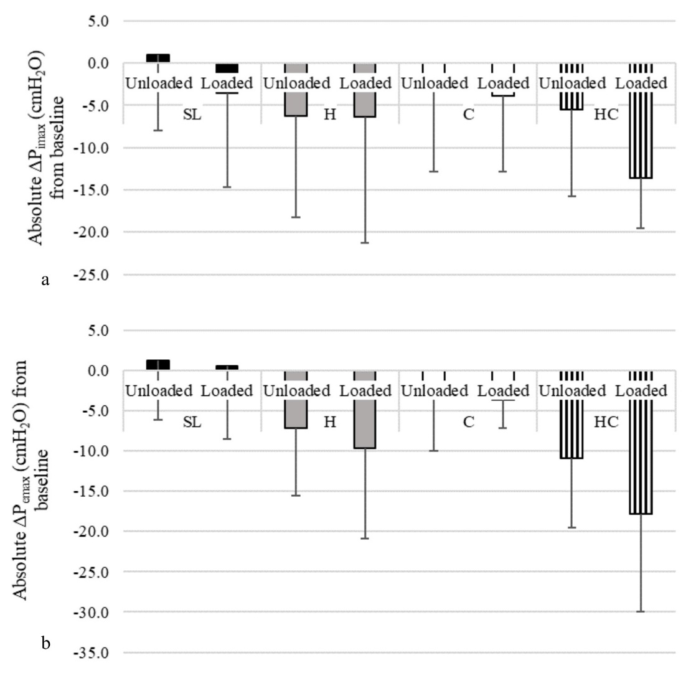
Figure 1a: Mean - SD Change in P_{imax} from baseline to 5.5km (cmH₂O) in all 4 environments, unloaded and loaded. 1b: Mean - SD Change in P_{emax} from baseline to 5.5km (cmH₂O) in all 4 environments, unloaded and loaded.

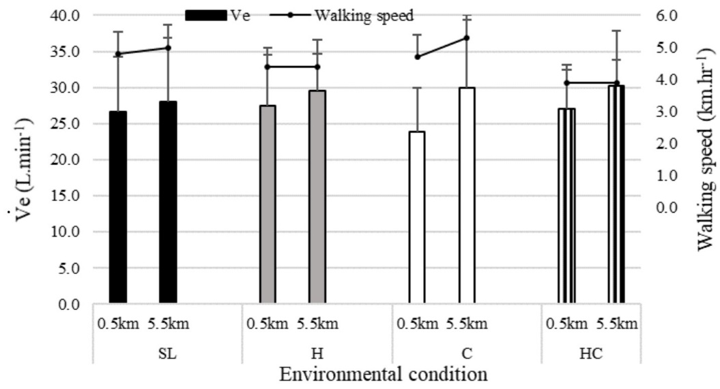
Figure. 2: Mean + SD minute ventilation (V̇e, L.min⁻¹) responses at 0.5 km and 5.5 km (bar chart), showing the significant interaction for V̇e between environment x distance, averaged across load conditions. Mean + SD walking speed (km.hr⁻¹) up to 0.5 km and from 5.0 to 5.5 km (line graph).
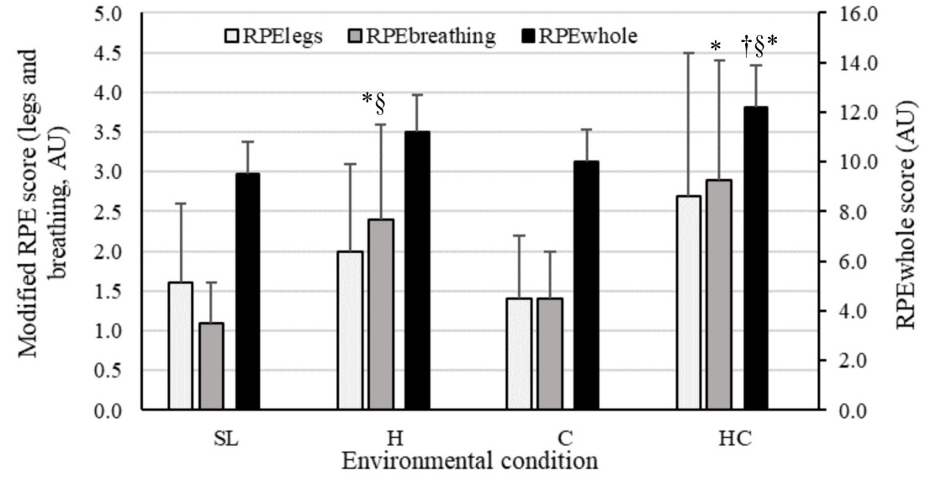
Figure 3: Mean + RPE (AU) for all environments averaged across load conditions and distances (* denotes a significant difference to SL responses, † denotes a significant difference to 4300m responses, § denotes a significant difference to -10°C responses).
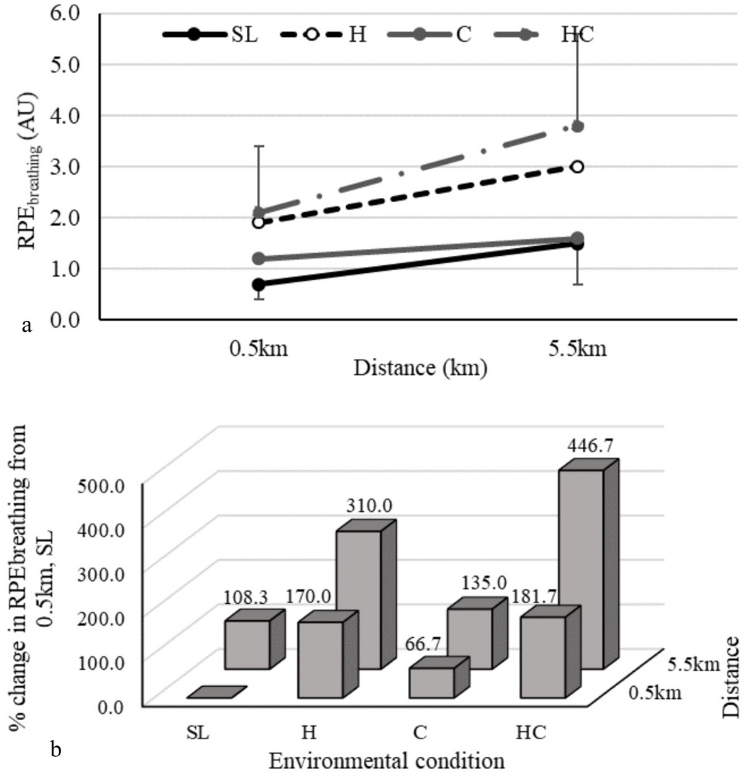
Figure. 4a: Mean ± SD RPE_{breathing} scores (AU) for all environments at 0.5km and 5.5km averaged across loads. 4b: Interaction for environment x distance showing mean percentage change in RPE_{breathing} from SL, 0.5 km averaged across loads.

