ENTRANCE TO A LANE
Hermeneutics in the field of British Landscape Painting in 20th and 21st centuries
Fine Art and The Otter Gallery Research project

The project linked the production of new paintings with The Otter Gallery Collection as a context and foundation for the conference/symposium on British landscape painting.
The development of modernist inspired landscape paintings can be seen as a specific characteristic or genre of 20th century British art. The relationship between 19th Century Romantic tradition and a new visual aesthetic centred on formalism and ‘significant form’(Clive Bell) produced a new visual language/vocabulary through which artists were able to engage critically with notions of abstraction, formalism and also with notions of memory, place and the natural world seen against the backdrop of industrial mechanisation. Lanyon, Heron, Sutherland and Moore (all present in The Otter Collection) produced work that inspired a range of more recent artists who have continued this critical approach to painting. Andrews, Oulton, Crowley, Greenland etc.

The question arises as to where the critical visual approach has gone in the 21st century. Landscape painting is everywhere yet most of it is the mannered and decorative rhetoric of painting as ‘interior design’ rather than as a critical re-invigoration of the tradition.
The conference/symposium will use this question as a point of departure.
The aim of the project is to produce a catalogue of the exhibition and a publication from the conference/symposium.

My own work, presented within the context of the exhibition and symposium, represented a new departure for me a move into the ‘territory’ of landscape derived paintings. Actually the work stemmed from a move to a new house and the fascination with how the overgrown and neglected garden became a site for visual exploration .For me the garden was not only a particular place but also began to ‘figure’ and work as metaphor of self rather than a direct representational ‘view’.. Other works in the series emerged out of the long travels to and from work where the experience of ‘landscape’ took on the Baudrillardian notion of ‘screen’ and network and disappearance [of the real] whereby the experience of landscape is rendered as speeding image across the windscreen ‘the landscape unfolding like a television screen. . . ‘(see ‘Ecstacy of Communication’ pg 127 in Foster H (1993) Postmodern Culture London Pluto)
Connected to my new reverie with landscape was the existence, the history, the evidence of other artists who had and were grappling with the themes and potentials of landscape. The exhibition, named after the Sutherlands Entrance to a Lane, one of the most significant paintings in the Otter Trust Collection gave both an impetus as well as a challenge as to how to adapt paintings’ language into the new century and then to take on the British Modernist painters who had done so much to synthesise the developments of Modernism from Europe and America into a distinctive British visual language. Of course the modernist trajectory into and around abstraction had already been modified, shifted and perhaps overrun by everything ‘Post’ through the latter part of the 20th Century. The ‘visual landscape’ had shifted; the possibilities of responding to of and visualising landscape had been problematized. Abstraction had lost its purity (did it ever have such) and the language of painting now operated across and between the ‘fields’ and ‘edges’ of complex signifying practices. The challenge was to use the Modernists as a point of Departure.
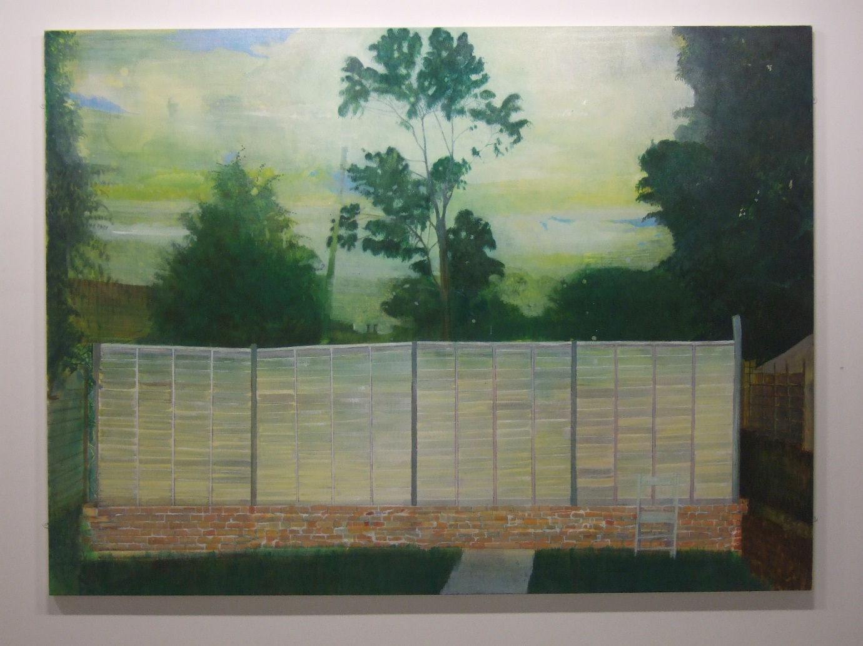
‘Exiled’ Oil on Canvas 2010
Fence as a visual barrier an edge that denies and frames. A gridded boundary. An imprisoning
Gardens are little bits of landscape fenced off and insular.
An interplay of Modernist flatness and Romantic lyrical allure
Always fenced in

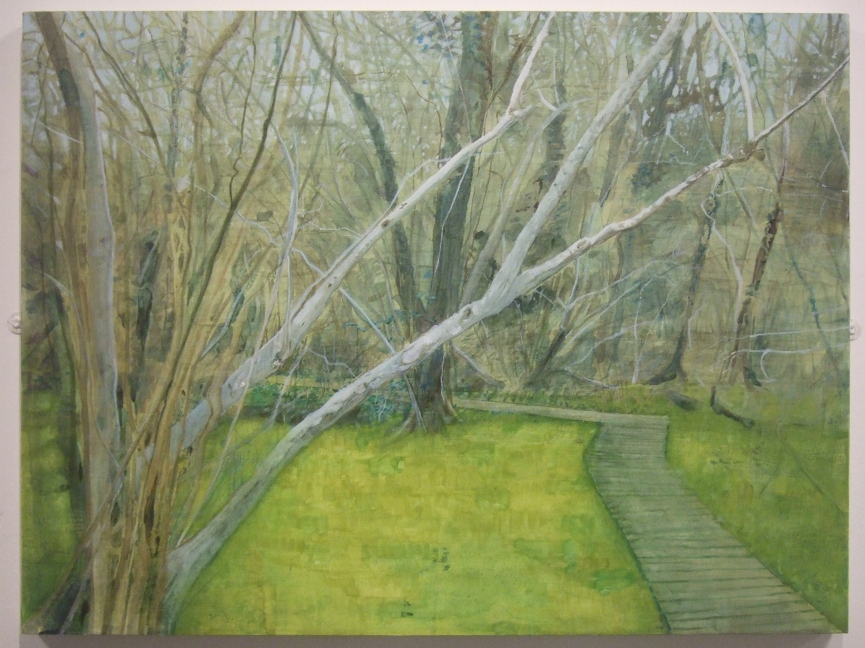
‘Boardwalk into a Wood’ Oil on Board 2010
Trees as ‘veiling’ The network of branches in the upper half divided from the possibility of entrance.
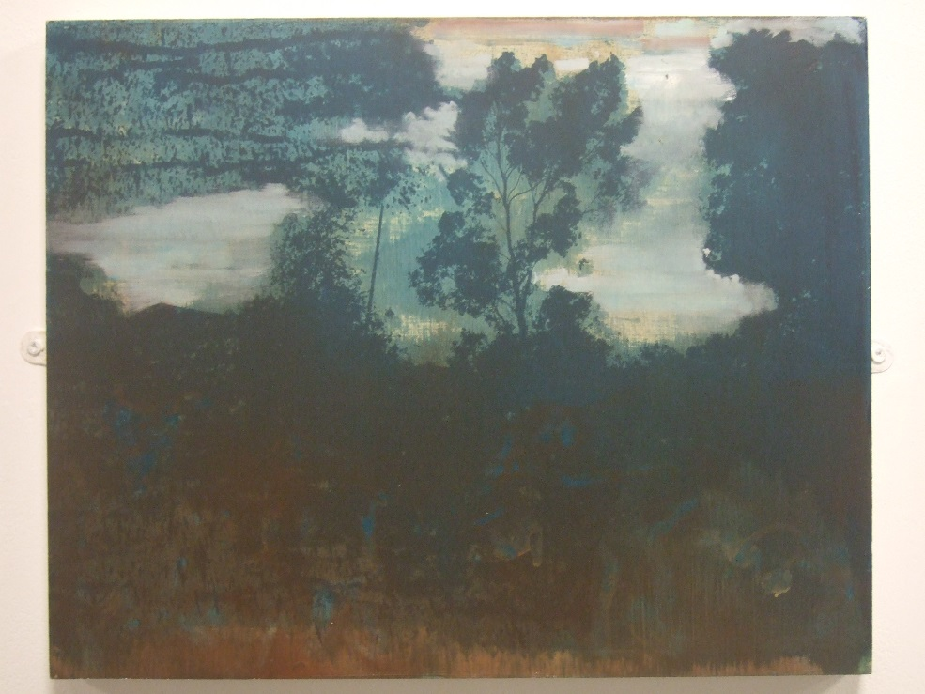
Untitled
Oil on Board 2010

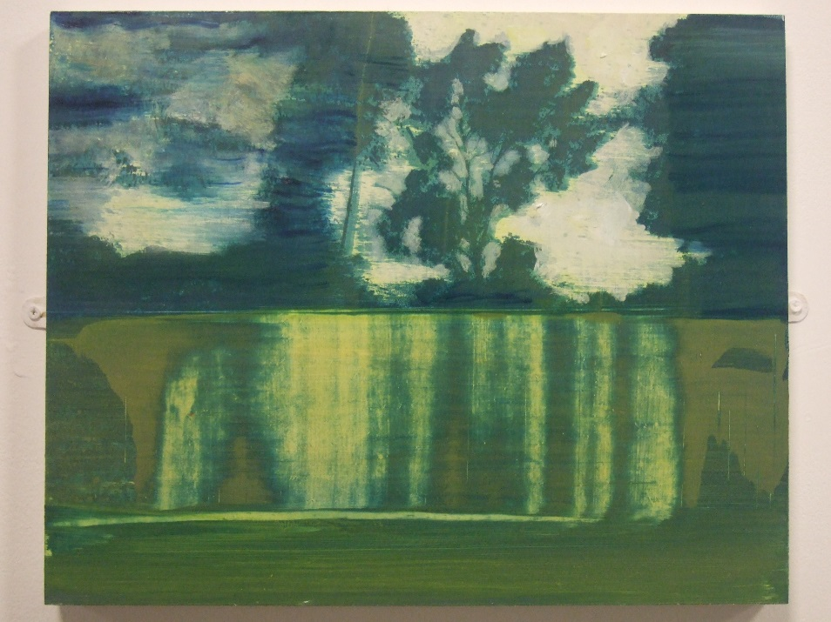
‘Edge’ Oil paint and screen print on board 2010

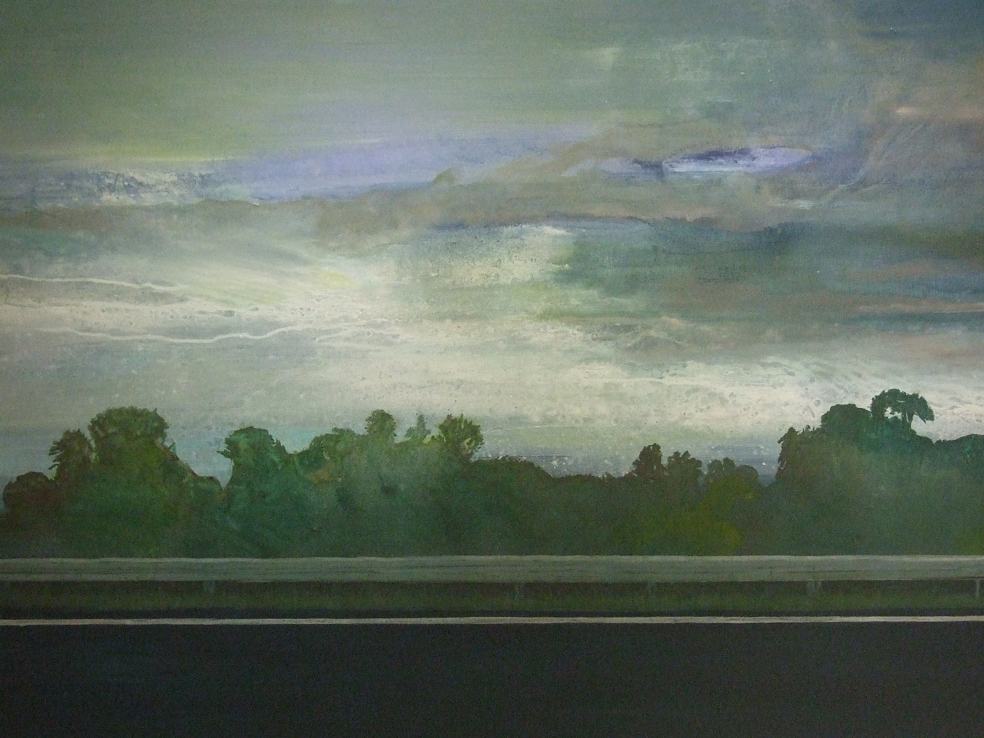
‘Barrier’ Oil on Canvass 2010

Two Views in the Otter gallery
