Shirley Chubb, Reader in Interdisciplinary Art, University of Chichester

Significant Walks Abstract

This paper will describe the trajectory of research between Thinking Path and Significant Walks and how the latter explores the reality of walking for individuals with chronic low back pain. Funded by the Wellcome Trust, Significant Walks pools the expertise of a research team that share a mutual interest in the resonance of walking as an interpretive tool and who came together following Shirley Chubb’s exhibition Thinking Path, which took Charles Darwin’s daily ritual of walking the same path in the grounds of his family home as its inspiration.

The collaborative research team are working with a group of participants who are invited to identify a personal walk that encapsulates memory, reminiscence and familiarity as well as being a measure of their physical experience. Manifested as an immersive digital artwork, a methodology has been identified that synthesizes eye level video documentation of participant’s personal walks with simultaneously gathered streams of kinematic data recording the movement of the spine.

Researchers and participants work together to explore how the interpretive qualities of visual effects can be applied to each body of synthesized footage in order to express the nature and resonance of personal movement whilst walking. Each micro journey expresses individual experience through the interpretation of clinically accurate data and acts as a vehicle for precise accounts of physical movement whilst also presenting the reflective individual at the core of scientific understanding.

-----------------------------------------------------------------------------------------------------------------

Paper

The journey to Significant Walks began in Thinking Path (2004), a body of work that responded to the daily rituals of Charles Darwin. The research process underpinning this work was undertaken with the support of English Heritage at Down House, Darwin’s family home. Here the experiential element of encounter explored in Chubb’s earlier exhibitions played an increasingly formative part, as the site itself became the pivotal core of the exhibition. Darwin loved the relative privacy of the house and grounds and in 1846 commented, “My life goes on like clockwork and I am fixed on the spot where I shall end it.”

The grounds surrounding Down House show Darwin’s typically Victorian fascination with every aspect of his natural environment. Most evocative is the Sand-walk, a small tract of land that Darwin leased, and eventually purchased from local landowner Sir John Lubbock. The Sand-walk provided a sheltered space for Darwin’s daily constitutionals walks with only the most extreme weather or ill health stopping his daily ritual. Predominantly a solitary exercise, Darwin also enjoyed company whilst walking, with Joseph Hooker recounting how they often

… trudged through the garden, where there was always some experiment to visit, and on to the Sand-walk, round which a fixed number of turns were taken, during which our conversation usually ran on foreign lands and seas, old friends, old books, and things far off both to mind and eye.

The resonance of this small rural space within the mind and experience of Darwin, and also as a metaphor for a broader synchronic sense of understanding was particularly intriguing. Darwin himself articulated with acute insight how apparently mundane encounters could reverberate with meaning and association. His often quoted observation of the “entangled bank”, close to Down House, being a prime example of his ability to see the extraordinary in the everyday.

The Sand-walk was a seminal part of Darwin’s daily experience. It was a haven from external pressures, encouraged his physical wellbeing and also became a vehicle for the meticulous long-term observations that fuelled his emerging theories. Often observed lost in thought during his walks, later anecdotes describe the Sand-walk as Darwin’s ‘thinking path’. Adopted as the exhibition title, the phrase acknowledges the actuality of Darwin’s physical and mental presence, whilst also enabling the path to signify the broader impact of his theories.

The resonance of the Sand-walk was reconstituted within the exhibition through moving and static images systematically extracted from video documentation of the path. The visual response generated by this encounter became an essential means to curate ideas, with the non-linguistic form providing a more openly associative alternative to the myriad texts analyzing Darwin, his theories and legacy. The documentation was also shown on small LCD screens within museum cases, effectively transforming experience into artifact. By accentuating a sense of contemporary physical presence in an external space the documentation reflects Rebecca Solnit’s observations that

Walking shares with making and working that crucial element of engagement of the body and the mind with the world, of knowing the world through the body and the body through the world.

The perception of meaning both within the walk and through the associations that the experience evokes is “purposively embodied” within static images extracted from the footage recorded on the anniversaries of Darwin’s birth, the return of the HMS Beagle from its five-year voyage; the publication of Origin of the Species and the day Darwin died. Each still alternates with found imagery detailing aspects of Darwin’s life and contemporary manifestations of his theories, creating a sense of synchronicity across timeframes and physical spaces. The found imagery considered aspects of each anniversary, from the fragility of birth and death to the empowerment of travel and the inexorable accumulation of global knowledge. Groups of imagery were generated, selected, manipulated and compiled to create narrative subdivisions, a process which resonates strongly with Darwin’s own methodology of gathering information in order to enable new theories. Janet Browne has noted how Darwin drew upon an eclectic mix of science and grass roots knowledge in the construction of his theories, and although he had an ambivalent attitude to this process of compilation, he recognized it as essential to the consolidation of his theories. The narrative content of each anniversary is both structured and fractured by the images of the path and in this way anticipates Tim Ingold’s consideration of the multiple linearities that physically and conceptually shape our engagement with the world. In considering Darwin’s celebrated diagram depicting the diversification of species fanning outwards from a single point Ingold suggests that “Retracing the lines of past lives is the way we proceed along our own.”

Individual glass lenses subtly animate each image and reference Darwin’s use of the microscope to reveal, literally and conceptually, what cannot be seen with the naked eye. Simultaneously it references how contemporary science and technology has expanded our vision of the world and how that knowledge is embedded within the everyday through photography, film and the media.

Within Thinking Path the element of physical progression through a significant site was fundamental to the construction of meaning. The consequent artwork constitutes a particular visual language that creates a liminal or illusionary space that can be accessed and interpreted individually by each viewer.

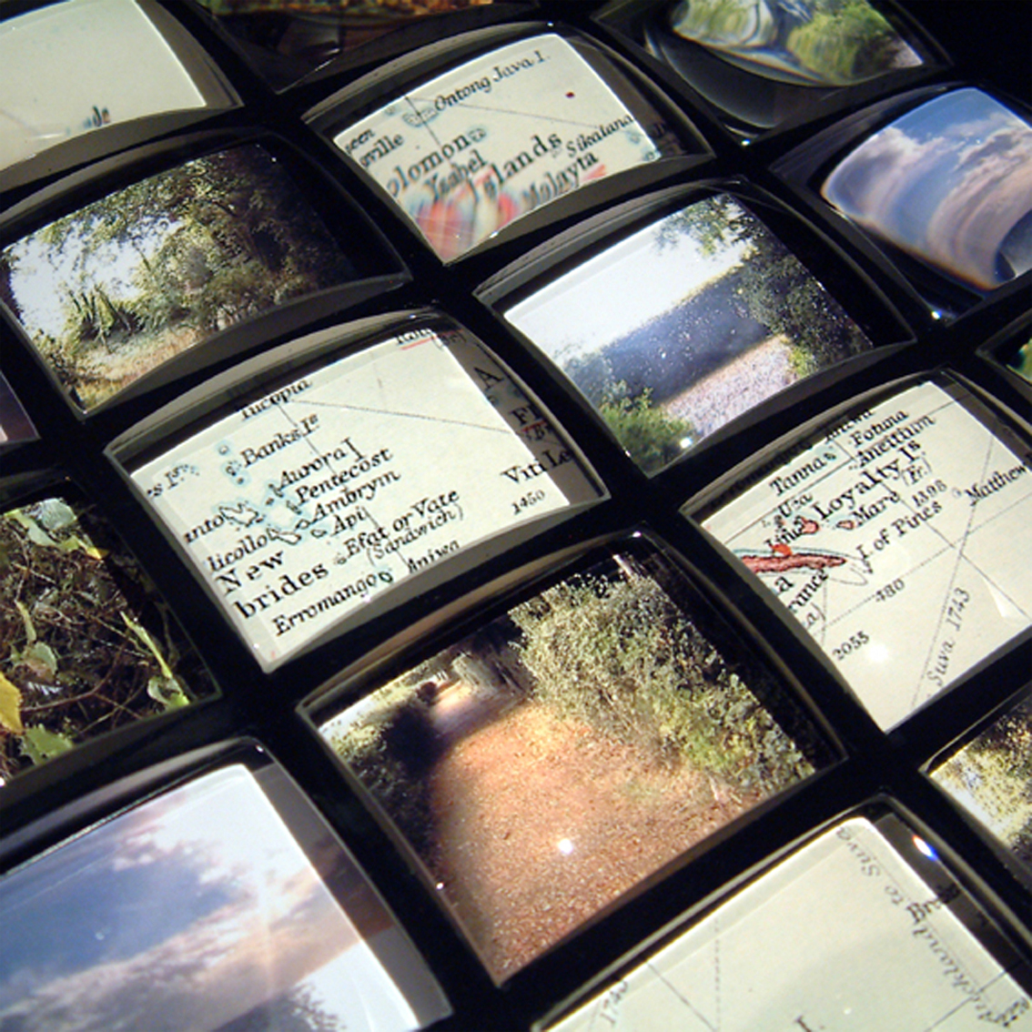

Shirley Chubb Thinking Path
Beagle Journey 02.10.1836/2003 #11 (detail), 2003
Glass lenses, polypropylene and digital print

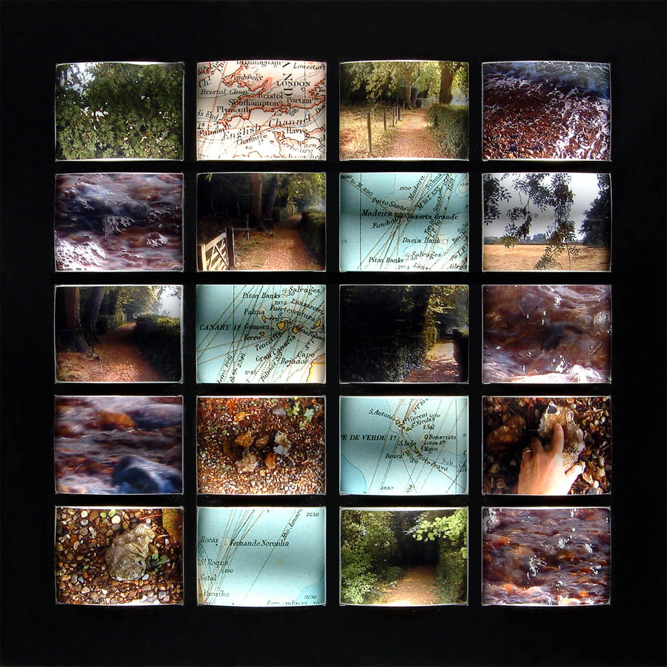

Shirley Chubb Thinking Path
Beagle Journey 02.10.1836/2003 #7, 2003
Glass lenses, polypropylene and digital print
25 x 26cms

The relationship between the individual and their sense of place is seminal to Chubb’s practice, which explores how our experiential engagement with cultural and social environments shapes our understanding of the world. The work developed for Thinking Path considered Charles Darwin as a cipher for synchronic knowledge, prompting an interest in the mechanics of motion and how visual art might become an effective means to manifest the significance of movement through particular environments and landscapes for other individuals. Fuelled by a mutual interest in the resonance of Darwin’s daily walks, discussion across discipline areas led to the formation of the Significant Walks research team which includes musculoskeletal physiotherapy specialist Professor Ann Moore and biomedical engineer Dr. Kambiz Saber-Sheikh (both at the University of Brighton), and digital artist Neil Bryant (University of Chichester).

The team came to realise the potential of Chubb’s approach as a means to conceptualise physical problems, and have worked together to identify a methodology that investigates the reality of walking for individuals with chronic low back pain. The collaborative research process involves working with participants to create an immersive digital artwork synthesizing eye level video documentation of participant’s personal walks with simultaneously gathered biomechanical data. The research process acknowledges the potential interdependence of qualitative and quantitative research and is underpinned by a desire to capture the relationship between actualised internal movement and the perceptual understanding of each participant as they consider their personal movement. Individual choice is key to this process, with each participant invited to identify a walk that is of personal significance to them. Here each participant’s engagement redefines the notion of site from a traditional or culturally socialized environment to a renewed sense of space that is enhanced through interaction and is

… transformed from a physical location – grounded, fixed, actual – to a discursive vector – ungrounded, fluid, virtual.

The walk process is recorded with head mounted video cameras whilst kinematic data is simultaneously collected using miniature 3D inertial sensors monitoring the movement of the participant’s spine. The resulting data provides continuous visual and biomechanical information on posture and movement patterns during each walk, whilst the data based evidence is supported by contextual information as each participant is asked to discuss the significance of their walk, commenting on memory, reminiscence or anecdote as well as the nature of their physical experience at the time. The research process reflects Solnit’s observation that

Walking is usually about something else – about the walkers character or encounters, about nature or about achievement, sometimes so much so it ceases to be about walking

The synthesis of video documentation and kinematic data generates tangible visual representations of the link between external and internal movement, with the significance of each individual’s walk crucial to this process. Experiential interpretation adds resonance to the understanding of core data, contributing a sense of immediacy and understanding as each participant explores and applies digital effects to their synchronized footage. Identifying ways to best represent their physical sensation and self-awareness whilst walking, the intensity of the effects is driven by the spinal data creating a synchronic outcome that realises factual measurements of time, movement and site within interpretive expressions of an individual’s engagement with the world.

The acute individuality of each walk reveals the codependence of differing forms of data and consequent visual responses manifesting Mark Dion’s observation that

The objective of the best art and science is not to strip nature of wonder but to enhance it. Knowledge and poetry are not in conflict.

This sense of engagement will be reflected in the presentation of the work with footage projected to life size. Viewers will recognize the generic act of walking, which can be seen as both a physical challenge and also a measure of memory, achievement and loss. The resonance of walking as a metaphor for understanding our individual place in the world is key to this research, both for participants and viewers. Walking is a part of our daily existence, providing opportunities to consider how we interact, navigate and respond to our environment. Given the prevalence of chronic low back pain this experience is compromised for many people and Significant Walks seeks to capture these individual realities by animating quantitative data whilst simultaneously communicating qualitative experience. In this way the work reflects Eisner’s theory that

Human knowledge is a constructed form of experience and, therefore, is a reflection of mind as well as of nature. Knowledge is made and not simply discovered…. The terms through which humans represent their conception if the world have a major influence on what they are able to say about it.

The resulting immersive artwork will act as a vehicle for both the science of data collection and also the reality of the individual at the core of scientific understanding, reminding us that in considering the experience of others we can better appreciate our own realities.

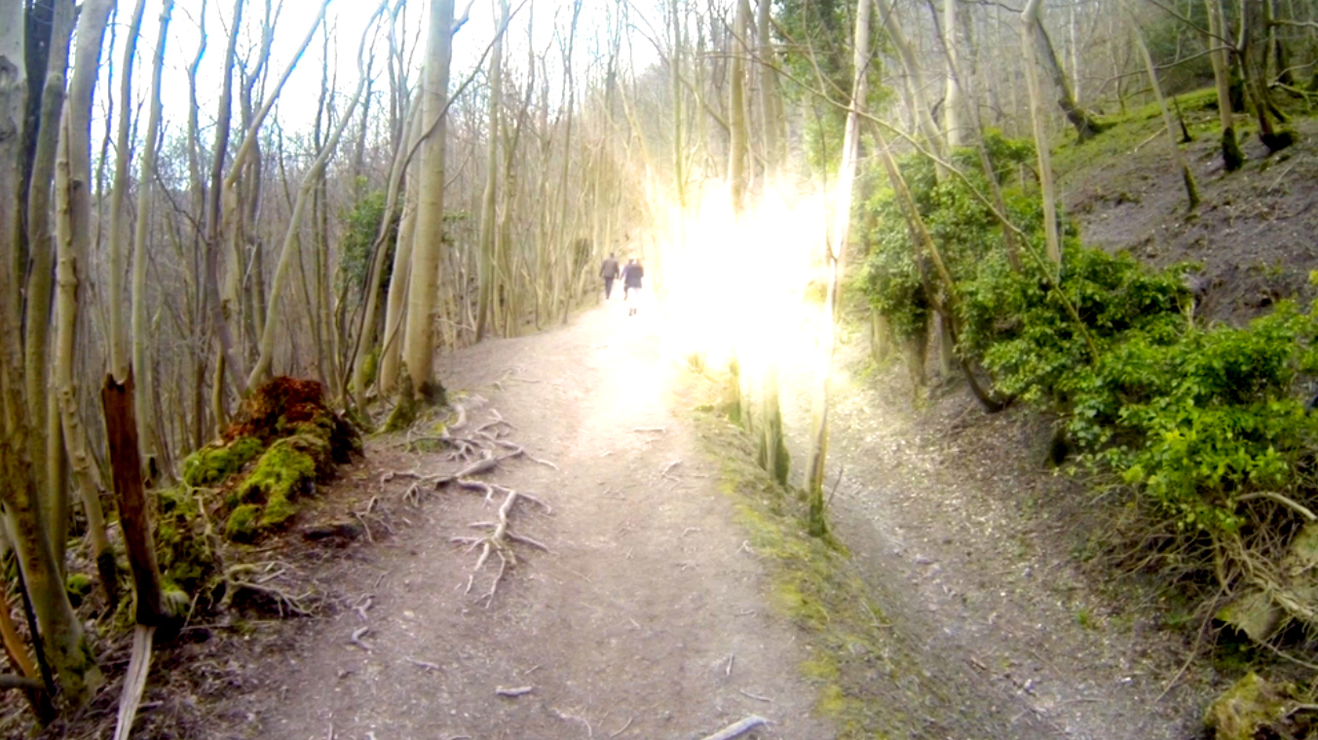

Significant Walks
Pilot Study #1, 2013
Video Still

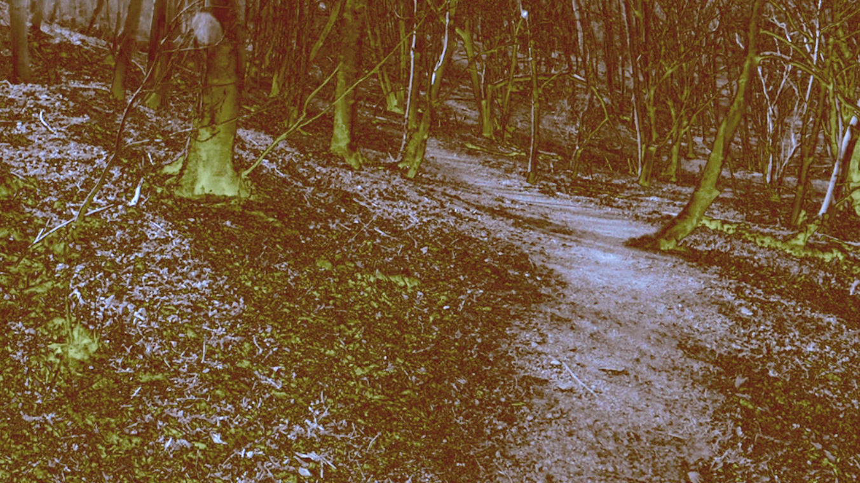

Significant Walks
Pilot Study #2, 2013
Video Still

http://www.shirleychubb.co.uk/exhib_thinking-path.htm.
http://www.english-heritage.org.uk/daysout/properties/home-of-charles-darwin-down-house/
Wilson, L. Ed.,Down House: The Home of Charles Darwin (London: English Heritage, 2000), 31.
Keynes, R., Coulter-Smith G. & Forgan. S., Thinking Path. (Shrewsbury Museums Service, 2004), 15.
Darwin’s chronic ill health has been the source of much debate and speculation.
Keynes, R., Coulter-Smith G. & Forgan. S., Thinking Path. (Shrewsbury Museums Service, 2004), 16.
Darwin, C, The Origin of Species (London: Penguin, 1985), 459.
Solnit, R, Wanderlust: A History of Walking (London: Verso, 2002), 29.
Biggs, M. in Mäkelä, M & Routarinne, S, The Art of Research: Research Practices in Art and Design (Helsinki: University of Art and Design, 2006), 189.
Browne, J, Charles Darwin: The Power of Place (London: Pimlico, 2003), 11.
For instance Darwin wrote to Joseph Hooker as follows “I sometimes despise myself as a poor compiler, as heartily as you could do, though I do not despise my whole work, as I think there is enough known to lay a foundation for the discussion on origin of species” (Darwin to Joseph Hooker, 2nd May, 1857. Keynes, Randal. E-mail to the author. 16th May, 2004)
Ingold, T, Lines: A Brief History (London: Routledge, 2007), 119.
Keynes, R., Coulter-Smith G. & Forgan. S., Thinking Path (Shrewsbury Museums Service, 2004), 28.
Kwon, M, One Place After Another: Site-Specific and Locational Identity. (MIT Press, 2004), 29.
Solnit, R, Wanderlust: A History of Walking (London: Verso, 2002), 132.
Dion, M, Microcosmographia ( London: South London Gallery, 2005), 38.
Eisner, E.W, The Enlighted Eye: Qualitative inquiry and the enhancement of educational practice (Upper Saddle River, NJ: Prentice Hall, 1998 original work published 1991)

