Contents
1. Logging in 2
2. Checking an item is not already available 2
3. Adding a new item 4
3.a. Importing items 5
DOI (via CrossRef) 5
Microsoft .docx 5
3.b. Entering an item from scratch 5
Type 7
Upload 7
Details 9
Subjects 9
Deposit 9
4. Editing previously saved items 9
5. Depositing an item 10
6. Managing deposits 10
7. Further guidance 11

Logging in
The ChiPrints research repository can be found at http://eprints.chi.ac.uk/ . If you are likely to use it a lot, it may be helpful to add the address to your internet browser’s favourites.
To add or edit items, click on Login from the grey menu bar on the left hand side and enter your university username and password.
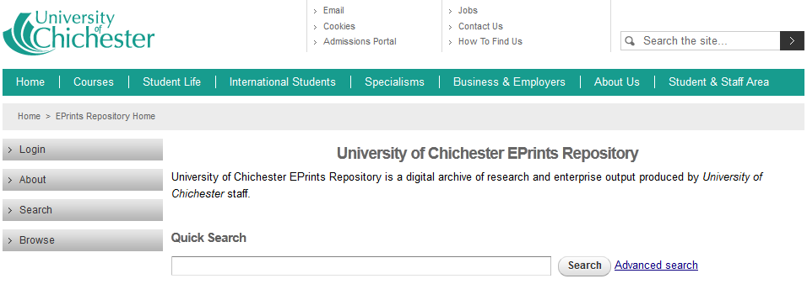
When you have successfully logged in, the message Logged in as <your name> will appear in place of the Login link, and an additional set of buttons will appear in the grey menu bar. (Don’t worry if you don’t have as many buttons as those shown in the screen shot below, this is an administrator’s account with a few additional options.)

Checking an item is not already available
The system should check each title entered automatically, but this feature is not entirely accurate and does not feature if your are importing from a DOI, so to save time it is advisable to check for the title first.
To do this, choose from the Browse button from the menu on the left, select Author and find your name in the A-Z list by surname. Alternatively enter terms in the search box.
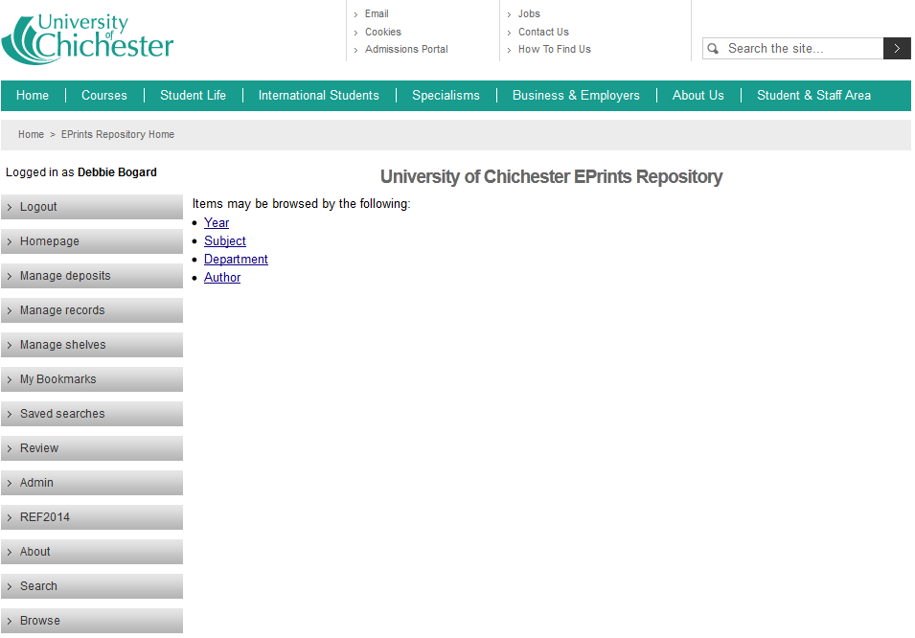
If the item is already available, please check that the information held is correct. To do this, click on the hyperlinked item title.
If anything is incorrect, please email the ChiPrints team at EPrint@chi.ac.uk explaining what needs to be changed and providing the URL of the item.
If you have a full-text electronic file for the item please also let us know and we can check if copyright allows it to be placed in the repository.
If the item is not currently available, follow the steps below to add a New Item.

Adding a new item
Go to the Manage deposits page by clicking on the Manage deposits button on the grey menu bar.
For items with a DOI (Digital Object Identifier) (journal and published conference papers) you can Import (3.a.). There are various other external sources that you can also Import from.
For other item types, you can add a New Item from scratch (3.b.) using the New Item button.
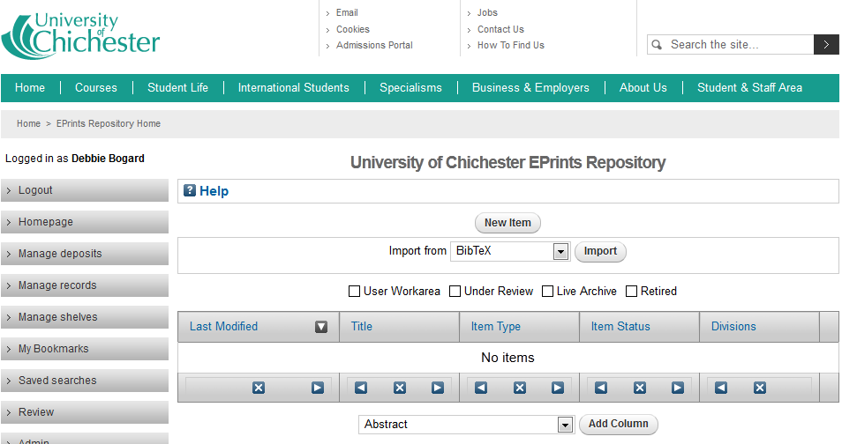

3.a. Importing items
There are several import options that can speed up the process of depositing. The list of available options can be seen on the drop-down list on the Manage Deposits screen. Most of these are unlikely to be used by the general user. The following describes those most commonly used. By using the Import function, some of the basic metadata for the item will be automatically populated for you, but you will need to check that they have imported correctly and fill in any required fields not populated automatically.
(If you wish to use one of the other available import types and require further assistance, please contact the ChiPrints team at eprint@chi.ac.uk.)

DOI (via CrossRef)
The DOI number must be formatted correctly (e.g. doi:10.1029/2005JC003173).

Microsoft .docx
Select a Microsoft Word document saved in the .docx format. Leave the drop-down list to the side of the Browse area in its default position and click Import Items.

3.b. Entering an item from scratch
Whether importing, or creating a new item from scratch from New Item from the Manage deposits screen, there are five pages that will guide you through entering the required information about the item you are recording (Type, Upload, Details, Subjects and Deposit).
(If you need to stop at any time during this process, you can click Save and Return. The item will then appear in your Manage deposits screen where you can choose to View, Remove, Edit or Deposit when you return to ChiPrints.)
Fields marked with a are mandatory, you will not be able to deposit an item without filling these fields in first – you may save the item without filling them in though.
The buttons will toggle helpful hints for filling in the current field – this can be particularly useful for seeing how things like dates should be entered.
You can navigate the five screens using the ‘breadcrumb’ buttons to the top of the screen:

Or by using the buttons that are directly beneath the breadcrumb and also towards the bottom of the screen:

Type
Select the most relevant type from the list.

Upload
You can check if the journal your article was published in complies with your funder's requirements for open access to research using SHERPA/FACT http://www.sherpa.ac.uk/fact/ (for Research Council UK and Wellcome Trust), or check SHERPA/ROMEO http://www.sherpa.ac.uk/romeo/ for the journal publisher’s copyright allowances with regard to open access.
However, don’t worry if you are unsure whether the copyright of an item allows for it to be included in the repository. Library staff will check all deposits’ copyright status before releasing them to the repository.
Once you have chosen your file select the relevant Content type from the drop-down list, and ensure you select the Creative Commons license type you wish your full-text item to be associated with. The University’s preferred license is Creative Commons: Attribution 3.0.
Select Update Metadata before moving to the next page.
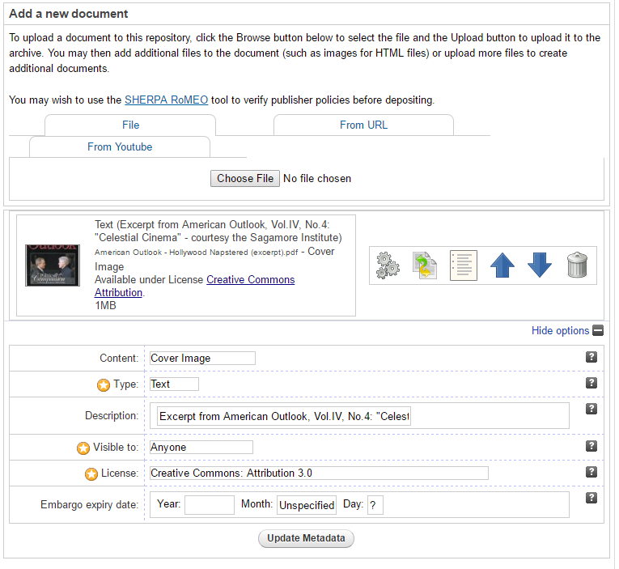
You may add multiple documents to each record by clicking Choose File. Removing files is achieved by clicking on the dustbin icon.

Details
Please include as much detail as possible in your entry to make the repository as helpful to users as possible, but also remember that once an item is live it will be accessible to anyone using the internet, so please do not include any sensitive information or information that is copyright protected.
You may select more than one Division or Department by holding down the Ctrl key.

Subjects
It is possible to expand a subject area by clicking on a button. Subjects are very useful for assisting users of the repository in finding your item, so be as precise as possible. NB the subject(s) chosen should reflect the content of the item, not the item type i.e. a film about the First World War should not be given the subject Motion Pictures as this will already be reflected in the item Type chosen on the first screen, the subject should be World War I.
A list of the currently chosen subjects is displayed near the top of the screen, with the option to remove a previously selected subject if desired.
If you feel that the subject that best describes this item is not currently available, please email us at EPrint@chi.ac.uk and if it is available through the Library of Congress’ subject headings standard we can add it for you. However, please note that the terminology and placement of subjects within the subject tree are dictated by the Library of Congress’s international standard and may not be altered.

Deposit
If you are confident that the item does not breach any of the copyright laws as stated on this screen, select Deposit Item Now.
(More information about depositing can be found in section 5.)

Editing previously saved items
If you wish to make changes to a previously saved item you may do so by navigating to your Manage deposits page and clicking on the Edit item icon.

This will then allow you to change Details, Upload more files, change the files already uploaded, and edit the Subjects associated with the item.

The item may then be Deposited, or Saved to go back to again later.

Depositing an item
When you are satisfied that you have entered everything you can and that all mandatory fields have been filled in, either navigate to the Deposit screen (the last of the five screens in Edit Item mode), or click the button from Manage deposits.
If you are confident that the item does not breach any of the copyright laws as stated, select Deposit Item Now.
Your item will then be sent to the ChiPrints team at the Library, who will check the item regarding authority control and add in links to the library catalogue etc., where relevant/possible. Your item will appear as Under Review on your Manage deposits page during this time, and will not become live in the repository until these actions have been carried out. Once the Library staff release the item to the repository its status will change to Live Archive and you will receive an email confirming this.
(Items may be returned to you with queries. If this happens you will receive an email notification.)

Managing deposits
From the Manage deposits screen you can add New Items or Import information to create new entries as described in Section 3 above.
Once you have created and saved one or more items you can View, Remove, Edit or Deposit them from here.
You can change the information and order shown for each item in Manage deposits by using the buttons under your list. You can also add columns using the Add Column drop-down list beneath your table of items. Clicking at the top of a column will make the list filter items by that category.

Further guidance
If you require further assistance to deposit an item please contact your Subject Librarian, or the ChiPrints team at eprint@chi.ac.uk.
Check the following short reading list of useful documents and websites relevant to Open Access for more information.
The ChiPrints Repository Moodle includes tips on how to use special features like My Bookmarks, FAQ, links to useful information about open access and funder compliance.

