Full Spectrum Offense:
Savoy’s Reverbstorm and the Weirding of Modernity

Benjamin Noys, University of Chichester

The recent rehabilitation of weird fiction as a genre has had to confront the racist and reactionary politics of the “Old Weird,” the original formation of weird fiction between 1890 and 1940. New Weird writers have engaged with the class hatred, racism, and anti-Semitism expressed by Old Weird writers, notably H. P. Lovecraft, and the ways in which these views fuel the horrors and anxieties of weird fiction (Miéville 2005, xviii-xxiv). Reactionary writers of the Old Weird often treated the weird as an object of horror to be expelled, reinforcing exclusions, in contrast, writers of the New Weird have welcomed the weird as the destabilization of normative orders, both literary and socio-political. Here I want to consider a more disturbing approach: the direct confrontation and replication of the racist and anti-Semitic strategies of the Old Weird in the work of the UK-based publisher Savoy and its central character “Lord Horror.” Lord Horror, created in 1984 by David Britton, is a fictionalized reworking of the wartime broadcaster for the Nazis, William Joyce, who was nicknamed Lord Haw-Haw and executed for treason in 1946.
In the work of Savoy, Lord Horror has survived the death of his namesake and lives on, espousing anti-Semitic views and engaging in extreme acts of anti-Semitic violence. This probing of historical fascism is deliberately disturbing and “carnivalesque” (Noys, 310-14), toying with glamorizing this past in its representation of Lord Horror as radio DJ and rock star: “chanticleer of rock ‘n’ roll-made-flesh in Auschwitz” (Britton 2013, 31). Central to these representations is an exploration of weird fiction; both as resource for the images and text, and as site to represent the nightmares of the twentieth century.
The Lord Horror works are a multimedia production: Lord Horror has appeared in novels, comic books and graphic novels, music, film, and criticism. The result is a remarkably dense visual and textual “universe”; somewhere between Lovecraft’s intertextual “synthetic myth-cycle” (Lovecraft 2015, 32), the “Cthulhu Mythos,” and the sprawling universes of comic-book publishers – like DC and Marvel. The Lord Horror universe is highly-focused, however, in the coordinated work of David Britton as writer, Michael Butterworth as editor, and Kris Guidio and John Coulthart as artists. The work of the New Weird has often been concerned with moving toward a respectability of genre and form. In contrast to the “pulp” tale of the Old Weird, New Weird writers like Jeff Vandermeer and China Miéville have published novels with mainstream publishers. There have also been signs of academic and critical interest in the weird, of which this issue is a part. Savoy’s defiant independence and multiplication of weird platforms suggests a different strategy that returns not only to the reactionary politics of the Old Weird but also to the “pulp” proliferation of the Old Weird.
My focus here will be on the graphic novel Reverbstorm (2012), which collects the seven Lord Horror comic books from the “Reverbstorm” series (1994-2000), and adds a final issue to complete the work. The title is derived from a song brought to Savoy by music journalist Paul Temple, and refers to the introduction of artificial reverberation in early rock and roll music. Written by David Britton and drawn by John Coulthart, with some art by Kris Guidio, Reverbstorm explores the postwar existence of Lord Horror as broadcaster and rock star in the dreamscape city of Torenbürgen. What is remarkable is how the text and visuals draw on a range of references, from the visual and literary currents of high modernism, especially James Joyce, to pop culture – and the phantasmagoria of weird fiction.
In constructing this “universe” Savoy reference a range of weird fiction, from H. P. Lovecraft, William Hope Hodgson, and David Lindsay, to more contemporary writers, such as William Burroughs, Michael Moorcock and M. John Harrison. It is Lovecraft, however, that will provide my primary point of reference, due to Lovecraft’s role in defining weird fiction, his avowed racism, and his centrality to Reverbstorm. John Coulthart’s initial images from Reverbstorm rework his previous graphic adaptations of the fiction of H. P. Lovecraft. In Reverbstorm, Lovecraft’s architectural sensibility, his focus on the built environment as site of the weird, is developed and exacerbated to generate a vision of the city-space as site of the weird. While Lovecraft often regarded the city with horror, as a site of racial mixing, Savoy intensifies this racialized vision of the city to generate a weirding of modernity.
Reverbstorm also connects this vision of the city with modernist forms, bringing together the racism of the Old Weird with the racist, anti-Semitic, and reactionary views of leading modernists. Mixing high modernism and the weird produces a new form of collage “text” that destabilizes both, probing the toxic core of anti-Semitism and racism that links them together. While Nazism and fascism operate by logics of purification, Reverbstorm pushes these logics to the point of collapse. What remains troubling, however, is that in this collapse the tropes of anti-Semitism, racism, and fascism, remain active. Finally, Reverbstorm develops a dynamic of disintegration, in the fracturing of visual and textual elements. This dynamic explodes the weird from within and, as with the rewriting of modernism, suggests a “weirding” of cultural forms. The fact that this “weirding” constantly engages and sustains reflection on racist and anti-Semitic tropes confronts us with a weird that defies acceptance and normalization. Instead of a respectable and generically stable New Weird, Revebstorm, and Savoy’s work in general, exposes us to a disturbing space in which the weird cannot easily be contained, expelled, or policed.

Weird Architectures
In 1986 the artist John Coulthart began adapting Lovecraft’s “The Haunter of the Dark,” which would be published in 1988. An adaptation of “The Call of Cthulhu” would eventually appear in 1994. The final element of his trilogy, an adaptation of “The Dunwich Horror,” remained unfinished due to the invitation from Savoy, in the person of David Britton, to Coulthart to contribute backgrounds for the final issue of the Lord Horror comic book series Hard Core Horror. This series, begun in 1989, had previously been drawn by Kris Guidio, and Coulthart was asked to provide backgrounds for the final Holocaust issue. This is the culmination of Lord Horror’s “odyssey,” from mid-war street Fascist to broadcaster for the Nazis. These images would become the sole subject of issue 5 of Hard Core Horror. Coulthart remarks that: “In essence, all my Lovecraftian impulses were redirected into the death camp architecture of Hard Core Horror 5.” (2006a) Coulthart’s Lovecraft adaptations and this early work on Lord Horror would be collected in the graphic novel H.P. Lovecraft’s The Haunter of the Dark and other Grotesque Visions, published in 2006.
The first drawing Coulthart produced for Hard Core Horror was based on his previous rendition of the scene from his adaptation of H. P. Lovecraft’s “The Call of Cthulhu” showing the sailors’ approach to the alien city of R’lyeh (Figure One). “The Call of Cthulhu” (written in 1926, published 1928) is one of Lovecraft’s most successful works of weird fiction. The story takes the form of detective fiction, as the narrator, “the late Francis Wayland Thurston,” slowly pieces together a number of clues to reveal the existence of a cult dedicated to the worship of a monstrous alien sea “god,” “great Cthulhu.” The story builds through a number of revelations before the narrator recovers a manuscript by a Norwegian sailor, Gustaf Johansen, which records a terrifying encounter with R’lyeh, the now-risen underwater city in which Cthulhu “lies dreaming,” and with Cthulhu itself.
Lovecraft’s original description of R’lyeh and Cthulhu are both classical examples of his capacity to combine precision and obscurity in his descriptions. This “baroque” style, according to China Miéville, indicates a struggle with representation that “looks like radical humility in the face of Weird ontology itself” (2009, 511). The effort for accuracy confronts the limits of representation, opening the experience of the weird. The precision of Lovecraft’s description includes the location of the city: S. Latitude 47º 9’, W. Longitude 126º 43’. Here the sailors find “a coastline of mingled mud, ooze, and weedy Cyclopean masonry which can be nothing less than the tangible substance of the earth’s supreme terror – the nightmare corpse-city of R’lyeh” (Lovecraft 1999, 165). Johansen and his men are “awed by the cosmic majesty of this dripping Babylon of elder daemons,” and Johansen’s description achieves something like “futurism” is his “dwell[ing] only on broad impressions of vast angles and stone surfaces” (Lovecraft 1999, 165). The geometry of the place is “all wrong” (Lovecraft 1999, 166), and the city a “phantasy of prismatic distortion” (Lovecraft 1999, 167). R’lyeh is also malignant in its own right, with one of the sailors “swallowed up by an angle of masonry which shouldn’t have been there; an angle which was acute, but behaved as it if were obtuse” (Lovecraft 1999, 167).
Such descriptions are tantalizingly visual, but also obviously pose an acute problem for visual representation. They provide “accurate” detail and, at the same time, metaphoric suggestion of the unrepresentable. Coulthart’s solution to this difficulty is to work with the precision of Lovecraft’s descriptions, even as these descriptions defy the possibilities of visual representation. His drawing style renders Lovecraft’s work in fine detail and so risks the passage through precision. Coulthart renders R’lyeh as a spiked domain, with one of the “towers” of the city taking the form of a Venus fly-trap plant that will soon close around the hapless sailors in their small row boat. Central to his first image is the phallic “bulb” tower, also spiked, which stands out erect against the moon. The sailors enter the space through arching spikes covered with seaweed, which form a kind of “gate” to the city. Immediately following, there is a double-page image of the sailors, barely visible, approaching the domed lair of Cthulhu and surrounded by these angled spires and spikes. As Cthulhu is released, Coulthart fragments the visual “boxes” of the comic strip into triangular shards. These convey the fragmentation of the perception of the city and Cthulhu, as well as the angular distortions referred to by Lovecraft.
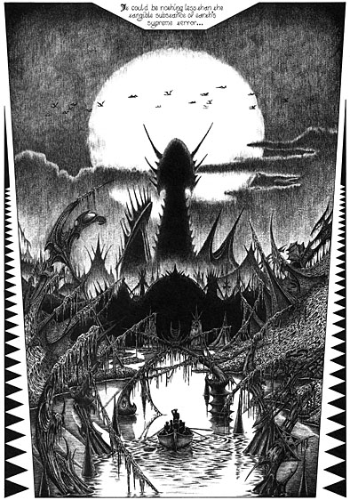
Figure One: John Coulthart “The Call of Cthulhu”
Cthulhu then appears in the doorway in full, as an insectoid and tentacular excess. In Lovecraft’s description Cthulhu is paradoxically indescribable: “there is no language for such abysms of shrieking and immemorial lunacy, such eldritch contradictions of all matter, force, and cosmic order. A mountain walked or stumbled” (1999, 167). We do, however, have the description of the Cthulhu idol earlier in the tale: “It represented a monster of vaguely anthropoid outline, but with an octopus-like head whose face was a mass of feelers, a scaly, rubbery-looking body, prodigious claws on hind and fore feet, and long, narrow wings behind.” (Lovecraft 1999, 148) Coulthart, wisely, does not bind himself to this description, preferring a Cthulhu which is more fluid and indistinct, more a series of flailing tentacles which echo the spikes of R’lyeh, but in organic form. As Cthulhu attacks the sailors the next two pages revert to the fragmentation of panes, presented as a series of broken shards as if the page is a piece of glass which has shattered.
Coulthart’s image of Auschwitz, in Hard Core Horror 5 and Reverbstorm, deploys the same perspective and a similar spiked approach to the camp as to R’lyeh (Figure Two). Alan Moore notes that “Coulthart re-images Auschwitz out of Lovecraft’s R’lyeh, as a horrible lost temple sunk beneath the murk of Europe’s dreamtime.” The central tower is more linear and Art Deco in style, although obscured by the empty white box, presumably originally for text before the decision was made to use the backgrounds as the sole images. The other chimneys that line the central railway tracks have a similar bulb, but more linear and less obviously phallic. Black smoke rises from these chimneys and the image belongs to the representation of Auschwitz as a site of “industrial” killing. The decision to represent Auschwitz at all is controversial, considering the argument of many, Claude Lanzmann most significantly, that any direct representation of the Holocaust and the camps is ethically problematic. This is compounded by the “weird” representation of Auschwitz, which treats the camp in the mode of fiction and threatens to estrange the actuality of the Holocaust.
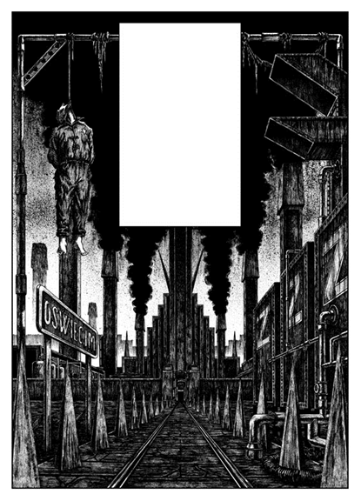
Figure Two: John Coulthart, Reverbstorm (32)
This disturbance and these problems cannot be simply resolved. Crucial to the dynamic of Reverbstorm is the violation of taboos, including the one on the representation of the Holocaust. The “weirding” of the architecture of the camp poses the problem of the submerged horrors of “European dreamtime” (Moore), which can emerge again, both in representation and in new forms of racism and anti-Semitism. In J. G. Ballard’s novel 1962 novel The Drowned World, this “dreamtime” is posed as emerging out of a new crisis of representation:
Just as the distinction between the latent and manifest contents of the dream had ceased to be valid, so had any division between the real and the super-real in the external world. Phantoms slid imperceptibly from nightmare to reality and back again, the terrestrial and psychic landscapes were now indistinguishable, as they had been at Hiroshima and Auschwitz, Golgotha and Gomorrah. (1965, 72)
In Ballard’s proposal dream and reality have collapsed, and the borders between “terrestrial” and the “psychic” have become unstable and indeterminate. Our reality is rendered as nightmare and the division of internal psychic space and external world is transgressed. Coulthart’s images of Auschwitz also inhabit this particular form of “dream logic”: they suggest that the “insane” and apocalyptic worlds of weird fiction, crafted out of reactionary and often racist anxieties, formed a predictive matrix for thinking the Holocaust, and that they form a model for the post-war “dreamscape” in which the camps “rise again,” but often in modes of denial and trauma.
Lovecraft’s visions, with their elements of racist horror at miscegenation and mutation, are transformed in the light of the Holocaust. They become more horrifying, in their articulation of racism, and they become resonant with the racist imaginary of Nazism. Coulthart and David Britton exploit this resonance, linking it to the insights of J. G. Ballard and William Burroughs into a postwar world in which our unconscious fantasies take physical form. For J. G. Ballard the Oedipus complex today resides in “the angle between two walls.” (1984, 49) Coulthart’s work integrates this claim with the weird “angles” of Lovecraft’s fiction, to produce images of the traumatic spaces of modernity. The embodied nightmares of racial anxiety continue to stalk our present, and are reactivated in Reverbstorm as they rise again into a new space of representation.

In the Fascist City
John Coulthart suggests the intensity of Reverbstorm’s integration of the Old Weird, and that this intensification takes a spatial and architectural form:
Reverbstorm throws these numerous influences out like a dark prism, flashing broken images of refracted black light: the place where the non-Euclidean geometries of The Dreams in the Witch House become the fractured visions of Picasso; Cities of the Red Night glimpsed in the Night Land, the smokestacks of Auschwitz rising over the Mountains of Madness. (2006a)
Reverbstorm is identified as a “place,” where its influences, from weird fiction and modernism, become “flashing broken images” of weird spatial forms: the non-Euclidean geometries of Lovecraft’s fiction are linked to Picasso’s cubism, Burroughs’ late modernist novel of pirate communities is at one with William Hope Hodgson’s weird vision of a dying Earth, and Auschwitz is now connected to Lovecraft’s city of the Old Ones in At the Mountains of Madness (1931). These provocative images develop a new spatial imaginary, in which the weird and modernism fuse and mutate.
Within Reverbstorm the architectural weird is most obviously extended by the setting: the fictional “future” city of Torenbürgen, the “unreal city” (Reverbstorm, 58), after T. S. Eliot’s modernist London. John Coulthart calls this “Lord Horror’s vicious dreamscape of fascist atrocity.” (2006a) The visual style of Torenbürgen is modelled on the work of the architectural draughtsman Hugh Ferriss, in his work The Metropolis of Tomorrow (1929). Coulthart notes how Ferriss renders humans as “specks” and his skyscrapers as “Art Deco spacecraft” (Coulthart 2013). Coulthart will use this vision to convey a lost dream or nightmare of weird architecture by integrating this vision of a future that never took place with the world of Lord Horror. Torenbürgen is also the multiplication of Coulthart’s image of R’lyeh and of Auschwitz as R’lyeh. Jon Farmer states that: “Torenbürgen swallows Europe whole, leaving behind an endlessly repeated cityscape, cemented and fuelled by the corpses of Jews it has sought to eradicate” (224, 226). This is a Spenglerian vision of the “world-city,” “a daemonic stone-desert,” realized in images (Spengler, 248). It can be paralleled to the Old Ones’ city, inspired by Spengler (Miéville 2005, xx-xxi), which “stretched nearly to the vision’s limit” (Lovecraft 2005b, 42). It also echoes “The Call of Cthulhu,” in which “Loathsomeness waits and dreams in the deep, and decay spreads over the tottering cities of men.” (Lovecraft 1999, 169). Torenbürgen exists as the dream city of this decay, a city literally “built on a foundation of slaughter” (Farmer, 226), in which the bodies and skulls of the dead are integrated into the built spaces.
Selecting one image of the city (Figure Three), we can see how it draws on the Art Deco aesthetic of Ferriss to create the dream-image of the weird city. The connection between this image and Coulthart’s image of R’lyeh, and his earlier image of Auschwitz, is evident in the spires and smokestacks that form the background. Even the lampposts, cables, and signs, in the bottom-right of the image, appear to be draped with seaweed, as if Torenbürgen has risen, like R’lyeh, from the waves. The flatiron-style building right-of-center gives the same perspectival effect as the previous two images, with train or tram tracks receding into a gate that is, at the same time, Auschwitz and, presumably, the lair of Cthulhu. In the air we see “the Soul” (aka The Soul of the Virgin Mary) which first appeared at the end of part one of Reverbstorm (Britton and Coulthart 2012, 84), and which grows throughout the series. We can note the Lovecraftian form of “the Soul,” with its vaginal openings – and spiked tentacles.
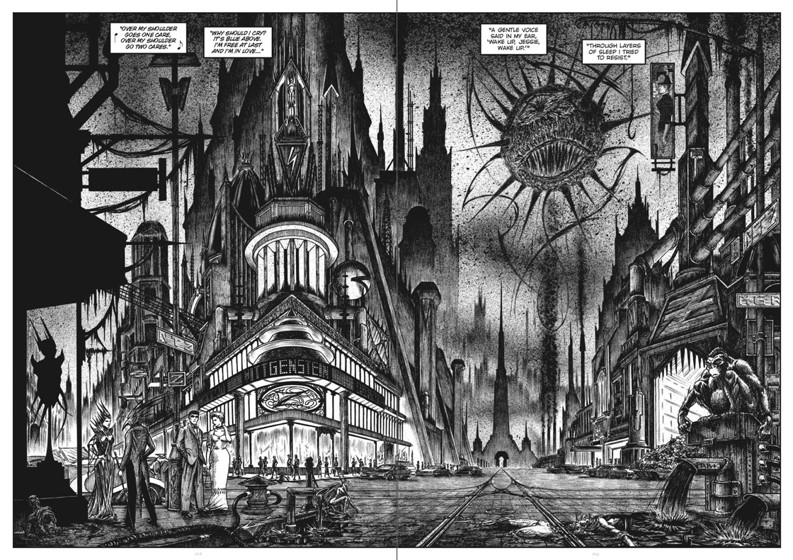
Figure Three: Torenbürgen John Coulthart, Reverbstorm (228-9)
This weird image of the city engages with Lovecraft’s architectural fascination – writing to Robert Bloch in 1933 Lovecraft noted: “My chief hobby is colonial architecture, & my chief passion is visiting various ancient towns where strong traces of the past linger in the houses & streets.” (2015, 24) Lovecraft’s antiquarian interest drove his rejection of modern architecture, which was accompanied by his racist rejection of the city as a “polyglot abyss” (Lovecraft 2005a, 118), as one of his characters describes New York in “The Horror at Red Hook” (1925). Writing to Robert Bloch about the visit of Bloch’s father to an exhibition of “The Century of Progress” at the Chicago World’s Fair in 1933, Lovecraft stated:
The wretchedly futuristic architecture of those damned exhibition buildings would be enough to keep me away even if I had the cash to get there! I dissent absolutely from the position of those who welcome the new machine-culture involving a complete break with the past. (2015, 64)
Lovecraft allied tradition, as a racialized concept, with a rejection of the new. This rejection is complicated, however, by the fact that Lovecraft’s beloved antiquarian New England is also a site of the emergence of horror, in stories like “The Dunwich Horror” (1928) and “The Shadow Over Innsmouth” (1931).
Reverbstorm takes-up, reworks, and partly reverses Lovecraft’s “anti-modernistic attitude” (Lovecraft 2015, 77) to the city and its “polyglot” mixing. Modernity, or more precisely a past imagining of modernity, in the images of Hugh Ferriss, becomes the site of Reverbstorm’s weird dreamtime. While Lovecraft’s characters remain psychologically and racially alienated from the city, Lord Horror’s racialized violence fluidly integrates with the city: Lord Horror is a dandy or flâneur at home in this nightmarish vision of the urban. The weird effect of the space of Torenbürgen is most evident in this gradual integration of Lord Horror within the city. At the beginning of Reverbstorm we have the absence of Lord Horror, except as a silhouette, through the use of the “background” images. Lord Horror, in the body of Reverbstorm, emerges more and more clearly, especially in the images drawn by Kris Guidio. In these sections we witness the sexual idyll, an S/M idyll, of his relationship with a fictionalized Jessie Matthews, the English actress, dancer, and singer, popular during the 1920s and 1930s. As the series comes to a close, however, Lord Horror starts to become overpowered by the city. In issue 7 of Reverbstorm, the final issue before the graphic novel completed the series, Lord Horror appears as one of the buildings in the city (Reverbstorm, 256-7), as a chimney processing corpses in this landscape of atrocity (Figure Four).

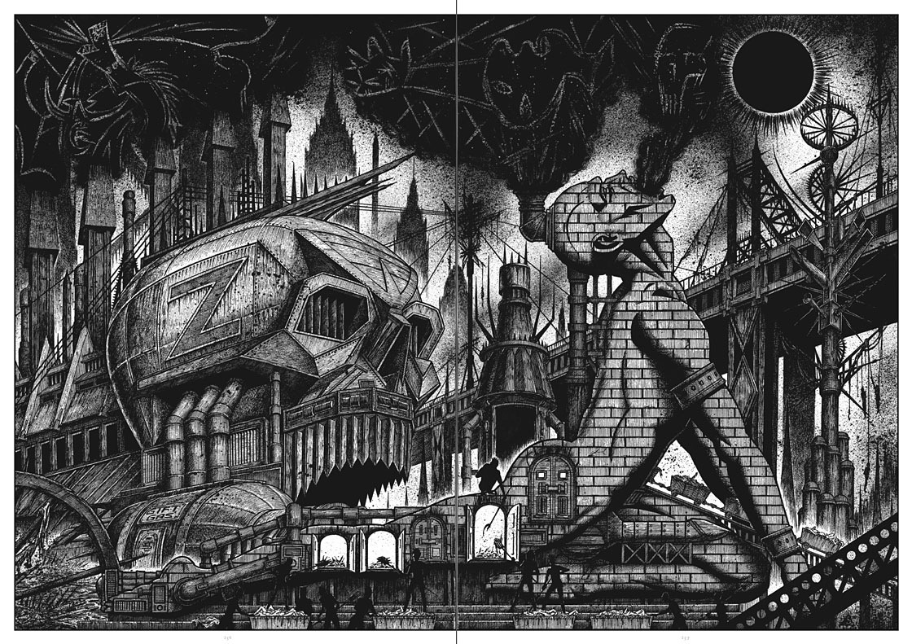
Figure Four: John Coulthart, Reverbstorm 7 (256-7)
If, in Lovecraft’s Old Weird, cosmic horror threatened the entire earth and could, potentially, be found in many places – from Arkham to Antarctica – in Reverbstorm’s New Weird the city of horror has become the entire earth. Even the archetypal anti-hero is threatened with absorption. This architecture denies any exteriority to the weird and any denial of the atrocities of the twentieth century, especially the Holocaust. Of course such an “inflation” of the Holocaust can be another mode of denying its singularity. Reverbstorm takes this risk in its visualization of the camps as “the biopolitical paradigm of the modern,” in Giorgio Agamben’s phrase (69). Instead of the weird as a reactionary shelter against modernity, now the weird and modernity are identified without reserve.
This visual and textual identification of the weird with modernity and, as we will see, with modernism, denies any exteriority to the weird. The weird no longer intrudes on the normal, but overruns it. In this way Reverbstorm develops Lovecraft’s contention that the cosmic weird is not something that can be escaped, but is one with the actual form of the universe. While Lovecraft’s fictions only offer a temporary respite from madness, death, and the inevitable return of the great Old Ones, we are now deprived of that respite. Against the vision of a “harmonious” postwar Europe, a false vision dependent on Cold War division and the denial of the Nazi and fascist past, Reverbstorm presents a vision of atrocity that persists and continues.

Pulped Modernism
Reverbstorm not only intensifies the architectural within the weird, but also intensifies the relationship between the weird and modernism. The text often cites or quotes major works of modernism, especially James Joyce’s Finnegans Wake (1939). This is reinforced by the identification of James Joyce, falsely, as the brother of William Joyce, that is of Lord Horror. This continues a joke made in Flann O’Brien’s novel The Dalkey Archive (1964), in which James Joyce is imagined living on after the war and in which a character remarks: “I remember they hanged your namesake – the broadcaster Joyce.” (164) Reverbstorm also draws much of its visual iconography from modernism, especially Picasso and Seurat. While this welcomes modernism into weird fiction, the relationship of Old Weird, especially Lovecraft, to modernism was often fraught. Lovecraft drew on analogies to the avant-garde and modernism to represent moments of the weird. In At the Mountains of Madness the art of the great Old Ones finds “its closest analogue in certain grotesque conceptions of the most daring futurists” (Lovecraft 2001, 295). The description of R’lyeh, as we have noted, comes close to futurism, and the bas-relief of Cthulhu has a “cryptic regularity” more disturbing than “the vagaries of cubism and futurism” (Lovecraft 1999, 141).
Here modernism and the avant-garde figure as objects of horror. This can be seen as reflecting Lovecraft’s own anti-modernist views. Reflecting on the work of the Imagist poets Lovecraft, in a letter to Rheinhart Kleiner of 24 September 1917, concluded: “I wish they’d might all be choloform’d & put out of their misery.” (2005c, 115) In 1917 he wrote a satirical poem “Futurist Art,” which suggested that the frustration of a court painter flinging his brush at the canvas and spattering his work was still superior to the “freakish toil” of the cubists (Lovecraft 2001b: 223). Lovecraft also wrote a lengthy parody of T. S. Eliot’s “The Waste Land” (1922), titled “Waste Paper” (2001b: 252-55), and criticized Eliot’s poem as “a practically meaningless collection of phrases, learned allusions, quotations, slang, and scraps in general” (in S. T. Joshi 2001, 179). It is not difficult to imagine Lovecraft having a similar, if not more violent, reaction to Reverbstorm.
Despite this hostility to modernism Lovecraft’s work still engages with modernism as a form and in its own probing of the limits of representation and horror at modernity echoes modernist effects (Sorensen, 504). Lovecraft can be identified with the category of “pulp-modernism” (Sorensen, 501-2), which refers to the peculiar antagonistic engagement between the “pulps” and modernism. Despite their differences in cultural status the pulps and modernism often shared similar forms, the small magazine, and a similar cultural space, concerned with anxieties about modernity. Lovecraft is a case in point. Lovecraft, while in New York, mixed in modernist circles, meeting the poet Hart Crane. He would also write a parody of Crane’s “Pastorale,” “Plaster-All” (Lovecraft 2001b, 248-50), but Lovecraft’s fictions integrate modernism, even if often in the mode of hostility. Lovecraft also, it should be noted, expressed regular criticisms of the poor quality and generic constraints of the pulps. In a letter to the young enthusiast of the weird Robert Nelson of 19 October 1934, Lovecraft remarked: “This weird stuff follows a set of lifeless & meaningless formulae just as closely as does any other pulp junk.” (Lovecraft 2015, 215) This instability of position within the literary market-place, Lovecraft noted that “[b]y the standards of real literature, I simply don’t exist” (2015, 391), left his writing in a tense state between the pulps and modernism.
Reverbstorm exacerbates both elements of this unlikely conjunction. In relation to modernism it draws parallels between the dream form of Finnegans Wake and Lovecraft’s “The Dream-Quest of Unknown Kadath” (1927), fuses the visual language of cubism that Lovecraft scorned as intrinsic to the weird, and treats modernism itself as a site of the weird. At the same time Reverbstorm also emphasizes the pulp, in terms of density of reference. This is a metaphorical use also because the production values of Savoy are resolutely high, with the “comic books” A4 formatted and with glossy covers, while the Reverbstorm graphic novel is a substantial hardcover work with a beautiful production design. “Pulp,” then, concerns the integration of visual elements, the mixing of “high” references, notably high modernism, and “low” references, not just weird fiction but also rock-and-roll.
This integration is also used to amplify the disturbing question of anti-Semitism and fascism. The “high” references include T. S. Eliot’s anti-Semitism, now embodied in the figure of Lord Horror, which is combined with the “demotic” street thuggery of the British fascist leader Oswald Moseley and Lord Horror’s radio broadcasts. If Old Weird writers have reactionary aims, then this is something they share with a number of major modernists. Not only Eliot, but Wyndham Lewis and Ezra Pound, to choose the obvious examples, indicate the reactionary, racist and anti-Semitic elements of modernism. If Savoy engaged the weird as anti-Semitic and racist, they do the same with modernism. Central to their disturbing aesthetic is the development of a logic of contamination, which contests fascist and Nazi logics of purification and cultural “regeneration.” This logic of impurity, however, is posed against the postwar repression of fascism and Nazism, suggesting that our culture remains impregnated with fascist and Nazi barbarism. The disturbing result is that the “leaky” formal and generic strategies of Savoy do not simply subvert the normative in the name of liberation, but release us into a textual and visual space in which we are confronted with “free-floating” elements of anti-Semitism, Nazism, and racism.
Reverbstorm and the Lord Horror works make use of what are usually regarded as signature “postmodern” strategies: intertextuality, pastiche, fragmentation, genre mixing, etc. The very flexibility of the category postmodern, however, suggests some of the tension surrounding identification. If Reverbstorm were to be classified as postmodern it would be under the form Perry Anderson identifies as “ultra-postmodernism,” to refer to “those which have gone beyond modernism in radicalizing its negations of immediate intelligibility or sensuous gratification” (102). This identification locates Reverbstorm, but this does little to help us understand the specificity of it as a form of weird fiction. It also does little to help us grasp the elements of antagonism and textual violence that challenge a sense of happy co-existence or neutrality in the elements selected to mix together. If any text, according to Barthes, is “multi-dimensional space in which a variety of writings, none of them original, blend and clash” (1977, 146), then in Reverbstorm the emphasis is placed on the clash of elements, which involves their close integration to bring them into the site of contamination. This, apparent, paradox results in a state of what we could call “violent co-existence” in the textual and visual space of the work.
The result is a work characterized by compression and claustrophobia, rather than the expansiveness and freedom often seen as the signature of the postmodern. This is a “pulped modernism”: the intensification and exacerbation of the elements of pulp fiction, the weird and modernism. The result is a deliberately unstable amalgam that presents a singular and coherent vision, but one that encompasses and places together contradictory and antagonistic visual and textual elements. What remain central are the disturbing enactments of anti-Semitism and racism, which trouble any notion of heterogeneity as a guarantee of a “hybrid” politics.
This also speaks to the question of irony. Fredric Jameson famously characterized the postmodern in terms of the replacement of parody with pastiche, and a resultant “blank irony” (1992, 17). In this situation there is no point of stability from which irony might be exercised and, instead, all statements and forms are rendered ironic. Savoy’s work plays with this situation. In regards to anti-Semitic, racist, or fascist images and statements they are rendered ironic, but at the same time they remain in place. This situation renders irony unstable, as it is not simply directed against the “secure” forms of normalization, whether literary or political. The forms of contamination I have traced leave us exposed to the disturbing elements without a means of escape. In this way the peculiar pulp modernism of Reverbstorm does not simply de-toxify the weird or our cultural space, but reveals that the claims that we have “overcome” Nazism and fascism are an act of repression which leaves those elements still active.

Dis-integration
The Reverbstorm graphic novel not only collects the previous issues of the comics but also offers a final summation of the work. This closing “issue” of Lord Horror adopts a new style of presentation and develops a narrative and visual effect of disintegration. This exploration of disintegration is indebted to both weird fiction and to New Wave science-fiction. In the first case, Lovecraft’s narratives often present the descent of the central character into madness and/or death in their confrontation with the existence and inevitable triumph of the Great Old Ones. In Lovecraft’s fiction there is no consolation of victory over the monstrous, only the most temporary delay. Not only this, but in several tales Lovecraft explores the transition of his central characters into the monstrous. In Lovecraft’s “Through the Gates of the Silver Key” (1932-33) the central character, Randolph Carter, experiences a “cosmic” disintegration:
His self had been annihilated; and yet he—if indeed there could, in view of that utter nullity of individual existence, be such a thing as he—was equally aware of being in some inconceivable way a legion of selves. (1968, 281)
Carter experiences “despair” (Ibid.) at this fragmentation, although Deleuze and Guattari have suggested such experiences as sites of cosmic “becoming” (1988, 240). Lovecraft’s general tendency, in light of the sense of dread of his weird fiction, is to suggest horror as these transitions and transformations. His expression is, however, often equivocal, in that these transitions also open new cosmic vistas of experience, even if these threaten the limits of human sanity.
New Wave science-fiction was a self-designation given to science fiction that explored “inner space,” as J. G. Ballard put it in 1962 (1997, 195-98), and was associated with Michael Moorcock’s editorship of the journal New Worlds, which began in 1964. In New Wave science-fiction similar processes of “disintegration” to Lovecraft’s weird occur, although given a more positive valence. J. G. Ballard’s early writings explore a series of scenarios in which characters “regress” into new states of being, becoming at one with the disintegrating worlds around them. More broadly, the New Wave had a fascination for entropic processes, particularly in relation to time. For New Wave science fiction the running down of time opened new weird possibilities for psychic expansion and fragmentation. True to Ballard’s original contention, of the exploration of “inner space,” the result was a psychedelic attention to the forms of the imagination as they fragment and collapse.
Drawing on these sources, the final issue of Reverbstorm presents a new visual language to portray the collapse of Lord Horror. The dense line-work of the previous images gives way to a representation of Lord Horror based on a drawing by the Bauhaus student Klaus Barthelmess (Figure Five). Lord Horror is now a geometric Harlequin, a simplified icon. The background now is no longer the images of Torenbürgen, although the text tells us Lord Horror is still in the city, but a series of repeated and fragmented images from the series. The text is arranged in black boxes across the page and, reinforced by the wave-form running across the pages, this appears to be Lord Horror’s last broadcast.
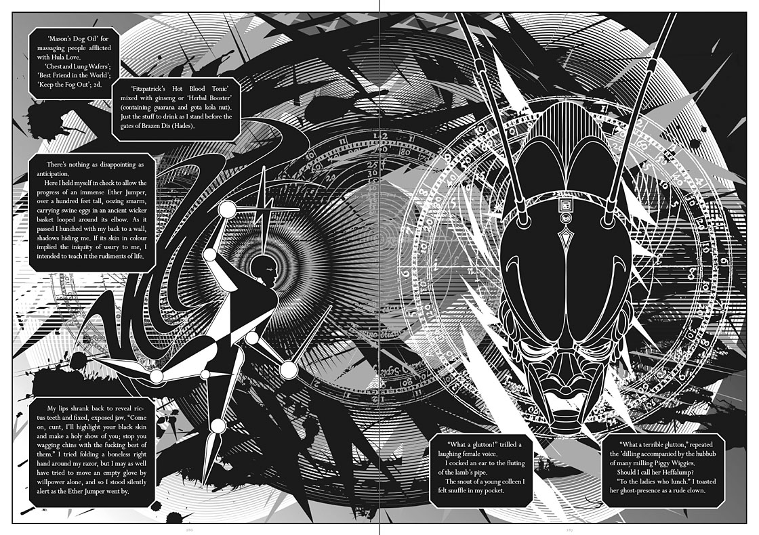
Figure Five: John Coulthart Reverbstorm (286-7)
Lord Horror has himself been “processed” by the engines of Torenbürgen, his body is “falling apart” (Britton and Coulthart 2012, 272), diseased and dying. Instead of a passage to the beyond or a new monstrous becoming, Lord Horror is returned from his state of mutation to finitude. Already having survived his “own” death, the hanging of William Joyce for treason in 1946, Lord Horror had seemed to become a time-traveler or, more accurately, lived in the suspension of time – a perpetual repetition of the Holocaust as “normal” state in Torenbürgen, the only city. Now Lord Horror is returned to time, the time of entropy – in the forms of decline and decay. If entropy, for New Wave fiction, opened a peculiar new time of regression, with a sense of rebirth, this regression now appears to end in collapse.
What does remain, however, is anti-Semitism. In these final pages Lord Horror reiterates his hatred for the Jews, seeking out his object of hate to prop-up his decaying body. The preoccupation here is with the image of the Jew as pig, the anti-Semitic “play” on the unclean animal. This suggests that the “integrity” of Lord Horror is predicated on hate and these racist reversals. In the Lord Horror novel Invictus Horror (2013) Lord Horror requires the weird “substance” of the Jews as “[w]ithout the binding glue-presence of the Goo Goo Muck on earth, he would discorporate” (Britton 2013, 37). In the moment of collapse, textual and visual, all that remains is the “will” as the “will to hate.” The weird is subject to the persistence of this anti-Semitism, as is modernism, and Reverbstorm refuses the easy evacuation of anti-Semitism from both. If we are inclined to read the physical extinction of Lord Horror as the sign of the end of anti-Semitism, the fragmentation of his body and of the images rather suggests that anti-Semitism will persist and be ineradicable. Once again, we have a logic of contamination that works to spread logics of purification, in a troubling equivocation and ambiguity. Lacking “binding” fascist and anti-Semitic elements lose something of their coherence, but also become unconfined.
Reverbstorm develops the disturbing elements of the trope of disintegration, which does not simply refer to the disintegration of normative literary and social structures. This echoes, in a different mode, Fredric Jameson’s critique of New Wave science-fiction:
Ballard’s work is suggestive in the way in which he translates both physical and moral dissolution into the great ideological myth of entropy, in which the historic collapse of the British Empire is projected outwards into some immense cosmic deceleration of the universe itself as well as of its molecular building blocks. (2005, 269)
For Jameson Ballard is not simply subverting the bourgeois ego, but also recoding the “decline” of the imperial ego. In Reverbstorm the collapse of these structures does not evacuate the history of British fascism, and the engagements with Nazism and fascism of both weird fiction and modernism, but reveals them as one of the remaining forms of “integration.” This suggests the persistence of fascism and Nazism as cultural and political forms, despite their defeat. In fact, Jean-François Lyotard noted the fact that although Nazism was “beaten down like a mad dog” (106), this military defeat prevented sustained attention to thinking-through Nazism and fascism. In however a problematic fashion, the work of Savoy and Reverbstorm is a contribution to this thinking, by its refusal to regard Nazism and fascism as simply past.
Instead of weird “becoming” marking the transit to a new state of being, one open to all the molecular processes of existence (MacCormack), here the weird is bent to a becoming that exposes virulent anti-Semitism and racism. This implies a critique of the strategy of the New Weird in believing that the welcoming of the weird and the monstrous will overcome or destabilize normative orders of exclusion and violence. Lord Horror as a character tests our limits in accepting the weird, if we are asked to accept anti-Semitic violence, and also poses the problem that destabilization is not a necessary good in itself. While destabilization of norms can create new alliances and engagements with others, it can also open new spaces of exclusion and the resurgence of atavisms.

Terminal Weird
Savoy’s Lord Horror productions remain relatively unknown. They are self-distributed and have received little critical and scholarly attention. What discussion there is has often focused on the legal persecution the company has experienced as a result of the controversial nature of their publications (Petley 2004). Despite this, the Lord Horror works constitute a singular intervention in the generic and political stakes of weird fiction. While weird fiction, Old and New, appears to be moving into a new phase of critical and popular acceptance and respectability, Savoy’s gesture threatens that with its exposure of the most disturbing elements of weird fiction. Their work appears paradoxical: the high production-values of each of the forms of the Lord Horror “universe” are put in service of the exploration of the “pulp” forms of weird fiction; the exposure of anti-Semitism and racism as core ideological elements does not simply lessen their effect, but leaves them active and present; and the expansion of the weird beyond its generic and political limits does not simply make it more “open,” but confronts us with the exclusionary and reactionary elements of the weird.
The result is a series of “textual” productions, which are at once as much visual and musical as “textual” in the usual sense, that threaten to push the conventions of the weird into a terminal state. If the Old Weird often treated the Other as monstrous horror and, in Lovecraft, gave this a materialist, biologizing and racist form, Lord Horror collapses this distance. The monstrous weird is no longer a state of threat, but present throughout our experience. Of course, in Lovecraft, there was no escape from the horrors, but there was the steady realization and exposure to this situation. In contrast, the Lord Horror works place us immediately in the weird, without the gradual revelations that characterize Lovecraft or other works of weird fiction, old and new. At the same time, however, the New Weird strategy of treating the weird as a subversion of norms is itself subverted as the dissolution of boundaries creates a generalized racialized space. The “dignity” claimed by weird fiction, asserting its rights to generic status and literary validity, is placed under threat. This, ironically, remains true to the weird as an unsettled and unstable generic form, discontinuous, fragmented, and of dubious “literary” status.
Such subversion, in line with Lord Horror’s carnivalesque inversions, also operates from the weird to the rest of culture. Reverbstorm weirds modernism and weirds the cultural forms and elements it draws, centripetally, into its orbit. Instead of the weird being one generic form amongst many, we have the suggestion of a general “weirding” that now echoes through popular culture, modernism and the “postmodern.” Instead of the solidification of the weird in a new generic space, we have the weird destabilizing generic space in its entirety, both in terms of medium and form. Jacques Derrida remarked that “As soon as genre announces itself, one must respect a norm, one must not cross a line of demarcation, one must not risk impurity, anomaly, or monstrosity.” (224-5) While Derrida points out such a law is constitutively impossible, we can add that such a demand is particularly ironic in the case of the genre of weird fiction, which concerns “impurity, anomaly, or monstrosity.” Reverbstorm and the Lord Horror productions play on this irony, deploying the weird to “cross a line of demarcation,” to threaten the genre that they inhabit through its own resources and so to threaten the concept of genre itself. The “leaking out” of the weird from generic confinement undoes all effects of generic policing, threatening the generic as a form of classification.
No longer subject to generic confinement, the weird leaks into our world and enacts, in a problematic fashion, Walter Benjamin’s contention that “there is no document of civilization which is not at the same time a document of barbarism.” (256) In the work of Savoy the barbarism is not, however, simply noted and rejected, but inhabited in its most extreme forms. This leaves us without a generic containment for the weird and, seemingly, without the possibility of detoxifying the weird. In this situation we cannot simply welcome the weird, but nor can we deny its prevalence. The result is the form mimics the fluid monstrous horrors of weird fiction, which defy representation and containment. It recalls Lovecraft’s “shoggoths,” from At the Mountains of Madness, which are composed of “[f]ormless protoplasm able to mock and reflect all forms and organs and processes” (Lovecraft 2005, 91). Reverbstorm, and the other Lord Horror works, operate through the ability “to mock and reflect” the various forms of the weird.
In a letter Lovecraft wrote concerning his work revising the weird tales of others, he remarked that his work involved “making that which was utterly amorphous & drooling just the minutest trifle less close to the protozoan stage.” (2015, 258) Lovecraft’s remark is a deliberate exercise in fine irony, as he corrects these formal defects in a fiction dominated by “amorphous & drooling” entities. Reverbstorm reverses this irony, as although it is a work of great formal organization, it also threatens a return to the “utterly amorphous.” The result is a “terminal weird,” which pushes the weird to its extreme point, even to the point of collapse. In this situation we cannot simply affirm the weird as a newly respectable genre, a new opening to the Other, and a new site of inventiveness. Instead, thanks to the exposure of the reactionary and racist elements of the weird and to the generic instabilities of the weird, we are forced into a situation of critique and negation. The weird regains its disturbing effect as something that confronts limits and generates a sense of horror. The weird as an experience of “wonder” remains, but this also takes on a critical and questioning aspect. For this reason Savoy’s neo-Weird is a crucial challenge to the constitution of weird fiction and, at the same time, also troubles a range of generic and political boundaries. It is this spatial and architectural antagonism that relieves us of the neutral and playful effects of a certain postmodernism and, once again, forces us to take the weird seriously as a truly disturbing site.

Acknowledgements
I would like to thank Tim Murphy, John Coulthart, David Britton, and Michael Butterworth, for their comments on this paper, and to thank John Coutlhart and Michael Butterworth for their kind permission to reproduce images from Reverbstorm.

Works Cited
Agamben, Giorgio. 1995. Homo Sacer: Sovereign Power and Bare Life. Translated by Daniel Heller-Roazen. Stanford, CA: Stanford University Press.
Anderson, Perry. 1998. Origins of Postmodernity. London and New York: Verso.
Ballard, J.G. 1965. The Drowned World. Harmondsworth: Penguin.
---. 1984. “Interview with Graeme Revell.” Re/Search 8/9: J. G. Ballard. Ed. V. Vale and Andrea Juno. 42-49.
---. 1997. A User’s Guide to the Millennium. London: Flamingo.
Barthes, Roland. 1977. Image – Music – Text. Translated by Stephen Heath. London: Fontana.
Benjamin, Walter. 1968. Illuminations. Edited and introduced by Hannah Arendt. New York: Shocken Books.
Britton, David. 2013. Invictus Horror. Illustrated by Kris Guidio. Manchester: Savoy.
Britton, David, and John Coulthart. 2012. Lord Horror: Reverbstorm. Manchester: Savoy.
Carlin, Gerry, and Nicola Allen. 2013. “Slime and Western Man: H. P. Lovecraft in the Time of Modernism.” In New Critical Essays on H. P. Lovecraft. Edited by David Simmons. Basingstoke: Palgrave Macmillan.
Coulthart, John. 2006a. “Drawing the Dark,” In H.P. Lovecraft’s The Haunter of the Dark and other Grotesque Visions. London: Creation Oneiros.
Coulthart, John. 2006b. H.P. Lovecraft’s The Haunter of the Dark and other Grotesque Visions. London: Creation Oneiros.
Coulthart, John. 2013. “The Metropolis of Tomorrow by Hugh Ferriss,” feulliton Blog, 3 October 2013:
http://www.johncoulthart.com/feuilleton/2013/10/03/the-metropolis-of-tomorrow-by-hugh-ferriss/
Deleuze, Gilles and Félix Guattari. 1988. A Thousand Plateaus. Translated by Brian Massumi. London: Athlone.
Derrida, Jacques. 1992. Acts of Literature. Ed. Derek Attridge. New York: Routledge.
Farmer, John. 2006. Sieg Heil Iconographers. Manchester: Savoy.
Ferrall, Charles. 2001. Modernist Writing & Reactionary Politics. Cambridge: Cambridge University Press.
Jameson, Fredric. 1992. Postmodernism: Or, the Cultural Logic of Late Capitalism. Durham, NC: Duke University Press.
---. 2005. Archaeologies of the Future: The Desire Called Utopia and Other Science Fictions. London and New York: Verso.
Joshi. S. T. 2001. A Dreamer and a Visionary: H. P. Lovecraft in His Time. Liverpool: Liverpool University Press.
Lanzmann, Claude. 1994. “Holocauste, la representation impossible.” Le Monde, March 3, I, V11.
Lovecraft, H. P. 1968. At the Mountains of Madness and other novels of terror. London: Paladin.
---. 1999. The Call of Cthulhu and Other Weird Stories. Edited and introduced by S. T. Joshi. London: Penguin.
---. 2001a. The Thing on the Doorstep and Other Weird Stories. Edited by S. T. Joshi. London: Penguin.
---. 2001b. Ancient Track: The Complete Poetical Works of H. P. Lovecraft. Edited by S. T. Joshi. San Francisco: Night Shade Books.
---. 2005a. The Dreams in the Witch House and Other Weird Stories. Edited by S. T. Joshi. London: Penguin.
---. 2005b. At the Mountains of Madness: The Definitive Edition. New York: Modern Library.
---. 2005c. Letters to Rheinhart Kleiner. Edited by S. T. Joshi and David E. Schultz. New York: Hippocampus Press.
---. 2015. Letters to Robert Bloch and Others. Edited by David E. Schultz and S. T. Joshi. New York: Hippocampus Press.
Lyotard, Jean-François. 1988. The Differend: Phrases in Dispute. Translated by Georges Van Den Abbeele. Manchester: Manchester University Press.
MacCormack. Patricia. 2010. “Lovecraft through Deleuzio-Guattarian Gates.” Postmodern Culture 20.2: https://muse.jhu.edu/ (accessed July 18, 2015).
Miéville, China. 2005. “Introduction to Lovecraft.” At the Mountains of Madness: The Definitive Edition. New York: Modern Library.
---. 2009. “Weird Fiction,” in The Routledge Companion to Science Fiction. Edited by Mark Bould. Oxford and New York: Routledge.
Moore, Alan. 2006. “Introduction,” in John Coulthart, H.P. Lovecraft’s The Haunter of the Dark and other Grotesque Visions. London: Creation Oneiros.
Noys, Benjamin. 2002. “Fascinating (British) Fascism: David Britton’s Lord Horror.” Rethinking History 6.3: 305-318.
O’Brien, Flann. 1993. The Dalkey Archive. London: Flamingo.
Petley, Julian. 2004. “Savoy Scrapbook.” In A Serious Life. Edited by D. M. Mitchell. Manchester, Savoy.
Spengler, Oswald. 1991. The Decline of the West. Oxford: Oxford University Press.

For a complete listing of Lord Horror’s appearances see the “Lord Horror Timeline” (Seward, 119-125).
Savoy has published a recording of “The Waste Land” read by P. J. Proby.
For parallels between Lovecraft and modernism, see Carlin and Allen.
For a useful survey and analysis of modernism and reactionary politics see Ferrall.
“Goo Goo Muck” is a reference to The Cramps song of that name.

