Analysis of a rainwater collection system for domestic water supply in Ringdansen, Norrköping, Sweden

Edgar L. Villarreal ^{a,}* , Andrew Dixon^{b}

ªDepartment of Water Resources Engineering, Lund University. Box 118, SE-221 00 Lund, Sweden.
^{b}School of Engineering, Sheffield Hallam University. Howard Street, Sheffield S1 1WB, U.K.

Abstract
The possibilities for implementing a rainwater collection system in Ringdansen, a residential area in Norrköping, Sweden, have been explored by analysing four scenarios for using rainwater in a dual water supply system to supplement drinking water. A computer model has been generated to quantify the water saving potential of the rainwater collection scheme. The performance of the rainwater system is described by its water saving efficiency (WSE). Standard and low water consumption appliances have been taken into account in evaluating WSE and water conservation. According to the analysis, suggested rainwater tank sizes are presented.

Key words: rainwater collection, rainwater tanks, water saving efficiency, water conservation, domestic water supply

1. Introduction
Urban development and increasing water demand are putting stress on existing water resources. Attention is now focusing on alternatives such as rainwater catchment systems as supplementary water sources with multi-purpose functions. Roofs represent an important percentage of the large impermeable areas covered by cities, hence offering a significant possibility for rainwater collection.

The sources of drinking water supply in Sweden are groundwater and surface water from streams, rivers, and lakes. About 75% of the Swedish municipal water works depend on lakes and streams for supplying drinking water, and about 25% uses natural groundwater [1]. Water in Sweden is still an abundant natural resource, where only 0.5% per year of the available resource is used [1]. However, widespread urbanisation and the consequent creation of large-scale centralised systems make local drinking water supply systems vulnerable to shortages and water quality deterioration.

In Sweden, 20% of household water use is for flushing toilets, 15% for laundry, and 10% for car washing and cleaning [2]. Collected rainwater can supply these uses with many economical and environmental benefits. By capturing and storing significant quantities of stormwater for landscape maintenance and improvement in residential areas, peak demands could be reduced, water conserved, and many stormwater management problems mitigated [3]. Rainwater collection systems can provide usage water for purposes not requiring drinking water quality.

The renovation of Ringdansen, a residential area in Norrköping, Sweden, offers the possibility to analyse how rainwater may contribute to environmental improvement of an area. In this paper, the use of rainwater for WC flushing, laundry, irrigation, and car washing in Ringdansen is analysed for several scenarios by means of a computer model. The performance of the rainwater system is described by its water saving efficiency (WSE). Suggestions for the possible implementation of a rainwater recirculation system are presented.

2. The Ringdansen Project
Ringdansen is part of Navestad, a residential area located in the south-eastern part of Norrköping, Sweden. Norrköping is located approximately 140 km to the southwest of Stockholm. The annual precipitation in Norrköping is 508 mm, being July to September the wettest period of the year (normal monthly precipitation > 50 mm), and February to March the driest period (normal monthly precipitation < 30 mm). Snow is typical during the period December to February. Normal temperatures for these months are -1.6, -3.1, and -3.3 respectively [4].

Two identical circular-shape blocks of flats constitute Ringdansen: Guldringen (Gold Ring) and Silverringen (Silver Ring). Each block has one inner and one outer circle-like building (2 to 8-stories) (Fig. 1). The blocks were constructed between 1970 and 1972 and belong to Hyresbostäder i Norrköping AB, a community owned housing company. In 1994, the Community started a development program to renovate the area. The project Ringdansen itself started in 1997 and is aimed to create an ecological, sustainable residential area with both low household consumption of energy, and various recycling plans. The refurbishment of Ringdansen implies an ecological changeover, which includes the following components [5]:

- Social development of the residential area
- Recycling adjustment
- Renewal of buildings and their architecture
- Reuse and recycling of the building’s parts

Through dismantling of sections and parts of the property, the present 'high rise' style building is changed to create lower home units to increase aesthetic harmony with the surroundings. The total amount of apartments is 1,100 after refurbishment. The roof area of each block is 27,600 m² (11,300 m² for the inner building, 16,300 m² for the outer building). The central area of each block, with an extension of 33,600 m², is a park with green areas and bushes. Between the inner and the outer building there is an area of 23,900 m² constituted by a paved pedestrian street and several small-grassed areas. On the street, there are also a few places for parking bicycles.

Stormwater runoff from Ringdansen is drained by a separate sewer system that serves the area (concrete pipes with diameters from 300 mm to 1800 mm). Stormwater from the sewer flows to a canal towards the Motala Ström (Motala Stream). The stream discharges to the Baltic Sea (Östersjön).

The following measures are aimed to reduce the use of water resources at Ringdansen [6]:

- Reduce consumption of drinking water
- Install high efficiency washing machines and dishwashers
- Install water saving toilets
- Local handling of stormwater through construction of ponds and wetlands
- Use rainwater for low water quality demands

The low quality demands that are being considered are as follows:

- Toilet flushing (WC)
An extensive pipe network is required to provide each flat with rainwater for toilet flushing. Low flush toilets should be implemented. The average water consumption for households in Norrköping is 194 litres per person per day [7] of which, 39 litres per person and day are for flushing standard toilets. With 1,100 flats and an average of 3 people per flat, there is a water demand of about 3,800 m³ per month for toilets alone.

- Water for laundry (WM)
Each building will have three laundry rooms. It is considered that building an extra pipe network for supplying washing machines with collected rainwater, as well as heating, ventilation and sanitation installations for the laundry rooms, can be relatively simple [8]. It is estimated that about 30 litres per person and day are used today for clothes washing. With 1,100 flats and an average of 3 people per flat there is a water demand of about 3,000 m³ per month for laundry.

- Car-washing and irrigation
Within the area of the project, there will be a number of places for car washing. Car washing installations will be provided with a cleaning facility to recycle up to 80 to 90% of the water used for car washing and avoid discharges to the sewer system. A car washing installation consumes a maximum of 300 to 350 litres each time a car is washed, of which 30 to 70 litres are drinking water that can be supplied with rainwater. Assuming that there will be 500 cars in the area, using the installation once a month on average, it is estimated that 25 m³ of rainwater are required per month (50 l/car washing). Communities in Sweden rarely have water shortages; discharge of nutrients and toxic substances (heavy metals and other pollutants) to the sewer system is a greater problem. Runoff from car washing and maintenance contributes to these polluting discharges. At Ringdansen, it is planned to reduce such pollution through the creation of special car maintenance and cleaning area to replace the present six car washing areas.

It is likely that the gardens and lawns surrounding the buildings on the Ringdansen site will require some artificial irrigation. The irrigation requirement is predominantly dependent upon a combination of the following: seasonal effects, temperature, rainfall depth and frequency, the lawn or garden irrigation requirements, and the behaviour of the site managers. Herrington [9] estimated that in the UK, garden irrigation typically occurs once every five days in the May to August period.

3. Other examples of large scale in-building rainwater re-use
In Japan, there are several examples of large scale rainwater collection systems. In three multipurpose stadiums located in Tokyo, Nagoya, and Fukoka with capacity for a large number of spectators, rainwater is used for WC flushing and irrigation of plants. The catchment areas are 16,000, 25,900 and 35,000 m² respectively, comparable to the catchment area at Ringdansen. Tank volumes are 1,000, 1,800 and 1,500 m³ respectively. A 19-month follow-up study carried out at the Fukoka Dome [10] showed that rainwater provided 65% of the volume of low quality water. Approximately 75% of the total rainfall on the roof was used, representing a significant economic saving.

Other large rainwater collection systems have been constructed in Japan to reduce local flood problems, decrease dependence on main supplies, reduce water bills, and to provide a backup emergency supply. At the Kokugikan Sumo Wrestling Stadium, Tokyo [11], rainwater from an 8,400 m² roof is stored in a 1,000 m³ reservoir in the basement, and used for toilet flushing and cooling the building. At the Izumo Dome in Izumo City [11] rainwater runoff from the dome and surroundings with a total catchment area of 13,200 m² is stored in two storage tanks with a total volume of 270 m³

Sumida City Office rainwater is collected from a 5,000 m² roof and stored in a 1,000 m³ tank located in the basement of the building [12]. The total amount of rainwater used for toilet flushing was 4,658m³ in 1998, which represented 36% of the WC water consumption [13].

The Millenium Dome in London is another example of a large-scale rainwater scheme. The roof of the Dome has a surface area of approximately 100,000 m² for collecting rainwater. The rainwater is collected using large hoppers, which discharge into a collection ring main that runs around the circumference of the Dome. The captured rainwater is then discharge into stormwater culvert containing an 800 m³ underground sump with 3 storm discharge pumps, from which rainwater can either be discharged into the River Thames, or pumped to the treatment plant [14]. Rainwater provided around 10% of the water demand which was limited by storage constrains on site, so a maximum of 100 m³ a day of rain could be collected [15]. Also in London, rainwater is collected from a 2,200 m² roof to a 14.56 m³ tank and used for toilet flushing in commercial building; an overall annual efficiency of the system was estimated on 51% [16].

At Nanyang Technological University, Singapore, a study indicated that roof runoff from an area of 38,700 m² could be collected and used for toilet flushing in the north spine of the University. Computer simulations have shown that a 2,542 m³ rainwater tank would save 12.4% of the monthly cost for water used [17].

In Berlin, at Daimler Chrysler Potzdamer Platz, roof runoff from 19 buildings (total area 32,000 m²) is collected and stored in a 3,500 m³ rainwater basement tank [18]. The water is then used for flushing toilets, watering gardens and roofs with vegetative cover, and for the replenishment of a vegetated pond. Another example in Berlin is the Belss-Luedecke-Strasse building estate. Rainwater from roofs (7,000 m²) is stored in a 160 m³ tank along with rain runoff from streets, parking places and pathways (4,200 m²). After treatment, the water is used for toilet flushing as well as for garden watering. About 58% of the rainwater is retained locally by using this system. A 10-year period simulation showed that a 2,430 m³ potable water savings per year can be achieved [18].

4. Rainwater collection system at Ringdansen

4.1. Arrangement of the rainwater collection system
There are a number of infrastructure options for a rainwater collection system at Ringdansen. The site is divided into two blocks with a central area. Runoff collection is possible from the roof of each building and the area between the inner and outer buildings. The effective collection area will depend on factors such as direction of prevailing winds, orientation of collection areas, surface material, and slope. The choices range between a central storage and treatment system to a system whose components are distributed throughout the site. The distributed system could have any number of tanks, treatment plant and connections.

The viability of such systems will depend on the capital and running costs of the system and the benefits of a rainwater collection system. Such benefits include reducing municipal water consumption, increasing local infiltration, and independence from the main water system. It would also have an educational and prestige benefit; it would be easy for people to make the connection between natural resources and their behaviour, thus encouraging a feeling of responsibility towards water use. In terms of prestige, residents will be part of a forward thinking, innovative project that benefits society and the environment.

There are other aspects of the rainwater collection system not reported here including, pipework, fittings, number of treatment plants, ease of installation and maintenance. The designers should also consider robustness; if a system fails what will the impact be? A central system that fails will have a potentially greater impact than the failure of many smaller distributed systems.

4.2. Rainwater runoff quality
In general, the quality of roof runoff is acceptable to supply low quality domestic uses. Pollutant additions to roof runoff include organic matter, inert solids, faecal deposits from animals and birds, trace amounts of some metals, and even complex organic compounds [19].

Factors such as type of roof material, antecedent dry period (atmospheric deposition) and surrounding environmental conditions (proximity of strong sources, such as motorways or industrial areas) have been shown to influence concentrations of heavy metals in roof runoff [20, 21, 22, 23]. Roof material represents a problem when the roof itself consists of heavy metals, a situation that can be avoided by using an appropriate kind of roof material. Recent research in roof water quality and health implications of using harvested rainwater have shown that exposure to UV, heat, and desiccation on the roof top destroy many bacteria, while wind removes some heavy metals accumulated from atmospheric fallout [24].

The results from a roof runoff quality investigation of four rainwater installations in Hamburg, Germany, revealed that levels of copper, lead and zinc were well below the standard for drinking water of the World Health Organization, as cited in [1]. Table 1 is a summary of published data for fresh and stored roof, runoff and contains the range of values for a number of typical water quality parameters. Some of the values reported here refer to mean values of water quality data and some refer to ranges of values.

4.3. First Flush
The first flush of runoff water that occurs at the beginning of a storm event has been reported to contain a high proportion of the pollutant load [19, 28]. The main cause of this phenomenon is the deposition and accumulation of pollutant material to the roof during dry periods. The longer the dry period, the greater the probability of a higher pollutant load in the first flush. It is relatively straightforward to install a device for diverting the first flush away from the collection system. However, first flush diversion is not considered within the scope of this study. In practical terms, simulation results may be slightly generous in their estimates of water saving efficiency.

4.4. Health impacts of rainwater runoff collection
Rainwater collection has a long and well documented history. In general, rainwater is considered to be a safe supply of water for many different uses, even drinking, yet it is a water source not entirely free from health risk. A preliminary risk analysis of rainwater collection was carried out by Lucke [29] who suggested that, ‘the restricted use of cistern water contributes little to the overall exposure of a user to pathogens in general’. One study of roof runoff water showed that potential pathogenic micro-organisms are present only in very low concentration [30]. Numbers of Faecal streptococci and Pseudomonas aeruginosa in rainwater runoff were in the region of 10 and 100 per 100 ml, and both were reportedly below the standard set by the authorities. Analyses were also undertaken for the following pathogens, but none could be detected in roof runoff samples; Salmonella sp. (0 in 100ml), Legionella sp. or Staphylococcus aureus (0 in 10 ml), Candida albicans (0 in 0.1 ml). Birds and other wildlife are the potential sources of these pathogens. The bacteria P. aeruginosa is an ubiquitous inhabitant of soil and known to cause ear infections. Yet, the following quote indicates that these bacteria are not always present in significant numbers, ‘....the quality of water draining from roofs and gutters of acceptable materials was well within the limits set by Health and Welfare Canada’ in the Guidelines for Canadian Drinking Water Quality, Nova Scotia Department of Health, 1992, [31]. According to studies carried out recently in Australia [32] ‘…the risk of transmitting pathogens that are responsible for major water born diseases (such as Cholera, Typhoid, Shigellosis and Salmonellosis) to the rainwater tank is minimal’. It is highly unlikely that human faeces or significant amounts of animal faeces will contaminate the roof catchment [33].

The quality of roof runoff is improved in a rainwater tank by several processes. Biofilms adsorb heavy metals, organics, and pathogens from the water. Many bacteria conglomerate in a macro-layer on the water surface, whereas many of the heavy metals and other contaminants precipitate out the water column, and settle at the bottom of the tank [24]. Water quality in a rainwater tank varies considerably from the water surface to the point of supply near the base of the tank [32]. The quality of the rainwater at the outlet point for delivery from a rainwater tank has been found to be significantly better than at the water surface.

Adequate selection of roof material, regular inspection and cleaning of the roof gutter system to limit contamination of rainwater, and correct implementation and maintenance of the rainwater tank will secure the quality of the harvested rainwater at Ringdansen. In the present analysis, for simulations with the computer model it was assumed that rainwater is collected from the roofs, thus having an acceptable quality for the intended uses. Water quality aspects were not considered for the simulations.

5. Modelling
5.1. Description of the model
A computer model has been used to explore the water saving potential of the rainwater collection scheme. This model comprises two modules, the first of which generates time series of domestic appliance usage flows at an hourly time interval using the Monte Carlo technique. The source data for the frequency of appliance usage is based upon a UK study of domestic water usage by Butler [34]. This was considered appropriated for the analysis since the key features (i.e., the diurnal pattern and the differences between weeks and weekends) are likely to be similar for Swedish appliance usage. The second module, essentially a simple reservoir storage model simulates the collection, storage, and use of the water (Fig. 2). A detailed description of the model can be found in Dixon et al. [35]. Discharge of rainwater runoff from impervious surfaces is simulated in the second module, using available rainfall time series and physical characteristics of the collection area. The simulation works on a ‘total storage volume’, i.e. the sum capacity of all storage tanks in the system.

The model storage component aggregates the inputs and outputs in hourly time steps assuming a ‘spill before yield’ concept for simultaneous supply and demand. The term ‘spill before yield’ means that within one time step of the model run, all inputs to the store together with the present volume of water stored are summed and compared with the maximum capacity of the store, any excess water is ‘spilled’ and bypasses the collection system, then all demands on the store are calculated. Spill before yield leads to slightly conservative results. If there is insufficient water in the store to meet the demand, then the mains potable water supply makes up the difference. Running the model allows performance of the system to be analysed. System performance is principally described by its water saving efficiency (WSE), which is a measure of how much potable water has been saved in comparison to the overall demand, as given by Eq (1).

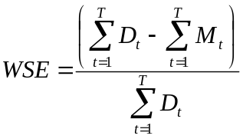 (1)
Where:
M_{t} : Mains makeup
D_{t} : Demand placed by the appliance
T : Run duration (hrs)

Originally, the model was used to simulate water use patterns for single-family homes. In the case of Ringdansen, the input model was modified to generate time series of appliance use for multiple apartments. A similar modification was made to take into account the effect of changing scale of building on the performance of rainwater collection systems. Dixon et al. [36] studied the effect of frequency of inspection and maintenance on water saving efficiency.

5.2. Modelling technique and general considerations
Discharge of rainwater runoff from the roofs at Ringdansen was simulated using hourly rainfall time series for Norrköping [37]. From the rainfall record, the most three recent years were selected (1997 to 1999). The average rainfall for these three years is 479 mm/yr. Fig. 3 shows the distribution in time for the selected period. During the winter months, some precipitation falls as snow. It has conservatively been assumed that during December to February, precipitation is not available for collection. A 3-year historical rainfall record was considered enough for the Monte Carlo aspect of the appliance usage model to generate datasets that were in statistical terms sufficiently similar to the long record [38].

A virtual Ringdansen population was built-up from a number of different occupancy households (one to five people for each flat), considering three different population densities: default, small, and large. For the default, most of the households have three people per flat; the small density considers mainly single occupancy; and the larger, four and five people per flat. A distribution of population for simulation is shown in Fig. 4. The first row of values corresponds to the different occupancy households; the following rows contain the number of flats according to different population densities. Default occupancy has a total of 3,300 people in 1,100 flats, small 2,000 in 1,100 flats, and large 3,300 in only 900 flats.

This virtual population is used to drive the input module to create the appliance use time series. Each household has unique, yet statistically similar patterns of appliance use. The washing machine use is simulated as if each household had its own washing machine (WM), although in reality the household would use the communal laundry facilities. It is assumed that the water demand for this activity would be similar in each case.

5.3. Simulations
The sensitivity of model output to changes in individual parameters has been explored. Four main scenarios for using rainwater (RW) have been considered:

- Using RW only for WC,
- Using RW only for WM,
- Internal scenario: WC + WM,
- Irrigation.

In addition, preliminary results were obtained for using rainwater to supplement car washing activities.

The key parameters for modelling were:

- Appliance discharge volume characteristics: according to the volume for stock appliances, discharge volumes of one and six litres for WC, and 40 and 60 litres for WM were selected. Flush volumes of one (WC) and 40 litres (WM) are for low flush appliances; six (WC) and 60 litres (WM) for ‘standard’ appliances.

- Storage capacity: rainwater tank volumes between 20 and 90 m³.

- Runoff collection area: it is assumed that only rainwater from roofs is collected to supply the in-house uses.

- For the irrigation scenario, it was assumed that one eighth of the central area of each block (4,200m²) is irrigated once every five days for the summer months May – August i.e., 25 mm to be delivered once every 5 days during a 3 hour irrigation period, with a default area of 4,200 m².

For each scenario, several combinations of collection area and storage capacity have been explored. For the WC and WM scenarios, collection areas of 20,000 to 60,000 m² along with storage volumes of 20 to 90 m³ have been tested. For the irrigation scenario, collection areas of 10,000 to 30,000 m² and tank volumes between 20 and 120 m³ have been taken into consideration.

6. Results and discussion
Effect of household occupancy
Each combination of roof area, storage and flush volume has been evaluated for the three population densities at Ringdansen. In general for a certain roof area/storage combination, the highest WSE is reached for the small population density, while those for default and large population densities are practically the same. For the WC only scenario, the difference between WSE values for the default population density is of the order of 3 to 6% compared to the small population density. The highest WSEs for the WM only scenario are also reached with the small population density, but in this case the difference between WSEs for the default population density compared to the one for small population density can be up to 13%. On a low use WC+WM scenario (flush volumes 1 and 40 litres, respectively) WSEs for the small population density were higher by about 10% compared to the default population density.

Impact of roof area and storage capacity
Water saving efficiency at Ringdansen is little affected by increases in effective surface area for all the storage capacities. Between 1% and 6% increase in WSE is made as surface area is increased from 20,000 to 60,000 m² for all flush volumes (see Figs. 5, 6 and 7). Water saving efficiency is more sensitive to changes in storage capacity: for the WC scenario, increases of up to 24% in WSE are made as storage volume is increased from 20 m³ to 90 m³. The respective figure for the WM scenario is 28% and WC+WM is 27%.

The trends for both the WM and WC+WM scenarios are very similar to those for the WC only scenario. Again, it is storage volume, then WM discharge that are the key parameters. If the most efficient WC and WM are installed, increasing the surface area from 20,000 to 60,000 m² brings a maximum 12% increase in WSE (Fig. 7). Increasing the storage tank capacity from 20 to 90 m³ brings up to 27% increase in WSE. For the WC+WM low water consumption scenario, a system with a 40 m³ rainwater tank and 60,000 m² catchment area has the same WSE as a rainwater tank of 90 m³ collecting from a roof area of 20,000 m². This indicates that at Ringdansen, it is not necessary to install a big rainwater tank but instead a medium size tank and use the whole roof area.

Influence of appliance discharge volume
Important water savings can be made with a 20 m³ rainwater tank and a collection area of 20,000 m², if low flush-volumes appliances are installed. If for any one reason, only a small portion of the whole roof area is available for collecting rainwater, and also if local conditions only allow the installation of the small rainwater tank, almost half of the drinking water used for flushing toilets, and at least one fifth of the water used for laundry can be saved on an annual basis (Fig. 5).

If existing WC and WM appliances are retained at Ringdansen (flush volumes of six and 60 litres, respectively), about one third of the water for flushing WC can be provided by rainwater only if a 90 m³ rainwater tank is installed (Fig. 6).

The results show a scenario with WC-flush volume of one litre, 20 m³ storage, and 20,000 m² collection area would return a WSE of 44%. A scenario with WC-flush volume of six litres, collection area of 60,000 m², and 60 m³ storage will give a maximum WSE of about 33%. Then, the design question becomes should the WC with the lowest possible flush be installed, and have a smaller scale collection system, or install more ‘standard’ flush WC and create a larger infrastructure for rainwater collection. As shown in Table 2, the costs of implementing a large infrastructure for rainwater collection are far lower than for a small scale one with low flush volume. The costs for the small scale infrastructure are increased since 1,100 new low flush WCs will be needed. By implementing a large tank, there will be no need for replacing the existing toilets at Ringdansen. Nonetheless, by implementing a big rainwater tank and keeping standard appliances, large volumes of drinking water will be still used, thus water consumption will not be considerably reduced. The small scale system with low flush appliances not only will contribute to drinking water savings, but to the reduction of water consumption, and hence to water conservation.

For a low water consumption combination of WC+WM, a rainwater system with a 40 m³ storage and 40,000 m² collecting area will save the same amount of drinking water as a system with only 20 m³ storage that uses the whole roof area, 60,000 m². A system with 40 m³ and 60,000 m² will return about the same saved volume of drinking water as one with 60 m³ and 60,000 m² (Table 3). Although the values presented in Table 3 show that there is not a significant difference in annual volumes of water saved between the low and high consumption scenarios, the differences between WSE show that the high WC+WM consumption scenario will not contribute to water conservation.

The scenarios considered here have storage capacities several orders of magnitude smaller than the Japanese rainwater collection systems described earlier. However, the catchment area is much the same. This is because the number of users at the stadiums in Japan is much larger (by a factor of 40-50) than for Ringdansen.

Irrigation
Results from the irrigation scenario (Fig. 8) show an almost linear relationship between storage capacity and WSE for collection areas of 20,000 and 30,000 m², and storage volume up to 100 m³. Furthermore, for storage volumes up to 80 m³ there is little difference between WSEs for the systems with such collection areas. Increases in storage capacity of the rainwater tank have no significant impacts on WSE for the small collecting area (10,000 m²). For collection areas of 20,000 and 30,000 m², this effect is noticed for rainwater tanks bigger than 80 and 100m³, respectively. Almost 60% of the water for irrigation during the summer months could be supplied with an 80m³ tank and a collection area of 20,000 m².

Car washing
Preliminary results reveal that if 50% of households have a car, they can meet about 60% of the water demand for this activity using water from a dedicated rainwater system of 20 m³ collecting from an area of 20,000 m². This assumes that 50 litres of water is used at each event and a car wash frequency of once a month. The model is being developed to explore this scenario in greater detail.

7. Conclusions and Recommendations
Important water saving efficiencies at Ringdansen are possible if rainwater tanks are included as part of a dual water supply solution, especially if low water consumption appliances are installed. Low flush toilets are available on the Swedish market [39] with flush volumes between one and two litres that may be installed to achieve high WSE and promote water conservation. Assuming that the whole roof area at Ringdansen is used to collect rainwater, and if rainwater is used only for WC flushing, a 40 m³ tank would be suitable, saving more than 60% of the main water supply. For low flush WM, a 40 m³ rainwater tank can be used to save almost 40% of the water demand. The same tank capacity would be suitable if a combination of WC and WM is to be supplied with rainwater, saving about 30% of the water demand. At each block, it is estimated that an 80m³ rainwater tank with a collection area of 20,000 m² would supply almost 60% of the water needed for irrigation of the central area during the summer months. Water saving efficiencies at Ringdansen are in the range of values reported in the reviewed case studies, which have been successfully operating for many years.

The present analysis shows that rainwater would contribute to important savings in drinking water. There may be two options for the rainwater tanks at Ringdansen: prefabricated plastic tanks, or on-site constructed concrete tanks. Geotechnical conditions and available space should be considered. If the rainwater tanks could be placed in available space, say, at the existing underground parking areas, there is no need to consider excavation thus reducing costs considerably.

A rainwater collection system at Ringdansen would be the first big scale rainwater scheme in Sweden and one of the biggest in Europe. In Sweden, there is a considerable potential for rainwater systems to be installed in many buildings with large roof areas, which would improve stormwater management, wastewater treatment, and appreciation of the water resource in urban environments.

Acknowledgements
Edgar Villarreal’s research studies at Lund University are partially funded by the MISTRA Urban Water Program. Göran Hermelin and Bengt Zetterdahl (Hyresbostäder Norrköping AB), and Anders Rydberg (VAI VA-Projekt AB) supplied valuable information about the Ringdansen Project. Dr. Peter Coombes, School of Engineering, University of Newcastle, Australia, gave valuable comments to the paper and supplied information on rainwater systems.
References
[1] National Board of Housing (Boverket). Spola wc med regnvatten –inte med dricksvatten (Flush the WC with rainwater –not with drinking water). (In Swedish). Karlskrona: Boverket, 1998.

[2] Brånvall, G., Eriksson, M., Johansson, U., Svensson, P. Physical and monetary data connected to abstraction, use and discharge of water in the Swedish NAMEA. Statistika centralbyrån (Statistics Sweden), 1999.

[3] Urban, L. Captured Storm Water Can Be a New Resource. Water/Engineering & Management. April 1987. p.12.

[4] Swedish Meteorological and Hydrological Institute (SMHI). Väder och Vatten (Weather and Water) (In Swedish). Norrköping: Swedish Meteorological and Hydrological Institute, 2002.

[5] Hyresbostäder Norrköping. Ringdansens miljöpolicy (Environmental policy for Ringdansen). (In Swedish). Norrköping: Hyresbostäder, 1999.

[6] Hyresbostäder Norrköping, HSB Östra Östergötland, Norrköpings Kommun, Skanska. Projektbeskrivning för kv Ringdansen i Navestad – ett miljonprogramsområde i utveckling (Project description for Ringdansen in Navestad – a million program area in development). (In Swedish). Norrköping, 1998

[7] Statistics Sweden (Statistika centralbyrån). Statistisk årsbok för Sverige 2002 (Statistical Yearbook of Sweden 2002). Available at http://www.scb.se/publkat/allman/a01sa0201.asp (in Swedish and English). Stockholm: Statistics Sweden, 2002.

[8] Hyresbostäder Norrköping. Program för lokalt omhändertagande av dagvatten (Program for local management of stormwater) (In Swedish). Stockholm: VA-Projekt AB, 2000.

[9] Herrington, P. Climate change and the demand for water. London: Her Majesty’s Stationery Office, 1996

[10] Zaizen, M., Urakawa, T., Matsumoto, Y., Takai, H. The collection of rainwater from dome stadiums in Japan. Urban Water 1999; 1(4):335-359

[11] Gould, J., Nissen-Petersen, E. Rainwater Catchment Systems for Domestic Supply. Design, construction, and implementation. London: Intermediate technology Publ., 1999.

[12] Centre for the Analysis and Dissemination of Demonstrated Energy Technologies (CADDET). Combined and stepped use of energy in Sumida City Office. 1999. Available at http://www.etis.net

[13] Murase, M. Promoting a Rainwater Utilization Based Society for Sustainable Development in Urban Areas. 2002. Available at www.ircsa.org

[14] Birks, R., 2002. Personal communication. Thames Water, U.K. Rebecca.Birks@thameswater.co.uk

[15] Hills, S., Birks, R., McKenzie B. The Millenium Dome “Watercycle” Experiment: to evaluate water efficiency and customer perception at a recycling scheme for 6 million visitors. Proceedings of the IWA 2nd World Water Congress, Berlin 15-19 October 2001

[16] Chilton, J.C., Midment, G.G., Marriott, D., Francis, A., Tobias, G. Case study of a rainwater recovery system in a commercial building with a large roof. Urban Water 1999; 1(4):345-354

[17] Appan, A. A dual-mode system for harnessing roof water for non-potable uses. Urban Water 1999; 1(4):317-321

[18] United Nations Environmental Programme-DTIE-EITC/ Sumida City Government/People for Promoting Rainwater Utilisation. Rainwater Harvesting and Utilization. An Environmentally Sound Approach for Sustainable Urban Water Management. An introductory Guide for Decision-makers. 2002

[19] Forster, J. Roof Runoff Pollution. In: Grottker, M., Schilling, W. editors. Proceedings of 2nd European Junior Scientist Workshop, Kastienbaum, Switzerland, 4-7th April 1991. p.145-158.

[20] Yaziz, M.I., Gunting, H., Sapari, N., Ghazali, A.W. Variations in rainwater quality from roof catchments, Water Research 1989; 23(6):761-765.

[21] Thomas, P.R., Greene, G. R. Rainwater quality from different roof catchments. Water Science and Technology 1993; 28(3-5):291-297.

[22] Forster, J. Patterns of roof runoff contamination and their potential implications on practice and regulation of treatment and local infiltration. Water Science and Technology 1996; 33(6):39-48.

[23] Forster, J. Variability of roof runoff quality. Water Science and Technology 1999; 39(5):137-144

[24] Spinks, A.T., Dunstan, R. H., Coombes, P., and Kuczera, G.A. Water Quality Treatment Processes & Health Implications of using Harvested Rainwater in the Urban Environment. Submitted to the 28th Hydrology and Water Resources Symposium, Institution of Engineers Australia, Wollongong, Australia, November 2003.

[25] Mottier, V., Bucheli, T., Kobler, D., Ochs, M., Zobrist, J., Ammann, A., Eugster, J., Mueller, S., Schoenenberger, R., Sigg, L., Boller, M. Qualitative Aspects of Roof Run-Off. In: Eighth Junior European Workshop - Urban rainwater: Resourcefully Used, Deventer, The Netherlands, 22-25 September 1990.

[26] Xanthopoulos, C., Hahn, H. Priority pollutants from urban storm water runoff into the environment. J. European Water Pollution Control 1994; 4(5):32-41.

[27] Surendran, S., Wheatley, A. Grey-water reclamation for non-potable re-use. J.CIWEM 1998; 12, December, p. 406-413.

[28] Fewkes, A. The reuse of rainwater for WC flushing, Water Recycling - Technical and Social Implications. ICHEME conference, 26th March 1996, London.

[29] Lucke, F.K. Process Water of Potable Quality: Sense or Nonsense? Mark Moodie, Newnham, UK., 1999.

[30] Nolde, E., Christen, S., Dott, W. Experiences with using stormwater and treated greywater in Berlin households - aspects of hygiene and greywater purification. Proceedings of Sixth Junior Scientist Course, Kastanienbaum, Switzerland, 1993.

[31] Vale, R., Vale, B. Water and sewage treatment in the autonomous house. Plumbing Magazine. November/December 1995 p. 17-19.

[32] Coombes, P. Rainwater tanks revisited: new opportunities for urban water cycle management. PhD Thesis, University of Newcastle, Australia, 2002.

[33] Coombes, P. 2003. Personal communication. School of Engineering, University of Newcastle, Australia. pcoombes@mail.newcastle.edu.au

[34] Butler, D. A small-scale study of wastewater discharges from domestic appliances. J.IWEM 1991; 5, pp.178-185.

[35] Dixon, A., Butler, D., Fewkes, A. Water saving potential of domestic water recycling systems using greywater and rainwater in combination. Water Science and Technology. 1999; 39(5):25-32.

[36] Dixon, A., Butler, D., Fewkes, A. Influence of scale in greywater recycling systems. Conference Proceedings of Water Recycling 2000 (AWWA), Texas, USA.

[37] Swedish Meteorological and Hydrological Institute. Rainfall records for Norrköping SMHI 8634, 1961-2000. Swedish Meteorological and Hydrological Institute, Head Office, SE-601 76 Norrköping, Sweden.

[38] Dixon, A. Computer simulation of domestic water re-use systems: greywater and rainwater in Combination. PhD thesis, Imperial College, University of London 2000.
[39] Af Petersen, E., Johansson, M., Anderson, J. Market Survey Extremely Low Flush Toilets. Plus urine diverting toilets and urinals, for collection of black water and/or urine. SwedEnviro report No. 2001:1, February 2001.

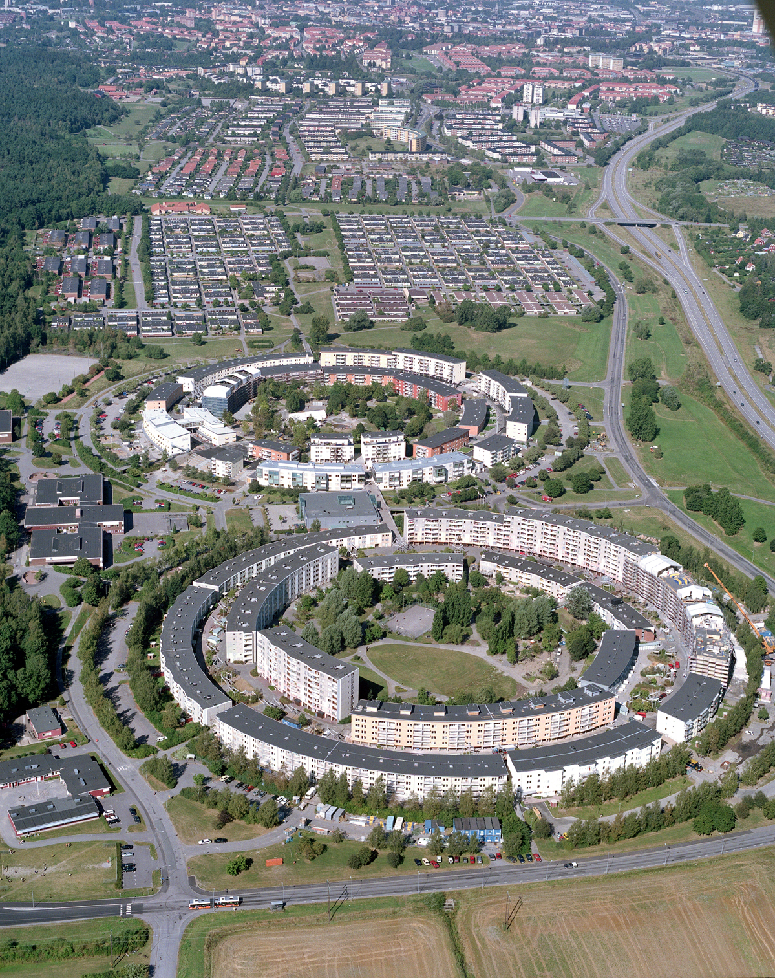
Fig. 1 – Project Ringdansen (Photo credit: Anders Witt)

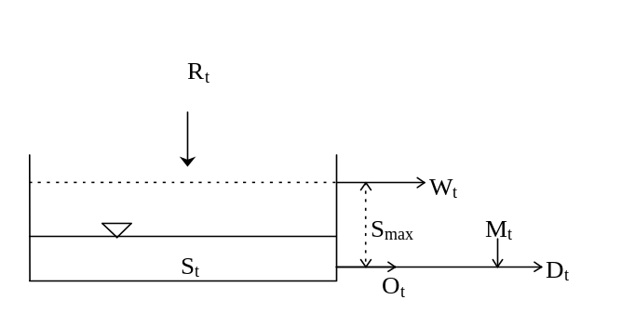
Fig. 2a. Schematic of the reservoir storage model

S_{t} + I_{t} - W_{t} < D_{t}
S_{t} + I_{t} > S_{max}
T
I_{t} = ∑ R_{t}
t = 1
D _{t}
W_{t} = 0
W_{t} = S_{t} + I_{t} - S_{max}
Y
N
Y
S_{t+1} = S_{t} + I_{t} - W_{t} - O_{t}
O_{t} = S_{t} + I_{t} - W_{t}
M_{t} = D_{t} - O_{t}
O_{t} = D_{t}
M_{t} = 0
N
Fig. 2b. Model flowchart
R_{t} - rainwater roof run-off
W_{t} - waste overflow
S_{max} - maximum storage capacity
O_{t} - output from store
M_{t} - mains supply make-up
D_{t} - appliance demand
S_{t} - volume in storage
t - time
I_{t} - accumulated input, sum of runoff discharges

Fig. 2. Rainwater reservoir storage model (from Dixon et al., 1999[35])

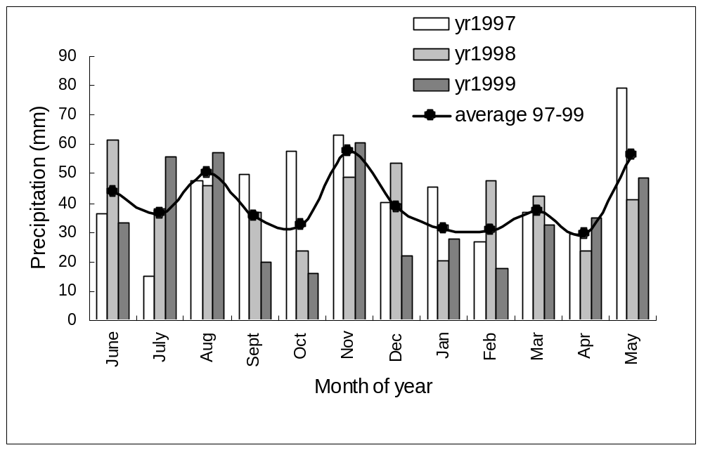
Fig. 3. Monthly average precipitation values used for simulation (1997-1999).

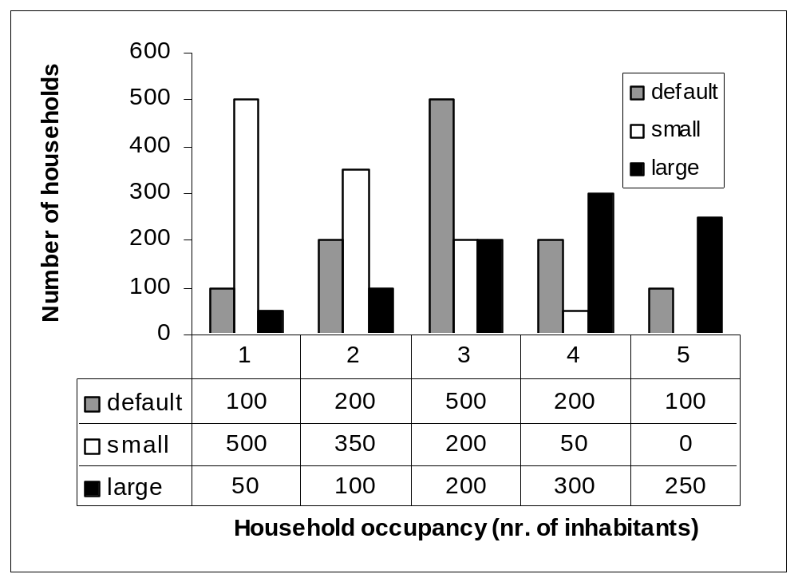
Fig. 4. Ringdansen population for simulation

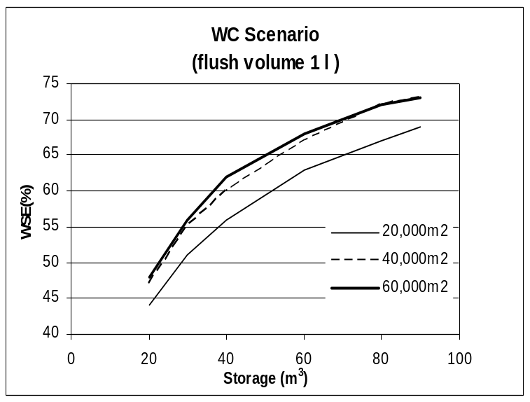 | 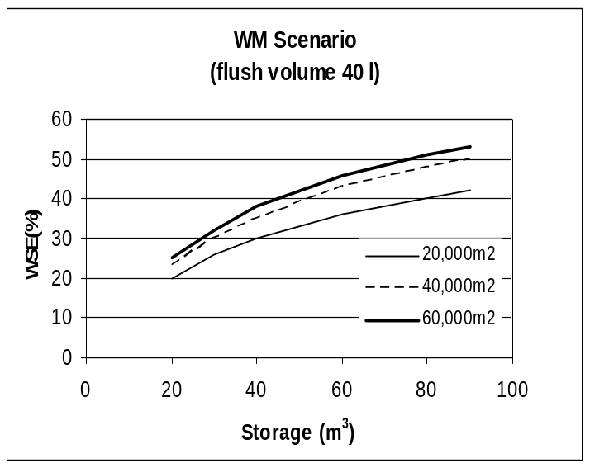
Fig. 5. Water Saving Efficiencies (%) for low flush appliances. Default occupancy

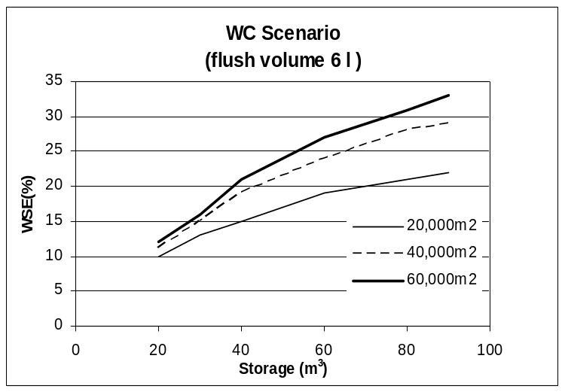 | 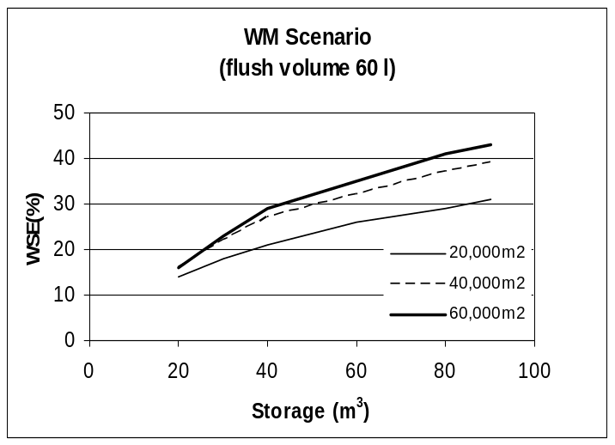
Fig. 6. Water Saving Efficiencies (%) for standard appliances. Default occupancy

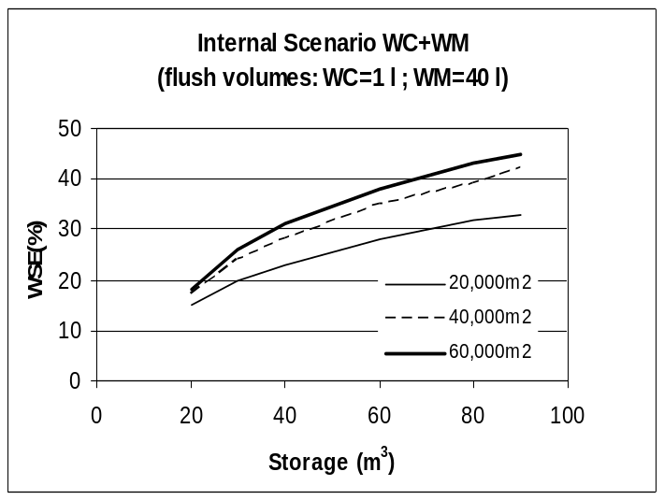 | 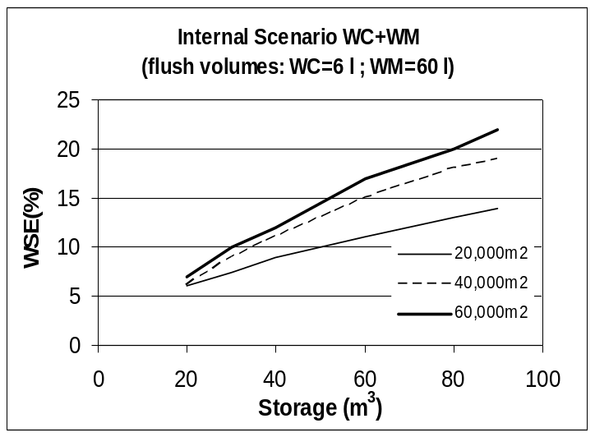
Fig. 7. Water Saving Efficiencies (%) WC+WM scenarios. Default occupancy

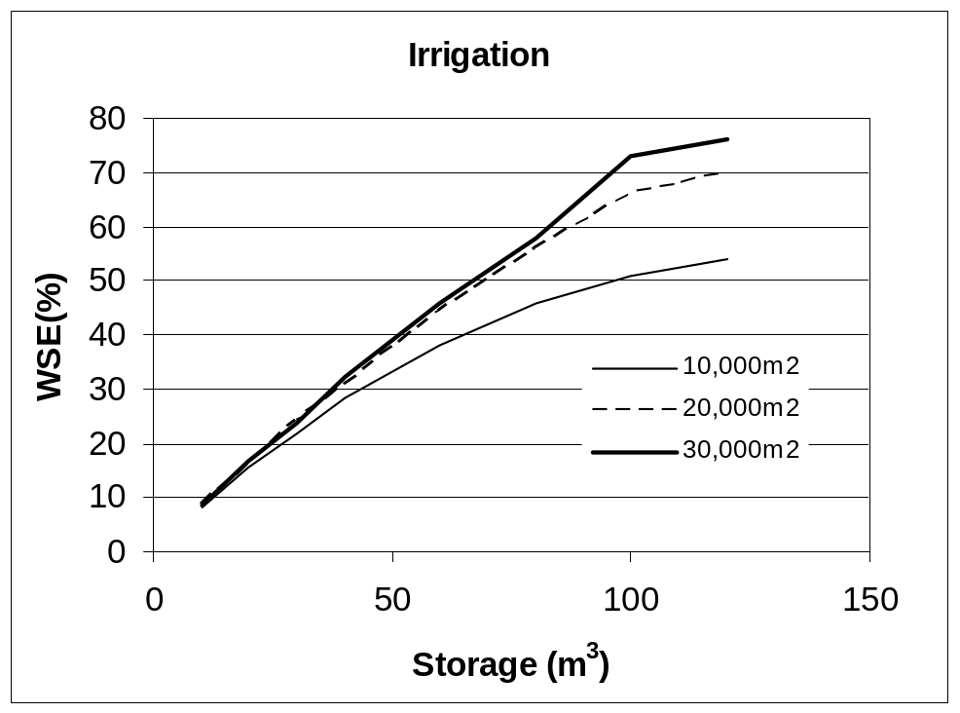
Fig. 8. Water saving efficiency - Irrigation scenario

Table 1. Summary of roof runoff water quality

 | PH | BOD  (mg/l) | COD  (mg/l) | TOC  (mg/l) | Turb  (NTU) | TS  (mg/l) | SS  (mg/l)
Roof Runoff | 5.2-7.9 | 7-24 | 44-120 | 6-13 | 10-56 | 60-379 | 3-281
Stored Runoff | 6-8.2 | 3 | 6-151 | - | 1-23 | 33-421 | 0-19

References:
[19, 20, 25, 26, 27]

Table 2. Costs comparison between a rainwater system with low flush WC and a rainwater system with standard WC.
WC flush volume  (litres) | 1,100WCs cost  (x1000 SEK) | Rainwater tank volume  (m³) | Plastic rainwater tank cost  (x1000SEK) | Sum costs  (x1000SEK) | Volume of saved water per year  (m³) | Cost of saved water per year^{b} (x1000SEK)
1 | 4,400 | 20 | 66 | 4,466 | 4,200 + 48,636ª | 808
6 | - * | 90⁺ | 270 | 270 | 19,200 | 294
*this cost will not be considered since the WC may be already installed at Ringdansen.
⁺ Three tanks of 30m³ each
ª volume of water saved just by implementing low flush WC
^{b} 1m³ of water in Norrköping costs 15.30SEK (1EUR=9.26SEK)

Table 3. Annual volumes of saved water (x1000m³)
A_{roof} (m²) | Scenario | Storage
A_{roof} (m²) | Scenario | 20 m³ | 40 m³ | 60 m³ | 80 m³ | 90 m³
20,000 | WC(1)+WM(40) | 5.4 | 6.2 | 6.6 | 11.5 | 12.0
20,000 | WC(6)+WM(60) | 5.6 | 6.3 | 6.7 | 12.8 | 13.4
40,000 | WC(1)+WM(40) | 8.4 | 10.3 | 11.1 | 14.3 | 15.1
40,000 | WC(6)+WM(60) | 8.7 | 11.0 | 12.0 | 17.4 | 18.7
60,000 | WC(1)+WM(40) | 10.2 | 13.0 | 14.0 | 15.6 | 16.4
60,000 | WC(6)+WM(60) | 11.1 | 14.5 | 16.4 | 20.1 | 21.6

* Corresponding author. Tel. +46 46 2224477 Fax. +46 46 2224435 e-mail: edgar.villarreal@tvrl.lth.se (Edgar Villarreal)

