Analysis of Crossing at the 2014 FIFA World Cup

Craig Pulling, David Eldridge, Emma Ringshall and Matthew T. Robins

Chichester Institute of Sport, University of Chichester, Bishop Otter Campus, Chichester, UK.

Corresponding author

Craig Pulling

Address

Department of Physical Education

University of Chichester

Bishop Otter Campus

College Lane

PO19 6PE

Email: [**c.pulling@chi.ac.uk**](mailto:c.pulling@chi.ac.uk)

Twitter: @craigpulling1

ORCiD: 0000-0003-3941-2021

Disclosure statement: The work has not been published previously and is not under review with any other journal. The authors declare no conflict of interest.

Analysis of Crossing at the 2014 FIFA World Cup

# Abstract

The aim of this study was to analyse open play crosses in the FIFA 2014 soccer World Cup. A total of 1332 open play crosses were observed from all 64 games of FIFA 2014 soccer World Cup. The dominant themes of analysis included: delivery side, delivery type, defensive pressure, time of cross and delivery outcome. Chi-squared tests of association were utilised to examine the association between each variable (e.g. delivery type) and each outcome category (e.g. goal scoring attempts). A total of 42 goals (3.2%) were scored from the 1332 open play crosses analysed. The zone of the outcome of the cross was significantly associated (p<0.05) with all outcome categories. Delivery type and zone of the crosser were significantly associated with defensive outcomes and attacking outcomes (p<0.05). Defensive pressure was significantly associated with goal scoring attempts and attacking outcomes (p<0.05). Pitch side of the delivery and time of the cross, were not significantly associated (p>0.05) with any of the outcome categories. Coaches should reflect on the variables presented and the impact they have on crossing outcomes.

Key words: performance analysis; tactics; strategy; coaching; attacking; defending.

# 1. Introduction

The focus of many performance analysis studies in soccer has been centred on the significant aspect of scoring or creating scoring opportunities (Tenga, Holme, Ronglan & Bahr, 2010; Wright, Atkins, Polman, Jones & Sargeson, 2011; Mara, Wheeler & Lyons, 2012; Gonzalez-Rodenas, Lopez-Bondia, Calabuig, Pérez-Turpin & Aranda, 2016). Dominant themes of analysis within goal scoring research commonly include, but are not limited to: shot type, shot location, shot outcome, assist zone, and assist type (e.g. Wright *et al.*, 2011). One such assist type is crossing, which has typically been examined only as a by-product of goal scoring research, so has rarely been the subject of examination in its own right (e.g. Partridge and Franks, 1989a; b; Yamada and Hayashi, 2015). A cross can be operationally defined as a ball being played into the penalty area (18-yard box) from the side of the pitch (Hargreaves and Bate, 2010). This apparent neglect of crossing as an area of study is somewhat surprising given: (i) the relative frequency of crosses within a match (Nesti and Sulley, 2015), (ii) the requirement and importance of this specific action for varying playing positions e.g. full-backs, midfielders and forwards (Taylor, Mellalieu & James, 2004; 2005) and, (iii) its role in producing goal scoring opportunities. Nesti and Sulley (2015) stated that the average number of crosses performed by a team per match during the 2010/2011 English Premier League season was 16, and that crosses were mostly performed by the right midfielder (3.7 crosses per game) and the left midfielder (3.3 crosses per game). Furthermore, crossing is considered a crucial tactic that has been shown to facilitate a good proportion of goal scoring opportunities (Konstadinidou and Tsigilis, 2005; Smith and Lyons, 2017). For instance, Konstadinidou and Tsigilis (2005) reported that the percentage of goals scored from crosses for the top four teams in the 1999 Women’s World Cup ranged from 10.9% (China) to 27% (Norway). This finding is corroborated by numerous other studies e.g. Jinshan, Xiaoke, Yamanaka & Matsumoto, 1993; Mara *et al.*, 2012; Smith & Lyons, 2017). Specifically, Mara *et al.* (2012) reported that 24% of goal outcomes resulted from crosses in the 2010/2011 W-League football competition. Smith and Lyons (2017) analysed open play goals across four FIFA World Cups (2002 – 2014 inclusive), and found that the percentage of open play goals originating from crosses ranged from 13% (2006 & 2010 World Cups) to 28% (2002 World Cup).

The importance of crossing as a mechanism for generating goal scoring opportunities is further advocated by previous coaching literature that has suggested wide areas of the pitch are where the attacking team can expect to find most space, and can lead to generating attempts on goal (Hughes, 1996). Empirical support for this contention can be found from an analysis of team strategies in the 1990 World Cup (Yamanaka, Hughes & Lott, 1993). Yamanaka *et al.* (1993) assessed team strategies of varying nations e.g. British, European, South American and “Emerging Nations”, and observed a higher prevalence of passes in the middle area of the pitch and fewer passes in either the defensive or attacking areas. One interpretation of this finding would be that the build up play seemed to be concentrated within the middle area, with the ball then manoeuvred out wide to generate crossing opportunities. The use of wide areas was also evidenced by James, Mellalieu & Hollely (2002) via an analysis of passing patterns in domestic and European football. It was revealed that attacking play tended to be focused more down the right-side channel in domestic games compared to European games. As such, if teams are able to exploit space out wide, delivering crosses into the box may represent a viable strategy to produce goal-scoring opportunities (Hargreaves and Bate, 2010).

It is interesting to note that crossing has received significantly less attention when compared to its “dead ball counterpart”, the corner kick. In comparison to crossing, corner kicks has been the topic of a much greater level of study e.g. Casal, Manerio, Arda, Losada, & Rial, (2015), with research looking at corner kicks in relation to delivery area (Pulling, 2015), match status (De Baranda, & Lopez-Riquelme, 2012), and defensive strategy (Pulling, Robins & Rixon, 2013; Pulling & Newton, 2017). However, due to the obvious similarities between crossing and corner kicks, the corner kick literature can be used to inform the approach by which crosses can be examined i.e. delivery side, delivery type, delivery location etc. To the authors’ knowledge there are only two studies that have formally examined crossing (Partridge and Franks, 1989a; b; Yamada and Hayashi, 2015). Partridge and Franks (1989a; b) completed a detailed analysis of crosses from the 1986 World Cup. In total, 1427 crosses were examined in relation to; build up play, area of the build up, origin of the cross, type of cross, player positions and movements, outcome of the cross and “overall outcome of the passage of play”. Partridge and Franks (1989a; b) commendably utilised a thorough list of delivery types, categorising cross type as: high lofted, clipped, chipped, driven, cut-pull back, bent round, lobbed and passed. This is in contrast to Smith and Lyons (2017) who analysed crosses in terms of ‘inswingers’, ‘outswingers’ or ‘passed in’. A total of 38 goals were scored from the 1427 crosses, equating to 2.7% of crosses analysed. Bent round crosses were used the most (21.8%) and yielded the highest number of goals scored (n = 14). Crosses that were played first time also resulted in 19 of the 38 goals. Based on the results, Partridge and Franks (1989a; b) developed key recommendations, which included: crosses should be played first time, behind defenders, past the near post, without loft and hang time, and should not be delivered from areas close to the corner flag. In another study, Yamanda and Hayashi (2015) examined 64 goals from crosses from the FIFA World Cup 2010. The location of the crossers, receivers and defending players were all included in the analysis. A total of 76.5% of crosses were delivered into the “prime target area”, the area effectively denoted by the “channel” located between the 6 yard box and penalty spot, and in agreement with the recommendations proposed by Partridge and Franks (1989a; b), more than half of all crosses examined were delivered behind the defensive line. Finally, the receiving players typically ran towards the front of the goal, or if positioned towards the rear of the penalty box, cut towards the “prime target area” with a diagonal or lateral movement.

In light of both the importance of crossing as a strategy to produce goal scoring opportunities and the distinct lack of research pertaining to crossing, additional scientific enquiry is certainly warranted. This apparent need is substantiated by Carling and Court (2013) who stated that the number of crosses, percentage of cross completion, number of goal attempts/goals scored from crosses and strike rate for crosses (ratio crosses to goals) are key variables that elite teams can use to analyse technical and tactical attacking play. However, there are some key contextual variables e.g. defensive pressure and time of cross, that have not been considered within the extant crossing literature, and which could yield some valuable insights. Defensive pressure has previously been used to analyse score-box possessions in soccer (Tenga, Holme, Ronglan & Bahr, 2010; Lago-Ballesteros, Lago-Penas & Rey, 2012), and relates to the: “*relative distance between the player with the ball and an immediate pressing opponent player*” (Tenga *et al.*, 2010, p.1457). Defensive pressure would provide useful insights into the effect this variable has on, for instance, delivery outcome. Similarly, time has typically been an important contextual variable to understand when goals are scored during the course of a match (Armatas, Yiannakos & Sileloglou, 2007; Alberti, Iaia, Arcelli, Cavaggioni & Rampinini, 2013; Michailidis, Michailidis & Primpa, 2013). Armatas *et al.* (2007), for instance, found significantly more goals were scored in the second half of a match and the highest frequency of goals were scored in the final 15 minutes of the match (76-90 minutes). Consequently, timing of cross could provide some important information about the relative success of crosses as a function of match time. Therefore, the aim of this study was to analyse open play crosses in the FIFA 2014 soccer World Cup.

# 2. Method

## 2.1. Participants

All 64 FIFA 2014 soccer World Cup matches were observed post-match through broadcast coverage provided by the British Broadcasting Company (BBC) and Independent Television (ITV). The 64 matches observed yielded a total of 1332 open play crosses, which is comparable to the 1427 crosses examined by Partridge and Franks (1989). The inclusion criteria dictated that only crosses delivered into the 18-yard box from the attacking quarter of the pitch were analysed. Moreover, crosses had to be delivered from either zone 1, 2, 3, 4 or 5 (see Figures 1a and 1b). As such, blocked crosses and crosses delivered from a set piece were excluded from the study.

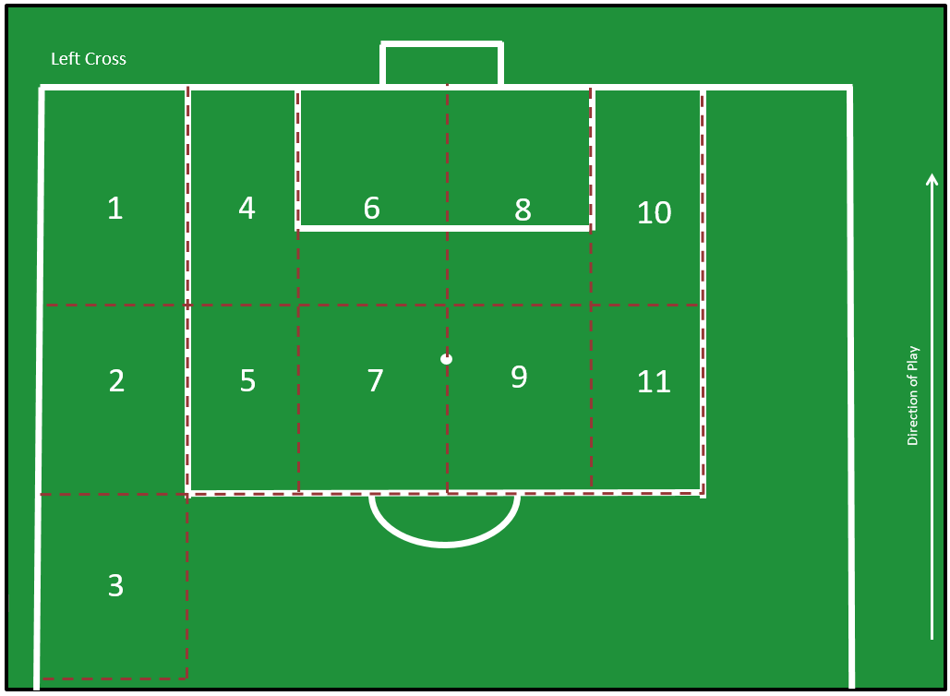

**Figure 1a.** Zonal analysis for crosses delivered from the left side of the pitch.

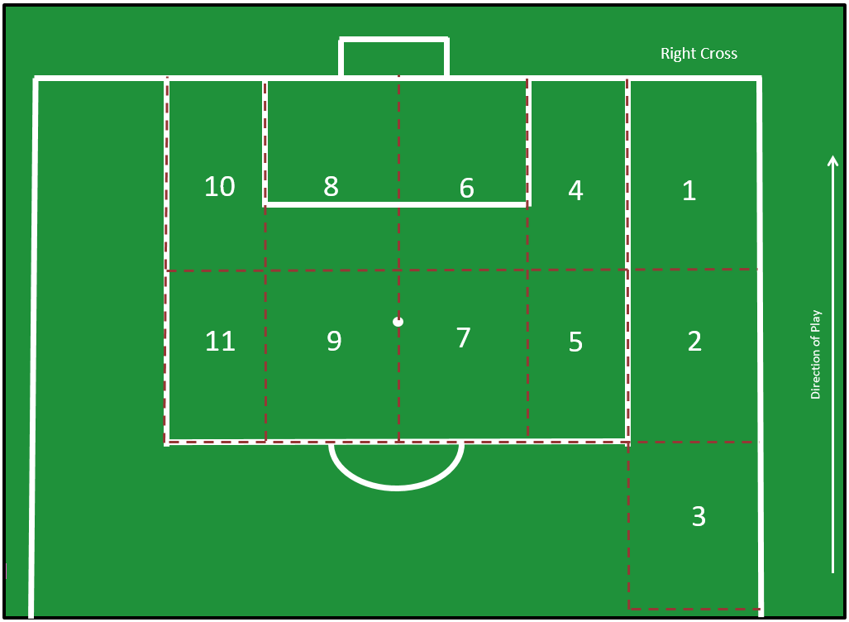

**Figure 1b.** Zonal analysis for crosses delivered from the right side of the pitch.

## 2.2. Procedure

Prior to completion of the main data collection a pilot study was conducted. A total of 59 crosses into the 18-yard box from two English Premier League soccer matches during the 2013/14 season were observed. The pilot study was used to validate the zones for the crosser and the zones for the cross outcomes, as well as enable the researchers to perform a functional assessment of the data collection system (O’Donoghue, Holmes & Robinson, 2018). Following the pilot study the zonal analysis undertaken was felt to represent a sensible compromise between precision and accuracy.

To facilitate a detailed depth of analysis, the following variables for each cross were recorded: (1) the pitch side of the delivery; (2) the delivery type; (3) the amount of defensive pressure being applied to the crosser; (4) the zone of the crosser (see Figures 1a and 1b); (5) the zone of the outcome of the cross (see Figures 1a and 1b); (6) the match time as the cross was delivered; (7) the outcome of the cross. Each of the variables was assigned a stringent operational definition, and where possible, cross-validated with the extant research (see Table 1). All of the events were notated using a bespoke data validated workbook within Microsoft Excel (Microsoft Corporation, Excel 2010, Redmond, WA).

**Table 1.** Operational definitions of the variables.

|  |  |
| --- | --- |
| **Variable** | **Operational definition** |
| **Pitch side of delivery** |  |
| Right | The cross was delivered from the right side of the pitch. |
| Left | The cross was delivered from the left side of the pitch. |
| **Delivery type** |  |
| Outswinger | The ball was kicked and moved in a curve away from the goal. |
| Inswinger | The ball was kicked and moved in a curve towards the goal. |
| Straight | The ball was kicked with no curve. |
| **Defensive pressure applied to the crosser (adapted from Tenga, 2010)** |  |
| Low | There is no defensive player within five metres of the crosser. |
| Medium | The defender is between one and a half metres and five metres away from the crosser. |
| High | The defender is zero metres to one and a half metres away from the crosser. |
| **Time of the cross**  **(Casal, Andujar, Losada, Arda & Maneiro, 2016)** |  |
| 0-15 minutes | The cross was taken within 0-15 minutes of the match time. |
| 16-30 minutes | The cross was taken within 16-30 minutes of the match time. |
| 31 minutes – half time | The cross was taken within 31 minutes – half time. |
| 46-60 minutes | The cross was taken within 46-60 minutes of the match time. |
| 61-75 minutes | The cross was taken within 61-75 minutes of the match time. |
| 76 minutes – full time | The cross was taken within 76 minutes – full time. |
| First period of extra time | The cross was taken within the first period of extra time. |
| Second period of extra time | The cross was taken within the second period of extra time. |
| **Cross outcome (taken or adapted from Pulling *et al,*. 2013; Pulling, 2015).** |  |
| Goal | The ball went over the goal-line and into the net after an attacking player touched it. The referee awarded a goal. |
| Own goal | The ball went over the goal-line and into the net after a defensive player touched it. The referee awarded a goal. |
| Attempt on target excluding goals | Any goal attempt that was heading towards the goal that was saved by the goalkeeper or blocked by a defensive player. |
| Attempt off target | Any attempt by the attacking team that was not directed within the dimensions of the goal. An attempt that made contact with the crossbar or either of the posts was classified as an attempt off target. |
| Penalty | A player on the defending team committed a foul and the referee awarded a penalty. |
| Ball recycled out of the 18 yard box | The attacking team made contact with the ball, which led to the ball exiting the 18-yard box and possession being retained by the attacking team. |
| Defensive clearance – corner | A defensive player made contact with the ball and the referee awarded a corner kick. |
| Defensive clearance – throw in | A defensive player made contact with the ball and the referee awarded a throw in. |
| Defensive clearance | A defensive player made contact with the ball and it exited the 18-yard box. |
| No contact in the 18-yard box | The ball was not touched by any other player and the ball exited the 18-yard box (includes goal kicks). |
| Goalkeeper gathers the ball | The goalkeeper comes and gathers/collects the ball (e.g. the cross bounces on the floor and then the goalkeeper collects the ball). |
| Goalkeeper catch | The goalkeeper gained possession of the ball by catching a cross. |
| Goalkeeper punch | The goalkeeper made contact with the ball by using a punching action. |

## 2.3. Reliability

Both inter-observer and intra-observer reliability tests were conducted. For the inter-observer reliability test, an analyst with over five years’ experience of analysing soccer observed 134 crosses (10.1% of the overall sample). One week prior to analysing the crosses, the analyst was given the operational definitions and access to the Excel workbook used for the data collection. The intra-observer reliability analysis was carried out four weeks after the initial analysis in an attempt to reduce intervening learning effects (O’Donoghue, 2015). The intra-observer reliability analysis was conducted by the initial observer analysing 134 crosses (10.1%) from the original sample. The kappa statistic was employed to evaluate both inter-observer and intra-observer reliability for all variables. According to the classification system proposed by McHugh (2012), the strength of agreement ranged from moderate (0.61) to perfect (1) agreement. Furthermore, 79% of the reliability values had at least a strong level of agreement.

**Table 2.** Reliability tests and Kappa statistics.

|  |  |  |
| --- | --- | --- |
| Variable | Intra-observer  Kappa Value | Inter-observer  Kappa Value |
| Pitch side of delivery | 0.99 | 0.94 |
| Delivery type | 0.85 | 0.61 |
| Defensive pressure applied to the crosser | 0.89 | 0.67 |
| Zone of the crosser | 0.96 | 0.90 |
| Zone of the outcome | 0.93 | 0.77 |
| Time of the cross | 1 | 1 |
| Cross outcome | 0.91 | 0.80 |

## 2.4. Data Analysis

Absolute frequencies and relative percentage occurrence were calculated for all of the crossing variables investigated. Prior to the statistical analysis, the main outcome variables for the cross (goal, own goal etc.) were collapsed into four outcome categories. This approach was undertaken to satisfy the assumptions underpinning the use of the chi-square test (see Field, 2018). The four outcome categories were as follows: 1. Goal scoring attempts (goal, own goal, attempt on target excluding goals and, attempt off target); 2. Attacking outcomes (penalty, ball recycled out of the 18-yard box, defensive clearance – corner, and defensive clearance – throw in); 3. Defensive outcomes (defensive clearance and no contact in the 18 yard box); and 4. Goalkeeper actions (goalkeeper gathers the ball, goalkeeper catch, and goalkeeper punch). Chi-square tests of association were completed to examine the association between each variable (e.g. delivery type) and each outcome category (e.g. goal scoring attempts). The alpha level was set at p < 0.05. When examining the association between the zone of the cross and outcome, only crosses that had an outcome within the 18-yard box were included. Specifically, all crosses that were defined as having no contact in the 18-yard box were removed from the chi-squared tests of association as these all led to a defensive outcome, and would arguably skew the data set and impact upon the resultant findings.

The results from the chi-square tests of association were utilised to conduct a log linear analysis for the outcome categories of goal scoring attempts, attacking outcomes and defensive outcomes. A log linear analysis is a multivariate method of modelling associations in categorical data (Calder & Sapsford, 2006). The log-linear analysis procedure aims to fit the natural logarithm of cell frequencies via a series of iterations consisting of main effects and interactions between the categorical variables (Norusis, 2011). Ideally, the log linear analyses would be conducted prior to the chi-square testing, however, due to such a large number of variables within the current study it was vital to only include the most significant variables from the chi square tests of association so that an appropriate model could be developed for exploring the interactions between the variables. The variables utilised for each log linear analysis were as follows: 1. Goal scoring attempts analysis included defensive pressure and the zone of the outcome; 2. Attacking outcomes analysis included the zone of the crosser and the zone of the outcome; and 3. Defensive outcomes analysis included the zone of the crosser and the zone of the outcome. The data for zone 5 for the zone of the crosser was collapsed into zone 4 of the crosser and the data for zone 11 for the zone of the outcome of the cross was collapsed into zone 10. This was conducted to meet the assumptions for the use of a log linear analysis, specifically the assumption that all cells must have expected frequencies of greater than one (Field, 2018). A stepwise backward elimination method was utilised for the log linear analyses (Field, 2018).

# 3. Results

## 3.1. Overview

The frequency data and resultant percentage occurrence for each crossing variable is presented in Table 3. From the 1332 crosses that were analysed a total of 42 goals (3.2%) and 1 own goal (0.1%) were scored. There were 56 attempts on target that did not lead to a goal (4.2%) and 80 attempts off target (6.0%). The most common outcome to occur following a cross was a defensive clearance that exited the 18-yard box, which happened on 493 occasions (37.0%). An outswinging cross was the predominant delivery type for crossing the ball (77.8%), followed by the inswinger (13.4%) and a straight delivery (8.9%). The crosser was mostly under medium defensive pressure (48.0%) or high defensive pressure (42.9%) when delivering the cross. Crosses were mostly performed from zones two (28.8%) and three (28.6%). The data for zone of the cross as a function of side of delivery is presented in Figures 2 and 3. Zone six had the highest number of outcomes (23.8%) and this was closely followed by zone seven (20.7%).

**Table 3.** Absolute frequencies and percentage occurrence for each crossing variable.

|  |  |  |
| --- | --- | --- |
| Variable | Variable detail | Frequency (%) |
| Pitch side of delivery | Right | 716 (53.8) |
|  | Left | 616 (46.2) |
| Delivery type | Outswinger | 1036 (77.8) |
|  | Inswinger | 178 (13.4) |
|  | Straight | 118 (8.9) |
| Defensive pressure | Low | 121 (9.1) |
|  | Medium | 639 (48.0) |
|  | High | 572 (42.9) |
| Zone of the crosser | One | 285 (21.4) |
|  | Two | 383 (28.8) |
|  | Three | 381 (28.6) |
|  | Four | 180 (13.5) |
|  | Five | 103 (7.7) |
| Zone of the outcome | Four | 111 (8.3) |
|  | Five | 80 (6.0) |
|  | Six | 317 (23.8) |
|  | Seven | 276 (20.7) |
|  | Eight | 173 (13.0) |
|  | Nine | 123 (9.2) |
|  | Ten | 49 (3.7) |
|  | Eleven | 26 (2.0) |
|  | No zone (e.g. there was no contact with the ball in the 18-yard box) | 177 (13.3) |
| Time | 0-15 minutes | 171 (12.8) |
|  | 16-30 minutes | 174 (13.1) |
|  | 31 minutes-half time | 202 (15.2) |
|  | 46-60 minutes | 236 (17.7) |
|  | 61-75 minutes | 220 (16.5) |
|  | 76 minutes-full time | 278 (20.9) |
|  | First period of extra time | 17 (1.3) |
|  | Second period of extra time | 34 (2.6) |
| Outcome | Goal | 42 (3.2) |
|  | Own goal | 1 (0.1) |
|  | Attempt on target excluding goals | 56 (4.2) |
|  | Attempt off target | 80 (6.0) |
|  | Penalty | 2 (0.2) |
|  | Ball recycled out of the 18-yard box | 111 (8.3) |
|  | Defensive clearance – corner | 151 (11.3) |
|  | Defensive clearance – throw in | 39 (2.9) |
|  | Defensive clearance | 493 (37.0) |
|  | No contact in the 18-yard box | 177 (13.3) |
|  | Goalkeeper gathers the ball | 66 (5.0) |
|  | Goalkeeper catch | 90 (6.8) |
|  | Goalkeeper punch | 24 (1.8) |

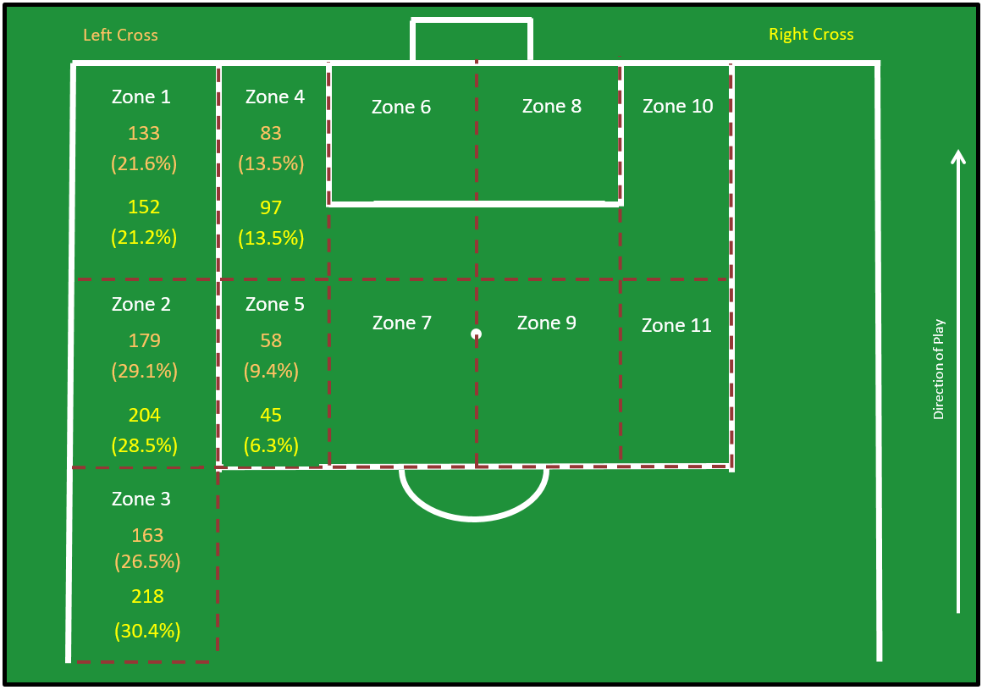

**Figure 2.** Origin of cross (frequency and (%)).

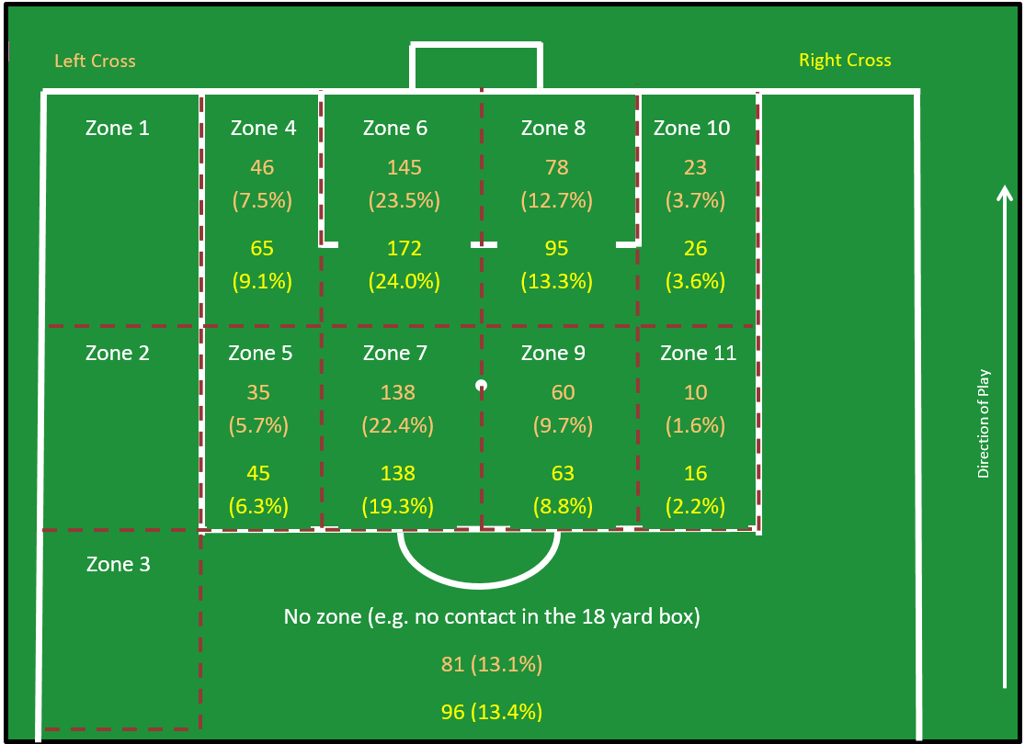

**Figure 3.** Destination of cross (frequency and (%)).

## 3.2. Goal scoring attempts

The three-way log linear analysis produced a final model that included two two-way associations (defensive pressure*zone of the outcome and zone of the outcome*goal scoring attempt). The model had a likelihood ratio of ᵡ212 = 14.539, p = 0.268. The zone of the outcome (ᵡ2 = 45.97, p = <0.001, V = 0.199) and defensive pressure (ᵡ2 = 6.16, p = 0.05, V = 0.068) were significantly associated with achieving a goal scoring attempt from a cross. Crosses resulted more frequently in a goal scoring attempt when the zone of the outcome was zone eight (27.2% of crosses where the main outcome was in zone eight were a goal scoring attempt) and when the crosser was under low defensive pressure (19.8% of crosses when the crosser was under low defensive pressure led to a goal scoring attempt) (Table 4).

Outswinging crosses had the highest percentage of goal scoring attempts (14.2%) compared to inswinging crosses (11.8%) and straight crosses (9.3%). Crosses from zone five had the largest percentage of attempts at goal (15.5%) compared to the other zones; zone four (13.9%); zone three (13.6%); zone two (13.1%); and zone one (12.6%). Crosses during the first period and second period of extra time were more likely to lead to a goal scoring attempt (23.5% and 26.5% respectively) than any period during normal time (the next highest percentage was 14.4% for crosses delivered between 46-60 minutes) (Table 4).

**Table 4.** Experimental and descriptive statistics for goal scoring attempts.

|  |  |  |  |  |  |  |  |  |
| --- | --- | --- | --- | --- | --- | --- | --- | --- |
| Variable | Variable detail | Yes (%) | No (%) | ᵡ2 | Sig. | Cramer’s V | SR - Attempt | SR – No attempt |
| Pitch side of delivery | Right | 98 (13.7) | 618 (86.3) |  |  |  | - | - |
|  | Left | 81 (13.1) | 535 (86.9) | 0.08 | 0.77 | - | - | - |
| Delivery type | Outswinger | 147(14.2) | 889 (85.8) |  |  |  | - | - |
|  | Inswinger | 21 (11.8) | 157 (88.2) |  |  |  | - | - |
|  | Straight | 11 (9.3) | 107 (90.7) | 2.63 | 0.27 | - | - | - |
| Defensive pressure | Low | 24 (19.8) | 97 (80.2) |  |  |  | 1.9 | -0.8 |
|  | Medium | 89 (13.9) | 550 (86.1) |  |  |  | 0.3 | -0.1 |
|  | High | 66 (11.5) | 506 (88.5) | 6.16 | 0.05 | 0.068 | -1.2 | 0.5 |
| Zone of the crosser | One | 36 (12.6) | 249 (87.4) |  |  |  | - | - |
|  | Two | 50 (13.1) | 333 (86.9) |  |  |  | - | - |
|  | Three | 52 (13.6) | 329 (86.4) |  |  |  | - | - |
|  | Four | 25 (13.9) | 155 (86.1) |  |  |  | - | - |
|  | Five | 16 (15.5) | 87 (84.5) | 0.64 | 0.96 | - | - | - |
| Zone of the outcome | Four | 5 (4.5) | 106 (95.5) |  |  |  | -2.9 | 1.3 |
|  | Five | 4 (5.0) | 76 (95.0) |  |  |  | -2.4 | 1.0 |
|  | Six | 38 (12.0) | 279 (88.0) |  |  |  | -1.6 | 0.7 |
|  | Seven | 44 (15.9) | 232 (84.1) |  |  |  | 0.2 | -0.1 |
|  | Eight | 47 (27.2) | 126 (72.8) |  |  |  | 3.9 | -1.7 |
|  | Nine | 28 (22.8) | 95 (77.2) |  |  |  | 2.0 | -0.9 |
|  | Ten | 11 (22.4) | 38 (77.6) |  |  |  | 1.2 | -0.5 |
|  | Eleven | 2 (7.7) | 24 (92.3) | 45.97 | <0.001 | 0.199 | -1.0 | 1.1 |
| Time | 0-15 minutes | 18 (10.5) | 153 (89.5) |  |  |  | - | - |
|  | 16-30 minutes | 23 (13.2) | 151 (86.8) |  |  |  | - | - |
|  | 31 minutes-half time | 22 (10.9) | 180 (89.1) |  |  |  | - | - |
|  | 46-60 minutes | 34 (14.4) | 202 (85.6) |  |  |  | - | - |
|  | 61-75 minutes | 30 (13.6) | 190 (86.4) |  |  |  | - | - |
|  | 76 minutes-full time | 39 (14.0) | 239 (86.0) |  |  |  | - | - |
|  | First period of extra time | 4 (23.5) | 13 (76.5) |  |  |  | - | - |
|  | Second period of extra time | 9 (26.5) | 25 (73.5) | 9.11 | 0.25 | - | - | - |

## 3.3. Attacking outcomes

The three-way log linear analysis produced a final model that retained all effects. The model had a likelihood ratio of ᵡ20 = 0, p = 1. This indicated that the highest order interaction (zone of the crosser*zone of the outcome*attacking outcome) was significant, ᵡ215 = 25.32, p = 0.046. The following variables were significantly associated with an attacking outcome produced from a cross: zone of the crosser (ᵡ2 = 47.98, p = <0.001, V *=* 0.186), zone of the outcome (ᵡ2 = 67.70, p = <0.001, V =0.242), delivery type (ᵡ2 = 12.99, p = 0.002, V *=* 0.099) and defensive pressure (ᵡ2 = 7.38, p = 0.025, V *=* 0.074). Crosses resulting in an attacking outcome were more frequently observed when the cross was taken from zone four (40.6% of crosses from zone four led to an attacking outcome), the zone of outcome was zone four (52.3% of crosses where the main outcome was in zone four were an attacking outcome), delivery type was an outswinger (24.8% of outswingers led to an attacking outcome), and the defensive pressure was high (25.9% of crosses where the defensive pressure was high resulted in an attacking outcome) (Table 5).

**Table 5.** Experimental and descriptive statistics for attacking outcomes.

|  |  |  |  |  |  |  |  |  |
| --- | --- | --- | --- | --- | --- | --- | --- | --- |
| Variable | Variable detail | Yes (%) | No (%) | ᵡ2 | Sig. | Cramer’s V | SR – Attacking outcome | SR – No attacking outcome |
| Pitch side of delivery | Right | 165 (23.0) | 551 (77.0) |  |  |  | - | - |
|  | Left | 138 (22.4) | 478 (77.6) | 0.08 | 0.78 | - | - | - |
| Delivery type | Outswinger | 257 (24.8) | 779 (75.2) |  |  |  | 1.4 | -0.8 |
|  | Inswinger | 23 (12.9) | 155 (87.1) |  |  |  | -2.7 | 1.5 |
|  | Straight | 23 (19.5) | 95 (80.5) | 12.99 | 0.002 | 0.099 | -0.7 | 0.4 |
| Defensive pressure | Low | 19 (15.7) | 102 (84.3) |  |  |  | -1.6 | 0.9 |
|  | Medium | 136 (21.3) | 503 (78.7) |  |  |  | -0.8 | 0.4 |
|  | High | 148 (25.9) | 424 (74.1) | 7.38 | 0.025 | 0.074 | 1.6 | -0.9 |
| Zone of the crosser | One | 69 (24.2) | 216 (75.8) |  |  |  | 0.5 | -0.3 |
|  | Two | 74 (19.3) | 309 (80.7) |  |  |  | -1.4 | 0.8 |
|  | Three | 59 (15.5) | 322 (84.5) |  |  |  | -3.0 | 1.6 |
|  | Four | 73 (40.6) | 107 (59.4) |  |  |  | 5.0 | -2.7 |
|  | Five | 28 (27.2) | 75 (72.8) | 47.98 | <0.001 | 0.190 | 0.9 | -0.5 |
| Zone of the outcome | Four | 58 (52.3) | 53 (47.7) |  |  |  | 5.4 | -3.2 |
|  | Five | 24 (30.0) | 56 (70.0) |  |  |  | 0.7 | -0.4 |
|  | Six | 76 (24.0) | 241 (76.0) |  |  |  | -0.8 | 0.5 |
|  | Seven | 54 (19.6) | 222 (80.4) |  |  |  | -2.2 | 1.3 |
|  | Eight | 36 (20.8) | 137 (79.2) |  |  |  | -1.4 | 0.8 |
|  | Nine | 22 (17.9) | 101 (82.1) |  |  |  | -1.8 | 1.1 |
|  | Ten | 24 (49.0) | 25 (51.0) |  |  |  | 3.1 | -1.9 |
|  | Eleven | 9 (34.6) | 17 (65.4) | 67.70 | <0.001 | 0.242 | 0.8 | -0.5 |
| Time | 0-15 minutes | 33 (19.3) | 138 (80.7) |  |  |  | - | - |
|  | 16-30 minutes | 46 (26.4) | 128 (73.6) |  |  |  | - | - |
|  | 31 minutes-half time | 43 (21.3) | 159 (78.7) |  |  |  | - | - |
|  | 46-60 minutes | 51 (21.6) | 185 (78.4) |  |  |  | - | - |
|  | 61-75 minutes | 49 (22.3) | 171 (77.7) |  |  |  | - | - |
|  | 76 minutes-full time | 73 (26.3) | 205 (73.7) |  |  |  | - | - |
|  | First period of extra time | 2 (11.8) | 15 (88.2) |  |  |  | - | - |
|  | Second period of extra time | 6 (17.6) | 28 (82.4) | 6.57 | 0.48 | - | - | - |

## 3.4. Defensive outcomes

The three-way log linear analysis produced a final model that retained all effects. The model had a likelihood ratio of ᵡ20 = 0, p = 1. This indicated that the highest order interaction (zone of the crosser*zone of the outcome*defensive outcome) was significant, ᵡ215 = 25.32, p = 0.046. The zone of the crosser (ᵡ2 = 16.59, p = 0.002, V *=* 0.112), zone of the outcome (ᵡ2 = 120.93, p = <0.001, V =0.324) and delivery type (ᵡ2 = 10.33, p = 0.006, V = 0.088) were significantly associated with a cross leading to a defensive outcome. Crosses resulted more frequently in a defensive outcome when the cross was delivered from zone three (55.6% of crosses from zone three led to a defensive outcome), when the zone of the outcome was zone seven (62.3% of crosses where the main outcome was in zone seven were a defensive outcome), and the delivery type was straight (60.2% of straight crosses led to a defensive outcome) (Table 6). The amount of defensive pressure appeared to only have a minimal impact on defensive outcomes. When the defensive pressure was low, 52.9% of crosses led to a defensive outcome, this was only slightly higher than when the crosser experienced medium defensive pressure (49.8%) or high defensive pressure (50.3%) (Table 6).

**Table 6.** Experimental and descriptive statistics for defensive outcomes.

|  |  |  |  |  |  |  |  |  |
| --- | --- | --- | --- | --- | --- | --- | --- | --- |
| Variable | Variable detail | Yes (%) | No (%) | ᵡ2 | Sig. | Cramer’s V | SR – Defending outcome | SR – No defending outcome |
| Pitch side of delivery | Right | 355 (49.6) | 361 (50.4) |  |  |  | - | - |
|  | Left | 315 (51.1) | 301 (48.9) | 0.32 | 0.57 | - | - | - |
| Delivery type | Outswinger | 497 (48.0) | 539 (52.0) |  |  |  | -1.1 | 1.1 |
|  | Inswinger | 102 (57.3) | 76 (42.7) |  |  |  | 1.3 | -1.3 |
|  | Straight | 71 (60.2) | 47 (39.8) | 10.33 | 0.006 | 0.088 | 1.5 | -1.5 |
| Defensive pressure | Low | 64 (52.9) | 57 (47.1) |  |  |  | - | - |
|  | Medium | 318 (49.8) | 321 (50.2) |  |  |  | - | - |
|  | High | 288 (50.3) | 284 (49.7) | 0.39 | 0.81 | - | - | - |
| Zone of the crosser | One | 141 (49.5) | 144 (50.5) |  |  |  | -0.2 | 0.2 |
|  | Two | 200 (52.2) | 183 (47.8) |  |  |  | 0.5 | -0.5 |
|  | Three | 212 (55.6) | 169 (44.4) |  |  |  | 1.5 | -1.5 |
|  | Four | 68 (37.8) | 112 (62.2) |  |  |  | -2.4 | 2.4 |
|  | Five | 49 (47.6) | 54 (52.4) | 16.59 | 0.002 | 0.112 | -0.4 | 0.4 |
| Zone of the outcome | Four | 45 (40.5) | 66 (59.5) |  |  |  | -0.3 | 0.3 |
|  | Five | 47 (58.8) | 33 (41.3) |  |  |  | 2.2 | -1.9 |
|  | Six | 98 (30.9) | 219 (69.1) |  |  |  | -3.2 | 2.8 |
|  | Seven | 172 (62.3) | 104 (37.7) |  |  |  | 5.0 | -4.3 |
|  | Eight | 36 (20.8) | 137 (79.2) |  |  |  | -4.4 | 3.8 |
|  | Nine | 68 (55.3) | 55 (44.7) |  |  |  | 2.1 | -1.8 |
|  | Ten | 12 (24.5) | 37 (75.5) |  |  |  | -1.9 | 1.7 |
|  | Eleven | 15 (57.7) | 11 (42.3) | 120.93 | <0.001 | 0.324 | 1.2 | -1.0 |
| Time | 0-15 minutes | 91 (53.2) | 80 (46.8) |  |  |  | - | - |
|  | 16-30 minutes | 84 (48.3) | 90 (51.7) |  |  |  | - | - |
|  | 31 minutes-half time | 107 (53.0) | 95 (47.0) |  |  |  | - | - |
|  | 46-60 minutes | 119 (50.4) | 117 (49.6) |  |  |  | - | - |
|  | 61-75 minutes | 113 (51.4) | 107 (48.6) |  |  |  | - | - |
|  | 76 minutes-full time | 134 (48.2) | 144 (51.8) |  |  |  | - | - |
|  | First period of extra time | 10 (58.8) | 7 (41.2) |  |  |  | - | - |
|  | Second period of extra time | 12 (35.3) | 22 (64.7) | 5.59 | 0.59 | - | - | - |

## 3.5. Goalkeeper actions

The zone of the outcome (ᵡ2 = 185.41, p = <0.001, V *=* 0.401) was the only variable that was significantly associated with a cross resulting in a goalkeeper action. Crosses resulting in a goalkeeper action were more frequently observed when the zone of the outcome was zone six (33.1%) (Table 7).

Inswinging crosses (18.0%) were more likely to lead to a goalkeeper action than compared to outswinging crosses (13.0%) and straight crosses (11.0%). Crosses delivered from zones two (15.4%) and three (15.2%) were more likely to lead to a goalkeeper action than when crosses were taken from zone one (13.7%), zone four (7.8%) and zone five (9.7%). A goalkeeper action was more commonly observed when the crosser was under medium defensive pressure (15.0%) than when the crosser was under low defensive pressure (11.6%) or high defensive pressure (12.2%) (Table 7).

**Table 7.** Experimental and descriptive statistics for goalkeeper actions.

|  |  |  |  |  |  |  |  |  |
| --- | --- | --- | --- | --- | --- | --- | --- | --- |
| Variable | Variable detail | % Yes | % No | ᵡ2 | Sig. | Cramer’s V | SR – Goalkeeper outcome | SR – No goalkeeper outcome |
| Pitch side of delivery | Right | 98 (13.7) | 618 (86.3) |  |  |  | - | - |
|  | Left | 82 (13.3) | 534 (86.7) | 0.04 | 0.84 | - | - | - |
| Delivery type | Outswinger | 135 (13.0) | 901 (87.0) |  |  |  | - | - |
|  | Inswinger | 32 (18.0) | 146 (82.0) |  |  |  | - | - |
|  | Straight | 13 (11.0) | 105 (89.0) | 3.87 | 0.14 | - | - | - |
| Defensive pressure | Low | 14 (11.6) | 107 (88.4) |  |  |  | - | - |
|  | Medium | 96 (15.0) | 543 (85.0) |  |  |  | - | - |
|  | High | 70 (12.2) | 502 (87.8) | 2.43 | 0.30 | - | - | - |
| Zone of the crosser | One | 39 (13.7) | 246 (86.3) |  |  |  | - | - |
|  | Two | 59 (15.4) | 324 (84.6) |  |  |  | - | - |
|  | Three | 58 (15.2) | 323 (84.8) |  |  |  | - | - |
|  | Four | 14 (7.8) | 166 (92.2) |  |  |  | - | - |
|  | Five | 10 (9.7) | 93 (90.3) | 8.48 | 0.08 | - | - | - |
| Zone of the outcome | Four | 3 (2.7) | 108 (97.3) |  |  |  | -3.4 | 1.5 |
|  | Five | 5 (6.3) | 75 (93.8) |  |  |  | -2.1 | 0.9 |
|  | Six | 105 (33.1) | 212 (66.9) |  |  |  | 7.9 | -3.4 |
|  | Seven | 6 (2.2) | 270 (97.8) |  |  |  | -5.6 | 2.4 |
|  | Eight | 54 (31.2) | 119 (68.8) |  |  |  | 5.2 | -2.2 |
|  | Nine | 5 (4.1) | 118 (95.9) |  |  |  | -3.2 | 1.4 |
|  | Ten | 2 (4.1) | 47 (95.9) |  |  |  | -2.0 | 0.9 |
|  | Eleven | 0 (0) | 26 (100) | 185.41 | <0.001 | 0.401 | -2.0 | 0.9 |
| Time | 0-15 minutes | 29 (17.0) | 142 (83.0) |  |  |  | - | - |
|  | 16-30 minutes | 21 (12.1) | 153 (87.9) |  |  |  | - | - |
|  | 31 minutes-half time | 30 (14.9) | 172 (85.1) |  |  |  | - | - |
|  | 46-60 minutes | 32 (13.6) | 204 (86.4) |  |  |  | - | - |
|  | 61-75 minutes | 28 (12.7) | 192 (87.3) |  |  |  | - | - |
|  | 76 minutes-full time | 32 (11.5) | 246 (88.5) |  |  |  | - | - |
|  | First period of extra time | 1 (5.9) | 16 (94.1) |  |  |  | - | - |
|  | Second period of extra time | 7 (20.6) | 27 (79.4) | 5.73 | 0.57 | - | - | - |

# 4. Discussion

***4.1. Overview***

The aim of this study was to analyse open play crosses in the FIFA 2014 soccer World Cup. A total of 42 goals were scored (3.2%) from the 1332 open play crosses that were observed. This result is highly comparable to that reported by Partridge and Franks (1989a; b), who reported a total of 38 goals from 1427 crosses analysed (2.7%). Furthermore, this goal scoring percentage is very similar to previous research that has highlighted the goal scoring percentage from corner kicks (Pulling, Robins & Rixon, 2013; Pulling & Newton, 2017). Therefore, the evidence appears to suggest that crossing has a similar relative occurrence for goals as that of corner kicks.

Outswinging crosses were performed considerably more than any other type of cross (77.8% of the total crosses), which is perhaps to be expected because players on the right side of the pitch would predominantly use their right foot to cross the ball, and vice versa. This is in contrast to Partridge and Franks (1989a; b) who found that, although bent round (21.8%) had the highest occurrence, high lofted (19.6%), clipped (10.9%) and chipped (10.9%) deliveries were also used. This suggests that a more diversified crossing strategy may have historically been used in comparison to recent times. However, it should be noted that crosses were not classified as outswinging or inswinging by Partridge and Franks (1989a; b), which makes comparisons between studies challenging. Outswinging crosses may be favourable because: (i) increased speed can be imparted on the ball, in comparison to lofted or chipped deliveries, minimising the time for defenders and the goalkeeper to react and position themselves to intercept the ball, and, (ii) the ball will be swinging away from the goalkeeper towards approaching attacking players, reducing the ease by which the goalkeeper can come to claim the cross. Finally, tactically this finding also suggests that coaches were mostly using ‘traditional’ wide midfielders and wingers rather than unorthodox/inverted wide midfielders and wingers (i.e. a right footed winger playing on the left side of the pitch and vice versa) (Erith & Curneen, 2016). It is also important to note that the defensive player applying pressure to a crosser could position themselves in a way that would channel the attacking player towards the side of the pitch rather than allowing them to come inside to central areas (Bangsbo & Peitersen, 2002). By preventing the attacker from moving into a central location, it will reduce passing options and playing space (Wein, 2004). This tactical behaviour from the defender would provide more opportunities for the crosser to perform an outswinger, if the attacking player was positioned on their dominant side of the pitch.

The most commonly observed defensive pressure applied to the crosser was medium pressure (48.0% of the total crosses), closely followed by high pressure (42.9% of the total crosses). Only 9.1% of the total crosses were performed under low pressure. A key coaching implication of this is that when players are practicing their open play crosses they should be experiencing a medium to high amount of defensive pressure so that it replicates the situations that predominantly occur within a competitive match (Fernandez-Navarro, Fradua, Zubillaga, Ford, & McRobert, 2016).

***4.2. Goal scoring attempts***

The three-way log linear analysis produced a final model that included two two-way associations (defensive pressure*zone of the outcome and zone of the outcome*goal scoring attempt). The model had a likelihood ratio of ᵡ212 = 14.539, p = 0.268. The zone of the outcome (ᵡ2 = 45.97, p < 0.001, V *=* 0.199) was significantly associated with achieving a goal-scoring attempt from a cross. Zone eight provided the highest percentage of goal scoring attempts (27.2%). Commensurate with the suggestions of Yamada and Hayashi (2015), zone eight could be considered a critical or prime target area, leading to an increased chance of converting a goal-scoring attempt. However, in light of differences between the current study and that of Yamada and Hayashi (2015) with regards to destination of cross, further research is required to substantiate this statement. However, only 13% of the total crosses had the main outcome in zone eight. The areas that had the highest frequency of outcomes, zones six and seven, had much lower percentages of goal scoring attempts, 12.0% and 15.9% respectively. Previous coaching literature has highlighted that defenders have difficulty in dealing with crosses that are delivered to areas beyond the mid goal area (zone eight) (Hughes, 1996). In these situations, the defenders may be travelling backwards, be unable to see approaching attacking players located behind them, and be unable to generate sufficient momentum to jump to compete/challenge for the ball. Defending players will therefore, ultimately, find it difficult to compete against an attacker who is running in to meet the cross (Hughes, 1996). Hawkins and Robinson (2016) also state that attacking teams will pressure the defence onto one side of the pitch by running most of its attackers and midfielders to one side, leaving a player on the opposite side with more space. Essentially, the attacking team have created a strong side overload and then they will cross the ball quickly to the opposite side (into areas such as zone eight) (Hawkins & Robinson, 2016). It appears that this central to rear post area that is 0-9 yards from the goal-line (zone eight) may be slightly under-utilised by attacking teams that were analysed for this current study. Therefore, this could offer important training implications whereby attacking players could target this zone and supporting players could perform runs or decoy runs to facilitate positive outcomes in this area.

Defensive pressure (ᵡ2 = 6.16, p = 0.05, V *=* 0.068) was significantly associated with achieving a goal scoring attempt from a cross. The percentage of goal attempts was considerably higher when the crosser was under low defensive pressure (19.8%) compared to medium pressure (13.9%) and high pressure (11.5%). High pressure is an advantageous strategy to delay the attacker, enabling the defensive team to become organised and balanced (Tenga, 2010; Erith & Curneen, 2016). Adopting high defensive pressure may also impact delivery quality by forcing the crosser to adjust the intended trajectory of the cross. This implies that the role of the defensive player in applying pressure could be very important and that coaches may need to consider coaching the appropriate distances of defensive pressure in training scenarios that involve open play crosses. From an attacking perspective, strategies should also be developed to facilitate crosses under low defensive pressure. Creating underlaps, overlaps and ensuring sufficient passing options (see Lago-Ballesteros *et al.*, 2012) may be crucial strategies to minimise pressure on the cross and optimise the delivery outcome.

## 4.3. Attacking outcomes

The three-way log linear analysis produced a final model that retained all effects. The model had a likelihood ratio of ᵡ20 = 0, p = 1. This indicated that the highest order interaction (zone of the crosser*zone of the outcome*attacking outcome) was significant, ᵡ215 = 25.32, p = 0.046. The following variables were significantly associated with an attacking outcome produced from a cross: zone of the crosser (ᵡ2 = 47.98, p < 0.001, V = 0.190), zone of the outcome (ᵡ2 = 67.70, p < 0.001, V *=* 0.242), delivery type (ᵡ2 = 12.99, p = 0.002, V =0.099) and defensive pressure (ᵡ2 = 7.38, p = 0.025, V =0.074). The zone of the outcome appears to have the most influence on attacking outcomes, with outcomes in zones four and ten leading to a much greater percentage of attacking outcomes compared to the other zones. These zones are positioned 0-9 yards from the goal-line and in front of the near post area (zone four) or beyond the rear post area (zone ten). A potential reason for this finding is that an attacking player may receive the ball in one of these zones and it is unlikely that they have an appropriate angle to create an attempt at goal (Pollard, Ensum & Taylor, 2004). This finding concurs with those of Yamada and Hayashi (2015) who observed that receiving players made runs towards the front of the goal. This may, in part, help to explain the percentage of crosses directed in front of the near post area for this particular outcome. Another explanation is that the player may choose to recycle possession with the purpose of generating a more favourable attacking position to generate a shooting opportunity. Alternatively, from a defensive perspective, the defender may contact the ball whilst under pressure and due to their close proximity to the goal-line remove the ball from the pitch for a corner kick (Widdows, 1989).

## 4.4. Defensive outcomes

The three-way log linear analysis produced a final model that retained all effects. The model had a likelihood ratio of ᵡ20 = 0, p = 1. This indicated that the highest order interaction (zone of the crosser*zone of the outcome*defensive outcome) was significant, ᵡ215 = 25.32, p = 0.046. The zone of the crosser (ᵡ2 = 16.59, p = 0.002, V = 0.112), zone of the outcome (ᵡ2 = 120.93, p < 0.001, V = 0.324), and delivery type (ᵡ2 = 10.33, p = 0.006, V = 0.088) were significantly associated with a cross leading to a defensive outcome. The zone of the outcome appears to have the most impact on the defensive outcomes. The zones that are positioned 0-9 yards from the goal-line had the lowest percentage of defensive outcomes (zone four – 40.5%; zone six = 30.9%; zone eight = 20.8%; zone ten = 24.5%), whilst the zones that are positioned 9.1-18 yards from the goal-line had the highest percentage of defensive outcomes (zone five = 58.8%; zone seven = 62.3%; zone nine = 55.3%; zone eleven = 57.7%). One obvious reason for this finding is that it will be easier to clear the ball out of the 18-yard box, without conceding a throw in or corner kick, if the defender is positioned closer to the edge of the 18-yard box (i.e. in zones five, seven, nine and eleven). Also, by keeping the ball in play it may create opportunities for the defending team to gain possession of the ball and create an attack (Wein, 2004), with counterattacks being an effective strategy to capitalise on a defence trying to transition. However, due to the large differences between these two groups of zones, it appears that coaches may need to reflect on how defenders can remove the ball successfully from the 18-yard box when they are defending relatively close to the goal-line (Hughes, 1996).

Crosses that were delivered from zone three had the highest percentage of defensive outcomes (55.6%). This zone is the furthest zone from the goal and therefore the ball is more likely to travel a greater distance and for a greater duration of time. This finding has implications for the defensive line adopted by the defending team. If the cross is being delivered from a deeper area (e.g. zone three), the players may consider adopting a higher defensive line to reduce the distance between the crosser and the defenders, which may enable them to clear the ball successfully. This tactic will also help to move the attackers who may receive the cross further away from goal; however, this will leave space in the area beyond the defensive line (Kim, Kwon & Li, 2011). Crosses resulted more frequently in a defensive outcome when the delivery type was straight (60.2%). A possible explanation for this is that defenders may find it easier to judge the flight and trajectory of a ball when it is travelling with no curve compared to a delivery where the ball may be swerving away from them (Hughes, 1996).

## 4.5. Goalkeeper actions

The zone of the outcome (ᵡ2 = 185.41, p < 0.001, V *=* 0.401) was the only variable that was significantly associated with a cross resulting in a goalkeeper action. Crosses resulting in a goalkeeper action were more frequently observed when the zone of the outcome was zone six (33.1%) and zone eight (31.2%). It is not surprising that these zones have a high percentage of goalkeeper actions as these areas are directly in front of the goal (Wilkinson, 1996; Welsh, 1999). Inswinging crosses were also the most prevalent for GK outcomes, presumably because the ball is angling towards the goalkeeper which makes the decision making process and the act of claiming the cross easier.

***4.6. Future research***

A number of variables have been considered within the current study when analysing the crosses at World Cup 2014, with the view to promote insight and a body of knowledge regarding crossing within Association Football, and to extend the very limited research in the area (e.g. Partridge and Franks, 1989a; b). However, there are still some variables which need to be explored in future studies. The formations (e.g. 3-5-2) and game style (see Hewitt, Greenham & Norton, 2016) of the attacking and defending teams will have a considerable influence on the opportunity to perform a cross as well as the outcome of a cross. Future research should explore the positioning of wide players (full backs, wide midfielders etc.) in different formations as this could provide insights into how crossing could be utilised more effectively to enhance the scoring potential of a team. Another consideration should be the number of defensive players and the number of attacking players that are positioned within the 18-yard box when the cross is delivered as these factors could influence the outcome of a corner kick. Also, the movement of these players prior to the delivery of cross could provide an interesting avenue for further research. The defensive line prior to a cross should be further investigated as this would provide a greater insight into defensive unit tactics when defending crosses (see Yamada & Hayashi, 2015). Within the current study, only the nearest defender was recorded for defensive pressure. However, on occasions more than one defensive player is applying pressure to the crosser, so the number of players applying pressure is a viable area for future studies. Finally, further analyses may seek to compare different competitions and the manner in which crosses are utilised. The World Cup is primarily a knock out competition and the tactics used could be different compared to league competitions (Mackenzie & Cushion, 2013).

# 5. Conclusion

The purpose of this study was to analyse open play crosses in the FIFA 2014 soccer World Cup. A total of 42 goals were scored (3.2%) from the 1332 open play crosses that were observed. The zone of the outcome and defensive pressure were significantly associated with achieving a goal scoring attempt from a cross. The delivery type, zone of the crosser and zone of the outcome were significantly associated with a defending outcome following a cross. Coaches should reflect on the variables that influence the different crossing outcomes and how they could design practices to represent crossing scenarios that are experienced during competitive games.

# References

Armatas, V., Yiannakos, A., & Sileloglou, P. (2007). Relationship between time and goal scoring in soccer games: analysis of three World Cups. *International Journal of Performance Analysis in Sport*, *7*(2), 48-58.

Bangsbo, J., & Peitersen, B. (2002). *Defensive soccer tactics: How to stop players and teams from scoring*. Champaign, Illinois: Human Kinetics.

Calder, J., & Sapsford, R. (2006). Statistical techniques. In R. Sapsford and V. Jupp (Eds.), *Data collection and analysis* (2nd edition) (pp.208-242). London: Sage.

Carling, C., & Court, M. (2013). Match and motion analysis. In A. M. Williams (Ed.), *Science and soccer: Developing elite performers* (pp.173-198). Abingdon: Routledge.

Casal, C.A., Manerio, R., Arda, T., Losada, J.L., Rial, A. (2015). Analysis of corner kick success in elite football. *International Journal of Performance Analysis in Sport, 15*(2), 430-451.

Casal, C. A., Andujar, M. A., Losada, J. L., Arda, T., & Maneiro, R. (2016). Identification of defensive performance factors in the 2010 FIFA World Cup South Africa. *Sports*, *4*, 54.

De Baranda, P.S., & Lopez-Riquelme, D. (2012). Analysis of corner kicks in relation to match status in the 2006 World Cup. *European Journal of Sports Science, 12*(2), 121-129.

Erith, S., & Curneen, G. (2016). Optimal preparation for defensive play. In T. Strudwick (Ed.), *Soccer Science* (pp. 459-482). Champaign, Illinois: Human Kinetics.

Fernandez-Navarro, J., Fradua, L., Zubillaga, A., Ford, P. R., McRobert, A. P. (2016). Attacking and defensive styles of play in soccer: analysis of Spanish and English elite teams. *Journal of Sports Sciences, 34*(24), 2195-2204.

Field, A. (2018). *Discovering Statistics Using IBM SPSS Statistics*. London: Sage.

Gonzalez-Rodenas, J., Lopez-Bondia, I., Calabuig, F., Perez-Turpin, J.A., & Aranda R. (2016). Association between playing tactics and creating scoring opportunities in counterattacks from United States Major League Soccer games. *International Journal of Performance Analysis in Sport,* *16*(2), 737-752.

Hargreaves, A., & Bate, R. (2010). *Skills and strategies for coaching soccer*. Champaign, Illinois: Human Kinetics.

Hawkins, R., & Robinson, D. (2016). Essential elements of attacking soccer. In T. Strudwick (Ed.), *Soccer Science* (pp. 503-528). Champaign, Illinois: Human Kinetics.

Hewitt, A., Greenham, G., & Norton, K. (2016). Game style in soccer: what is it and can we quantify it? *International Journal of Performance Analysis in Sport,* *16*(1), 355-372.

Hughes, C. (1996). *The Football Association Coaching Book of Soccer Tactics and Skills.* Harpenden: Queen Anne Press.

James, N., Mellalieu, S.D. & Hollely, C. (2002). Analysis of strategies in soccer as a function of European and domestic competition. *International Journal of Performance Analysis in Sport,* *2*(1), 85-103.

Jinshan, X., Xiaoke, C., Yamanaka, K., & Matsumoto, M. (1993). Analysis of the goals in the 14th World Cup. In T. Reilly (Ed.) *Science and Football II* (pp. 203-205). London: E & FN Spon.

Kim, H. C., Kwon, O., & Li, K. J. (2011). *Spatial and spatiotemporal analysis of soccer*. Proceedings of the 19th ACM SIGSSPATIAL International Conference on Advances in Geographic Information Systems.

Konstadinidou, X., & Tsigilis, N. (2005). Offensive playing profiles of football teams from the 1999 Women’s World Cup Finals. *International Journal of Performance Analysis in Sport,* *5*(1), 61-71.

Lago, C. (2009). The influence of match location, quality of opposition, and match status on possession strategies in professional association football. *Journal of Sports Sciences, 27*(13), 1463-1469.

Lago-Ballesteros, J., Lago-Penas, C., & Rey, E. (2012). The effect of playing tactics and situational variables on achieving score-box possessions in a professional soccer team. *Journal of Sports Sciences*, *30*(14), 1455-1461.

Mackenzie, R., & Cushion, C. (2013). Performance analysis in football: A critical review and implications for future research. *Journal of Sports Sciences*, *31*(6), 639-676.

Mara, J. K., Wheeler, K. W., & Lyons, K. (2012). Attacking strategies that lead to goal scoring opportunities in high level women’s football. *International Journal of Sports Science & Coaching*, *7*(3), 565-577.

McHugh, M.L. (2012). Interrater reliability: the kappa statistic. *Biochemia Medica, 22*(3), 276-282.

Michailidis, Y., Michailidis, C., & Primpa, E. (2013). Analysis of goals scored in European Championships 2012. *Journal of Human Sport & Exercise*, *8*(Proc2), 367-375.

Nesti, M., & Sulley, C. (2015). *Youth development in football: Lessons from the world’s best academies*. Abingdon: Routledge.

Norusis, M. J. (2011). *IBM SPSS Statistics 19 guide to data analysis: International edition*. London: Pearson.

O’Donoghue, P. (2015). *An introduction to performance analysis of sport*. Abingdon: Routledge.

O’Donoghue, P., Holmes, L., & Robinson, G. (2018). *Doing a research project in sports performance analysis*. Abingdon: Routledge.

Partridge, D. and Franks, I. M. (1989a) A detailed analysis of crossing opportunities in the 1986 World Cup Part I. *Soccer Journal*, May/June: 47-50.

Partridge, D. and Franks, I. M. (1989b) A detailed analysis of crossing opportunities in the 1986 World Cup Part II. *Soccer Journal*, June/July: 45-48.

Pollard, R., Ensum, J., & Taylor, S. (2004). Estimating the probability of a shot resulting in a goal: The effects of distance, angle and space. *International Journal of Soccer and Science, 2*(1), 50-66.

Pulling, C. (2015). Long corner kicks in the English Premier League: Deliveries into the goal area and critical area. *Kinesiology, 47*(2), 193-201.

Pulling, C., & Newton, J. (2017). Defending corner kicks in the English Premier League: near-post guard systems. *International Journal of Performance Analysis in Sport*, *17*(3), 283-292.

Pulling, C., Robins, M., & Rixon, T. (2013). Defending corner kicks: Analysis from the English Premier League*. International Journal of Performance Analysis in Sport*, *13*(1), 135-148.

Smith, R. A., & Lyons, K. (2017). A strategic analysis of goals scored in open play in four FIFA World Cup football championships between 2002 and 2014. *International Journal of Sports Science & Coaching*, *12*(3), 398-403.

Tabachnick, B. G., & Fidell, L. S. (2013). *Using multivariate statistics* (6th edition). Harlow, Essex: Pearson Education.

Taylor, J.B., Mellalieu, S.D., & James, N. (2004). Behavioural comparison of positional demands in professional soccer. *International Journal of Performance Analysis in Sport*, *4*(1), 81-97.

Taylor, J.B., Mellalieu, S.D., & James, N. (2005). A comparison of individual and unit tactical behaviour and team strategy in professional soccer. *International Journal of Performance Analysis in Sport*, *5*(2), 87-101.

Tenga, A. (2010). *Reliability and validity of match performance analysis in soccer: a multidimensional qualitative evaluation of opponent interaction*. PhD thesis, Norwegian School of Sports Sciences.

Tenga, A., Holme, I., Ronglan, L. T., & Bahr, R. (2010). Effect of playing tactics on goal scoring in Norwegian professional soccer. *Journal of Sports Sciences,* *28*(3), 237-244.

Wein, H. (2004). *Developing game intelligence in soccer*. Spring City, Pennsylvania: Reedswain.

Welsh, A. (1999). *The Soccer Goalkeeping Handbook: The Essential Guide for Players and Coaches.* Indianapolis, USA: Masters Press.

Widdows, R. (1988). *The Hamlyn Book of Football Techniques and Tactics*. London: Treasure Press.

Wilkinson, W. H. G. (1996). *Soccer Tactics: Top Team Strategies Explained.* Marlborough: Crowood.

Wright, C., Atkins, S., Polman, R., Jones, B., & Sargeson, L. (2011). Factors associated with goals and goal scoring opportunities in professional soccer. *International Journal of Performance Analysis In Sport*, *11*(3), 438-449.

Yamada, H., & Hayashi, Y. (2015). Characteristics of goal-scoring crosses in international soccer tournaments. *Football Science*, *12*, 24-32.

Yamanaka, K., Hughes, M., & Lott, M. (1993). Association football. In T. Reilly (Ed.) *Science and Football II* (pp. 206-214). London: E & FN Spon.