"Significant Walks" : Visualising Well-Being, Articulations of the Data and Experience of Chronic Low Back Pain

Authors Chubb, Shirley (1); Moore, Ann (2); Bryant, Neil (1); Saber-Sheikh, Kambiz (2)
Affiliations 1: University of Chichester, UK; 2: University of Brighton, UK

The "Significant Walks" project reveals the reality and positive impact of walking for individuals with chronic low back pain (LBP), a substantial but often invisible physical problem. Funded by the Wellcome Trust, the project brought together a collaborative research team of two visual artists, a musculoskeletal physiotherapy expert and a biomechanical engineer.
Objectives: The project involved working with twelve participants with non-specific, chronic LBP who were invited to identify a regular necessary, or recreational walk that could be used as a measure of their physical experience and capability.
Methodology: The research methodology records each walk by synthesizing point of view video documentation with simultaneously gathered biomechanical data collected via inertial sensors recording the movement of the participant’s spine. Additional layers of interpretation are added to the synthesized footage as the team worked with participants to explore personal narratives and how visual effects could further express the nature, challenge and reward of their chosen walk. The intensity of these effects was driven by the biomechanical data creating a sequence of films that are simultaneously qualitative and quantitative in the way that they interpret clinically accurate data whilst also expressing individual experience.
Results: The project showed how digital technology enabled each participant to express the connection between walking and an awareness of personal well-being.
Conclusions: By disseminating outcomes in arts and health related venues and contexts "Significant Walks" has raised awareness of the invisibility and commonality of LBP to a wider community whilst also promoting walking as an enabling and positive activity.

Keywords
Well-Being
Walking
Back Pain
Environment
Engagement

Introduction
“Significant Walks” explored the reality of walking for individuals with chronic low back pain. The project team benefited from the inclusion of four discipline areas, sharing expertise across the visual arts and health professions. Initiated by the collaborative team of artist Dr. Shirley Chubb, musculoskeletal physiotherapy specialist Professor Ann Moore, biomedical engineer Dr Kambiz Saber-Sheikh and digital artist Neil Bryant, the project involved working with a group of twelve participants from Sussex. An essential element of the project was the additional interpretive involvement of the participants, with each stage of project development reliant on mutual input to develop and realise the resulting artwork, scientific outputs and dissemination opportunities.

The project produced an immersive digital artwork synthesizing eye level video documentation of participant’s personal walks with simultaneously gathered biomechanical and pain level data. Exploring the interpretive qualities of visual effects processes, the team worked with participants on identifying the most effective way to express the nature and challenge of their personal walking experience. The resulting films have been exhibited to life size scale where they engaged viewers in micro journeys that interpret clinically accurate data whilst also expressing the individual experience (Figure 1).

Engaging with individual experience also considered and responded to a range of contextual discourse such as Solnit’s (2002, pg132) observation that “Walking is usually about something else – about the walkers character or encounters, about nature or about achievement, sometimes so much so it ceases to be about walking.”

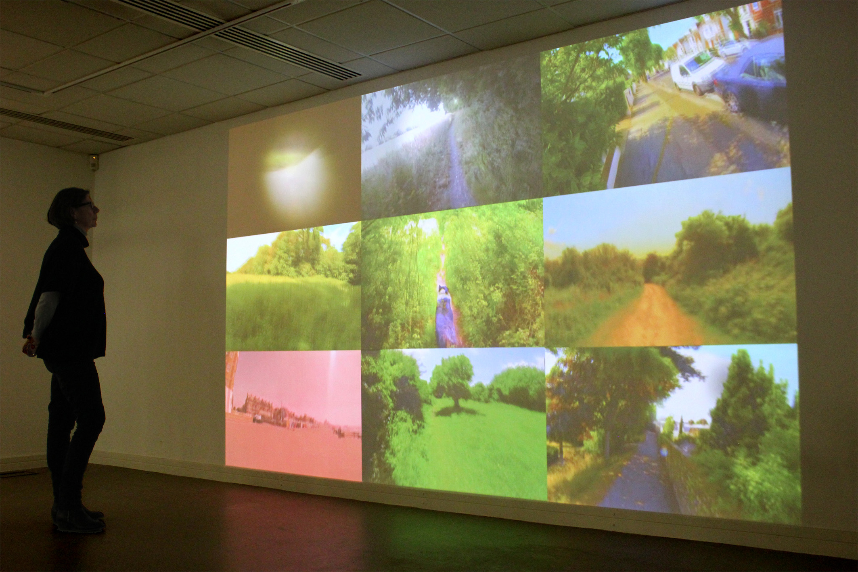
Figure 1 - Significant Walks Exhibition, Otter Gallery, University of Chichester 2014

This research builds on the research team’s mutual interest in the resonance of walking as an interpretive tool. The team came together in response to Shirley Chubb’s site specific exhibition “Thinking Path” (2003) which took Charles Darwin’s daily ritual of walking the same path in the grounds of his family home as its inspiration.

The team came to realise the potential of Chubb’s approach as a means to conceptualise physical problems, and worked together to identify a new way to investigate how people suffering with low back pain experience walking. Using lightweight high definition video cameras to record eye level views of participant’s walks and the simultaneous use of state of the art inertial sensors to monitor posture and movement the hybrid material forms the basis of an immersive projected artwork that synthesizes video footage with it’s corresponding stream of kinematic data.

The potential of these investigations as a tool to inform the understanding of lower back pain has become increasingly apparent. An area of particular economic and social interest, back pain accounts for an estimated 80% of people suffering with back pain at some stage in their lives (Maniadakis, 2000, pp 95-103).

The project was jointly approved by the University of Chichester Ethics Committee and the University of Brighton, Faculty of Health & Social Sciences, Ethics and Governance Committee.

Objectives
Key objectives of the project were:

To invite participants to interpret the nature of their pain through synchronized technology
To use the above experiential footage to create an immersive digital artwork for public exhibition
To disseminate the above elements in order to promote increased understanding of long term non specific chronic pain to the wider population

Methodology
The research invited participants from the large but predominantly unrecognized community of people with chronic low back pain. Participants were recruited via open calls to the research team’s respective universities and also within the wider community through local press channels. Respondents were asked to outline the nature and longevity of their condition in order to check that they were appropriate to the remit of the study which required non-specific low back pain. The interdisciplinary and collaborative nature of the project attracted interest from a variety of audiences including those interested in the visual arts as well as patient groups, health professionals and students and interested parties from a range of discipline areas.

Recruited participants were given an overview of the origins of the project and the methods used to gather video and data documentation. They were then invited to identify a short walk (approximately 20 minutes), within their local area, which was of particular significance to them (Figures 2 and 3). Each individual undertook their chosen walk accompanied by the research team who were recording data collection a small head mounted video camera with kinematic data simultaneously collected using miniature 3D inertial sensors taped across the participant’s spine (Figure 4).
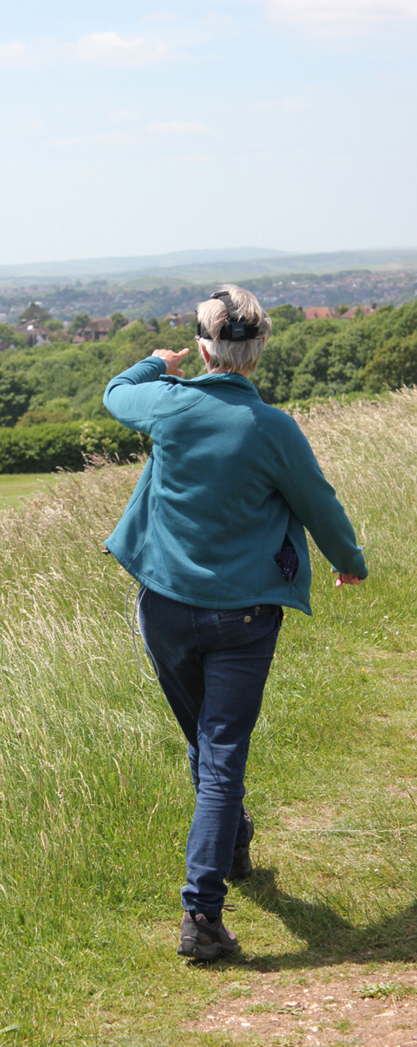

Figure 2 - Significant Walks, Subject 11 project walk, 2013

Figure 3 - Significant Walks, Subject 01 project walk #2, 2014

The resulting data provided continuous biomechanical information on posture and movement patterns during each walk, including deviations from pain free movement. Pain levels on a scale of 1-10 were captured verbally every 2 minutes during the walk along with verbal comments form the participants re their choice and experience of the chosen walk.
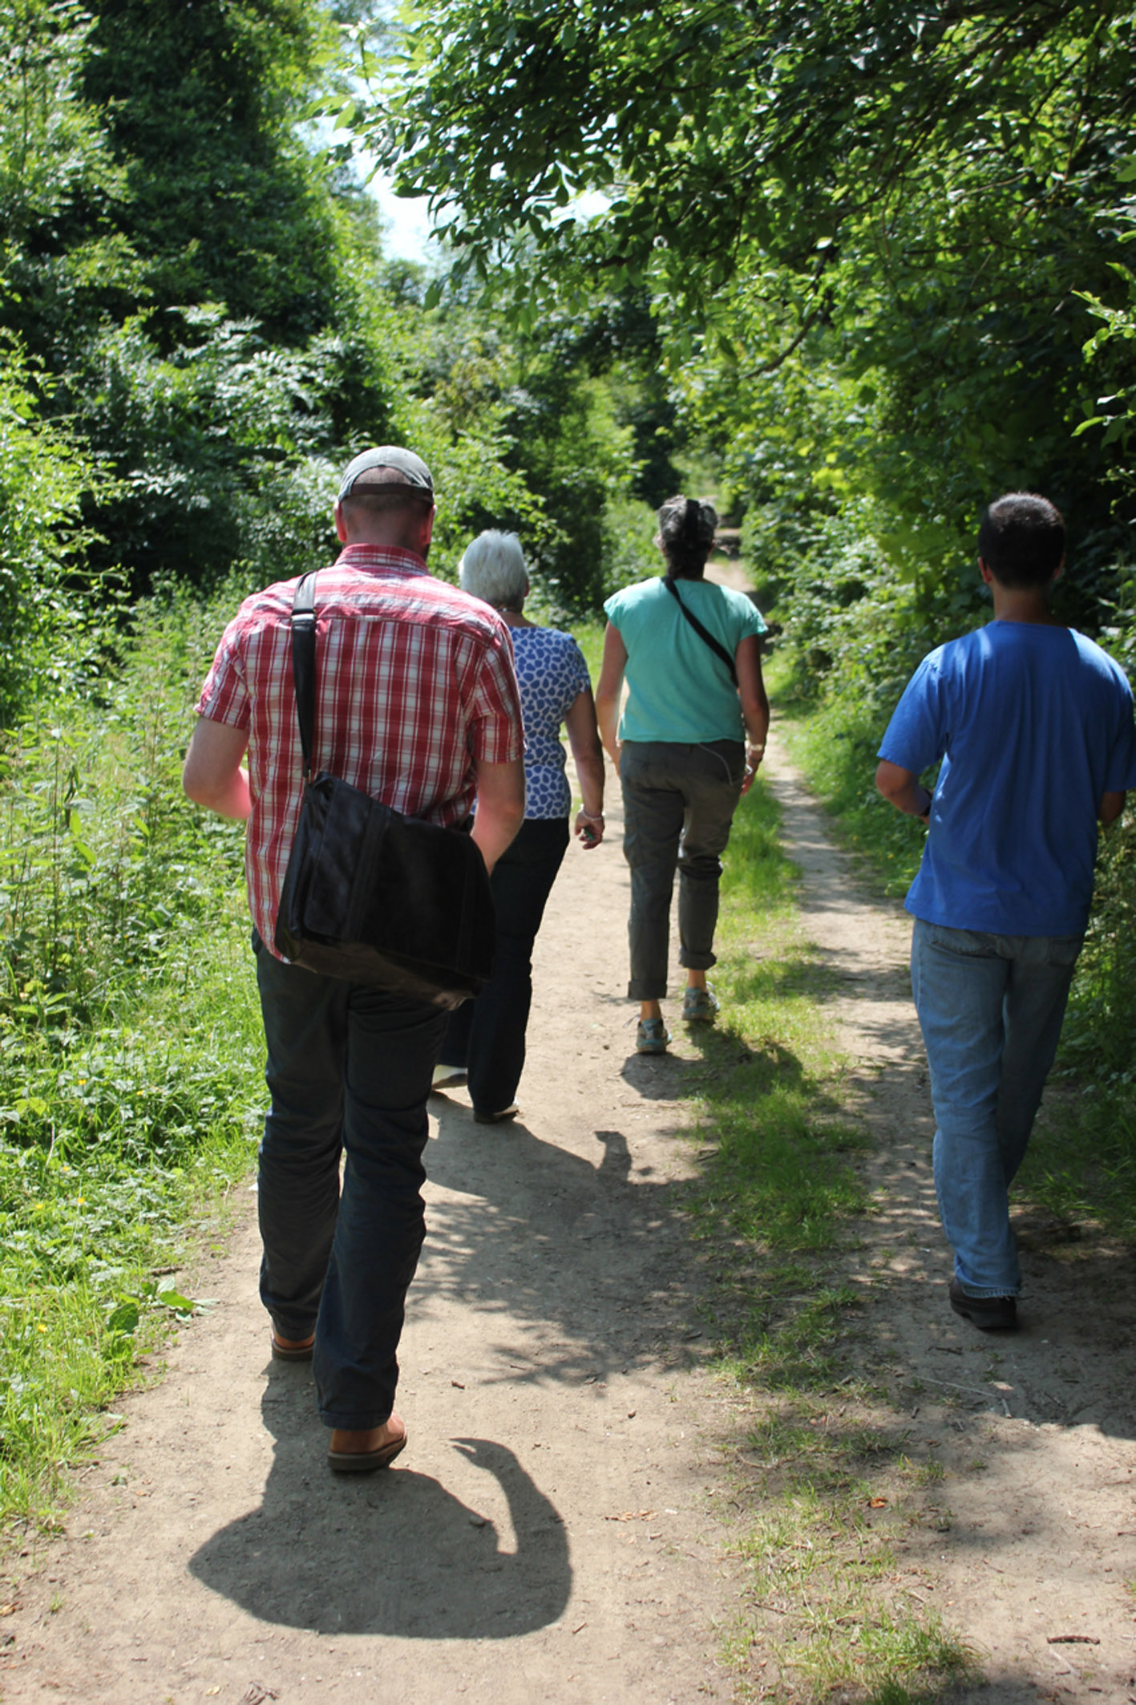

Figure 4 - Significant Walks, Subject 14 project walk including research team monitoring data capture, 2014

The relationship between the individual and their sense of place is seminal to Chubb’s practice, which explores how our experiential engagement with cultural and social environments shapes our understanding of the world. “Significant Walks” furthered her interest in synchronic approaches to production, and built on a methodology of manifesting factual measurements of time, space or site as interpretive expressions of an individual’s engagement with the world (Chubb, 2011, pg 199-213). Here the synthesis of video documentation, kinematic and pain data generated tangible visual representations of the link between external and internal movement, with the significance of each individual’s walk crucial to this process.

Each participant was asked to discuss the significance of their walk, commenting on memory, reminiscence or anecdote as well as the nature of their physical experience at the time. Exploring the use of inertial sensors, an emerging area in the biomedical sciences (Ha, 2011, pp. 87-91), the small size and portability of devices allowed the possibility, for the first time, of monitoring people and patients in their natural environments as opposed to the laboratory. (Ha, 2008, accessed 22.06.16). Experiential interpretation added resonance to the understanding of gathered visual and kinematic data, contributing a sense of immediacy to current debate and understanding The expertise of the project team enabled participants to explore an innovative approach to expressing their individual engagement with the world.

The resulting documentary footage was synthesized with the kinematic data capturing the movement and acceleration occurring. Each participant was shown how the video documentation of their walks and corresponding kinematic data had been synchronized, and were invited to consider how visual effects could be used to interpret the nature and challenge of their movement. Using laptops provided by the project and with the help of the research team, they then explored how choices from a menu digital effects, colour and saturation levels applied to their footage/data sets could most accurately interpret the nature of their personal walk (Figure 5). This involved one to one interaction with each participant to introduce the range of effects and consequent support to help each of them to investigate how the available options could communicate their individual experience whilst walking. This process included considering how, for instance, applying and adapting colour or adding textual elements to the synchronized footage might convey the nature of their individual experience. Participants were also able to change the use and duration of effects at different stages of the walk in response to their personal preferences. The process allowed an immediate review of the effects on their personal film, with the team then applying and synthesizing the range of choices throughout each film. Participants were then invited to a second review meeting where they could refine their choices and make any necessary changes with the help of the research team.

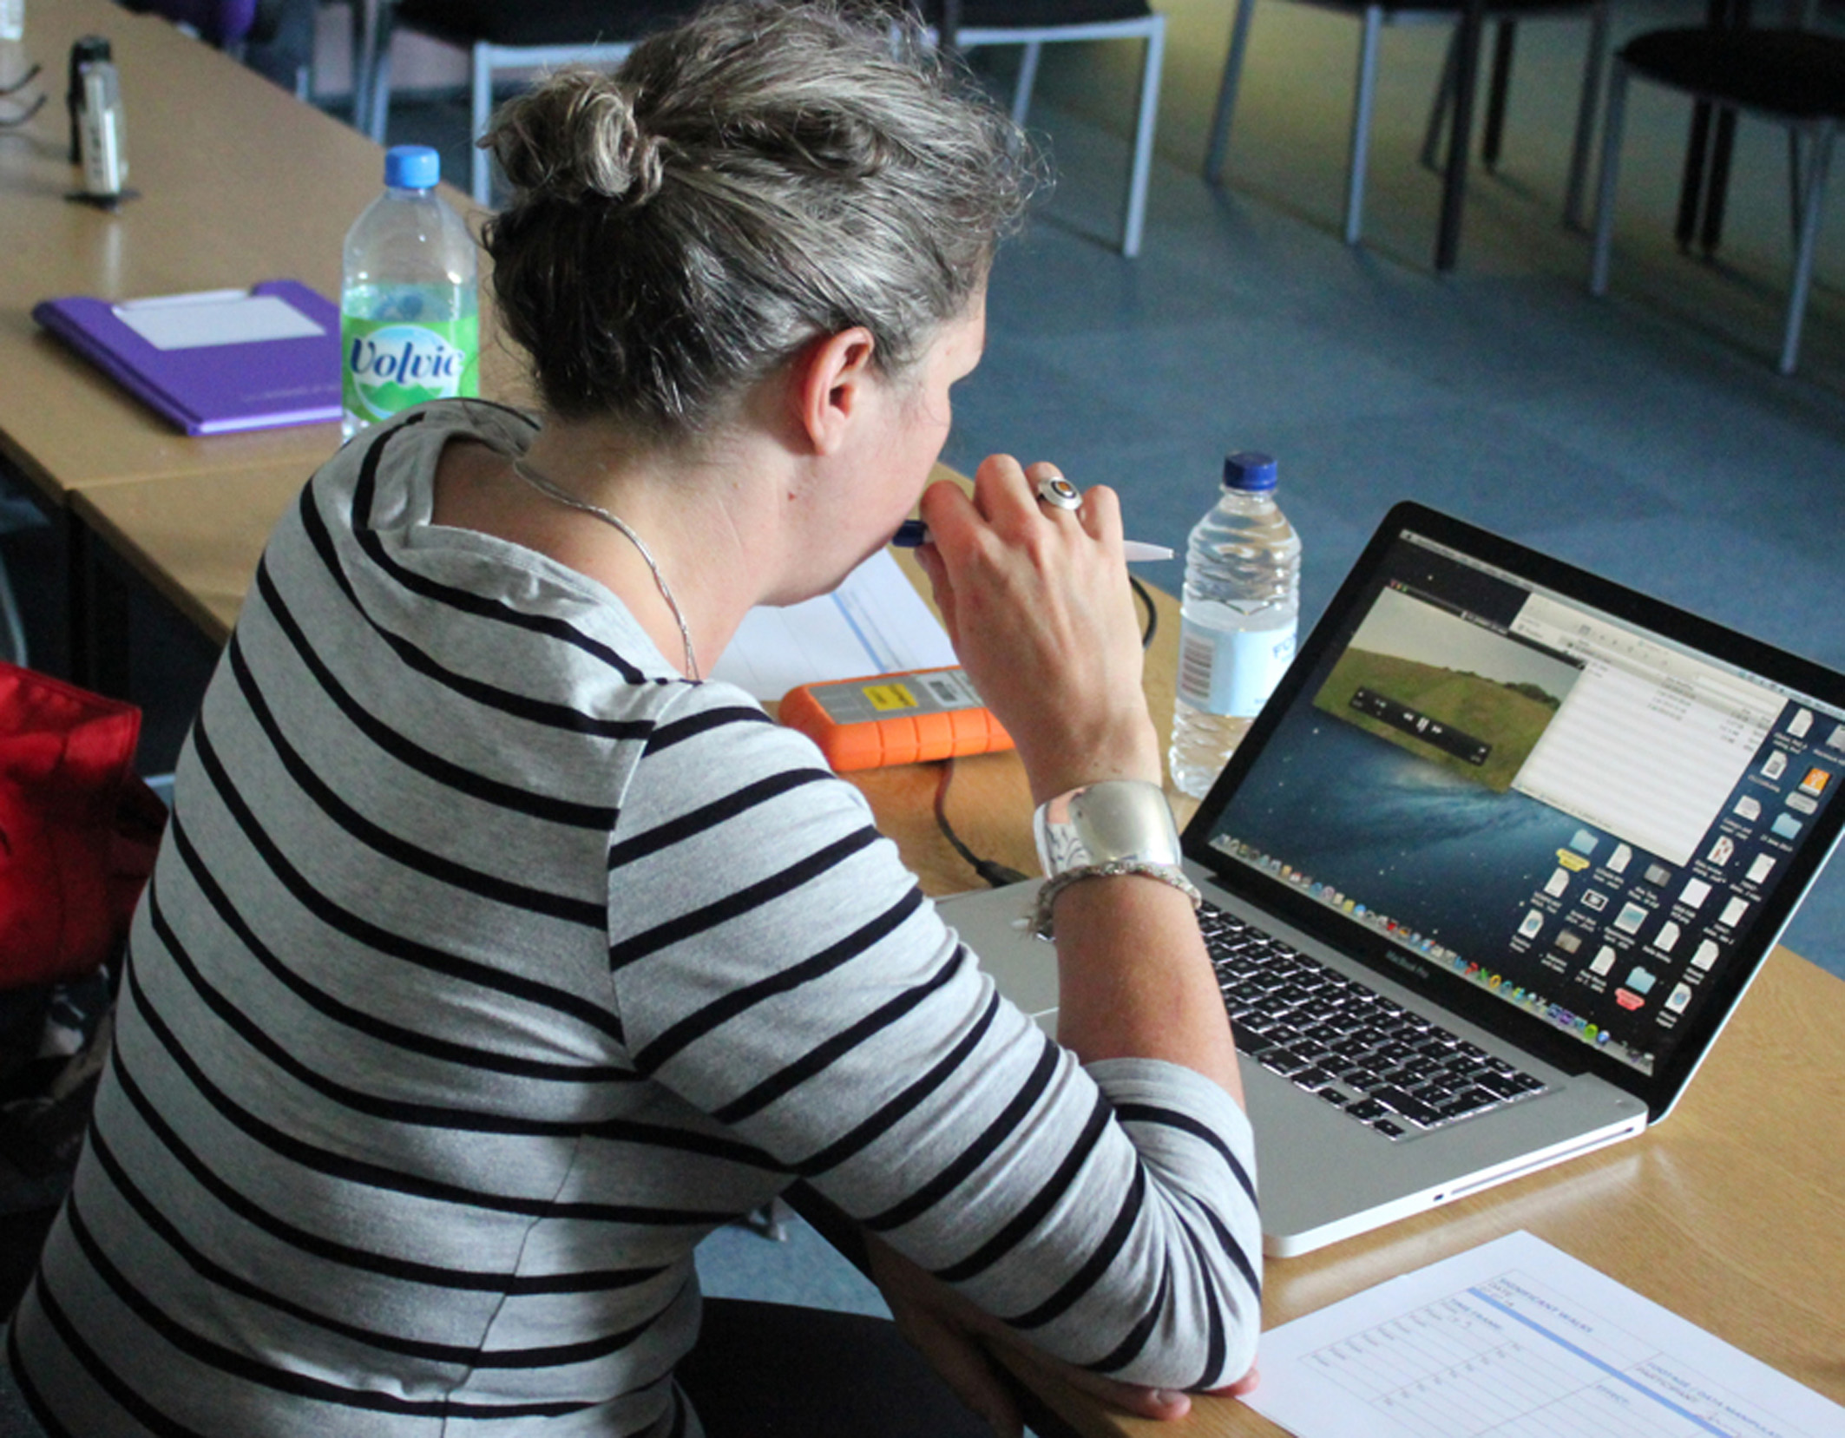

Figure 5 - Significant Walks, Subject 14 adapting synchronized footage, 2014

A final session provided the opportunity to discuss the edited artwork with the participants invited to reflect upon how the process of walking, gathering documentation and the manipulation of this material captured their individual experience, and how their experience of the project helped them to understand, and potentially manage, their condition. The outcomes from these sessions were then edited and combined to produce a cumulative video artwork featuring the walks of each participant.

At each session, participant’s commentary was recorded and used to inform the final editing stage and public display of the work. The sense of engagement is reflected in the presentation of the work where footage was projected to life size. Viewers recognised the generic act of walking, which could be seen as both a physical challenge and also a measure of memory, achievement and loss. The resonance of walking as a metaphor for understanding our individual place in the world was key to the research, both for participants and viewers. Walking is a part of our daily existence, providing opportunities to consider how we interact, navigate and respond to our environment. Given the prevalence of chronic low back pain this experience is compromised for many people and “Significant Walks” captured these individual realities by animating quantitative data whilst simultaneously communicating the qualitative experience (Figures 6 and 7). The resulting immersive artwork acted as a vehicle for both the science of data collection and also the reality of the individual at the core of scientific understanding, reminding us that in considering the experience of others we can better appreciate our own realities.

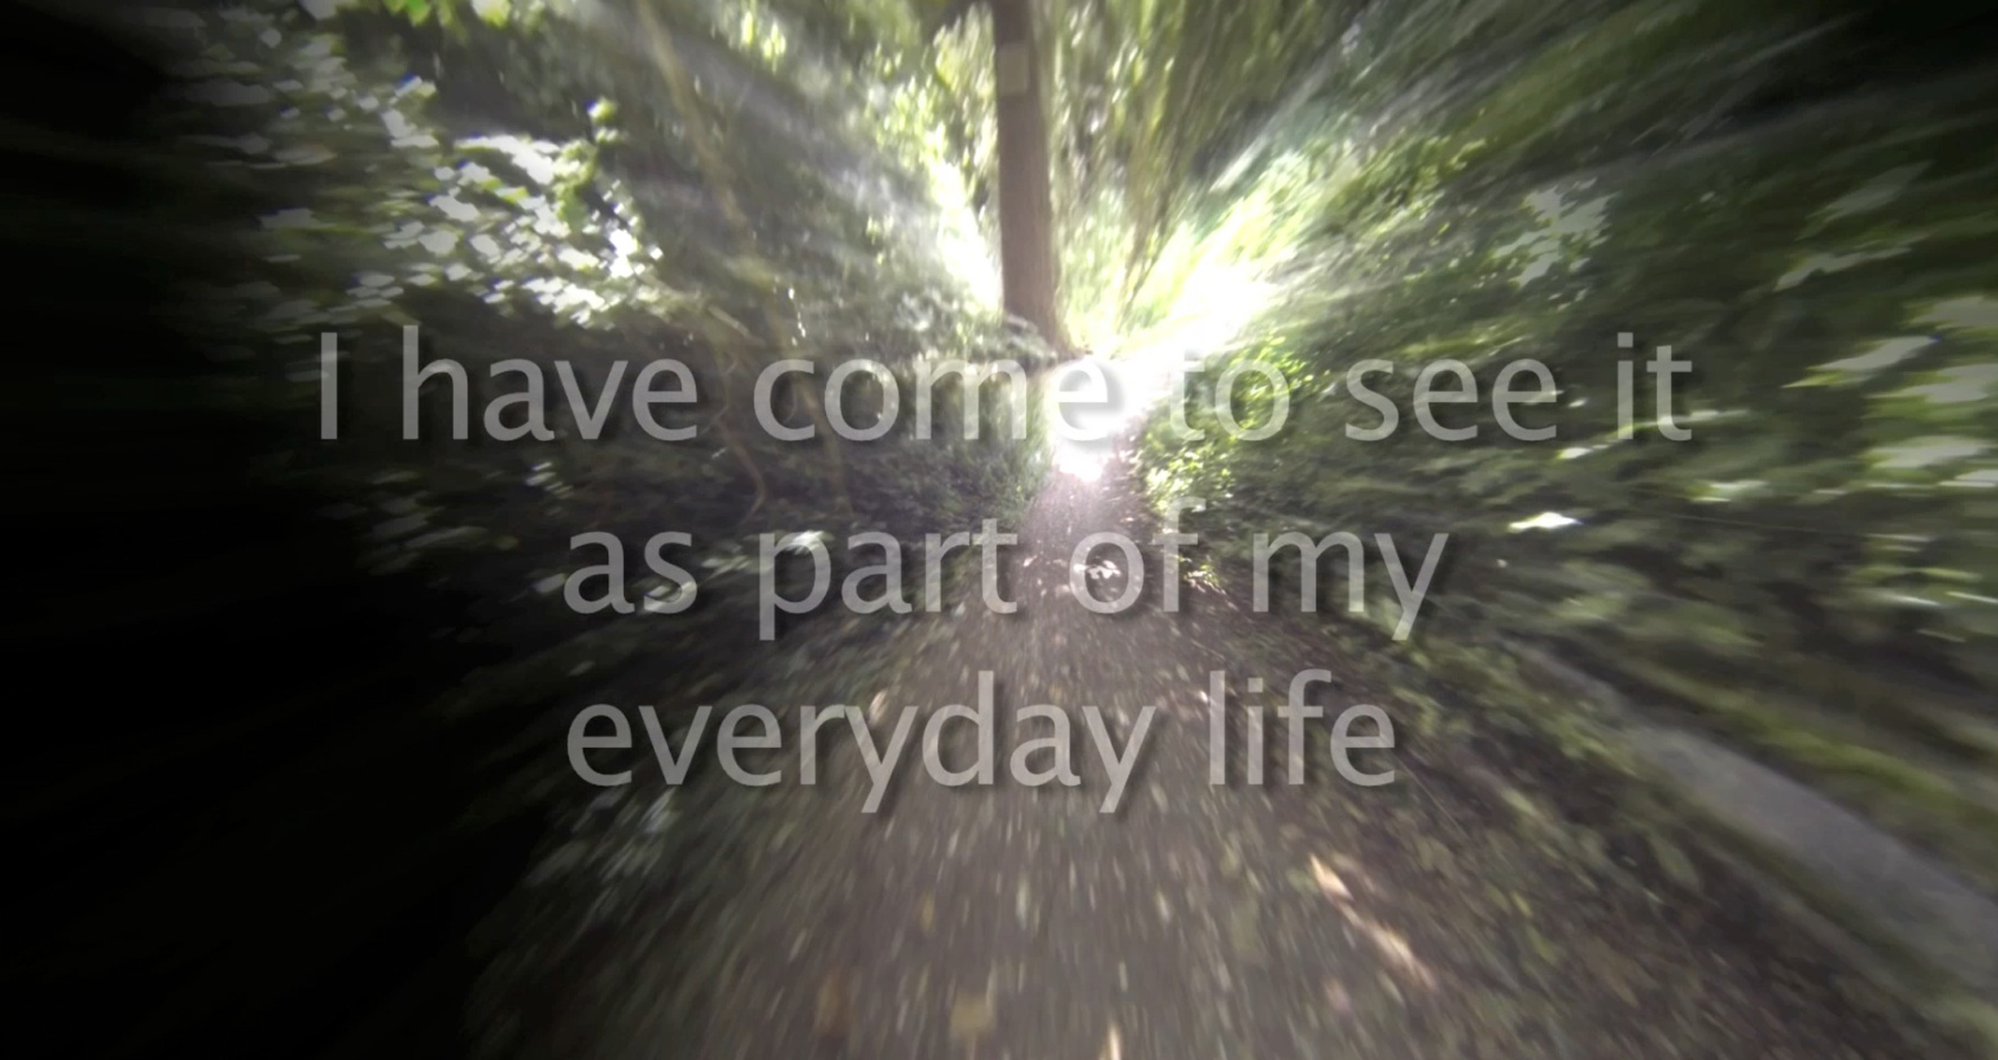

Figure 6 - Significant Walks, Subject 04 still of footage including digital effects and participant statement

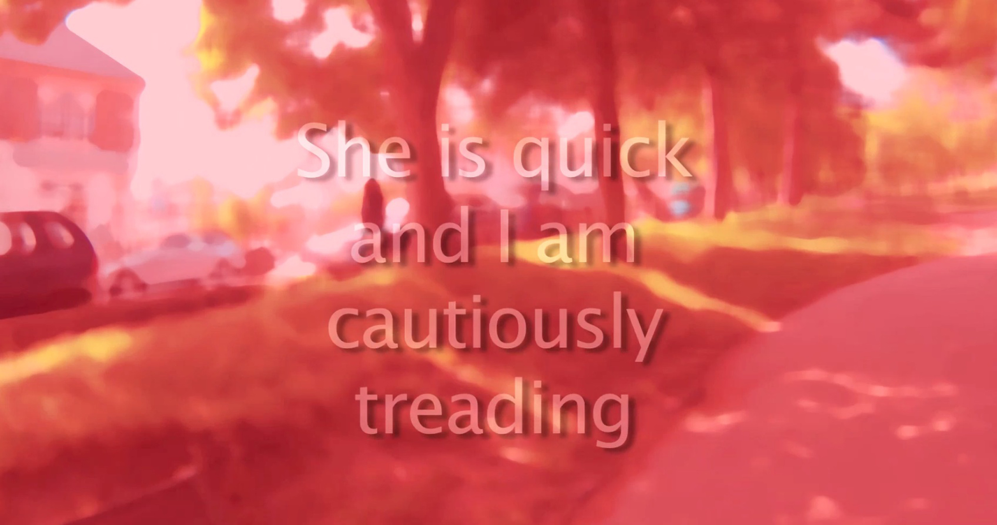

Figure 7 - Significant Walks, Subject 03 still of footage including digital effects and participant statement

Results
The study has shown that the systems utilized to capture data in this context worked well. To the researcher’s knowledge this is the first study of its kind and represents a very positive link between art and health approaches to research. The quantitative and qualitative data captured during the twelve significant walks together with the utilization of the effects at the application sessions and consequent group discussions has led to a number of outcomes.

a). A number of participants expressed positive benefits in relation to the involvement in the project and the insight it had given them to their particular low back problem but also in terms of the benefits of knowing how other people also experience low back pain.

b). It is likely that through awareness if the project via the website and public display, members of the public would gather a greater understanding of low back pain and the issues that those with the problem face on a daily basis.

c). The data from the study has been used to provide a range of informative and exploratory visual displays that can be used as exhibits or informal presentations. These include projected and screen based videos which provide an immediate immersive experience for the audience as well as symposia and conference posters, presentations and papers that have presented the project to professional arts and health audiences.

d). Within the visual arts the research contributes to the growing arena of socially engaged practice that puts the participant at the centre of production within a collaborative approach to research.

Conclusion
The project shows how collaborative interdisciplinary expertise and the use of emerging technology to visualize quantitative and qualitative data can create new knowledge and understanding between creative arts and health professionals, participants and the viewing public. This innovative project, which to our knowledge has not be carried out before, indicates developing understanding, particularly in the field of Musculoskeletal problems. The study has demonstrated benefits to the participants and has the possibility to increase public and health practitioners understanding of low back pain as an issue (Figure 8).

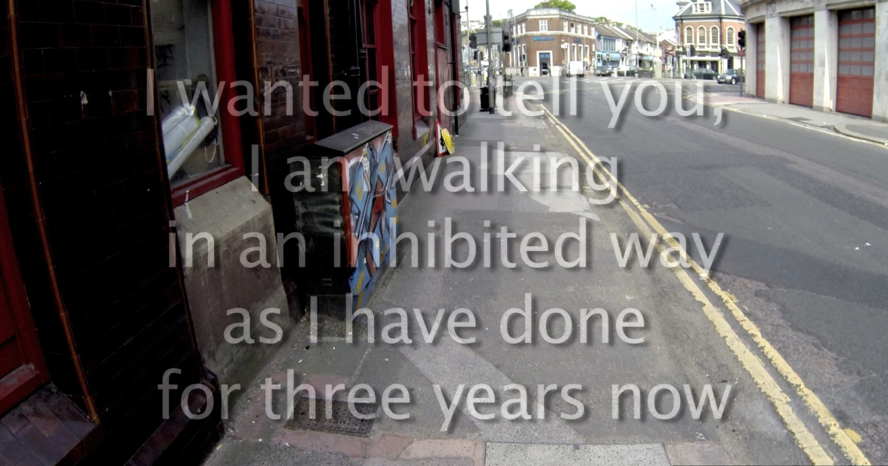

Figure 8 - Significant Walks, Subject 01 still of footage including digital effects and participant statement

Acknowledgements
The Wellcome Trust
University of Chichester
University of Brighton

References
Chubb, S., 2011. Location & Intervention: Visual practice enabling a synchronic view if artefacts and sites. In Dudley, S., Barnes, A.J., Binnie, J., Petrov, J., & Walklate, J. eds. The Thing About Museums: Objects and experience, representation and contestation. Routledge. pp.199-213.

Ha T.H., Moore A.P., Lee R.Y.W., Saber-Sheikh K., Jones M.P., 2008. Measurement of Spinal Motion Using Inertial Sensors - Comparison of different Computational Methods. 3DMA 10th International Symposium 3D Analysis of Human Movement. Amsterdam, Netherlands. 28 – 31 October. http://www.3dma-08.org/ Accessed 22.06.16.

Ha T.H., Moore A.P., Jones, M.P., 2011. Measurement of Lumbar Spine Range of Movement and Coupled Motion Using Inertial Sensors – a protocol validity study. Manual Therapy, 18, pp. 87-91.

Maniadakis, N., Gray, A., 2000, The Economic Burden of Back Pain in the U.K. Pain, 84, pp. 95-103

Solnit, R., 2002. Wanderlust. Verso p.132

