LISTENING TO ….

DEMENTIA

How to live well

Grahame Browne
Gill Constable
Emma Day
Andrea Linell
Jill Hayes
Eleanor Langridge
Marilyn Noble
David Sheard
Christine van der Valk

Listening to…. Number FOUR

LISTENING TO ….

DEMENTIA

A series of contributions collected and edited
by
ANDREA LINELL

University of Chichester 2015

In memory of

Paul Foster
University of Chichester

Jill Hayes
University of Chichester

Bob Noble
Member of the HOPE Group
CONTENTS

I
Positive Practice Approaches with People with Dementia
Gill Constable

II
Our Journey with Frontal Temporal Lobe Dementia
Christine van der Valk

III
Music, Dance and Movement in Dementia Care
Jill Hayes

IV
Good Dementia Care: it all comes down to mattering
David Sheard

V
Who Picked on Me
Grahame Browne

VI
Dementia Care today
Emma Day

VII
Positive Thinking- Helping to cope!
Marilyn Noble

VIII
End of Life Care and Dementia
Eleanor Langridge

LISTENING TO…

[For] the doctor
…sits raptly, raptly,
As if absorbed
Attention were in itself
A virtue.
As it is.
(U.A.Fanthorpe, 1987)

Listening to Dementia is the fourth paper in a series of (occasional) papers devoted to accounts of illness. To give voice to people’s experiences of illness (and of treatment and care) is of therapeutic value to people with Dementia and also provides critical insights for carers - doctors, nurses, relatives and others about their illness, about people with Dementia and about best care. This is particularly true about the present paper, for whereas we may be able on grounds of gender, say, or geography, to distance ourselves from some illnesses, all of us (present readers included) are unlikely to escape experience - either personally or within our own family or friendship group - of one or another form of Dementia.

The subject matter for the series as a whole (initiated by Paul Foster- Emeritus Professor at the University of Chichester) ranges widely across the clinical-pastoral axis; similarly, authorship is sometimes individual, sometimes multiple. Whole circumstances papers, with contributions from people with Dementia, from a clinical practitioner, and from a relative or friends are also included in the brief for the series.

Previous Papers

Listening to… Number ONE: A Case of Malaria (2002): Christopher Smith
Listening to… Number TWO: Diabetes Type 2- A Scourge of Affluence (2003): Claire Akehurst, Lorraine Avery, Larrie Dean, Gill Kester, Michael Waite, Betty Williams
Listening to… Number THREE: Facing Bereavement (2006): Jenny Buckley, Charles Causley, Colin Hartree, Sue Snodin, Mary Stirland, Hugo Williams, John Wyatt

SERIES LOGO- (see back cover) The snake is often taken as a representative of the administration of medicine, because of an ability to cast (slough) it’s skin and thereby achieve fresh growth and new vigour, but the choice has been made to use an ox. The ox is symbolic of St Luke, the patron saint of the medical profession and the surrounding words - LOOK as well as LISTEN - remind us that ‘Listening’ is always best accompanied by ‘Observation’ and, of course, any necessary action.

The design is by Eric James Mellon.

Preface

Dementia is the result of a range of diseases causing gradual decline in the brain’s functioning. A variety of symptoms can be experienced but they are likely to manifest differently in each individual. These symptoms will interfere with a person’s ability to perform the normal tasks of daily living. Special difficulty may be experienced with memory of recent events, processing information and completing tasks that have a logical sequence. There may also be changes in mood, increasing anxiety and depression and a sense of confusion.

There are about one hundred types of Dementia which is an umbrella term covering all the types of diseases that lead to these symptoms. The most common form is Alzheimers disease. This is where protein deposits in the form of ‘plaques’ or ‘tangles’ build up in the brain and cause the brain cells to die.

The next most common form is Vascular Dementia where the arteries carrying blood to the brain become blocked and cause small strokes which are not felt but damage the brain cells. Whereas Alzheimers is a steady process of degeneration, Vascular Dementia progresses more in a stepwise fashion, and some people can have a mixture of both forms. Lewy bodies is another form of Dementia and accounts for about ten percent of cases and is marked by hallucinations, and personality and behavioural change. Other illnesses that can lead to Dementia include HIV, heavy alcohol use, injury from sport and Creutzfeldt-Jakob disease.

Symptoms of Dementia

These vary considerably from person to person and sometimes develop slowly although this can also vary considerably. However these symptoms can include:

- Problems with memory, understanding, learning or making decisions;
- Finding it harder to complete tasks like making a cup of tea;
- Psychological changes such as increased agitation and depression, withdrawing from social activities, and sometimes personality changes;
- Some Dementias are accompanied by hallucinations.

Diagnosis of Dementia

Much emphasis has been put upon the importance of early diagnosis in order that people and their families can begin to plan for the future. It is thought that fewer than half the people with Dementia in the UK have a diagnosis. There are simple tests that can be done by a GP that involve asking a few questions. If the GP is concerned referral can be made to specialist services. There is also a new software program available which can be used by a GP and which can identify memory problems. However, it is important to recognise that there are physical conditions that sometimes produce Dementia-like symptoms. These include, for example, chest or urine infections or reactions to medication. It is important that full physical tests are performed, especially for the over-75s, to rule out other possible reasons for poor brain functioning.

Treatment of Dementia

There are no cures for most of the causes of Dementia, although there are drugs known as anti-Dementia drugs such as Aricept which may slow down the progress of certain types of Dementia. There can be difficult side effects to these drugs and they are generally prescribed in the early stages to test their effectiveness, but usually discontinued as the disease progresses.

The best approach for a person with Dementia is to maintain as much independence as possible, but people do need information about what is happening to their brains and also what support is available. Support offered should take full account of the person as an individual, their past history, their occupation, family life, interests, likes and dislikes. Communication needs to be specially tailored to the stage of the Dementia and developed as a skill, particularly in the absence of speech but all the way through the decline in cognitive functioning. You will see in several contributions to this booklet, a developing understanding of the importance of feeling and emotion in a person with Dementia will lead to the real possibility of reducing the “suffering” associated with the disease and immensely improve the quality of life for that person. The attitude that Dementia is the worst thing that can happen to a person needs to be eroded and replaced, as the quality of both care and skill improve, by a more hopeful response. The purpose of this booklet is to achieve that response.

Andrea Linell
September 2014

The Editor writes: As the number of people ageing in our world increases, Dementia is often portrayed as a disease much to be feared. This booklet aims to reduce some of that fear by bringing together contributions from a variety of people touched by Dementia, by their carers and by professional staff. These contributions are chosen because of their shared positive approach to the possibility of living well with Dementia. We hear from members of the HOPE group who are both people with Dementia and their carers who have been actively involved in providing their perspectives in staff training, conferences and policy making. The direct experience is invaluable and much of it is positive and where it is not there is a lot to be learned.

We learn of the contribution the arts can make to enhancing the creative output of people with Dementia, as well as providing unique opportunities for expression. There may be many things a person would like to say but cannot do so in the way they previously did, and the arts often provides alternatives. Emphasis is thus put on the emotional life of people with Dementia as their cognitive functioning declines.

Psychological input is increasingly significant in devising the most effective approach to each individual experience and we have a piece that brings those methods up to date. The founder of Dementia Care Matters - a training and consultancy organisation - makes a significant contribution, emphasising the compassion needed for both person and carer in providing person-centered care. As we hear of some of the poor care provided in our health system, this can be particularly relevant to people with Dementia. Finally, end of life and Dementia is a topic that also lends itself to the question as to how we preserve the quality of life throughout life.

ONE

Positive Practices: Approaches with
People with Dementia
Gill Constable

Background
It is estimated that there are 750,000 people living with Dementia in the UK who are supported by 500,000 partners, family members and friends. If health and social care services were providing this care, the estimated cost would be £6 billion a year (Department of Health, 2009). Services provided to people with Dementia continue to be highly variable as person-centered practice that is relationship based is not consistently embedded (Constable, 2013; Commission for Social Care Inspection, 2009). Moreover, people with Dementia are especially vulnerable to abuse, including while being supported by family carers (Cooper et al, 2009). In spite of legislation and social policies that entitle carers to support, in reality eligibility criteria to access an assessment for services has become increasingly restrictive, so that only people with the highest level of need are assessed for services. Additionally, those services provided by Local Authorities are means tested.

The Experience of Dementia
Inadequate support to carers due to limited services and understanding of the illness leads to people with Dementia experiencing ill-being. Kitwood (1997) argues that often people with Dementia do not have their needs for comfort, attachment, inclusion, occupation, identity and love met; and consequently their sense of personhood is not sustained. Bryden (2005: 127) speaks of her experience of having Dementia and advises:

“How you relate to us has a big impact on the course of the disease. You can restore our personhood, and give us a sense of being needed and valued. There is a Zulu saying that is very true, ‘A person is a person through others’. Give us reassurance, hugs, support, a meaning in life. Value us for what we can still do and be, and make sure we retain our social networks”.

In order for Bryden’s advice to be implemented, carers require an understanding of the impact of the illness and support available. In 2010 the government published research based on the views of 4,000 carers regarding the priorities for service delivery. It found that insufficient assistance was provided, many carers were not routinely offered a carer’s assessment, and there was a shortage of high quality respite care or domiciliary care (Gardner, 2009; HM Government, 2010).

It is for these reasons that this booklet is important. We want to focus on positive approaches that enhance well-being for the cared for and care-giver.

We aim to provide some insights into the lived experience of Dementia, and how people can be best supported through positive and creative approaches. These are individualised and take account of people’s life stories, thereby seeing the whole person in contrast to focusing on the illness. The intention is to increase knowledge and understanding so relationships can be built and sustained with people with Dementia. We hope this booklet will give some helpful guidance and signposting. An important point to reflect upon is not only what we do, but what people with Dementia give back to us. How we are reminded of the importance of the moment and valuing those things that give us hope, pleasure and contentment.

References

Bryden, C. (2005) Dancing with Dementia. London: Jessica Kingsley.

Commission for Social Care Inspection (2008) See me, not just the Dementia. London: Commission for Social Care Inspection.

Constable, G. (2013) Carers’ Stories. Newcastle upon Tyne: Cambridge Scholars.

Cooper, C., Selwood, A., Blanchard, M., Walker, Z., Blizard, R., Livingstone, G. (2009) Abuse of people with Dementia by family carers: representative cross sectional survey, British Medical Journal, 338.

Department of Health (2009) National Dementia Strategy. London: The Stationary Office.

Gardner, A. (2011) Personalisation in Social Work. Exeter: Learning Matters.

HM Government (2010) Recognised, valued and supported: Next steps for the Carers’ Strategy. http://dh.dov.uk/publications [accessed: 31/1/11]

Kitwood, T. (1997) Dementia Re-considered. Buckinghamshire: Open University.
TWO

Our Journey with Fronto Temporal Lobe Dementia
Christine van der Valk

In June 1996 Willem, who is Dutch and with a Masters degree in Civil Engineering, needed brain surgery to clip off a blood vessel which had developed a weak spot, leading to a number of bleeds in the frontal region of his brain.

He returned to work both around the UK and overseas; work which required him to be able to get on with people. Willem is a people person with a great sense of humour. There was a change though; the ambition had gone, whilst the ‘happy idiot’ side of his personality remained. We also noticed a growing lack of empathy, of scary financial decisions and of a developing obsessive compulsiveness. He arranged to buy a car costing £23,000 without considering the finances; when shopping with me he would rearrange each item in the trolley when a new item was added.

In early 2004, Willem fell and broke a kneecap, requiring surgery followed by six weeks in plaster and the need to learn to walk again. This time the changes afterwards were more marked. Willem was less keen to find work, or to think of alternative ways of earning a living; each of the contracts he did get all ended very early, though very diplomatically.

In July 2005 Willem suddenly became unable to complete his weekly invoice, or remember where I was when I telephoned to ask him to collect me from work. I took him to the GP, and at 60 years of age he had to give up work, something which he had loved. Months later he also had to stop driving.

It was 2007 before Willem got his diagnosis of the semantic variation of Fronto Temporal Lobe Dementia. Willem has particular problems with words - finding words to use in conversation, understanding the meaning of them.

Willem attends a fortnightly Dementia Respite Club and a day centre twice a week. His needs are such that following reassessment; he keeps his place at the day centre, whilst I continue to work and contribute to my pension to secure my own future. Willem is described by his key workers and volunteers as very funny and very caring, facets of his character which are not seen at home but which were appreciated by his colleagues at work. Social contacts outside home are enabling Willem to be himself.

When employed Willem was generally away from home. Since his enforced retirement, we have been able to develop a social life. We see more of our grown up daughters, their families and friends and are looking forward to becoming grandparents.

Willem has discovered an ability to draw, he loves walking - he meets people, can watch the natural world, and pass the time of day enjoyably. We belong to the National Trust; we spend many happy hours in art galleries, at sculpture exhibitions, at the theatre, both locally and in London.

In 2008 I was given a leaflet entitled ‘People with Dementia into Staff Training’. West Sussex County Council was looking for people living with Dementia to learn how to share their experiences with professionals such as social workers. Willem and I signed up; we did the six sessions over six months and had a great time getting to know a group of people with similar experiences. We became the Hope of People with Experience group and talk to groups about what it is like to live with Dementia.

Along the way we learned about the research that is being carried out on how best to manage Dementia. Willem engages totally in whatever is asked of delegates at conferences, providing an example of the benefits to someone with Dementia. His lack of shyness enables a relaxed atmosphere where everybody feels able to join in.

During training it became evident that for those of us who belong to the HOPE group, there is a need to be positive; to make the best of each day. I have learnt to problem solve, to be creative and develop strategies to enable Willem to remain as independent as possible for as long as possible. Yes, there can be tears of frustration but there is also a great deal of laughter.
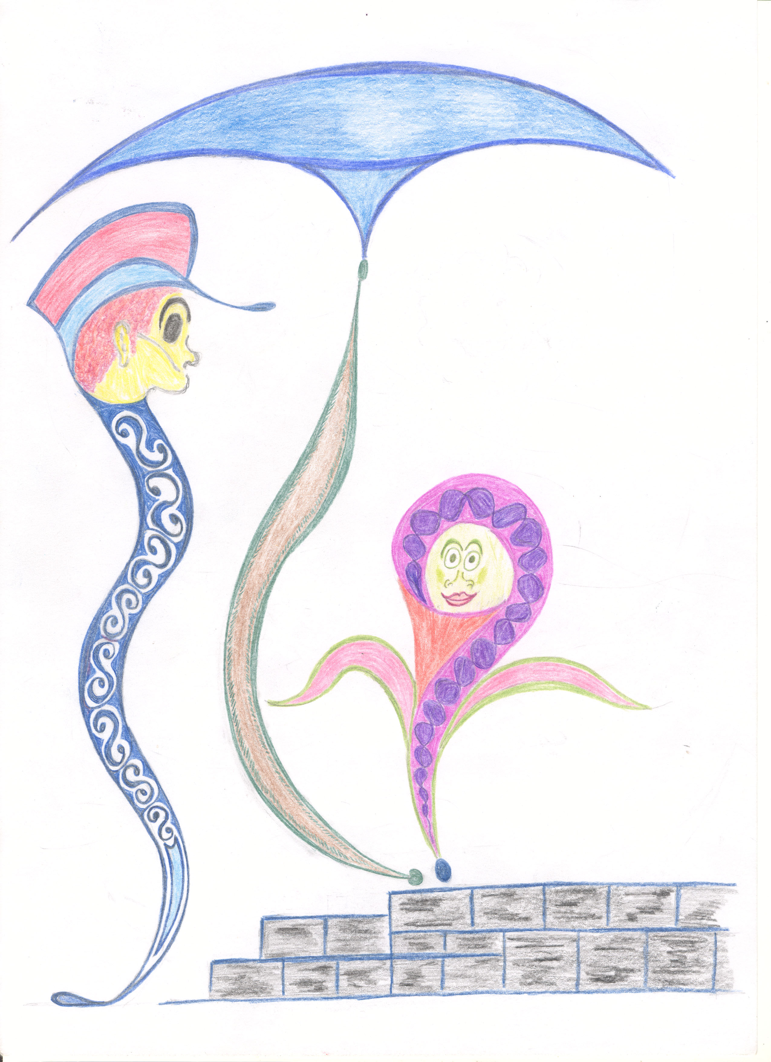

Illustration by Willem van der Valk

THREE

Music, dance and movement in Dementia care
Jill Hayes, BA, PGCE, MSc, MA, PhD

Do you know why the caged bird sings? Because it longs to be free. Do you know why the tiger paces timelessly up and down in its enclosure? Because it’s body seeks expression. It is the same for us. There is something inside - I’ll call it soul if I may - which is like the bird and like the tiger. These animals are metaphors for our deep feeling and sensation of a freedom in our hearts, which we variously cage and control with rationalism and materialism.

Sensitivity to the bird and tiger is nowhere more needed than in Dementia care because rationalism and materialism no longer make sense. Logical explanations may just as well be thrown out of the window and whilst physical care is indeed most necessary for dignity, physical presence is also essential for care of the soul.

I will boldly say that often (but not always) people with Dementia who listen to music, who sing, move and dance are again able to be free to express the cares of their hearts. They seem to come alive and find relationship in the moment of the song and in the moment of the dance. By offering these media of expression, we tend to the needs of the soul, which I might link to the deep needs of a heart which is drifting away from its human identity.

Can we make room for a different way of being in the day-to-day life of the home? Can we stop what we are doing for just a moment to appreciate the needs of the heart? Music, song, dance and movement are expressive modalities, which teach us the language of the heart; they help the expresser and the listener to take time to get outside of time and to be with the longings of the soul.

My colleague Sarah Povey (Voice Movement Therapist) and I have recently written a book about the value of the creative arts in Dementia care (Hayes and Povey, 2010). In this book we outline our philosophy of listening to the heart through the arts and show with various miniature case references how this may be achieved. The first point that we have made is that anyone can enjoy the process of creativity through participation in the arts, once we have dissolved the old feelings of inadequacy and embarrassment, which schooldays instilled by labeling us ‘un-artistic’, ‘un-musical’, ‘un-coordinated’. For such a little prefix, ‘un’ has done a lot of damage; it is the first tracing of the cage.

So it is the process of art making, of music, movement and dance which is important in bringing the arts into Dementia care. Let rip, fly, let go of inhibitions and enjoy playing like you did when you were a child. Workers can have fun in this creative adventure with the heart. People with Dementia are not tied down by self-consciousness; they often (but not always) welcome the opportunity to sing and move/dance no matter how that sound/movement/ dance might be judged aesthetically. They simply do not care; they are in it for the experience not the judgment. We too need to leave our judgments of self and others behind and experience the song and the dance, so we can encourage the person with Dementia to participate and meet them through music and dance in a place of feeling.

The second point that we have made is that music movement and dance create an opportunity for a vast array of feelings to be expressed; the sad and angry feelings as well as the happy joyful ones. Making a space for the expression of inner feelings, whatever they may be, is important in the care of the soul. The weight of history may have a presence in the song or the dance, even though the person cannot locate it in time. It is as if the life of the soul has an impetus of its own and needs an outlet for peaceful resolution.

The final point we have made is that the song and the dance can carry the life of the soul. They can be metaphoric emanations of inner feelings. So I can tell about the landscape of my heart in the quality of my voice, in the images of my song, in the inner presence of my movements. These aspects of our humanity are not lost when we have Dementia, but they are often invisible because we do not create the right environment and opportunities for them to be expressed. And yes, sometimes the automatic mannerisms and words which take hold in Dementia can obscure an underlying life which is distressed. Song and dance can loosen the grip of such mannerisms and allow the faint life of the soul to breathe again.

In witnessing the person with Dementia being open to their presence, the movements they make, the tone of their voice, the songs and the music which seem to awaken them, we can sensitively follow their lead in our choice of music, song and dance. We may learn a song which they mention and sing it with them, we may mirror any movements they make when they listen to music, and dance with them. In this way we do not impose the art from outside, we let the song and dance grow from being with the person, so that it has a stronger meaning for them. This kind of creativity is not about teaching or fixing; it is about listening to the voice of the soul expressing itself through the art.

References

Hayes, J. and Povey, S. (2010) The Creative Arts in Dementia Care: Practical Person-Centred Approaches and Ideas. London and Philadelphia: JKP.

FOUR

Good Dementia care: it all comes down to mattering
David Sheard

Mattering is feeling deep inside that to someone, to something, or to somewhere you really count.

Mattering is having evidence you can see, hear and feel that you make a difference and are really needed.

Mattering is about knowing that just being who you are really matters.

The long and winding road
It all began over 35 years ago. Walking down a long drive to a large Victorian ‘mental hospital’ in Hull, I was met by a man with a large bunch of keys. He took me through vast, scary, white, long corridors with door after door swinging behind us. Finally, we came to the ward I was to work on. Iron beds in long rows, shiny linoleum, a nurses’ office looking out on to the ward. ‘Patients’ with ‘Senile Dementia’ looking lost, disorientated and confused. Everyone wearing hospital gowns with ‘patients’ hair in seeming disarray. I had entered another world- the hidden world of Dementia care in the 1970s.

The drive to care
In the 1980s I became a social worker in Nottingham, where I drove ‘patients’ with Dementia, discharged from hospital, to live in Local Authority care homes. At the time this didn’t seem so alarming, yet I could spot these ‘homes’ a mile off. These two storey concrete buildings were often on council estates, and contained faceless chairs around the edge of large institutional lounges. ‘Residents’ paced the corridors trying to get out. Those ‘residents’ with Alzheimers disease often calling out for their mother, enduring stultifying boredom and the smell of an institution. Clothes were all muddled together in the laundry, your life history wiped out in facelessness. A home in a locality, but not part of the community, and a ‘home’ a million miles away from feeling at home inside yourself.

The path towards hotels
By the 1990s I was a General Manager of Old Age Psychiatry in Coventry. Closing down Dementia care wards in long stay hospitals felt essential. This would be the way of getting rid of the restraint chairs. There would be no more set waking up times, nor lining up people for the toilet, and bath lists could finally be banned. ‘Clients’ with Dementia were to be moved to the private sector and there they would live in care homes modelled on hotels. These new private sector homes would sweep away the Local Authority idea, based on austerity, of what a care home should look like. Smart reception areas, high quality furnishings and fabrics, even en suite bathrooms would be provided.

Of course the long empty corridors remained. ‘Service users’ wearing their own clothes continued to look lost as they ‘wandered’ around. These homes still ran like hospitals to clockwork set routines, task orientated, the ‘running’ of the home being everything. Nothing seemed to be done about the boredom. The message was at least everything looked ‘nice’ and ‘service users’ bodies were cared for. Hotel-like care homes were not in the business of personal feelings but of a corporate ‘look’. The silent, or not so silent, emotional impact of experiencing a Dementia was not to be thought about.

Fresh steps towards feelings
In 1995 I arrived home, resigning from the NHS with the words:
I can’t run factories in Dementia care anymore. Dementia care is so far away from why I came into it. I’m going to sit at the kitchen table next week and start again.

Starting again felt lonely, but in my gut I knew Dementia care could be so different, but proving it then was another matter. A chance phone call from an inspiring care home owner set the new destination - I would move into a new Dementia care home to sweep away the past. The idea that ‘people’ living with Dementia were more feeling beings than thinking beings took hold. It seemed obvious that when people couldn’t rely on logic, reasoning or memory that ‘Feelings Matter Most’.

The new destination
So out went the locks, routines and set meal times. There were to be no more ‘them and us’ barriers that separated people living and working together. No more uniforms, no staff toilets, no staff crockery. The language of calling people patients, clients and service users was to go. Boredom was to be banned.

Instead people were going to matter. People’s past lives were known and honoured with life story books, memory boxes and framed life histories. Hallways were filled with the stuff of life. Hooks to hang feather boas and handbags, boards with things to fiddle with, rummaging was central to helping people feel busy. Recreating bits of people’s past lives helped people to be who they were. Accepting people as they were and not trying to fix people living with a Dementia was the key. Helping people just to ‘be’ in their reality, unchallenged but loved for who they are, really worked. People came alive again, so called ‘behaviours’ disappeared and it was all about bringing out the best in people living and working together. Seventeen years later these messages continue to need to be spread further, but to change people and cultures of care takes a long time.

The right journey
So has the answer been found to the long and winding quest for compassion in care? Is the drive to find good Dementia care now completed? Does the care sector no longer need to search how to provide real hospitality? Has the hunt for real person-centered care as a destination for all care services finally been discovered? The answer is sadly no. Whilst the health and social care sector got stuck in outdated hospitals, whilst it replaced these with faceless Local Authority homes, whilst it then jumped at the idea of hotel-like care it forgot the one key thing. Good Dementia care comes not from buildings and not even from professional models of Dementia care but from people really mattering.

People walking together
Every generation provides the best care it can in the context of the best knowledge at the time. It would be arrogant to think that the nurses in the outdated 1970s ‘mental’ hospitals didn’t care. It would be a grave mistake to believe Local Authority care staff in the old care homes didn’t want to come to work to do their best. It is clearly now not the case that staff in independent care homes aren’t basically caring. There were very caring nurses, care workers and managers in previous decades. What distinguishes very caring people across time is whether people hold on to their feelings that people as individuals really matter. Similarly we need to be careful that simply reframing our language will lead in itself to better care. Whether you were called in the 1970’s a patient with Senile Dementia, in the 1980s a resident with Alzheimer’s disease, and in the 1990s a service user with Dementia, was not evidence that you mattered less than if you had Dementia now. Being called in the 21st century a person living with Dementia does not in itself guarantee that you will matter more than in past decades. What distinguishes your chance of receiving really good Dementia care is if the person supporting you walks the walk of really believing you matter as well as just talking the talk.

Eight steps towards mattering
In Dementia Care Matters we believe this focus on mattering will help us all as we continue to search for what brings together the many elements of good Dementia care. We have identified eight clear steps:

FEEL: Feelings matter most in Dementia care. Becoming more feeling-based ourselves and focusing on people as feeling beings helps us all to connect with each other.

LOOK: Looking like ‘home’ means feeling like home inside ourselves. Appearing formal and work-like is not person centered. Creating rooms that look like home, helps feelings to be expressed.

CONNECT: Connecting with someone involves accepting a person’s Own sense of truth. This means being in the moment with someone and looking to the meaning behind people’s words.

OCCUPY: Occupying people is different from providing activities. It involves knowing someone’s life and giving people purpose. This is helped by creating opportunities for people and encouraging spontaneous moments.

SHARE: Sharing our lives, thoughts and feelings as people living and working together is key. By doing this in a family-like community is how we all learn what really matters.

REACH: Reaching and connecting to someone on the inside sometimes involves rescuing people from their behaviour. This demonstrates to someone they matter.

RELAX: Relaxing the atmosphere and freeing people up from task orientation is vital. This gives everyone permission to have more emotional connection.

MATTER: Knowing your life is of importance to others and feeling you are influential is life enhancing. Having a sense of well being inside means knowing you as a person carry weight - it is this that makes you feel you count.

These ideas are not rocket science. As human beings we all know what really matters in life. We all want to feel good inside and to sense the look of our home feels right inside ourselves. We all want to be reached and connected with. We all want to feel busy, occupied and that life is meaningful. We want to feel relaxed and free to be ourselves whilst sharing our lives together with others. What matters in life is what should matter in health and social care too.

The final journey
So across the decades different types of health and social care buildings may come and go. Professional ideas and approaches to caring may differ over time. What in the end differentiates progress in good Dementia care will be none of these things but whether in the end within the care services people really matter.

Feeling you matter is the core of being a person
Knowing you matter is the heart of being alive
Seeing you matter is at the centre of carrying on in life

References

Sheard, D. (2013) The Feeling of Mattering: the positioning of emotions in dementia care. The Journal of Dementia Care March/April.

Sheard, D. (2012) Mattering in a dementia care home. Part one- core skills. DVD training programme. Dementia Care Matters.

Sheard, D. (2013) Mattering in a dementia care home. Part Two- culture change. DVD training programme. Dementia Care Matters.

Sheard, D. (2013) Choosing a dementia care home. Barchester Healthcare.

Sheard, D. (2012) Needing a good quality dementia care home. DVD information for families. Dementia Care Matters.

Sheard, D. (2007) Being: an approach to life and dementia. Alzheimer’s Society.

Bibliography

Moore, T. (1992) Care of the Soul. A Guide for Cultivating Depth and Sacredness in Everyday Life. NY NY: Harper Collins Inc.

Romanyshyn, R. D. (2007) The Wounded Researcher; Research With Soul in Mind. USA: Spring Journal Books.

FIVE

Who Picked on me
Graham Browne

This is the story of my journey with Dementia and for many others too - sometimes it has been down, but mainly it has been on a high plain. I remember the day I was diagnosed. We drove (my wife Debbie driving as I no longer could) past a newsagent with a sign proclaiming “Mental Health Cuts” and we both looked at each other and at exactly the same time said we hated the word “Mental”.

When I was finally diagnosed, about two hours later, with front temporal degeneration otherwise known as Pick’s disease we were lost for words and did not know what to say except to ask how long have I got left (two to ten years was the answer). There were no information leaflets to smooth our pathway into this new world of ours but after the initial shock we left the hospital and I jumped for joy and lit a cigarette. I actually had something wrong with me. I was not telling lies. The company I worked for and other people, I felt were beginning to question if there was anything actually wrong. After all, there were no outer symptoms and all the doctor would put on my sick notes was ‘neurological investigations’. So I went home and told the family. My two daughters went into denial whilst my son got information from the Pick’s Society website and now knows more than me! I only need to know that I have Pick’s and I can live everyday to the full and not sit at home waiting for the next stage to kick in.

Not long after that I was invited to join The Towner Club in Brighton, a club for younger people with Dementia. It is a saviour, and I get out of the house for two days a week with a great bunch of people. Before this I was offered two other places, one was a club for older people where they sat around a room having tea/coffee even if you did not want it. If you won a game of bingo you received a bar of chocolate. What an insult! When we had lunch I sat with four people who told me a lot about their past lives. The staff then split us up and I realised then that I probably knew more about those four than the staff!

The other offer was with a gardening club. We were given a piece of land to landscape so I sat down and did a sketch and put it forward. I was told that they would put it to the other members but there were only three other members and we all had tea together and could talk about it. Nothing came of this as yet again the staff did not seem that bothered. I did not go back again.

I had to go and see a local psychologist who gave me a test for Alzheimers (which I do not have) and he asked me a few questions which I felt suggested I was an axe-murderer. I am not mentally ill.

About six months after joining the Towner Club I was asked by a wonderful man called Neil McArthur to speak about my experiences at the University of Brighton. I had never spoken to large groups before but accepted his invitation. Unfortunately before this could happen Neil passed away, but out of respect for him I did go through with it. It changed my life for the good, and I was reborn into a life with dementia. This was followed up with visits from writers on the Alzheimer Society’s magazine and I was then asked to represent the Society as an Ambassador. I am proud to do this and have met some wonderful people both with and without dementia. I have spoken at Conferences and Congresses and to Companies. Last year I even went to Toronto to talk at the Alzheimer’s International Conference.

It was at the Bournemouth conference that I first met Andrea Linell who mentioned starting a group later called the HOPE Group which I joined. Its aim was to involve both people with dementia and their carers in staff training to improve the quality of care to people with dementia and their families. When Andrea retired it was taken over by David Moore and then by Kirsty Jones who is charged with taking the club further forward which I think we are achieving.

Going back to the beginning and that headline with the word “Mental” - I know that I live with dementia as do 800,000 others. Maybe if you do pre-meditate a killing that could be called “mental”. It was suggested I was a potential axe-murderer with a label of personality disorder. However I am living a full life with dementia and often none of us benefit from being given labels by professionals.

SIX

Dementia care today
Emma Day

Over the past twenty years, the drive to improve Dementia care services has been building momentum. Recent Government publications highlight that it has now become a national priority. In 2009, the first Dementia strategy (DoH, 2009) was released highlighting the shift towards the understanding that Dementia is not an inevitable consequence of ageing. Importantly, if a person is diagnosed with Dementia, much can be done to enhance an individual’s well-being and quality of life. Indeed, the very title of recent publications such as Living well with Dementia represents the shift towards more positive attitudes of Dementia.

In light of a renewed interest in Dementia care, research has been undertaken looking into current provision and has indicated that a re-evaluation of current Dementia care services is necessary (DoH 2009, 2011; NAO 2007). There has been much concern in the over use of ‘anti-psychotic’ medication. This is due to the limited benefits of the medication, alongside significant side effects. Some studies have also argued that it causes an increased risk of mortality (DoH, 2009). With this in mind, a new awareness and interest in non-pharmacological interventions has developed and could shape the future of Dementia services.

Recent non-pharmacological approaches to Dementia have focused on ‘person-centered’ care. This term was coined by Professor Tom Kitwood who stated that it is very important that care staff understand the person with Dementia, rather than focusing on the diagnosis itself (Kitwood, 1997). In this way, Dementia is viewed not in terms of neurological damage alone. Instead, Dementia is viewed as a combination of neurological impairment, a person’s life history, personality, physical health and the social environment that surrounds the person. This is known as the ‘enriched’ model of Dementia (Kitwood, 1993). Those who embrace this enriched model feel the very term Dementia can act as a barrier to understanding its effects and it may prevent care staff from understanding the underlying person and sense of personhood that can be so easily lost within services (Stokes, 2001). Interventions are therefore focused on improving well-being and quality of life rather than being directed towards the management of ‘symptoms’.

This new frame of working is supported in recent Dementia strategies and implementation plans as well as the recently issued National Institute of Clinical Excellence (NICE) guidelines. These state that there are two strands of non-pharmacological interventions; psychological and alternative therapies. NICE (2006) states that people with Dementia who display non-cognitive symptoms (e.g. changes in mood, sleep, appetite and behaviour) that cause them significant distress, should be offered a psychological assessment. This assessment would help to find out the likely factors that may cause, make worse or improve the individual’s current difficulties.

Furthermore, the NICE guidelines (2006) indicate that interventions should be tailored to meet people’s individual needs and preferences. This can for example include aromatherapy, massage and music and dance therapy, as well as the traditional ‘talking therapies’ such as Cognitive Behavioural Therapy (CBT). There has also been a drive for cognitive and sensory stimulation therapy which can be considered as either an alternative, or in combination with, pharmacological interventions for the treatment of cognitive difficulties.

Families and loved ones who are supporting a person with Dementia can play a key part in these new interventions. For example, families should be encouraged to play a person’s favourite music or cook favourite foods so the person’s senses can be stimulated by all the things they love the most. Taste, touch, smell, sound and sight are all important in helping the person to adjust and familiarise themselves with new situations and to remind themselves of happy memories. This also engages people in activities providing the opportunity for increased socialisation and well-being.

These new ways of working have resulted in a major overhaul of Dementia care services and pave an exciting future of further improvements and changes. It is hoped that good quality research will lead to further evaluation of creative therapies that can serve to meet individual needs and preferences rather than using medication as a first line intervention. In this way person-centered care can become the norm rather than the exception and hope can be restored in everyone who has been touched by the effects of Dementia.

References

Department of Health (2011) Living Well with Dementia: A National Dementia Strategy. Good Practice Compendium- an assets approach. London: Department of Health.

Department of Health (2009) Living Well with Dementia: A National Dementia Strategy. London: Department of Health.

Kitwood, T. (1993) Discover the person not the disease. Journal of Dementia Care 1 (1) 16-17.

Kitwood, T. (1997) Dementia Reconsidered: The Person Comes First. Buckingham: Open University Press.

National Audit Office (NAO) (2007) Improving Services and Support for People with Dementia. London: The Stationary Office.

National Institute for Clinical Excellence (NICE) (2006) Supporting people with dementia and their carers in health and social care. UK: NICE Clinical Guideline 42.

Stokes, G. (2001) Challenging Behaviour in Dementia: A person-centered approach. Bicester, UK: Speechmark.

SEVEN

Positive Thinking - Helping to cope!
Marilyn Noble
Wife and Carer

My husband was only 56 years old when he was diagnosed with Dementia. He was younger than most people, and the diagnosis followed three years of suffering illness which was mainly passed off as stress. Although the diagnosis was a life-changing blow, we both decided to face it head on although we did not know what we were facing. We tried to find the right help for the diagnosis, but found there are real gaps in the services, particularly for the younger than average sufferers of Dementia.

We decided to try and help change things by sitting on various committees and have an input on where things are going in the future. It is very much in the public interest and is being discussed at various government levels. I sit on committees at East Sussex County Council and West Sussex County Council to express the view from a carer’s angle, and we jointly attended political party conferences, doctors’ training sessions, social worker meetings, lobby meetings and have also assisted in the making of information videos. We were able to do this together for 5 years before I was no longer able to provide single-handed the high level 24-hour care at home that was required by my husband.

My family is fully supportive of the decision to have my husband placed in professional residential care. In actual fact they were instrumental in the decision, due to their concerns for my own welfare and they took me to visit various residential homes to search for the right one. I found this very enlightening and thought provoking to consider what care I would like and expect for my husband to have. The most important factor for us was that it is person-centered to my husband’s needs and wants for his happiness. We didn’t want him to have to fit into a strict routine, and wanted to ensure that his needs were respected and that the staff is caring and happy in their work. I have after some searching found such a place, however the placement of my husband in residential care has been quite a journey with my emotions up and down. I am confident that he is being better looked after than I can manage at home - as he deserves.

When I go and visit him, it is quality time that we can enjoy. Our communication skills for our new situation of having to cope with Dementia have improved and he is genuinely pleased to see me. It was a very hard decision for me to make, but he was increasingly unhappy with not being able to do all the things he wanted. He had always done all the home, garden, repairs and maintenance, and was very frustrated and angry at not being able to manage even simple tasks successfully. The pressures on me of balancing work, our income and the care tasks, is now gone. The initial settling in period was awkward, as my husband’s new surroundings are different.

Life has not turned out as we had planned or expected; however, it is not a wasted journey as we have found a lot of new friends, many through attendance at the local Alzheimer Society activities, i.e. coffee mornings, Alzheimer’s café, outings etc. These experiences have made us feel less helpless and more able, through our own journey, to help others. I am able to inform other newly diagnosed sufferers and their families of what our situation is or was and how we have tried to cope. We have had to come to terms with living in our different worlds, as in my husband’s case of Dementia he is living in various time scales, but the new situation enables us to have newfound quality time for us to enjoy, without many frustrating pressures. It is by no means an easy journey, but it is possible to make it as positive and pleasant as possible!
EIGHT

End of Life Care and Dementia
Eleanor Langridge

It is estimated that one in three people over the age of 65 years will die with some form of Dementia. As a result it is becoming increasingly important to understand the specific issues that impact on the quality of end of life care. In the same way that Dementia is experienced individually, so too are the signs and symptoms of the end stages of Dementia. This can make determining when the person with Dementia is nearing the end of their life problematic. However, there are symptoms that are common to the end stages of any Dementia. In the later stages of Dementia the person’s memory loss becomes more severe to the extent of them being unable to recognise themselves as well as other people, and withdraw in to their own world with only occasional flashes of recognition. The individuals’ past becomes their present. The ability to communicate verbally and through facial expressions becomes more difficult. They increasingly lose their ability to understand what is being said and to make sense of their surroundings. They become unable to walk and manage everyday tasks, often resulting in becoming confined to a chair or bed. The desire to eat or drink reduces and weight loss occurs. Urinary and faecal incontinence are also common symptoms. The NHS Lothian Supportive and Palliative Care Indicators Tool (SPICT ™) is a guide to identifying people who are at risk of dying within the next 12 months (see http://www.spict.org.uk- Appendix 1)

The individuals’ quality of end of life care can be enhanced if the individuals’ values, wishes and preferences are known to those involved in their care. This can be achieved by ensuring that the person with Dementia is given the opportunity to discuss their wishes and preferences regarding end of life care early on in the illness when they still have the mental capacity to make informed decisions. Although it may not be possible to comply fully with the individuals’ wishes and preferences an Advance Care Plan (ACP) and an understanding of what is really important to the individual will enable those around them to make better informed decisions within the limitations of what is possible. The ACP also enables services to plan ahead and provide appropriate support to meet the individuals’ wishes as far as is possible and practicable.

The individual may also have an Advance Directive to Refuse Treatment (ADRT) which specifies those things they do not wish to happen such as cardiopulmonary resuscitation. In addition, a Health and Welfare Lasting Power of Attorney gives an appointed person (the Attorney) the power to make decisions regarding health and welfare on behalf of another person when they lack the mental capacity to do so themselves.

It is well recognised that hospital is not the ideal place for people with Dementia to die as it is unfamiliar and the overstimulation resulting from the ‘busyness’ can be distressing. Having an ACP or ADRT in place can help to avoid the individual’s final days or hours being in an inappropriate environment and avoid unnecessary hospital admissions.

The alleviation of pain, which is thought to be present in over 60% of people with a Dementia, can make a considerable difference to the quality of the individual’s life. The person with Dementia is unlikely to request pain relief spontaneously, therefore practitioners need to use and consistently apply a recognised Pain Assessment Tool such as PAINAD (find out more at: http://prc.coh.org/pain_assessment.asp- Appendix 2). Regular doses of analgesics such as paracetamol have been shown to be sufficient to manage chronic pain and eliminate behaviour that had previously challenged the service.
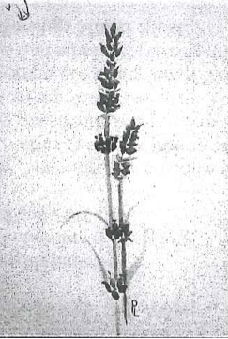

A sprig of lavender
Drawn by Pam Lawrence

In terms of end of life care, programmes such as Namaste Care which is based on the premise of ‘honouring the spirit within’ are beginning to be introduced in nursing and residential care homes in the UK (find out more at: http://namastecare.com- Appendix 3). Namaste Care focuses on stimulating all the individuals’ senses providing sensitive, compassionate care which nurtures the individuals’ sense of wellbeing. The environment is kept warm, calm and tranquil with soft relaxing music and lavender aromas. Individuals are reassured with soothing voices, gentle hand, face and foot massages. Care workers provide regular sips of liquid and finger foods to tempt the taste buds and maintain hydration. Research has shown this approach reduces the need for antipsychotic medication and sedation. Namaste Care also offers the opportunity for relatives to reconnect with the person with Dementia as they can be actively involved in the programme which gives their visits a renewed purpose. It is not uncommon for the individual with Dementia at the end of their life to respond and communicate through touch when receiving a hand massage. This can be a great comfort to relatives in particular, as they come to terms with the loss of their loved one.

Further reading

Alzheimer’s Society, ‘My life until the end. Dying well with dementia’ (October 2012) http://www.alzheimers.org.uk/site/scripts/documents_info.php?documentID=2017

Appendix 1- http://www.spict.org.uk

Appendix 2- http://prc.coh.org/pain_assessment.asp

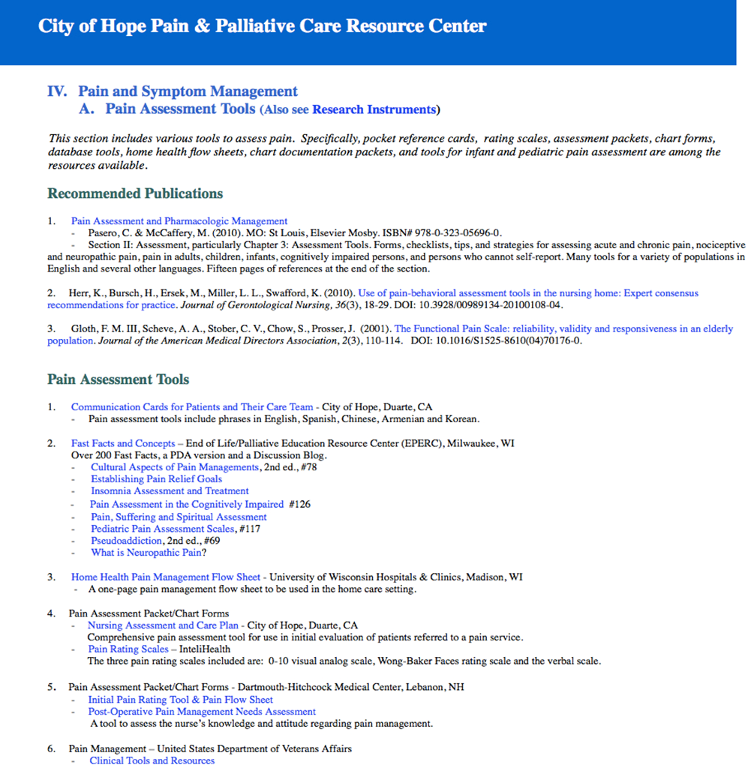

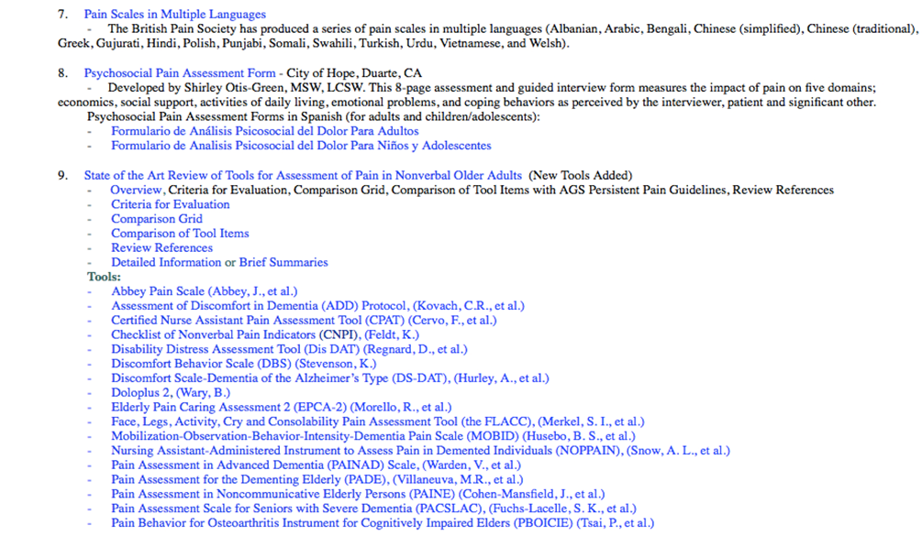

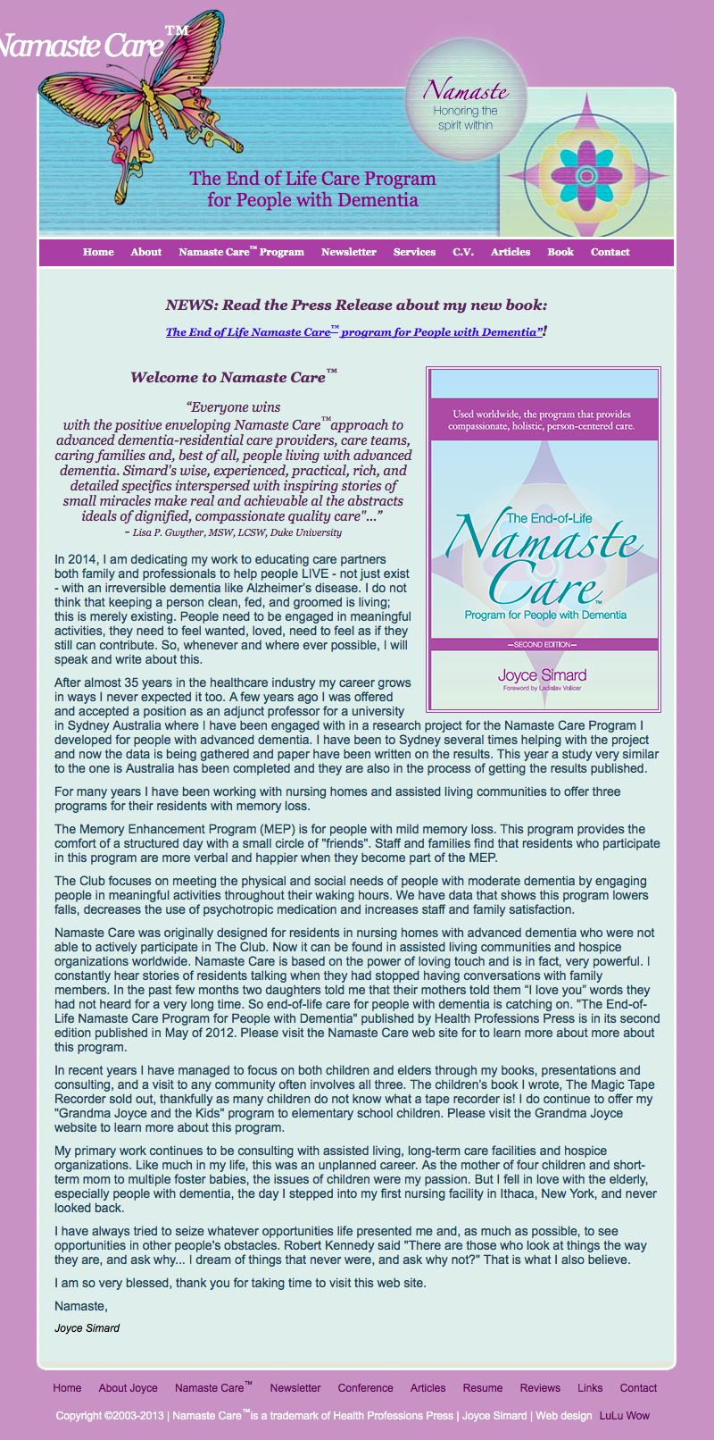
Appendix 3- http://namastecare.com

CONTRIBUTORS

Graham BROWNE was diagnosed in 2006 with Pick’s Disease, a form of Fronto-Temporal Lobe Dementia. He is an Alzheimer’s Society ambassador for good Dementia care and has spoken widely of his experience.

Gill CONSTABLE, formerly on the staff at the University of Chichester, is a Lecturer in Social Work in the School of Health and Life Sciences at Glasgow Caledonian University. Gill is especially interested in how well-being can be enhanced for people with Dementia and for carers.

Emma DAY is a Clinical Psychologist.

Marilyn NOBLE, living in Eastbourne, cared for her husband Bob and both of them were founder members of the HOPE group aimed at involving people in training staff. Bob died in 2013.

David SHEARD worked in specialist Dementia care services and then founded Dementia Care Matters in 1995. He has written extensively on Dementia, run training courses in Dementia care and is Visiting Senior Fellow in the School of Health and Social Care at the University of Sussex.

Eleanor LANGRIDGE works as End of Life and Dementia Project Manager for the NHS in Sussex and has developed an integrated end of life and Dementia care pathway, and trains staff to implement it.

Jill HAYES worked as an expressive arts and dance movement Psychotherapist in private practice and as Senior Lecturer in counselling and dance at the University of Chichester. She died in 2014.

Christine van der VALK is a nurse and married to Willem who has the semantic version Fronto-Temporal Lobe Dementia. They are both members of the HOPE group and have made many appearances at conferences and training courses.

PUBLISHED

By

University of Chichester
Bishop Otter Campus
CHICHESTER
PO19 6PE

ISBN
978-1-907852-23-7

© INDIVIDUAL AUTHORS

British Library Cataloguing-in-publication Data available

